**WATERDEEP WAZOO NEWS**



Editor: Shah Chien

Since 1400

We Dig Deep

CRIME

WAVE!

Following a week of wonder our glorious city was struck with tragedy this week starting in the bustling old market area of Trollskull when, according to Black cloak preliminary investigatory reports, a Fireball went off at the Bronze Ball inn taking the lives of 12 (including the proprietor). Tragedy struck further when as the violence literally bled over to the Gralhund estate with multiple bodies being seen escorted to the city morgue. In typical fashion regarding the lofty nobles of Waterdeep, authorities have been tight lipped about the causes and who might have been involved but the Waterdeep Wazoo believes that it is related to the multitude of gang related violence about the city. The Black cloaks are currently encouraging citizens to be on the lookout for any suspicious packages and to report any to a city watch official at once. There has also been talk regarding a city wide fireball ban but other magic users and restaurant owners strongly oppose stating that ‘the freedom of casting is tantamount to their craft’ continuing ‘weave exploration is a way of life What next? ban cantrips?’

When asked who to blame for the attack and whether or not the Grahlund noble family lost any of its prestigious members. Officials have been tight lipped however more information has been given as to some of the leading culprits. More to come as information emerges. Find it here. At the Wazoo! Story Continues on W-1

**Zhent Double-down**

Open Zhent agents have begun yelling openly that Manshoon “the great” mage of old and founder of the zhentarim himself has returned to the city. Any harm to Zhents, they say, will return 10 fold onto the city itself. Manshoon, the long since dead? founder of the zhents is said to have been but in hiding for the last 100 years. So, what could this mean for the city? Well officials are not going to “negotiate with the terrorist organization Zhentarim” but if what they say is true then there are worse things than approaching Zombie armies led by Lord Dagult Neverember! See W-2 for related stories.

**Griffon Academy Crack down**

Violence in the Dock Ward continues to escalate and even the most hardened Waterdavians on edge. City officials have begun to increase Griffon patrols and have informared local wards to institute a city wide 9pm curfew. The Gods day festival and opening of the prestigious Mountain top gardens have also been cancelled until next year. The Academy insists that, due to the increased level of violence citizens refrain from partaking in Reign of Misrule shenanigans for their own safety and security..

WANTED  
  
(Avareen Windrive (left), Urstul Floxin (center), Zorbog Jyarkoth (right)  
  
**W-1** Three notorious Zhentarim agents are currently at large within the city of Splendor. All three men should be considered armed and extremely dangerous. Authorities however are requesting any information on these three fugitives so that they may come to a swift and just end. All three men are wanted in connection for various cases of murder, arson and robbery about the city. -The Griffon academy

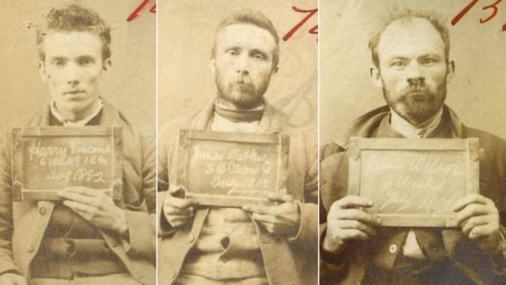

**W-2 MANSHOONS SHADOW?**

In a rare public appearance the religious leader extremist and Manshoon consipiracy theorist Agorn Fuoco spoke out against the recent criminal violence in the city. “The City watch can only protect you so far,” Fuoco began, “the ‘*deep’* is infinitely stronger and plans its own day of reckoning. Oust the vampire lord Jury Grando and what do you have? A weak beast struggling to stay alive. Such is Waterdeep. The deep shall slit its throat while it gasps for breath. Turn now to religion, to Manshoon and to the Zhentarim alone who will save thee against this heathenish and corrupt city. He alone can protect you from the coming madness”. He went on at length in similar fashion with protesters nearby enraged that the city would allow a platform for such insane and toxic opinions. The rare sighting of Agorn Fuoco and his public statement has left people fearful of the coming months, while others in protest, more war hardened Waterdavians merely laugh it off saying ”Just another day in Waterdeep.”



**BUSINESS IN BRIEF**

**Snowbeetle Winerly** Orange Peel Exlixer (O.P.E.) opened to mixed success last week. While the hype was certainly there and even somewhat bolstered due to what have been called “production problems” by Redcast Winers spokesmen, Critics argue that that new brew, while high in alcohol content lacks the depth and aged quality locals have come to enjoy from Redcast . Snowbeetle officials have even stated a possible recall of all Snowbeetle producted barring a criminal investigation related to their competor.

**Avi and Embic Armory** have made an announcement that they have been working on a new line of rapidly heated an dcooled products that provide customers with’ easily tempered, bendable and strong weapons’. Perhaps their strongest yet, the couple claim.

**Vincent Trench Tiger Agency** Accepting new cases.

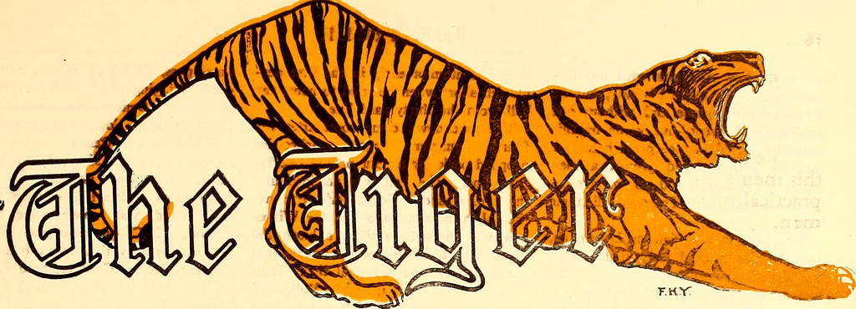

**Stoneshal Collection wagons** will be traversing the city in hopes for donations for the poor after Stoneshal upheavels last week. Get your unused basement tools out and donate to the cause.

**Curious Concoctions** now with the latest and greatest Nimblewright connecters, adaptors and locators. Wealthy enough to afford a nimblewright or thinking about purchasing one? Well then certainly a few extra gold pieces won’t hurt the purse to bling it out some more or pick up one of the new affordable models? Questions or Queries please inquire within.

**Saragauth River Tours** are said to begin operations again with pricey but adventurous excersions too Skullport and back. Not for the week at heart.

**Art and Culture**

**New Operas?**In a surprise announcement for theater lovers. Despite the smash success of the Easter epic Toska, Roland Ronquan of The Seven Masks theater has announced yet another opera based on the cities recent rumours and cravings for gold. Set in Waterdeep itself, “The Ecstacy of Gold” is said to get people in on the hunt. This time, your favoroute, Malkolm Brizzenbright, will be taking the role of Lord Nevermber in what Ronquan assures audience will be as bawdy and theatrical as it is entertaining.

**THE GALA of all GALAS**The Cassalantar family, in preparation for its opulent winter ball this year assures the elite of Waterdeep that, in keeping with tradition, enough Redcast wine will be available for purchase and consumption at this years Gala event. Only the first 99 visitors who respond to their invitations will be allowed to attend so do be on the lookout for your origami swan invitation. The Noble house, in classic mysterious manner have mentioned that those who receive their invitation, in order to make sure only the best attend this years function, come with is a special way of reserving but have mentioned nothing more. Typical.

SPEAK OF THE SPLENDOR

- Looking for unique flowers along the Undermountain. Anyone free ? Come join the at River Gate on M16   
-Toska tickets for sale. (low prices) -B. Peabody

-Post Stoneshal Anything you don’t want… Ill take it off your hands! Cheap like. -Skeemo

-COWERdz! WE cum fyynd uR den!

-Dark figures more in the seas. The City watch is too busy, or stupid to do anything about it. So I will. –G

-Looking to put your name on the marquee of the Seven Masks Theater? Well R.R. of theater fame is putting out a casting call for all those who have the vocal acccumen to make it big? Auditions being on M12.

-Did anyone see those grave diggers out in the City of the Dead? More Necromancers or Zhent robbers?

-Hey Renaer, come out, come out wherever you are? We seeeeee you and will finish the job this time. –anon.  
  
1) ______________________________________  
  
2)_______________________________________

-I saw one of them move I did. Really? Why doesn’t anyone believe me?

-Did anyone see those grave diggers out in the City of the Dead? More Necromancers or Zhent robbers?

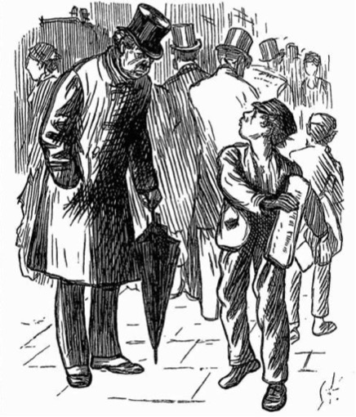

“You telling me that the Wazoo is only a copper!?”  
“But I’ve been paying a drag

**WANT TO PLACE AN AD OR COMMENT IN THE WATERDEEP WAZOO, CONTACT SHAH CHIEN FOR INFORMATION**

