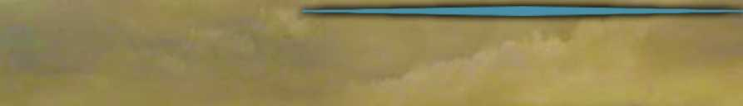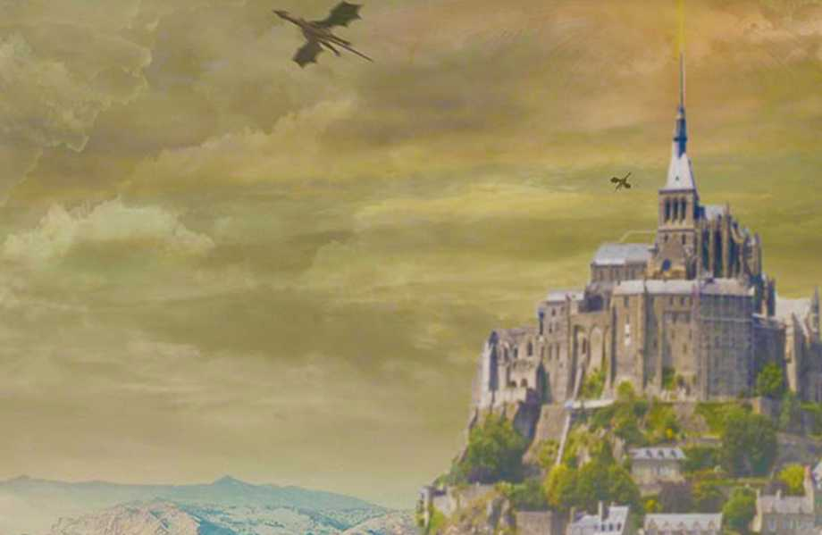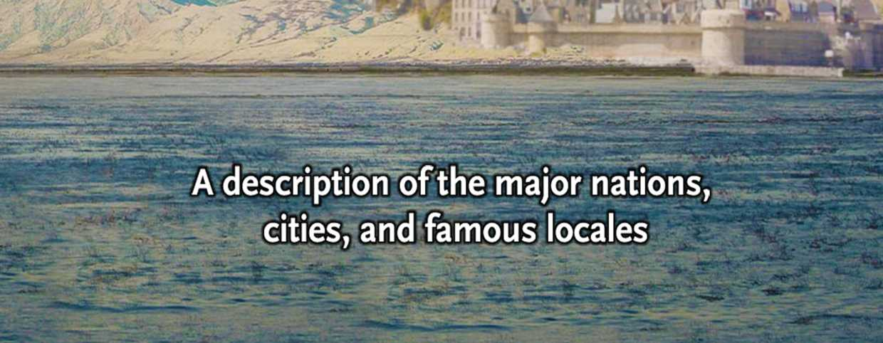

This guide is an overview of some of the major regions, cities, and landmarks of Northern Faerun. It was created as a handout for my own campaign, as one of the items found by my players in the backpack of a long-dead traveller. It can easily be introduced into any Forgotten Realms campaign by placing it in a library, a bookstore, a mage’s workshop, or anywhere else nosy adventurers go poking around!

The descriptions have been culled from various sources, and are presented from the point of view of a travelling NPC named Samwon Bayeg. There is very little reference to the people, political organizations, and other historical trends occuring in the campaign setting, making it useful for games set in any of the recent ages of the Forgotten Realms.

While it was originally created to augment player and character knowledge, to help them get their bearings and aid their travel and adventuring decisions, it is also makes a great reference for DMs who are new to the vast continent of Faerun. It is organized by geographical region, and includes short and simple descriptions of some of the major kingdoms, cities, and other famous locations that might be of interest. If your players decide to actually travel to a region based on what they find here, that’s when the real work begins of researching and developing those areas in more detail.

This guide is neither complete nor exact. In fact, many locations that experienced players might consider essential to the Forgotten Realms are completely omitted, while other locations which might be considered less ’’important” have been included. One possible justification for this is that like all of us, Samwon Bayeg, has a limited experience of the world he lives in, and can only draw on his own haphazard experiences of what he’s seen or heard about. But in the end, what is included is based solely on the personal preferences of the author. Furthermore, some simplifications and consolidations have been made with regard to the major geographical regions, in order to avoid overwhelming players with too much information.

The artwork found here is all licensed for use in content submitted to the Dungeon Masters Guild program and published under the Community Content Agreement for the DMs Guild program, and the layout was created using The Homebrewery on naturalcrit.com.

It has been a great reference aid to my players, and a great learning and reference tool for myself as a DM. I hope you find it just as valuable! Needless to say, if you intend to print this and give it to your players as a handout to use as an in-character item, you should omit this page!

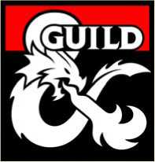

Design: Hojou Fotytu

Acknowledgements: This content is based on the numerous Forgotten Realms campaign sourcebooks published over the years, originally created by Ed Greenwood.

DUNGEONS & DRAGONS, D&D, Wizards of the Coast, Forgotten Realms, the dragon ampersand, Player’s Handbook, Monster Manual, Dungeon Master’s Guide, D&D Adventurers League, all other Wizards of the Coast product names, and their respective logos are trademarks of Wizards of the Coast in the USA and other countries. All characters and their distinctive likenesses are property of Wizards of the Coast. This material is protected under the copyright laws of the United States of America. Any reproduction or unauthorized use of the material or artwork contained herein is prohibited without the express written permission of Wizards of the Coast.



**A Guide to Faerun**

**A description of the major nations, cities, and famous locales**

**By  
Samwon Bayeg**

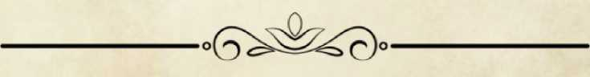

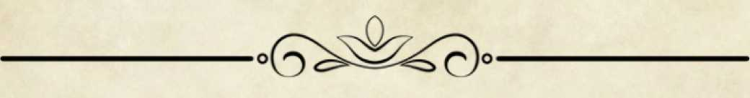

Table Of Contents

1. Faerun p.l
2. The Heartlands p.2
   1. Cormyr
      1. Suzail
      2. Marsember
   2. The Dalelands
   3. Sembia
      1. Daerlun
      2. Ordulin
   4. The Western Heartlands
      1. Baldur’s Gate
      2. Candlekeep
      3. Darkhold
      4. Elturel
      5. Evereska
3. The Dragon Coast p.4
   1. Westgate
   2. Proskur
   3. Teziir
4. Eversult
5. The North p.5
   1. Anauroch
      1. Thultanthar
   2. The High Forest
      1. Dire Wood
6. The East p.8
   1. The Cold Lands
      1. Heliogabalus
      2. Bildoobaris
   2. The Unapproachable East
      1. Aglarond
      2. Thay
7. The South p.9
   1. Chultan Peninsula
      1. Chult
      2. Tashalar
   2. The Old Empires
      1. Cimbar
      2. Skuld
   3. The Shining South
      1. Underhome
      2. Halruaa
      3. Luiren
   4. The Lands of Intrigue
      1. Athkatla
      2. Calimport
      3. Zazesspur
8. The Island Kingdoms p.ll
   1. Leuthilspar
   2. Caer Callidyrr

4.2.2 The Star Mounts

4.3 The Moonsea

1. Hillsfar
2. Melvaunt
3. Mulmaster

8 The Underdark

8.1 Gracklstugh

8.2 Menzoberranzan

p.ll

1. Zhentil Keep
   1. The Silver Marches
      1. Citadel Adbar

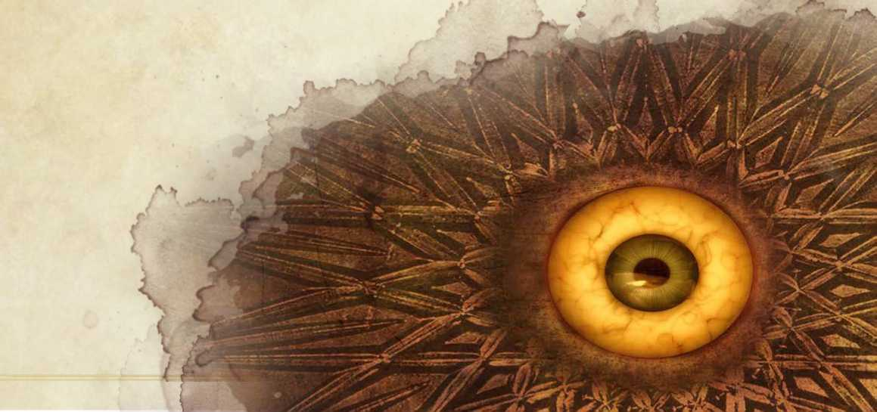

1. Mithral Hall
2. Silverymoon

4.5 The Sword Coast North

1. Icewind Dale
2. Luskan
3. Mirabar
4. Neverwinter
5. Yartar
6. Waterdeep

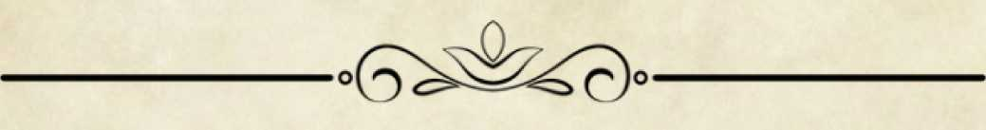

Faerûn

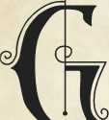

reetings traveller! I’ve created this guide to provide you with the most basic information about the northern lands of Faerûn. Much of what I present here is commonly known, in one way or another, to most of inhabitants of these lands. However what might be common knowledge in one land, might be all but unknown in another. It is my goal to bring all this information together in one place.

Faerun is primarily dominated by human lands. Interspersed among the lands of humans are old dwarven kingdoms and hidden elven enclaves, assimilated populations of gnomes and halflings, as well as more exotic folk. Faerun is filled with a rich history and wondrous tales of adventure and magic, but the lives of most of its people is focused on agriculture and trade, and it’s politics suffer the same mundane squabbles and schemes that occupy the power-obsessed everywhere.

k

Realmspace

At the center of the crystal sphere is our sun, an enormous sphere of fire that is orbited by eight heavenly bodies. The third from the center is our home Toril, which is orbited by its moon Selune.

Toril

Our planet is teeming with life, in the air, on the land, and under the seas. The known continents are Kara-Tur, Zakhara, Anchorome, Maztica, Katashaka, and Faerun.

F

*:alien Stars*

*The Island*

*itl'fortk*

77u *Shinina South*

À

*The Western^*

*The. /*

**UnA-ofl** *tvM. habl e*

o

HI

PART 1 | Northern Faerûn

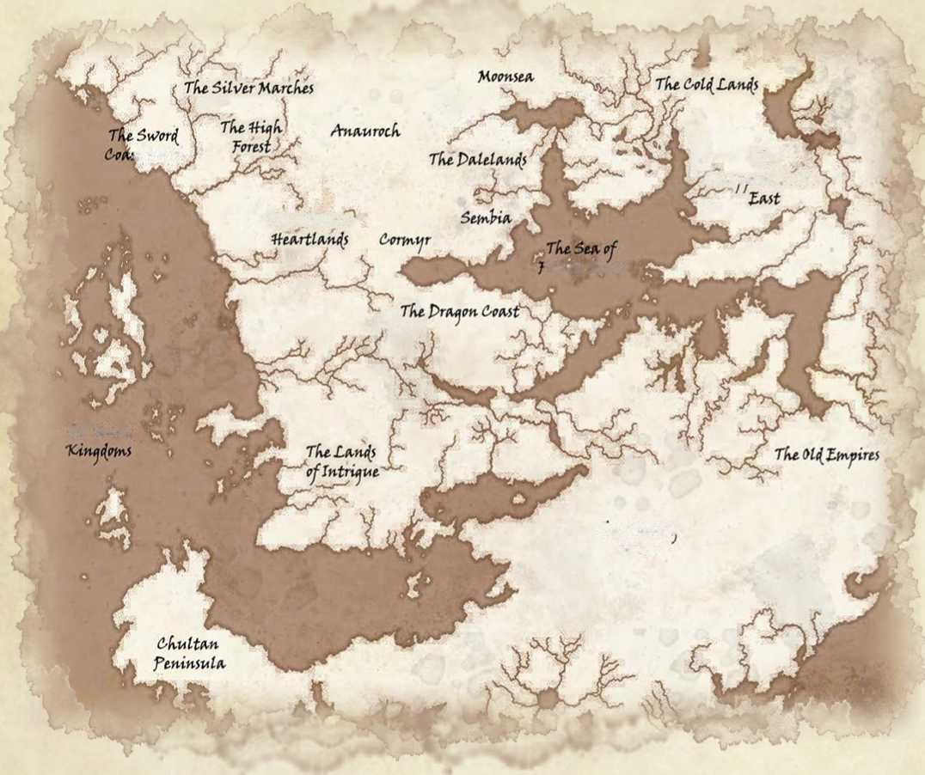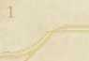



The Heartlands

PART 2 | The Heartlands

he center of Faerun is the Heartlands, a region of great nations and cities, that share **№ 1** a common language, culture, heritage and **K >** J social order. Travelers from one part of the

*J* Heartlands generally find the same kind of villages, merchants, and overlords in other

1 parts of the Heartlands that they are accustomed to at home.

Cormyr

Founded more than a thousand years ago, the kingdom of Cormyr benefits from an enlightened monarchy, hard­working citizens, and an advantageous location. It is a civilized land of rolling, green, pleasant lands, surrounded by mountains and forests. Known for its well-trained military, Cormyr also boasts fine food, honest people, and abundant contacts with other parts of the world. Despite an often-violent past defending its borders against beasts and internal intrigues, Cormyrians remain loyal, content, prosperous, and peace-loving. A force of battle-mages known as The War Wizards serve the kingdom by keeping both the monarchy and the nobility in check.

Suzail

The royal capital of the kingdom, and home to the royal palace, Suzail is the largest city in Coymyr, unchallenged as the centore of power, wealth, beauty, and importance. The city maintains a large barracks for the Purple Dragons, often considered the one of the strongest armies in the Realms, and renowned for their heroism and valor. In addition to its cosmopolitan inns, feast halls, and temples, the city is also famous for its expert ivory carvers.

Marsember

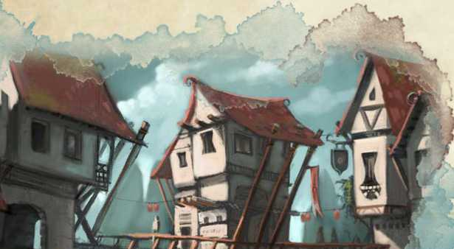The second largest city in Cormyr, Marsember is a seaport constructed on a series of islands connected by bridges and cut with canals. Originally built on a swamp, the canals also function as a common sewer, and during the summer the stench can be overpowering. Small boats crowd the canals, and flat hard ground is hard to find here. Only the wealthy can afford large paved areas. The city relies on trade, and is often referred to as the City of Spices, due to the trading companies that procure many such goods from far-away nations.

The Dalelands

The Dales are broad forest vale of rolling hills, linked by narrow trade roads running through beautiful woods. Blessed with a temperate climate, the Dales are the breadbasket of the Heartlands. The Dales’ independent spirit and age-old alliance with the elves of Cormanthor have made them independent and stubborn. Each dale exists with its own government, militia, and ambitions, and culture. In the past, the presence of the Elven Court of Cormanthor deterred most enemies, but with the Elven migration to Evermeet, the Dales Folk must rely on the strength of their own communities.

—i

Archendale

A wealthy militaristic autocracy, the people are fair and decent. Known for its picturesque landscapes. Capital: Archenbridge

Battledale

At the center of a traditional invasion route through the Dalelands, it is racially diverse, open- minded. Capital: Essembra

Cormanthor

Ancestral lands of the elves, the ancient forest is occupied by competing factions of drow, humans, elves, and gnolls.

Daggerdale

Dagger Folk are hard, grim, unforgiving, and private, due to decades of defending their lands against conquering Zhents. Capital: Dagger Falls

Deepingdale

A republic honoring the ancient ways, humans and elves work together to protect the forest, welcoming those they trust. Capital: Highmoon

**MlSTLEDALE**

A republic of fertile farm lands at the center of excellent trade routes, its inhabitants are fiercely independent. Capital: Ashabenford.

Scardale

Shattered by the wars its started, it's cities are centers of anarchy, controlled by outside factions. Capital: Chandlers Cross

Shaowdale

Famous for its victories against drow conquerors, its quiet, farmlands are home to many retired adventurers, among them the famed Elminster.

A land of merchants adept at holding onto power, and young merchants scheming for their share. Sembians relish the art of the deal. Unlike the thugs of the Moonsea cities and the Pirate Isles, Sembians observe the law of contracts, debts, and interest, exploiting loopholes where possible. The leaders are expansionist but their in-fighting has made them incapable of uniting and working together. It is a land of costers, cabals, cults, where corrupt old money commands respect. The lands are covered in extensive farms, hunting estates, vineyards, and breeding stables, while the coastline is crammed with bustling ports of trade and industry.

Daerlun

Enjoying a close relationship with Cormyr, centuries of inter-marriage and trade have left its citizens with a blend of Sembian business acumen, and Cormyrian warmth and courtesy.

Ordulin

The crossroads capital is the one place where politics is as important as commerce. It is a new city designed to showcase Sembia’s might. Laid out like a great sunburst, great buildings occupy the center while mighty roads radiate outward like the rays of the sun.

**The Western Heartlands**

The Western Heartlands are known to caravan drivers as ’’miles and miles of miles and miles.’’ Spread out across scattered wilderness settlements among the grassy flats, impassable bogs, badlands, high moors, and forests, the frontier folk who live there are strong and independent, proud of their ability to carve out a living while surrounded by dangerous creatures and monsters.

Baldur's Gate

One of the two great cities of the Sword Coast, ’’The Gate” is a metropolis situated along the north bank of the River Chionthar before it flows into the Sea of Swords. A mercantile port, it is perhaps the wealthiest city in all of Faerun. Tolerant and open, visitors are expected to abide by the laws, which are enforced by the ubiquitous city guards, and the mercenary guilds which keep the city peaceful and prosperous.

Candlekeep

A great citadel of learning, Candlekeep stands atop a volcanic crag overlooking the Sea of Swords. A many­towered fortress, it is home to the largest known library in Faerun, containing numerous texts, maps, and magical tomes. The price of entry is any book which is not already part of the library’s collection. The citadel is protected by mighty wards that prevent paper from burning, block all teleportation magic, kill all molds and insects, and limit all destructive magic.

For decades, the black walls and towering spires have been the Zhentarim western base of operations. The fort's massive doorways and corridors were originally built for giants, in ancient times when giants ruled all of Faerun. Nearly a thousand warriors stand ready to do the bidding of the dark and secretive mercenary company's leaders.

k

Fields of the Dead

The site of an ancient battle between the human empires and kingdoms of the Sword Coast and Amn. Now rich farmlands, old armor, weapons, and magical items occasionally turn up under the plow.

Forest of Wyrms

Great redwoods and thick pines shelter a multitude of green dragons, who consider themselves masters of the forest.

Green Fields

Grasslands that stretch for miles, that see little more than a constant stream of caravans travelling north from the Cloud Peaks to Berdusk.

Greycloak Hills

An ancient elven burial site, still protected by Moon Elves that move stealthily through the perpetual grey mist.

High Moor

A vast rocky wilderness, inhabited only by trolls, orcs, and hobgoblins.

Sword Coast

Named after the white cliffs that rise like a flashing blade, cutting off the sea and the land for hundreds of miles along the coastline between Baldur's Gate and Waterdeep.

F

Elturel

Situated atop a cliff dominating the River Chionthar, ensuring one of the safest, best policed, and most efficient trading and farming communities in the Western Heartlands. Its crack army of mounted warriors known as the Hellriders patrol the lands nearby. A shining orb known as "The Companion" hangs over the city producing a light painful to the undead, which can be seen for miles.

Evereska

The last great stronghold of moon and sun elves remaining on Faerun. Nestled between twelve high hills that function as natural walls, access is only possible by air, or through the high passes guarded by elite elven sentinels. A center of great elven learning and power, many of its inhabitants live deep within elven mysteries, and never leave their city. Protected by powerful mythals, few humans have ever seen the inside of the city.

PART 2 | The Heartlands



The Dragon Coast

he lands and islands on the south shore of the Inner Sea, also known as the Sea of

**№ 1** Fallen Stars, are more a way of life, than a

**K >** J geographical area. Consisting of powerful

*J* city-states, thieves guilds, pirates, and dark societies at the center of otherwise-ideal 1 trading routes, it’s a perfect place to get things done. There is little government and law enforcement, and visitors to the region can expect to meet all kinds of beings, from drow to lizardfolk, and generally anyone on the run from justice elsewhere.

Westgate

The major trading city of the southern coast of the Sea of Fallen Stars, it has a reputation for "anything goes and everything has a price." Its citizens pride themselves on a city open to all races, faiths, and coins, and it’s merchant rulers believe personal ethics have no place in business.

Proskur

Just outside Cormyr and the Stormhorn Mountains, on the Overmoor Trail, Proskur is a trading city run by a merchant council. Unlike most other councils, its rulers are confessed thieves, and former guild bosses who realized they could become richer by taking over the government, rather than fighting it. Ironically, it is known as an honest city, in the sense that it’s rulers are up front and efficient, and difficult to deceive.

Teziir

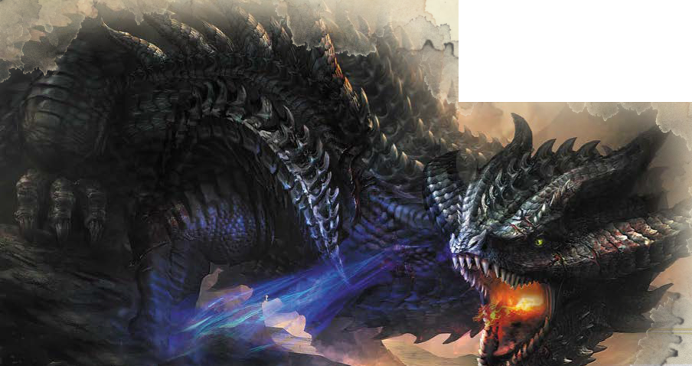Built on the ruins of a previous city, a group of merchants who disapproved of Westgate, wanted a port on the the Inner Sea they could control themselves. Subsidized by the merchant council, the city has more than its share of temples and shrines, due to the belief that pilgrims, tithes, and the occasional miracle are all good for business.

PART« I The Dragon Coast

k

Sea of Fallen Stars

This huge body of water connects the east and west ends of Faerun. Many nations maintain powerful navies on this "Inner Sea," but for the most part they are merchant waters. Beneath the water are undersea kingdoms of aquatic elves and merfolk.

Giant's Run Mountains

Some great civilization of giants once occupied the mountains. Dozens of the peaks are carved with giant spiral staircases, and rough-hewn palaces designed for fifty-foot-tall creatures. Most avoid these mountains, due to the roosting perytons that now occupy the peaks.

Gulthmere Forest

A wild tangled forest dividing the Dragon Coast from the Vilhon Reach. The forest is noted for rich loads of minerals and gems. Prospectors and miners roam the wooded hill, challenging the monsters and tribesfolk for the riches within.

Pirate Isles

A collection of rocky spurs dotting the sea about one hundred miles from the coast of Sembia. The natural harbors here are fortified and controlled by generations of pirates who constantly talk of unifying and attacking the mainland.

F

Eversult

A rich community south of the Lake of Dragons at the junction of many trading roads. Although not a port, its warehouses are the branching point for trade north to Cormyr and west to the Sword Coast. Quickly becoming of the most honest cities in the Dragon Coast, centuries of smuggling and intrigue are slowly being reversed. The city is a known staging point for the Cult of the Dragon, who struggle to cloak their activities and hold onto their power.

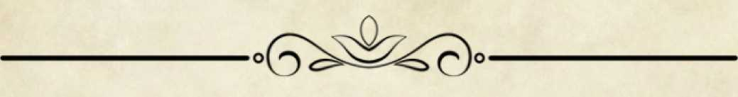

The North

espite settlements and civilizations that have

■ orc invasions, harsh weather, and unyielding

**V** wilderness prove that the north is still a *savage* frontier. ’’The North” is a term Cormyrians and Dales Folk use to refer to the lands west of the great Anauroch deserts, and north of the High Moor.

espite settlements and civilizations that ha\ endured for a thousand years, the constant

D

The High Forest

A holdover from the early days of the world when elves, giants, and dragons ruled a continent covered in green. Home to all the woodland races, the few humans who live or travel within the forest are usually druids or rangers. Too large for any one group to rule, the greatest powers within the forest are the treants, the wood elves, and the centaurs.

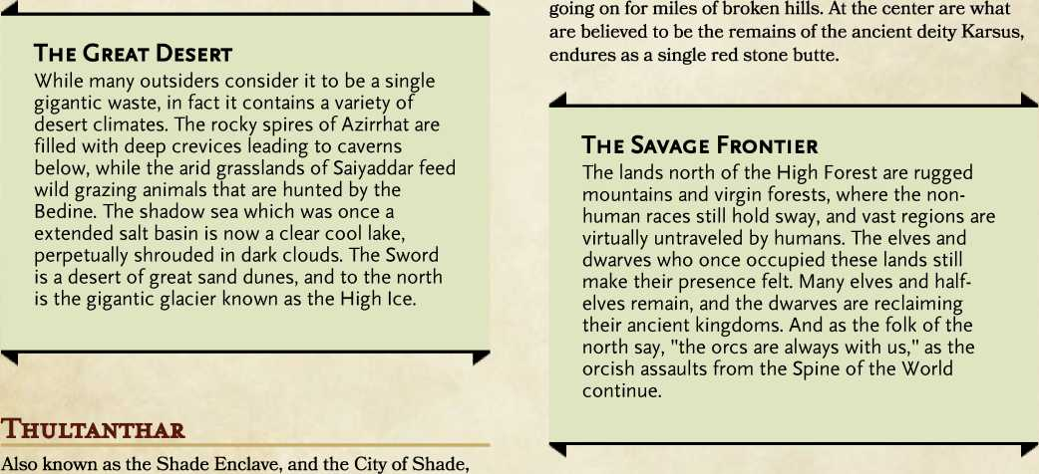

Thultanthar is a floating metropolis located in the middle

A ring of albino oak trees surrounds these mysterious hills in the eastern part of the forest. Within the this ring stands a thicker ring of blackened petrified rings. Those who enter, find that it expands as they travel deeper inside, seemingly

Anauroch

The Great Sand Sea, or the Great Desert, has relentlessly grown and encroached on the nations bordering it, splitting the north of Faerun into eastern and western halves. Over fifteen centuries ago, the ancient empire of Netheril was swallowed by the desert. It is far from empty. A nomadic race of noble barbarians known as the Bedine roam its wastes. A line of oases along the Black Road, winding from the Silver Marches to Cormanthor, is maintained by Zhentarim garrisons and patrols.

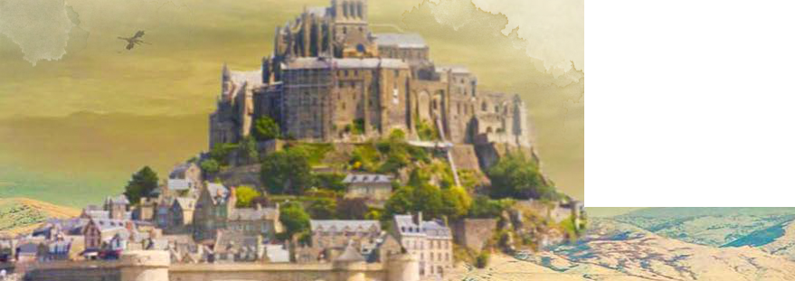of the Anauroch desert. Thrust into the Plane of Shadow some three thousand years ago, it has recently returned to our world, and its archwizards are some of of the most powerful in the realms.

Many believe the gods themselves wander here in animal form, making wise travelers loath to harm or offend any creature, from snail to stag. Merchant caravans visit the cities on the edge of the great wood, but the the inhabitants of the High Forest live in a self-contained and self-sufficient world, and need little the outside world has to offer.

Dire Wood

The Star Mounts

These soaring mountains at the heart of the forest have been landmarks and mysterious places of legend for centuries. They rise high above the trees, cloaked in clouds, prompting many to wonder who -- or what - lairs there. Elves report that huge crystals the size of a house sprout on the slopes, creating webworks of of reflected light when the moonlight strikes just right.

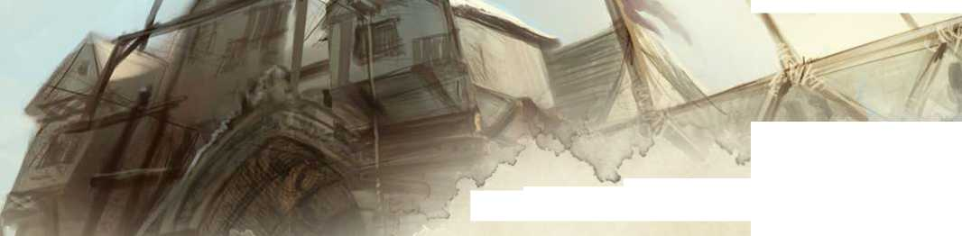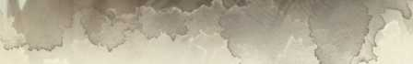The Moonsea

The region is named after a deep natural lake north of the Dalelands, and west of Anauroch, which is connected to the Sea of Fallen Stars by the shallow swampy River Lis. It holds a great mineral wealth for those who brave the infamous bleak landscapes, harsh winters, dragons, pirates and aggressive local governments. It is a frontier land, ruled by evil folk who ruthlessly control their lands. The people here view the rest of the world with suspicion and distrust. In return, the rest of Faerun sees its people and unfriendly and dangerous.

HlLLSFAR

Located on the southern shore, the city vies with Zhentil Keep for control of the region. Like many cities of the region, it is crouched behind a circular wall with a single great gate. Access to the city is restricted to individuals approved by the current government. It is also famous for its gladiatorial arena.

Melvaunt

A large multiple walled community north of the Moonsea, it is a cold, austere place, full of forges and smelters. It is a merchant town and smith’s heaven, but it’s population is generally ruthless and unfriendly. It is known for engaging in a lucrative slave-trade, protected by a large standing army.

Mulmaster

Built on the slopes of mountains to the south, and the Moonsea on its north, the entire city is a naturally protected fort. It has a large army and navy, and a collects of wizards sword to defend the throne.

Zhentil Keep

The first human city built on the Moonsea north coast, the city has always been rich due to the nearby mines. It was once a walled metropolis of some fifty-thousand inhabitants, until it was sacked about one hundred years ago. The souther portion and the harbor have been rebuilt, and walled off from the surrounding ruins. Press gangs roam the streets looking for civilians to force into the Zhent military or to sell into slavery, and evil deities are revered. The Black Network of the Zhentarim rules openly with an iron fist, and currently has a large standing army and navy to promote its evil interests.

The ruler of Silverymoon recently reached out to the rulers of other human, elven, and dwarven strongholds north of the High Forest, and after much debate, they all decided to create a confederacy known as the Silver Marches. The members include Citadel Adbar, Citadel Felbarr, Deadsnows, Everlund, Jalanthar, Mithral Hall, Quaervarr, Silverymoon, and Sundabar. The people are confident and content, and many immigrants from all over Faerun have moved north drawn by the new alliance and its promise of equality and hope. All around them stands a wide and beautiful land with the promise of growth and prosperity. All people are free, and no one has rights or privileges that are denied to others. Although many enemies surround these cities, the new confederacy represents the unfolding of a dream and a chance to forge a better Faerun.

**The Silver Marches**

Citadel Adbar

A powerful, underground, dwarven fortress, the aboveground citadel may be the mightiest fortress of the north, having withstood hundreds of major orc attacks over the centuries. Reaching Adbar is difficult, and many merchant caravans generally travel through the Underdark from Mithral Hall or Mirabar.

Mithral Hall

Once one of the greatest of the northern shield dwarf holds, around two hundred years ago, it fell to a shadow dragon when members of Clan Battlehammer dug too deeply in search of mithriL The dragon slew most of the dwarves and took possession of the halL Bruenor Battlehammer set things right and slew the dragon a hundred years later, and proclaimed himself king. Shield dwarves from all over Faerun have been returning and cleaning out the Underdark below, providing Silverymoon with an energetic sister city and staunch ally.

Silverymoon

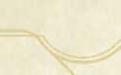A beautiful place of ancient trees and soaring towers, with curving stonework and gardens adorning every nook and balcony, where magic, learning, music, are revered. Considered one of the foremost centers of learning and culture in the north, the city contains fascinating shops full of maps, books, magical items, and objects of beauty. Noted for its musicians and sculptors, the city also boasts a large population of mages, who gather here in greater numbers than most cities. Built on the spirit of cooperation between the races, all live together, rather than dividing up into separate wards. The city’s army numbers over five hundred, and patrols the city constantly, augmenting the mysterious wards that protect the city.

PART 4 | The North

6

A region of coastal mountains and forests, stretching from Waterdeep at its southernmost end to Icewind Dale in the north. Many of the major cities in the region, including Neverwinter and Yartar, are members of the Lord’s Alliance, working together to maintain peace and stability throughout the north. The Long Road stretching from Waterdeep, through Red Larch, to Mirabar define the eastern edge of the region.

Mere of Dead Men

Centuries ago, thousands of human, dwarven, and elven warriors died in this salt marsh fighting an invading army of orcs. Since then, the mere has gone from bad to terrifying. Tales of treasures sunk in half-submerged castles are a beacon for many adventurers, who never return.

Neverwinter Wood

A charmed forest to the east of the city of neverwinter, perpetually warmed by the river that flows from the nearby volcano, Mount Hotenow. Most fear the wood, and tend to avoid it.

Dessarin Valley

Situated between the Sword Mountains and the High Forest, the Dessarin River cuts through an area of rugged badlands and the farmlands of Goldenfields. The main industry in the region is agriculture, and it plays a large role in the agricultural economy of the North.

Sword Mountains

Northwest of Waterdeep and east of the Mere of Dead Men, the sharp peaks and hilly terrain of the Sword Mountains extend down the coast for nearly two hundred miles. Long home to orc tribes, trolls, and other fearsome creatures, the mountains are rarely traveled. Those foolish enough to go searching for the ruins of civilizations past usually find only death.

Icewind Dale

The northernmost human land below the great glaciers, Icewind Dale is actually a collection of ten towns and villages populated by nomads, barbarians, rangers, ice fishers, dwarves, and merchants all willing to brave the harsh climate. Polar bears, elk and yeti are more numerous than people.

Also known as the City of Sails, Luskan is populated by many who once sailed as pirates. A council of five High Captains rule the city, but the true power lies in the hands of an evil mage society called the Arcane Brotherhood.

MlRABAR

A mining center, the city’s shield dwarves live underground to oversee their workshops. The humans above cooperate with the dwarves to help move the ore to market, as well as defend the city. The city is governed by a council of humans and dwarves, that meets annually to determine production quotas and deal with other policy matters.

Neverwinter

A walled city of humans and half-elves, the city is cultured without being arrogant, bustling without being greedy, and charming without being quaint. The city is best known for the products of its master crafts folk, and also famous for its gardens, heated by the supernaturally warm waters of the neverwinter Rivers.

Yartar

A small fortified city on the site where the Surbrin River meets the Dessarin river, on the northern edge of the Dessarin Hills. The inhabitants build many barges that are used to send goods downriver to Waterdeep, and it’s location on a major trade route between the north and The Sword Coast make it a center of bustling trade and caravan activity. It is famous for an open market known as ’’the fish yard,’’ where in addition to fish, all manner of exotic goods can be purchased.

Waterdeep

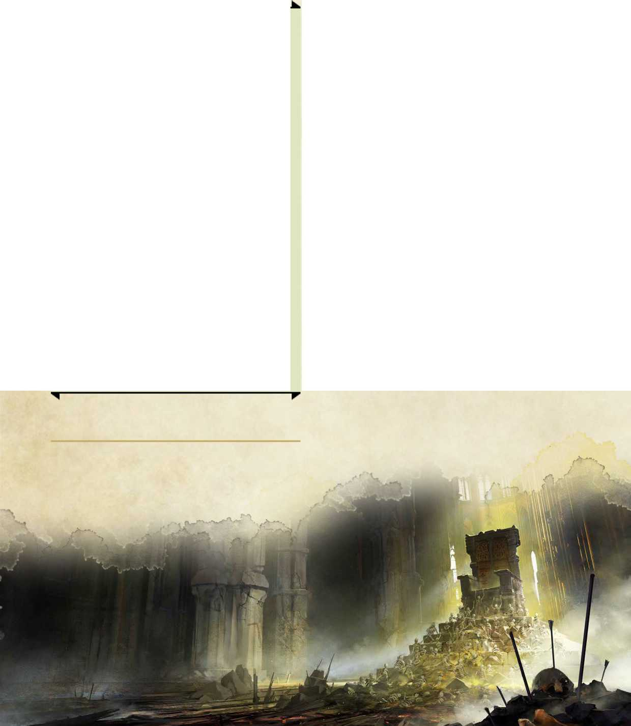A major cosmopolitan power of Faerun, it benefits from an excellent harbor, wise rule, a tolerant spirit, and a powerful magical tradition. Nicknamed ’’The City of Splendors,’’ the city is an important center of trade and social change, where the rich gather to trade, and generate wealth with a swiftness unknown in most of Faerun. The local powers of guilds, nobles, trading costers, and citizens, are locked in an endless struggle for supremacy, always striving against each other for an upper hand. Spies are everywhere, representing the major cults, trade cabals, wizard organizations, and foreign rulers, and many citizens establish false identities to avoid their enemies’ ears.

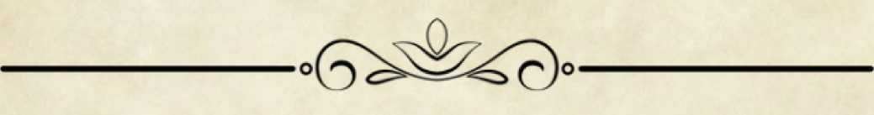

The East

he eastern lands of Faerun are vast and unforgiving. From the frozen lands east of

№ 1 the Great Desert of Anauroch, to the

i Hordelands, and the

The Cold Lands

The northern region near the Great Glacier, to the east of Anauroch are inhospitable climates. Sometimes also referred to as the ’’Bloodstone Lands,” they are rich in mineral wealth, which attracts many looking to strike it rich, who quickly become daunted by the hostile environment and aggressive tribesfolk.

Heliogabalus

A prosperous trading city in Damara, it is literally the end of the road for merchants travelling north from other areas of Faerun. The city supplies all of Damara with foreign goods and is heavily influenced by the independent merchant’s guild.

i i

Damara

East of the Moonsea lies this once-mighty realm, still rebuilding from decades of war against the orcs and gnolls from the mountains. Tolerant and friendly, it has a thriving gem trade based on bountiful bloodstone mines.

Narfell

A country where only the strong survive, it is a land of infertile soil supporting only scraggly grass. The tribal folk are fierce horse-riders who judge others by their actions. The tundras are home to hordes of hobgoblins, and ruins of an ancient civilization ruled by wizards.

Vaasa

This untamed wasteland of frozen moors and tundra is a lonely land dotted with scratch farms, and evil humanoids. Mostly untapped, the mountains are rich in metals and gems but remain unclaimed.

Bildoobaris

For only a tenday each summer, the tribes of Narfell gather in a massive tent city that stretches for miles. The natives welcome merchants from other countries to exchange horses and other items taken from ruins, for clothing, jewelry, and weapons. After ten days, the city disappears until the following year.

The Unapproachable East

To those in the west, these lands are mysterious, exotic, and deadly - a region of terrible magic and untold wealth, with strange culture and laws. They are considered "unapproachable" not only because of their geographic isolation, but because of the aggressive temperament toward outsiders. Rumored to be a land of witches and the most powerful mages in all of Faerun.

Aglarond

A nation that is hailed for keeping the Red Wizards of Thay from attacking the rest of Faerun. It is itself a place of ancient magic, that holds one of the largest half-elf populations in the world. The small beaches along the peninsula’s rocky coast are dotted with fishing villages, since all pirates have been declared agents of Thay, and to be put to death on sight, making the waters of the Inner Sea around Aglarond safe for seafaring merchants.

Thay

A nation ruled by cruel wizards who rely on slavery to provide them with the wealth and luxury they need to support their magical research and dreams of conquest. Throughout Faerun, Thay is considered a dark and evil empire where the cruel Red Wizards transform disobedient slaves into strange monsters. The power of the Red Wizards extends well beyond the lands of Thay, with enclaves throughout the majors cities of the Inner Sea lands. While the Thayans are widely disliked and distrusted, the magic items and devices they trade are highly valued making them indispensable to many of their clients. All Thayan children are examined for magical aptitude at an early age, and those who show promise are taken from their families and subjected to rigorous schooling in the arcane arts. For hundreds of years, Thay and the Red Wizards have been ruled by a wise, scheming, and cruel lich known at Szass Tam.

—i

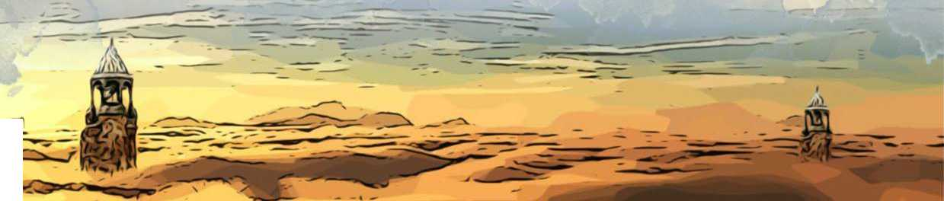

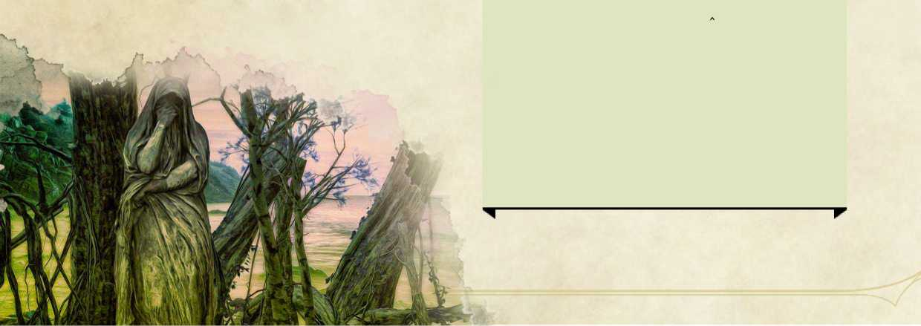

The South

ot much is known about the southern

**Of ■** lands up north, other than the basic

**II I** information brought back by merchants

and travelers regarding the major ports ***JI* I** and cities. Much of the south has a **<1** reputation for being primitive and dangerous, where only the brave or the desperate travel in search of coin or adventure.

Chultan Peninsula

The Chultan Peninsula is the dominant area of Southwest Faerun. It has an undeserved reputation of being a backward place with a complete lack of civilisation populated by savages. These lands' reputations derive from their isolation from the rest of the world, the magical concealment of key cities, and the fever-induced rants of old sailors. In fact, it boasts several large cities with stable governments that are all rife with culture. The Mhair Jungles mark the eastern end of the peninsula.

Chult

The westernmost country of the Peninsula is a dangerous place, covered almost entirely by deadly jungle and infested with disease and savage beasts. Reclusive human tribes, goblins, and strange monstrous folk haunt this dangerous land. Faith in the deity Ubtao holds dominion in this land. The tribal humans of Chult distrust power and wealth, and prefer to live simply. Fort Beluarian, Port Nyanzaru, and the metropolis Mezro, are centers of civilization carved out of the savage lands, and are frequented by traders and visitors.

Tashalar

More civilized than Chult, Tashalar is an exotic land of strange food, beautiful people, and great wealth, along the coastline of the Shining Sea. The skilled craftsmen are known for the excellent crossbows and fast sips. The grapes are so perfect, that even the worse vineyard produces wines worth a hundred gold pieces in Waterdeep. The larger towns are home to wealthy and ostentatious merchant families, whose princes control the merchant consortiums that rule the country, and whose fleets protects its borders. The city of Tashluta is the common port, and is most welcoming to visitors.

The Old Empires

The southern coast of the Inner Sea are a collection of fallen realms that rose to power thousands of years ago, but have been in decline ever since. Resistant to change and hostile to visitors for centuries, they have been becoming more engaged with the rest of the world recently, and are even regaining a prominent position in Faerunian politics and culture.

ClMBAR

Hundreds of years ago, Cimbar was chosen as the center of the short-lived Chessentan Empire. It is still the traditional capital, and is a great center of the arts, philosophy, and music, and is known for its college of sages. Cimbar boasts the second largest fleet in the easter Inner Sea, which frequently battles with cities on the northern coast.

Skuld

The oldest continually inhabited city in Faerun, Skult was founded over thirty-five hundred years ago. Its inhabitants boast that no invading army has ever breached its walls. Within is an area known as the City of the Gods, with temples and the former residences of incarnated deities, that contrast starkly with the squalor of the rest of the city.

The Shining South

Along the southeastern coast of Faerun stretches vast lands of magic, mystery, and legend. To the folk of the Heartlands, the South is a place of myths and tales that seem unbelievable: a land where everyone is a wizard, a kingdom of halflings, and a realm ruled by drow.

The Great Rift

The center of the Eastern Shaar is cut open by a great canyon which plunges thousands of feet below the surrounding plains. Quarried by dwarves for centuries, homelands of the gold dwarves who have flourished here for generations, it is one of the most powerful dwarven kingdoms in all of Faerun. They control the tunnels and caves honeycombing its walls, and the nearby portions of the Underdark.

The Shaar

A vast rolling grassland running from the Shining Sea to the distant lands of the east, bake by day, and freeze by night. Civilization has almost no hold on the area, and nomadic humans and nonhumans populate the lands.

Underhome

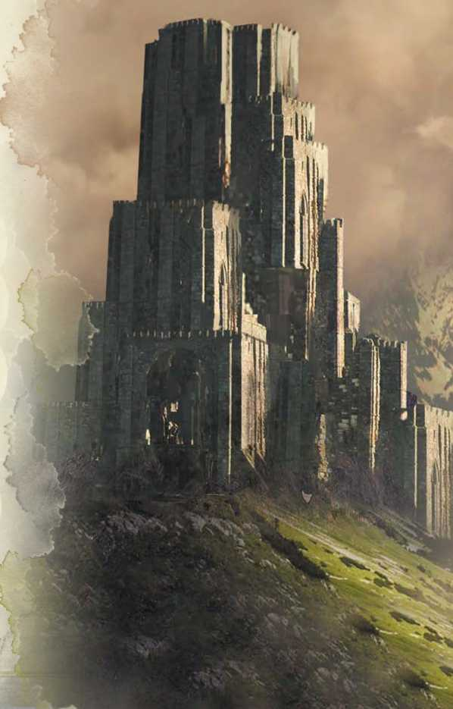

The center of the gold dwarven society, its rulers are known as the Deep Lords, noble dwarves who lead great clans of warriors. It bears responsibility for defending the Great Rift, and the herds that graze around the Riftlake at the bottom. Magical wards and runes protect the seventy­foot-tall doors guarding the main halls leading into the city in the Underdark.

Halruaa

Far to the south and ringed by mountains, Halruaa is a nation of wizards descended from refugees from the mighty Netheril kingdom. Its inhabitants have retained the Netherese fascination with magic, pursuing it with fanatical devotion. They are a self-satisfied lot, more interested in pursuing their research in the privacy of their home laboratories. Those who do leave their native lands are typically merchants in search of unusual spell components.

Luiren

The only realm of Faerun ruled and inhabited nearly exclusively by halflings. It is the homeland of the strongheart halflings, along with small numbers of lightfoot halflings. Mostly farmers, artisans, and merchants, the rich fields of Luiren feed the Great Rift, and its orchards produce citrus fruits that are in great demand in the north.

The Lands of Intrigue

Between the Heartlands, and Lake of Steam are the lands of Amn, Calimshan, and Thethyr. Tied to each other by a long history of invasions, conquest, and competition, the people of these countries have learned to survive by wits and sword, while presenting a pleasant face to their enemies. The lands are populous and and rely heavily on trade, particularly with distant countries.

Amn

A nation of merchants where caravans start and end, and ships regularly leave for exotic ports to return laden with gold and exotic items. The rulers are an anonymous group known as the Council of Six. Interestingly, For unknown reasons, divine spellcasters are respected here, while arcane spell casters are universally reviled.

Calimshan

A land obsessed with wealth and unimpressed by magic, its people are heirs to an old empire founded by genies, and now fear such creatures and ban them from their lands. Some say the blood of the efreet runs in many Calishites, giving them sorcerous powers and a natural talent for magic.

Tethyr

Recently emerging from a decades-long civil war between two competing monarchs, hope is slowly returning to a cynical, suspicious, war-torn land. However, the forest elves living here are still wary of the new rulers, as are most of the kingdom's neighbors.

Athkatla

One of the busiest ports in all of Faerun, almost any sort of non-magical goods can be found here. As Amn’s only remaining free port, with a marketplace twice the size of Waterdeep's, all types of goods can be found here, including exotic fruits, jewelry, and treasures from far-away and lost civilizations.

Calimport

In addition to its huge population, this metropolis draws large numbers of seasonal residents and transient traders. Of ot the oldest continuously populated cities in Faerun, it contains two great arenas, and impressive examples of all sorts of exotic architecture.

Zazesspur

A mix of Tethyrian, Calishite, and other cultural influences, the city is the former capital of Tethyr whose leaders resent its loss of prestige to the new capital of Darromar. It consists of two major sections, separated by the Sulduskoon River.

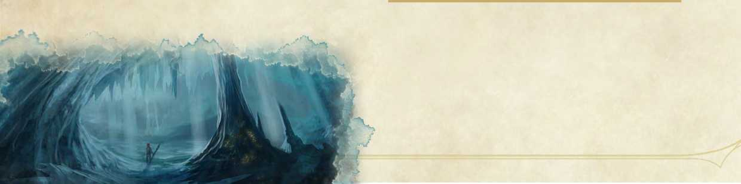

The Island Kingdoms

he great island kingdoms of the western seas have little to with each other, nor do **№ 1** that have much to do with the rest of Faerun. **HI** j Each has its own people, history, and way of

*J* life, ranging from the magic surrounding the Elves of Evermeet, to the brutal raiders of 1 the Nelanther Isles.

Leuthilspar

An elven metropolis, it is a radiant example of the elves organic architecture in which buildings are grown rather than built. Even the most coarse of taste would catch their breath at their first glimpse of the queen’s palace. Crystals as tall as might trees are riddled with spiral passageways and glass-floored quarters. Trees grow into citadels linked by fluting branches, soaring arches and shimmering fields of magical force support airy palaces that seem too fragile to exist even in a dream. Vigilant warrior in armor of gleaming glass guard the tranquil city.

Caer Callidyrr

A city left-over from a previous civilization, with a mighty castle build on the island of Alaron, towers above a sprawling port city. Unlike the rest of the Moonshaes, the city is accustomed to the presence of visitors and merchants from all over the world.

I

Evermeet

Originally populated by sun elves for thousands of years, moon elves and wood elves have followed Queen Amlaruil over the past century, after she moved the center of elven life from its ancient homeland of Cormanthor. The island is protected by great distances and powerful magic, and is far removed from the influence of men.

Moonshae Isles

A cold cluster of rocky mountain islands cloaked in mists and deep woods, the isles are populated predominantly by humans, the seafaring Northlanders, and the native Ffolk in the south.

Nelanther Isles

A widely scattered chain of nearly a thousand islands sprinkled from the Amn coastline into the Trackless Sea. More than half the islands are only fit for shipwrecks, but there are hundreds of others that are fought over by orc pirates who prey upon the merchant ships of the Sword Coast and the Moonshae Isles.

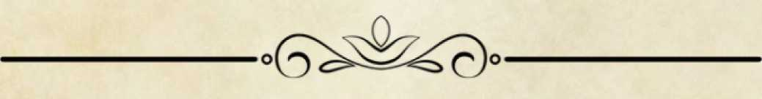

The Underdark

he vast world beneath the surface of Faerun is a dark and dangerous place. Inhabited by **№ 1** evil creatures that shun the daylight, the HI "HI i immense caverns and vast networks of WL/cT) *J* tunnels are home to great cities of drow, deep gnomes, and duergar. All these

1 creatures and their slaves battle and trade with each other for resources, magic, power, and water, sometimes even forming temporary alliances. Interspersed among the warring city-states are enclaves of gnomes, dwarves, and other good folk who remain isolated and fight to resist the encroachment by their evil neighbors.

Gracklstugh

Also known as the City of Blades, this duergar nation rests just south of the Evermoors. Consisting of a large grotto of hollowed-out stalagmites that borders the Darklake, the gray dwarves use the stone pillars as smelting centers. They control the territory for several miles around, allowing only visitors intent on trade.

Menzoberranzan

Far north of Gracklstugh, is the greatest of all drow cities, trading in poisons, mushrooms, riding lizards, spell scrolls, and water. Ruled by a council of matriarchs from its noble houses, almost two-thirds of the city’s population are slaves. While the city is dangerous, it is open to outsiders and traders by necessity.