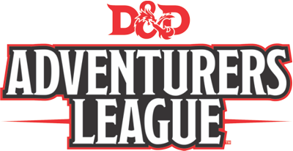

**How do I CCC? (and Other Questions)**

*Greg Marks*

A little over a year ago, the D&D Adventurers League (DDAL) started a new program called the Convention Creation Content (CCC) program. Through this program, convention organizers who follow a few rules can create (or arrange to have created) unique adventure content set in the Moonsea region of the Forgotten Realms and have that content approved and declared legal for D&D Adventurers League play. We get a lot of questions about these adventures and so let's try to answer them here.

**About the Program**

***What is a CCC and what is it for?*** CCCs are adventures for the D&D Adventurers League that are produced by convention organizers instead of the DDAL Administrators. These adventures might be two, four, or in rare circumstances, eight hours in length and are intended to follow the model of a standard DDAL adventure. We instituted this program for several reasons but the two primary purposes of the program are to A) Help the Administrators find new writers who cut their teeth on a CCC that we might not have seen otherwise and B) Give conventions something special to encourage public play because we believe that helps build community. Keep these two goals in mind, finding talented new writers and increasing convention play to expand the community, when thinking about CCCs and why we use them the way we do. Of course, the program has the added advantage of increasing the number of adventures you get to play!

***How does my convention apply to get a CCC?*** In order to be eligible to be considered for sponsorship of a CCC, your convention must be of sufficient size. In general this means your convention must be large enough to span multiple days and run at least 15 total tables of D&D Adventurers League adventures over the course of your event. If your convention meets these criteria, you must submit your application at least nine months prior to your show. You can find complete details on how to apply for a CCC [here](http://media.wizards.com/2016/downloads/DND/AL_content_creation.pdf).

***Why might my convention get turned down for a CCC?*** We want to be as inclusive as possible, but there are some common circumstances that might cause you to be turned down for creating new content. One of the most common is not submitting your request in time. Not meeting deadlines is a good indicator of problems to come. Another possibility is that you have requested a CCC for a show that is the same general geographic location at the same time as another convention that we have already approved to get a CCC. Too many unique events at the same time and place means it is likely that there will be less players available to take part in these unique adventures. You might also get turned down if you ask for something special such as an Epic-style event, a location outside the Moonsea, or a plot that significantly changes the region such as completely destroying a city. While the DDAL Administrators do not go out of their way to police the plots of CCCs, massive changes that are not reflected in other adventures are confusing to players and we try to avoid them. These are just a few of the many reasons that a request might be turned down. If we turn you down, you should expect an explanation, as well as some details on how you might improve your request and try again.

***What sort of support do the D&D Adventurers League Administrators provide?*** We provide a style guide, rewards information and a template that must be followed. We check your adventure over to make sure you meet the reward and content guidelines, but we DO NOT edit them, check encounter balance, provide playtesting or otherwise help develop your adventure. We do not find authors, artists, or cartographers for you. Editing, development and art are the responsibility of the writer and the sponsoring convention. This also means that the DDAL Administrators will not make changes adventures once they have premiers even if significant issues are discovered unless the adventure violates our content or reward guidelines. Policing quality is the responsibility of the convention organizer. Adventures that violate our guidelines will be taken down from the DMsGuild.com until they are fixed. If you should notice an issue with a CCC for which you are not the writer or sponsoring convention organizer, you are encouraged to leave a review for the author that they might make the corrections. The DMsGuild has a great feature that allows an author to send updated files to anyone who has already purchased a product!

***Where do I go to apply for a CCC?*** If you are ready to apply you can go [here](https://docs.google.com/forms/d/e/1FAIpQLSc5scuqsfgaJTpQmcU5Wmi2hU79AgVVBn0PVHudn9tWbRb6hQ/viewform) and fill out the form. We'll get back to you in a few weeks. If you have any questions, don't hesitate to email us at [resource@dndadventurersleague.org](mailto:resource@dndadventurersleague.org).

**Writing CCCs**

***How do I write a CCC if I don't have a convention sponsor?*** In short, you don't. We only accept content created for and by conventions. If you have a great idea for an adventure, start by contacting local conventions and see if they are interested in your adventure. If you are not sure what conventions are in your area, check the [convention map](http://conmap.dndadventurersleague.org/al). Consider writing and outline and one or two of the encounters so you can show convention organizers the quality you can deliver.

***Where can CCC adventures be set?*** All DDAL adventures are set in Faerûn, and CCCs specifically must be around the Moonsea (roughly that area surrounded by the red line). This is the only area we have set aside for aspiring writers and conventions to use. In general your CCC adventure cannot leave this area, though some exceptions might be made with DDAL administrator approval, but expect exceptions to be unlikely.

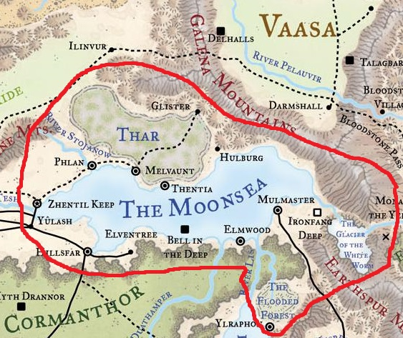

***Can I use a different template?*** No. You can make slight adjustments to add your convention logo, add a new type of subsection, or the like, but your adventure must keep the same dress as our other CCC adventures. You must use our listed fonts and formatting.

***What rewards items can I put in my adventure?*** You may only choose magic items from the *Dungeon Masters Guide*. You can modify the in small ways, such as described in the tables on page 143, but any changes must be approved by the DDAL Administrators. You may not invent new items. Story Awards may be included that note the favor or disfavor of NPCs, but generally should not provide mechanical benefits.

***What monsters can I put in my adventure?*** You can choose from creatures in published sources such as the *Monster Manual* or *Volo's Guide to Monsters*. You can modify the in small ways, such changing a bandit to an elf bandit using the rules *Dungeon Masters Guide*, or saying the party faces a large animated statue, but using the statistics of an ogre reskinned as that statue. You may not invent new monsters. The stat blocks in the adventure's appendix must be faithful reproductions of the creature as found in its original product. Minor adjustments should be called out in a sidebar.

***What happens when I am done writing?*** Part of this depends on what you have worked out with the convention that is sponsoring your event. You or the convention MUST provide a final, edited copy of your adventure to the DDAL Administrators three months prior to the convention and await its approval before the adventure is declared legal. This means the DDAL Administrators have final say over you may premier or sell your content. You may NOT run your adventure (beyond playtesting) or post your adventure for sale without the express consent of the DDAL Administrators. You adventure MUST appear on the DMsGuild.com for sale within six months of its premier.

***What can I put up for sale?*** Your adventure, absolutely! You cannot post additional art packs, maps, or other files in the Adventurers League category. You may have only one version of each CCC adventure listed for sale (so, no "normal version", "premium version", "platinum scale edition", etc). If you want to post additional support for your adventure, you may do so, but it cannot use the D&D Adventurers League logo, may not be tagged as an Adventurers League product and may not be posted to the Adventurers League section of the DMsGuild.   
  
**Playing CCCs**

***Do I get character rewards for CCC adventures?***  Absolutely, CCCs offer the same sorts of rewards for your DDAL character as other adventures we offer. Normal rules for treasure distribution and story awards apply.

***Do I get DM rewards for CCC adventures?***  You get many of the same rewards such as experience and gold, but CCCs do not qualify for all of the DM Quest rewards. The DM Quest reward program is designed both to help DMs keep their characters up with the players but also encourage the playing of DDAL and Hardcover adventures. Because we want to promote the adventures of the current storyline produced by the DDAL Administrators and Wizards of the Coast (WOTC), we are not providing the bonus DM Quest rewards for adventures created by others. It is up to conventions to promote their CCCs. CCC adventures apply to the following rewards: Acolyte of Oghma, Adventure Calls, Bounty Hunter, Giving DM, On/Off the Grid, & Saint of Ilmater.

***How do I find CCCs?*** CCC adventures are posted to the [DMsGuild](http://www.dmsguild.com/) like other adventures. They have adventure codes that look like CCC-XXX-## where the X's denote a code for the convention and the #'s are a unique number for the adventure. There are lots of great conventions that have already put out content you should check out!

