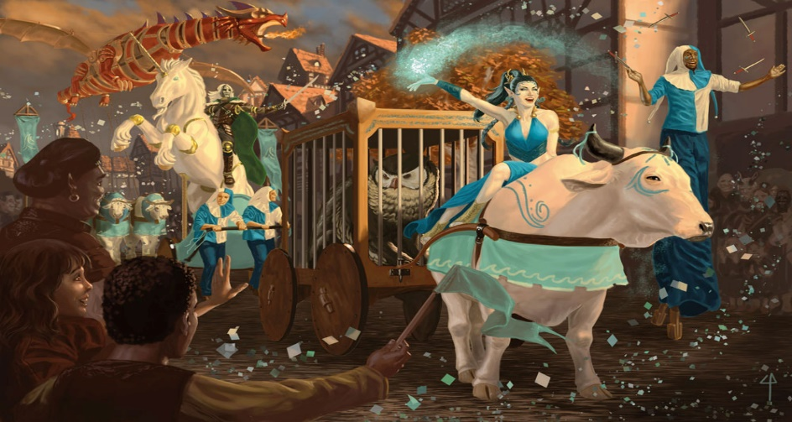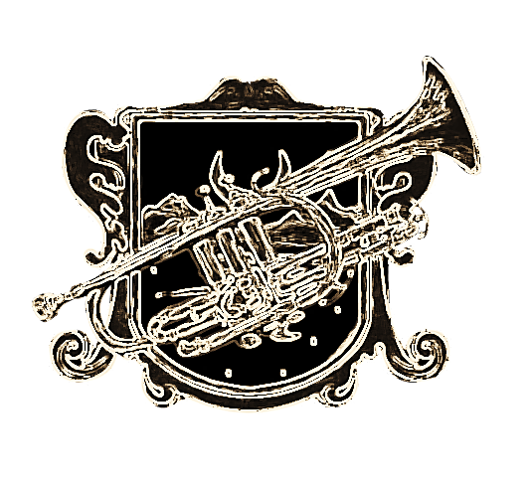v

**Day of Wonders Parade to Launch**

**Famous Luskan Faire of Marvels!**

**pp**



**Sea Maiden’s**

**Faire Returns**

**pp**



only, at Master Evereth’s pleasure.

All citizens of Waterdeep can look forward to the Parade and Fairegrounds, which opens upon the parade’s conclusion beyond the South Gate.

The Big Top Show premiers at sunset of the same day. Tickets available at the corner of Odd Street and Dock Street. Enquire at the Sea Maiden’s Booth.



**p**

**Candle Lane Disturbance.**

Reported warehouse break-in on Candle Lane. The Watch has cordoned off the area and no further information is available. Witness claimed to have seen Renaer Neverember. Witness then vomited on reporter’s shoes. Witness’s testimony deemed unreliable.

**Monstrosity Emerges at The Yawning Portal Inn.**

Reports of a monstrosity emerging from the hole within The Yawning Portal Inn last night have shined a spotlight on the famous tavern. Authorities have again requested that the chasm have a door affixed to its rim to avoid such monster appearances. The proprietor continues to refuse, commenting, “I’m my own guard.”

Single Orc (37) Seeks Wife. Must like kittens/hamsters. Letters to 4B, Leanwall Alley.

**advertisSements.**



**p**

**The Daily Trumpet**

**THE Sea Maidens Faire is to begin with Days of Wonder Parade, held on the 10th of Mirtul, commencing at the third hour after dawn. The Parade will proceed north along Snail Street and the Street of Bells, before turning south along the High Road and the Way of the Dragon, ending at the Faire’s site beyond the South Gate**

The Faire, owned and operated by Master Evereth Zord, is a seafaring carnival based in Luskan that travels along the Sword Coast. It provides good, wholesome entertainment in the form of fantastic street parades.

The Faire’s fleet, which comprises of 3 carrack vessels, arrived last Fifthday and berthed at the corner of Dock Street and Odd Street in the Dock Ward. Master Evereth Zord has only just concluded negotiations with the Priests of Gond to coordinate the siting and tithing cost of the Faire within the city. The tenday-long Faire will be located within the walls beyond the South Gate.

This reporter has witnessed

workmen already erecting a big top tent on location. When approached, a foreman who requests to remain unnamed commented, “Piss off or you’ll feel the back of my hand, and no mistake.”

Nobles and worthy patrons of Waterdeep may partake of The Scarlet Marpenoth, a 4-masted carrack that serves as flagship and luxury pleasure vessel. Boarding is by invitation

**RUMOUR MILL.**

— Can the young Blackstaff be trusted with control of the city’s best defenses? Young people can’t be trusted!

— Dagult’s Horde has been found under a Walking Statue!



**P**



**p**



**p**

**pp**



**p**

**Crime**

**reports.**



**p**

appendages. It slew six guests by biting and breaking their limbs, and injured another eight as guests scrambled to draw largely ornamental weapons and fight it off.

Unconfirmed reports say the creature was slain by magic cast by a beautiful courtesan hitherto unknown as a sorcerer -- and that three of the wounded guests took their injuries while trying to get to, and slay, Urtos Phylund. The patriarch was protected by his servants and remains unharmed.

Despite Phylund’s denial that he intended to summon the demon, it is rumored the heads of no less than four other noble families have delivered stiff notes to him, warning that if ever he and they meet in the streets, he will take “fatal harm."

**Maw Demon slaughters six at revel**

**T**ragedy befell six wealthy merchants and would-be consorts to the wealthy at a revel hosted by Urtos Phylund last night.

It is alleged that the conversation and views of some of his guests so angered the patriarch of the Phylund noble family that he released a captive fiend to pounce on guests and devour them. Although Phylund servants swear the monster's summoning was a complete surprise, over a dozen surviving guests (some of them of noble birth) say otherwise. They all say Lord Phylund bellowed, “So unguarded and careless your viperous, flapping maws -- well, guard yourselves against a true maw!"

The monster was a strange beast known as a “maw demon," described by one guest as an enormous toothy mouth surrounded by small brown

**Noble Denies Summoning**



**pp**



**pp**

Cloudless day lead to cloudless nights, star watchers take note.

~ Guild of Soothsayers



**p**

**The Weather.**

**No. 120.971. | Established 1160 DR. | THIRDDAY OF THE FIRST TENDAY, 3 MIRTUL 1491 DR. PRICE: 1 SHARD.**

**SUPREME IN SALE AND INFLUENCE THROUGHOUT THE CITY OF SPLENDOUR.**

adult cinema ticket

movie ticket

Jeff Lynne’s ELO Announce Summer 2019 North American Tour