CS680 – Assignment 2

Ali ElSaid (20745892)

Q1.1:

Q1.2:

Q1.3:

Q1.4:

Q1.5:

Q2.1:

Q2.2:

Q2.3:

Q2.4:

Q3.1:

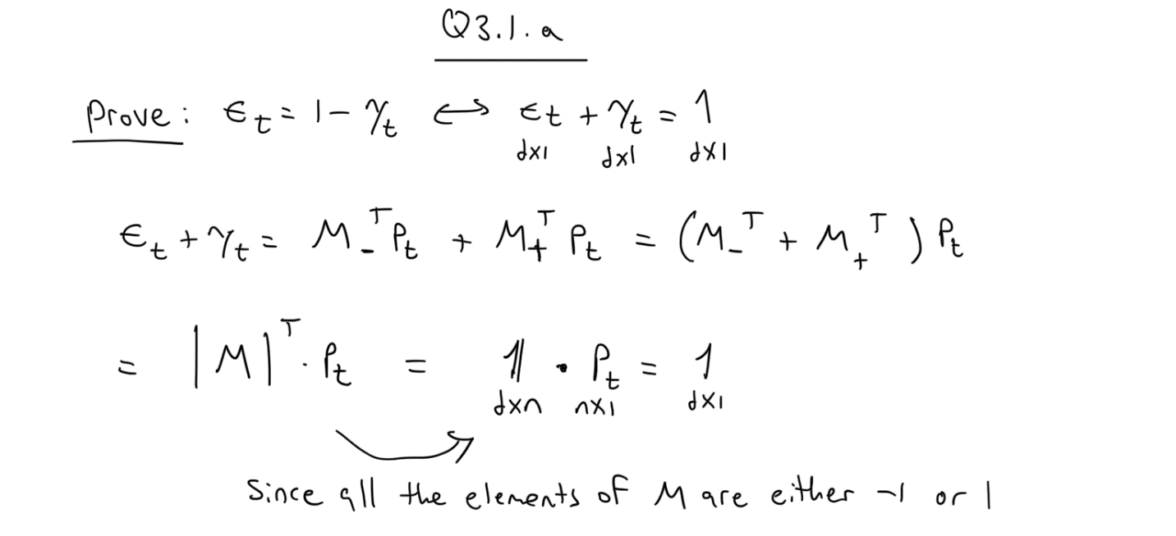

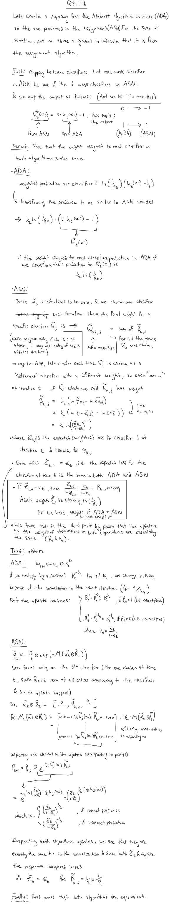





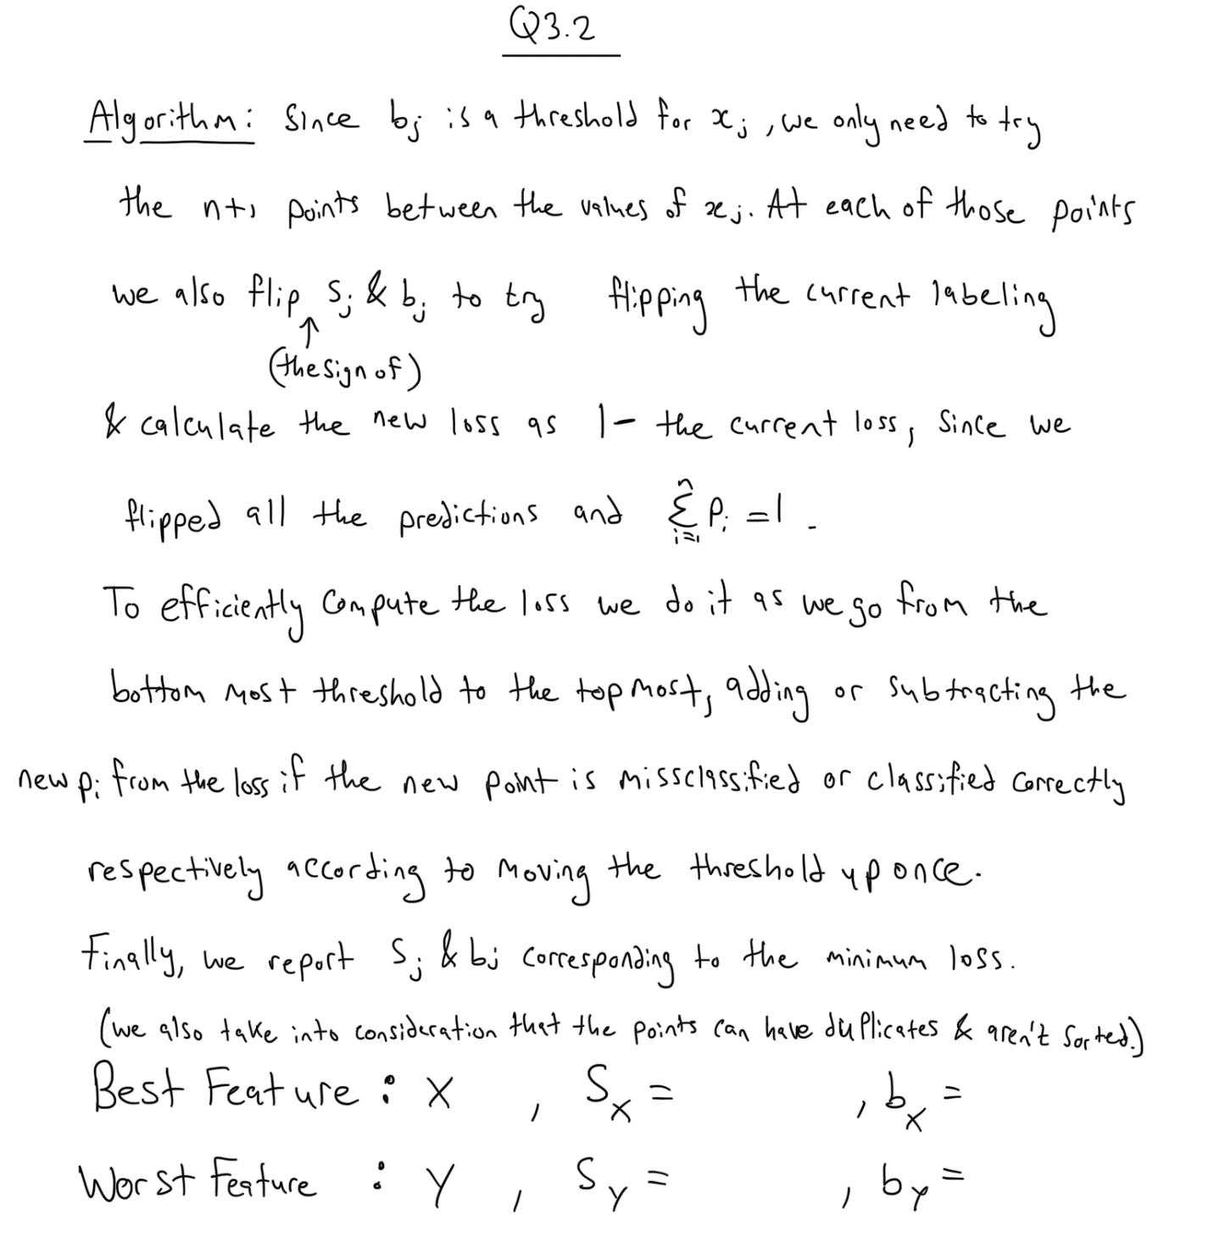Q3.2:

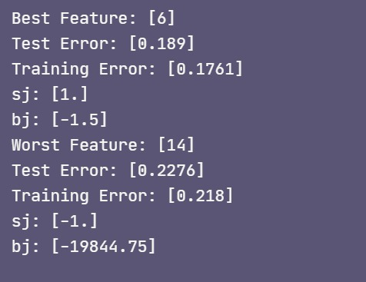

Q3.3:

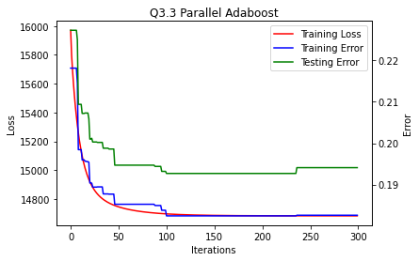

Q3.4:

