CS680 – Assignment 4

Ali ElSaid (20745892)

Q1.1:

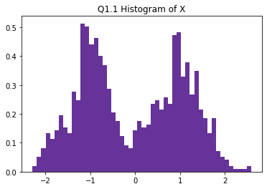

Q1.2: Ui should follow a standard Gaussian distribution approximately.

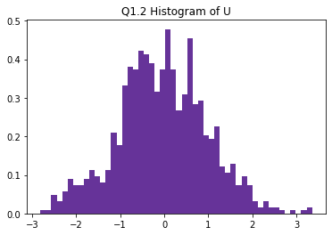

Q1.3: (Note: I ran with the tolerance = 1e-10 instead of 1e-5 to get a smooth graph throughout the whole range)

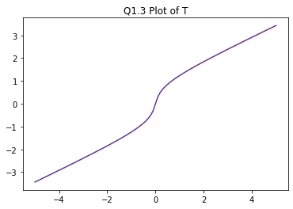

Q1.4: Yes, the histogram is very similar to Q1.1.

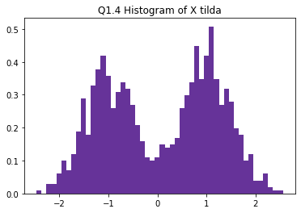

Q1.5: Ui should follow a standard Gaussian distribution approximately.

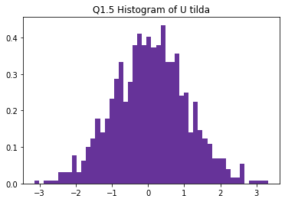

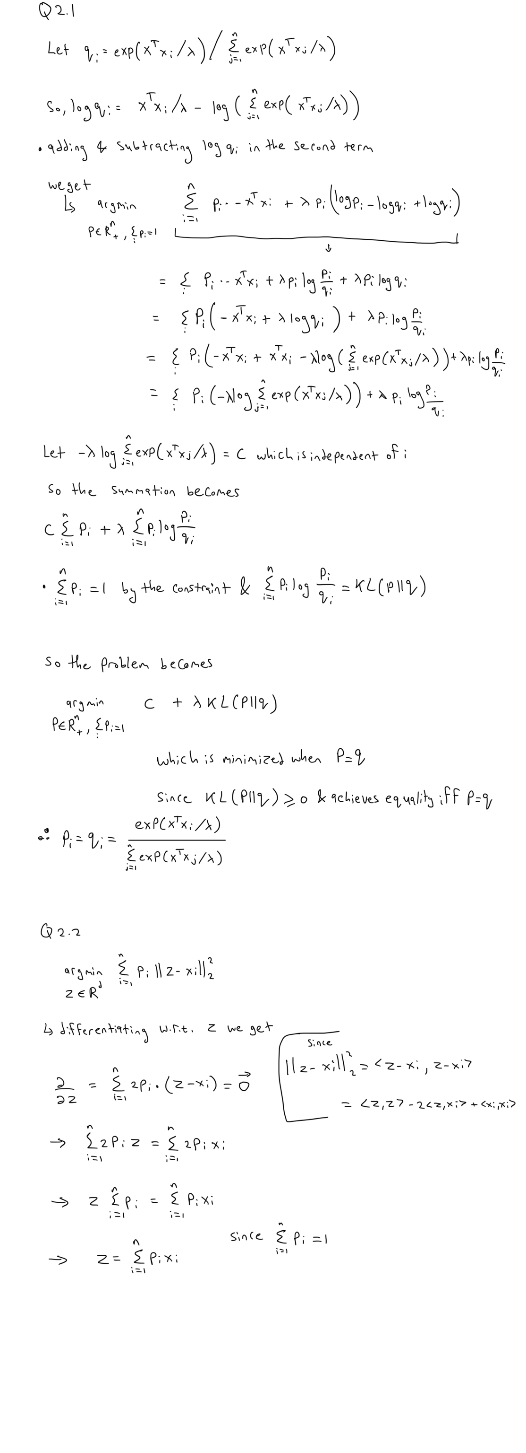Q2.1:

Q2.2:



Q2.3: They do all converge to one point. It seems like the point of convergence is some kind of mean but I’m not sure which.

