Html

1. We need to have a HTML containing three lists.

List 1 will contain the following :

1) One

a. Uno

b. Hanna

2) Two

a. Dos

b. Dool

3) Three

a. Tres

b. Set

List 2 will contain :

• Chevy

o Cavilier

o Malibu

• Ford

o Escort

o F100

• Mazda

o 626

List 3 should be of two types : Fruits and Vegetables

A. Fruits

i. Apples,Oranges,Pears,Banana

B. Vegetables

i. Corn

a)On the cob

b)Cream

ii. Carrots

iii. Green Beans

**Source Code:**

<!DOCTYPE *html*>

<html>

<head>

    <title>HTML Lists Example</title>

</head>

<body>

    <h2>List 1</h2>

    <ol>

        <li>One

            <ol *type*="a">

                <li>Uno</li>

                <li>Hanna</li>

            </ol>

        </li>

        <li>Two

            <ol *type*="a">

                <li>Dos</li>

                <li>Dool</li>

            </ol>

        </li>

        <li>Three

            <ol *type*="a">

                <li>Tres</li>

                <li>Set</li>

            </ol>

        </li>

    </ol>

    <h2>List 2</h2>

    <ul>

        <li>Chevy

            <ul>

                <li>Cavilier</li>

                <li>Malibu</li>

            </ul>

        </li>

        <li>Ford

            <ul>

                <li>Escort</li>

                <li>F100</li>

            </ul>

        </li>

        <li>Mazda

            <ul>

                <li>626</li>

            </ul>

        </li>

    </ul>

    <h2>List 3</h2>

    <ol *type*="A">

        <li>Fruits

            <ol *type*="i">

                <li>Apples, Oranges, Pears, Banana</li>

            </ol>

        </li>

        <li>Vegetables

            <ol *type*="i">

                <li>Corn

                    <ol *type*="a">

                        <li>On the cob</li>

                        <li>Cream</li>

                    </ol>

                </li>

                <li>Carrots</li>

                <li>Green Beans</li>

            </ol>

        </li>

    </ol>

</body>

</html>

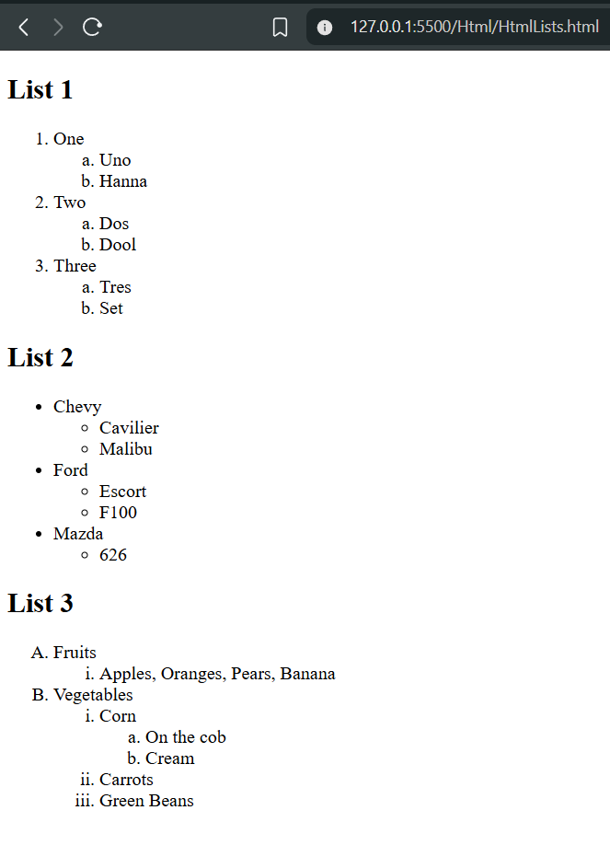**Output:**

1. Write a HTML program to create visitor information capture. The page should have the heading “Visitors information” and should ask the following information from the user :

Email address using a textbox ,

User’s interest web for research or purchase as check box.

Occupation as  drop down box and preselected value should be given as (select one).

Check “want us to send you junk emails?” and the options given are “absolutely” and “no way man” using the radio button.

A horizontal line divides the heading and the body content. Once all the inputs are given, the user should be able to submit or reset.

This whole form should be tabulated using table tag.

**Source Code:**

<!DOCTYPE *html*>

<html *lang*="en">

<head>

  <title>Visitors information</title>

</head>

<body>

  <h1>Visitors information</h1>

  <hr>

  <form *action*="#" *method*="post">

    <table *style*="border:1px solid black;" *cellpadding*="5">

      <tr>

        <td><label *for*="email">Email address:</label></td>

        <td><input *type*="email" *id*="email" *name*="email" *placeholder*="you@example.com"></td>

      </tr>

      <tr>

        <td>User's interest (web):</td>

        <td>

          <input *type*="checkbox" *id*="interest_research" *name*="interest" *value*="research">

          <label *for*="interest_research">Research</label>

          <br>

          <input *type*="checkbox" *id*="interest_purchase" *name*="interest" *value*="purchase">

          <label *for*="interest_purchase">Purchase</label>

        </td>

      </tr>

      <tr>

        <td><label *for*="occupation">Occupation:</label></td>

        <td>

          <select *id*="occupation" *name*="occupation">

            <option *value*="" *selected*>(select one)</option>

            <option *value*="student">Student</option>

            <option *value*="employed">Employed</option>

            <option *value*="self-employed">Self-employed</option>

            <option *value*="unemployed">Unemployed</option>

            <option *value*="other">Other</option>

          </select>

        </td>

      </tr>

      <tr>

        <td>Want us to send you junk emails?</td>

        <td>

          <input *type*="radio" *id*="junk_yes" *name*="junk_email" *value*="absolutely">

          <label *for*="junk_yes">absolutely</label>

          <br>

          <input *type*="radio" *id*="junk_no" *name*="junk_email" *value*="no_way_man">

          <label *for*="junk_no">no way man</label>

        </td>

      </tr>

      <tr>

        <td></td>

        <td>

          <input *type*="submit" *value*="Submit">

          <input *type*="reset" *value*="Reset">

        </td>

      </tr>

    </table>

  </form>

</body>

</html>

**Output:**

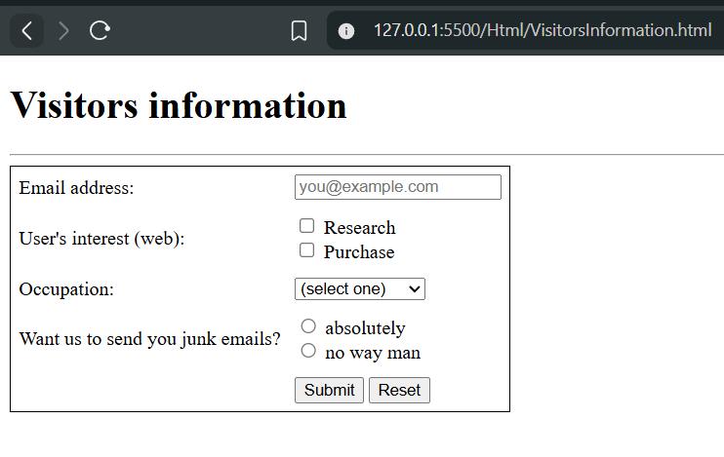

1. Write a HTML program to create an online registration form which captures the following data:

Username, Password, Confirm password, Name using text boxes.

Gender by radio buttons.

Address should be taken by multiple line inputs from the user.

Finally the Profession should be provided by selecting from the drop down box.

Make sure the contents of the page is aligned in the middle.

**Source Code:**

<!DOCTYPE *html*>

<html>

<head>

    <title>Online Registration Form</title>

    <style>

        body {

            display: flex;

            justify-content: center;

            align-items: center;

            min-height: 100vh;

            font-family: Arial, sans-serif;

        }

*.reg-form-container* {

            border: 1px solid #ccc;

            padding: 24px 32px;

            border-radius: 8px;

            box-shadow: 0 0 8px #eee;

            background: #fafafa;

        }

        table {

            margin: 0 auto;

        }

        td {

            padding: 8px;

        }

    </style>

</head>

<body>

    <div *class*="reg-form-container">

        <h2 *style*="text-align:center;">Online Registration Form</h2>

        <form>

            <table>

                <tr>

                    <td>Username:</td>

                    <td><input *type*="text" *name*="username" *required*></td>

                </tr>

                <tr>

                    <td>Password:</td>

                    <td><input *type*="password" *name*="password" *required*></td>

                </tr>

                <tr>

                    <td>Confirm Password:</td>

                    <td><input *type*="password" *name*="confirmpassword" *required*></td>

                </tr>

                <tr>

                    <td>Name:</td>

                    <td><input *type*="text" *name*="name" *required*></td>

                </tr>

                <tr>

                    <td>Gender:</td>

                    <td>

                        <input *type*="radio" *name*="gender" *value*="male" *required*> Male

                        <input *type*="radio" *name*="gender" *value*="female"> Female

                        <input *type*="radio" *name*="gender" *value*="other"> Other

                    </td>

                </tr>

                <tr>

                    <td>Address:</td>

                    <td>

                        <textarea *name*="address" *rows*="3" *cols*="25" *required*></textarea>

                    </td>

                </tr>

                <tr>

                    <td>Profession:</td>

                    <td>

                        <select *name*="profession" *required*>

                            <option *value*="" *selected* *disabled*>(select one)</option>

                            <option *value*="student">Student</option>

                            <option *value*="engineer">Engineer</option>

                            <option *value*="teacher">Teacher</option>

                            <option *value*="doctor">Doctor</option>

                            <option *value*="other">Other</option>

                        </select>

                    </td>

                </tr>

                <tr>

                    <td *colspan*="2" *style*="text-align:center;">

                        <input *type*="submit" *value*="Register">

                        <input *type*="reset" *value*="Reset">

                    </td>

                </tr>

            </table>

        </form>

    </div>

</body>

</html>

**Output:**

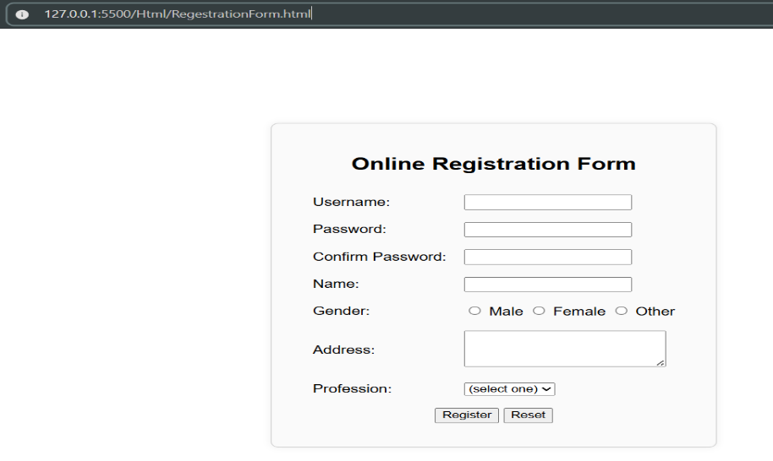

1. Write a HTML program to display the HTML page as described below:

• Create a page which is divided in 3 parts. 30% horizontally on top and the rest 70 % bellow is split vertically in 2 parts again 30 % and 70% each

• The Top header frame should display an image

• Left side below frame should have a menu of “Font” and “Alignment”.

• If we click on “Font” link a different page which contains 5 different fonts with font’s names should be shown on the RHS

• If we click on “Alignment” link a different page which contains a different alignment type should be shown on the RHS frame.

• For this create 2 webpages named Font and Alignment.

• Font page should have 5 names of different fonts displayed like this

Agency FB

Cambria

Elephant

• Alignment page should have sample text aligned to different alignments

**Source Code:**

**Frameset.html**

<!DOCTYPE *html*>

<html>

<head>

    <title>Frameset Layout Demo</title>

</head>

<frameset *rows*="30%,70%">

*<!-- Top frame with image -->*

    <frame *src*="Header.html" *name*="headerFrame" *scrolling*="no" *noresize*>

    <frameset *cols*="30%,70%">

*<!-- Left menu frame -->*

        <frame *src*="Menu.html" *name*="menuFrame" *noresize*>

*<!-- Right content frame -->*

        <frame *src*="Welcome.html" *name*="contentFrame">

    </frameset>

</frameset>

</html>

**Header.html**

<!DOCTYPE *html*>

<html>

<head>

    <title>Header Image</title>

</head>

<body *style*="margin:0; padding:0; text-align:center; background:#f0f0f0;">

    <img *src*="https://static.vecteezy.com/system/resources/thumbnails/002/082/615/small/header-with-black-and-blue-overlapped-arrows-abstract-modern-banner-with-place-for-your-text-material-design-abstract-widescreen-background-vector.jpg" *alt*="Header Image" *style*="margin-top:20px;">

</body>

</html>

**Welcome.html**

<!DOCTYPE *html*>

<html>

<head>

    <title>Welcome</title>

</head>

<body>

    <h2>Welcome!</h2>

    <p>Select a menu option to view content.</p>

</body>

</html>

**Font.html**

<!DOCTYPE html>

<html>

<head>

    <title>Fonts</title>

</head>

<body>

    <h3>Different Fonts</h3>

    <div style="font-family:'Agency FB', Arial;">Agency FB</div>

    <div style="font-family:'Cambria', serif;">Cambria</div>

    <div style="font-family:'Elephant', serif;">Elephant</div>

    <div style="font-family:'Courier New', monospace;">Courier New</div>

    <div style="font-family:'Comic Sans MS', cursive;">Comic Sans MS</div>

</body>

</html>

**Alignment.html**

<!DOCTYPE *html*>

<html>

<head>

    <title>Alignment</title>

</head>

<body>

    <h3>Text Alignment Examples</h3>

    <div *style*="text-align:left;">This text is left aligned.</div>

    <div *style*="text-align:center;">This text is center aligned.</div>

    <div *style*="text-align:right;">This text is right aligned.</div>

    <div *style*="text-align:justify; width:300px;">

        This text is justified. Lorem ipsum dolor sit amet, consectetur adipiscing elit. Pellentesque euismod.

    </div>

</body>

</html>

**Menu.html**

<!DOCTYPE *html*>

<html>

<head>

    <title>Menu</title>

</head>

<body *style*="font-family:Arial; background:#e0e0e0;">

    <h3>Menu</h3>

    <ul *style*="list-style:none; padding-left:0;">

        <li><a *href*="Font.html" *target*="contentFrame">Font</a></li>

        <li><a *href*="Alignment.html" *target*="contentFrame">Alignment</a></li>

    </ul>

</body>

</html>

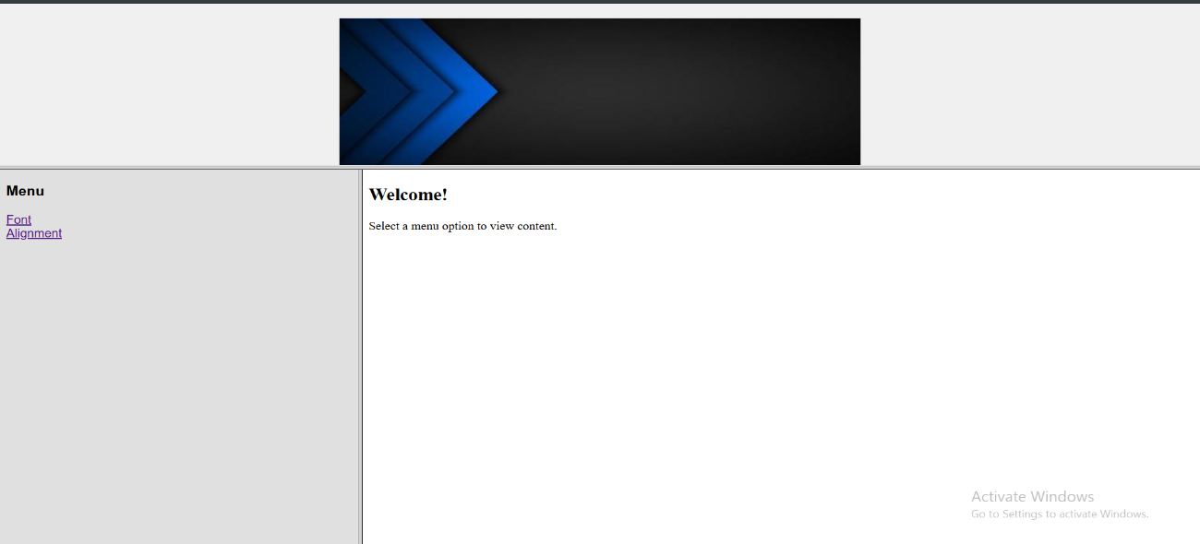**Output:**

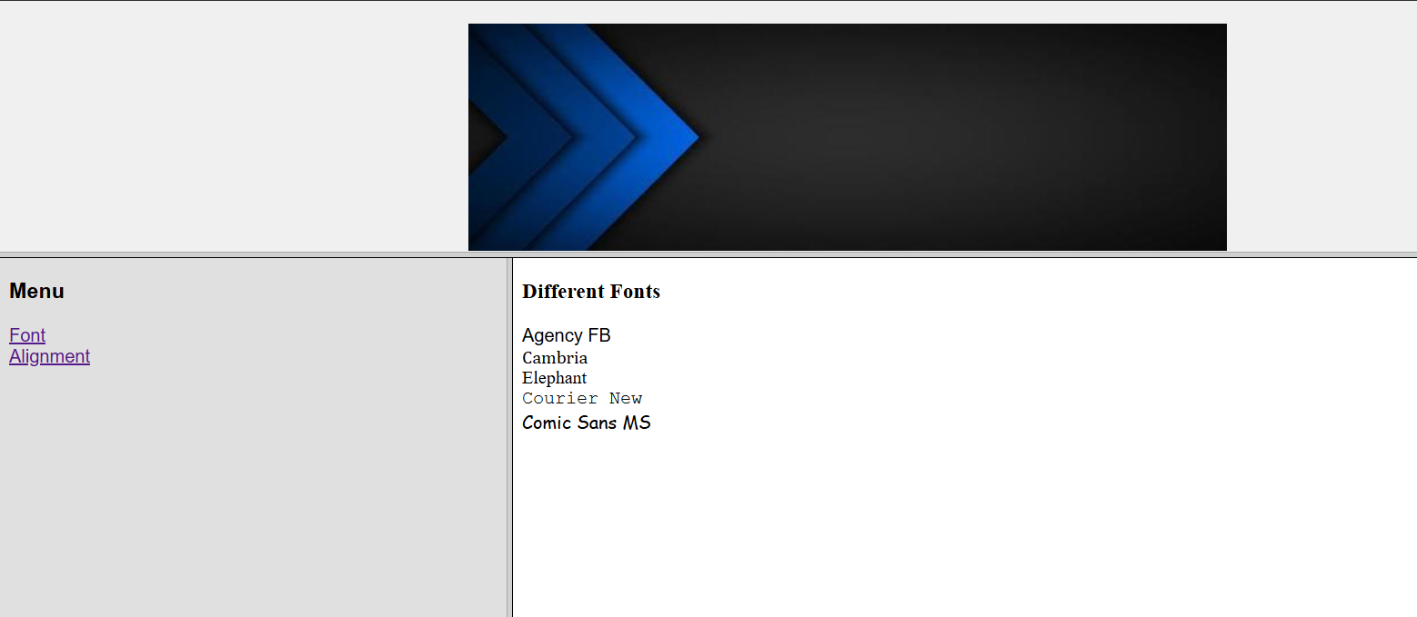

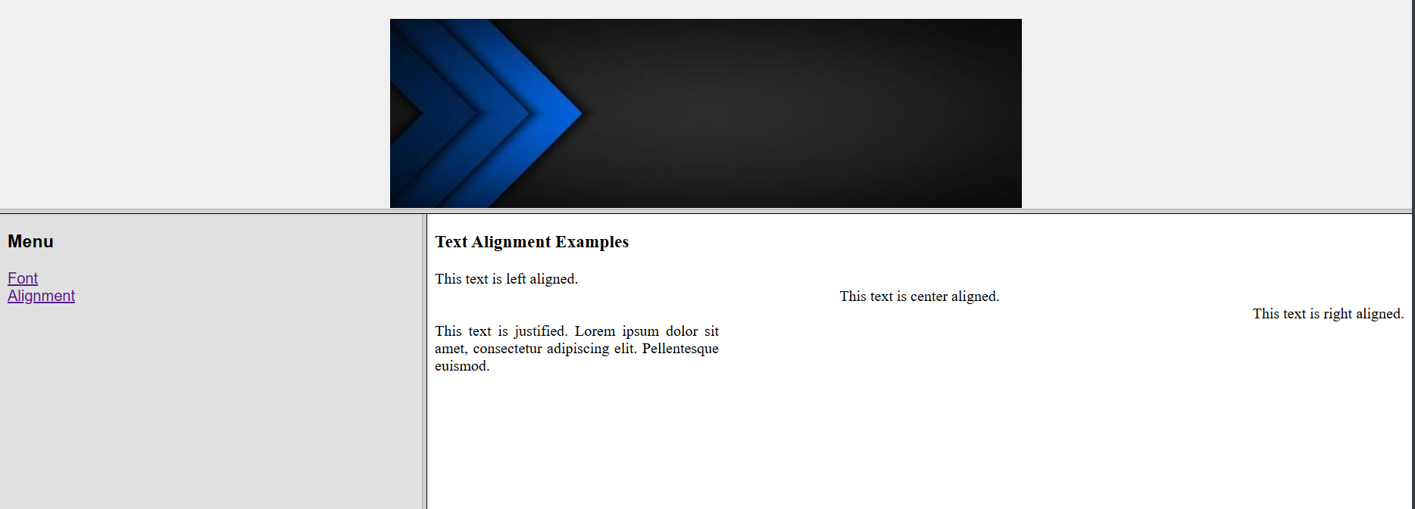

1. Apply the HTML 5 attributes in the Hands-on Assignment 2 and 3 on Forms

Sample Attributes : email, placeholder, required, multiple.

**Source Code:**

<!DOCTYPE *html*>

<html *lang*="en">

<head>

    <meta *charset*="UTF-8">

    <title>Visitor & Registration Forms</title>

    <style>

        body {

            display: flex;

            flex-direction: column;

            align-items: center;

            font-family: Arial, sans-serif;

            background: #f8f8f8;

        }

*.form-section* {

            background: #fff;

            border: 1px solid #ccc;

            border-radius: 8px;

            margin: 32px 0;

            padding: 24px 32px;

            box-shadow: 0 0 8px #eee;

            min-width: 350px;

        }

        h2 {

            text-align: center;

        }

        table {

            margin: 0 auto;

        }

        td {

            padding: 8px;

        }

        hr {

            margin: 16px 0;

        }

    </style>

</head>

<body>

*<!-- Visitor Information Form -->*

    <section *class*="form-section">

        <h2>Visitors information</h2>

        <hr>

        <form>

            <table>

                <tr>

                    <td><label *for*="email">Email address:</label></td>

                    <td><input *type*="email" *id*="email" *name*="email" *placeholder*="you@example.com" *required*></td>

                </tr>

                <tr>

                    <td>User’s interest (web):</td>

                    <td>

                        <input *type*="checkbox" *id*="interest_research" *name*="interest" *value*="research">

                        <label *for*="interest_research">Research</label>

                        <input *type*="checkbox" *id*="interest_purchase" *name*="interest" *value*="purchase">

                        <label *for*="interest_purchase">Purchase</label>

                    </td>

                </tr>

                <tr>

                    <td><label *for*="occupation">Occupation:</label></td>

                    <td>

                        <select *id*="occupation" *name*="occupation" *required*>

                            <option *value*="" *selected* *disabled*>(select one)</option>

                            <option *value*="student">Student</option>

                            <option *value*="employed">Employed</option>

                            <option *value*="self-employed">Self-employed</option>

                            <option *value*="unemployed">Unemployed</option>

                            <option *value*="other">Other</option>

                        </select>

                    </td>

                </tr>

                <tr>

                    <td>Want us to send you junk emails?</td>

                    <td>

                        <input *type*="radio" *id*="junk_yes" *name*="junk_email" *value*="absolutely" *required*>

                        <label *for*="junk_yes">Absolutely</label>

                        <input *type*="radio" *id*="junk_no" *name*="junk_email" *value*="no_way_man">

                        <label *for*="junk_no">No way man</label>

                    </td>

                </tr>

                <tr>

                    <td *colspan*="2" *style*="text-align:center;">

                        <input *type*="submit" *value*="Submit">

                        <input *type*="reset" *value*="Reset">

                    </td>

                </tr>

            </table>

        </form>

    </section>

*<!-- Registration Form -->*

    <section *class*="form-section">

        <h2>Online Registration Form</h2>

        <hr>

        <form>

            <table>

                <tr>

                    <td><label *for*="username">Username:</label></td>

                    <td><input *type*="text" *id*="username" *name*="username" *required*></td>

                </tr>

                <tr>

                    <td><label *for*="password">Password:</label></td>

                    <td><input *type*="password" *id*="password" *name*="password" *required*></td>

                </tr>

                <tr>

                    <td><label *for*="confirmpassword">Confirm Password:</label></td>

                    <td><input *type*="password" *id*="confirmpassword" *name*="confirmpassword" *required*></td>

                </tr>

                <tr>

                    <td><label *for*="name">Name:</label></td>

                    <td><input *type*="text" *id*="name" *name*="name" *required*></td>

                </tr>

                <tr>

                    <td>Gender:</td>

                    <td>

                        <input *type*="radio" *id*="male" *name*="gender" *value*="male" *required*>

                        <label *for*="male">Male</label>

                        <input *type*="radio" *id*="female" *name*="gender" *value*="female">

                        <label *for*="female">Female</label>

                        <input *type*="radio" *id*="other" *name*="gender" *value*="other">

                        <label *for*="other">Other</label>

                    </td>

                </tr>

                <tr>

                    <td><label *for*="address">Address:</label></td>

                    <td>

                        <textarea *id*="address" *name*="address" *rows*="3" *cols*="25" *required*></textarea>

                    </td>

                </tr>

                <tr>

                    <td><label *for*="profession">Profession:</label></td>

                    <td>

                        <select *id*="profession" *name*="profession" *required*>

                            <option *value*="" *selected* *disabled*>(select one)</option>

                            <option *value*="student">Student</option>

                            <option *value*="engineer">Engineer</option>

                            <option *value*="teacher">Teacher</option>

                            <option *value*="doctor">Doctor</option>

                            <option *value*="other">Other</option>

                        </select>

                    </td>

                </tr>

                <tr>

                    <td *colspan*="2" *style*="text-align:center;">

                        <input *type*="submit" *value*="Register">

                        <input *type*="reset" *value*="Reset">

                    </td>

                </tr>

            </table>

        </form>

    </section>

</body>

</html>

**Output:**

