**JUNIT**

1. Create a Project named JunitLearning
2. Create a package named com.wipro.task.
3. Copy the given class into the com.wipro.task package

**Source Code**

File name: DailyTask.java

package com.wipro.task;

import java.util.Arrays;

public class DailyTask {

public String doStringConcat (String s1, String s2) {

return s1+" "+s2;

}

public int[] sortValues(int arr[]){

Arrays.*sort*(arr);

return arr;

}

public boolean checkPresence(String str,String a){

return str.contains(a);

}

}

1. Create a new package called com.wipro.test;
2. Create a class named TestStringConcat to test the functionality of doStringConcat method [hint: use assertEquals method]

**Source Code**

File name: TestStringConcat.java

package com.wipro.test;

import static org.junit.jupiter.api.Assertions.*;

import org.junit.jupiter.api.Test;

import com.wipro.task.DailyTask;

class TestStringConcat {

@Test

void test() {

DailyTask dt = new DailyTask();

String name = dt.doStringConcat("vinod", "mvgr");

assertEquals("vinod mvgr", name);

} }

**Output**

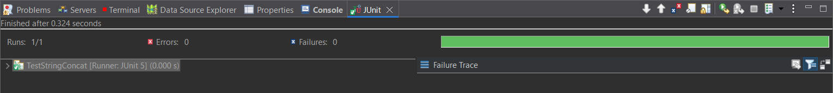

1. Create a class named TestSort to test the functionality of the sortValues method [hint: use assertArrayEquals method]

**Source Code**

File name: TestSort.java

package com.wipro.test;

import static org.junit.Assert.*assertArrayEquals*;

import java.util.Arrays;

import org.junit.Test;

import com.wipro.task.DailyTask;

public class TestSort {

*@Test*

public void num() {

DailyTask dt = new DailyTask();

int[] arr = {5,4,3,2,1};;

int[] sortarr = dt.sortValues(arr);

Arrays.*sort*(arr);

*assertArrayEquals*(arr,sortarr);

}

}

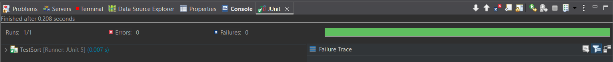**Output**

1. Create a class named TestCheckPresence to test the functionality of sortValues method [hint: use assertTrue and assertFalse methods]

**Source Code**

File name: TestCheckPresence.java

package com.wipro.test;

import static org.junit.Assert.*assertTrue*;

import org.junit.Test;

import com.wipro.task.DailyTask;

public class TestCheckPresence {

*@Test*

public void testpresence() {

DailyTask dt = new DailyTask();

boolean check = dt.checkPresence("Absolute", "so");

*assertTrue*(check);

}

}

**Output:**

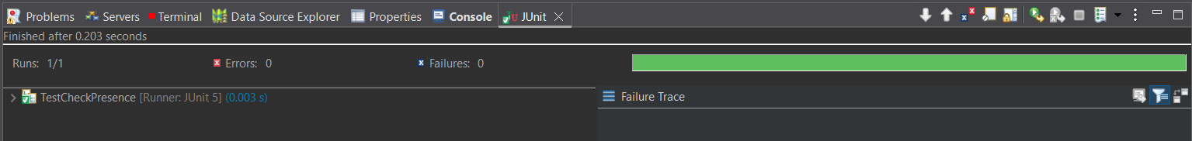

1. Create a test suite for all the 3 classes created under the com.wipro.test package and execute the same

**Source Code**

File name: TestSuit.java

package com.wipro.test;

import org.junit.platform.suite.api.SelectClasses;

import org.junit.platform.suite.api.Suite;

import org.junit.runner.RunWith;

*@Suite*

*@SelectClasses*({

TestStringConcat.class,

TestSort.class,

TestCheckPresence.class

})

public class TestSuit {

}

**Output**

