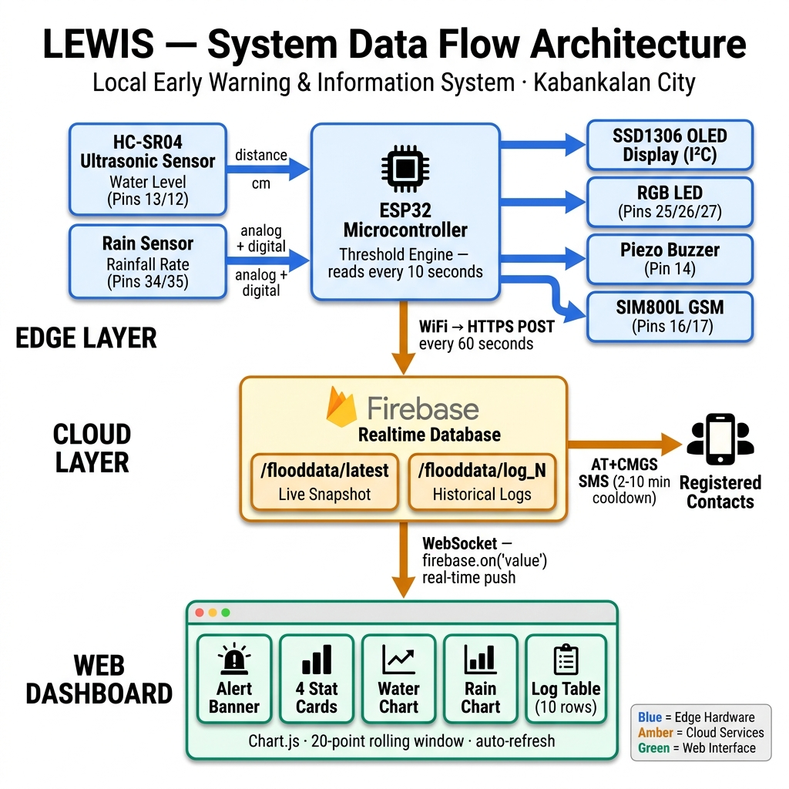
Figure 1: LEWIS System Data Flow Architecture — Edge Sensors → ESP32 → Firebase Cloud → Web Dashboard

V. Prototype Functionalities
1. Continuous Real-Time Environmental Monitoring
  - The system utilizes an HC-SR04 ultrasonic sensor to measure water levels and a rain sensor to track precipitation, updating local and remote interfaces every 60 seconds.
2. Automated Status Evaluation & Triggering
  - The firmware evaluates data against three thresholds:
    - Safe ( 60cm or ≥ 15mm/hr): Red LED active, loud Buzzer engaged, urgent SMS sent.
3. Local Visual and Acoustic Feedback
  - The device features an on-board SSD1306 OLED display for immediate visual readouts of current metrics, accompanied by an RGB LED and Buzzer for immediate on-site alerting.
4. Cloud-Based Remote Dashboard
  - Sensor data is synchronized in real-time to a Firebase Realtime Database. An interactive web interface fetches this data, displaying live metrics and rendering a 20-reading historical trend graph using Chart.js.
5. Decentralized SMS Notification System
  - Independent of the internet connection, the integrated SIM800L module dispatches critical SMS warnings via the cellular network to registered community members and local authorities.

VI. Challenges
During the conceptualization and development of the LEWIS project, the team encountered significant hardware integration and calibration hurdles. Interfacing the SIM800L GSM module with the ESP32 proved technically demanding due to strict power supply requirements and voltage logic level mismatches. The SIM800L can draw sudden peaks of current up to 2A during network transmission, which frequently caused the ESP32 to reset or behave erratically until a dedicated, stable buck-converter power supply circuit was designed and implemented. Furthermore, calibrating the HC-SR04 ultrasonic sensor to provide consistent readings over moving water required implementing software-level data smoothing algorithms to filter out noise and false echoes.
Another major challenge revolved around establishing a reliable and low-latency cloud synchronization pipeline. Relying on an intermittent local Wi-Fi connection meant that data payloads to the Firebase Realtime Database could occasionally drop or timeout. The team had to optimize the C++ firmware to handle network disconnections gracefully, implementing non-blocking asynchronous routines and retry mechanisms to ensure the ESP32 would automatically reconnect to the network without halting the critical local monitoring and SMS alerting loops. Managing the asynchronous nature of Firebase updates alongside the time-sensitive hardware polling was a complex synchronization task.
Finally, standardizing the user interface to be accessible and intuitive presented a design challenge. The team needed the web dashboard to not only display raw data but to interpret it meaningfully for non-technical community members. Ensuring that the Chart.js graphs updated fluidly without causing memory leaks in the browser, and designing a responsive CSS layout that worked well on both desktop monitors in a command center and on the mobile screens of local residents, required multiple iterations and extensive cross-browser testing.

VII. Summary and Future Improvements
The development of the LEWIS project yielded a highly functional, cost-effective early warning system capable of autonomously monitoring flood risks and actively notifying the community. The system successfully demonstrated that integrating edge IoT devices with cloud infrastructure can provide localized, real-time disaster alerts faster than traditional methods. The local alerting mechanisms, particularly the SMS dispatch and on-site acoustic/visual alarms, proved highly robust, functioning flawlessly during simulated threshold breaches. The remote web dashboard effectively visualized historical trends and current status, validating the team's approach to decentralized data reporting.
However, the current prototype possesses certain limitations that constrained its scope. The reliance on local Wi-Fi for cloud synchronization limits the physical placement of the monitoring node to areas with stable internet router coverage, potentially restricting deployment in remote riverbeds. Additionally, the system currently relies on a hardcoded list of phone numbers for SMS alerts, lacking a dynamic subscription model for residents to opt-in or opt-out autonomously. The physical enclosure of the prototype also remains rudimentary, necessitating a more rugged, IP67-rated waterproof housing before it can survive prolonged exposure to actual typhoons.
For future improvements, the team highly recommends transitioning the cloud connectivity module from standard Wi-Fi to a LoRaWAN or NB-IoT network topology, which would drastically increase the deployment range and reliability in off-grid locations. Secondly, integrating a solar panel and a high-capacity lithium-ion battery array with a charge controller would make the system entirely energy-independent, ensuring uninterrupted operation during grid power failures common during severe storms. Finally, the team suggests expanding the software architecture to include a fully functional backend API and administrative panel, allowing local authorities to dynamically manage SMS subscriber lists, adjust threshold levels remotely, and generate automated historical reports for long-term climate analysis.

VIII. Appendices
- Appendix A: Complete System Source Code (ESP32 Firmware, HTML/JS/CSS)
- Appendix B: Hardware Wiring Schematic Diagram
- Appendix C: User and Installation Manual
- Appendix D: Photos of the Assembled Prototype and Web Dashboard Interface

