**Task: DM-30**

Create table ‘Products’ in SMSS:

**Synatx to Create table:**

CREATE TABLE <tableName> (<ColumnName1> <DataType>, <ColumnName2> <DataType>, so on …);

Example:

CREATE TABLE Products

(ProductID int PRIMARY KEY NOT NULL,

ProductName varchar(25) NOT NULL,

Price money NULL,

ProductDescription varchar(max) NULL

)

;

**To get some information of the table:**

exec sp_help <tableName>;

exec sp_help Products;

OUTPUT:

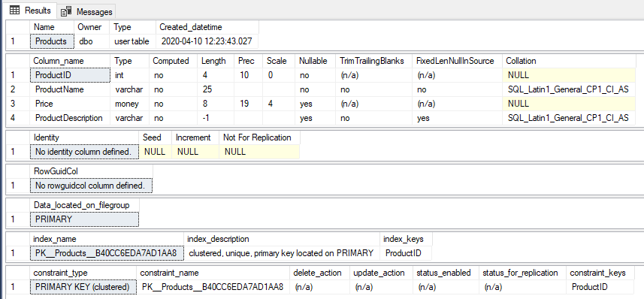

**To get some information of the table’s Column:**

exec sp_columns <tableName>;

exec sp_columns Products;

**Synatx to see column:**

SELECT top 0 * FROM <tableName>;

Example;

SELECT top 0 * FROM Products;

Output:

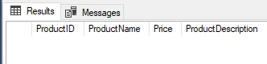

Note: There is no rows because we haven’t added the Values in the table.

**Syntax to add Values in the Table:**

INSERT <tableName> (<ColumnName1>, <ColumnName2>, so on …) VALUES (value1, value2, so on …);

Example;

INSERT Products (ProductID, ProductName, Price, ProductDescription)

VALUES (1, 'Clamp', 12.48, 'Workbench clamp');

To See data in table use SELECT Query:

SELECT * FROM Products;

OUTPUT:

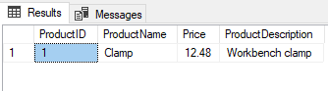

**Changing the order of the columns:**

INSERT Products (ProductName, ProductID, Price, ProductDescription)

VALUES ('Screwdriver', 50, 3.17, 'Flat head');

**Skipping the column list, but keeping the values in order:**

INSERT Products

VALUES (75, 'Tire Bar', NULL, 'Tool for changing tires.');

**Dropping the ProductDescription column:**

INSERT Products (ProductID, ProductName, Price)

VALUES (3000, '3 mm Bracket', 0.52);

OUTPUT:

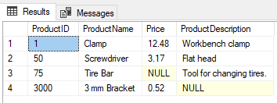

**To add Primary Key in Table:**

**NOTE:** If you are adding Primary Key in table after creation of the table then the column should be of NOT NULL type.

ALTER TABLE <tableName> ADD Primary Key (<columnName>);

**To check the NULL Value and ‘’ in the Column(s):**

SELECT * FROM <tableName> AS <aliasName> WHERE <aliasName.ColumnName> <conditions>;

SELECT * FROM Products WHERE ProductDescription IS NULL OR ProductDescription = '';

OUTPUT:

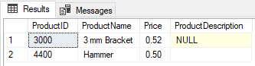

**To check the NOT NULL and ‘’ Value in the Column(s):**

SELECT ProductDescription FROM Products WHERE ProductDescription IS NOT NULL AND ProductDescription != '';

OUTPUT:

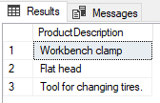

**To Count the Number of NOT NULL in Column(s):**

select count(ProductID) as cName from Products as CT where CT.ProductDescription is NOT null AND CT.ProductDescription != '';

OUTPUT:

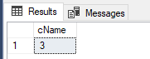

**To Count the Number of NOT NULL in Column(s):**

select count(ProductID) as cName from Products as CT where CT.ProductDescription is null OR CT.ProductDescription = '';

OUTPUT:

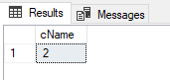

**Calculate the percentage of a column:**

declare @perc decimal;

set @perc = (select (count(price) * 100 )/count(ProductID) from Products);

select @perc as NotNullPer , 100 - @perc as NullPer;

OUTPUT:

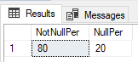

Not Null percentage of Price column in Product Table is 80%.

Null percentage of Price column in Product Table is 20%.