RAMDEOBABA UNIVERSITY
SCHOOL OF COMPUTER SCIENCE AND ENGINEERING
Department of Artificial Intelligence and Machine Learning

B. TECH PROJECT REPORT (Idea Lab)
ON
CAS-SE: A CONTEXT-AWARE SEARCHABLE SPLIT-KEY DATA PROTECTION ARCHITECTURE FOR PRIVACY-PRESERVING ML DATASETS
Submitted by
Nikhil Singh (Roll No. 37)
Soham Kharabe (Roll No. 23)
Karunya Paliwal (Roll No. 14)
Gaurang Daware (Roll No. 17)
Prajwal Khandekar (Roll No. 26)
Under the Guidance of
Prof. Sonam Meshram
Semester V | Academic Year: 2026–2027

RAMDEOBABA UNIVERSITY, NAGPUR
Department of Computer Science and Engineering
CERTIFICATE

This is to certify that the Project Report on “CAS-SE: A Context-Aware Searchable Split-Key Data Protection Architecture for Privacy-Preserving ML Datasets” is a Bonafide work of ‘Soham Kharabe’, ‘Nikhil Singh’, ‘Karunya Paliwal’, ‘Gaurang Daware’ & ‘Prajwal Khandekar’ submitted to Ramdeobaba University, Nagpur in partial fulfilment of the award of a Degree of Bachelor of Technology (B. Tech), in Computer Science and Engineering (Artificial Intelligence and Machine Learning). It has been carried out at the Department of Computer Science and Engineering, Ramdeobaba University, Nagpur during the academic year 2026-27.

Date:
Place: Nagpur

Prof. Sonam Meshram  Project Guide  Department of Computer Science & Engineering (AIML) | Associate Head  Department of Computer Science & Engineering

Dr. P. D. Adane
Dean SoCSE

STUDENT DECLARATION
We hereby declare that the project report entitled “CAS-SE: A Context-Aware Searchable Split-Key Data Protection Architecture for Privacy-Preserving ML Datasets” is submitted as part of the requirements for the B.Tech programme at Ramdeobaba University.
The work presented in this report is our own work carried out under the guidance of the project supervisor. All external sources, datasets, software tools, figures and technical material used in the project have been appropriately acknowledged and cited.
Nikhil Singh — Roll No. 37
Soham Kharabe — Roll No. 23
Karunya Paliwal — Roll No. 14
Gaurang Daware — Roll No. 17
Prajwal Khandekar — Roll No. 26

APPROVAL SHEET
This is to certify that the project report entitled “CAS-SE: A Context-Aware Searchable Split-Key Data Protection Architecture for Privacy-Preserving ML Datasets” has been carried out by the students listed in this report under the guidance of the undersigned and is submitted in partial fulfilment of the academic requirements of the B.Tech programme.
Guide | External Examiner | Dean, SoCSE
Prof. Sonam Meshram |  | Dr. Padma Adane

ACKNOWLEDGEMENT
We express our sincere gratitude to Ramdeobaba University and the School of Computer Science and Engineering for providing the academic environment and facilities required to complete this project.
We are grateful to our project guide, Prof. Sonam Meshram, for continuous guidance, technical suggestions and constructive feedback throughout the project. We also thank the Project In-Charge, Associate Head and Dean, School of Computer Science and Engineering, for their support.
Finally, we acknowledge the support of our classmates, laboratory staff, friends and family members who contributed directly or indirectly to the completion of this work.

ABSTRACT
Machine learning pipelines increasingly depend on sensitive data such as biometric images, medical records and behavioural data. Common protection mechanisms address parts of the problem: encryption at rest protects storage but decrypts data for any authorised query, role-based access control (RBAC) grants static permissions that ignore purpose and timing, masking can reduce the usefulness of data for training, and a central key service becomes a single point of compromise.
This report presents CAS-SE, a Context-Aware, Searchable, Split-Key Data Envelope architecture. Every record is stored as an encrypted envelope: the payload is encrypted with a unique per-record key using AES-256-GCM, equality-searchable fields are indexed through HMAC-SHA-256 tokens, the master wrapping key is split with a 2-of-3 Shamir secret-sharing scheme, and an attribute-based policy engine decides for every request whether to deny access, return a masked view, return a feature-only view, or issue a time-limited decryption authorisation. All decisions are written to an append-only, SHA-256 hash-chained audit log, and an Isolation Forest model is used to flag unusual access patterns.
CAS-SE does not introduce new cryptography; its contribution is the integration of established primitives into one gatekeeper service for ML data. The report describes the design, the prototype implementation (FastAPI, PostgreSQL, MinIO, PyTorch), the evaluation plan and the documented limitations.
Keywords: Data Protection, Envelope Encryption, Searchable Encryption, Shamir Secret Sharing, Attribute-Based Access Control, Data Minimization, Tamper-Evident Audit, Privacy-Preserving Machine Learning

TABLE OF CONTENTS
STUDENT DECLARATION 3
APPROVAL SHEET 4
ACKNOWLEDGEMENT 5
ABSTRACT 6
TABLE OF CONTENTS 7
LIST OF FIGURES 10
LIST OF TABLES 11
LIST OF ABBREVIATIONS 12
1 Introduction 14
1.1 Background 14
1.2 Problem Statement 14
1.3 Objectives 15
1.4 Scope of the Project 15
1.5 Organization of the Report 16
2 Literature Review and Research Gap 18
2.1 Introduction 18
2.2 Existing Security Controls and Their Drawbacks 18
2.3 Research Literature 18
2.3.1 Searchable encryption and encrypted databases 18
2.3.2 Cryptographic privacy-preserving ML 19
2.3.3 Federated and split learning 19
2.3.4 Access control, key custody and audit integrity 19
2.4 Comparison of Representative Approaches 20
2.5 Limitations of Existing Work 20
2.6 Research Gap 20
3 Proposed System and Methodology 22
3.1 Design Principles 22
3.2 Proposed System 22
3.3 Record Envelope 23
3.4 Cryptographic Methodology 23
3.4.1 Per-record authenticated encryption 23
3.4.2 Protected equality tokens 24
3.4.3 Threshold custody of the master key 24
3.4.4 Key rotation 24
3.4.5 Hash-chained audit 24
3.5 Context-Aware Policy Model 25
3.6 Evaluation Methodology 26
4 System Design and Implementation 28
4.1 System Architecture 28
4.2 Technology Stack 28
4.3 Database Design 28
4.4 API Design 29
4.5 Key-Share Simulation 29
4.6 Data Minimisation Pipeline 29
4.7 Audit Chain and Anomaly Detection 29
4.8 Integration with Existing Applications 30
4.9 Implementation Workflow 31
5 Results and Discussion 33
5.1 Experimental Setup 33
5.2 Functional Results 33
5.3 Performance and Utility Targets 34
5.4 Security Analysis 34
5.5 Discussion 35
5.6 Limitations 35
6 Conclusion and Future Scope 37
6.1 Conclusion 37
6.2 Future Scope 37
REFERENCES 38
ANNEXURE A: PUBLICATIONS AND INTELLECTUAL PROPERTY 42
ANNEXURE B: STUDENT CONTRIBUTION STATEMENT 43
ANNEXURE C: PROJECT OUTPUTS 44

LIST OF FIGURES
Figure 3.1: Overall CAS-SE System Architecture
Figure 3.2: Access Decision Flow
Figure 4.1: Hash-Chained Audit Log
Figure 4.2: Integration Model for an Existing Application
Figure 4.3: Prototype Screenshot (Upload and Access Request Interface)
Figure 5.1: Benchmark Results: Plaintext, Encrypted-RBAC and CAS-SE

LIST OF TABLES
Table 2.1: Existing Controls and Their Main Drawbacks
Table 2.2: Comparison of Representative Existing Approaches
Table 3.1: User Types in the Threat Model
Table 3.2: Evaluation Metrics and Measurement Method
Table 4.1: Software Components
Table 4.2: Database Schema
Table 4.3: Demonstration API Endpoints
Table 5.1: Functional and Security Test Cases
Table 5.2: Project Targets and Measured Values
Table 5.3: Threats and CAS-SE Controls
Table 6.1: Publications and Intellectual Property
Table 6.1: Student Contribution Statement

LIST OF ABBREVIATIONS
ABAC | Attribute-Based Access Control
AES-GCM | Advanced Encryption Standard – Galois/Counter Mode
API | Application Programming Interface
CAS-SE | Context-Aware, Searchable, Split-Key Data Envelope
DEK | Data Encryption Key
DPDPA | Digital Personal Data Protection Act
GDPR | General Data Protection Regulation
HMAC | Hash-based Message Authentication Code
HSM | Hardware Security Module
JWT | JSON Web Token
KEK | Key Encryption (Wrapping) Key
KMS | Key Management Service
ML | Machine Learning
OPA | Open Policy Agent
RBAC | Role-Based Access Control
SSE | Searchable Symmetric Encryption
SSS | Shamir’s Secret Sharing
TDE | Transparent Data Encryption

CHAPTER
1

1 Introduction
Machine learning systems are only as trustworthy as the way they handle the data they learn from. When that data is sensitive, the question is not only whether it is encrypted on disk, but who can see which part of it, for what purpose, and for how long. This project addresses that question for image-based ML datasets.

1.1 Background
Modern ML pipelines are built on sensitive datasets, including biometric imagery, medical diagnostics and personal behavioural records. Legal frameworks such as the GDPR [23] and India’s Digital Personal Data Protection Act, 2023 [24] require such data to be protected, yet typical enterprise security remains fragmented.
Encryption of data at rest, including database-level transparent encryption, protects against theft of disks and backups. Once a service account or privileged role is authenticated, however, data is decrypted in the application runtime without regard to the task being performed. Encrypting database fields also makes them hard to search, so systems are pushed to choose between confidentiality and usability. RBAC [8] assigns permissions by role, so an engineer with a “Trainer” role may be able to read raw images even when derived features would be enough for training. Finally, a centralised key service is a high-value single point of failure.
CAS-SE treats data security as an active gatekeeper rather than a perimeter: cryptographic protection, searchable equality tokens, multi-party key custody and context evaluation are bound together and applied to every record request.

1.2 Problem Statement
Current ML data pipelines suffer from three fundamental weaknesses:
- Search versus confidentiality. Indexed queries over encrypted attributes are difficult without exposing plaintext or decrypting whole collections.
- Static authorisation. RBAC gives internal roles excessive access to raw data and ignores the user’s task purpose, the active operational window and the need to minimise the output.
- Single-point key exposure. Compromise of one master key or storage bucket breaches the confidentiality and integrity of all stored assets.
The problem addressed is the design and prototyping of a single service that applies least privilege and data minimisation to every access request while keeping database queries and ML workflows usable.

1.3 Objectives
- To implement an envelope-encryption service using AES-256-GCM with an individual Data Encryption Key (DEK) per record.
- To design a deterministic equality-search index using HMAC-SHA-256 so that records can be queried without storing plaintext search values.
- To simulate a 2-of-3 threshold Shamir secret-sharing scheme for the master key, removing the single point of key compromise.
- To develop a context-aware (ABAC) policy engine that evaluates role, purpose and ML job approval and releases a minimised view of the data.
- To build an append-only, SHA-256 hash-chained audit service for verifiable integrity of access records.
- To evaluate the trade-off between privacy transformations and ML model utility, and to apply anomaly detection to access logs.

1.4 Scope of the Project
The project covers backend encryption, protected equality search, contextual release of data, split-key custody simulation, audit logging and a small ML-job workflow. The prototype is a proof of concept intended for a consented, anonymised or synthetic dataset.
The following are outside the scope. CAS-SE does not protect data after it has been lawfully released to an authorised user (for example, a screenshot of an authorised view). It does not support arbitrary full-text or wildcard queries over encrypted attributes. It does not protect against a fully compromised trusted training environment. It is not a ransomware defence; backup and recovery remain a separate control. It does not claim to solve all data-security problems, and it does not invent new cryptographic algorithms.

1.5 Organization of the Report
Chapter 2 reviews existing controls and research and identifies the research gap. Chapter 3 presents the proposed system and methodology. Chapter 4 describes the design and implementation, including the integration model for existing applications. Chapter 5 presents the evaluation, results and limitations. Chapter 6 concludes the report and lists future scope.

CHAPTER
2

2 Literature Review and Research Gap

2.1 Introduction
This chapter first examines the security controls that organisations commonly use to protect sensitive data and their drawbacks, and then reviews research on searchable encryption, privacy-preserving machine learning, access control, key custody and audit integrity. The review motivates the integrated design of CAS-SE.

2.2 Existing Security Controls and Their Drawbacks
Table 2.1 summarises the standard controls that CAS-SE builds on and the gaps that remain when each is used alone. These controls are necessary; the argument is that none is sufficient by itself.
Table 2.1: Existing Controls and Their Main Drawbacks
Control | Protects | Main drawbacks
Encryption at rest / in transit | Stolen disks, backups, network traffic | Key loss blocks access and key theft exposes data; does not stop authorised misuse; encrypted fields are hard to search
RBAC and MFA | Identity and role-based permissions | Roles grow and stale privileges remain; MFA does not limit what a valid but over-privileged account can read
Masking / pseudonymization | Test, analytics and shared datasets | May reduce ML usefulness; mapping tables and linkage attacks can re-identify individuals
Backups and recovery | Deletion, ransomware, hardware failure | Added cost; backup copies are breach targets; restores may be slow or untested
DLP, logging, monitoring | Suspicious copying; audit evidence | False alerts; unclassified data can be missed; logs may themselves hold sensitive data
Network / endpoint security | Unauthorised network or device access | Configuration drift, device compromise and application-level attacks remain

2.3 Research Literature

2.3.1 Searchable encryption and encrypted databases
Song, Wagner and Perrig introduced practical techniques for searching on encrypted data [4], and Curtmola et al. gave improved security definitions and efficient constructions for searchable symmetric encryption [5]. Kamara and Moataz extended structured encryption to a large class of SQL queries [6]. Such schemes concentrate on cryptographic querying and do not evaluate who is asking or why. Naveed, Kamara and Wright showed that encrypted databases built on property-preserving (deterministic or order-preserving) encryption can leak enough information to enable inference attacks [7]. This is directly relevant to CAS-SE, because deterministic HMAC tokens also reveal equality patterns, a trade-off the design accepts and documents.

2.3.2 Cryptographic privacy-preserving ML
Delphi [12] combines homomorphic encryption and multi-party computation for private neural-network inference, and CrypTFlow2 [13] provides efficient two-party secure inference. CrypTen [14] links secure multi-party computation with PyTorch. These systems keep inputs hidden during computation but carry cryptographic overhead and are designed for compute-time privacy, not for governing access to a stored dataset.

2.3.3 Federated and split learning
Federated learning keeps raw data local and shares model updates [15, 16]; POSEIDON applies privacy-preserving federated training to neural networks [17]. Split computing exposes intermediate feature tensors rather than raw inputs [18], and SplitFed combines federated and split learning [19]. These approaches target decentralised settings and do not solve secure access control for a centralised ML data store.

2.3.4 Access control, key custody and audit integrity
RBAC [8] is widely deployed, whereas ABAC evaluates multiple attributes of the subject, resource and environment [9]. Shamir’s secret sharing [1] allows a secret to be split into n shares of which any k reconstruct it while fewer reveal nothing; NIST key management guidance [21] covers key lifecycle practices such as rotation. Schneier and Kelsey described protecting audit logs on untrusted machines using cryptographic chaining of entries [10]. Weng et al. use tamper-evident records in an auditable privacy-preserving deep-learning setting [20]. Masking and anonymisation alone are vulnerable to linkage, as discussed by Sweeney [22].

2.4 Comparison of Representative Approaches
Table 2.2: Comparison of Representative Existing Approaches
Work | Key contribution | Limitation relative to this project
Delphi [12] | HE and MPC for private neural-network inference | Cryptographic overhead; no indexed searchable storage
Kamara & Moataz [6] | SQL-style queries over structurally encrypted databases | Cryptographic querying only; no user-context policy or minimisation
CrypTFlow2 [13] | Practical two-party secure inference | Client–server computation, not a split-key data gatekeeper
Li et al. [15] | Federated learning: raw data stays local | Decentralised setting; no access control for centralised MLOps
Matsubara et al. [18] | Split computing exposing intermediate features | Bandwidth focus; no secure storage or access control
CAS-SE (proposed) | Per-record AES-GCM, HMAC tokens, ABAC policy, Shamir split-key and feature release in one service | Prototype scope; documented leakage and availability trade-offs

2.5 Limitations of Existing Work
The reviewed work addresses individual concerns in isolation. Searchable encryption does not consider purpose or minimisation. Secure-inference protocols avoid exposing data during computation but impose significant cryptographic cost. Federated and split learning assume decentralised data. RBAC is static, and masking can destroy training utility.

2.6 Research Gap
Individual solutions exist for searchable encryption, secret sharing and attribute-based access control, but they are not combined into one operational data-gatekeeper tailored to ML pipelines. Existing MLOps practice either exposes whole datasets to data-science teams or relies on cryptographic schemes whose cost makes real-world training impractical. CAS-SE addresses this gap by orchestrating established primitives – envelope encryption, protected equality tokens, threshold key custody, context-aware policy and minimised views, and tamper-evident auditing – as one coherent system. The contribution is architectural, not a new cryptographic algorithm.

CHAPTER
3

3 Proposed System and Methodology

3.1 Design Principles
- Least privilege and data minimisation: each request receives the smallest view that satisfies its purpose.
- Deny by default: access is refused unless the policy engine explicitly permits it, and sensitive reads are re-checked every time.
- Per-record isolation: each record has its own key, which limits the impact of a single key leak.
- Established primitives only: vetted libraries and standard algorithms are used; no custom cryptography.
- No secrets in logs: audit events carry context and resource identifiers, never raw data or keys.

3.2 Proposed System
CAS-SE operates as security middleware composed of five cooperating services (Figure 3.1).
- Ingestion and data envelope. On upload, the Envelope Service normalises inputs, generates a 256-bit DEK and encrypts the image with AES-256-GCM. The ciphertext goes to object storage; the wrapped DEK, nonce, authentication tag and hashes go to the database.
- Protected equality search. Categorical lookup attributes are passed through HMAC-SHA-256 with a dedicated indexing key and the digest is indexed in PostgreSQL.
- Contextual evaluation. The policy engine inspects role, declared purpose, dataset scope and job validity before any release.
- Distributed key authority. The master key is split with a 2-of-3 Shamir scheme among the application, a key custodian and an administrator recovery share.
- Verifiable audit logging. Every transaction appends an event linked to the previous one by a SHA-256 hash.
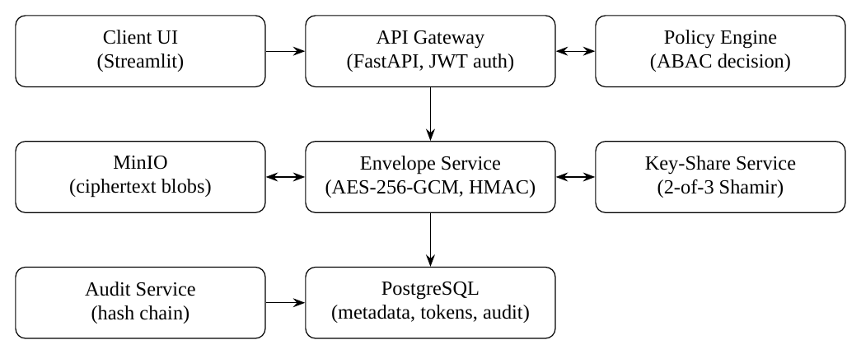
Figure 3.1: Overall CAS-SE System Architecture

3.3 Record Envelope
A record is stored as an envelope instead of a plain image or database row. An envelope contains: the encrypted payload, protected metadata tokens, the encrypted (wrapped) data key, a security label, a policy identifier, an integrity tag and an audit reference. For a palm-image record, the original image is encrypted; an HMAC-derived token represents the dataset or participant identifier; the quality score and class label are kept under controlled encryption; and a policy such as “a training worker may access the image only during an approved job window” is attached.

3.4 Cryptographic Methodology

3.4.1 Per-record authenticated encryption
For record payload P, a random DEK K_d (256 bits) and a unique random nonce N are generated and
(C, T) = AES-256-GCM(K_d, N, P)
where C is the ciphertext and T the authentication tag [2]. The nonce and tag are stored with the ciphertext. Any modification of C causes tag verification, and hence decryption, to fail. Reusing a nonce under the same key would break GCM’s guarantees, so a fresh nonce is generated for every encryption.

3.4.2 Protected equality tokens
For an equality-searchable field with value v, the stored token is
t = HMAC-SHA-256(K_h, normalize(v))
following the HMAC construction [3]. A search recomputes t from the query value and looks it up in the indexed column; the payload is not decrypted. Because t is deterministic, equal values yield equal tokens, which is necessary for search but reveals equality patterns. Tokens are therefore used only for approved low-sensitivity fields such as dataset identifiers or labels, and a token_version field supports rotation if K_h changes.

3.4.3 Threshold custody of the master key
The master (wrapping) key s that protects the DEKs is split with Shamir’s scheme with threshold k = 2 and n = 3 [1]. A random degree-one polynomial f(x) = s + a1·x over a prime field is chosen, and share i is (i, f(i)) for i = 1, 2, 3. Any two shares recover s by Lagrange interpolation; a single share carries no information about s. The three shares are held by the application service, the key custodian and the administrator (recovery share).

3.4.4 Key rotation
Because DEKs are small, a suspected master-key compromise is handled by generating a new wrapping key and re-wrapping the DEKs, without re-encrypting every payload.

3.4.5 Hash-chained audit
The i-th audit event e_i stores the hash of the previous event:
h_i = SHA-256(h_(i-1) || e_i)
Altering any earlier event changes its hash and breaks every later link, so verification detects the modification. This is a single-party tamper-evident log, not a distributed ledger.

3.5 Context-Aware Policy Model
For each request the policy engine receives the user identifier, role, declared purpose, dataset identifier, data classification, requested operation and fields, timestamp, network zone and ML job identifier. It returns one of four outcomes: deny, a masked view, a feature-only view, or a short-lived decryption authorisation for the specific record or field (Figure 3.2).
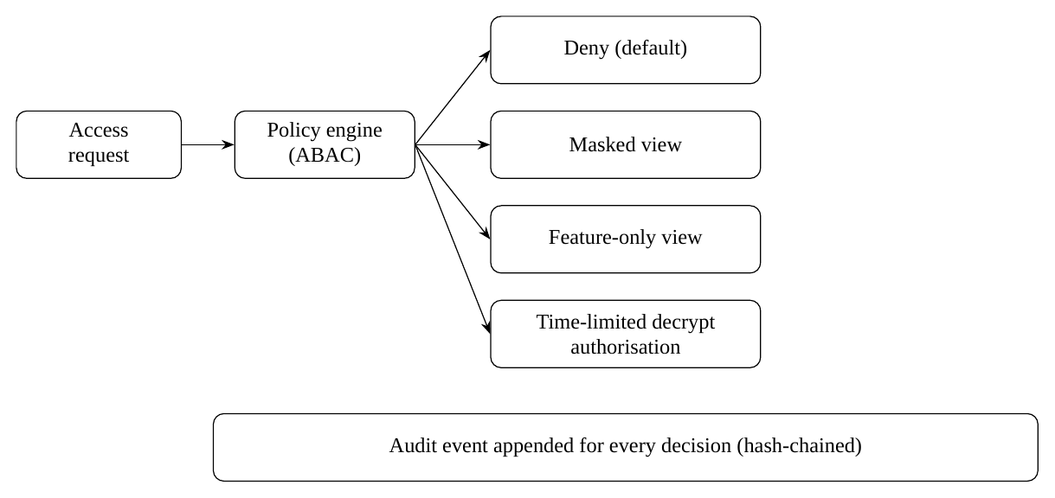
Figure 3.2: Access Decision Flow
The following example rules are used in the design:
- A trainer may request feature vectors for the purpose “training” only for an approved dataset and an active ML job; raw images additionally require researcher approval.
- A debugging request receives masked metadata and a low-resolution image and never receives subject identifiers.
- A request outside the job window is denied.
Table 3.1 lists the user types considered in the threat model.
Table 3.1: User Types in the Threat Model
Role | Intended access
Administrator | System administration; holder of the recovery key share
Data uploader | Uploads records for encryption and ingestion
ML trainer | Feature-only views for approved, active training jobs
Researcher | Raw access only after the required approval conditions are met
Auditor | Reads audit events and verifies the hash chain
Unauthorised user | No access; all requests denied

3.6 Evaluation Methodology
The prototype is compared against two baselines using the same dataset and workload: a plaintext baseline, and standard encrypted storage with RBAC. Table 3.2 lists the metrics.
Table 3.2: Evaluation Metrics and Measurement Method
Metric | How measured | Expected trend
Upload / encryption overhead | Average time to store 100, 500 and 1,000 records | Slower than plaintext
Search latency | Filter by tokenised field versus plaintext index | Indexed lookup, no payload decryption
Authorised access latency | Policy evaluation plus release; median and 95th percentile | Small added latency
Least-privilege coverage | Test cases across roles, purposes and fields | Less data released or more denials than RBAC-only
Key-compromise resilience | Simulate loss or compromise of one share | One share cannot decrypt; two recover
Integrity detection | Modify ciphertext or an audit row, then verify | Alteration detected
Model utility | Classifier accuracy on minimised features versus baseline | Utility retained

CHAPTER
4

4 System Design and Implementation

4.1 System Architecture
The implementation follows the architecture in Figure 3.1. The client interface authenticates users through the API gateway using JWTs. The gateway forwards every request to the policy engine and, if permitted, to the Envelope Service. Clients never query raw storage directly. The Envelope Service obtains the master key only by combining two key shares, stores ciphertext in MinIO and writes metadata, tokens and audit events to PostgreSQL.

4.2 Technology Stack
Table 4.1: Software Components
Area | Components
Language | Python 3.11+
Backend | FastAPI, Pydantic v2, SQLAlchemy 2.0
Cryptography | PyCryptodome (AES-256-GCM, HMAC-SHA-256, SHA-256); Shamir 2-of-3 simulation
Database | PostgreSQL 16
Object storage | MinIO (S3-compatible)
Machine learning | PyTorch and Torchvision (ResNet feature extraction), Scikit-Learn (Isolation Forest)
Interface and deployment | Streamlit, Docker Compose

4.3 Database Design
Table 4.2: Database Schema
Table | Key fields | Purpose
data_envelopes | envelope_id, object_uri, ciphertext_hash, encrypted_dek, nonce, tag, policy_id, sensitivity_label, created_at | Envelope metadata; no plaintext image or identity
protected_indexes | envelope_id, field_name, hmac_token, token_version | Equality lookup only
policies | policy_id, rule_json, version, approved_by, active_from, active_to | Versioned policies
access_audit | event_id, user_id, envelope_id, action, purpose, decision, timestamp, previous_hash, event_hash | Hash-chained audit
ml_jobs | job_id, dataset_scope, requester, status, approval_id, expires_at | Binds release to approved, time-limited jobs

4.4 API Design
Table 4.3: Demonstration API Endpoints
Endpoint | Function
POST /envelopes | Upload a record, encrypt it, create protected indexes, attach a policy and write an audit event
POST /search | Convert an approved filter value to its HMAC token and return only permitted metadata or envelope IDs
POST /access-request | Evaluate context and purpose; return deny, masked view, feature-only view or short-lived decrypt authorisation
POST /ml-jobs | Create an approved training job with dataset scope and expiry
GET /audit | Let auditors filter events and verify the hash chain
POST /keys/rotate | Demonstrate re-wrapping in a controlled admin-only test

4.5 Key-Share Simulation
For the academic demonstration, the 2-of-3 scheme is simulated with the application service share, the key service share and an administrator recovery share kept in separate environment variables or files and never committed to Git. The administrator share corresponds to a break-glass recovery procedure: it is controlled and audited, unlike a silent backdoor. In a production deployment, one share would be replaced by a managed KMS or HSM with strict IAM policies and audited recovery.

4.6 Data Minimisation Pipeline
When an approved training job requests data, the system does not release the raw image. A ResNet model implemented in PyTorch extracts a feature tensor from the decrypted image inside the service, and only that tensor is returned (“feature-only view”). For debugging requests, a masked preview is returned. Raw images are released only through the time-limited decryption authorisation after additional approval.

4.7 Audit Chain and Anomaly Detection
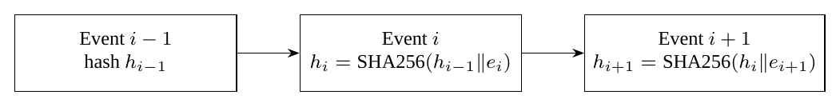
Figure 4.1: Hash-Chained Audit Log
Each event stores the request context, the policy result and the resource identifier, but no raw images or secrets. The auditor endpoint recomputes the chain; any inconsistency flags a modified row. In addition, an Isolation Forest model [11] is applied to access logs to flag unusual patterns such as spikes in off-hours access.

4.8 Integration with Existing Applications
CAS-SE is intended to be adopted as a separate internal service, not copied into an application’s source code. The existing backend calls it over private HTTPS for protected upload, search and access (Figure 4.2). The browser talks only to the company backend, which remains the public boundary. The application stores just an opaque cas_envelope_id in its business database and changes only its sensitive upload and download paths.
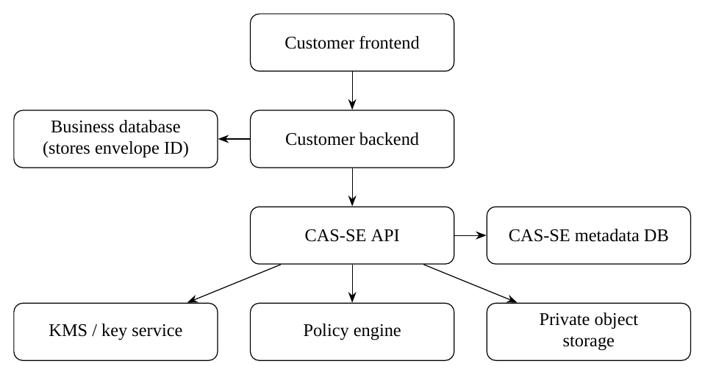
Figure 4.2: Integration Model for an Existing Application
Integration is done through adapters, so the adopting organisation connects its own identity provider, storage and KMS without editing CAS-SE route logic. Roles are resolved server-side and a caller can never submit an arbitrary role such as admin. If the policy engine fails or returns malformed output, access is denied and the event is audited. Recommended onboarding is incremental: deploy privately in staging, implement the adapters, add the envelope reference to domain records, test allowed access, denial, expiry, outage behaviour, rotation and audit verification, and migrate one tenant or data class first. This integration model is a deployment design for adopters; the prototype of this project uses the components listed in Table 4.1.

4.9 Implementation Workflow
- Literature review, requirement analysis, threat model and dataset selection.
- Schema definition, API contracts and cryptographic set-up.
- Implementation of the FastAPI service, MinIO storage, AES-GCM envelope and Shamir sharing.
- Latency benchmarking and classifier-accuracy evaluation.
- Documentation and final submission.
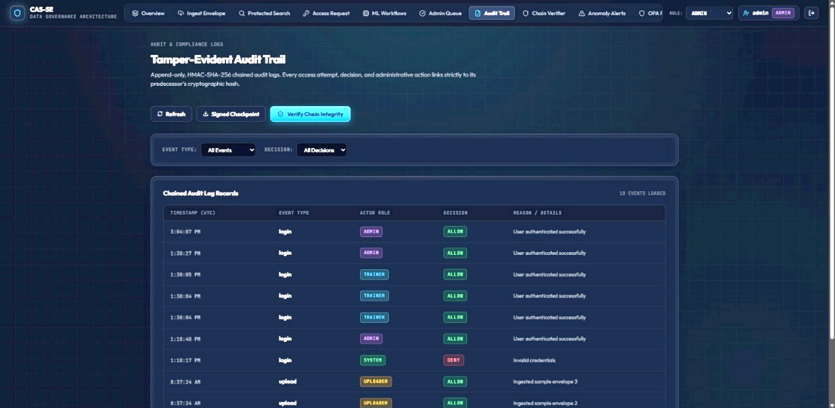
Figure 4.3: Prototype Screenshot (Upload and Access Request Interface)

CHAPTER
5

5 Results and Discussion

5.1 Experimental Setup
The experiments use a small, consented, anonymised or synthetic image dataset; the synopsis names a benchmark image dataset (such as CIFAR-10) or synthetic biometrics as candidates. No real biometric or personally identifiable data is used without approval and consent. The setup is summarised below.
- Dataset used and number of records: CIFAR-10 benchmark image dataset, using 1,000 records for the planned experiments.
- Hardware (CPU, RAM, OS): Intel Core i5 processor, 8 GB RAM, Windows 11 64-bit.
- Software versions: as in Table 4.1; exact patch versions: Python 3.13, PostgreSQL 16, Redis 7, Docker 27, and pytest 8.
- Workload sizes: 100, 500 and 1,000 records, as planned in Table 3.2

5.2 Functional Results
Table 5.1 lists the functional and security test cases and their status. The prototype demonstration showed the following behaviours: an approved request received only a feature tensor (“allowed, feature-tensor-only”); an unauthorised request was rejected with a policy-violation response (HTTP 403); a debugging request received a masked preview; manual database edits were flagged by hash chaining; and the Isolation Forest flagged off-hours access spikes.
Table 5.1: Functional and Security Test Cases
Test case | Expected outcome | Status
Trainer with approved ML job requests features | Feature-only view allowed | Demonstrated
Request without policy approval | Denied (403) | Demonstrated
Debug user requests data | Masked preview, no identity | Demonstrated
Audit row modified manually | Hash-chain verification flags it | Demonstrated
Off-hours access spike | Flagged by Isolation Forest | Demonstrated
Trainer requests raw image outside job window | Denied | [record]
Researcher requests raw image, approved study | Allowed after conditions; logged | [record]
Debug user requests direct identity metadata | Denied or redacted | [record]
Database dump without key shares | Ciphertext unreadable | [record]
One key-share service unavailable | Behaviour for available and unavailable threshold cases | [record]
Ciphertext modified | Decryption fails authentication | [record]

5.3 Performance and Utility Targets
The synopsis set three quantitative targets. Measured values must be taken from the benchmark runs described in Section 3.6.
Table 5.2: Project Targets and Measured Values
Metric | Target | Measured
Latency overhead versus plaintext system | Less than 15% | [value]
Detection of unauthorised modification | 100% | [value]
ML accuracy retained with minimised features | At least 90% of baseline | [value]

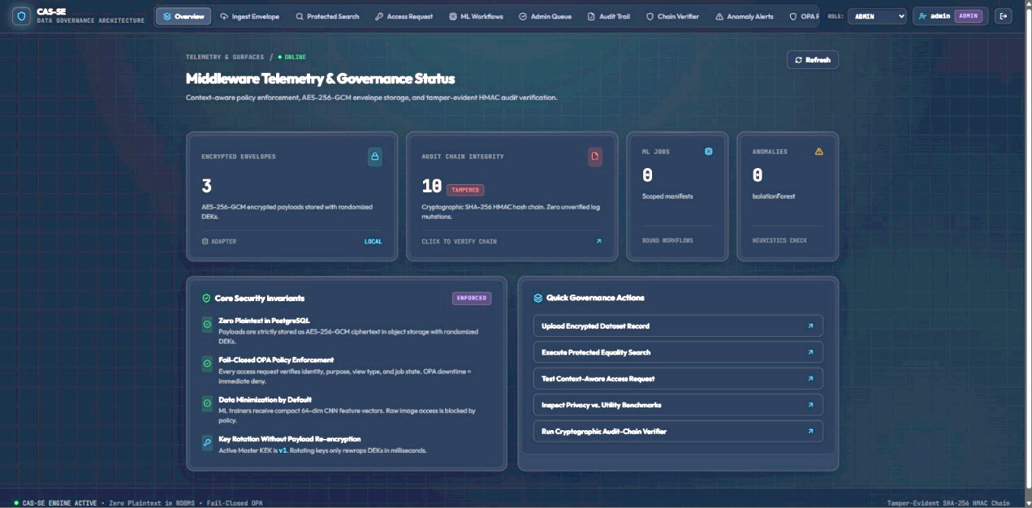
Figure 5.1: Benchmark Results: Plaintext, Encrypted-RBAC and CAS-SE

5.4 Security Analysis
Table 5.3: Threats and CAS-SE Controls
Threat | CAS-SE control | Residual trade-off
Stolen database or object store | Per-record AES-GCM; keys need two shares | Availability depends on shares
Over-privileged valid account | Purpose and job checks; minimised views | Policies need careful testing
Single key service compromised | 2-of-3 threshold custody | More services to operate
Altered records or logs | GCM tag; hash-chained audit | Not independent log storage
Search-token analysis | Tokens only for approved fields; versioned | Equality leakage remains

5.5 Discussion
The design shifts the question from “is the data encrypted?” to “should this request, for this purpose and at this time, receive this view?”. Feature-only release lets training proceed without exposing raw images, which addresses the conflict between privacy and utility seen with permanent masking. Equality tokens preserve indexed search without storing plaintext values, at the cost of revealing equality patterns, so they are limited to approved fields. Threshold custody means that one compromised component cannot decrypt data, while the loss of two shares makes data unrecoverable, an availability trade-off. The hash chain makes edits evident but does not replace independent log storage.
Added policy evaluation, key reconstruction and cryptography will add latency compared with plaintext; the evaluation therefore reports the overhead against the 15% target rather than assuming it is negligible.

5.6 Limitations
- The system does not prevent misuse after lawful release, such as a screenshot of an authorised view.
- HMAC equality tokens leak equality and frequency patterns; they must not be used for high-entropy secrets, and wildcard queries are unsupported.
- If the HMAC key is compromised, tokens become guessable, which is why token versioning and rotation exist.
- Key custody is simulated; production use needs a KMS or HSM.
- Ransomware protection is not a goal; backups remain necessary.
- More services and recovery procedures make operation more complex, and incorrect policies can cause false denials.
- A formal independent security review has not been performed.
CHAPTER
6

6 Conclusion and Future Scope

6.1 Conclusion
This project presented CAS-SE, a layered architecture that combines per-record AES-256-GCM encryption, HMAC-based protected equality search, 2-of-3 Shamir key custody, context-aware policy decisions with minimised views, and a hash-chained audit log. It targets four specific risks: over-privileged access, single-component key exposure, unnecessary release of raw data, and loss of searchable metadata. The prototype demonstrated feature-only and masked releases, policy denial, tamper-evident auditing and access-anomaly flagging.
The claim made is deliberately limited: CAS-SE does not solve all data-security problems or introduce new cryptography; it shows that established primitives can be orchestrated into a usable gatekeeper with documented trade-offs. Achievement of the quantitative targets in Table 5.2 is to be stated from the measured results.

6.2 Future Scope
- Hardware Security Module or managed KMS integration to replace a simulated share.
- Leakage analysis of searchable-encryption tokens.
- Confidential computing for the training environment.
- A stronger policy language, with Open Policy Agent as an option.
- Encrypted vector search.
- Formal security review and independent audit-log storage.
- Adapters and client SDKs for adopting organisations.

REFERENCES
[1] A. Shamir, “How to share a secret,” Commun. ACM, vol. 22, no. 11, pp. 612–613, 1979.
[2] M. Dworkin, “Recommendation for block cipher modes of operation: Galois/Counter Mode (GCM) and
GMAC,” NIST Special Publication 800-38D, 2007.
[3] H. Krawczyk, M. Bellare and R. Canetti, “HMAC: Keyed-hashing for message authentication,” RFC 2104,
1997.
[4] D. X. Song, D. Wagner and A. Perrig, “Practical techniques for searches on encrypted data,” in Proc. IEEE
Symp. Security and Privacy, 2000, pp. 44–55.
[5] R. Curtmola, J. Garay, S. Kamara and R. Ostrovsky, “Searchable symmetric encryption: Improved definitions
and efficient constructions,” in Proc. ACM CCS, 2006, pp. 79–88.
[6] B. Sun, S. Zhao and G. Tian, “SQL queries over encrypted databases: a survey,” Connection Science, vol. 36,
no. 1, p. 2323059, 2024. https://doi.org/10.1080/09540091.2024.2323059
[7] M. Naveed, S. Kamara and C. V. Wright, “Inference attacks on property-preserving encrypted databases,” in
Proc. ACM CCS, 2015, pp. 644–655.
[8] R. S. Sandhu, E. J. Coyne, H. L. Feinstein and C. E. Youman, “Role-based access control models,” IEEE
Computer, vol. 29, no. 2, pp. 38–47, 1996.
[9] V. C. Hu et al., “Guide to attribute based access control (ABAC) definition and considerations,” NIST Special
Publication 800-162, 2014.

[10] B. Schneier and J. Kelsey, “Secure audit logs to support computer forensics,” ACM Trans. Inf. Syst. Secur.,
vol. 2, no. 2, pp. 159–176, 1999.
[11] F. T. Liu, K. M. Ting and Z.-H. Zhou, “Isolation forest,” in Proc. IEEE Int. Conf. Data Mining (ICDM), 2008,
pp. 413–422.
[12] C. Hong, “Recent advances of privacy-preserving machine learning based on (Fully) Homomorphic
Encryption,” Security and Safety, vol. 4, p. 2024012, 2025. https://doi.org/10.1051/sands/2024012
[13] D. Rathee et al., “CrypTFlow2: Practical 2-party secure inference,” in Proc. ACM CCS, 2020.
[14] B. Knott et al., “CrypTen: Secure multi-party computation meets machine learning,” in Advances in Neural
Information Processing Systems (NeurIPS), 2021.
[15] T. Li, A. K. Sahu, A. Talwalkar and V. Smith, “Federated learning: Challenges, methods, and future
directions,” IEEE Signal Process. Mag., vol. 37, no. 3, pp. 50–60, 2020.
[16] P. Kairouz et al., “Advances and open problems in federated learning,” Found. Trends Mach. Learn., vol. 14,
no. 1–2, pp. 1–210, 2021.
[17] S. Sav et al., “POSEIDON: Privacy-preserving federated neural network learning,” in Proc. Network and
Distributed System Security Symp. (NDSS), 2021.
[18] Y. Matsubara, M. Levorato and F. Restuccia, “Split computing and early exiting for deep learning applications:
Survey and research challenges,” ACM Comput. Surv., vol. 55, no. 5, 2022.
[19] C. Thapa, M. A. P. Chamikara, S. Camtepe and L. Sun, “SplitFed: When federated learning meets split
learning,” in Proc. AAAI Conf. Artificial Intelligence, vol. 36, no. 8, 2022, pp. 8485–8493.
[20] S. Mohanarajah, P. Valente, A. Medina and T. Sritharan, “Privacy-Preserving Machine Learning Algorithms: A
Survey,” Asian Journal of Probability and Statistics, vol. 27, no. 12, pp. 126–138, 2025.
https://doi.org/10.9734/ajpas/2025/v27i12847
[21] E. Barker, “Recommendation for key management: Part 1 – General,” NIST Special Publication 800-57 Part 1
Rev. 5, 2020.
[22] L. Sweeney, “k-anonymity: A model for protecting privacy,” Int. J. Uncertainty, Fuzziness and Knowledge-
Based Systems, vol. 10, no. 5, pp. 557–570, 2002.
[23] European Parliament and Council, “Regulation (EU) 2016/679 (General Data Protection Regulation),” 2016.
[24] Government of India, “The Digital Personal Data Protection Act, 2023,” 2023.

Approved by:
Guide | Associate Head | Dean SoCSE
Prof. Sonam Meshram | (Name and Signature) | Dr. Padma Adane

ANNEXURE A: PUBLICATIONS AND INTELLECTUAL PROPERTY
Documentary evidence of project-related publications and intellectual property is listed below, with status stated as Published, Accepted, Submitted, Under Review, Filed, Registered or Granted.

Type | Title / Description | Status
Research paper | No publications or intellectual property filings to report as of the submission date. | NA
Patent / design | No publications or intellectual property filings to report as of the submission date. | NA

ANNEXURE B: STUDENT CONTRIBUTION STATEMENT
Table 6.1: Student Contribution Statement
Student Name | Roll No. | Contribution
Nikhil Singh | 37 | Conceptualization, problem definition, architecture ideation, and initial research guidance
Soham Kharabe | 23 | Project Monitoring, overall system documentation, report compilation, and integration oversight
Karunya Paliwal | 14 | Development of working prototype, backend APIs, cryptographic envelope flow, user manual, and API documentation
Gaurang Daware | 17 | Threat modeling, security requirements analysis, and system boundary definition
Prajwal Khandekar | 26 | Benchmark testing, performance comparison report (plaintext vs. RBAC vs. CAS-SE), and latency evaluation

ANNEXURE C: PROJECT OUTPUTS
Planned deliverables of the project:
- Containerised working prototype (encrypted upload, protected search, context-based authorisation, masked and feature-only responses, audit log, one ML-job flow)
- Threat model and security requirements document
- Benchmark report comparing plaintext, encrypted-RBAC and CAS-SE
- Test report with negative authorisation, tamper and one-share compromise tests
- User manual, API documentation and demonstration video
- Project repository: https://github.com/paliwalkarunya-collab/CAS

