MACHINE LEARNING LAB – 4
Decision Tree Classification
Lab No.: 4
Name of Student: Karunya Paliwal
Section: C
Roll No.: 14
Batch Number: c1
Lab Aim: To implement the Decision Tree Classification algorithm on a suitable dataset.
Objective: To inspect and prepare the wine quality dataset, build a Decision Tree Classifier, evaluate its classification performance, tune its hyperparameters, and analyze the model using feature importance, cross-validation, learning curves, validation curves, a normalized confusion matrix, and ROC-AUC.
Dataset / Resources Used: WineQT.csv dataset; Python/Jupyter Notebook; Pandas, NumPy, Matplotlib, Seaborn and Scikit-learn.

1. Theory
Decision Tree Classification is a supervised machine learning technique that predicts a categorical target by recursively splitting the data according to feature-based decision rules. Each internal node represents a test on a feature, each branch represents an outcome of the test, and each leaf represents a predicted class.
In this experiment, the WineQT dataset is used to predict the wine quality class from physicochemical properties such as acidity, sulphates, alcohol, pH and sulfur dioxide. The DecisionTreeClassifier is configured with the entropy criterion in the notebook.
The dataset is divided into training and testing sets using train_test_split with a test size of 20%, random_state 42 and stratification on the target. Model performance is evaluated using accuracy, precision, recall and F1-score.
The notebook also investigates the effect of tree depth, feature importance and overfitting. GridSearchCV is used to tune the Decision Tree hyperparameters. Cross-validation, learning and validation curves, a normalized confusion matrix and ROC-AUC are used for additional model analysis.

2. Materials / Software Used
- Python 3.x and Jupyter Notebook
- WineQT.csv dataset
- Pandas and NumPy for data handling
- Matplotlib and Seaborn for visualization
- Scikit-learn for train/test split, Decision Tree, metrics, GridSearchCV and cross-validation
- Computer system with Python/Jupyter environment

3. Procedure
1. Import the required libraries for data handling, visualization, model building and evaluation.
2. Load WineQT.csv into a Pandas DataFrame.
3. Inspect the first and last records, shape, information and descriptive statistics.
4. Check for missing values and duplicate records.
5. Visualize feature distributions, boxplots, class distribution and relationships among variables.
6. Use the interquartile range (IQR) to inspect selected feature ranges and possible outliers.
7. Create X by removing quality and use quality as the target y.
8. Split the data into training and testing sets with stratification.
9. Train an original Decision Tree using entropy and evaluate its classification performance.
10. Compare different maximum depths to study model complexity.
11. Visualize the decision tree and calculate feature importance.
12. Compare training and testing accuracy to identify possible overfitting.
13. Use GridSearchCV to find suitable Decision Tree hyperparameters.
14. Evaluate the tuned tree using classification metrics and accuracy.
15. Perform 5-fold cross-validation and analyze learning and validation curves.
16. Plot the normalized confusion matrix and calculate ROC-AUC for Class 6.

4. Code and Output
The code below is taken from the uploaded Lab 4 notebook. Each code section is followed immediately by the output produced by that code. Cells that produced no displayed output are not included.
df.head()
# Output
fixed acidity volatile acidity citric acid residual sugar chlorides \
0 7.4 0.70 0.00 1.9 0.076
1 7.8 0.88 0.00 2.6 0.098
2 7.8 0.76 0.04 2.3 0.092
3 11.2 0.28 0.56 1.9 0.075
4 7.4 0.70 0.00 1.9 0.076
free sulfur dioxide total sulfur dioxide density pH sulphates \
0 11.0 34.0 0.9978 3.51 0.56
1 25.0 67.0 0.9968 3.20 0.68
2 15.0 54.0 0.9970 3.26 0.65
3 17.0 60.0 0.9980 3.16 0.58
4 11.0 34.0 0.9978 3.51 0.56
alcohol quality Id
0 9.4 5 0
1 9.8 5 1
2 9.8 5 2
3 9.8 6 3
4 9.4 5 4

Output Description
The first five rows confirm that WineQT.csv has been loaded successfully.
The dataset contains physicochemical measurements of wine samples.
The quality column is the target used for classification.
The Id column is also present in the original dataset.
This output provides the initial view of the data before analysis.
df.tail()
# Output
fixed acidity volatile acidity citric acid residual sugar chlorides \
1138 6.3 0.510 0.13 2.3 0.076
1139 6.8 0.620 0.08 1.9 0.068
1140 6.2 0.600 0.08 2.0 0.090
1141 5.9 0.550 0.10 2.2 0.062
1142 5.9 0.645 0.12 2.0 0.075
free sulfur dioxide total sulfur dioxide density pH sulphates \
1138 29.0 40.0 0.99574 3.42 0.75
1139 28.0 38.0 0.99651 3.42 0.82
1140 32.0 44.0 0.99490 3.45 0.58
1141 39.0 51.0 0.99512 3.52 0.76
1142 32.0 44.0 0.99547 3.57 0.71
alcohol quality Id
1138 11.0 6 1592
1139 9.5 6 1593
1140 10.5 5 1594
1141 11.2 6 1595
1142 10.2 5 1597

Output Description
The last five rows show the final records of the dataset.
The same feature columns and quality target are present at the end of the DataFrame.
The output confirms that the complete dataset was read into Pandas.
The quality values include multiple wine-quality classes.
This inspection helps verify the dataset before preprocessing and modeling.
df.shape
# Output
(1143, 13)

Output Description
The shape of the dataset is 1143 rows and 13 columns.
There are 1143 wine samples available for the experiment.
The 13 columns include 11 floating-point features and two integer columns.
The target quality is included among these columns.
This gives the overall size of the classification dataset.
df.info()
# Output
<class 'pandas.core.frame.DataFrame'>
RangeIndex: 1143 entries, 0 to 1142
Data columns (total 13 columns):
# Column Non-Null Count Dtype
--- ------ -------------- -----
0 fixed acidity 1143 non-null float64
1 volatile acidity 1143 non-null float64
2 citric acid 1143 non-null float64
3 residual sugar 1143 non-null float64
4 chlorides 1143 non-null float64
5 free sulfur dioxide 1143 non-null float64
6 total sulfur dioxide 1143 non-null float64
7 density 1143 non-null float64
8 pH 1143 non-null float64
9 sulphates 1143 non-null float64
10 alcohol 1143 non-null float64
11 quality 1143 non-null int64
12 Id 1143 non-null int64
dtypes: float64(11), int64(2)
memory usage: 116.2 KB

Output Description
The info output shows 1143 entries and 13 columns.
Every column has 1143 non-null values, so no missing values are present.
Eleven columns are float64 and two are int64.
The memory usage reported for the DataFrame is about 116.2 KB.
This confirms that the dataset is structurally ready for the next checks.
df.describe()
# Output
fixed acidity volatile acidity citric acid residual sugar \
count 1143.000000 1143.000000 1143.000000 1143.000000
mean 8.311111 0.531339 0.268364 2.532152
std 1.747595 0.179633 0.196686 1.355917
min 4.600000 0.120000 0.000000 0.900000
25% 7.100000 0.392500 0.090000 1.900000
50% 7.900000 0.520000 0.250000 2.200000
75% 9.100000 0.640000 0.420000 2.600000
max 15.900000 1.580000 1.000000 15.500000
chlorides free sulfur dioxide total sulfur dioxide density \
count 1143.000000 1143.000000 1143.000000 1143.000000
mean 0.086933 15.615486 45.914698 0.996730
std 0.047267 10.250486 32.782130 0.001925
min 0.012000 1.000000 6.000000 0.990070
25% 0.070000 7.000000 21.000000 0.995570
50% 0.079000 13.000000 37.000000 0.996680
75% 0.090000 21.000000 61.000000 0.997845
max 0.611000 68.000000 289.000000 1.003690
pH sulphates alcohol quality Id
count 1143.000000 1143.000000 1143.000000 1143.000000 1143.000000
mean 3.311015 0.657708 10.442111 5.657043 804.969379
std 0.156664 0.170399 1.082196 0.805824 463.997116
min 2.740000 0.330000 8.400000 3.000000 0.000000
25% 3.205000 0.550000 9.500000 5.000000 411.000000
50% 3.310000 0.620000 10.200000 6.000000 794.000000
75% 3.400000 0.730000 11.100000 6.000000 1209.500000
max 4.010000 2.000000 14.900000 8.000000 1597.000000

Output Description
The descriptive statistics summarize the central tendency and spread of the numeric features.
For example, fixed acidity has a mean of about 8.31.
The quality variable ranges across several integer classes.
The statistics also show minimum, quartile, median, maximum and standard deviation values.
These values help understand feature scales before classification.
df.isnull().sum()
# Output
fixed acidity 0
volatile acidity 0
citric acid 0
residual sugar 0
chlorides 0
free sulfur dioxide 0
total sulfur dioxide 0
density 0
pH 0
sulphates 0
alcohol 0
quality 0
Id 0
dtype: int64

Output Description
The missing-value check returns zero for every column.
Therefore, the uploaded WineQT dataset contains no missing observations.
No missing-value imputation is required for this experiment.
This simplifies the preprocessing stage before training the classifier.
The clean result allows the model-building steps to proceed.
df.hist(figsize=(12,8))
plt.show
# Output
<function matplotlib.pyplot.show(close=None, block=None)>
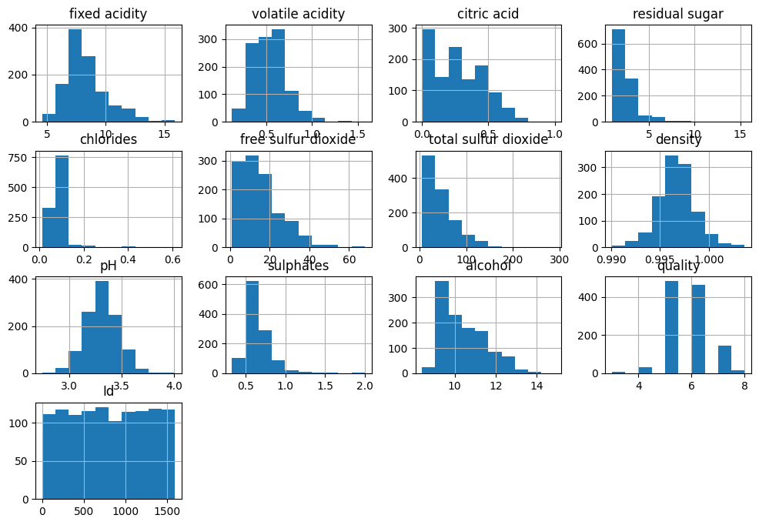

Output Description
The histogram grid shows the distributions of the numerical variables.
Different wine properties have different ranges and distribution shapes.
The plots help identify skewness and unusual concentration of observations.
The quality distribution can also be visually inspected among the variables.
This exploratory analysis is useful before selecting and training the classifier.
sns.boxplot(x=df["fixed acidity"])
plt.show()
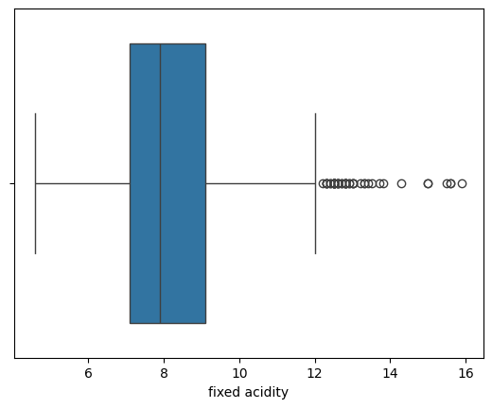

Output Description
The boxplot displays the distribution of fixed acidity.
The median and interquartile range are visible inside the box.
Points beyond the whiskers indicate observations that may be potential outliers.
The plot helps assess the spread of this feature before classification.
It is part of the notebook's exploratory data analysis.
sns.boxplot(x=df["volatile acidity"])
plt.show()
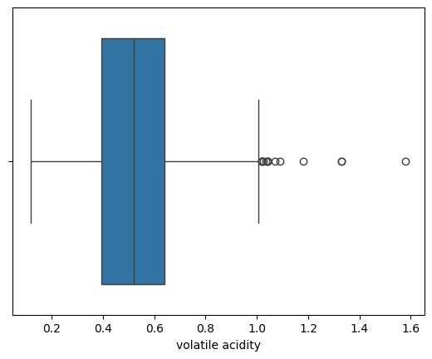

Output Description
The boxplot displays the distribution of volatile acidity.
The box and whiskers show the central spread of the feature.
Potential extreme observations can be identified beyond the whiskers.
Volatile acidity is one of the input features used by the classifier.
The visualization helps understand the feature before modeling.
sns.boxplot(x=df["citric acid"])
plt.show()
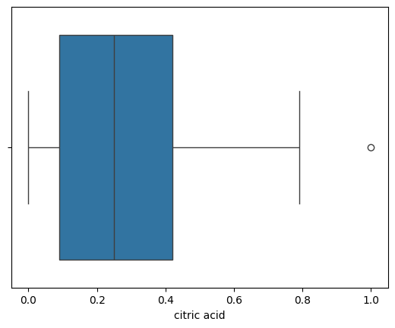

Output Description
The citric acid boxplot summarizes the central distribution of the feature.
The median and interquartile range are shown by the box.
The whiskers and individual points indicate the spread and possible extreme values.
Citric acid is retained as an input feature for the decision tree.
This plot supports the exploratory analysis of the wine data.
sns.boxplot(x=df["quality"])
plt.show()
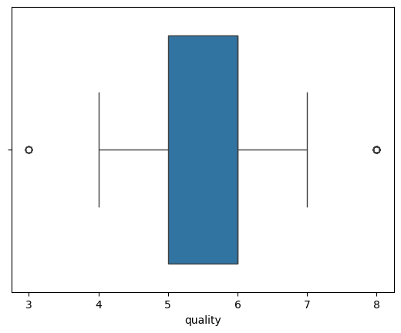

Output Description
The quality boxplot shows the distribution of the target classes.
It provides a compact view of the class values and their spread.
The target is discrete, so the boxplot is mainly useful for visual inspection.
The classification task uses these quality values as the target variable.
This output helps understand the target before model training.
index=0
labels=df['quality']
features=df.drop('quality',axis=1)
for col in features.items():
plt.figure(figsize=(10,5))
sns.barplot(x=labels,y=col[index],data=df,color="red")
plt.tight_layout()
plt.show()
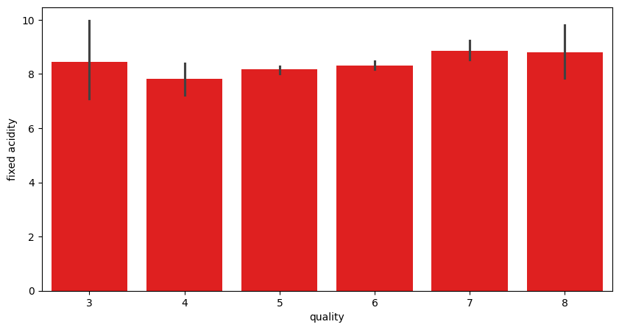
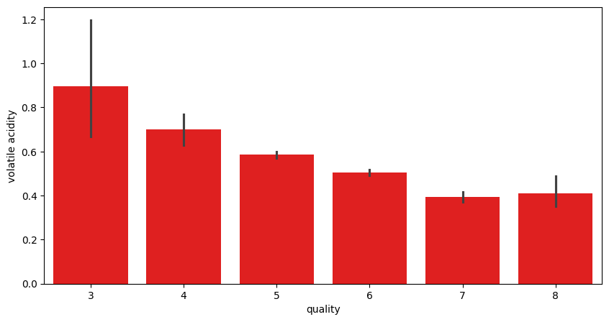
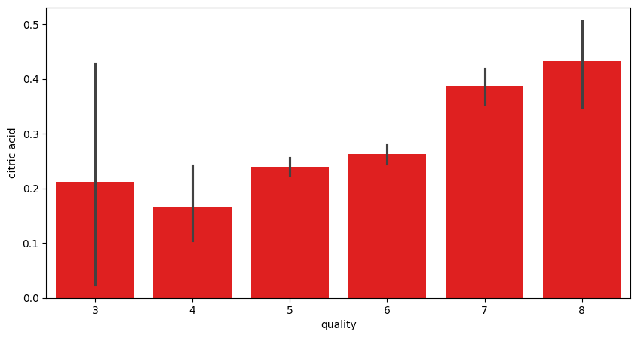
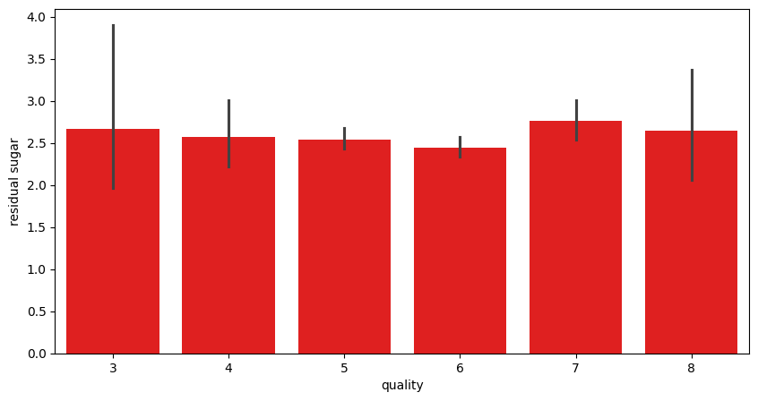
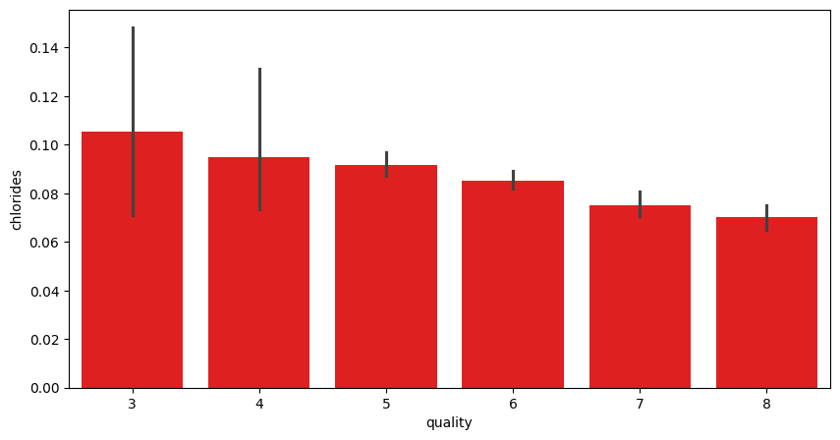
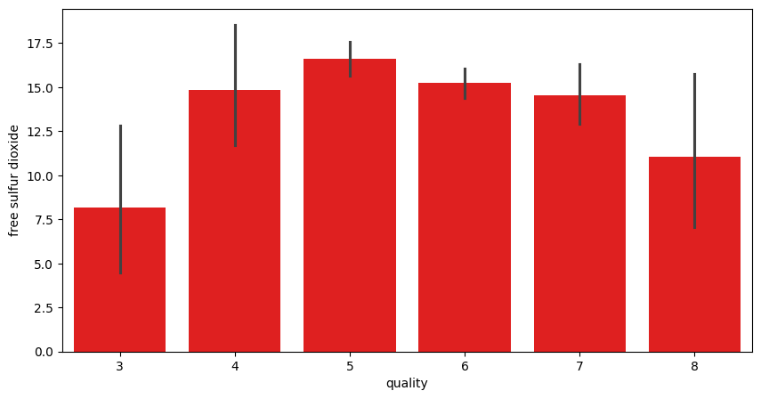
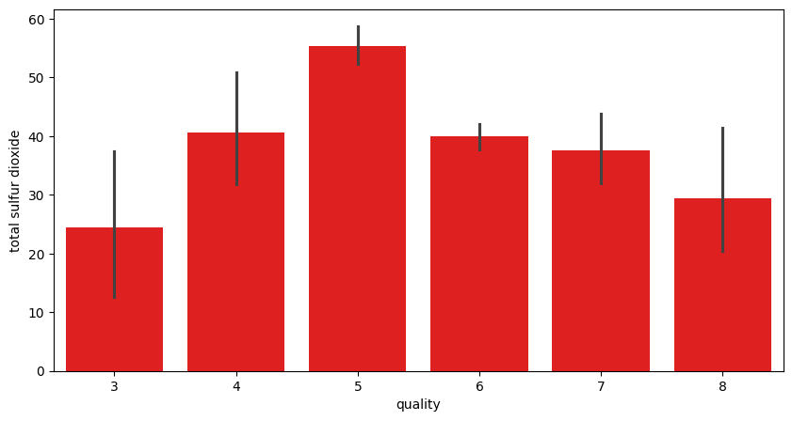
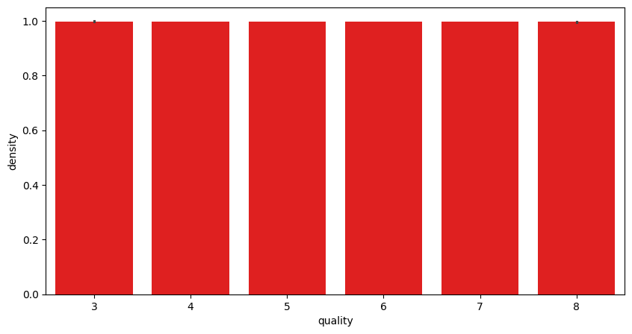
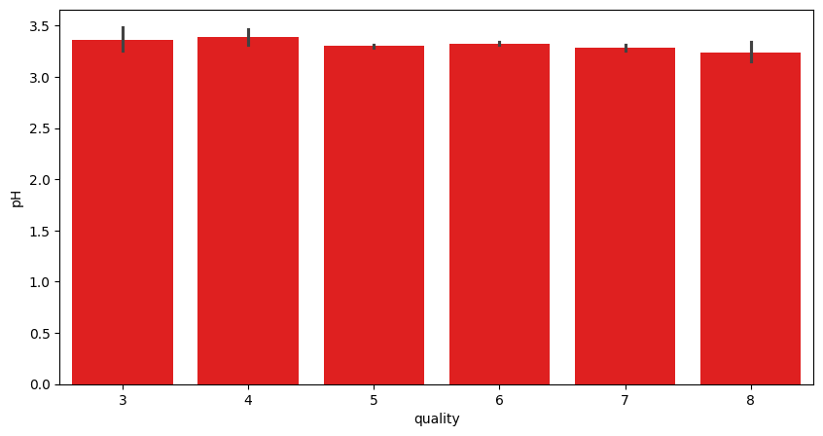
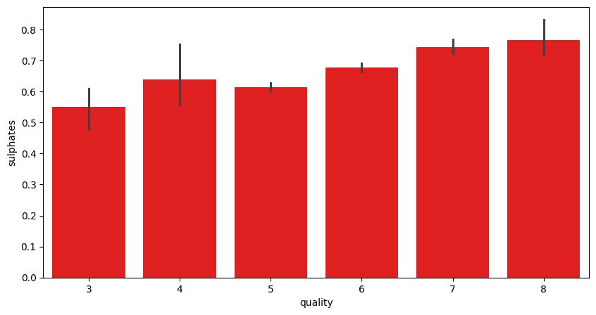
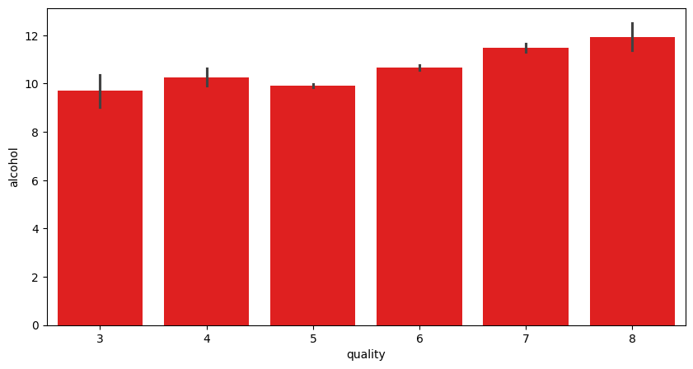
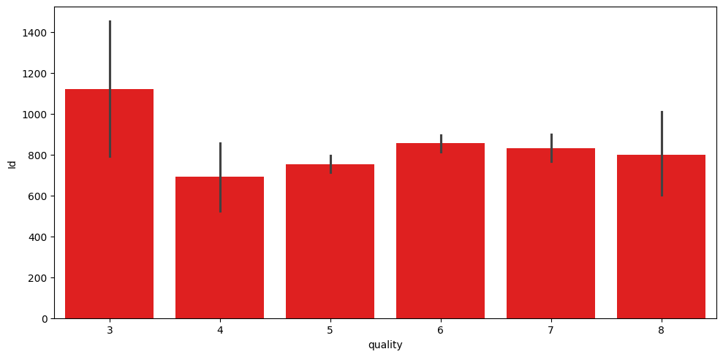

Output Description
The generated barplots compare the target quality with each feature in the loop.
They provide visual comparisons between wine quality and individual input attributes.
The plots help identify whether feature values differ across quality classes.
The notebook produces multiple figures because the loop processes each feature separately.
Together, these plots provide a broad exploratory view of the feature-target relationships.
df.duplicated().sum()
# Output
np.int64(0)

Output Description
The duplicate-record check returns zero.
This means no duplicated rows were detected in the dataset.
Therefore, no duplicate removal was necessary before training.
Removing duplicates can otherwise prevent repeated observations from influencing a classifier.
The clean result supports continuing with the existing records.
sns.countplot(x="density", hue="quality", data=df)
plt.show()
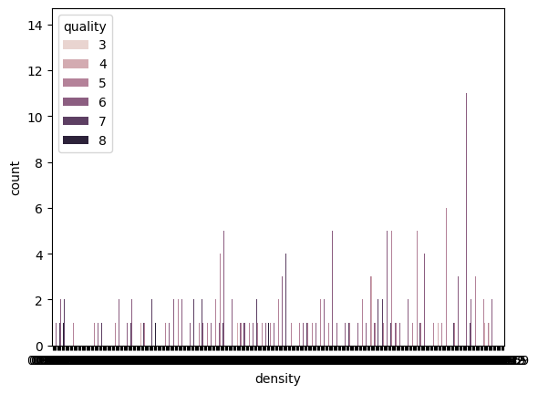

Output Description
The count plot compares density-related observations across quality classes.
The hue represents the different quality categories.
This visualization shows how the target classes are distributed with respect to density values.
It helps identify whether class patterns are visible in the dataset.
The plot is part of the exploratory analysis before classification.
sns.countplot(x='quality',data=df)
plt.xlabel('Quality')
plt.ylabel('Count')
plt.show()
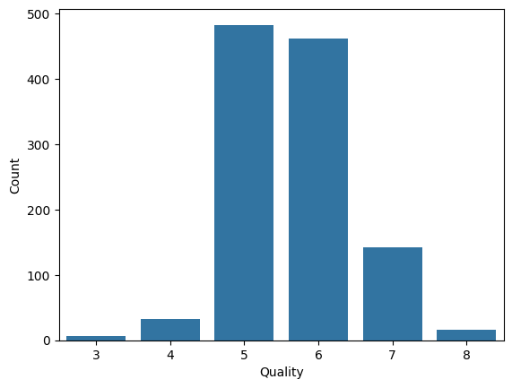

Output Description
The quality count plot displays the number of observations in each wine-quality class.
It shows that the classes are not equally represented.
The larger classes contribute more observations to the training and testing sets.
The imbalance helps explain why some classes may have weaker recall or precision.
This is important when interpreting the final classification report.
sns.barplot(x=df["quality"])
plt.show()
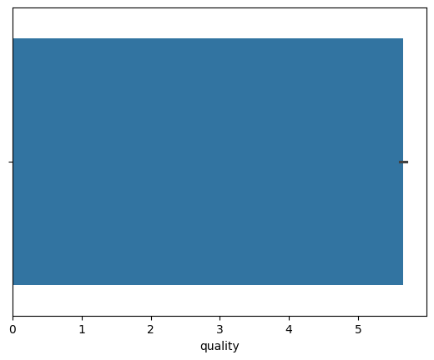

Output Description
This barplot gives another visual representation of the quality variable.
The x-axis contains the observed quality values in the dataset.
It provides a simple view of the target distribution.
The result complements the quality count plot shown earlier.
Understanding the target distribution is important before classification.
sns.barplot(x=df["quality"], y=df["alcohol"])
plt.show()
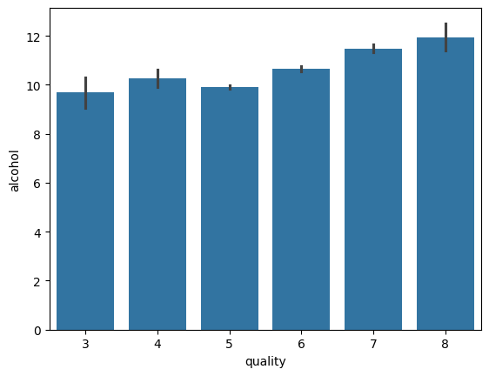

Output Description
The barplot compares quality with alcohol values.
It visually explores how alcohol measurements vary across the quality target.
The relationship helps identify whether alcohol may be useful for predicting quality.
The plot is part of the feature-target exploratory analysis.
The information is later reflected in the model's feature importance.
sns.boxplot(x=df["quality"], y=df["alcohol"])
plt.show()
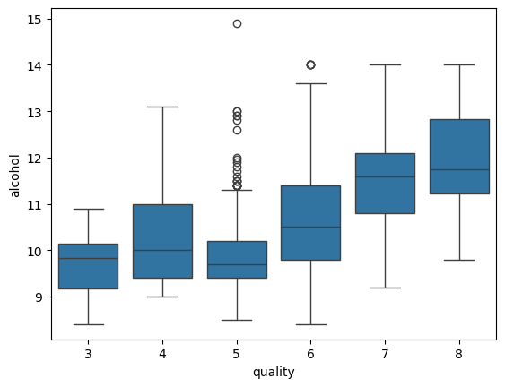

Output Description
The boxplot compares alcohol values across wine-quality classes.
The distribution and spread of alcohol can be compared between target categories.
Differences between classes indicate that alcohol may carry predictive information.
The plot also makes unusually high or low observations easier to notice.
This exploratory result supports using alcohol as a model feature.
fig ,ax=plt.subplots(ncols=6,nrows=3,figsize=(15,10))
index=0
ax=ax.flatten()
for col,value in df.items():
sns.boxplot(y=col,data=df,ax=ax[index])
index+=1
plt.tight_layout(pad=0.4,w_pad=0.5,h_pad=5.0)
plt.show()
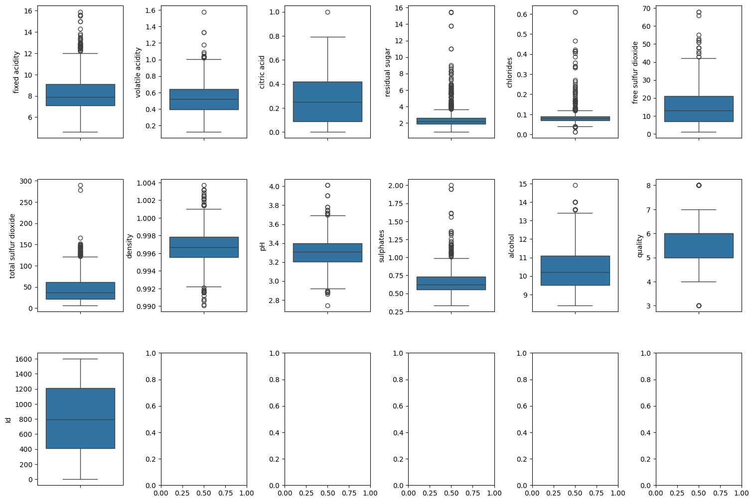

Output Description
The figure displays boxplots for the numerical columns in the dataset.
Each subplot summarizes the distribution and possible outliers of one feature.
Using multiple boxplots makes it easier to compare feature spreads.
The visualization highlights that the wine variables have different scales and distributions.
These observations are useful during exploratory data analysis.
sns.barplot(x=df["alcohol"])
plt.show()
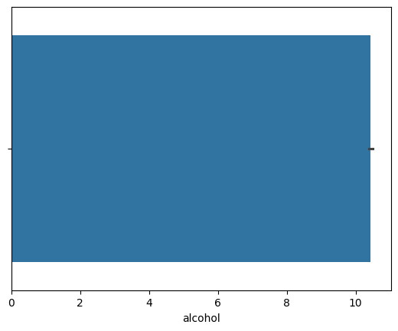

Output Description
The barplot displays the alcohol feature values used in the dataset.
It provides a direct visual view of the distribution of alcohol observations.
Alcohol is later identified as an important feature in the trained decision tree.
The plot therefore provides context for the model's feature-importance result.
It is included as part of the notebook's exploratory visualizations.
sns.barplot(x=df["pH"], y=df["alcohol"])
plt.show()
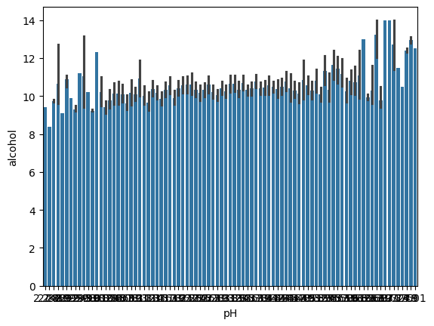

Output Description
The plot compares pH values with alcohol measurements.
It is used to visually inspect the relationship between these two physicochemical variables.
The scatter or bar representation helps identify general patterns in the observations.
Both variables are available as input features for the classifier.
This visualization contributes to understanding the feature relationships.
Q1_alcohol = df['alcohol'].quantile(0.25)
Q3_alcohol = df['alcohol'].quantile(0.75)
IQR_alcohol = Q3_alcohol - Q1_alcohol
print(f"IQR for alcohol: {IQR_alcohol}")
# Output
IQR for alcohol: 1.5999999999999996

Output Description
The IQR for alcohol is reported as approximately 1.60.
IQR is calculated as the third quartile minus the first quartile.
It represents the spread of the middle 50 percent of alcohol observations.
The value is used to understand the distribution and possible outlier range.
This is part of the notebook's outlier analysis.
Q1_chlorides = df['chlorides'].quantile(0.25)
Q3_chlorides = df['chlorides'].quantile(0.75)
IQR_chlorides = Q3_chlorides - Q1_chlorides
print(f"IQR for chlorides: {IQR_chlorides}")
# Output
IQR for chlorides: 0.01999999999999999

Output Description
The IQR for chlorides is reported as approximately 0.02.
The small IQR indicates that the middle half of chloride observations are relatively close together.
IQR is useful for identifying potential outliers using the 1.5×IQR rule.
The calculation provides a numerical summary of chloride variability.
This supports the exploratory preprocessing analysis.
Q1_sulphates = df['sulphates'].quantile(0.25)
Q3_sulphates = df['sulphates'].quantile(0.75)
IQR_sulphates = Q3_sulphates - Q1_sulphates
print(f"IQR for sulphates: {IQR_sulphates}")
# Output
IQR for sulphates: 0.16999999999999993

Output Description
The IQR for sulphates is reported as approximately 0.17.
This value represents the spread of the middle 50 percent of sulphate observations.
The IQR method provides a simple way to inspect potential extreme values.
Sulphates are also used as a feature by the Decision Tree classifier.
The calculation complements the earlier boxplot analysis.
sns.scatterplot(x="citric acid",y="quality",data=df)
sns.scatterplot(x="residual sugar",y="quality",data=df)
sns.scatterplot(x="chlorides",y="quality",data=df)
sns.scatterplot(x="free sulfur dioxide",y="quality",data=df)
sns.scatterplot(x="total sulfur dioxide",y="quality",data=df)
sns.scatterplot(x="alcohol",y="quality",data=df)
sns.scatterplot(x="density",y="quality",data=df)
sns.scatterplot(x="pH",y="quality",data=df)
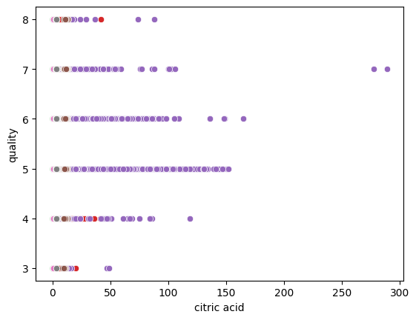

Output Description
The scatterplot output compares selected physicochemical features with wine quality.
Several feature-versus-quality relationships are plotted on the same figure.
The visualization helps inspect whether changes in these features correspond to different quality values.
It provides an intuitive view of possible predictive relationships.
These observations support the subsequent classification stage.
sns.distplot(df["quality"])
sns.distplot(df["pH"])
sns.distplot(df["alcohol"])
sns.distplot(df["residual sugar"])
sns.distplot(df["chlorides"])
sns.distplot(df["free sulfur dioxide"])
sns.distplot(df["total sulfur dioxide"])
sns.distplot(df["density"])
plt.show()
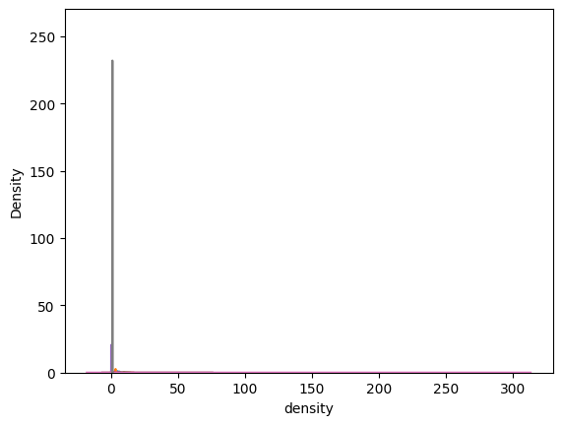

Output Description
The distribution plots show the shapes of quality, pH, alcohol and other selected features.
The variables have noticeably different ranges and distribution patterns.
Such plots are useful for understanding skewness and concentration of values.
They also provide additional exploratory evidence before modeling.
The output is part of the notebook's data analysis stage.
plt.figure(figsize=(15,7))
sns.heatmap(df.corr(), annot=True)
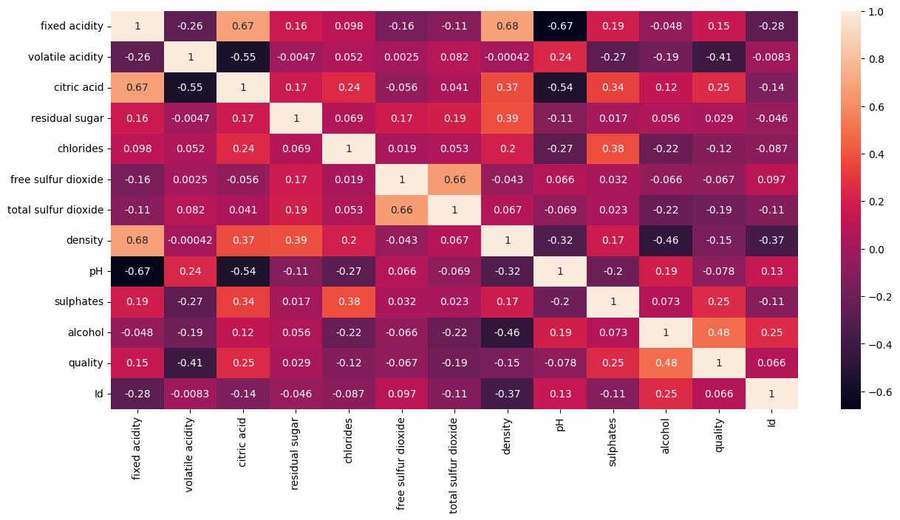

Output Description
The correlation heatmap shows pairwise correlations among the numeric variables.
The annotated values make the direction and strength of relationships easier to compare.
It helps identify features that are more strongly related to the quality target.
The heatmap also reveals relationships among predictor variables themselves.
This is useful context before fitting the Decision Tree model.
tree=evaluate('Original',DecisionTreeClassifier(criterion='entropy',random_state=42))
plt.figure(figsize=(35,15))
plot_tree(tree,feature_names=X.columns,filled=True,max_depth=5)
plt.show()
# Output
Original 0.5110132158590308
precision recall f1-score support
3 0.00 0.00 0.00 1
4 0.00 0.00 0.00 6
5 0.58 0.65 0.61 97
6 0.51 0.45 0.47 92
7 0.43 0.43 0.43 28
8 0.00 0.00 0.00 3
accuracy 0.51 227
macro avg 0.25 0.25 0.25 227
weighted avg 0.50 0.51 0.51 227
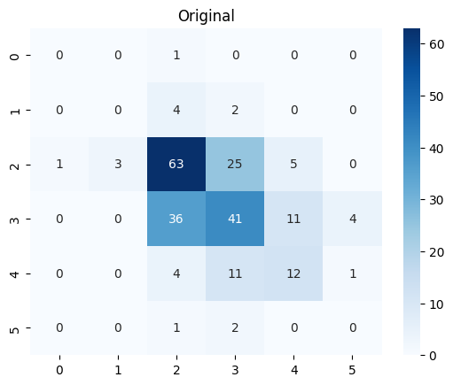
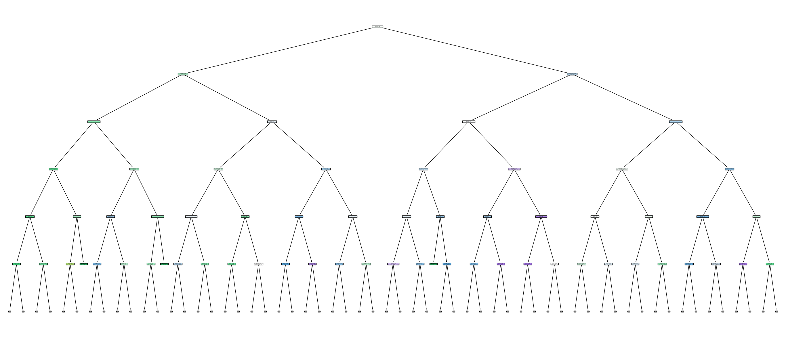

Output Description
The original Decision Tree achieves an accuracy of approximately 0.511 on the test set.
The classification report shows that performance differs substantially across quality classes.
Classes 3, 4 and 8 have zero precision and recall in this test result.
The tree visualization shows the learned decision rules using entropy.
The result provides the baseline against which tuned models can be compared.
for d in [2,3,4,5,None]:
evaluate(f'depth={d}',DecisionTreeClassifier(criterion='entropy',max_depth=d,random_state=42))
# Output
depth=2 0.5638766519823789
precision recall f1-score support
3 0.00 0.00 0.00 1
4 0.00 0.00 0.00 6
5 0.66 0.63 0.64 97
6 0.50 0.73 0.59 92
7 0.00 0.00 0.00 28
8 0.00 0.00 0.00 3
accuracy 0.56 227
macro avg 0.19 0.23 0.21 227
weighted avg 0.48 0.56 0.51 227
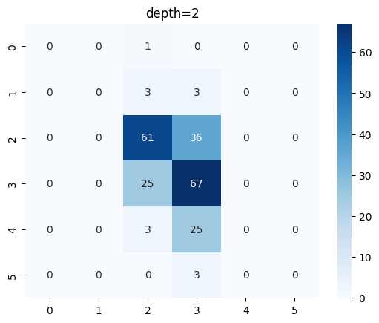
# Output
depth=3 0.5726872246696035
precision recall f1-score support
3 0.00 0.00 0.00 1
4 0.00 0.00 0.00 6
5 0.61 0.82 0.70 97
6 0.54 0.45 0.49 92
7 0.45 0.32 0.38 28
8 0.00 0.00 0.00 3
accuracy 0.57 227
macro avg 0.27 0.27 0.26 227
weighted avg 0.54 0.57 0.54 227
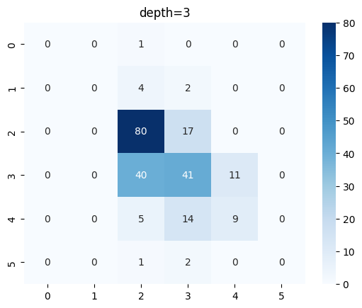
# Output
depth=4 0.5594713656387665
precision recall f1-score support
3 0.00 0.00 0.00 1
4 0.00 0.00 0.00 6
5 0.65 0.65 0.65 97
6 0.49 0.61 0.54 92
7 0.53 0.29 0.37 28
8 0.00 0.00 0.00 3
accuracy 0.56 227
macro avg 0.28 0.26 0.26 227
weighted avg 0.54 0.56 0.54 227
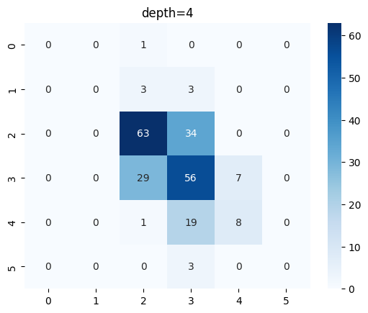
# Output
depth=5 0.5550660792951542
precision recall f1-score support
3 0.00 0.00 0.00 1
4 0.00 0.00 0.00 6
5 0.62 0.74 0.67 97
6 0.52 0.49 0.51 92
7 0.39 0.32 0.35 28
8 0.00 0.00 0.00 3
accuracy 0.56 227
macro avg 0.25 0.26 0.26 227
weighted avg 0.52 0.56 0.54 227
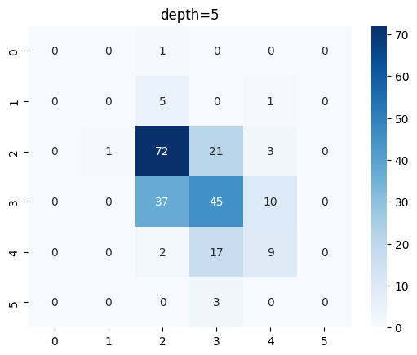
# Output
depth=None 0.5110132158590308
precision recall f1-score support
3 0.00 0.00 0.00 1
4 0.00 0.00 0.00 6
5 0.58 0.65 0.61 97
6 0.51 0.45 0.47 92
7 0.43 0.43 0.43 28
8 0.00 0.00 0.00 3
accuracy 0.51 227
macro avg 0.25 0.25 0.25 227
weighted avg 0.50 0.51 0.51 227
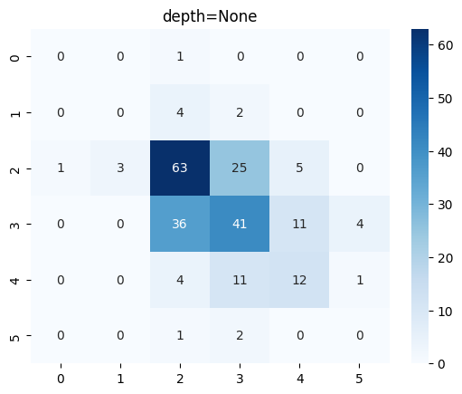

Output Description
The depth comparison shows the effect of limiting the Decision Tree depth.
The best accuracy among the tested depths is about 0.573 at depth 3.
Depth 2 gives about 0.564, while depth 4 and depth 5 are slightly lower.
The unrestricted tree returns to about 0.511 accuracy.
This indicates that controlling tree complexity improves the observed test performance in this experiment.
plt.figure(figsize=(25,15))
plot_tree(
tree,
feature_names=X.columns,
class_names=[str(i) for i in sorted(y.unique())],
filled=True,
max_depth=3,
fontsize=12,
impurity=False
)
# Output
[Text(0.5, 0.9, 'alcohol <= 10.525\nsamples = 904\nvalue = [5, 27, 385, 365, 110, 12]\nclass = 5'),
Text(0.25, 0.7, 'sulphates <= 0.625\nsamples = 542\nvalue = [4, 16, 320, 184, 17, 1]\nclass = 5'),
Text(0.375, 0.8, 'True '),
Text(0.125, 0.5, 'sulphates <= 0.535\nsamples = 331\nvalue = [2.0, 12.0, 232.0, 84.0, 1.0, 0.0]\nclass = 5'),
Text(0.0625, 0.3, 'volatile acidity <= 0.873\nsamples = 129\nvalue = [1, 7, 106, 15, 0, 0]\nclass = 5'),
Text(0.03125, 0.1, '\n (...) \n'),
Text(0.09375, 0.1, '\n (...) \n'),
Text(0.1875, 0.3, 'total sulfur dioxide <= 19.5\nsamples = 202\nvalue = [1, 5, 126, 69, 1, 0]\nclass = 5'),
Text(0.15625, 0.1, '\n (...) \n'),
Text(0.21875, 0.1, '\n (...) \n'),
Text(0.375, 0.5, 'alcohol <= 9.85\nsamples = 211\nvalue = [2, 4, 88, 100, 16, 1]\nclass = 6'),
Text(0.3125, 0.3, 'total sulfur dioxide <= 59.5\nsamples = 126\nvalue = [1, 4, 67, 52, 2, 0]\nclass = 5'),
Text(0.28125, 0.1, '\n (...) \n'),
Text(0.34375, 0.1, '\n (...) \n'),
Text(0.4375, 0.3, 'pH <= 3.285\nsamples = 85\nvalue = [1, 0, 21, 48, 14, 1]\nclass = 6'),
Text(0.40625, 0.1, '\n (...) \n'),
Text(0.46875, 0.1, '\n (...) \n'),
Text(0.75, 0.7, 'volatile acidity <= 0.445\nsamples = 362\nvalue = [1, 11, 65, 181, 93, 11]\nclass = 6'),
Text(0.625, 0.8, ' False'),
Text(0.625, 0.5, 'alcohol <= 11.55\nsamples = 164\nvalue = [0.0, 1.0, 14.0, 70.0, 69.0, 10.0]\nclass = 6'),
Text(0.5625, 0.3, 'total sulfur dioxide <= 48.5\nsamples = 88\nvalue = [0, 0, 13, 44, 27, 4]\nclass = 6'),
Text(0.53125, 0.1, '\n (...) \n'),
Text(0.59375, 0.1, '\n (...) \n'),
Text(0.6875, 0.3, 'sulphates <= 0.61\nsamples = 76\nvalue = [0.0, 1.0, 1.0, 26.0, 42.0, 6.0]\nclass = 7'),
Text(0.65625, 0.1, '\n (...) \n'),
Text(0.71875, 0.1, '\n (...) \n'),
Text(0.875, 0.5, 'sulphates <= 0.585\nsamples = 198\nvalue = [1.0, 10.0, 51.0, 111.0, 24.0, 1.0]\nclass = 6'),
Text(0.8125, 0.3, 'volatile acidity <= 0.817\nsamples = 71\nvalue = [1.0, 8.0, 31.0, 29.0, 2.0, 0.0]\nclass = 5'),
Text(0.78125, 0.1, '\n (...) \n'),
Text(0.84375, 0.1, '\n (...) \n'),
Text(0.9375, 0.3, 'total sulfur dioxide <= 83.5\nsamples = 127\nvalue = [0, 2, 20, 82, 22, 1]\nclass = 6'),
Text(0.90625, 0.1, '\n (...) \n'),
Text(0.96875, 0.1, '\n (...) \n')]
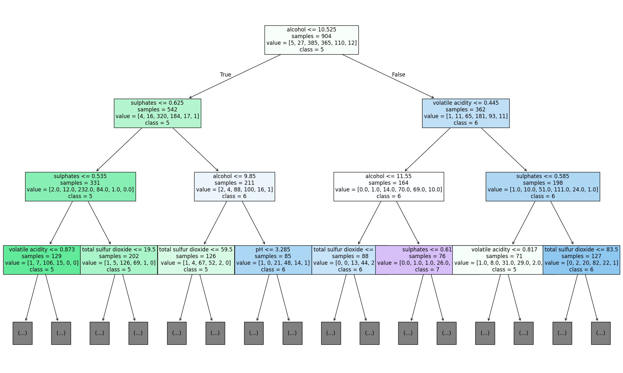

Output Description
The displayed tree shows the learned decision structure of the classifier.
Alcohol is the root split in the shown portion of the tree.
Further decisions use variables such as sulphates and volatile acidity.
The leaves represent predicted wine-quality classes.
The visualization makes the classifier's rule-based structure easier to interpret.
import pandas as pd
importance=pd.Series(tree.feature_importances_,index=X.columns).sort_values(ascending=False)
print(importance)
# Output
alcohol 0.190926
volatile acidity 0.112460
Id 0.104585
sulphates 0.100510
total sulfur dioxide 0.097128
chlorides 0.080681
pH 0.072771
density 0.061828
free sulfur dioxide 0.055859
citric acid 0.055794
residual sugar 0.039139
fixed acidity 0.028318
dtype: float64

Output Description
The feature-importance output ranks the variables according to their contribution to the trained tree.
Alcohol has the highest importance at approximately 0.191.
Volatile acidity and Id follow with values of about 0.112 and 0.105.
The remaining features have smaller but non-zero importance values.
This ranking helps identify which inputs the tree used most strongly for its decisions.
plt.figure(figsize=(10,6))
importance.sort_values().plot(kind='barh')
plt.title('decision tree feature importnace')
plt.xlabel('Features importance')
plt.ylabel('Features')
plt.show()
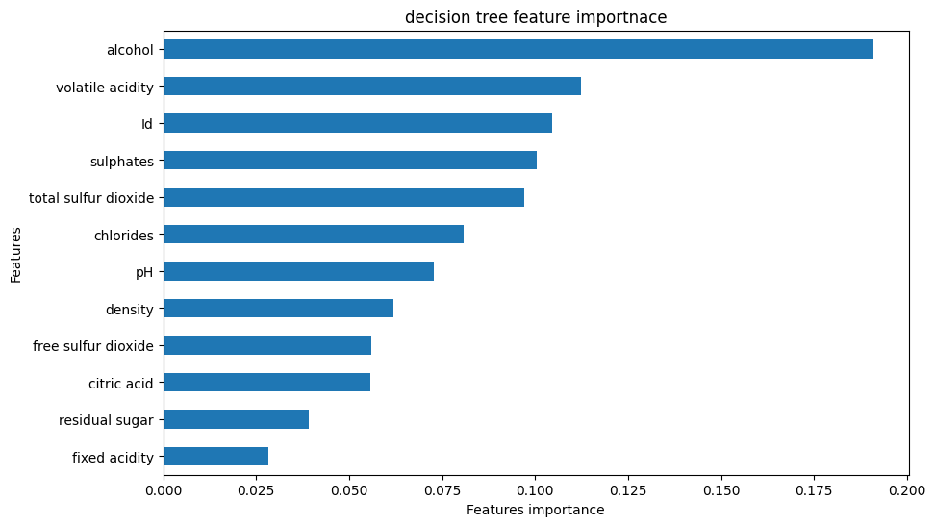

Output Description
The horizontal bar chart visualizes the feature-importance values.
Alcohol appears as the most important feature in the trained tree.
Several other variables, including volatile acidity, Id and sulphates, also contribute.
Features with shorter bars have a smaller influence on the tree's split decisions.
The graph makes the numerical feature-importance ranking easier to compare.
train_pred = tree.predict(X_train)
test_pred = tree.predict(X_test)
train_accuracy = accuracy_score(y_train, train_pred)
test_accuracy = accuracy_score(y_test, test_pred)
print("Training Accuracy:", train_accuracy)
print("Testing Accuracy:", test_accuracy)
# Output
Training Accuracy: 1.0
Testing Accuracy: 0.5110132158590308

Output Description
The training accuracy is 1.0, while the testing accuracy is about 0.511.
The perfect training score combined with the lower test score indicates overfitting.
The tree has learned the training observations extremely closely.
Its performance on unseen test data is considerably weaker.
This motivates the use of depth control and hyperparameter tuning.
from sklearn.model_selection import GridSearchCV
param_grid={
'criterion':['entropy'],
'max_depth':[3,5,7,10,None],
'min_samples_split':[2,5,10,20],
'min_samples_leaf':[1,2,4,8],
'max_features':['None','sqrt','log2'],
'ccp_alpha':[0.001,0.01,0.1,1]
}
grid=GridSearchCV(DecisionTreeClassifier(),param_grid,cv=5,n_jobs=-1,scoring='accuracy')
grid.fit(X_train,y_train)
print("Best Parameters")
print(grid.best_params_)
print("Best Score")
print(grid.best_score_)
best_tree=grid.best_estimator_
# Output
Best Parameters
{'ccp_alpha': 0.001, 'criterion': 'entropy', 'max_depth': None, 'max_features': 'sqrt', 'min_samples_leaf': 8, 'min_samples_split': 10}
Best Score
0.582940454266421

Output Description
GridSearchCV selects the best Decision Tree hyperparameters using cross-validation.
The best configuration uses entropy, max_features='sqrt', min_samples_leaf=8 and min_samples_split=10.
The selected max_depth is None and ccp_alpha is 0.001.
The best cross-validation score reported is approximately 0.583.
This tuned configuration is used for the following evaluation.
y_pred=best_tree.predict(X_test)
print(classification_report(y_test,y_pred))
print("Accuracy=",accuracy_score(y_test,y_pred))
# Output
precision recall f1-score support
3 0.00 0.00 0.00 1
4 0.00 0.00 0.00 6
5 0.61 0.71 0.65 97
6 0.54 0.54 0.54 92
7 0.35 0.25 0.29 28
8 0.00 0.00 0.00 3
accuracy 0.56 227
macro avg 0.25 0.25 0.25 227
weighted avg 0.52 0.56 0.53 227
Accuracy= 0.5550660792951542

Output Description
The tuned tree achieves a test accuracy of approximately 0.555.
The classification report shows improved performance for class 5 compared with some of the original results.
Classes 3, 4 and 8 still have zero precision and recall in this test split.
The weighted average F1-score is about 0.53.
The tuning therefore improves the baseline accuracy somewhat but does not solve all class-imbalance difficulties.
from sklearn.model_selection import cross_val_score
scores=cross_val_score(best_tree,X,y,cv=5,scoring='accuracy')
print(scores)
print("Mean Accuracy=",scores.mean())
print("Std=",scores.std())
# Output
[0.46255507 0.44247788 0.57964602 0.5 0.51327434]
Mean Accuracy= 0.4995906592335581
Std= 0.04739151011173148

Output Description
Five-fold cross-validation gives accuracy scores ranging from about 0.442 to 0.580.
The mean cross-validation accuracy is approximately 0.500.
The standard deviation is about 0.047, showing variation across the folds.
This provides a more robust estimate than relying on a single train-test split.
The result also shows that model performance varies across subsets of the dataset.
from sklearn.model_selection import learning_curve
train_sizes,train_scores,test_scores=learning_curve(best_tree,X,y,cv=5,scoring='accuracy')
plt.figure(figsize=(8,5))
plt.plot(train_sizes,train_scores.mean(axis=1),marker='o',label='Training Accuracy')
plt.plot(train_sizes,test_scores.mean(axis=1),marker='o',label='Validation Accuracy')
plt.xlabel('Train Size')
plt.ylabel('Accuracy')
plt.legend()
plt.show()
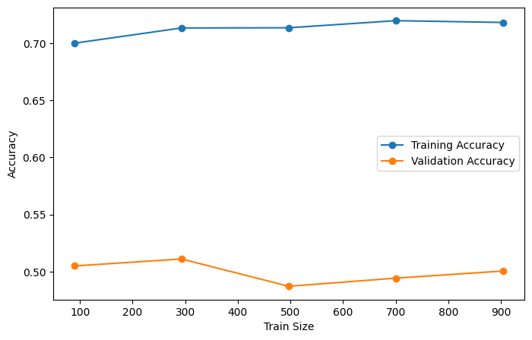

Output Description
The learning curve compares training and validation performance as the training set grows.
It helps show how model performance changes with more training examples.
The gap between training and validation performance provides information about model fit.
A learning curve is useful for diagnosing overfitting or underfitting.
This output complements the training and testing accuracy comparison.
from sklearn.model_selection import validation_curve
param_range=[1,2,3,4,5,6,7,8,9,10,None]
train_scores,test_scores=validation_curve(best_tree,X,y,param_name='max_depth',param_range=param_range,cv=5,scoring='accuracy')
plt.figure(figsize=(8,5))
plt.plot(param_range,train_scores.mean(axis=1),marker='o',label='Training Accuracy')
plt.plot(param_range,test_scores.mean(axis=1),marker='o',label='Validation Accuracy')
plt.xlabel('Max Depth')
plt.ylabel('Accuracy')
plt.legend()
plt.show()
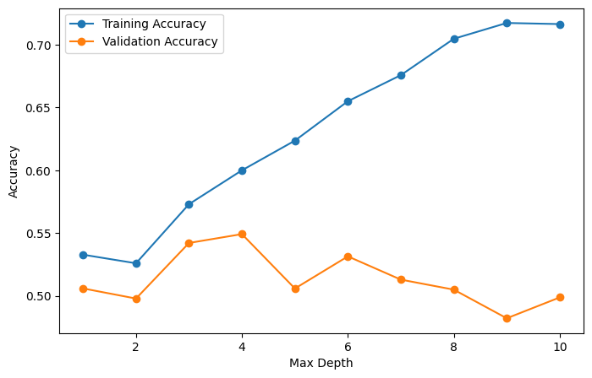

Output Description
The validation curve evaluates model performance for different max_depth values.
It compares training and test scores as tree depth changes.
The curve helps identify a depth range that balances model complexity and generalization.
Very deep trees can fit training data strongly while generalizing less effectively.
This analysis supports choosing an appropriate tree depth.
cm=confusion_matrix(y_test,y_pred)
cm_normalized=cm.astype('float')/cm.sum(axis=1)[:,np.newaxis]
plt.figure(figsize=(8,5))
sns.heatmap(cm_normalized,annot=True)
plt.show()
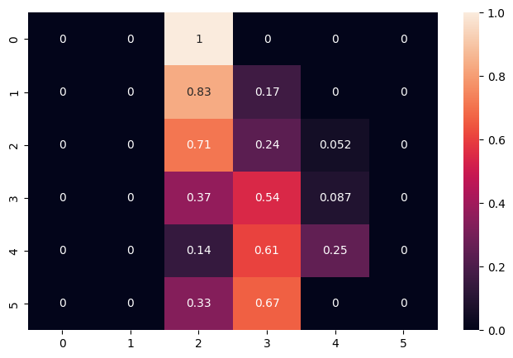

Output Description
The normalized confusion matrix shows the proportion of predictions for each actual quality class.
Each row is normalized so that the class-specific prediction proportions can be compared.
Strong diagonal values indicate correct predictions for the corresponding class.
Off-diagonal values show where the classifier confuses one quality class with another.
The matrix gives more detailed class-level information than overall accuracy alone.
from sklearn.metrics import roc_curve, roc_auc_score
# Get prediction probabilities for the best_tree model
y_prob = best_tree.predict_proba(X_test)
# For multi-class classification, we typically plot ROC for one class against the rest.
# Let's choose 'quality' class 6 as the positive class for this example.
# Find the index of class 6 in the model's classes_
class_6_index = list(best_tree.classes_).index(6)
# Get the probabilities for class 6
y_prob_class_6 = y_prob[:, class_6_index]
# Create a binary target for class 6 (1 if class 6, 0 otherwise)
y_test_binary_class_6 = (y_test == 6).astype(int)
# Calculate FPR and TPR
fpr, tpr, thresholds = roc_curve(y_test_binary_class_6, y_prob_class_6)
# Calculate AUC score for context (optional, but good practice)
roc_auc = roc_auc_score(y_test_binary_class_6, y_prob_class_6)
print(f"AUC for Class 6: {roc_auc:.2f}")
plt.plot([0,1],[0,1],"k--")
plt.plot(fpr,tpr,label=f'Decision Tree (Class 6 vs Rest, AUC = {roc_auc:.2f})')
plt.xlabel('False Positive Rate')
plt.ylabel('True Positive Rate')
plt.title('ROC Curve')
plt.legend()
plt.show()
# Output
AUC for Class 6: 0.66
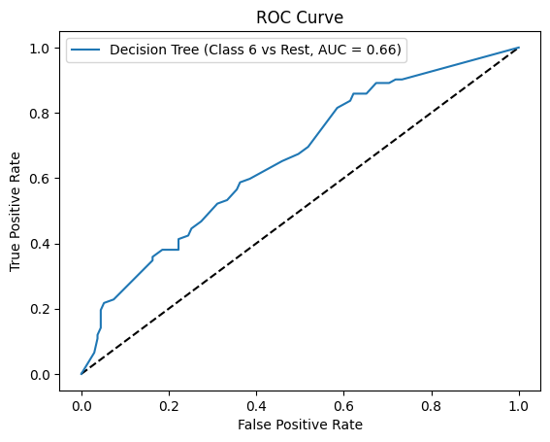

Output Description
The ROC analysis reports an AUC of 0.66 for Class 6.
The ROC curve evaluates the ability of the classifier to distinguish Class 6 from the other classes.
An AUC above 0.5 indicates discrimination better than random classification.
The plotted curve visualizes the trade-off between true-positive and false-positive rates.
This provides an additional evaluation measure for the multiclass classification problem.

5. Viva Questions with Answers
What is a Decision Tree Classifier?
Answer: It is a supervised classification algorithm that recursively splits data using feature-based rules until reaching decision nodes or leaves that represent predicted classes.
What is the purpose of the entropy criterion?
Answer: Entropy measures impurity in a node. A Decision Tree using entropy selects splits that provide high information gain and reduce impurity.
Why can a Decision Tree overfit?
Answer: A deep tree can keep splitting until it closely fits the training observations, producing very high training accuracy but weaker performance on unseen data.
What is the purpose of GridSearchCV?
Answer: GridSearchCV evaluates combinations of hyperparameters using cross-validation and selects the configuration that gives the best validation score.
What does a normalized confusion matrix show?
Answer: It shows the proportion of predictions for each actual class, making class-wise correct and incorrect predictions easier to compare even when class sizes differ.

6. Result
The Decision Tree Classification algorithm was successfully implemented on the WineQT dataset. The original entropy-based tree achieved a test accuracy of about 0.511, while the depth comparison showed the best tested accuracy of about 0.573 at depth 3. Hyperparameter tuning using GridSearchCV selected a regularized configuration with a cross-validation score of about 0.583 and produced a test accuracy of about 0.555. The analysis also demonstrated overfitting in the original tree, identified alcohol as the most important feature, and evaluated the tuned model using cross-validation, learning and validation curves, a normalized confusion matrix and an AUC of 0.66 for Class 6.

7. GitHub Repository
https://github.com/paliwalkarunya-collab/ML.git

