LAB-6
To implement the Perceptron Learning Algorithm
Lab No. | 6
Lab Aim and Objective | To implement the Perceptron Learning Algorithm.
Dataset or resources used | Seeds dataset; Python; Jupyter Notebook; libraries used in the uploaded notebook.
Date of Performance | ________________________
Name of Student | Karunya Paliwal
Section | C
Roll No. | 14
Batch Number | C1
GitHub URL | https://github.com/paliwalkarunya-collab/ML.git

Theory
The Perceptron Learning Algorithm is a supervised learning algorithm used for classification. This report follows the uploaded ML_EXP6_EDA.ipynb notebook and keeps its Seeds dataset neural-network workflow.
The uploaded notebook uses a multi-layer neural network with TensorFlow/Keras. It does not show the classical perceptron weight-update algorithm.

Procedure
The code cells and their available outputs are shown separately in the same order as the uploaded Jupyter notebook.

Name:Karunya Paliwal

C-C1-14

ML EXP6
In [ ]:
import pandas as pd
import numpy as np
import matplotlib.pyplot as plt
import seaborn as sns
import warnings
warnings.filterwarnings('ignore')
import tensorflow as tf
from tensorflow import keras
from tensorflow.keras.models import Sequential
from tensorflow.keras.layers import Input,Dense
from tensorflow.keras.optimizers import Adam
from tensorflow.keras.callbacks import EarlyStopping
from sklearn.model_selection import train_test_split
from sklearn.metrics import accuracy_score,confusion_matrix,classification_report
In [ ]:
df=pd.read_csv("seeds.csv")
In [ ]:
df=df.dropna(axis=1,how="all")
In [ ]:
df=df.loc[:, ~df.columns.str.startswith("Unamed")]
In [ ]:
df.head()
Output:
Area Perimeter Compactness Length of kernel Width of kernel \
0 15.26 14.84 0.8710 5.763 3.312
1 14.88 14.57 0.8811 5.554 3.333
2 14.29 14.09 0.9050 5.291 3.337
3 13.84 13.94 0.8955 5.324 3.379
4 16.14 14.99 0.9034 5.658 3.562

Asymmetry coefficient Length of kernel groove Class (1, 2, 3)
0 2.221 5.220 1
1 1.018 4.956 1
2 2.699 4.825 1
3 2.259 4.805 1
4 1.355 5.175 1
In [ ]:
df.tail()
Output:
Area Perimeter Compactness Length of kernel Width of kernel \
205 12.19 13.20 0.8783 5.137 2.981
206 11.23 12.88 0.8511 5.140 2.795
207 13.20 13.66 0.8883 5.236 3.232
208 11.84 13.21 0.8521 5.175 2.836
209 12.30 13.34 0.8684 5.243 2.974

Asymmetry coefficient Length of kernel groove Class (1, 2, 3)
205 3.631 4.870 3
206 4.325 5.003 3
207 8.315 5.056 3
208 3.598 5.044 3
209 5.637 5.063 3
In [ ]:
df.shape
Output:
(210, 8)
In [ ]:
df.columns
Output:
Index(['Area', 'Perimeter', 'Compactness', 'Length of kernel',
'Width of kernel', 'Asymmetry coefficient', 'Length of kernel groove',
'Class (1, 2, 3)'],
dtype='object')
In [ ]:
df.info()
Output:
<class 'pandas.core.frame.DataFrame'>
RangeIndex: 210 entries, 0 to 209
Data columns (total 8 columns):
# Column Non-Null Count Dtype
--- ------ -------------- -----
0 Area 210 non-null float64
1 Perimeter 210 non-null float64
2 Compactness 210 non-null float64
3 Length of kernel 210 non-null float64
4 Width of kernel 210 non-null float64
5 Asymmetry coefficient 210 non-null float64
6 Length of kernel groove 210 non-null float64
7 Class (1, 2, 3) 210 non-null int64
dtypes: float64(7), int64(1)
memory usage: 13.3 KB
In [ ]:
df.describe()
Output:
Area Perimeter Compactness Length of kernel Width of kernel \
count 210.000000 210.000000 210.000000 210.000000 210.000000
mean 14.847524 14.559286 0.870999 5.628533 3.258605
std 2.909699 1.305959 0.023629 0.443063 0.377714
min 10.590000 12.410000 0.808100 4.899000 2.630000
25% 12.270000 13.450000 0.856900 5.262250 2.944000
50% 14.355000 14.320000 0.873450 5.523500 3.237000
75% 17.305000 15.715000 0.887775 5.979750 3.561750
max 21.180000 17.250000 0.918300 6.675000 4.033000

Asymmetry coefficient Length of kernel groove Class (1, 2, 3)
count 210.000000 210.000000 210.000000
mean 3.700201 5.408071 2.000000
std 1.503557 0.491480 0.818448
min 0.765100 4.519000 1.000000
25% 2.561500 5.045000 1.000000
50% 3.599000 5.223000 2.000000
75% 4.768750 5.877000 3.000000
max 8.456000 6.550000 3.000000
In [ ]:
df.isnull().sum()
Output:
Area 0
Perimeter 0
Compactness 0
Length of kernel 0
Width of kernel 0
Asymmetry coefficient 0
Length of kernel groove 0
Class (1, 2, 3) 0
dtype: int64
In [ ]:
df.duplicated().sum()
Output:
np.int64(0)
In [ ]:
df.nunique()
Output:
Area 193
Perimeter 170
Compactness 186
Length of kernel 188
Width of kernel 184
Asymmetry coefficient 207
Length of kernel groove 148
Class (1, 2, 3) 3
dtype: int64
In [ ]:
df['Class (1, 2, 3)'].value_counts()
Output:
Class (1, 2, 3)
1 70
2 70
3 70
Name: count, dtype: int64
In [ ]:
df.corr(numeric_only=True)
Output:
Area Perimeter Compactness Length of kernel \
Area 1.000000 0.994341 0.608288 0.949985
Perimeter 0.994341 1.000000 0.529244 0.972422
Compactness 0.608288 0.529244 1.000000 0.367915
Length of kernel 0.949985 0.972422 0.367915 1.000000
Width of kernel 0.970771 0.944829 0.761635 0.860415
Asymmetry coefficient -0.229572 -0.217340 -0.331471 -0.171562
Length of kernel groove 0.863693 0.890784 0.226825 0.932806
Class (1, 2, 3) -0.346058 -0.327900 -0.531007 -0.257269

Width of kernel Asymmetry coefficient \
Area 0.970771 -0.229572
Perimeter 0.944829 -0.217340
Compactness 0.761635 -0.331471
Length of kernel 0.860415 -0.171562
Width of kernel 1.000000 -0.258037
Asymmetry coefficient -0.258037 1.000000
Length of kernel groove 0.749131 -0.011079
Class (1, 2, 3) -0.423463 0.577273

Length of kernel groove Class (1, 2, 3)
Area 0.863693 -0.346058
Perimeter 0.890784 -0.327900
Compactness 0.226825 -0.531007
Length of kernel 0.932806 -0.257269
Width of kernel 0.749131 -0.423463
Asymmetry coefficient -0.011079 0.577273
Length of kernel groove 1.000000 0.024301
Class (1, 2, 3) 0.024301 1.000000
In [ ]:
plt.figure(figsize=(10,6))
sns.heatmap(df.corr(numeric_only=True),annot=True,cmap='coolwarm')
plt.show()
Output:
<Figure size 1000x600 with 2 Axes>
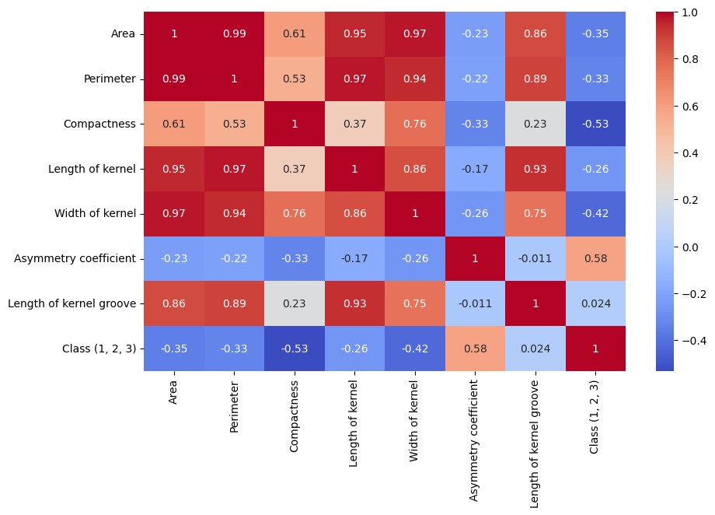
Output figure from the uploaded notebook.
In [ ]:
df.hist(figsize=(12,8))
plt.tight_layout()
plt.show()
Output:
<Figure size 1200x800 with 9 Axes>
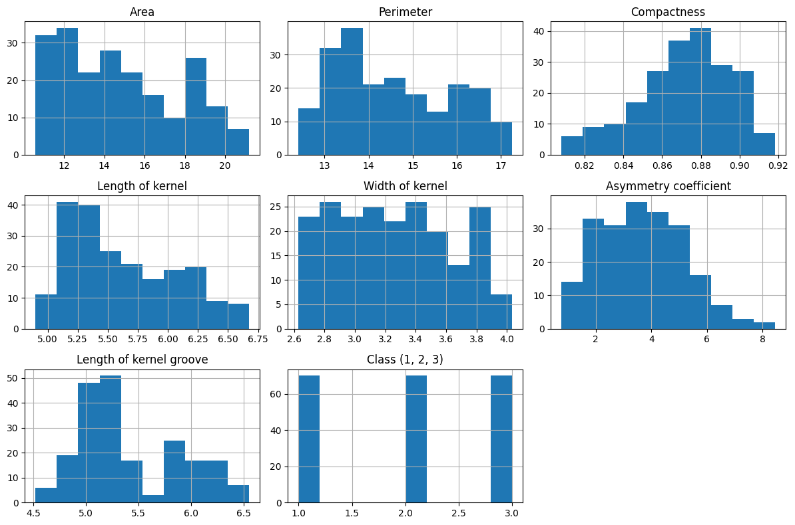
Output figure from the uploaded notebook.
In [ ]:

df.boxplot(figsize=(12,6))
plt.xticks(rotation=45)
plt.show()
Output:
<Figure size 1200x600 with 1 Axes>
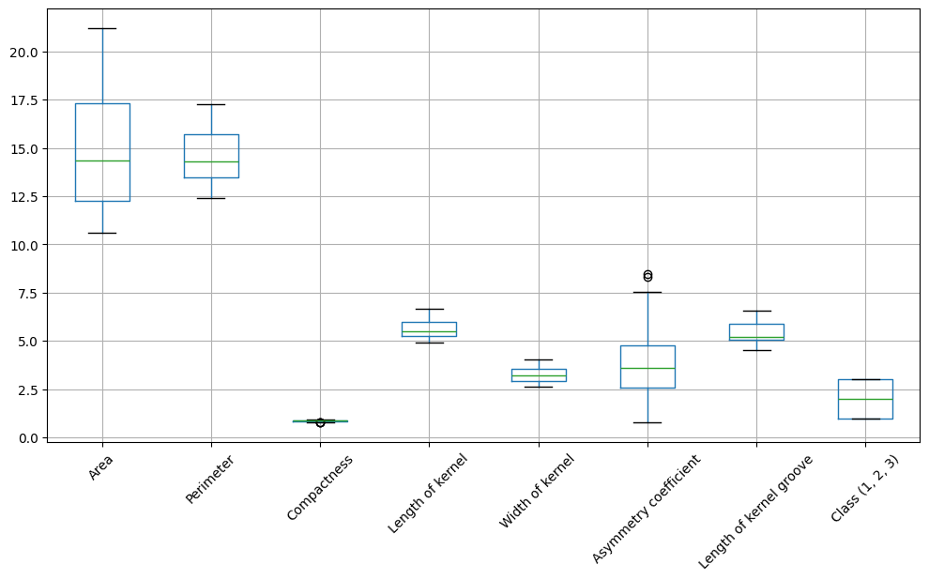
Output figure from the uploaded notebook.
In [ ]:
X=df.drop('Class (1, 2, 3)',axis=1)
y_original=df["Class (1, 2, 3)"]
print(X.shape)
print(y_original.shape)
Output:
(210, 7)
(210,)
In [ ]:
y=y_original-1
print(sorted(y_original.unique()))
print(sorted(y.unique()))
Output:
[np.int64(1), np.int64(2), np.int64(3)]
[np.int64(0), np.int64(1), np.int64(2)]
In [ ]:
X_train,X_test,y_train,y_test=train_test_split(X,y,test_size=0.2,random_state=42)
In [ ]:
from sklearn.preprocessing import StandardScaler
scaler=StandardScaler()
X_train=scaler.fit_transform(X_train)
X_test=scaler.transform(X_test)
In [ ]:
scaler.fit_transform(X_test)
Output:
array([[-0.52991291, -0.49623599, -0.27871655, -0.28725548, -0.68950684,
-1.89773913, -0.63786437],
[-1.17566801, -1.13903806, -1.3157494 , -1.08016108, -1.23712694,
0.29497821, -0.74893692],
[ 1.63968755, 1.68929104, 0.22486319, 1.68850928, 1.44414504,
-0.56016822, 1.60143767],
[-0.66658066, -0.82898059, 1.01010617, -1.11265721, -0.22454638,
-0.64523847, -1.08612146],
[-1.12441761, -1.22222421, -0.18909643, -1.25347378, -1.01239605,
-0.7264996 , -1.52842824],
[-1.20300156, -1.07853904, -2.02417513, -0.72920286, -1.46444094,
1.24979649, -0.3145639 ],
[-0.31124452, -0.32986369, 0.28460994, -0.45623536, -0.22454638,
-1.45023154, -0.82629102],
[-0.8613322 , -0.84410535, -0.63292941, -0.75086695, -0.85999234,
0.64287742, -0.43555364],
[ 0.5907626 , 0.58518396, 0.65162568, 0.64430027, 0.6795434 ,
-1.19057684, 0.30823578],
[-0.65633058, -0.71554493, 0.25046894, -0.78552949, -0.48544086,
1.04029514, -0.83224134],
[ 0.90509841, 0.9708652 , 0.24620131, 1.20973295, 0.85777824,
-0.20211137, 1.17698183],
[-1.29866898, -1.26759847, -1.51632776, -1.08016108, -1.46444094,
0.21244737, -0.83620822],
[-0.51624614, -0.61723403, 0.66442855, -0.75953258, -0.02564663,
2.83819765, -0.63786437],
[ 1.34585189, 1.46241972, -0.12508205, 1.51303017, 0.90944052,
0.34703612, 1.43681227],
[-0.04132572, -0.14836664, 1.13386729, -0.51039558, 0.23524785,
0.21625649, -1.18330995],
[ 1.5030198 , 1.34898406, 1.50941828, 1.22923063, 1.77736671,
-0.57667439, 1.39119319],
[-0.89208244, -1.00291527, 0.28034231, -1.04333213, -0.7773327 ,
-1.04329104, -0.63786437],
[-0.00374209, -0.20130328, 1.81668727, -0.82669126, 0.57880197,
-1.31881706, -1.44512383],
[-1.14833446, -1.0256024 , -1.86200538, -0.88951711, -1.48252273,
0.31275408, -0.48712304],
[ 1.32535173, 1.19017414, 1.4454039 , 0.97576081, 1.59654875,
1.36914877, 0.99053862],
[ 0.70351349, 0.86499191, -0.38113955, 0.73745585, 0.50647479,
0.68287313, 0.82789666],
[ 0.1090088 , 0.22218985, -0.29578705, 0.25001388, -0.0773089 ,
-1.21343153, 0.12179257],
[-0.75883139, -0.76848158, -0.29578705, -0.69237391, -0.71017175,
0.36608169, -0.74497005],
[ 1.31168496, 1.31873455, 0.5876113 , 1.22706422, 1.11608961,
-1.33722778, 1.02425707],
[ 1.78660537, 1.84810096, 0.10536969, 2.35792958, 1.34598673,
-0.37606097, 2.32539271],
[-0.46841243, -0.39792509, -0.45795679, -0.42807205, -0.43377859,
1.36533966, -0.14002131],
[ 0.50534526, 0.51712256, 0.5193293 , 0.53381343, 0.46256185,
-1.86732969, -0.14002131],
[ 1.38001883, 1.28848504, 1.15947304, 1.13607505, 1.61979677,
0.21816104, 1.21863404],
[-0.24632734, -0.48867362, 1.94471602, -1.01300241, 0.36440353,
0.88221684, -1.18330995],
[-1.13125099, -1.05585191, -1.50352489, -0.97617346, -1.23712694,
1.10695466, -0.5724109 ],
[-0.97066639, -1.10122618, 0.28887756, -0.98483909, -0.74633534,
-0.15703683, -0.48712304],
[-0.67683074, -0.54917263, -1.14931203, -0.37824465, -0.92973641,
-0.1976674 , -0.61604654],
[ 1.12035011, 1.04648897, 1.12959966, 0.65729873, 1.16775188,
-1.12772643, 0.91120108],
[-0.23949395, -0.14080426, -0.43661867, 0.04853787, -0.21679704,
-1.03313339, -0.48712304],
[ 1.4483527 , 1.4699821 , 0.43397681, 1.43287305, 1.32532182,
-0.30241807, 1.52805044],
[ 0.22859307, 0.32050075, -0.09094105, 0.64430027, 0.06734546,
0.39211065, 0.82789666],
[-1.1278343 , -1.15416282, -0.71401429, -1.07582826, -1.20612957,
0.70636268, -1.09603866],
[ 0.73768043, 0.88767905, -0.3384633 , 1.1967345 , 0.57105263,
-0.09418643, 1.16904808],
[ 1.87543941, 1.82541383, 0.71137242, 1.51303017, 1.60688121,
0.84349084, 1.60540455],
[-1.10050075, -0.94997863, -1.98149888, -0.61221679, -1.41277866,
0.97998414, -0.134071 ],
[-0.45816235, -0.5264855 , 0.5193293 , -0.57755425, -0.29429045,
0.52415999, -0.56844402],
[-0.90916591, -0.80629346, -1.32855227, -0.69237391, -1.02014539,
0.72604311, -0.65769875]])
In [ ]:
print(X_train[:5])
Output:
[[-1.05385596 -1.04083248 -0.88880831 -0.86174582 -1.13018592 1.03548208
-0.22342116]
[ 1.52927104 1.5495697 0.46355711 1.60878046 1.46287997 -0.1265987
1.69031688]
[-0.86392015 -0.87893234 -0.40975723 -0.96258363 -0.73186961 1.222849
-0.76198116]
[-0.17669786 -0.14652697 0.0862514 -0.16046471 -0.29345435 -1.48822186
-0.23781017]
[-1.2230715 -1.31837557 -0.4648693 -1.34301718 -1.10612655 -0.21453263
-0.84831521]]
In [ ]:
model=Sequential([
Input(shape=(7,)),
Dense(64, activation="relu"),
Dense(16, activation="relu"),
Dense(8, activation="softmax")
])
In [ ]:
model.summary()
Output:
[1mModel: "sequential_1"[0m

┏━━━━━━━━━━━━━━━━━━━━━━━━━━━━━━━━━┳━━━━━━━━━━━━━━━━━━━━━━━━┳━━━━━━━━━━━━━━━┓
┃[1m [0m[1mLayer (type) [0m[1m [0m┃[1m [0m[1mOutput Shape [0m[1m [0m┃[1m [0m[1m Param #[0m[1m [0m┃
┡━━━━━━━━━━━━━━━━━━━━━━━━━━━━━━━━━╇━━━━━━━━━━━━━━━━━━━━━━━━╇━━━━━━━━━━━━━━━┩
│ dense_3 ([38;5;33mDense[0m) │ ([38;5;45mNone[0m, [38;5;34m64[0m) │ [38;5;34m512[0m │
├─────────────────────────────────┼────────────────────────┼───────────────┤
│ dense_4 ([38;5;33mDense[0m) │ ([38;5;45mNone[0m, [38;5;34m16[0m) │ [38;5;34m1,040[0m │
├─────────────────────────────────┼────────────────────────┼───────────────┤
│ dense_5 ([38;5;33mDense[0m) │ ([38;5;45mNone[0m, [38;5;34m8[0m) │ [38;5;34m136[0m │
└─────────────────────────────────┴────────────────────────┴───────────────┘

[1m Total params: [0m[38;5;34m1,688[0m (6.59 KB)

[1m Trainable params: [0m[38;5;34m1,688[0m (6.59 KB)

[1m Non-trainable params: [0m[38;5;34m0[0m (0.00 B)
In [ ]:
model.compile(
optimizer=Adam(learning_rate=0.001),
loss="sparse_categorical_crossentropy",
metrics=["accuracy"]
)
In [ ]:
early_stop=EarlyStopping(monitor="val_loss",patience=10,restore_best_weights=True)
In [ ]:
history=model.fit(
X_train,y_train,
validation_data=(X_test,y_test),
batch_size=32,
validation_split=0.2,
epochs=100,
callbacks=[early_stop]
)
Output:
Epoch 1/100
[1m6/6[0m [32m━━━━━━━━━━━━━━━━━━━━[0m[37m[0m [1m2s[0m 83ms/step - accuracy: 0.0000e+00 - loss: 2.2924 - val_accuracy: 0.0476 - val_loss: 2.1294
Epoch 2/100
[1m6/6[0m [32m━━━━━━━━━━━━━━━━━━━━[0m[37m[0m [1m0s[0m 24ms/step - accuracy: 0.0298 - loss: 2.0749 - val_accuracy: 0.2619 - val_loss: 1.9411
Epoch 3/100
[1m6/6[0m [32m━━━━━━━━━━━━━━━━━━━━[0m[37m[0m [1m0s[0m 23ms/step - accuracy: 0.3690 - loss: 1.9136 - val_accuracy: 0.6190 - val_loss: 1.7855
Epoch 4/100
[1m6/6[0m [32m━━━━━━━━━━━━━━━━━━━━[0m[37m[0m [1m0s[0m 28ms/step - accuracy: 0.5417 - loss: 1.7666 - val_accuracy: 0.7381 - val_loss: 1.6390
Epoch 5/100
[1m6/6[0m [32m━━━━━━━━━━━━━━━━━━━━[0m[37m[0m [1m0s[0m 21ms/step - accuracy: 0.7024 - loss: 1.6228 - val_accuracy: 0.7619 - val_loss: 1.4906
Epoch 6/100
[1m6/6[0m [32m━━━━━━━━━━━━━━━━━━━━[0m[37m[0m [1m0s[0m 28ms/step - accuracy: 0.7738 - loss: 1.4803 - val_accuracy: 0.8333 - val_loss: 1.3405
Epoch 7/100
[1m6/6[0m [32m━━━━━━━━━━━━━━━━━━━━[0m[37m[0m [1m0s[0m 30ms/step - accuracy: 0.8393 - loss: 1.3443 - val_accuracy: 0.8095 - val_loss: 1.1974
Epoch 8/100
[1m6/6[0m [32m━━━━━━━━━━━━━━━━━━━━[0m[37m[0m [1m0s[0m 29ms/step - accuracy: 0.8512 - loss: 1.2106 - val_accuracy: 0.8571 - val_loss: 1.0720
Epoch 9/100
[1m6/6[0m [32m━━━━━━━━━━━━━━━━━━━━[0m[37m[0m [1m0s[0m 30ms/step - accuracy: 0.8512 - loss: 1.0963 - val_accuracy: 0.8810 - val_loss: 0.9640
Epoch 10/100
[1m6/6[0m [32m━━━━━━━━━━━━━━━━━━━━[0m[37m[0m [1m0s[0m 27ms/step - accuracy: 0.8512 - loss: 0.9955 - val_accuracy: 0.8810 - val_loss: 0.8693
Epoch 11/100
[1m6/6[0m [32m━━━━━━━━━━━━━━━━━━━━[0m[37m[0m [1m0s[0m 27ms/step - accuracy: 0.8512 - loss: 0.9071 - val_accuracy: 0.8810 - val_loss: 0.7859
Epoch 12/100
[1m6/6[0m [32m━━━━━━━━━━━━━━━━━━━━[0m[37m[0m [1m0s[0m 22ms/step - accuracy: 0.8631 - loss: 0.8300 - val_accuracy: 0.8810 - val_loss: 0.7126
Epoch 13/100
[1m6/6[0m [32m━━━━━━━━━━━━━━━━━━━━[0m[37m[0m [1m0s[0m 29ms/step - accuracy: 0.8631 - loss: 0.7619 - val_accuracy: 0.9048 - val_loss: 0.6483
Epoch 14/100
[1m6/6[0m [32m━━━━━━━━━━━━━━━━━━━━[0m[37m[0m [1m0s[0m 48ms/step - accuracy: 0.8690 - loss: 0.6993 - val_accuracy: 0.9048 - val_loss: 0.5918
Epoch 15/100
[1m6/6[0m [32m━━━━━━━━━━━━━━━━━━━━[0m[37m[0m [1m0s[0m 44ms/step - accuracy: 0.8750 - loss: 0.6393 - val_accuracy: 0.9048 - val_loss: 0.5409
Epoch 16/100
[1m6/6[0m [32m━━━━━━━━━━━━━━━━━━━━[0m[37m[0m [1m0s[0m 39ms/step - accuracy: 0.8869 - loss: 0.5846 - val_accuracy: 0.8810 - val_loss: 0.4962
Epoch 17/100
[1m6/6[0m [32m━━━━━━━━━━━━━━━━━━━━[0m[37m[0m [1m0s[0m 37ms/step - accuracy: 0.9048 - loss: 0.5297 - val_accuracy: 0.8810 - val_loss: 0.4555
Epoch 18/100
[1m6/6[0m [32m━━━━━━━━━━━━━━━━━━━━[0m[37m[0m [1m0s[0m 42ms/step - accuracy: 0.9048 - loss: 0.4824 - val_accuracy: 0.8810 - val_loss: 0.4188
Epoch 19/100
[1m6/6[0m [32m━━━━━━━━━━━━━━━━━━━━[0m[37m[0m [1m0s[0m 40ms/step - accuracy: 0.9107 - loss: 0.4335 - val_accuracy: 0.9286 - val_loss: 0.3859
Epoch 20/100
[1m6/6[0m [32m━━━━━━━━━━━━━━━━━━━━[0m[37m[0m [1m0s[0m 44ms/step - accuracy: 0.9167 - loss: 0.3928 - val_accuracy: 0.9286 - val_loss: 0.3586
Epoch 21/100
[1m6/6[0m [32m━━━━━━━━━━━━━━━━━━━━[0m[37m[0m [1m0s[0m 36ms/step - accuracy: 0.9226 - loss: 0.3584 - val_accuracy: 0.9286 - val_loss: 0.3400
Epoch 22/100
[1m6/6[0m [32m━━━━━━━━━━━━━━━━━━━━[0m[37m[0m [1m0s[0m 39ms/step - accuracy: 0.9226 - loss: 0.3304 - val_accuracy: 0.9286 - val_loss: 0.3223
Epoch 23/100
[1m6/6[0m [32m━━━━━━━━━━━━━━━━━━━━[0m[37m[0m [1m0s[0m 36ms/step - accuracy: 0.9226 - loss: 0.3087 - val_accuracy: 0.9286 - val_loss: 0.3067
Epoch 24/100
[1m6/6[0m [32m━━━━━━━━━━━━━━━━━━━━[0m[37m[0m [1m0s[0m 54ms/step - accuracy: 0.9226 - loss: 0.2897 - val_accuracy: 0.9286 - val_loss: 0.2930
Epoch 25/100
[1m6/6[0m [32m━━━━━━━━━━━━━━━━━━━━[0m[37m[0m [1m0s[0m 19ms/step - accuracy: 0.9286 - loss: 0.2733 - val_accuracy: 0.9286 - val_loss: 0.2839
Epoch 26/100
[1m6/6[0m [32m━━━━━━━━━━━━━━━━━━━━[0m[37m[0m [1m0s[0m 13ms/step - accuracy: 0.9226 - loss: 0.2590 - val_accuracy: 0.9286 - val_loss: 0.2766
Epoch 27/100
[1m6/6[0m [32m━━━━━━━━━━━━━━━━━━━━[0m[37m[0m [1m0s[0m 13ms/step - accuracy: 0.9167 - loss: 0.2478 - val_accuracy: 0.9286 - val_loss: 0.2705
Epoch 28/100
[1m6/6[0m [32m━━━━━━━━━━━━━━━━━━━━[0m[37m[0m [1m0s[0m 14ms/step - accuracy: 0.9226 - loss: 0.2373 - val_accuracy: 0.9286 - val_loss: 0.2648
Epoch 29/100
[1m6/6[0m [32m━━━━━━━━━━━━━━━━━━━━[0m[37m[0m [1m0s[0m 13ms/step - accuracy: 0.9226 - loss: 0.2292 - val_accuracy: 0.9286 - val_loss: 0.2591
Epoch 30/100
[1m6/6[0m [32m━━━━━━━━━━━━━━━━━━━━[0m[37m[0m [1m0s[0m 14ms/step - accuracy: 0.9226 - loss: 0.2214 - val_accuracy: 0.9286 - val_loss: 0.2548
Epoch 31/100
[1m6/6[0m [32m━━━━━━━━━━━━━━━━━━━━[0m[37m[0m [1m0s[0m 13ms/step - accuracy: 0.9226 - loss: 0.2145 - val_accuracy: 0.9286 - val_loss: 0.2526
Epoch 32/100
[1m6/6[0m [32m━━━━━━━━━━━━━━━━━━━━[0m[37m[0m [1m0s[0m 13ms/step - accuracy: 0.9286 - loss: 0.2078 - val_accuracy: 0.9286 - val_loss: 0.2492
Epoch 33/100
[1m6/6[0m [32m━━━━━━━━━━━━━━━━━━━━[0m[37m[0m [1m0s[0m 16ms/step - accuracy: 0.9286 - loss: 0.2021 - val_accuracy: 0.9286 - val_loss: 0.2444
Epoch 34/100
[1m6/6[0m [32m━━━━━━━━━━━━━━━━━━━━[0m[37m[0m [1m0s[0m 14ms/step - accuracy: 0.9286 - loss: 0.1969 - val_accuracy: 0.9286 - val_loss: 0.2426
Epoch 35/100
[1m6/6[0m [32m━━━━━━━━━━━━━━━━━━━━[0m[37m[0m [1m0s[0m 14ms/step - accuracy: 0.9226 - loss: 0.1921 - val_accuracy: 0.9286 - val_loss: 0.2414
Epoch 36/100
[1m6/6[0m [32m━━━━━━━━━━━━━━━━━━━━[0m[37m[0m [1m0s[0m 13ms/step - accuracy: 0.9345 - loss: 0.1882 - val_accuracy: 0.9286 - val_loss: 0.2433
Epoch 37/100
[1m6/6[0m [32m━━━━━━━━━━━━━━━━━━━━[0m[37m[0m [1m0s[0m 13ms/step - accuracy: 0.9345 - loss: 0.1837 - val_accuracy: 0.9286 - val_loss: 0.2390
Epoch 38/100
[1m6/6[0m [32m━━━━━━━━━━━━━━━━━━━━[0m[37m[0m [1m0s[0m 13ms/step - accuracy: 0.9405 - loss: 0.1793 - val_accuracy: 0.9286 - val_loss: 0.2302
Epoch 39/100
[1m6/6[0m [32m━━━━━━━━━━━━━━━━━━━━[0m[37m[0m [1m0s[0m 13ms/step - accuracy: 0.9405 - loss: 0.1742 - val_accuracy: 0.9286 - val_loss: 0.2268
Epoch 40/100
[1m6/6[0m [32m━━━━━━━━━━━━━━━━━━━━[0m[37m[0m [1m0s[0m 14ms/step - accuracy: 0.9405 - loss: 0.1709 - val_accuracy: 0.9286 - val_loss: 0.2261
Epoch 41/100
[1m6/6[0m [32m━━━━━━━━━━━━━━━━━━━━[0m[37m[0m [1m0s[0m 13ms/step - accuracy: 0.9405 - loss: 0.1674 - val_accuracy: 0.9286 - val_loss: 0.2260
Epoch 42/100
[1m6/6[0m [32m━━━━━━━━━━━━━━━━━━━━[0m[37m[0m [1m0s[0m 13ms/step - accuracy: 0.9405 - loss: 0.1645 - val_accuracy: 0.9286 - val_loss: 0.2257
Epoch 43/100
[1m6/6[0m [32m━━━━━━━━━━━━━━━━━━━━[0m[37m[0m [1m0s[0m 14ms/step - accuracy: 0.9524 - loss: 0.1618 - val_accuracy: 0.9286 - val_loss: 0.2253
Epoch 44/100
[1m6/6[0m [32m━━━━━━━━━━━━━━━━━━━━[0m[37m[0m [1m0s[0m 22ms/step - accuracy: 0.9524 - loss: 0.1591 - val_accuracy: 0.9286 - val_loss: 0.2215
Epoch 45/100
[1m6/6[0m [32m━━━━━━━━━━━━━━━━━━━━[0m[37m[0m [1m0s[0m 15ms/step - accuracy: 0.9524 - loss: 0.1557 - val_accuracy: 0.9286 - val_loss: 0.2154
Epoch 46/100
[1m6/6[0m [32m━━━━━━━━━━━━━━━━━━━━[0m[37m[0m [1m0s[0m 15ms/step - accuracy: 0.9464 - loss: 0.1533 - val_accuracy: 0.9048 - val_loss: 0.2076
Epoch 47/100
[1m6/6[0m [32m━━━━━━━━━━━━━━━━━━━━[0m[37m[0m [1m0s[0m 14ms/step - accuracy: 0.9464 - loss: 0.1498 - val_accuracy: 0.9048 - val_loss: 0.2050
Epoch 48/100
[1m6/6[0m [32m━━━━━━━━━━━━━━━━━━━━[0m[37m[0m [1m0s[0m 14ms/step - accuracy: 0.9464 - loss: 0.1473 - val_accuracy: 0.9048 - val_loss: 0.2028
Epoch 49/100
[1m6/6[0m [32m━━━━━━━━━━━━━━━━━━━━[0m[37m[0m [1m0s[0m 14ms/step - accuracy: 0.9524 - loss: 0.1456 - val_accuracy: 0.9048 - val_loss: 0.2016
Epoch 50/100
[1m6/6[0m [32m━━━━━━━━━━━━━━━━━━━━[0m[37m[0m [1m0s[0m 14ms/step - accuracy: 0.9524 - loss: 0.1426 - val_accuracy: 0.9048 - val_loss: 0.1964
Epoch 51/100
[1m6/6[0m [32m━━━━━━━━━━━━━━━━━━━━[0m[37m[0m [1m0s[0m 13ms/step - accuracy: 0.9464 - loss: 0.1433 - val_accuracy: 0.9286 - val_loss: 0.1941
Epoch 52/100
[1m6/6[0m [32m━━━━━━━━━━━━━━━━━━━━[0m[37m[0m [1m0s[0m 13ms/step - accuracy: 0.9524 - loss: 0.1412 - val_accuracy: 0.9286 - val_loss: 0.1945
Epoch 53/100
[1m6/6[0m [32m━━━━━━━━━━━━━━━━━━━━[0m[37m[0m [1m0s[0m 13ms/step - accuracy: 0.9524 - loss: 0.1386 - val_accuracy: 0.9048 - val_loss: 0.1941
Epoch 54/100
[1m6/6[0m [32m━━━━━━━━━━━━━━━━━━━━[0m[37m[0m [1m0s[0m 14ms/step - accuracy: 0.9583 - loss: 0.1346 - val_accuracy: 0.9048 - val_loss: 0.1926
Epoch 55/100
[1m6/6[0m [32m━━━━━━━━━━━━━━━━━━━━[0m[37m[0m [1m0s[0m 14ms/step - accuracy: 0.9464 - loss: 0.1326 - val_accuracy: 0.9048 - val_loss: 0.1898
Epoch 56/100
[1m6/6[0m [32m━━━━━━━━━━━━━━━━━━━━[0m[37m[0m [1m0s[0m 14ms/step - accuracy: 0.9464 - loss: 0.1296 - val_accuracy: 0.9286 - val_loss: 0.1876
Epoch 57/100
[1m6/6[0m [32m━━━━━━━━━━━━━━━━━━━━[0m[37m[0m [1m0s[0m 14ms/step - accuracy: 0.9464 - loss: 0.1287 - val_accuracy: 0.9286 - val_loss: 0.1858
Epoch 58/100
[1m6/6[0m [32m━━━━━━━━━━━━━━━━━━━━[0m[37m[0m [1m0s[0m 15ms/step - accuracy: 0.9464 - loss: 0.1274 - val_accuracy: 0.9048 - val_loss: 0.1831
Epoch 59/100
[1m6/6[0m [32m━━━━━━━━━━━━━━━━━━━━[0m[37m[0m [1m0s[0m 14ms/step - accuracy: 0.9464 - loss: 0.1253 - val_accuracy: 0.9048 - val_loss: 0.1824
Epoch 60/100
[1m6/6[0m [32m━━━━━━━━━━━━━━━━━━━━[0m[37m[0m [1m0s[0m 15ms/step - accuracy: 0.9464 - loss: 0.1237 - val_accuracy: 0.9048 - val_loss: 0.1808
Epoch 61/100
[1m6/6[0m [32m━━━━━━━━━━━━━━━━━━━━[0m[37m[0m [1m0s[0m 14ms/step - accuracy: 0.9464 - loss: 0.1212 - val_accuracy: 0.9048 - val_loss: 0.1817
Epoch 62/100
[1m6/6[0m [32m━━━━━━━━━━━━━━━━━━━━[0m[37m[0m [1m0s[0m 14ms/step - accuracy: 0.9524 - loss: 0.1198 - val_accuracy: 0.9048 - val_loss: 0.1835
Epoch 63/100
[1m6/6[0m [32m━━━━━━━━━━━━━━━━━━━━[0m[37m[0m [1m0s[0m 13ms/step - accuracy: 0.9524 - loss: 0.1204 - val_accuracy: 0.9048 - val_loss: 0.1863
Epoch 64/100
[1m6/6[0m [32m━━━━━━━━━━━━━━━━━━━━[0m[37m[0m [1m0s[0m 13ms/step - accuracy: 0.9464 - loss: 0.1217 - val_accuracy: 0.9286 - val_loss: 0.1813
Epoch 65/100
[1m6/6[0m [32m━━━━━━━━━━━━━━━━━━━━[0m[37m[0m [1m0s[0m 16ms/step - accuracy: 0.9524 - loss: 0.1178 - val_accuracy: 0.9048 - val_loss: 0.1775
Epoch 66/100
[1m6/6[0m [32m━━━━━━━━━━━━━━━━━━━━[0m[37m[0m [1m0s[0m 14ms/step - accuracy: 0.9464 - loss: 0.1163 - val_accuracy: 0.9286 - val_loss: 0.1793
Epoch 67/100
[1m6/6[0m [32m━━━━━━━━━━━━━━━━━━━━[0m[37m[0m [1m0s[0m 13ms/step - accuracy: 0.9524 - loss: 0.1140 - val_accuracy: 0.9286 - val_loss: 0.1777
Epoch 68/100
[1m6/6[0m [32m━━━━━━━━━━━━━━━━━━━━[0m[37m[0m [1m0s[0m 14ms/step - accuracy: 0.9524 - loss: 0.1122 - val_accuracy: 0.9286 - val_loss: 0.1767
Epoch 69/100
[1m6/6[0m [32m━━━━━━━━━━━━━━━━━━━━[0m[37m[0m [1m0s[0m 13ms/step - accuracy: 0.9464 - loss: 0.1131 - val_accuracy: 0.9286 - val_loss: 0.1735
Epoch 70/100
[1m6/6[0m [32m━━━━━━━━━━━━━━━━━━━━[0m[37m[0m [1m0s[0m 13ms/step - accuracy: 0.9464 - loss: 0.1103 - val_accuracy: 0.9286 - val_loss: 0.1705
Epoch 71/100
[1m6/6[0m [32m━━━━━━━━━━━━━━━━━━━━[0m[37m[0m [1m0s[0m 13ms/step - accuracy: 0.9464 - loss: 0.1085 - val_accuracy: 0.9048 - val_loss: 0.1692
Epoch 72/100
[1m6/6[0m [32m━━━━━━━━━━━━━━━━━━━━[0m[37m[0m [1m0s[0m 14ms/step - accuracy: 0.9405 - loss: 0.1070 - val_accuracy: 0.9286 - val_loss: 0.1678
Epoch 73/100
[1m6/6[0m [32m━━━━━━━━━━━━━━━━━━━━[0m[37m[0m [1m0s[0m 14ms/step - accuracy: 0.9464 - loss: 0.1061 - val_accuracy: 0.9286 - val_loss: 0.1665
Epoch 74/100
[1m6/6[0m [32m━━━━━━━━━━━━━━━━━━━━[0m[37m[0m [1m0s[0m 14ms/step - accuracy: 0.9464 - loss: 0.1044 - val_accuracy: 0.9286 - val_loss: 0.1653
Epoch 75/100
[1m6/6[0m [32m━━━━━━━━━━━━━━━━━━━━[0m[37m[0m [1m0s[0m 22ms/step - accuracy: 0.9464 - loss: 0.1034 - val_accuracy: 0.9286 - val_loss: 0.1661
Epoch 76/100
[1m6/6[0m [32m━━━━━━━━━━━━━━━━━━━━[0m[37m[0m [1m0s[0m 14ms/step - accuracy: 0.9464 - loss: 0.1024 - val_accuracy: 0.9286 - val_loss: 0.1637
Epoch 77/100
[1m6/6[0m [32m━━━━━━━━━━━━━━━━━━━━[0m[37m[0m [1m0s[0m 14ms/step - accuracy: 0.9524 - loss: 0.1002 - val_accuracy: 0.9286 - val_loss: 0.1633
Epoch 78/100
[1m6/6[0m [32m━━━━━━━━━━━━━━━━━━━━[0m[37m[0m [1m0s[0m 13ms/step - accuracy: 0.9464 - loss: 0.0993 - val_accuracy: 0.9524 - val_loss: 0.1629
Epoch 79/100
[1m6/6[0m [32m━━━━━━━━━━━━━━━━━━━━[0m[37m[0m [1m0s[0m 13ms/step - accuracy: 0.9464 - loss: 0.0981 - val_accuracy: 0.9286 - val_loss: 0.1640
Epoch 80/100
[1m6/6[0m [32m━━━━━━━━━━━━━━━━━━━━[0m[37m[0m [1m0s[0m 13ms/step - accuracy: 0.9524 - loss: 0.0975 - val_accuracy: 0.9524 - val_loss: 0.1642
Epoch 81/100
[1m6/6[0m [32m━━━━━━━━━━━━━━━━━━━━[0m[37m[0m [1m0s[0m 13ms/step - accuracy: 0.9464 - loss: 0.0982 - val_accuracy: 0.9286 - val_loss: 0.1595
Epoch 82/100
[1m6/6[0m [32m━━━━━━━━━━━━━━━━━━━━[0m[37m[0m [1m0s[0m 13ms/step - accuracy: 0.9524 - loss: 0.0977 - val_accuracy: 0.9286 - val_loss: 0.1548
Epoch 83/100
[1m6/6[0m [32m━━━━━━━━━━━━━━━━━━━━[0m[37m[0m [1m0s[0m 14ms/step - accuracy: 0.9524 - loss: 0.0988 - val_accuracy: 0.9286 - val_loss: 0.1502
Epoch 84/100
[1m6/6[0m [32m━━━━━━━━━━━━━━━━━━━━[0m[37m[0m [1m0s[0m 13ms/step - accuracy: 0.9524 - loss: 0.0942 - val_accuracy: 0.9286 - val_loss: 0.1498
Epoch 85/100
[1m6/6[0m [32m━━━━━━━━━━━━━━━━━━━━[0m[37m[0m [1m0s[0m 13ms/step - accuracy: 0.9524 - loss: 0.0920 - val_accuracy: 0.9286 - val_loss: 0.1530
Epoch 86/100
[1m6/6[0m [32m━━━━━━━━━━━━━━━━━━━━[0m[37m[0m [1m0s[0m 16ms/step - accuracy: 0.9583 - loss: 0.0906 - val_accuracy: 0.9524 - val_loss: 0.1546
Epoch 87/100
[1m6/6[0m [32m━━━━━━━━━━━━━━━━━━━━[0m[37m[0m [1m0s[0m 13ms/step - accuracy: 0.9643 - loss: 0.0894 - val_accuracy: 0.9524 - val_loss: 0.1551
Epoch 88/100
[1m6/6[0m [32m━━━━━━━━━━━━━━━━━━━━[0m[37m[0m [1m0s[0m 14ms/step - accuracy: 0.9702 - loss: 0.0883 - val_accuracy: 0.9286 - val_loss: 0.1531
Epoch 89/100
[1m6/6[0m [32m━━━━━━━━━━━━━━━━━━━━[0m[37m[0m [1m0s[0m 13ms/step - accuracy: 0.9643 - loss: 0.0871 - val_accuracy: 0.9286 - val_loss: 0.1505
Epoch 90/100
[1m6/6[0m [32m━━━━━━━━━━━━━━━━━━━━[0m[37m[0m [1m0s[0m 13ms/step - accuracy: 0.9643 - loss: 0.0883 - val_accuracy: 0.9286 - val_loss: 0.1501
Epoch 91/100
[1m6/6[0m [32m━━━━━━━━━━━━━━━━━━━━[0m[37m[0m [1m0s[0m 14ms/step - accuracy: 0.9702 - loss: 0.0896 - val_accuracy: 0.9286 - val_loss: 0.1497
Epoch 92/100
[1m6/6[0m [32m━━━━━━━━━━━━━━━━━━━━[0m[37m[0m [1m0s[0m 14ms/step - accuracy: 0.9702 - loss: 0.0862 - val_accuracy: 0.9286 - val_loss: 0.1485
Epoch 93/100
[1m6/6[0m [32m━━━━━━━━━━━━━━━━━━━━[0m[37m[0m [1m0s[0m 13ms/step - accuracy: 0.9702 - loss: 0.0846 - val_accuracy: 0.9286 - val_loss: 0.1497
Epoch 94/100
[1m6/6[0m [32m━━━━━━━━━━━━━━━━━━━━[0m[37m[0m [1m0s[0m 13ms/step - accuracy: 0.9762 - loss: 0.0832 - val_accuracy: 0.9524 - val_loss: 0.1493
Epoch 95/100
[1m6/6[0m [32m━━━━━━━━━━━━━━━━━━━━[0m[37m[0m [1m0s[0m 14ms/step - accuracy: 0.9762 - loss: 0.0819 - val_accuracy: 0.9524 - val_loss: 0.1454
Epoch 96/100
[1m6/6[0m [32m━━━━━━━━━━━━━━━━━━━━[0m[37m[0m [1m0s[0m 14ms/step - accuracy: 0.9762 - loss: 0.0809 - val_accuracy: 0.9524 - val_loss: 0.1424
Epoch 97/100
[1m6/6[0m [32m━━━━━━━━━━━━━━━━━━━━[0m[37m[0m [1m0s[0m 15ms/step - accuracy: 0.9702 - loss: 0.0796 - val_accuracy: 0.9524 - val_loss: 0.1411
Epoch 98/100
[1m6/6[0m [32m━━━━━━━━━━━━━━━━━━━━[0m[37m[0m [1m0s[0m 13ms/step - accuracy: 0.9702 - loss: 0.0788 - val_accuracy: 0.9524 - val_loss: 0.1407
Epoch 99/100
[1m6/6[0m [32m━━━━━━━━━━━━━━━━━━━━[0m[37m[0m [1m0s[0m 13ms/step - accuracy: 0.9702 - loss: 0.0779 - val_accuracy: 0.9524 - val_loss: 0.1440
Epoch 100/100
[1m6/6[0m [32m━━━━━━━━━━━━━━━━━━━━[0m[37m[0m [1m0s[0m 13ms/step - accuracy: 0.9762 - loss: 0.0773 - val_accuracy: 0.9524 - val_loss: 0.1440
In [ ]:
plt.figure(figsize=(8,5))
plt.plot(history.history['accuracy'],label='Training Accuracy')
plt.plot(history.history['val_loss'],label='Validation Accuracy')
plt.xlabel('Epochs')
plt.ylabel('Accuracy')
plt.legend()
plt.show()
Output:
<Figure size 800x500 with 1 Axes>
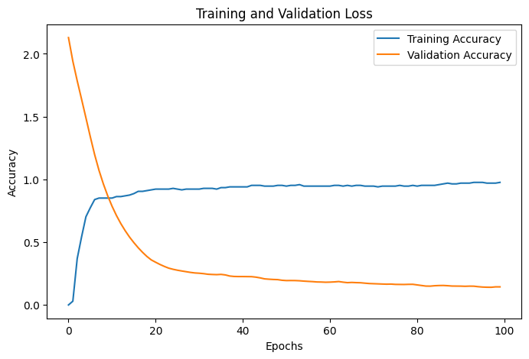
Output figure from the uploaded notebook.
In [ ]:
plt.figure(figsize=(8,5))
plt.plot(history.history['loss'],label='Training Loss')
plt.plot(history.history['val_loss'],label='Validation Loss')
plt.xlabel('Epochs')
plt.ylabel('Loss')
plt.legend()
plt.show()
Output:
<Figure size 800x500 with 1 Axes>
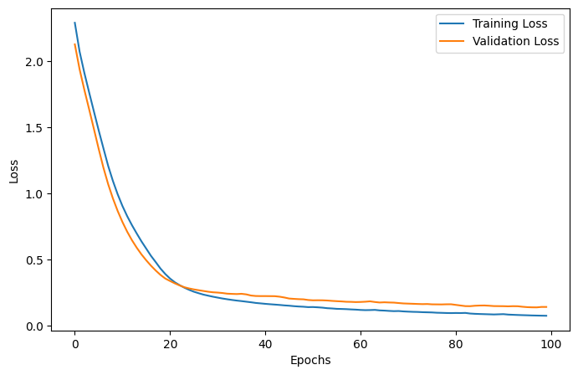
Output figure from the uploaded notebook.
In [ ]:
test_loss,test_acc=model.evaluate(X_test,y_test)
print(f"Test Accuracy: {test_acc}")
print("test loss:",test_loss)
Output:
[1m2/2[0m [32m━━━━━━━━━━━━━━━━━━━━[0m[37m[0m [1m0s[0m 31ms/step - accuracy: 0.9524 - loss: 0.1407
Test Accuracy: 0.9523809552192688
test loss: 0.14074283838272095
In [ ]:
y_Prob=model.predict(X_test,verbose=1)
print(y_Prob[:5])
Output:
[1m2/2[0m [32m━━━━━━━━━━━━━━━━━━━━[0m[37m[0m [1m0s[0m 81ms/step
[[9.94878948e-01 1.43171026e-04 4.83162422e-03 1.96521505e-05
5.30736143e-05 2.13577550e-05 4.31842545e-06 4.77905633e-05]
[1.67225883e-03 1.88041918e-06 9.98310983e-01 1.43470716e-05
1.08555774e-07 2.16031452e-07 5.86280571e-08 1.51636897e-07]
[3.75519885e-04 9.99623597e-01 6.62096156e-08 1.19937180e-08
7.14979365e-07 1.42539065e-07 4.42635306e-09 1.48574015e-08]
[8.13727140e-01 2.78153503e-03 1.80028901e-01 1.06633676e-03
8.57798674e-04 5.22998627e-04 1.51142696e-04 8.64129979e-04]
[5.06756485e-01 7.67491001e-05 4.93062913e-01 6.89712106e-05
1.29941800e-05 7.05295224e-06 1.53494909e-06 1.32963423e-05]]
In [ ]:
y_pred = np.argmax(y_Prob, axis=1)
y_pred_original = y_pred + 1
y_test_original = y_test + 1
print(y_pred_original[:10])
Output:
[1 3 2 1 1 3 1 3 1 3]
In [ ]:
comparison=pd.DataFrame({'Actual':y_test_original,'Predicted':y_pred_original})
print(comparison.head(15))
Output:
Actual Predicted
30 1 1
172 3 3
84 2 2
199 3 1
60 1 1
155 3 3
45 1 1
182 3 3
9 1 1
196 3 3
136 2 2
187 3 3
207 3 3
126 2 2
15 1 1
In [ ]:
accuracy=accuracy_score(y_test_original,y_pred_original)
print(f"Accuracy: {accuracy}")
Output:
Accuracy: 0.9523809523809523
In [ ]:
from sklearn.metrics import precision_score
precision=precision_score(y_test_original,y_pred_original,average='weighted')
print(f"Precision: {precision}")
Output:
Precision: 0.9523809523809523
In [ ]:
from sklearn.metrics import recall_score
recall=recall_score(y_test_original,y_pred_original,average='weighted')
print(f"Recall: {recall}")
Output:
Recall: 0.9523809523809523
In [ ]:
from sklearn.metrics import f1_score
f1=f1_score(y_test_original,y_pred_original,average='weighted')
print(f"F1 Score: {f1}")
Output:
F1 Score: 0.9523809523809523
In [ ]:
print(classification_report(y_test_original,y_pred_original))
Output:
precision recall f1-score support

1 0.91 0.91 0.91 11
2 1.00 1.00 1.00 14
3 0.94 0.94 0.94 17

accuracy 0.95 42
macro avg 0.95 0.95 0.95 42
weighted avg 0.95 0.95 0.95 42

In [ ]:
cm=confusion_matrix(y_test_original,y_pred_original)
print(cm)
Output:
[[10 0 1]
[ 0 14 0]
[ 1 0 16]]

Viva Questions and Answers
Q. What dataset is used in the notebook?
Answer: The Seeds dataset.
Q. Which library is used to build the neural network?
Answer: TensorFlow/Keras.
Q. Why is StandardScaler used?
Answer: It scales the input features using statistics learned from the training data.
Q. What does a confusion matrix show?
Answer: It compares actual classes with predicted classes.
Q. Does the notebook implement a classical perceptron?
Answer: No. It implements a multi-layer neural network using Dense layers.

GitHub URL
https://github.com/paliwalkarunya-collab/ML.git

