JAYPEE INSTITUTE OF INFORMATION AND TECHNOLOGY

(2014-2015)
Batch B3
MINOR PROJECT – Report

Based on : Web Technology and Android
CAMPUS CONNECT

Efforts By :
Shubhi Agarwal (12103461)
Akshita Singh (12103462)
Nishant Paliwal (12103483)
Acknowledgements-

First, I would like to thanks Mr Prashant Kaushik sir, who gave me this interesting project, and gave me his help, his time and the tools to make my project properly.

SCOPE OF THE PROJECT- We hope this application and website will surely be helpful for the students to stay touched with every campus activities. Now from the use of this app students from any stream can get information of events organized by any hub. Students get all the important information regarding event details, location and timings etc.
As Android mobiles have taken over 60% of mobile market, developing applications in android can be seen as a job opportunity.

Tools/Languages Used:
- JavaScript version 1.8.5
- JQuery version 2.1.1
- Wampp for windows 32 bit
        - Apache 2.4.10 web server
        - MySQL 5.6.20
        - PHP 5.5.15
        - phpMyAdmin 4.2.7.1
  - HTML
  - CSS
  - PHP 5.5.20
  - Notepad++
  - Google Chrome developer tools
  - Mozilla Firefox developer tools

ANDROID:
- Eclipse Juno adt bundle version 21.1.0
- Java development kit 7
- Java
- Android xml language
- Android sdk manager(upto API 21)
DATABASE :
Name: CampusConnect
Tables:Coordinator

Open Source tools:

ANDROID:
Android itself is an open source lightweight operating system used to develop applications

List of Project features:
ANDROID and WEBSITE:
The application has two sections:
- The first section shows the various clubs of university. The student can select one of the club of which he is enquiring about.
- In this section after selecting the optional club there are various subsections which will provide you information regarding that club.

- Events – This window will give you important information regarding the upcoming events.
- Team information - This window will give you detail about the events organizing team.
- Contact – This window will give you the contact information of the club.
- Registration Form - This window will be used for registration of participating students for the events.

2. PROJECT-
The application has two sections:
2.1. The first section shows the various clubs of university. The student can select one of the club of which he is enquiring about.

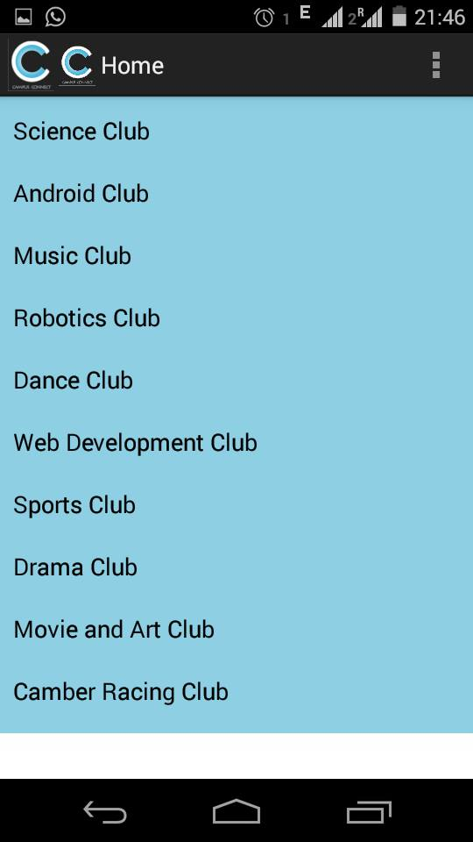

2.2. In this section after selecting the optional club there are various subsections which will provide you information regarding that club.

2.2.1. Events –
This window will give you important information regarding the upcoming events.

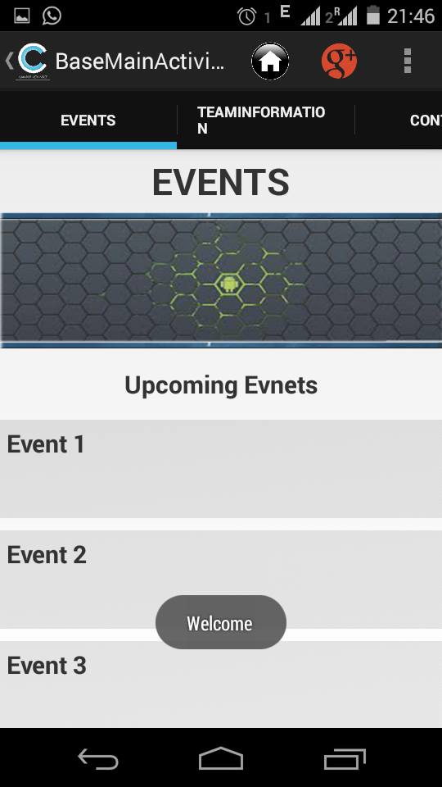

2.2.2 Team information-
This window will give you detail about the events organizing team.

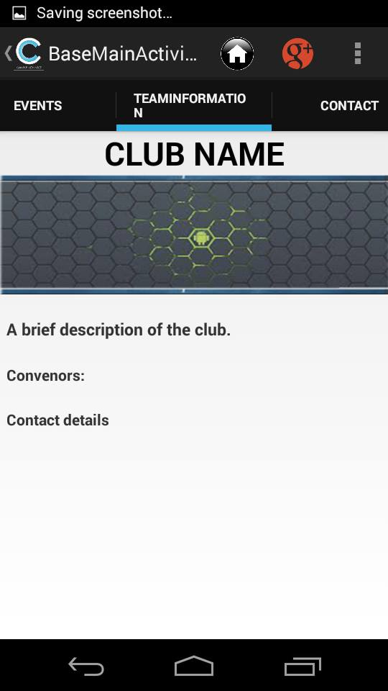

2.2.3. Contact –
This window will give you the contact information of the club.

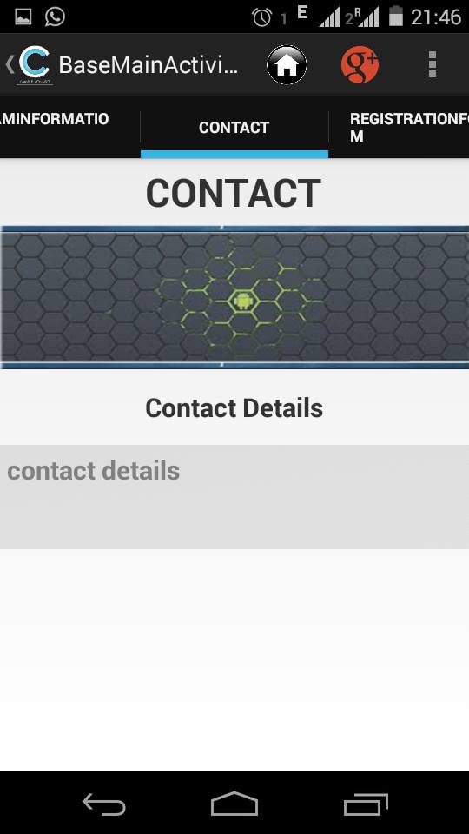

2.2.4 Registration Form-
This window will be used for registration of participating students for the events.

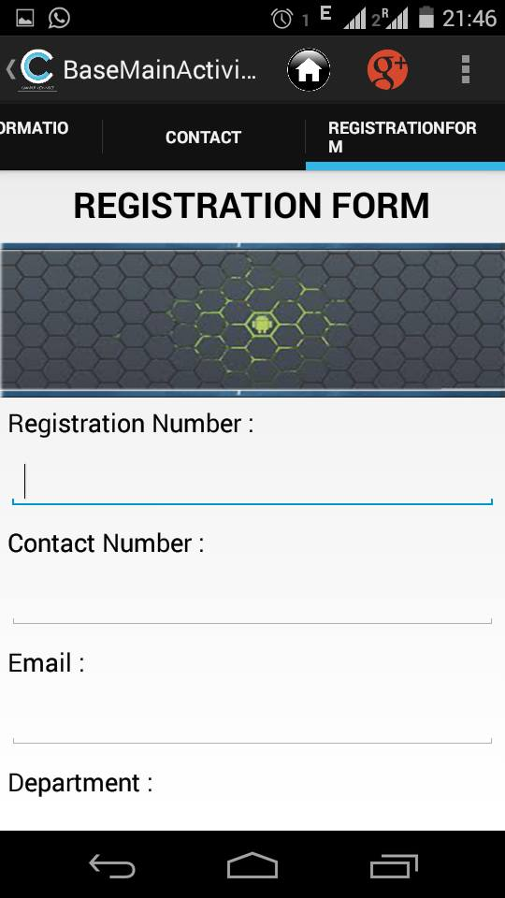

3. Project code –
The major components used in application are Splash screen, Action bar, Progress bar, Alert Dialog and List View etc.
Splash screen – Splash screen is an activity that will show for set time when your app is starting and after set time period redirect to application main screen.

Progress Bar – Progress bars are used to show progress of a task. For example. When you are uploading or downloading something from the internet, it is better to show the progress of download/upload to the user.



Code-
JAVA FILE
package com.example.campusconnect;

import android.app.Activity;
import android.content.Intent;
import android.os.Bundle;
import android.view.Menu;
import android.view.MenuItem;
import android.widget.ProgressBar;

public class CCMainActivity extends Activity {

private ProgressBar pbar = null;
Thread splash_thread = null;
@Override
protected void onCreate(Bundle savedInstanceState) {
super.onCreate(savedInstanceState);
setContentView(R.layout.activity_ccmain);

pbar = (ProgressBar) findViewById(R.id.progressBar1);
splash_thread = new Thread(new Runnable() {

@Override
public void run() {
// TODO Auto-generated method stub
int i = 0;
for( i=0;i<100;i++){

pbar.setProgress(i);

// counter_txt.setText(i+" %");
try {
splash_thread.sleep(100);
} catch (InterruptedException e) {
// TODO Auto-generated catch block
e.printStackTrace();
}
}
if(i==100){
Intent intent = new Intent(getBaseContext(),BuzzHome.class);
startActivity(intent);
finish();
}
}
});
splash_thread.start();

}
@Override
protected void onDestroy() {
// TODO Auto-generated method stub
super.onDestroy();
}

}
XML FILE
<RelativeLayout xmlns:android="http://schemas.android.com/apk/res/android"
xmlns:tools="http://schemas.android.com/tools"
android:layout_width="match_parent"
android:layout_height="match_parent"
android:paddingBottom="@dimen/activity_vertical_margin"
android:paddingLeft="@dimen/activity_horizontal_margin"
android:paddingRight="@dimen/activity_horizontal_margin"
android:paddingTop="@dimen/activity_vertical_margin"
tools:context=".MainScreen"
android:background="@raw/collegeconnectsplash" >

<ProgressBar
android:id="@+id/progressBar1"
style="?android:attr/progressBarStyleHorizontal"
android:progressDrawable="@drawable/customprogressbar"
android:layout_width="match_parent"
android:layout_height="wrap_content"
android:layout_alignParentBottom="true"
android:layout_centerVertical="true"
android:layout_centerHorizontal="true" />
</RelativeLayout>

List View –

Code –
JAVA FILE –
package com.example.campusconnect;

import java.util.ArrayList;
import android.widget.AdapterView.OnItemClickListener;
import android.app.Activity;
import android.app.AlertDialog;
import android.app.Fragment;
import android.app.FragmentManager;
import android.app.ListActivity;
import android.app.ListFragment;
import android.content.DialogInterface;
import android.content.Intent;
import android.content.res.Configuration;
import android.content.res.TypedArray;
import android.os.Bundle;
import android.support.v4.app.ActionBarDrawerToggle;
import android.support.v4.widget.DrawerLayout;
import android.util.Log;
import android.view.LayoutInflater;
import android.view.Menu;
import android.view.MenuItem;
import android.view.View;
import android.view.ViewGroup;
import android.widget.AdapterView;
import android.widget.ArrayAdapter;
import android.widget.ListAdapter;
import android.widget.ListView;
import android.widget.TextView;
import android.widget.Toast;

public class BuzzHome extends Activity {

private DrawerLayout mDrawerLayout;
private ListView mDrawerList;
private ActionBarDrawerToggle mDrawerToggle;

// nav drawer title
private CharSequence mDrawerTitle;

// used to store app title
private CharSequence mTitle;

// slide menu items
private String[] navMenuTitles;
private TypedArray navMenuIcons;

private ArrayList<NavDrawerItem> navDrawerItems;
private NavDrawerListAdapter adapter;

ListView list;
ArrayAdapter<String> adapter1;

@Override
public void onCreate(Bundle savedInstanceState) {
super.onCreate(savedInstanceState);
setContentView(R.layout.buzzhome);
list=(ListView)findViewById(R.id.listview);

String[] clubs= {"Science Club","Android Club","Music Club","Robotics Club","Dance Club","Web Development Club","Sports Club","Drama Club","Movie and Art Club","Camber Racing Club"};

adapter1=new ArrayAdapter<String>(BuzzHome.this, android.R.layout.simple_list_item_1,clubs);

list.setAdapter(adapter1);
list.setOnItemClickListener(new OnItemClickListener() {
public void onItemClick(AdapterView parent, View v, int position, long id)
{
Toast.makeText(BuzzHome.this,"Welcome ", Toast.LENGTH_LONG).show();
Intent in = new Intent(getApplicationContext(),
BaseMainActivity.class);

startActivity(in);
finish();
}
});

XML FILE –
<RelativeLayout android:orientation="vertical"
xmlns:android="http://schemas.android.com/apk/res/android"
android:layout_width="fill_parent"
android:layout_height="fill_parent">
<android.support.v4.widget.DrawerLayout
xmlns:android="http://schemas.android.com/apk/res/android"
android:id="@+id/drawer_layout"
android:layout_width="match_parent"
android:layout_height="match_parent">
<!-- Framelayout to display Fragments -->
<FrameLayout
android:id="@+id/frame_container"
android:layout_width="match_parent"
android:layout_height="match_parent" />

<!-- Listview to display slider menu -->
<ListView
android:id="@+id/list_slidermenu"
android:layout_width="240dp"
android:layout_height="match_parent"
android:layout_gravity="start"
android:choiceMode="singleChoice"
android:dividerHeight="1dp" />

</android.support.v4.widget.DrawerLayout>

<ListView android:id="@+id/listview"
android:layout_width="fill_parent"
android:layout_height="wrap_content"
android:background="#8ecfe4"
android:smoothScrollbar="true"
android:listSelector="#000033"
android:divider="#000000"
android:padding="2dp"
></ListView>
</RelativeLayout>

Action Bar swipable tabs –
Code-
package com.example.campusconnect;

import info.androidhive.tabsswipe.adapter.TabsPagerAdapter;
import android.app.ActionBar;
import android.app.ActionBar.Tab;
import android.app.Activity;
import android.content.Intent;
import android.net.Uri;
import android.os.Bundle;
import android.support.v4.app.FragmentActivity;
import android.support.v4.app.FragmentTransaction;
import android.support.v4.view.ViewPager;
import android.view.Menu;
import android.view.MenuInflater;
import android.view.MenuItem;
import android.view.View;
import android.widget.Button;
import android.support.v4.app.Fragment;
import android.support.v4.app.FragmentActivity;
import android.support.v4.app.FragmentTransaction;
import android.support.v4.view.ViewPager;
import android.app.ActionBar.TabListener;

public class BaseMainActivity extends FragmentActivity implements
ActionBar.TabListener {
private ViewPager viewPager;
private TabsPagerAdapter mAdapter;
private ActionBar actionBar;
// Tab titles
private String[] tabs = { "Events", "TeamInformation", "Contact","RegistrationForm" };
Button fb1,go1,aak1;
protected void onCreate(Bundle savedInstanceState) {
super.onCreate(savedInstanceState);
setContentView(R.layout.activity_base_main);

viewPager = (ViewPager) findViewById(R.id.pager);
actionBar = getActionBar();
mAdapter = new TabsPagerAdapter(getSupportFragmentManager());

viewPager.setAdapter(mAdapter);
actionBar.setHomeButtonEnabled(false);
actionBar.setNavigationMode(ActionBar.NAVIGATION_MODE_TABS);

// Adding Tabs
for (String tab_name : tabs) {
actionBar.addTab(actionBar.newTab().setText(tab_name)
.setTabListener(this));

}

viewPager.setOnPageChangeListener(new ViewPager.OnPageChangeListener() {

@Override
public void onPageSelected(int position) {
// on changing the page
// make respected tab selected
actionBar.setSelectedNavigationItem(position);
}

@Override
public void onPageScrolled(int arg0, float arg1, int arg2) {
}

@Override
public void onPageScrollStateChanged(int arg0) {
}
});
}
public void onTabReselected(Tab tab, FragmentTransaction ft) {
}

public void onTabSelected(Tab tab, FragmentTransaction ft) {
// on tab selected
// show respected fragment view
viewPager.setCurrentItem(tab.getPosition());
}

public void onTabUnselected(Tab tab, FragmentTransaction ft) {
}
public void onTabReselected(android.app.ActionBar.Tab arg0,
android.app.FragmentTransaction arg1) {
// TODO Auto-generated method stub

}

public void onTabSelected(android.app.ActionBar.Tab arg0,
android.app.FragmentTransaction arg1) {
// TODO Auto-generated method stub

}

public void onTabUnselected(android.app.ActionBar.Tab arg0,
android.app.FragmentTransaction arg1) {
// TODO Auto-generated method stub

}
@Override
public boolean onCreateOptionsMenu(Menu menu) {
MenuInflater inflater = getMenuInflater();
inflater.inflate(R.menu.action_button, menu);

return super.onCreateOptionsMenu(menu);
}

@Override
public boolean onOptionsItemSelected(MenuItem item) {
// Take appropriate action for each action item click
switch (item.getItemId()) {
case R.id.action_home:
// location found
GoHome();
return true;
case R.id.action_google:
GoGoogle();
return true;
case R.id.action_facebook:
GoFacebook();
return true;
case R.id.action_aakash:
GoAakash();
return true;
default:
return super.onOptionsItemSelected(item);
}

}
private void GoAakash() {
// TODO Auto-generated method stub

Intent browserIntent = new Intent(Intent.ACTION_VIEW, Uri.parse("https://www.srmaakash.in"));
startActivity(browserIntent);

}
private void GoFacebook() {
// TODO Auto-generated method stub

Intent browserIntent = new Intent(Intent.ACTION_VIEW, Uri.parse("https://www.facebook.com/srmteamaakash"));
startActivity(browserIntent);

}
private void GoGoogle() {
// TODO Auto-generated method stub

Intent browserIntent = new Intent(Intent.ACTION_VIEW, Uri.parse("https://www.google.com"));
startActivity(browserIntent);
}

private void GoHome() {
Intent i = new Intent(getBaseContext(),BuzzHome.class);
startActivity(i);
finish();
}

}

Alert Dialog-

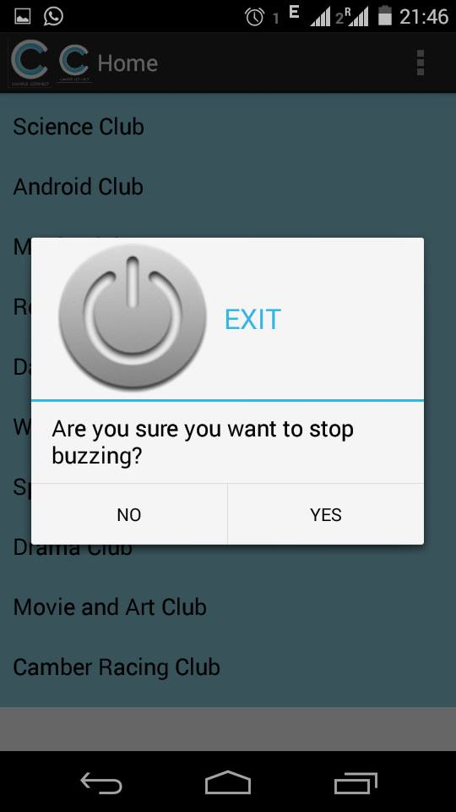

CODE-

@Override
public void onBackPressed() {

AlertDialog.Builder alertDialog = new AlertDialog.Builder(BuzzHome.this);

// Setting Dialog Title
alertDialog.setTitle("EXIT");

// Setting Dialog Message
alertDialog.setMessage("Are you sure you want to stop buzzing?");

// Setting Icon to Dialog
alertDialog.setIcon(R.drawable.exit);
alertDialog.setPositiveButton("YES", new DialogInterface.OnClickListener() {
public void onClick(DialogInterface dialog,int which) {

// Write your code here to invoke YES event
Toast.makeText(getApplicationContext(), "finishing", Toast.LENGTH_SHORT).show();
finish();
}
});
alertDialog.setNegativeButton("NO", new DialogInterface.OnClickListener(
) {
public void onClick(DialogInterface dialog, int which) {
// Write your code here to invoke NO event
Toast.makeText(getApplicationContext(), "buzz", Toast.LENGTH_SHORT).show();
dialog.cancel();
}
});
alertDialog.show();

}

}

Navigation Drawer-
Code-
//Navigation drawer code........
mTitle = mDrawerTitle = getTitle();

// load slide menu items
navMenuTitles = getResources().getStringArray(R.array.nav_drawer_items);

// nav drawer icons from resources
navMenuIcons = getResources()
.obtainTypedArray(R.array.nav_drawer_icons);

mDrawerLayout = (DrawerLayout) findViewById(R.id.drawer_layout);
mDrawerList = (ListView) findViewById(R.id.list_slidermenu);

navDrawerItems = new ArrayList<NavDrawerItem>();

// adding nav drawer items to array
// Home
navDrawerItems.add(new NavDrawerItem(navMenuTitles[0], navMenuIcons.getResourceId(0, -1)));
// Find People
navDrawerItems.add(new NavDrawerItem(navMenuTitles[1], navMenuIcons.getResourceId(1, -1)));
// Photos
navDrawerItems.add(new NavDrawerItem(navMenuTitles[2], navMenuIcons.getResourceId(2, -1)));
// Communities, Will add a counter here
navDrawerItems.add(new NavDrawerItem(navMenuTitles[3], navMenuIcons.getResourceId(3, -1), true, "22"));
// Pages
navDrawerItems.add(new NavDrawerItem(navMenuTitles[4], navMenuIcons.getResourceId(4, -1)));
// What's hot, We will add a counter here
navDrawerItems.add(new NavDrawerItem(navMenuTitles[5], navMenuIcons.getResourceId(5, -1), true, "50+"));

// Recycle the typed array
navMenuIcons.recycle();

mDrawerList.setOnItemClickListener(new SlideMenuClickListener());

// setting the nav drawer list adapter
adapter = new NavDrawerListAdapter(getApplicationContext(),
navDrawerItems);
mDrawerList.setAdapter(adapter);

// enabling action bar app icon and behaving it as toggle button
getActionBar().setDisplayHomeAsUpEnabled(true);
getActionBar().setHomeButtonEnabled(true);

mDrawerToggle = new ActionBarDrawerToggle(this, mDrawerLayout,
R.drawable.ic_launcher, //nav menu toggle icon
R.string.app_name, // nav drawer open - description for accessibility
R.string.app_name // nav drawer open - description for accessibility

) {
public void onDrawerClosed(View view) {
getActionBar().setTitle(mTitle);
// calling onPrepareOptionsMenu() to show action bar icons
invalidateOptionsMenu();
}

public void onDrawerOpened(View drawerView) {
getActionBar().setTitle(mDrawerTitle);
// calling onPrepareOptionsMenu() to hide action bar icons
invalidateOptionsMenu();
}
};
mDrawerLayout.setDrawerListener(mDrawerToggle);

if (savedInstanceState == null) {
// on first time display view for first nav item
displayView(0);
}
}

XML FILE FOR DIFFERENT LAYOUT –
Fragments_events.xml-
<?xml version="1.0" encoding="utf-8"?>
<LinearLayout xmlns:android="http://schemas.android.com/apk/res/android"
android:layout_width="match_parent"
android:layout_height="match_parent"
android:orientation="vertical" >
<ScrollView

android:layout_width="match_parent"
android:layout_height="match_parent"
android:orientation="vertical"
>
<RelativeLayout
android:layout_width="match_parent"
android:layout_height="match_parent"
android:orientation="vertical" >

<TextView
android:layout_alignParentTop="true"
android:layout_width="wrap_content"
android:layout_height="wrap_content"
android:text="EVENTS"
android:id="@+id/events_id"
android:textSize="30sp"
android:textStyle="bold"
android:layout_centerHorizontal="true"
android:padding="5dp"
/>
<ImageView
android:layout_width="match_parent"
android:layout_height="5dp"
android:id="@+id/events_strip1"
android:background="@raw/strip"
android:contentDescription="@string/desc"
android:layout_below="@+id/events_id"
android:padding="5dp"
/>

<ImageView
android:layout_width="match_parent"
android:layout_height="100dp"
android:id="@+id/events_image"
android:background="@raw/kripson"
android:contentDescription="@string/desc"
android:layout_below="@+id/events_strip1"
android:padding="5dp"
/>
<ImageView
android:layout_width="match_parent"
android:layout_height="5dp"
android:id="@+id/events_strip2"
android:background="@raw/strip"
android:contentDescription="@string/desc"
android:layout_below="@+id/events_image"
android:padding="5dp"
/>
<TextView
android:layout_below="@+id/events_strip2"
android:layout_width="wrap_content"
android:layout_height="wrap_content"
android:text="Upcoming Evnets"
android:id="@+id/events_upcoming_id"
android:textSize="20sp"
android:textStyle="bold"
android:layout_centerHorizontal="true"
android:padding="5dp"
android:layout_marginTop="10dp"
/>
<TextView
android:layout_below="@+id/events_upcoming_id"
android:layout_width="match_parent"
android:layout_height="80dp"
android:text="Event 1"
android:id="@+id/events_upcoming_button"
android:textSize="20sp"
android:textStyle="bold"
android:layout_centerHorizontal="true"
android:padding="5dp"
android:background="@raw/viewback"
android:layout_marginTop="10dp"
/>
<TextView
android:layout_below="@+id/events_upcoming_button"
android:layout_width="match_parent"
android:layout_height="80dp"
android:text="Event 2"
android:id="@+id/events_upcoming_button1"
android:textSize="20sp"
android:textStyle="bold"
android:layout_centerHorizontal="true"
android:padding="5dp"
android:background="@raw/viewback"
android:layout_marginTop="10dp"
/>
<TextView
android:layout_below="@+id/events_upcoming_button1"
android:layout_width="match_parent"
android:layout_height="80dp"
android:text="Event 3"
android:id="@+id/events_upcoming_button2"
android:textSize="20sp"
android:textStyle="bold"
android:layout_centerHorizontal="true"
android:padding="5dp"
android:background="@raw/viewback"
android:layout_marginTop="10dp"
/>
<TextView
android:layout_below="@+id/events_upcoming_button2"
android:layout_width="match_parent"
android:layout_height="80dp"
android:text="Event 4"
android:id="@+id/events_upcoming_button3"
android:textSize="20sp"
android:textStyle="bold"
android:layout_centerHorizontal="true"
android:padding="5dp"
android:background="@raw/viewback"
android:layout_marginTop="10dp"
/>
</RelativeLayout>
</ScrollView>
</LinearLayout>

Fragments_contacts.xml-
<?xml version="1.0" encoding="utf-8"?>

<LinearLayout xmlns:android="http://schemas.android.com/apk/res/android"
android:layout_width="match_parent"
android:layout_height="match_parent"
android:orientation="vertical" >
<ScrollView

android:layout_width="match_parent"
android:layout_height="match_parent"
android:orientation="vertical"
>
<RelativeLayout
android:layout_width="match_parent"
android:layout_height="match_parent"
android:orientation="vertical" >

<TextView
android:layout_alignParentTop="true"
android:layout_width="wrap_content"
android:layout_height="wrap_content"
android:text="CONTACT"
android:id="@+id/contact_id"
android:textSize="30sp"
android:textStyle="bold"
android:layout_centerHorizontal="true"
android:padding="5dp"
/>
<ImageView
android:layout_width="match_parent"
android:layout_height="5dp"
android:id="@+id/contact_strip1"
android:background="@raw/strip"
android:contentDescription="@string/desc"
android:layout_below="@+id/contact_id"
android:padding="5dp"
/>

<ImageView
android:layout_width="match_parent"
android:layout_height="100dp"
android:id="@+id/contact_image"
android:background="@raw/kripson"
android:contentDescription="@string/desc"
android:layout_below="@+id/contact_strip1"
android:padding="5dp"
/>
<ImageView
android:layout_width="match_parent"
android:layout_height="5dp"
android:id="@+id/contact_strip2"
android:background="@raw/strip"
android:contentDescription="@string/desc"
android:layout_below="@+id/contact_image"
android:padding="5dp"
/>
<TextView
android:layout_below="@+id/contact_strip2"
android:layout_width="wrap_content"
android:layout_height="wrap_content"
android:text="Contact Details"
android:id="@+id/contact_new"
android:textSize="20sp"
android:textStyle="bold"
android:layout_centerHorizontal="true"
android:padding="5dp"
android:layout_marginTop="10dp"
/>
<TextView
android:layout_below="@+id/contact_new"
android:layout_width="match_parent"
android:layout_height="80dp"
android:hint="contact details"
android:id="@+id/contact_new1"
android:textSize="20sp"
android:textStyle="bold"
android:layout_centerHorizontal="true"
android:padding="5dp"
android:background="@raw/viewback"
android:layout_marginTop="10dp"
/>

</RelativeLayout>
</ScrollView>
</LinearLayout>

Fragments_teaminfo.xml-
<?xml version="1.0" encoding="utf-8"?>
<LinearLayout xmlns:android="http://schemas.android.com/apk/res/android"
android:layout_width="match_parent"
android:layout_height="match_parent"
android:orientation="vertical" >
<ScrollView

android:layout_width="fill_parent"
android:layout_height="match_parent">
<LinearLayout
android:layout_width="fill_parent"
android:layout_height="match_parent"

android:orientation="vertical" >

<TextView
android:id="@+id/teamName"
android:layout_width="fill_parent"
android:layout_height="wrap_content"

android:gravity="center"
android:text="CLUB NAME"
android:textAppearance="?android:attr/textAppearanceLarge"

android:textSize="30sp"
android:textStyle="bold" />

<ImageView
android:layout_width="match_parent"
android:layout_height="5dp"
android:id="@+id/events_strip1"
android:background="@raw/strip"
android:contentDescription="@string/desc"
android:padding="5dp"
/>

<ImageView
android:layout_width="match_parent"
android:layout_height="100dp"
android:id="@+id/events_image"
android:background="@raw/kripson"
android:contentDescription="@string/desc"

android:padding="5dp"
/>
<ImageView
android:layout_width="match_parent"
android:layout_height="5dp"
android:id="@+id/events_strip2"
android:background="@raw/strip"
android:contentDescription="@string/desc"

android:padding="5dp"
/>

<TextView
android:id="@+id/teamDetails"
android:layout_width="match_parent"
android:layout_height="wrap_content"
android:layout_marginTop="15dp"
android:text="A brief description of the club."
android:textSize="15sp"
android:padding="6dp"
android:textStyle="bold"

/>

<TextView
android:id="@+id/convenors"
android:layout_width="match_parent"
android:layout_height="wrap_content"
android:layout_marginTop="10dp"
android:text="Convenors: "
android:padding="6dp"
android:textStyle="bold"
/>

<TextView
android:id="@+id/contact"
android:layout_width="match_parent"
android:layout_height="wrap_content"
android:layout_marginTop="10dp"
android:text="Contact details "
android:padding="6dp"
android:textStyle="bold"/>

</LinearLayout>
</ScrollView>
</LinearLayout>
Fragments_registration.xml-
<?xml version="1.0" encoding="utf-8"?>
<LinearLayout xmlns:android="http://schemas.android.com/apk/res/android"
android:layout_width="match_parent"
android:layout_height="match_parent"
android:orientation="vertical" >
<ScrollView
android:layout_width="match_parent"
android:layout_height="match_parent" >

<LinearLayout
android:layout_width="match_parent"
android:layout_height="wrap_content"
android:orientation="vertical" >

<TextView
android:id="@+id/textView1"
android:layout_width="wrap_content"
android:layout_height="wrap_content"
android:layout_gravity="center"
android:layout_margin="10dp"
android:text="REGISTRATION FORM"
android:textAppearance="?android:attr/textAppearanceMedium"
android:textSize="25sp"
android:textStyle="bold" />

<ImageView
android:layout_width="match_parent"
android:layout_height="5dp"
android:id="@+id/events_strip1"
android:background="@raw/strip"
android:contentDescription="@string/desc"
android:padding="5dp"
/>

<ImageView
android:layout_width="match_parent"
android:layout_height="100dp"
android:id="@+id/events_image"
android:background="@raw/kripson"
android:contentDescription="@string/desc"

android:padding="5dp"
/>
<ImageView
android:layout_width="match_parent"
android:layout_height="5dp"
android:id="@+id/events_strip2"
android:background="@raw/strip"
android:contentDescription="@string/desc"

android:padding="5dp"
/>

<TextView
android:id="@+id/textView2"
android:layout_width="wrap_content"
android:layout_height="wrap_content"
android:layout_margin="5dp"
android:text="Registration Number :"
android:textAppearance="?android:attr/textAppearanceMedium" />

<EditText
android:id="@+id/editText1"
android:layout_width="match_parent"
android:layout_height="wrap_content"
android:layout_margin="5dp"
android:ems="10"
android:inputType="number ="5dp"
android:text="Contact Number :"
android:textAppearance="?android:attr/textAppearanceMedium" />

<EditText
android:id="@+id/editText2"
android:layout_width="match_parent"
android:layout_height="wrap_content"
android:ems="10"
android:layout_margin="5dp"
android:inputType="phone" />

<TextView
android:id="@+id/textView4"
android:layout_width="wrap_content"
android:layout_height="wrap_content"
android:text="Email :"
android:layout_margin="5dp"
android:textAppearance="?android:attr/textAppearanceMedium" />

<EditText
android:id="@+id/editText6"
android:layout_width="match_parent"
android:layout_height="wrap_content"
android:ems="10"
android:layout_margin="5dp"
android:inputType="textEmailAddress" />

<TextView
android:id="@+id/textView5"
android:layout_width="wrap_content"
android:layout_height="wrap_content"
android:text="Department :"
android:layout_margin="5dp"
android:textAppearance="?android:attr/textAppearanceMedium" />

<EditText
android:id="@+id/editText3"
android:layout_width="match_parent"
android:layout_height="wrap_content"
android:ems="10"
android:layout_margin="5dp" />

<TextView
android:id="@+id/textView6"
android:layout_width="wrap_content"
android:layout_height="wrap_content"
android:text="Branch :"
android:layout_margin="5dp"
android:textAppearance="?android:attr/textAppearanceMedium" />

<EditText
android:id="@+id/editText4"
android:layout_width="match_parent"
android:layout_height="wrap_content"
android:ems="10"
android:layout_margin="5dp" />

<TextView
android:id="@+id/textView7"
android:layout_width="wrap_content"
android:layout_height="wrap_content"
android:text="Year :"
android:layout_margin="5dp"
android:textAppearance="?android:attr/textAppearanceMedium" />

<EditText
android:id="@+id/editText5"
android:layout_width="match_parent"
android:layout_height="wrap_content"
android:ems="10"
android:layout_margin="5dp"
android:inputType="date"/>"

<Button
android:id="@+id/button1"
android:layout_width="wrap_content"
android:layout_height="wrap_content"
android:layout_gravity="center"
android:layout_margin="5dp"
android:background="#a4c739"
android:paddingLeft="7dp"
android:paddingRight="7dp"
android:text="Register"
android:textColor="#ffffff"
/>

</LinearLayout>

</ScrollView>

</LinearLayout>

ANDROID MANIFEST FILE-
<?xml version="1.0" encoding="utf-8"?>
<manifest xmlns:android="http://schemas.android.com/apk/res/android"
package="com.example.campusconnect"
android:versionCode="1"
android:versionName="1.0" >

<uses-sdk
android:minSdkVersion="14"
android:targetSdkVersion="19" />
<uses-permission android:name="android.permission.INTERNET" />
<application
android:allowBackup="true"
android:icon="@drawable/ic_launcher"
android:label="@string/app_name"
android:theme="@style/AppTheme" android:logo="@raw/iconcc">
<activity
android:name=".CCMainActivity"
android:label="@string/app_name" >
<intent-filter>
<action android:name="android.intent.action.MAIN" />

<category android:name="android.intent.category.LAUNCHER" />
</intent-filter>
</activity>
<activity
android:name="com.example.campusconnect.BuzzHome"
android:label="@string/buzzhome"
android:parentActivityName="com.example.campusconnect" >
<meta-data
android:name="android.support.PARENT_ACTIVITY"
android:value="com.example.collegeconnect" />
</activity>
<activity
android:name="com.example.campusconnect.BaseMainActivity"
android:label="@string/title_activity_base_main"
android:parentActivityName="com.example.campusconnect" >
<meta-data
android:name="android.support.PARENT_ACTIVITY"
android:value="com.example.campusconnect" />
</activity>
</application>

</manifest>

