**Cyber Crimes in India**

June 30, 2023.

# Cyber Crimes against Women and Children

## Introduction

In this section, the main interest is to carry out statistical analysis of the Cyber Crimes happening particularly against women and children.  
The major cyber crimes against women for which the data is collected by NCRB include: Cyber Blackmailing/Threatening, Cyber Bullying/Stalking, Cyber Pornography, Fake Profiles, Defamation/Morphing etc.

## Cyber Crimes against Children

**Year 2020**

**State-Wise**

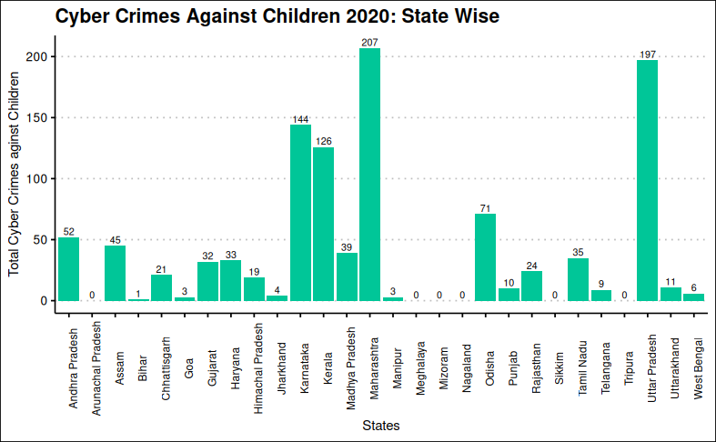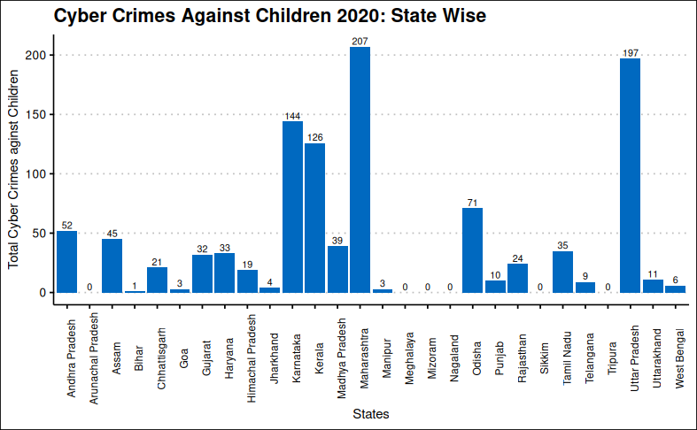

The states of Maharashtra, Uttar Pradesh, Karnataka, Kerala registered higher cyber-crimes against children in the year 2020.

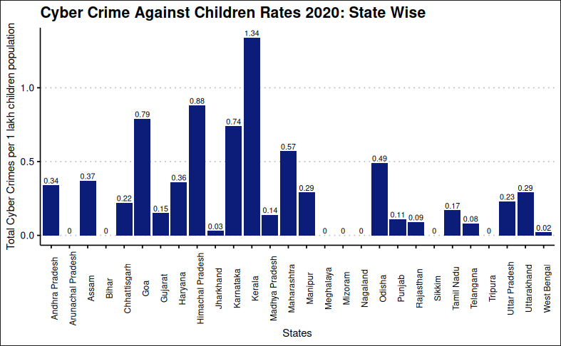 However, in terms of rates, Kerala has the maximum cyber crime rate against children in the year 2020

#### Runs Test for randomness

##   
## Runs Test  
##   
## data: child20$rate[1:28]  
## statistic = 1.1555, runs = 18, n1 = 14, n2 = 14, n = 28, p-value =  
## 0.2479  
## alternative hypothesis: nonrandomness

Since, p-value > 0.05, the results are coming out be non-significant. Thus, we conclude that the cyber-crime rates against children throughout the states is random.

#### Komlogorov-Smirnov Test

##   
## Exact two-sample Kolmogorov-Smirnov test  
##   
## data: child20$rate[1:28] and child21$rate[1:28]  
## D = 0.10714, p-value = 0.9927  
## alternative hypothesis: two-sided

##   
## Exact two-sample Kolmogorov-Smirnov test  
##   
## data: child17$rate[-c(10, 30:39)] and child21$rate[1:28]  
## D = 0.60714, p-value = 1.732e-05  
## alternative hypothesis: two-sided

##   
## Exact two-sample Kolmogorov-Smirnov test  
##   
## data: child18$rate[-c(10, 30:39)] and child21$rate[1:28]  
## D = 0.42857, p-value = 0.009589  
## alternative hypothesis: two-sided

##   
## Exact two-sample Kolmogorov-Smirnov test  
##   
## data: child19$rate[-c(10, 30:39)] and child21$rate[1:28]  
## D = 0.39286, p-value = 0.01865  
## alternative hypothesis: two-sided

##   
## Exact two-sample Kolmogorov-Smirnov test  
##   
## data: child19$rate[-c(10, 30:39)] and child20$rate[1:28]  
## D = 0.39286, p-value = 0.01988  
## alternative hypothesis: two-sided

The distribution of cyber-crime rates against children is same for the years 2020 and 2021 throughout the states, however it differs significantly between the years 2021 amd 2017, 2018, 2019.

The distrubution of cases also differs significantly for the consecutive years 2019 and 2020 at 5% level of significance.

**U.T. Wise**

Data Visualization can be done for the Union Territories as follows:

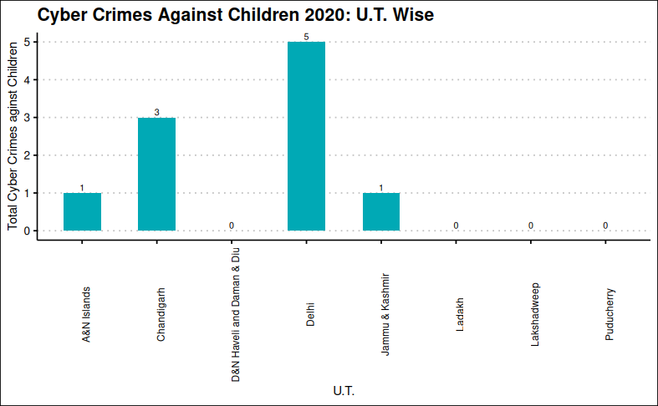

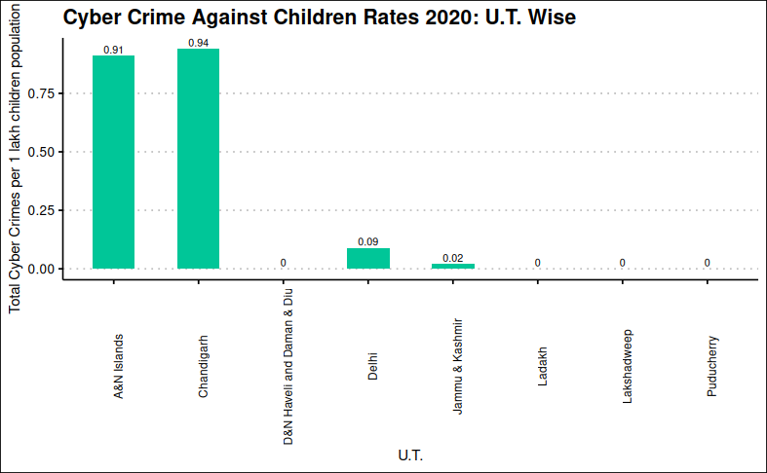

**Year 2021**

**State-Wise**

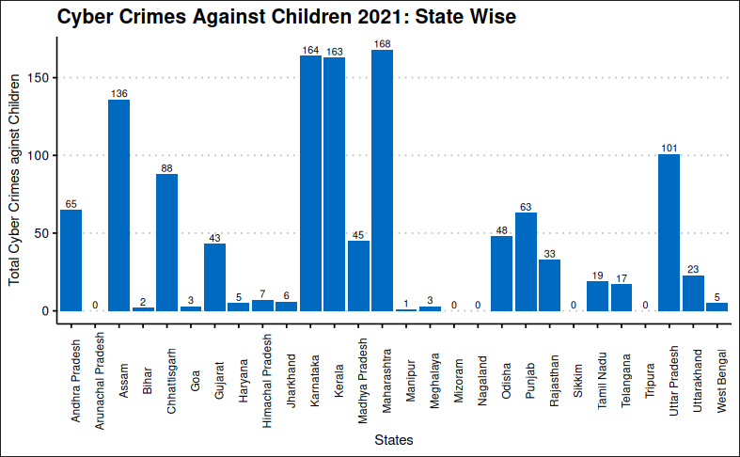

Maharashtra, Karnataka, Kerala, Assam and Uttar Pradesh have comparatively higher cyber crimes against children in 2021.

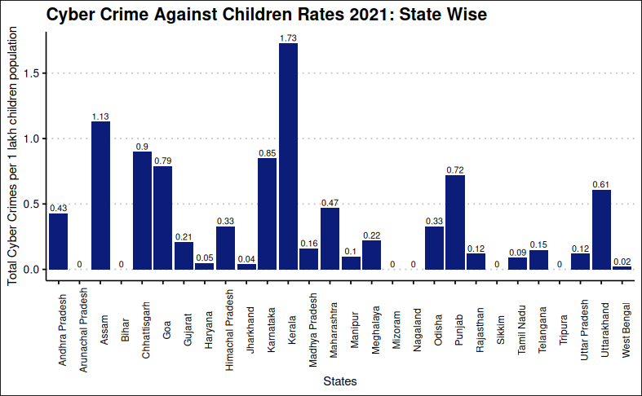

However, in terms of rates, the state of Kerala again has the maximum cyber crime rate against children.

**U.T. Wise**

Data for the Union Territories can also be viewed as folows:

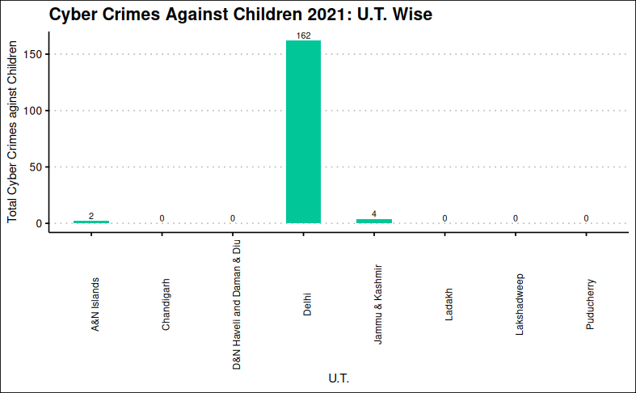

A huge increase in the cyber crimes against children can be noticed in Delhi as compared to previous year.

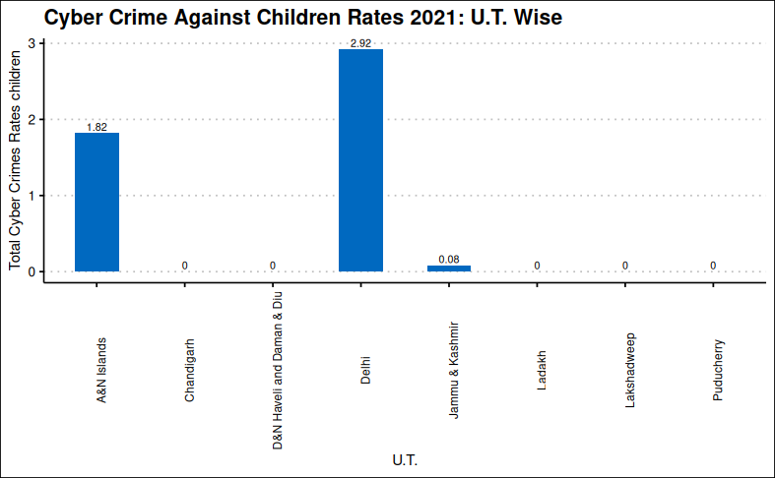

## Cyber Crimes against Women

#### Komlogorov-Smirnov Test

##   
## Exact two-sample Kolmogorov-Smirnov test  
##   
## data: women20$rate[1:28] and women21$rate[1:28]  
## D = 0.21429, p-value = 0.5204  
## alternative hypothesis: two-sided

##   
## Exact two-sample Kolmogorov-Smirnov test  
##   
## data: women17$rate[-c(10, 30:39)] and women21$rate[1:28]  
## D = 0.46429, p-value = 0.003746  
## alternative hypothesis: two-sided

##   
## Exact two-sample Kolmogorov-Smirnov test  
##   
## data: women18$rate[-c(10, 30:39)] and women21$rate[1:28]  
## D = 0.35714, p-value = 0.05419  
## alternative hypothesis: two-sided

##   
## Exact two-sample Kolmogorov-Smirnov test  
##   
## data: women19$rate[-c(10, 30:39)] and women21$rate[1:28]  
## D = 0.39286, p-value = 0.02504  
## alternative hypothesis: two-sided

##   
## Exact two-sample Kolmogorov-Smirnov test  
##   
## data: women19$rate[-c(10, 30:39)] and women20$rate[1:28]  
## D = 0.28571, p-value = 0.1902  
## alternative hypothesis: two-sided

The distribution of cyber crime rates against women throughout the states is same for the years 2020 and 2021. However, the distribution differs significantly for the years 2017 and 2021.

**Year 2020**

**State-Wise**

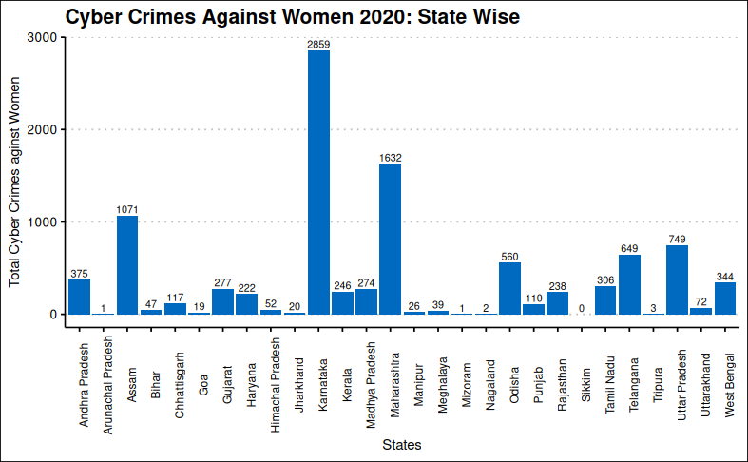

The states of Karnataka, Maharashtra, Assam have comparatively higher cyber crimes against women.

#### Runs Test for randomness

##   
## Runs Test  
##   
## data: women20$rate[1:28]  
## statistic = 0.38516, runs = 16, n1 = 14, n2 = 14, n = 28, p-value =  
## 0.7001  
## alternative hypothesis: nonrandomness

Since, p-value > 0.05, the results are coming out be non-significant. Thus, we conclude that the cyber-crime rates against women throughout the states is random.

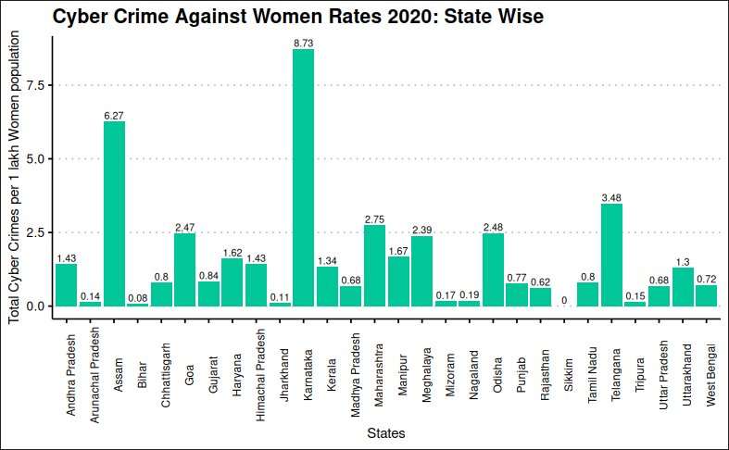

In terms of rates, Karnataka has the maximum 8.73 cyber crimes against women followed by Assam and Telangana.

**U.T. Wise**

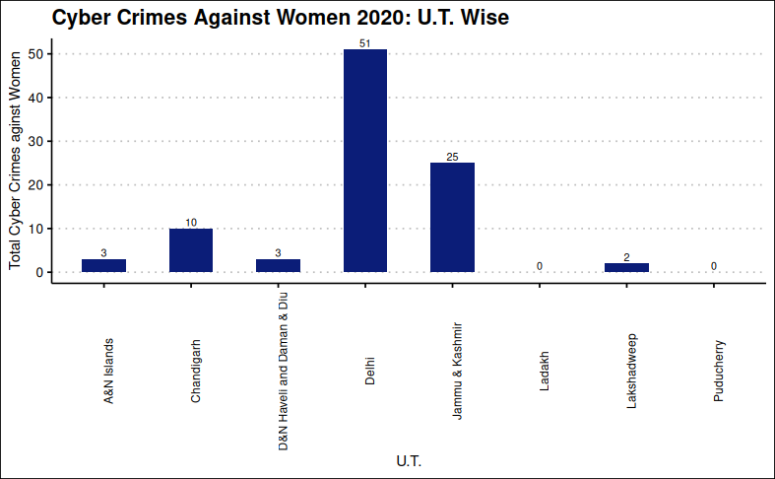

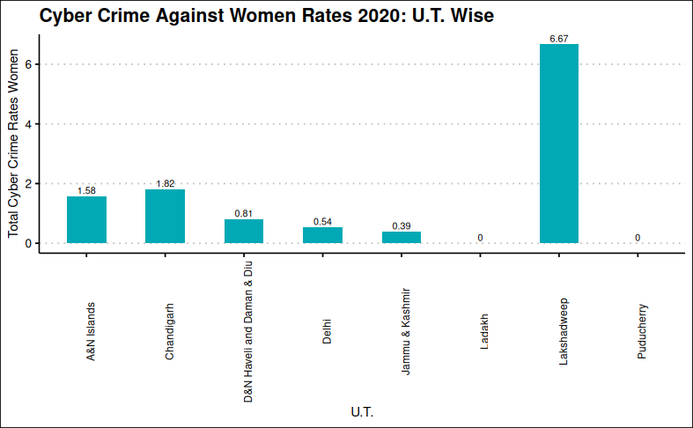

**Year 2021**

**State-Wise**

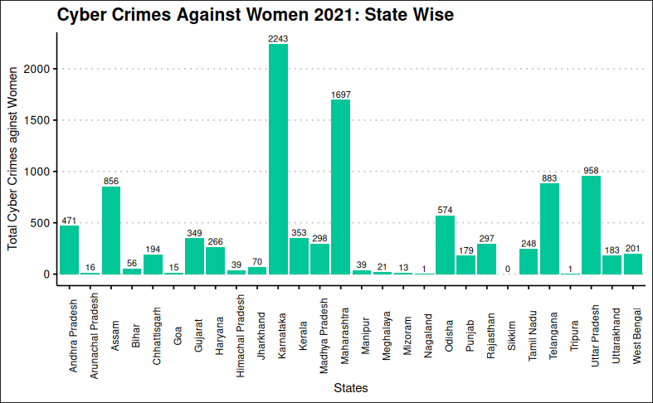

Karnataka, Maharashtra and Assam are again the states with higher cyber crimes against women.

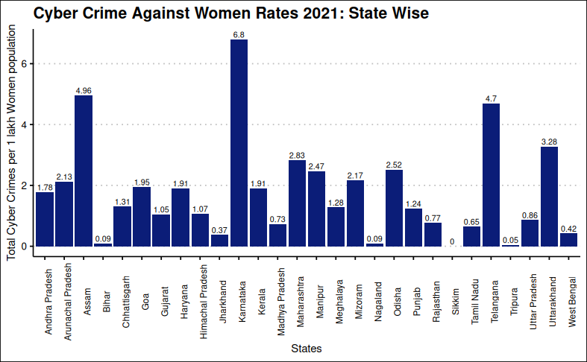

Again, the state of Karnataka has the maximum cyber crime rate against women followed by Assam, Telangana and Uttar Pradesh.

**U.T. Wise**

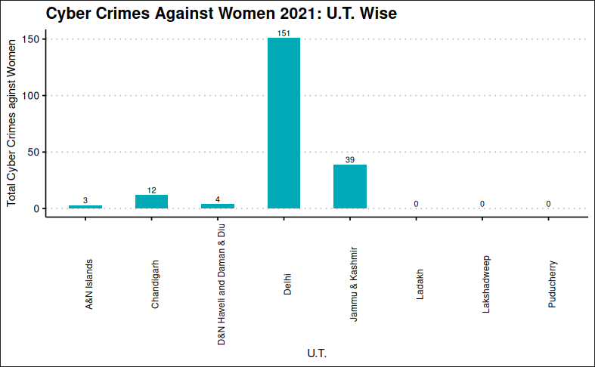

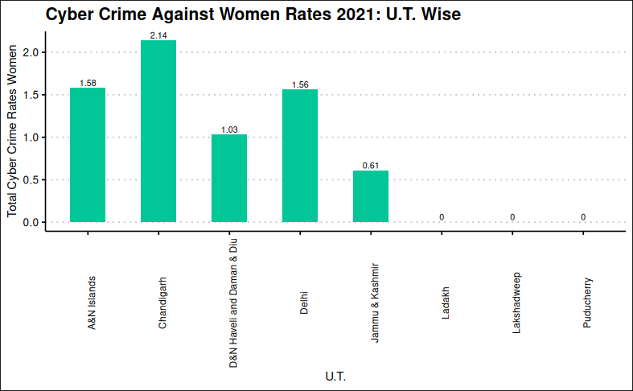

**References:**

* IAMAI and Kantar Joint Report (2023): 759 Million Indians Active Internet Users, to Reach 900 Million by 2025.
* Crime in India Statistics (2021): National Crime Records Bureau (NCRB), Ministry of Home Affairs, Govt. of India, Volume II, Chapter 9, Table 9.A.1.
* Crime in India Statistics (2016 - 2021): National Crime Records Bureau (NCRB), Ministry of Home Affairs, Govt. of India, Volume II, Chapter 9.
* Crime in India Statistics (2012 - 2015): National Crime Records Bureau (NCRB), Ministry of Home Affairs, Govt. of India, Chapter 18.
* Crime in India (2002 - 2011): National Crime Records Bureau (NCRB), Ministry of Home Affairs, Govt. of India, Chapter 18.
* Individuals using the Internet (% of population) – India (2021): International Telecommunication Union (ITU) World Telecommunication/ICT Indicators Database. M. Dasgupta (2009): Cyber Crime in India: A Comparative Study, Eastern Law House Private Ltd., 54, Ganesh Chunder Avenue, Kolkata – 700013.
* A. Bhangla and J. Tuli (2021): A Study of Cyber Crime and its Legal Framework in India, International Journal of Law Management and Humanities, Volume 4, Issue 2, 493-504.