**Cyber Crimes in India**

**Project Report**

Jaswinderpal Singh

Table of Contents

## Introduction

Cyber Crime is any kind of criminal activity that involves the use of computers, networks, or the internet for the exploitation of data and resources. Examples include hacking, identity theft, phishing scams, and distributing malware etc.

Situation is getting worse with every passing year and at the same time lack of awareness in terms of digital literacy is still there. Currently, the active internet users in India are more than 50% of the country’s population. The Cyber Crimes started increasing rapidly by the years 2015-2016. Phishing, Identity Theft, Computer Related Offenses, Frauds, Cyber-Bullying, Spamming, data leaks etc. are major Cyber Crimes on the increase in India. India reported 52,974 incidents of cyber crimes in 2021, an increase of nearly six percent from the year before, in which 50035 was the number.

Here, the objective is to analyze the year-wise trend and future prediction of the number of cyber crimes registered in India using the data from 2002 - 2021. Some state wise comparisons are done, Non-Parametric tests are applied to test the similarity of distributions and randomness of cases, keeping the population variation of the states under consideration. Major Cyber Crime Motive is identified and States with similar crime incidence rates are divided into clusters using Statistical Cluster Analysis Techniques.

**Keywords:** Cyber Crimes, Phishing, Malware, Fraud, Statistics, Cluster Analysis.

### Cyber Crime

Cyber crimes are a new class of crimes rapidly increasing due to extensive use of Internet and I.T. enabled services. Any criminal activity with the use of computers, networks, or the internet for the exploitation of data and resources comes under cyber crimes. Examples include hacking, identity theft, phishing scams, and distributing malware etc. Women are commonly targeted for cyber stalking, cyber pornography, impersonation etc.

Cyber crimes are a new class of crimes rapidly increasing due to extensive use of Internet and I.T. enabled services.

### Major Cyber Crimes in India

Some major cyber crimes in India include:  
1. *Hacking:* Unauthorized access to computer systems, networks, or websites to steal sensitive information or disrupt operations.  
2. *Phishing:* Attempts to trick individuals into providing personal or financial information through fake emails or websites.  
3. *Identity Theft:* Using someone else’s personal information to commit fraud or other crimes.  
4. *Fraud:* Using the internet to scam people out of their money or personal information.  
5. *Cyberstalking:* Harassment or bullying through electronic means.  
6. *Child pornography:* Using the internet to distribute or view child pornography.  
7. *Ransomware:* A type of malware that encrypts a victim’s files and demands payment to restore access.  
8. *Crypto jacking:* Unauthorized use of someone’s computer or device to mine cryptocurrency.  
9. *Distributed Denial of Service (DDoS) attacks:* Overwhelming a website or network with traffic to make it unavailable. 10. *Spamming:* Sending unsolicited messages through email or other means.

These are some major cyber crimes reported in India, but there can be various other types of cyber-attacks that are emerging with technology advancements.

# Cyber Crimes in India: Statistics and Data Visualization

## Introduction

In this section, the main objective is to have a visualization of the datasets and to figure out which states and Union Territories have Major role in the Cyber Crimes in India in the past few years. Also, the Cyber Crime registration trend for the country is analyzed over the years and predictions are made for the coming years.

## Cyber Crimes State-Wise:

### Year 2020

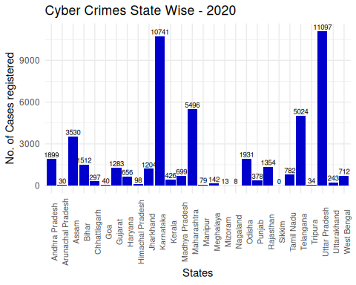

The above figure shows the highest number of cases being registered in Uttar Pradesh, followed by Karnataka, Maharashtra and Telangana. But one must note that the population in these states may vary. So to get a better comparison, rates can be calculated, which gives the cyber crime cases registered in the state per 1 lakh population. Mid year projected population for each state for the year 2021 is available. Hence the Cyber Crime Rate can be calculated as:

$$\text{Rate}=\frac{\text{No.of cases registered}}{\text{Mid year projected population (in lakhs)}}$$

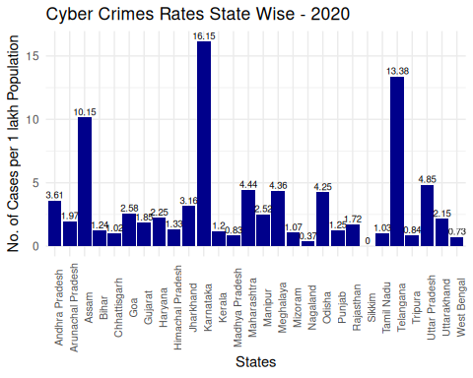 As far as the rates are concerned, Karnataka and Telangana emerged as the states with highest cyber crime rates followed by Assam, Uttar Pradesh and Maharashtra.

Now, keeping the population variation of the states into account, the better comparative picture here is given by the rates. Now, it can be seen that the state of Karnataka has the maximum cyber crime rate of 16.15 cyber crimes registered per 1 lakh population in the year 2020, followed by Telangana and Assam with cyber crime registeration rate of 13.38 and 10.15 cases per 1 lakh population.

## [1] 0.7172579

**The above value indicates that almost 71.72579 % of the total cyber crimes reported in the country India in 2021 came only from the five states: Telangana, Uttar Pradesh, Karnataka, Maharashtra and Assam.**

### Year 2021

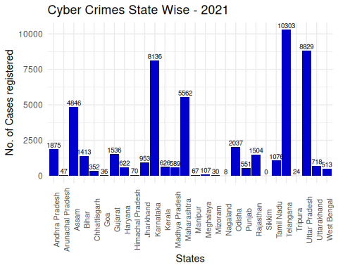

From the above figure it looks like Telangana tops the Cyber Crimes tally followed by Uttar Pradesh and Karnataka in 2021.  
It can be noticed that the cyber crimes in the state of Telangana almost doubled in a year, which is a matter of huge concern.

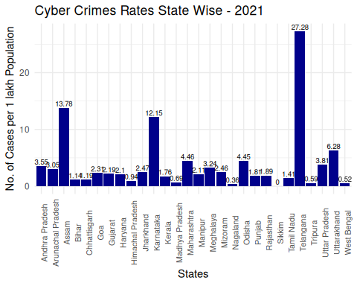

But for better comparison, the Cyber Crime Rates, i.e. Cyber Crimes in a State per 1 lakh population, can be seen.  
Now, from here it is evident that infact Telangana is the state with highest cyber crime rate of **27.28** cases per 1 lakh population, followed by Assam and Karnataka with rates **13.78** and **12.15** respectively.

Also, the cyber crimes in Assam are also increasing with every passing year.  
However, Karnataka registered slightly lesser number of cyber crimes this year as compared to the previous year.  
Despite all, There is no cyber crime case regitered in Sikkim as per the record of National Crime Records Bureau (NCRB) in the past few years.

## [1] 0.7112168

**The above value indicates that almost 71.12168 % of the total cyber crimes reported in the country India in 2021 came only from the five states: Telangana, Uttar Pradesh, Karnataka, Maharashtra and Assam. However, they together contributed almost 36% of the Indian Population**

Now, for the past 5 years, the cyber crime trend in these 5 major states is to be viewed. The trend is shown for each state for the years 2017 - 2021. The data can be visualized both in terms of actual crime registered count as well as in terms of rates in these states.

### Cyber Crimes Trend: Major States

From the above analysis, it can be seen that the states of Telangana, Uttar Pradesh, Karnataka, Maharashtra and Assam have comparatively higher cyber crime rates as well as larger number of cyber crimes registered in the last two years. Now, it is of interest to analyze these states based on their records of the previous years.

These States can be analyzed further based on last 5 years as follows:

##   
## Telangana

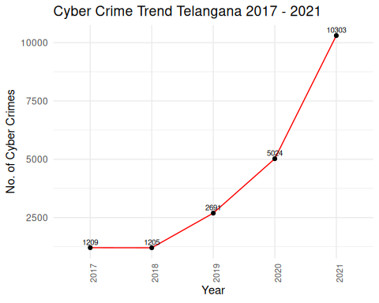

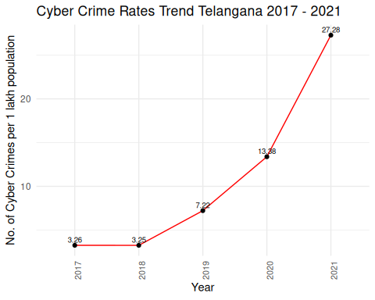

##   
##   
## Karnataka

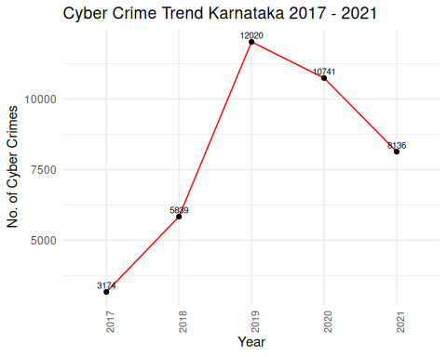

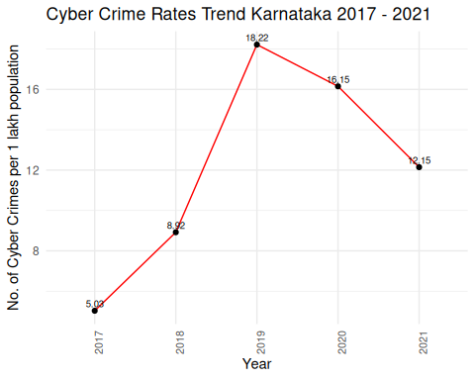

##   
##   
## Maharashtra

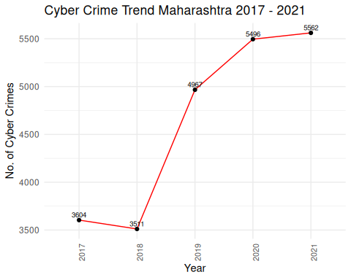

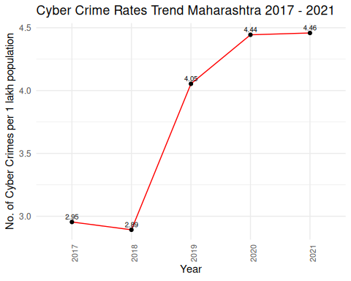

##   
##   
## Assam

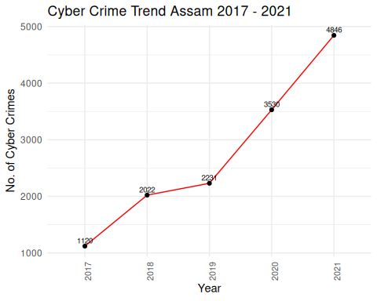

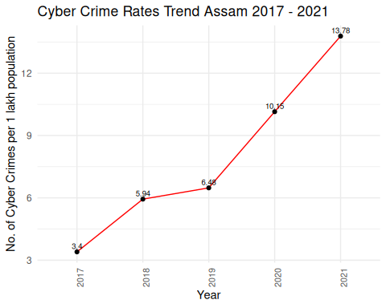

##   
##   
## Uttar Pradesh

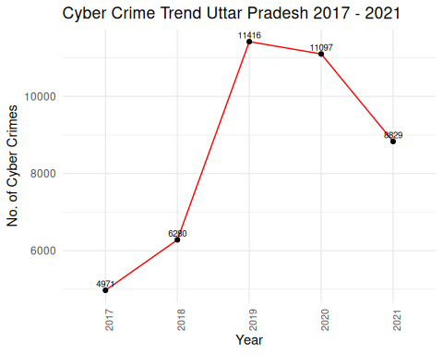

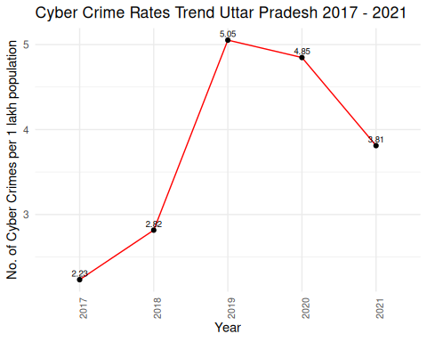

Now, it is evident from that the states of Assam and Telangana are showing rapid increasing trend in Cyber Crimes in last 5 years. However, U.P. and Karnataka are registering some lesser number of cases as compared to previous years.

## Cyber Crimes U.T. - wise

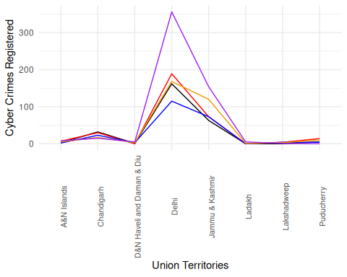

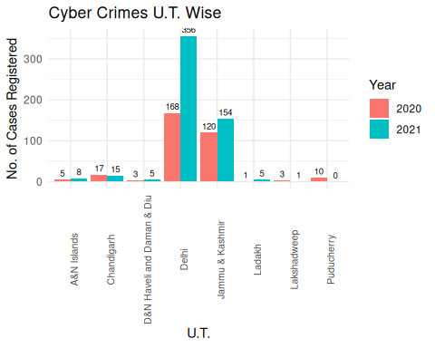

In terms of numbers, the Union Territory of Delhi registered the most 356 cyber crime cases in 2021, followed by Jammu&Kashmir and Chandigarh with 154 ans 15 cases respectively. Also, **the cases in Delhi are more than double in 2021 from 2020.** However, in terms of rates, the picture is somewhat like this in all the Union Territories:

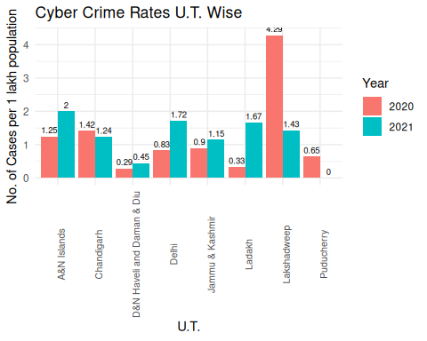

## Cyber Crime Trend India

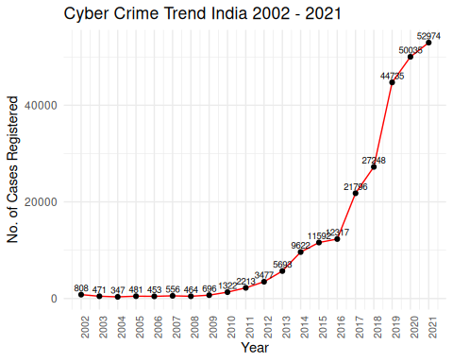

Now, the above plot shows the Trend for the number of Total Cyber Crimes registered in overall India from the year 2002 - 2021.

Now, it is evident from the plot, that India registered more than **4 times** cyber crimes in 2021 as compared to 2016.

Also, in a span of an year, India registered **1.5 times** more Cyber Crime cases in 2018 from 2017. And if we see 2018 from 2016, then the registration of the cases is **just above double**.

Also, one may note that initially, from the years 2002 - 2009, the cases registered were much much lower due to the fact that the internet was not that cheaply and easily accessible for the. people of India.  
But from the year 2016 to 2017, the cyber crimes were **almost doubled** due to the fact that in this year the telecom sector in India experienced drastic changes with the entry of Jio in the Telecom Market. To tackle with their bussiness strategies, other telecom networks reduced the data charges to a huge extent, leading to a very large increase in the Internet accessibility among the Indian Population.

Also, it is a fact that the population of India also varied in these years. For that matter, we can observe the Cyber Crime Rgistration Rate of India from 2002 - 2021 as follows:

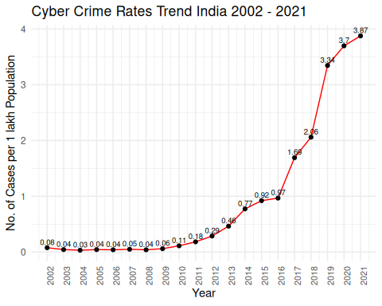

The cyber crime rate prediction for the coming years can be done using the following fitted model:

$$log\left(Y_{t}\right)=−4.26073+0.28345 t$$

or

$$Y_{t}=exp\left(−4.26073+0.28345 t\right)$$

where:  
t $≥$ 1 $Y_{t}$ 
 : Predicted Cyber Crime Rate in India for the year $\left(2001+t\right)$

##   
## Call:  
## lm(formula = log(rate) ~ t)  
##   
## Residuals:  
## Min 1Q Median 3Q Max   
## -0.93734 -0.29522 -0.01532 0.22008 1.41202   
##   
## Coefficients:  
## Estimate Std. Error t value Pr(>|t|)   
## (Intercept) -4.26073 0.24395 -17.47 9.85e-13 ***  
## t 0.28345 0.02036 13.92 4.47e-11 ***  
## ---  
## Signif. codes: 0 '***' 0.001 '**' 0.01 '*' 0.05 '.' 0.1 ' ' 1  
##   
## Residual standard error: 0.5251 on 18 degrees of freedom  
## Multiple R-squared: 0.915, Adjusted R-squared: 0.9103   
## F-statistic: 193.7 on 1 and 18 DF, p-value: 4.475e-11

Clearly, from the summary of the model, it is evident that the values of $R^{2}$ and Adjusted $R^{2}$ do not differ much. Here t denotes the time index. t = 2 corresponds to the year 2002, upto so on t = 20 for the year 2021. The parameter estimates are coming out to be highly significant.

The plot of the fitted curve along with the actual values as dots is shown below:

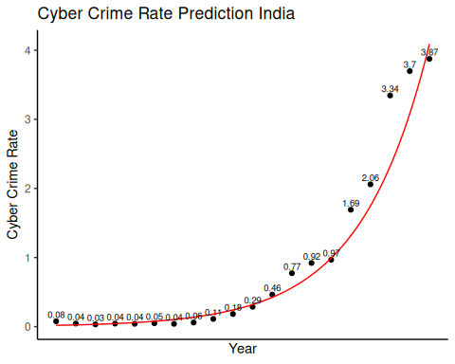

The Cyber Crime Rates predicted for the coming years using the above model are:

## year predicted_rate  
## 1 2022 5.429  
## 2 2023 7.209  
## 3 2024 9.571  
## 4 2025 12.707  
## 5 2026 16.871  
## 6 2027 22.400  
## 7 2028 29.741  
## 8 2029 39.488  
## 9 2030 52.428  
## 10 2031 69.609

To get a more clear idea about the previous year comparison, percentage increase in the cases can be calculated using the formula:

$$\text{Percentage Increase}=\frac{\text{Current Value - Previous Value}}{\text{Previous value}}*100$$

From the Percentage Increase plot, following facts can be noted:

* India registered 5.87% more cyber crimes in 2020 as compared to 2021.
* It must be noted that the any dip in the graph does not mean decrease in the crimes, rather it means that there is less percentage increase in the cases as compared to previous year. However any point below zero, i.e. negative percentage increase indicates that there are lesser number of cases from the previous year.

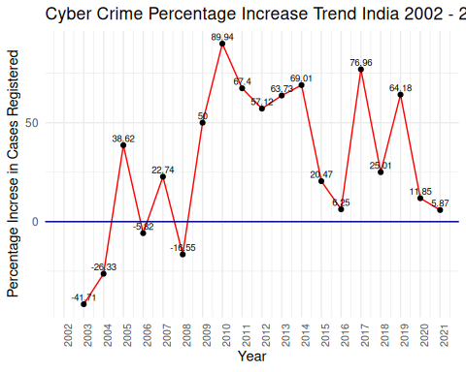

**Internet user-base of India**

Besides these cyber crime incidents and trend analysis, one should also have a look on the active internet users in India over the years. Data of active internet users in the country is taken from the world bank and visualized as follows:

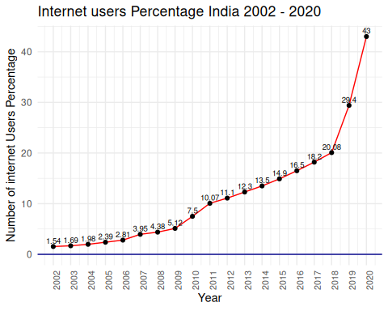

# Cyber Crime Motives

## Introduction

In this section, the motives behind the emerging cyber crime incidents in India are analyzed. Major motive is figured out and states are futher analyzed for that for the past few years. Cluster Analysis Technique is used to divide states into two groups (clusters) based on their crime incidence for the major motive keeping mid year projected population under consideration.

## Cyber Crime Motives Year Wise

### Year 2020

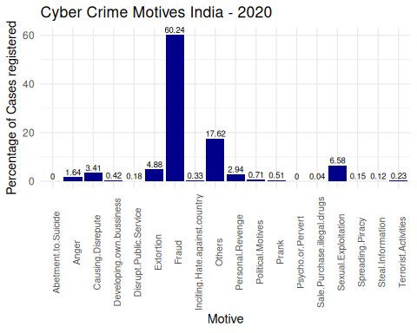

From the above figure, it is evident that, in 2020, the major motive behind the cyber crimes in India was Fraud, contributing to 60% of the total cyber crimes in India.

### Year 2021

Again in the next consecutive year 2021, it can be seen that Fraud emerges as the major cyber crime motive in India, contributing to 60.24% of the total cyber crimes in the country.

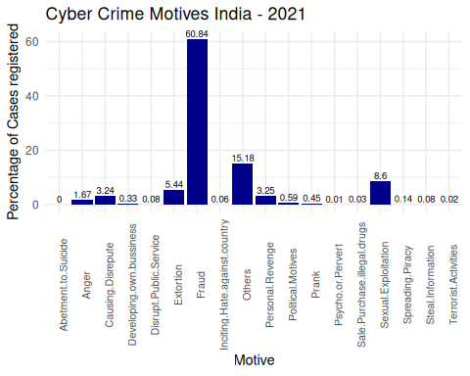

## Cluster Analysis

For the fraud cases, different states of India are divided into different clusters based on the fraction of fraud in the total cyber crimes in that states for the years 2017 to 2021.

States are divided into 4 clusters, K-Means Clustering is implemented as Non-Hierarchical cluster analysis and Agglomerative & Divisive Techniques are also implemented under Hierarchical cluster anlaysis.

### Distance Matrix Calculations

Data has been scaled to centre 0, and unit variability of each year rate (Variables).

## Andhra Pradesh Arunachal Pradesh Assam  
## Andhra Pradesh 0.000000 3.937371 4.223798  
## Arunachal Pradesh 3.937371 0.000000 3.029010  
## Assam 4.223798 3.029010 0.000000

This is some part of the 28x28 distance matrix of states.

### K-Means Clustering (Non-Hierarchical)

To determine the optimum number of clusters, consider the following plot of number of clusters v/s Total within sum of squares.

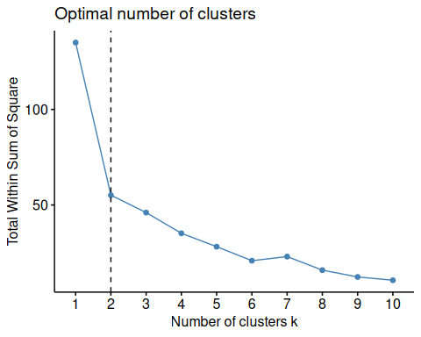

According to the above plot, the Total within sum of squares starts flattening after k = 2.

We now proceed with **K-Means clustering** with 2 clusters.

## Andhra Pradesh Arunachal Pradesh Assam Bihar   
## 2 1 1 2   
## Chhattisgarh Goa Gujarat Haryana   
## 1 2 2 1   
## Himachal Pradesh Jharkhand Karnataka Kerala   
## 1 2 2 1   
## Madhya Pradesh Maharashtra Manipur Meghalaya   
## 1 2 1 2   
## Mizoram Nagaland Odisha Punjab   
## 1 1 2 1   
## Rajasthan Sikkim Tamil Nadu Telangana   
## 1 1 1 2   
## Tripura Uttar Pradesh Uttarakhand West Bengal   
## 1 1 1 1

This is the required clustering of 28 states into 2 clusters.

Define

$$ Z_{ji} = 1, \qquad if \ \bf{X_i} \in \ jth \ cluster $$

and

$$ Z_{ji} = 0, \qquad if \ \bf{X_i} \notin \ jth \ cluster $$

where $\bf{X_i}$ is the ith case vector. i = 1,2,… N.

Let $\bf{m_j}$ be the mean vector of jth cluster, and $\bf{m}$ be the grand mean.

Let $n_{j}$ be the number of elements in the jth cluster.

The Within cluster sum of squares vector are given by:

$$WSSV=diag\left(S_{W}\right)$$

,

where

$$S_W = \frac{1}{N} \sum_{j=1}^{g} \sum_{i = 1}^{N} Z_{ji} \bf{(X_i - m_j)(X_i - m_j)'} $$

## [1] 40.44021 14.70286

The Total Within cluster sum of squares are given by:

$$WSS=trace\left(S_{W}\right)$$

, where

$$S_W = \frac{1}{N} \sum_{j=1}^{g} \sum_{i = 1}^{N} Z_{ji} \bf{(X_i - m_j)(X_i - m_j)'} $$

## [1] 55.14307

and Between Cluster Sum of Squares are:

$$BSS=trace\left(B_{W}\right)$$

, where

$$B_W = \frac{1}{N} \sum_{j=1}^{g} n_j \bf{(m_j - m)(m_j - m)'} $$

## [1] 79.85693

The Total cluster sum of squares are given by:

$$TSS=WSS+BSS$$

$\frac{WSS}{TSS}$ must be small.

## [1] 0.4084672

To have a better picture of the clusters, a look on the cluster plot will be helpful:

#### Cluster Plot

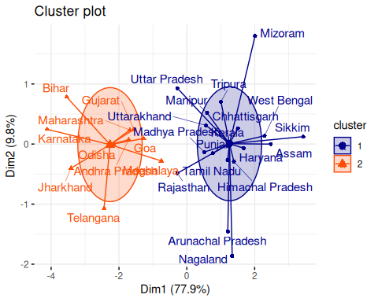

1. As it is evident from the above cluster plot that the states with fewer fraud Cyber Crimes : Arunachal Pradesh and Nagaland are in one cluster.
2. However the states with extensive fraud rates: Karnataka, Bihar,Telangana, Jharkhand,Uttar Pradesh, Maharashtra etc. are in other cluster.

### Hierarchical Clustering

#### Agglomerative Clustering

Also, Under the Hierarchical Clustering, using **Agglomerative Custering** with *Ward D2 Linkage*, the states are more likely to be divided into 2 clusters.

The states with major fraction of the Fraud cases are in one Cluster: Telangana, Jharkhand, Bihar etc.

However, the states with comparatively lesser number of frauds are in the other cluster.

The cluster means are given by

## rate2021 rate2020 rate2019 rate2018 rate2017   
## 0.5713483 0.6334256 0.5143662 0.4825693 0.4667825

## rate2021 rate2020 rate2019 rate2018 rate2017   
## 0.2367204 0.2255833 0.1450668 0.2455529 0.2827396

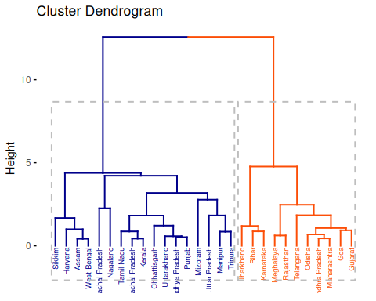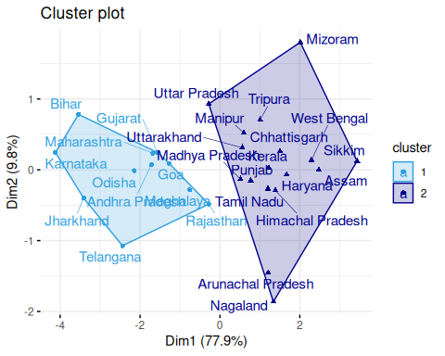 Previously, for better demarkation, we applied K-Means clusteing for 4 clusters. However, under the Hierarchical Clustering, using **Agglomerative Custering** with *Ward D2 Linkage*, the states are more likely to be divided into 2 clusters.

#### Divisive Clustering

On the other hand, if **Divisive Clustering** is applied, the two main clusters so formed are given as follows:

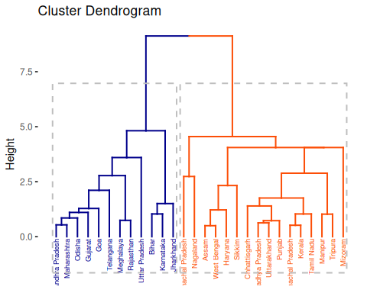

# Analysis of Cyber crimes under IT Act and IPC Act

## Introduction

### Information Technology ACT, 2000

The IT Act was introduced in 17 October 2000. It is the primary law in India dealing with cyber crime and electronic commerce. The original Act contained 94 sections, divided into 13 chapters and 4 schedules. The laws apply to the whole of India. If a crime involves a computer or network located in India, persons of other nationalities can also be indicted under the law. The sections of IT Act included in the analysis are

* Tampering Computer Source Documents (Section 65)
* Computer Related Offences (Sec 66 & Sec 66 B to E)(TOTAL)
* Cyber Terrorism (Section 66F)
* Publication/ transmission of obscene / sexually explicit act in electronic form

|  |
| --- |
| rates section-wise yearly it-act cases |

rates section-wise yearly it-act cases

The figure 1 shows the rate of cases of Information Technology Act, 2000 being registered in INDIA per 1 lakh population in years 2016-21. One must note that the COMPUTER RELATED OFFENSES (Sec 66 & Sec 66 B to E) are reported mostly.

#### Computer Related Offenses (Sec 66 & Sec 66 B to E)

This includes punishment regarding sending offensive messages through communication service,Punishment for dishonestly receiving stolen computer resource or communication, Punishment for identity theft, Punishment for cheating by personation by using computer resource, Punishment for violation of privacy, Penalty and compensation for damage to computer, computer system, etc.

### Indian Penal Code , 1862

The Indian Penal Code (IPC) is the official criminal code of India. It is a comprehensive code intended to cover all substantive aspects of criminal law. It came into force in India during the British rule in 1862. The sections of IPC included in the analysis are

* Data theft (Sec.379 to 381)
* Fraud (Sec.420 r/w Sec.465,468-471 IPC)
* Cheating (Sec.420)
* Forgery (Sec.465, 468 & 471)

|  |
| --- |
| rates section-wise yearly ipc-act cases |

rates section-wise yearly ipc-act cases

The figure 2 shows the rate of cases of Indian Penal Code (here only those sections are included which include punishments to cyber crimes ) being registered in INDIA per 1 lakh population in years 2016-21. One must note that the FRAUD cases are reported mostly.

#### Fraud (Sec.420 r/w Sec.465,468-471 IPC)

This include that whoever cheats and thereby dishonestly induces the person deceived to deliver any property to any person, or to make, alter or destroy the whole or any part of a valuable security, or anything which is signed or sealed, and which is capable of being converted into a valuable security, shall be punished with imprisonment and shall also be liable to fine.

## Percentage share of major crimes under IT Act and IPC

## year CRO Total per_share  
## [1,] 2016 0.5351648 0.9667975 55.3544  
## [2,] 2017 0.7844598 1.6915400 46.3755  
## [3,] 2018 1.0685517 2.0589702 51.8974  
## [4,] 2019 1.7652248 3.3300190 53.0095  
## [5,] 2020 1.6198963 3.6969307 43.8173  
## [6,] 2021 1.4566373 3.8746626 37.5939

## year Fraud Total per_share  
## [1,] 2016 0.004395604 0.9667975 0.4547  
## [2,] 2017 0.268988693 1.6915400 15.9020  
## [3,] 2018 0.253366380 2.0589702 12.3055  
## [4,] 2019 0.465976884 3.3300190 13.9932  
## [5,] 2020 0.768054263 3.6969307 20.7755  
## [6,] 2021 1.024510127 3.8746626 26.4413

The above data table shows that Computer Related Offenses (Sec 66 & Sec 66 B to E) ,( here , Computer Related Offenses (Sec 66 & Sec 66 B to E) is named CRO ) , has been contributing about 48% and Fraud contribute about 15% of the total cyber crimes each year as per the NCRB data for cyber crimes from year 2016 - 2021. Hence Computer Related Offenses (Sec 66 & Sec 66 B to E) is the major contributor to the cyber crimes in INDIA.

## Randomness and Association

### 1-sample Run test for randomness

1-sample run test is used to test whether the observations are random

#### Computer related offenses (Sec 66 & Sec 66 B to E)

##   
## Runs Test for Randomness  
##   
## data: cro_c  
## runs = 2, m = 3, n = 3, p-value = 0.2  
## alternative hypothesis: true number of runs is not equal the expected number  
## sample estimates:  
## median(x)   
## 17028

This shows that year wise incidence of cases of Computer related offenses is random .

#### Fraud

##   
## Runs Test for Randomness  
##   
## data: fr_c  
## runs = 2, m = 3, n = 3, p-value = 0.2  
## alternative hypothesis: true number of runs is not equal the expected number  
## sample estimates:  
## median(x)   
## 4849.5

This shows that year wise incidence of cases of Fraud is random .

### Kolmogorov Smirnov test

This test is used for testing whether both the samples come from same distribution

Test statistics,

where $F_{1,n}$ and $F_{2,m}$ are the empirical distribution functions of the first and the second sample respectively, and sup is the supremum function.

##   
## Exact two-sample Kolmogorov-Smirnov test  
##   
## data: y2016 and y2021  
## D = 0.14286, p-value = 0.9333  
## alternative hypothesis: two-sided

##   
## Exact two-sample Kolmogorov-Smirnov test  
##   
## data: y2017 and y2021  
## D = 0.14286, p-value = 0.9366  
## alternative hypothesis: two-sided

##   
## Exact two-sample Kolmogorov-Smirnov test  
##   
## data: y2018 and y2021  
## D = 0.10714, p-value = 0.9956  
## alternative hypothesis: two-sided

##   
## Exact two-sample Kolmogorov-Smirnov test  
##   
## data: y2019 and y2021  
## D = 0.14286, p-value = 0.9301  
## alternative hypothesis: two-sided

##   
## Exact two-sample Kolmogorov-Smirnov test  
##   
## data: y2020 and y2021  
## D = 0.14286, p-value = 0.9361  
## alternative hypothesis: two-sided

This shows that the distribution of computer related offenses throughout the states remains the same in the years 2016 - 2021 i.e. cases are concentrated in specific states and are distrubuted similarily each year.

### Kendall Tau Measure of Association

It measures the relationship between two columns of ranked data.

Null hypothesis, The columns are not associated with each other against, The columns are associated with each other

Test statistics,

Test is to reject null hypothesis for

##   
## Kendall's rank correlation tau  
##   
## data: cro_c and fr_c  
## T = 11, p-value = 0.2722  
## alternative hypothesis: true tau is not equal to 0  
## sample estimates:  
## tau   
## 0.4666667

This shows that there is no association between cyber crimes under Computer Related Offenses (Sec 66 & Sec 66 B to E) and Fraud.

## Testing variability and location

Now, checking for variability wrt location and scale for Computer Related Offenses (Sec 66 & Sec 66 B to E) in years 2016-21 using Levene’s Test for variability and Kruskal Wallis Test for location

### Levene Test

Null hypothesis, variances of all samples are equal against , variances of all samples are not equal

Test statistics,

where, k: number of different groups to which the sampled cases belong. Ni: Number of elements in different groups. N: total number of cases in all groups

where, $Y_{ij}$: the value of jth case and ith group

Test is to reject null hypothesis for larger values of W

## Levene's Test for Homogeneity of Variance (center = median)  
## Df F value Pr(>F)  
## group 5 0.6081 0.6938  
## 162

Since p-value > 0.05 , for levene’s test hence the test is not significant i.e. we failed to reject null hypothesis. Therefore there is no significant variability in the data through 2016-21

Now testing for equality in location using Kruskal Wallis Test

### Kruskal Wallis Test

Null hypothesis, location of all populations is same against, location of any two populations differs

Test Statistics,

Test is to reject null hypothesis for large values OF H

##   
## Kruskal-Wallis rank sum test  
##   
## data: cases by as.factor(year)  
## Kruskal-Wallis chi-squared = 1.0211, df = 5, p-value = 0.9608

Since p-value > 0.05 , for Kruskal Wallis test, the result is not significant i.e. we failed to reject null hypothesis. Therefore there is no significant change in the locations throughout the years 2016-21

Hence, from both the tests,  
Since there is no significant difference in location and variability in different years. Hence we conclude that Computer Related Offenses (Sec 66 & Sec 66 B to E) are statistically same in terms of location and variability for different states.

## State-wise comparison for Cases of Computer Related Offenses (Sec 66 & Sec 66 B to E)

### Count of cases in each state

|  |
| --- |
| counts state-wise yearly CRO cases |

counts state-wise yearly CRO cases

The figure 3 shows the highest number of cases being registered in Karnataka, followed by Uttar Pradesh and Assam. But one must note that the population in these states may vary. So to get a better comparison, rates can be calculated, which gives the cyber crime cases registered in the state per 1 lakh population. Mid year projected population for each state for the year 2016 - 2021 is available. Hence the Crime Rate can be calculated.

### Crime rate in each state

|  |
| --- |
| rates state-wise yearly CRO cases |

rates state-wise yearly CRO cases

The figure 4 shows the highest rate of cases being registered in Karnataka wrt 1 Lakh population in respective year, followed by Assam and UttarPradesh. But one must note that the Uttrakhand had observed a peak in year 2021

The crime rate as well as counts of cyber crimes in Karnataka is surprisingly high. The pattern of crime rate wrt 1 Lakh population in respective year in Karnataka can be seen in figure 5.

|  |
| --- |
| karnataka |

karnataka

### Year wise increment of Computer Related Offenses (Sec 66 & Sec 66 B to E)

## year CRO per_inc  
## [1,] 2016 0.5351648 NA  
## [2,] 2017 0.7844598 46.5828  
## [3,] 2018 1.0685517 36.2150  
## [4,] 2019 1.7652248 65.1979  
## [5,] 2020 1.6198963 -8.2329  
## [6,] 2021 1.4566373 -10.0784

The above data table shows the Computer Related Offenses got a peak in year 2019 when they increased by 65% as compared to previous year 2018. However a slight % decrease can be seen after that .

## References:

* Cyber Crimes data: National Crime Records Bureau (NCRB), Ministry of Home Affairs, Govt. of India.
* Individuals using the Internet (% of population) - India: International Telecommunication Union ( ITU ) World Telecommunication/ICT Indicators Database.
* M. Dasgupta, Cyber Crime in India: A Comparative Study.
* Apoorva Bhangla and Jahanvi Tuli, A Study of Cyber Crime and its Legal Framework in India.
* Anupreet Kaur Mokha, A Study on Awareness of Cyber Crimes and Cyber Security.
* Shivani Reddy, Analytical Study on Cyber Crimes in India.