Image processing | Task No. 2
Task variant: H3 S1 O5
Day and time: 13.11.2013  Academic year 2013/2014 | Full name Piotr Łukomiak  Full name Krzysztof Palka
Description of the implementation of the histogram-based image enhancement method
Firstly, we wrote algorithm according to formula:
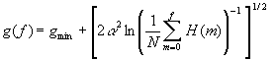

Here g is old brightness and f is an old brightness of the pixel. We decided to precompute all possible values of pixels. To do it algorithm calculate histogram (TC: O(N), N—the number of pixels), than in loop from 0 to 255 calculate new value. Inside this loop we put another one, from current element to 255—to increase next values with current value ([256-0]/2*256 operations). After applying inversing operation (the power of -1) we encountered a problem—if we'd plot previous new values, we'll obtain non-decreasing function (Cumulative distribution function), after this transformation we'll obtain non-increasing function. That means—even after applying all reaming operations the highest values will be placed at the beginning—those values which should be the lowest. So we decided to “invert” values—when we checking new value, it is taken with index: 255 - old index. Thanks to this trick assigned function seems to have sense—we don't obtaining something like negative anymore. Then we iterates through all pixels assigning new values (TC: O(N), N—the number of pixels). g_{min} mean minimum value. We decided to set it to 0—increasing it would not improver contrast in anyway—it'll just shift the histogram. α is argument received form user—usually 150 – 200. It is possible to operate on single channel if --channel parameter is set as well as on all channels—when it is not or when is set to “A”, which stands for “all”. The bigger the parameter is, the brighter the is the image.
Image analysis on the basis of the histogram
To decide which parameter use we made a following graph...
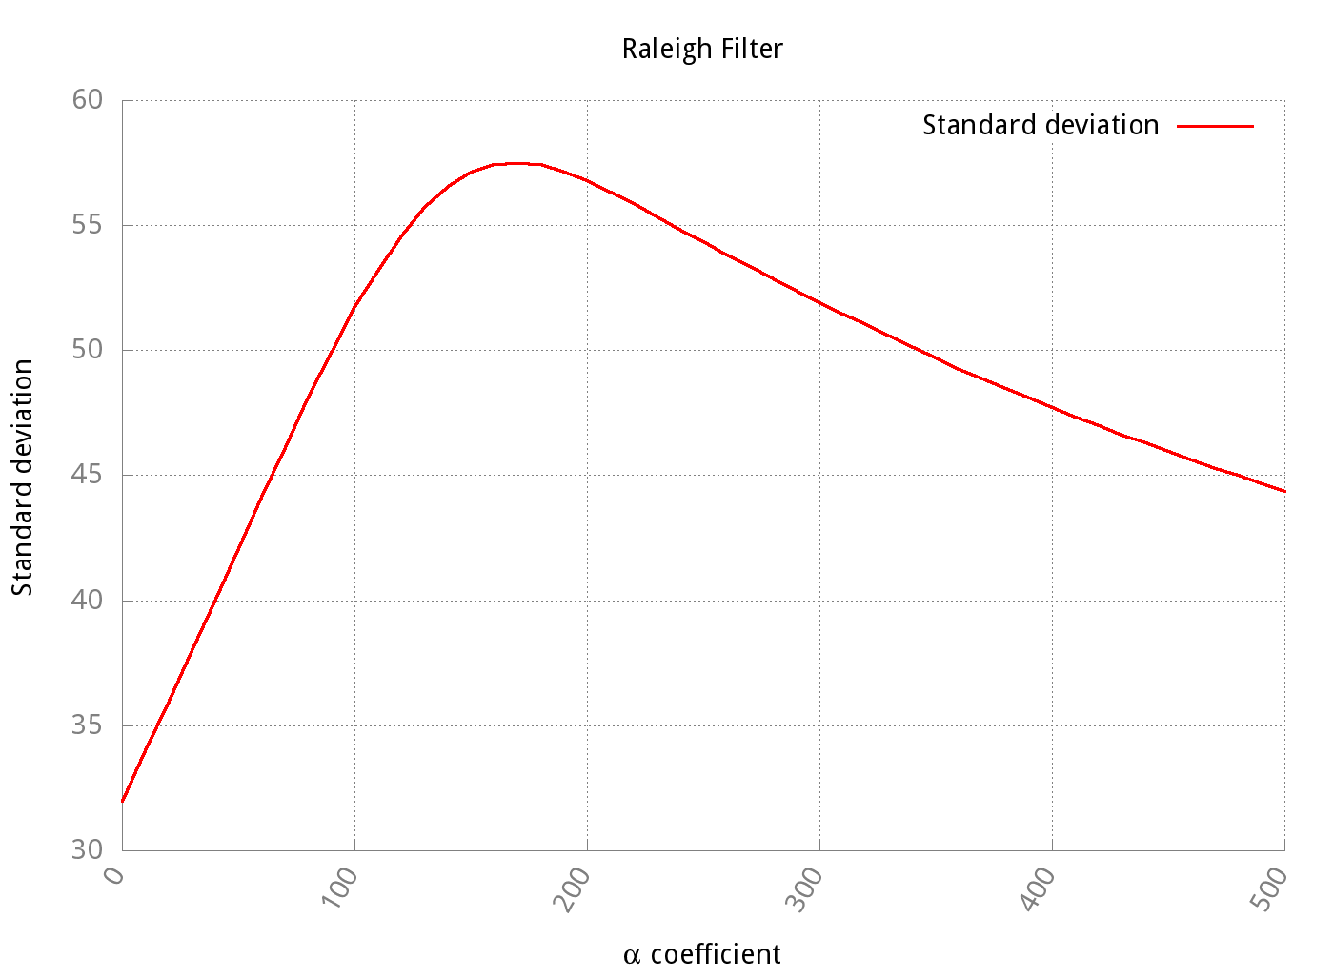
…and we have chosen 165.
Black and white image
Original:  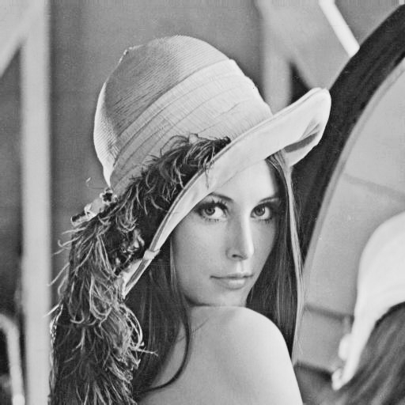  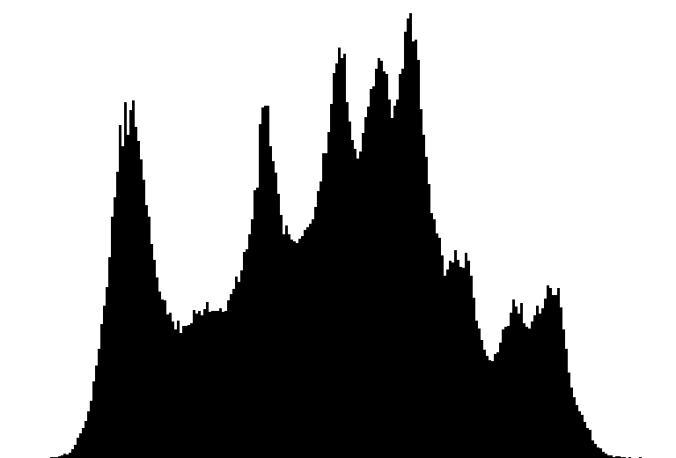 | “Improved” (--hraleigh 165):  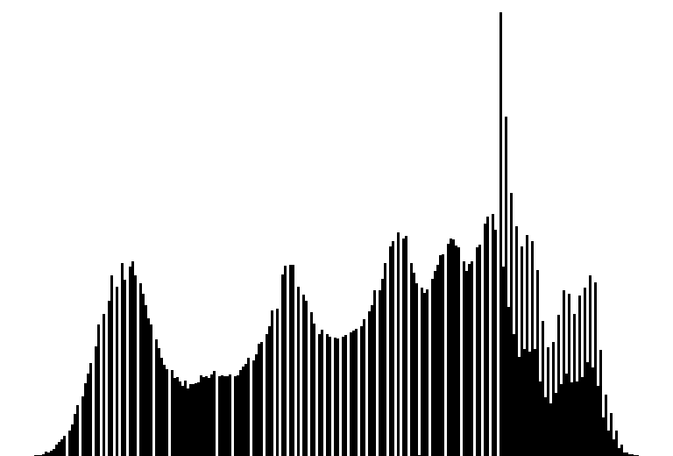
Even if big improvement is not visible at first glance, histogram shows that distribution of brightness is better. As well as Image charcteristics:
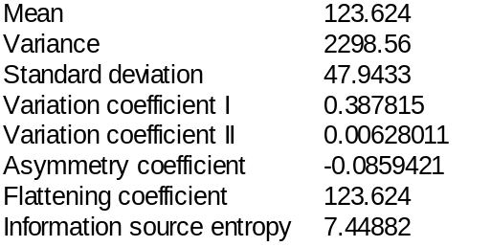 | 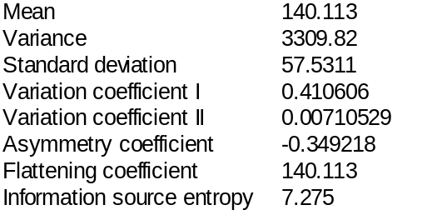
Higher mean sugests that image is a litte bit brighter.
Color image:
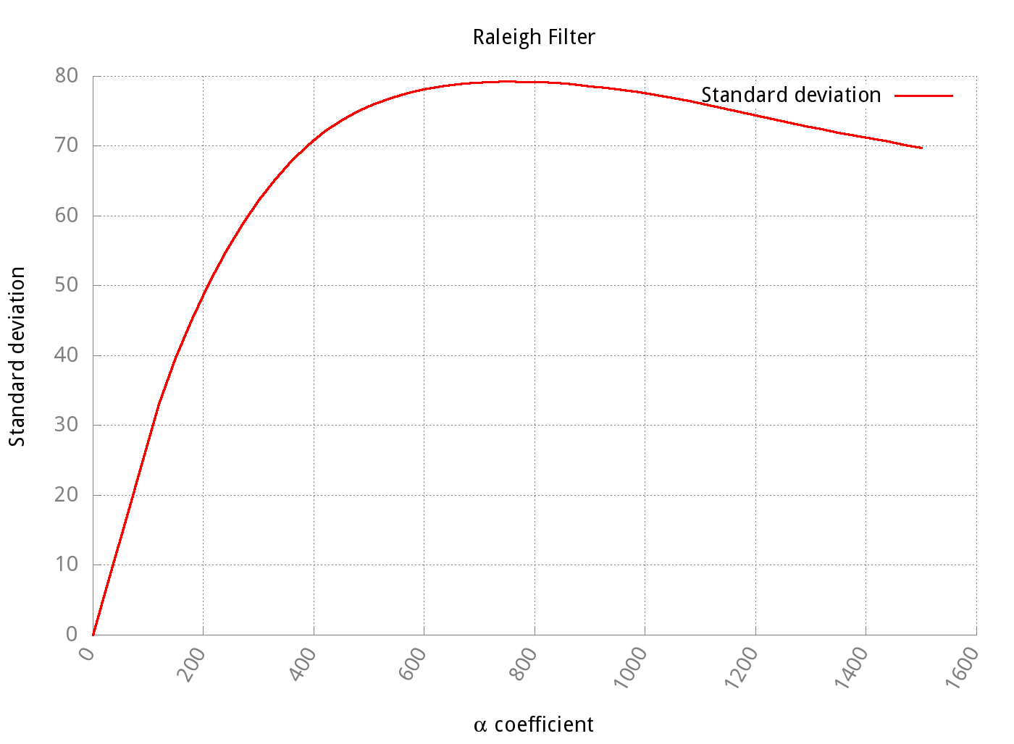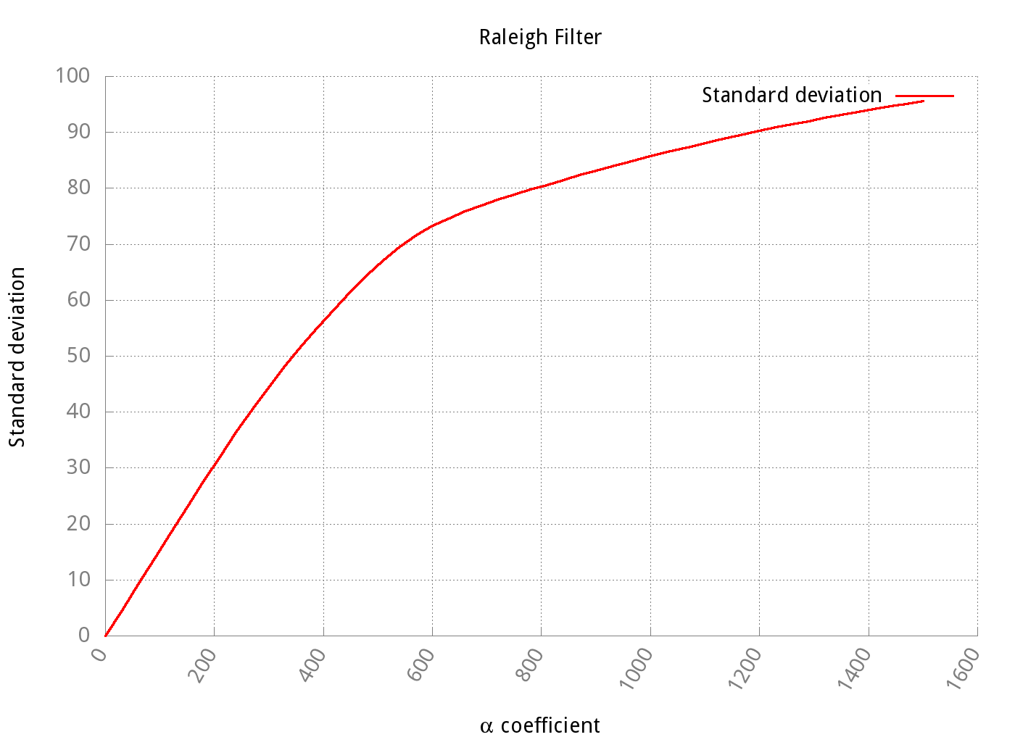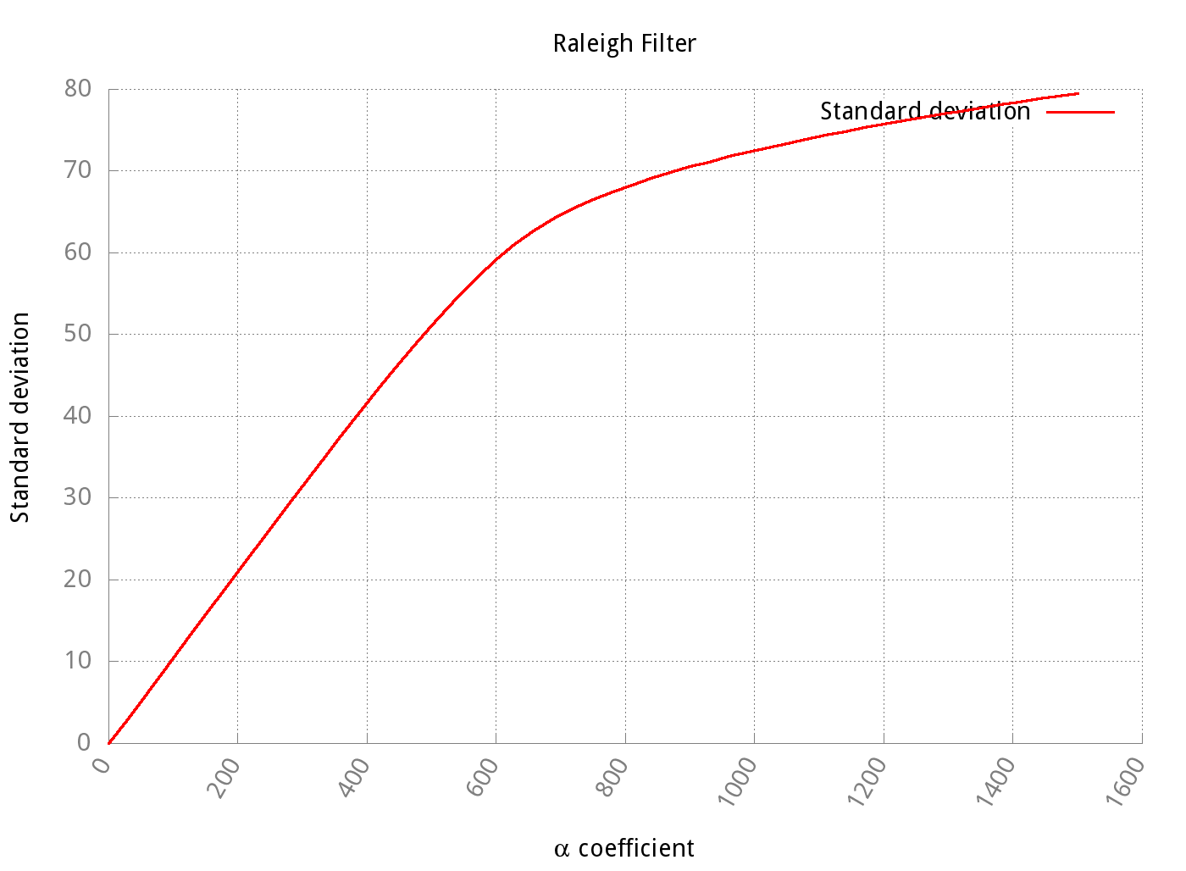
Red: peak at 750 = 79.267, Green—to avoid excessive overburing the image we've choose α at 1230 = 90.8688, and as Blue channel at α =1500 gets sdv similar to red (79.4821), we've chooce this value.
As value of red grows faster, than if we've chosed uniform value of α, in this case 320, we get image with red cast
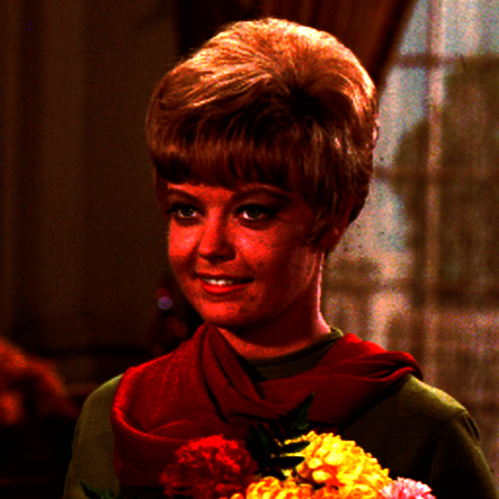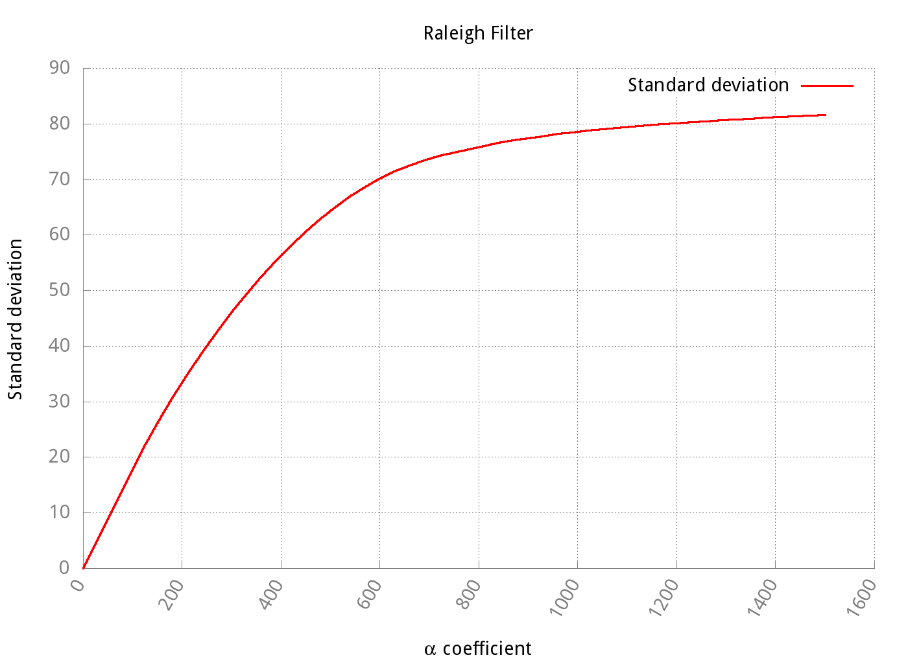
Uniform α parameter. Graph shows average value of R, G and B

Original:  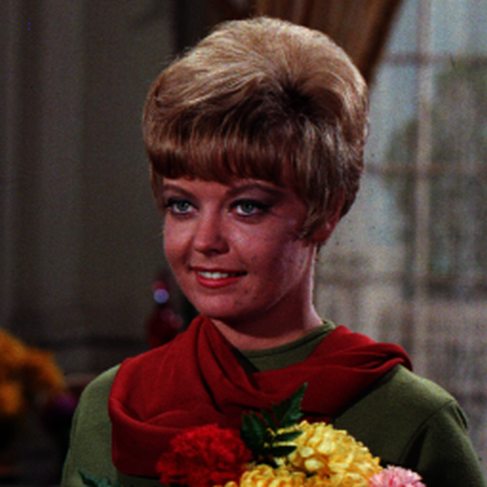 | “Improved” (--hraleigh 750 --channel R / --hraleigh 1230 --channel G / --hraleigh 1500 --channel B / ):  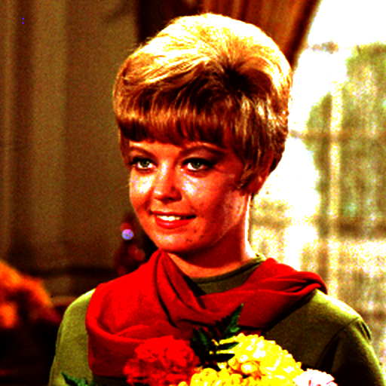
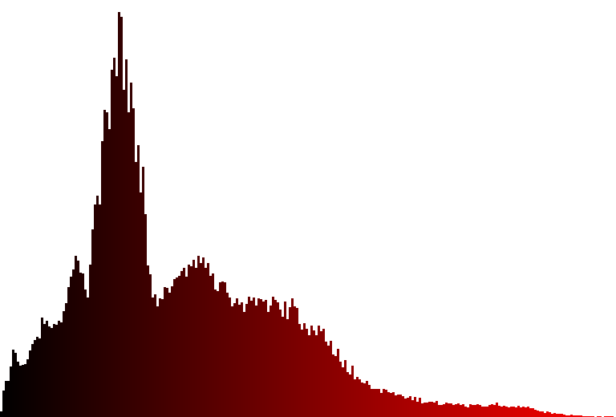 | 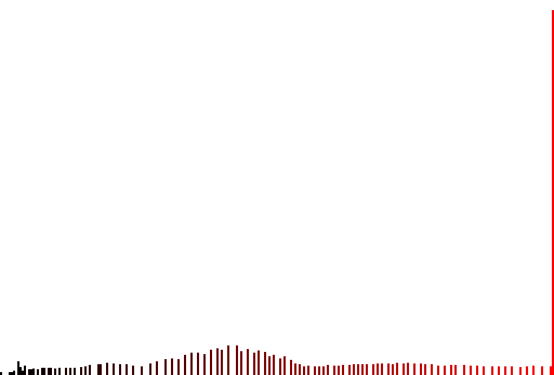
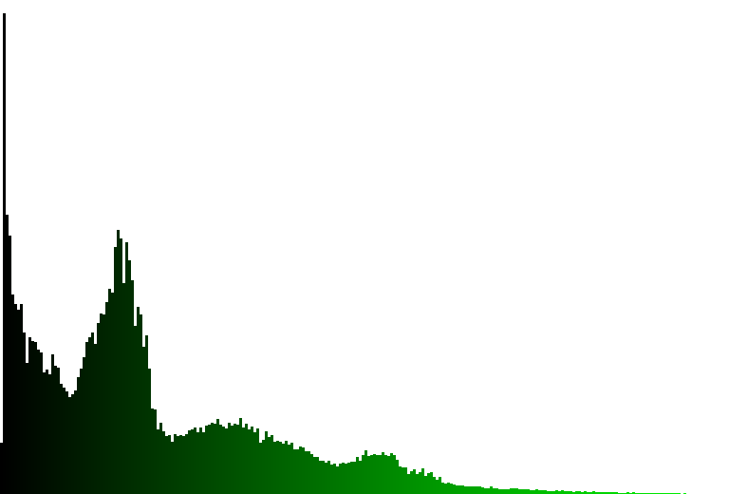 | 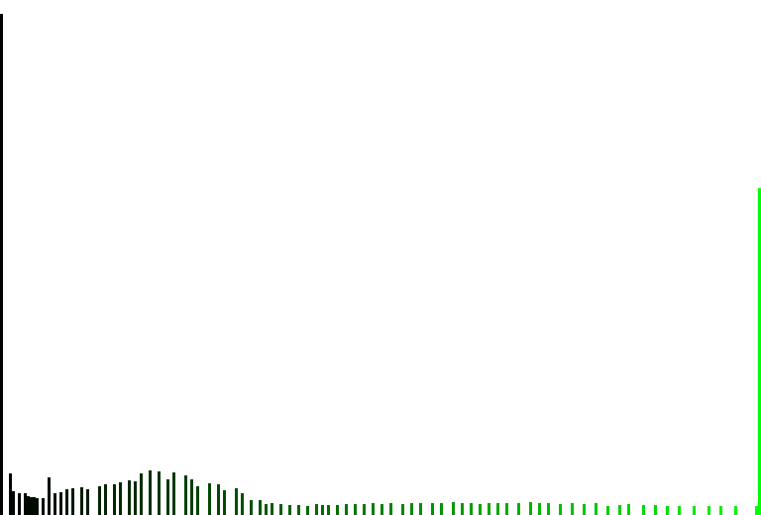
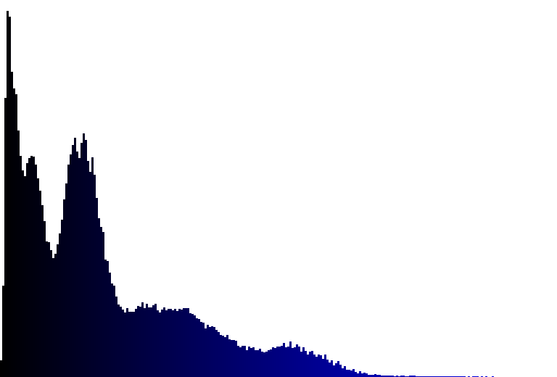 | 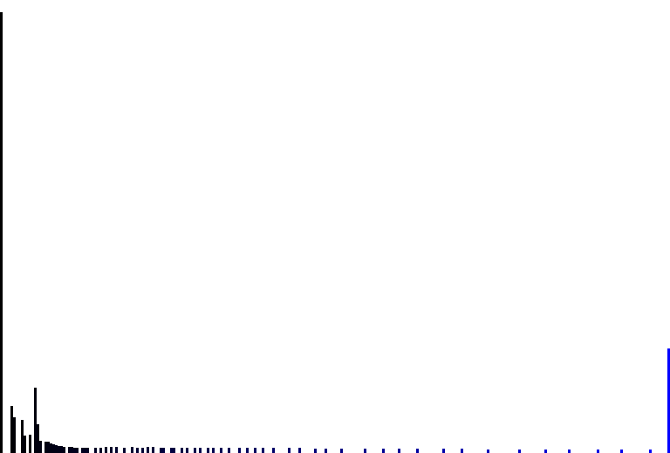
Conclusion: higher sdv doesn't mean better image. With high alpha parameters the image is in some places overburned. But at least one can say that the image have wider range of intensities. What is more—the noise is more visible. This method could be used to improve image, but the best situation would be if sb. can see histogram during modification of the image to deduce when to stop increasing value of alpha. Images with bad contrast would be appropriate for that filter.

Description of the linear filter implementation (general formulation)
To apply any given mask algorithm should iterate over all pixels, sum up value of processing pixel and its neighbors earlier multiplied by value given in the appropriate mask field. On the borers in case, where mask's size is for example 3x3 loop can skip 1 pixel by the border, in case of mask of size 5x5 2 pixels and so on. Later it can copy the values nearest borders and fill missing pixels. Another approach is to just not sum values outside borders and iterate through whole image. Sometimes summed value is divided by given number, so it is good idea to use appropriate variable that can contain more than 255 values, so after division result value could be again in permitted range. In case of our variant, (Low-pass filter, first mask) we just use arithmetic mean filter to limit extreme values. We dividing sum of surrounding pixels by 9, as the mask is 3x3. Then we are assigning new value to currently processing pixel, and after whole loop we copying neighbor values of “empty pixels”
Description of the linear filter implementation (with optimization)
For low pass filter we have chosen 3x3 mask with all factors equals to 1, with blur the image like a arithmetic mean filter. (TC: O(N), N—the number of pixels). As all fields of mask are equal to 1, there is no possibility of skipping some fields (like in case where there are some 0s). But the value of any neighbor does not have to be multiplied by any factor.
Analysis of the filtering results (linear filter)
We tested this filter on image with noise with uniform distribution
Original: | --slowpass
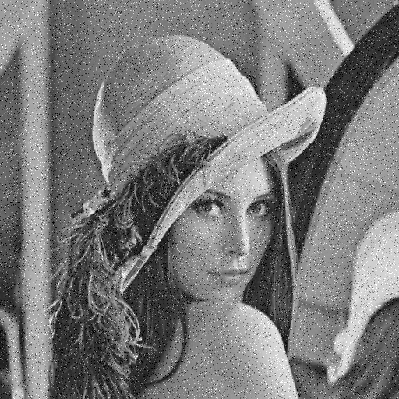 | 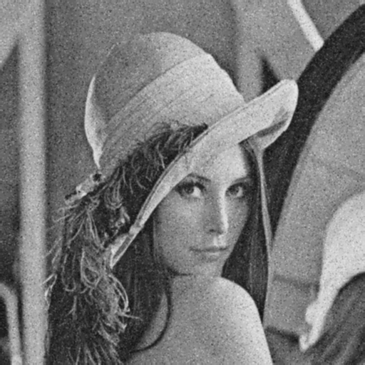
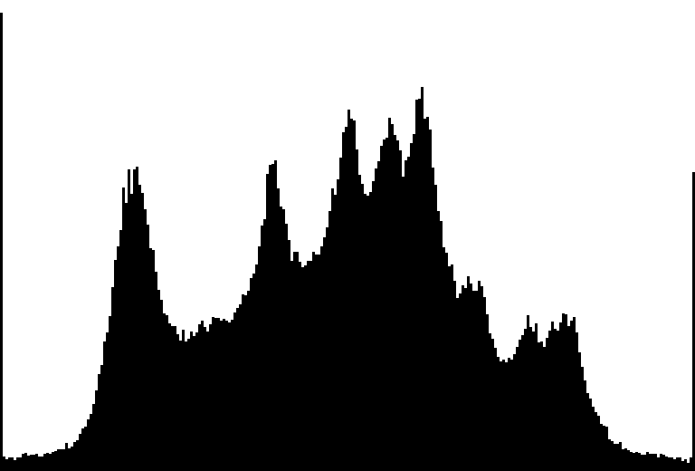 | 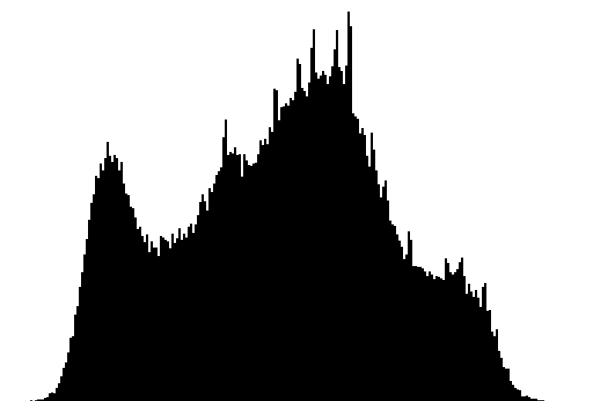
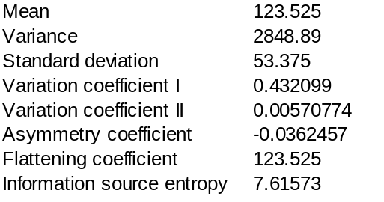 | 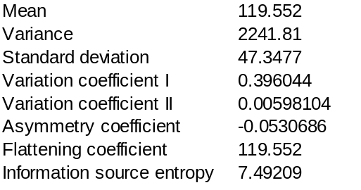
After applying this filer the most extrema values, as it is visible on histogram, disappeard. The histogram is more narrow (lower SD). That contrast of new image is smaller and image itself is blur. Bu this filter helped to remove, or rather blur the noise.
Description of the non-linear filter implementation

Here, the description of the non-linear filter implementation should be placed, with special attention paid to methods of its potential optimization and solving some possible unusual situations.
Analysis of the filtering results (non-linear filter)
In this section the analysis of the results of the non-linear filter application should be placed for different image types, along with observations about: the way the filter modifies an image, what can it be applied for, what influences its operation, etc.
Description of other changes which took place in the application
In this place, the description of any other changes which have taken place in the application since the last report should be presented. Please, boast about everything :-)
Teacher's remarks

This is a section for teacher's remarks for the laboratory group (please leave some free place).

