MULTI-CHANNEL FASHION MARKETING CASE STUDY
PLAYHAUS
Improving paid media efficiency while defining a focused SEO roadmap
INDUSTRY  Fashion / e-commerce | CHANNELS  SEO, Google Ads, TikTok Ads
ACTIVE PERIOD  August 2026 | PROJECT STATUS  Paused 22 August at client instruction

14  TIKTOK CONVERSIONS | $0.29  TIKTOK AVG. CPC | 3.42%  TIKTOK CTR | $22.13  GOOGLE COST / CONVERSION

Executive Summary
PLAYHAUS needed a channel-specific approach aligned with its positioning as a fashion brand. The work combined SEO planning with Google Ads and TikTok Ads management, focusing on search efficiency, cost-effective traffic and measurable conversions.

Results at a Glance
- Google Ads conversions increased from 1 to 2, while implied cost per conversion improved from $45.99 to $22.13 - approximately 51.9% lower.
- TikTok generated 14 conversions from $144.39 in broader-period spend, equal to an implied blended cost per conversion of approximately $10.31.
- A phased SEO scope was prepared around keywords, metadata, technical fixes, schema, content and speed.
MY CONTRIBUTION
SEO prioritization and implementation planning; Google Ads monitoring and optimization; TikTok creative and audience testing; budget and targeting adjustments; performance reporting and next-step recommendations.

PAID SEARCH PERFORMANCE

Google Ads: Higher Conversion Efficiency
The second available reporting window produced twice as many conversions on slightly lower spend. This lifted the reported conversion rate to 3.08% and reduced cost per conversion to $22.13.
Metric | 1-9 Aug | 8-16 Aug | Change | Interpretation
Impressions | 3,386 | 2,363 | -30.2% | Lower reach
Clicks | 70 | 65 | -7.1% | Traffic remained close
Spend | $45.99 | $44.26 | -3.8% | Slightly lower spend
CTR | 2.07%* | 2.75% | +0.68 pp | Improved click efficiency
Conversions | 1 | 2 | +100% | Conversion volume doubled
Conversion rate | 1.43%* | 3.08% | +1.65 pp | Stronger traffic quality
Cost / conversion | $45.99* | $22.13 | -51.9% | More efficient acquisition
*Calculated from supplied clicks, spend and conversion totals. Percentage-point change shown as pp.

Optimization Focus
- Reviewed search terms and identified negative keyword opportunities.
- Monitored budget use, click trend and conversion cost.
- Planned keyword, targeting and ad relevance refinements.
- Reviewed conversion tracking, including the enhanced-conversions warning.
- Prepared landing-page and ad-copy recommendations to improve qualified traffic.
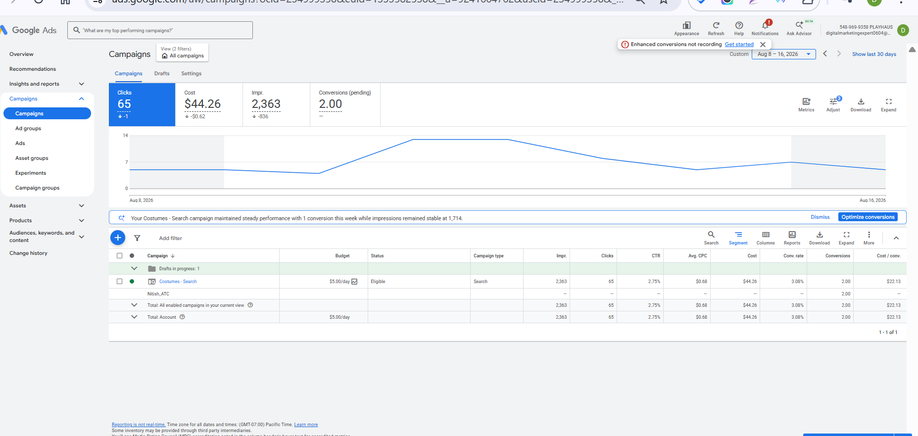
Google Ads campaign view, 8-16 August 2026. Account-identifying header information has been excluded from the portfolio view.
REPORTING NOTE
The supplied Google Ads windows overlap on 8-9 August, so the comparison is directional. The two 8-16 August conversions were shown as pending when reported.

SOCIAL PERFORMANCE

TikTok Ads: Cost-Efficient Attention and Conversions
11,546  IMPRESSIONS | 395  CLICKS | 3.42%  CTR | 4  LATEST-PERIOD CONVERSIONS

TikTok creatives generated a 3.42% click-through rate and an average CPC of $0.29 in the supplied campaign view. The broader campaign period generated 14 conversions from $144.39 in spend.
PERFORMANCE TAKEAWAY
TikTok was the stronger traffic-efficiency channel in the supplied data. The combination of a 3.42% CTR, $0.29 average CPC and measurable conversions indicates that the creative-led approach was attracting attention at a comparatively low click cost.

TikTok Optimization Work
- Tested video creative concepts and monitored response by creative.
- Tested and refined audiences based on campaign performance.
- Adjusted budget and targeting to support stronger-performing combinations.
- Tracked conversions and identified creatives and audiences worth prioritizing.

ORGANIC GROWTH FOUNDATION

SEO: Focused Roadmap for a Fashion Brand
After reviewing the initial audit, the client prioritized SEO and technical improvements instead of broader UX/UI recommendations. The approved scope was translated into a phased work plan with estimated implementation hours.
Keyword research | Keyword mapping
Meta titles and descriptions | Technical SEO fixes
Schema implementation | Content planning
Website speed optimization | Phased implementation plan

SCOPE ACCURACY
The SEO strategy, priorities and implementation plan were prepared and shared; no completed SEO implementation or ranking outcome is claimed. Overall, Google Ads improved conversion efficiency, TikTok delivered cost-efficient traffic and measurable conversions, and the SEO roadmap established the next practical phase. Work stopped on 22 August 2026 following instructions to pause.

