**Project**

DIGITAL CAMERA

**Procedure:**

**Step 1:** Open Blender. Create a blank file.

**Step 2:** Add a plane and scale it to an average area of a Digital Camera using Shift+A>S.

**Step 3:** Switch to edit mode using TAB.

**Step 4:** Add some lines to create a 2D drawing.

**Step 5:** Now, we extrude (E) the drawing up to the height of an average camera.

**Step 6:** To make the lens of the camera, again select a plane.

**Step 7:** Now, create a 2D drawing to make a camera lens.

**Step 8:** Now, add thickness to the camera lens by extrude (E) command.

**Step 9:** To make a plane and draw a 2D drawing.

**Step 10:** Now to create a button (E) extrude the same command to have 3D buttons to the camera.

**Step 11:** Adding fillet to the edges of the camera.

**Screenshots:**

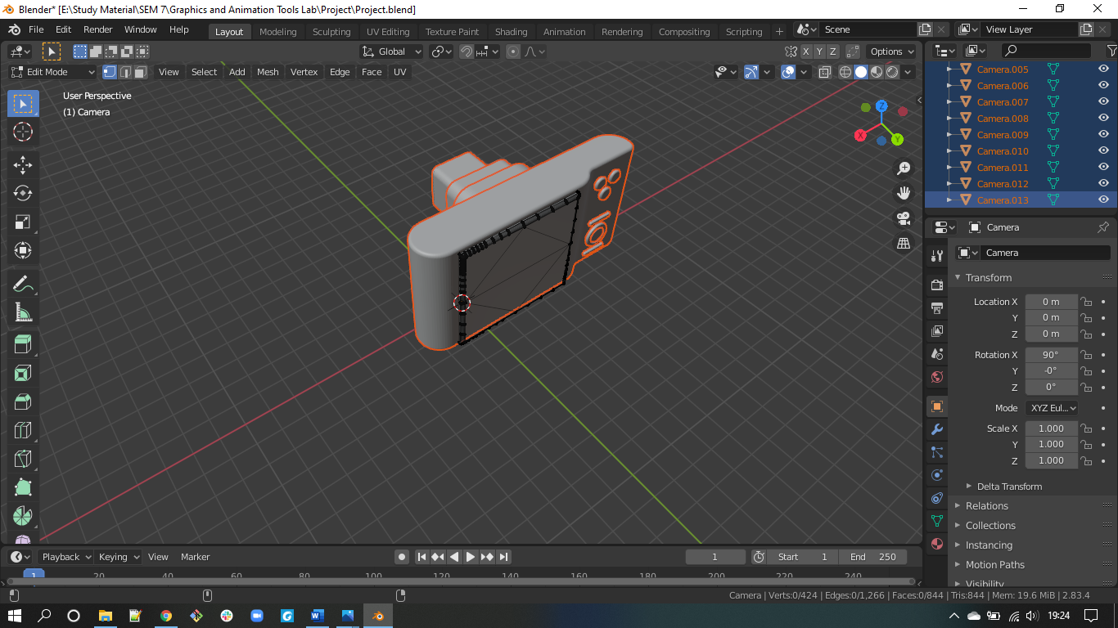

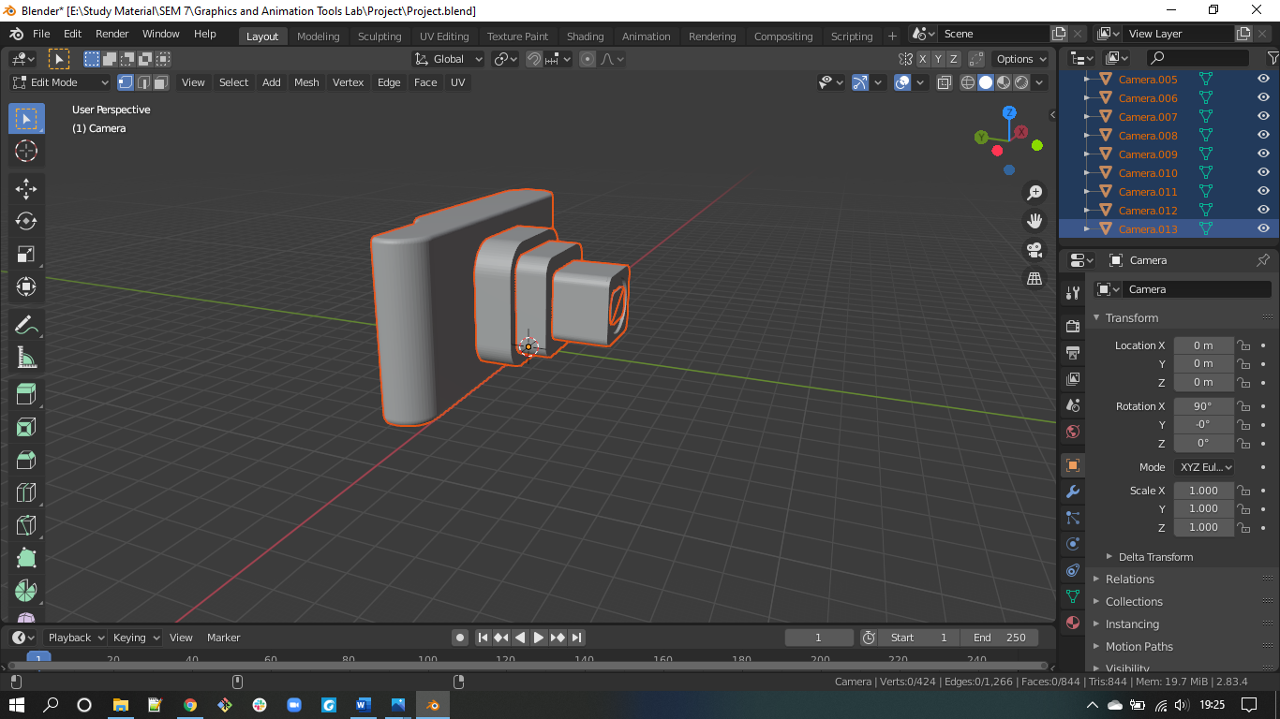

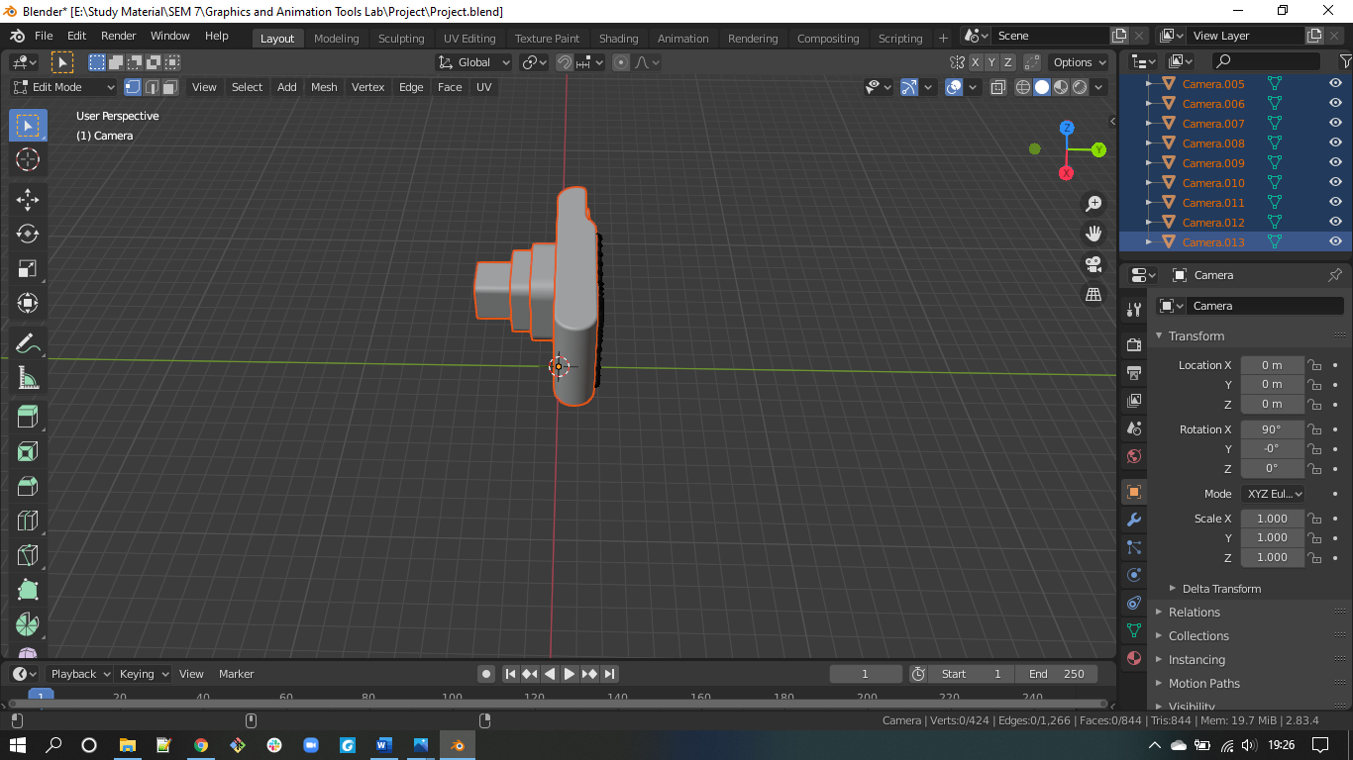

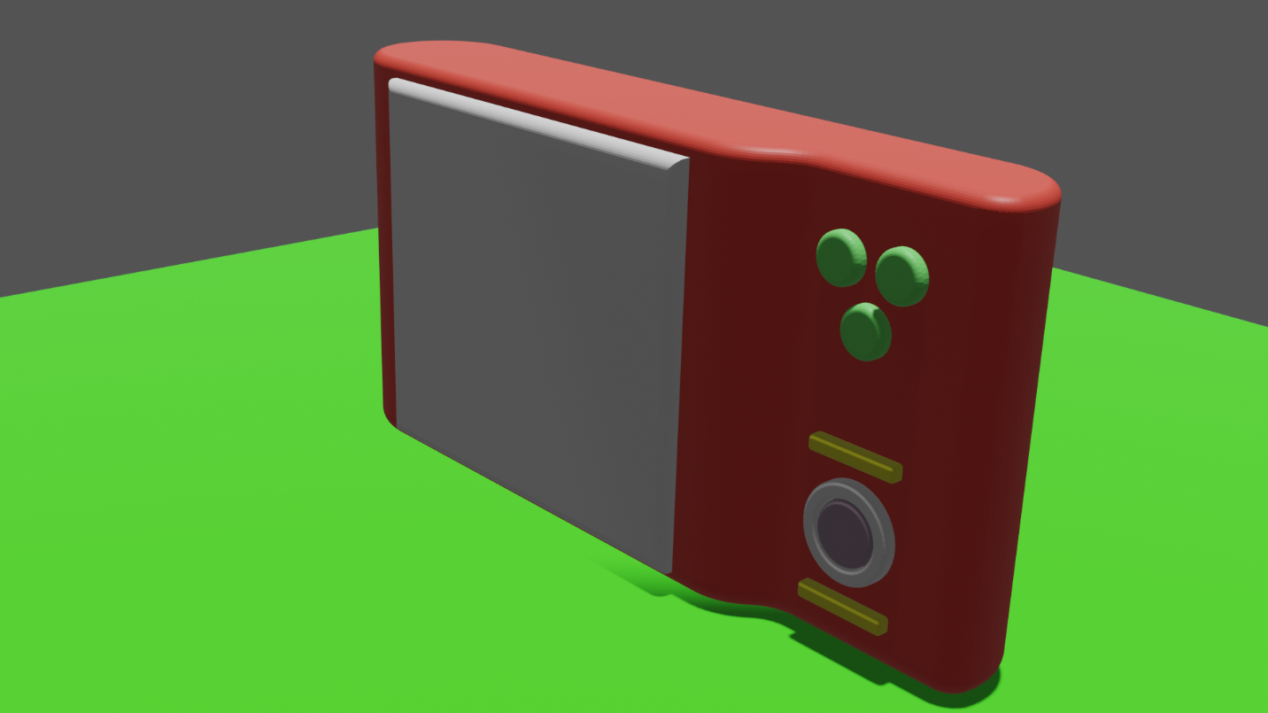

**Link:** [Project](https://drive.google.com/drive/folders/1hzy3_ymhjdzV8oplNPzib8PlG_uvZxAW?usp=sharing)