|  |
| --- |
| Experiment No.1 |
| ER / EER Relationship Model |
| Date of Performance: 9/01/2024 |
| Date of Submission: 23/02/2024 |

**Experiment No. 1:** **Identify the case study and detail statement of problem.**

**Design an Entity-Relationship (ER) / Extended Entity-Relationship (EER) Model.**

**Course Outcome [CSL503.1]:** Design ER and EER diagram for the real life problem with software tool.

**Aim**: Identify the case study and detail statement of problem.

Design an Entity-Relationship (ER) / Extended Entity-Relatio nship (EER) Model.

**Theory**: Summary of ER, EER Diagram Notation

# Strong Entities

Entity Name

# Weak Entities

Entity Name

Attributes

Multi Valued Attributes

Composite Attributes

Relationships

Relationship Name

# Identifying Relationships

Relationship Name

**N-ary relationships**

1. More than 2 participating entities.

# Constraints - Participation

1. **Total Participation** - entity X has total participation in Relationship Z, meaning that every instance of X takes part in AT LEAST one relationship. (i.e. there are no members of X that do not participate in the relationship.

*Example*: X is Customer, Y is Product, and Z is a ‘Purchases’ relationship. The figure below indicates the requirement that every customer purchases a product.

Relationship Z

**X**

**Y**

1. **Partial Participation** - entity Y has partial participation in Relationship Z, meaning that only some instances of Y take part in the relationship.

*Example*: X is Customer, Y is Product, and Z is a ‘Purchases’ relationship. The figure below indicates the requirement that not every product is purchases by a customer. Some products may not be purchased at all.

Constraints - Cardinality

1. 1:N – One Customer buys many products, each product is purchased by only one customer.
2. N:1 - Each customer buys at most one product, each product can be purchased by many customers.
3. 1:1 – Each customer purchases at most one product, each product is purchased by only one customer.
4. M:N – Each customer purchases many products, each product is purchased by many customers.

# Specialization/Generalization

1. Each subclass inherits all relationships and attributes from the super-class.

Constraints on Specialization/Generalization

1. **Total Specialization** – Every member of the super-class must belong to at least one subclass. For example, any book that is not a text book, or a novel can fit into the “Other” category.
2. **Partial Specialization** – each member of the super-class may not belong to one of the subclasses. For example, a book on poetry may be neither a text book, a novel or a biography.

# Disjointness Constraint

1. **Disjoint** – every member of the super-class can belong to at most one of the subclasses. For example, an Animal cannot be a lion and a horse, it must be either a lion, a horse, or a dog.

**Overlapping** – every member of the super-class can belong to more than one of the subclasses. For example, a book can be a text book, but also a poetry book at the same time.

**Multiple Inheritance** – a subclass participates in more than one subclass/super-class relationship, and inherits attributes and relationships from more than one super-class. For example, the subclass Mermaid participates in two subclass/super-class relationships, it inherits attributes and relationships of Animals, as well as attributes and relationships of Humans.

**Union** – a subclass/super-class relationship can have more than one super-class, and the subclass inherits from at most one of the super-classes (i.e. the subclass purchase will inherit the relationships and attributes associated with either service or product, but not both). Each super class may have different primary keys, or the same primary key. All members of the super-classes are not members of the super-class. For example, a purchase can be a product, or a service, but not both. And all products and services are not purchase

Purchase

Product

Service

1. ER -diagram

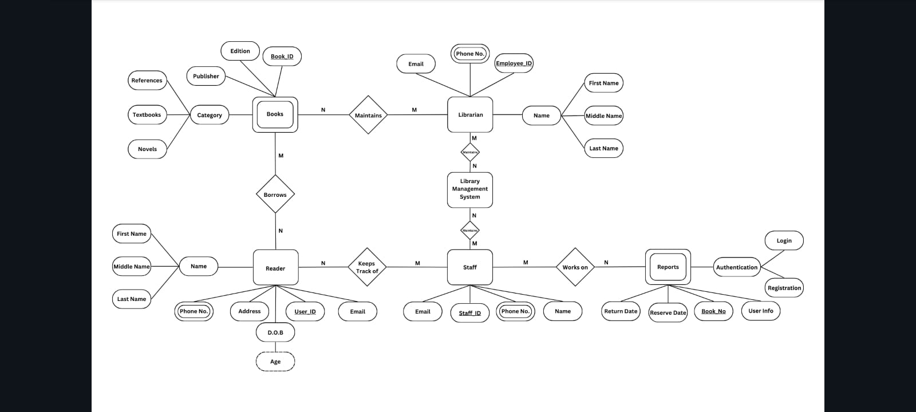

2.EER -diagram

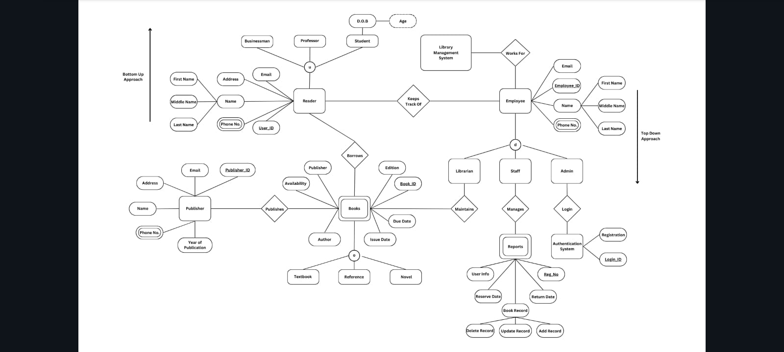

**Conclusion:-**

In conclusion, the Entity-Relationship (ER) and Enhanced Entity-Relationship (EER) diagrams have been successfully constructed for the provided case study. These diagrams serve as powerful tools for visualizing the relationships between entities and attributes within the system. By representing the data model in a clear and structured manner, they facilitate efficient database design and implementation.

The ER diagram illustrates entity types, their attributes, and the relationships among them, while the EER diagram extends this by incorporating additional features like specialization, generalization, and inheritance, offering a more comprehensive view of the data model. Overall, these diagrams play a crucial role in conceptualizing and communicating the database schema effectively.