**3.1) Sample code of the project**

**Sample #1 :**

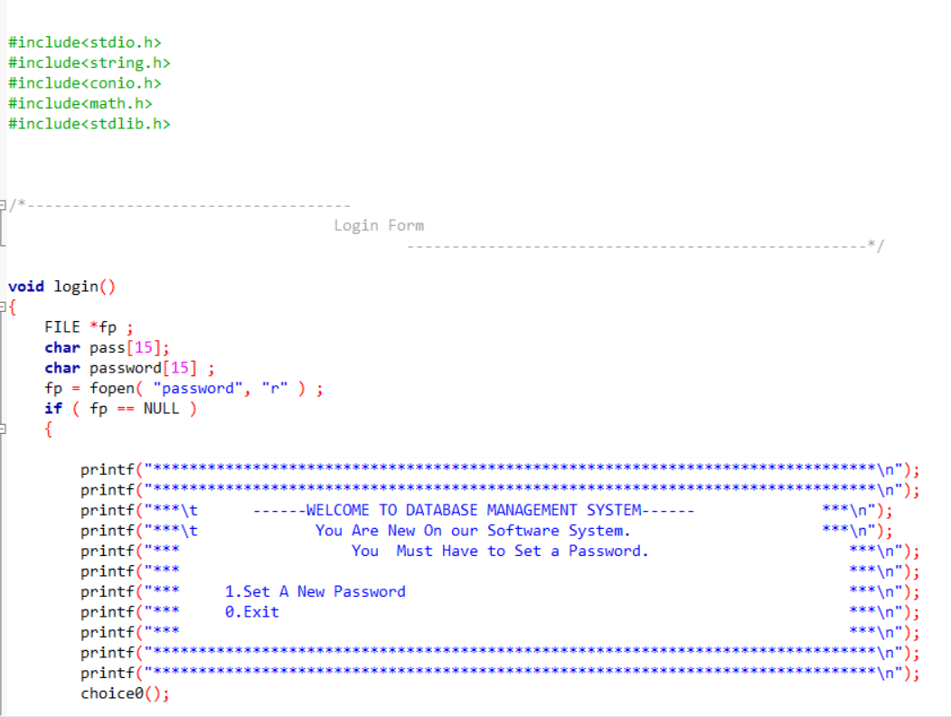

**Sample #2 :**

Page||09

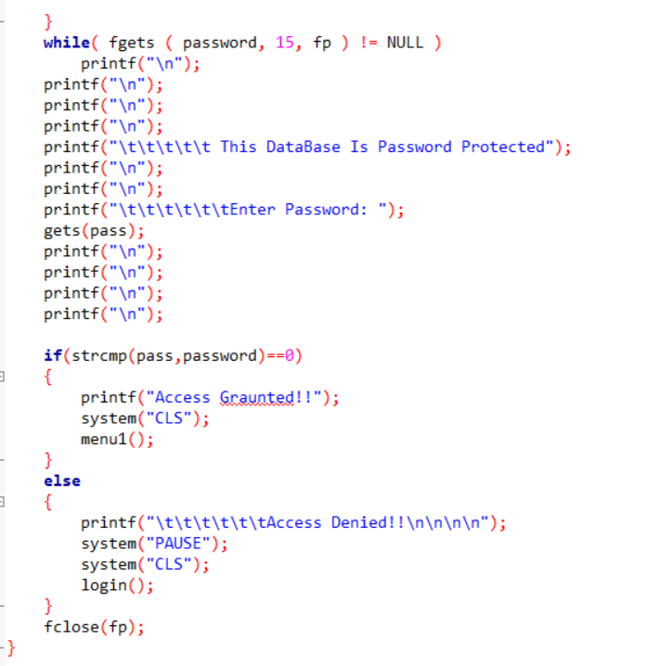

**Sample #3 :**

Page||10

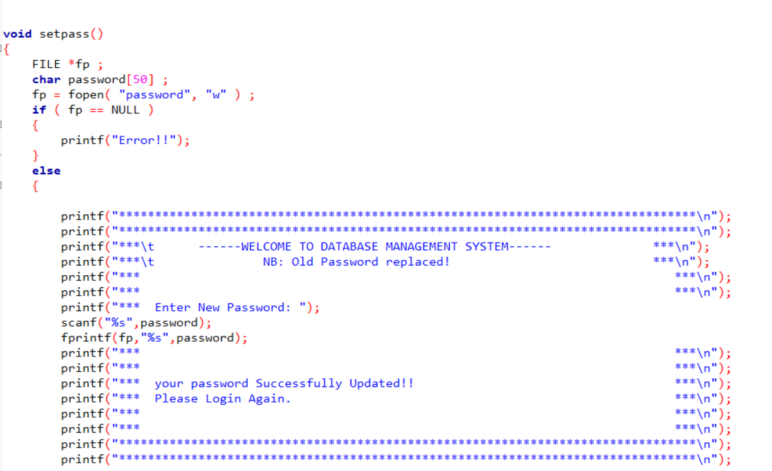

**Sample #4 :**

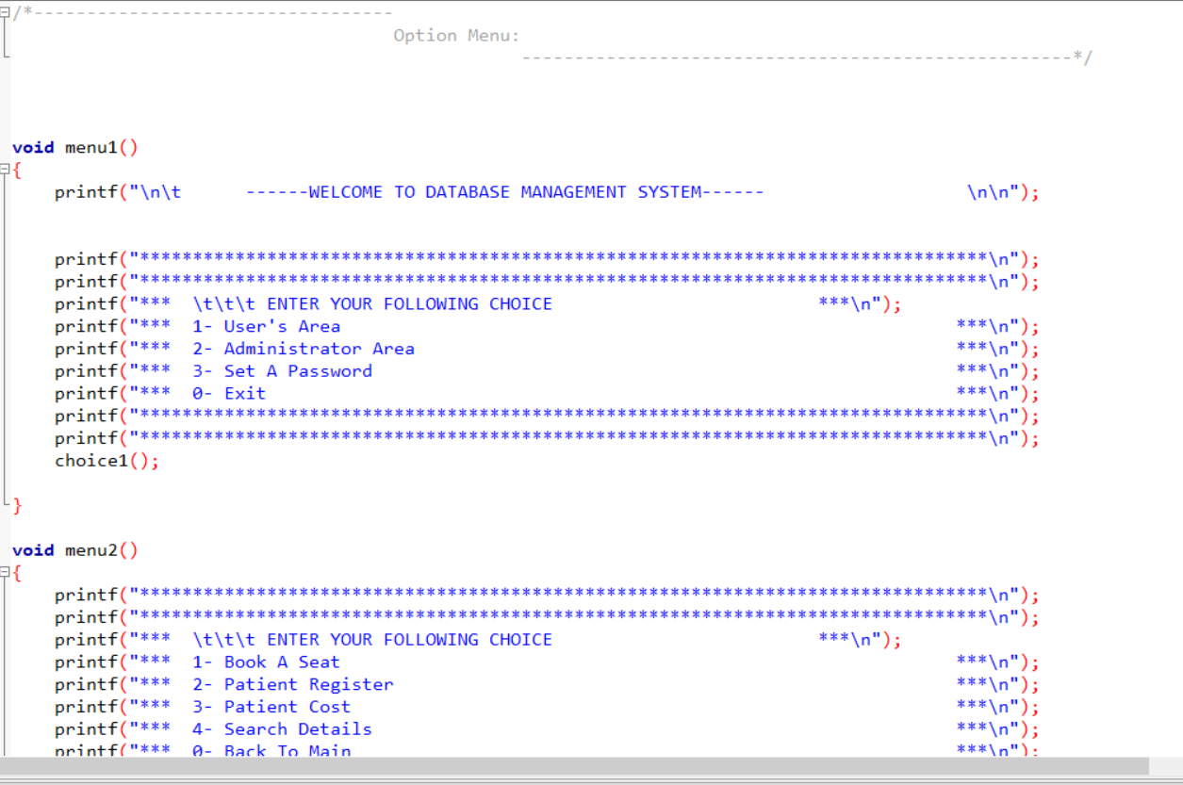

Page||11

**Sample #5 :**

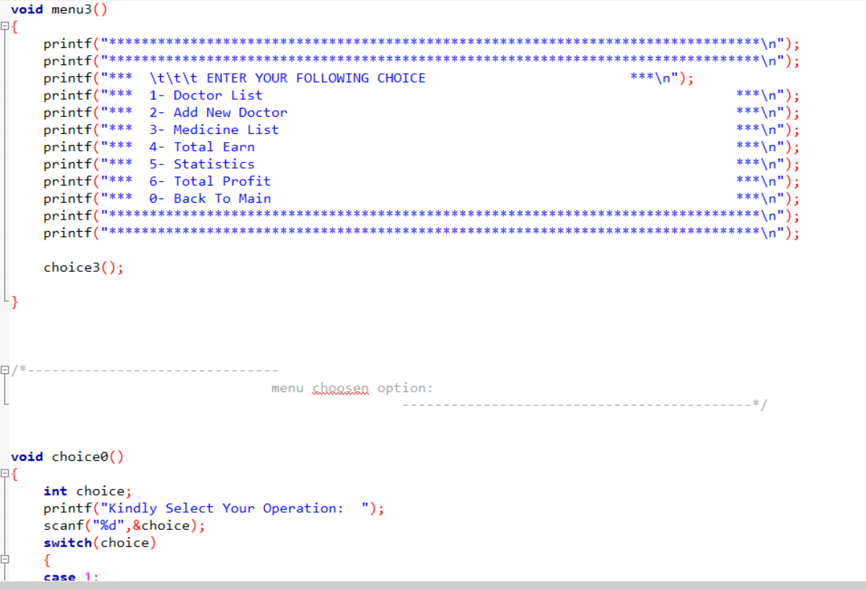

**Page||12**

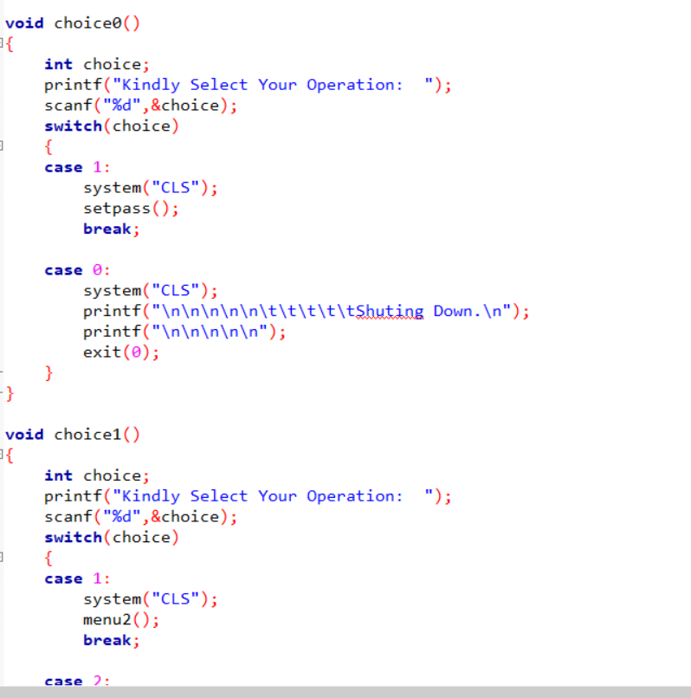

Page||13

**3.2 ) Sample screenshort of the project :**

**Screenshort #1 :** 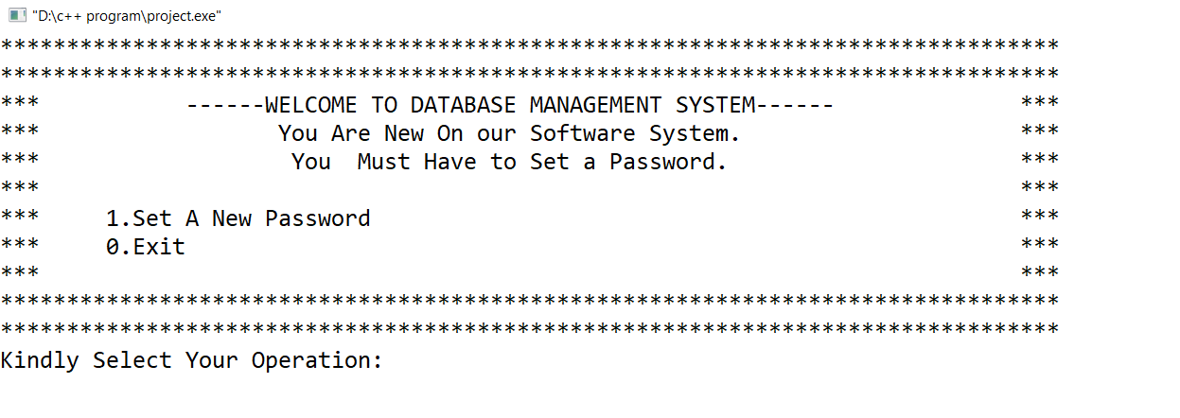

**Screenshort #2 :**

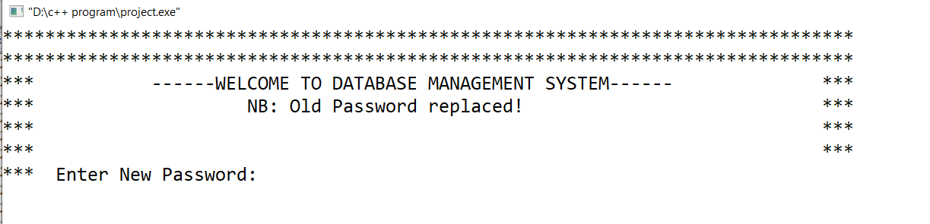

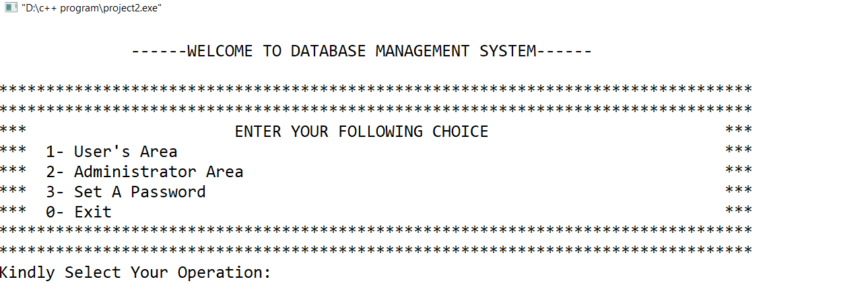**Screenshort #3 :**

Page||14

**Screenshort # 4 :**

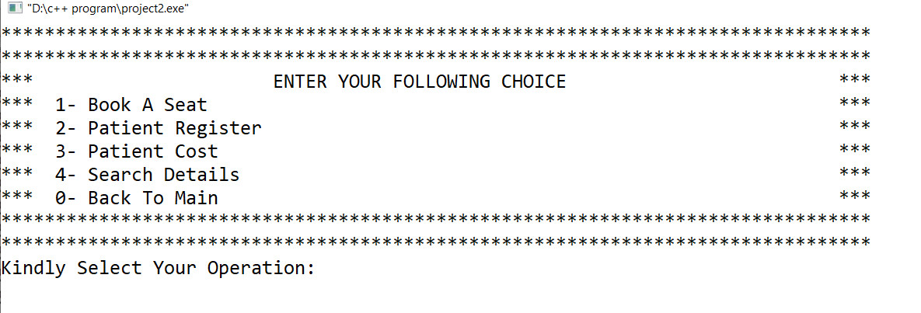

**Screenshort #5 :**

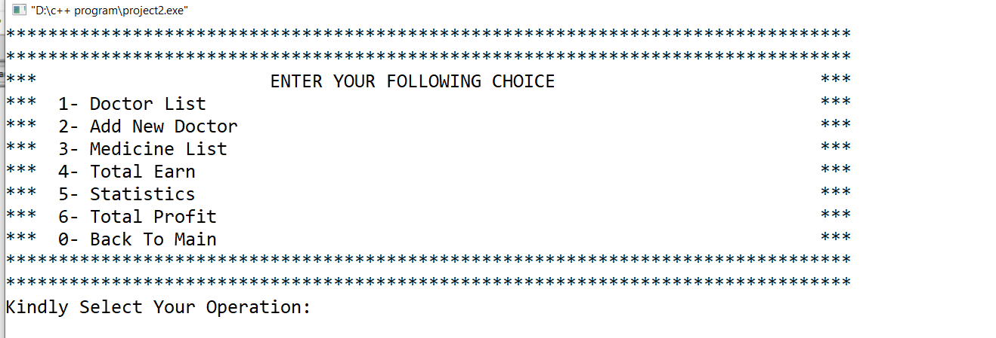

**3.3 ) Limitation of the project:**

* Medicine List is Build-in Added. No one can Add New invented Medicine.
* String ( Patient Name,Doctor Name) can take only two word if we separate them with space.
* After Changing Or After set a password, Login in process Show Access denied for Frist time then it work smoothly.

Page||15

**3.4) Future Work of the project:**

* Custom Medicine Adding system will be added on future , when Clinet Will request for that. Its a Business Trick.
* Login in Bug will be fixed on Future Update.
* String Problem also be fixed on future work.
* We will also add some feature “How much medicine Have left after selling, Which doctor are free to Treate ment,Doctor Earning list etc” in Future udate.
* We will secure our software in future.

**3.4) References :**

1. programiz

Learn same details about c structure.

Link : <https://www.programiz.com/>

2. .geeksforgeeks

Learn same details about c structure.

Link : <https://www.geeksforgeeks.org/>

3. stackoverflow

Learn details about file.

Link : <https://stackoverflow.com/>

Page||16