**Alumni Management System - DML - Nested Queries I**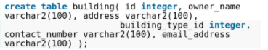

**Create table building (id integer,owner_name varchar2(100),address varchar2(100),building_type_id integer,contact_number varchar2(100),email_address varchar2(100));**

**Alter building**

Alter table building rename column email_address to email;

Write a query to display the contents of posts posted by Ram in the year 2012, sorted by date.

Alter table building add description varchar(255) not null;

Remove column from b

...

Alter table building drop column address;

Change column type i.



alter table building modify owner_name varchar2(500);

Table building_type insert

Q15



Select variance(payable_amount)”variance_payable_amount” from Bill where payment_Date Like ‘%ocy%’;

QQ4