**Steps to install master and slave Redis with Sentinel in one node**

Redis requires a gcc compiler to run.

The latest version of Redis is 6.3.0 which requires a higher gcc version (latest 9.x). The default gcc package available for RHEL7 is gcc 4.8.x which supports upto Redis 5.0.9.

**Pre-requisites:**

1. Redis setup requires Developer Tools and gcc to be installed beforehand.
2. A user with sudo privileges should be present (The user is redisops in the below steps). All installation and setup work for Redis and Sentinel should be done using this dedicated user.

**Steps:**

1. Download the latest Redis tar ball. Replace <version> with the corresponding version according to the gcc version installed.

**wget** [http://download.redis.io/releases/redis-<version>.tar.gz](http://download.redis.io/releases/redis-%3cversion%3e.tar.gz)

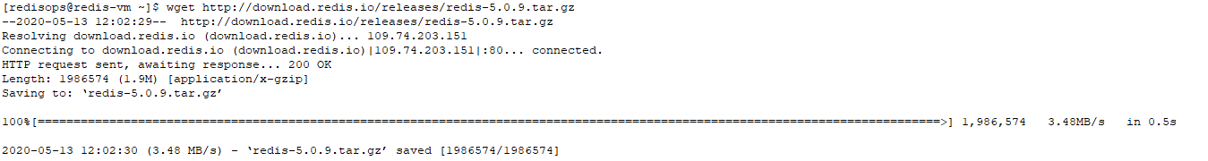

The following steps use redis-5.0.9

Untar the downloaded tar ball.

**tar -xvzf redis-5.0.9.tar.gz**

1. Move the folder to /etc

**sudo mv redis-5.0.9 /etc**

1. Compile Redis

**cd /etc/redis-5.0.9/deps/**

**make hiredis lua jemalloc linenoise**



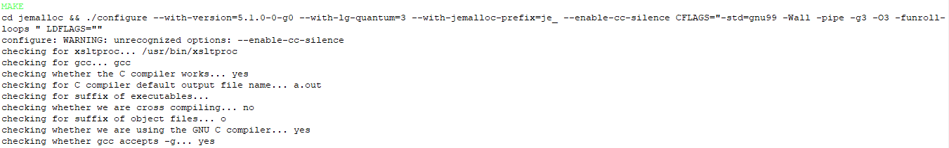



**cd ..**

**make**



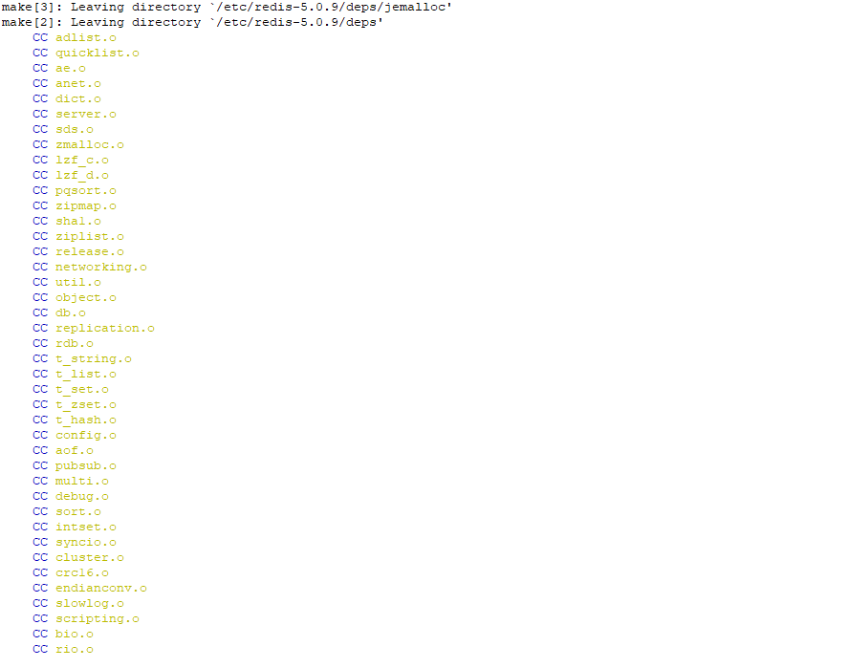

1. Send the redis server and the command line executables to their proper place in /usr/local/bin/

**sudo make install**

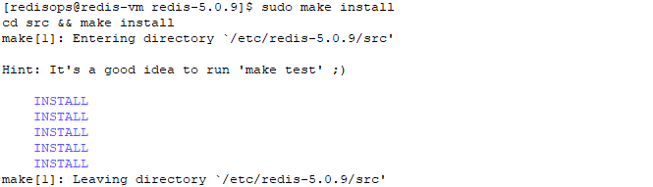

1. Make a log directory in /var/log and create log files for the redis and sentinel processes. Give the redisops user permission to the folder and files.

**cd /var/log**

**sudo mkdir redis**

**cd redis**

**sudo touch redis_1.log redis_2.log sentinel_1.log sentinel_2.log**

**cd ..**

**sudo chown -R redisops:redisops redis/**

1. Make a data directory in /var/lib/ and create directories for the redis and sentinel processes to store any data. Give the redisops user permission to the folders.

**cd /var/lib/**

**sudo mkdir redis**

**cd redis**

**sudo mkdir redis_1 redis_2 sentinel_1 sentinel_2**

**cd ..**

**sudo chown -R redisops:redisops redis/**

Then return to /etc/redis-5.0.9

**cd /etc/redis-5.0.9**

1. Rename the redis.conf file to redis_1.conf

Copy redis_1.conf and make another file redis_2.conf

**mv redis.conf redis_1.conf**

**cp redis_1.conf redis_2.conf**

1. Rename the sentinel.conf file to sentinel_1.conf

Copy sentinel_1.conf and make another file sentinel_2.conf

**mv sentinel.conf sentinel_1.conf**

**cp sentinel_1.conf sentinel_2.conf**

1. In redis_1.conf add/edit the following lines (making it the master initially)

Replace <host ip> with the internal/external IP address of the VM according to requirement

**vim redis_1.conf**

bind <host ip>

port 6379

supervised systemd

pidfile /var/run/redis_6379.pid

logfile "/var/log/redis/redis_1.log"

dbfilename dump_1.rdb

dir /var/lib/redis/redis_1

1. In redis_2.conf add/edit the following lines (making it the slave initially)

Replace <host ip> with the internal/external IP address of the VM according to requirement.

Replace <master ip > with the IP given in the master.

**vim redis_2.conf**

bind <host ip>

port 6378

supervised systemd

pidfile /var/run/redis_6378.pid

logfile "/var/log/redis/redis_2.log"

dbfilename dump_2.rdb

dir /var/lib/redis/redis_2

slaveof <master ip> 6379

slave-priority 100

If the slave should also accept write requests instead of being read only also add this line in redis_2.conf

slave-read-only no

1. In sentinel_1.conf add/edit the following lines (making it the sentinel of the initial master Redis process)

Replace <host ip> with the internal/external IP address of the VM according to requirement.

Replace <master ip > with the IP given in the master.

**vim sentinel_1.conf**

bind <host ip>

port 26379

pidfile /var/run/redis-sentinel_26379.pid

logfile "/var/log/redis/sentinel_1.log"

dir /var/lib/redis/sentinel_1

sentinel monitor redis-master <master ip> 6379 1

sentinel down-after-milliseconds redis-master 30000

sentinel parallel-syncs redis-master 1

sentinel failover-timeout redis-master 180000

1. In sentinel_2.conf add/edit the following lines (making it the sentinel of the initial slave Redis process)

Replace <host ip> with the internal/external IP address of the VM according to requirement.

Replace <master ip > with the IP given in the master.

**vim sentinel_2.conf**

bind <host ip>

port 26378

pidfile /var/run/redis-sentinel_26378.pid

logfile "/var/log/redis/sentinel_2.log"

dir /var/lib/redis/sentinel_2

sentinel monitor redis-master <master ip> 6379 1

sentinel down-after-milliseconds redis-master 30000

sentinel parallel-syncs redis-master 1

sentinel failover-timeout redis-master 180000

1. Go to /etc/systemd/system/ and create 4 service files for the Redis and Sentinel processes.

redis_1.service, redis_2.service, sentinel_1.service, sentinel_2.service

**cd /etc/systemd/system/**

**sudo touch redis_1.service redis_2.service sentinel_1.service sentinel_2.service**

Edit the files and add the following lines in them

**sudo vim redis_1.service**

[Unit]

Description=Advanced key-value store

After=network.target

[Service]

User=redisops

Group=redisops

ExecStart=/usr/local/bin/redis-server /etc/redis-5.0.9/redis_1.conf

Restart=on-abnormal

[Install]

WantedBy=multi-user.target

**vim redis_2.service**

[Unit]

Description=Advanced key-value store

After=network.target

[Service]

User=redisops

Group=redisops

ExecStart=/usr/local/bin/redis-server /etc/redis-5.0.9/redis_2.conf

Restart=on-abnormal

[Install]

WantedBy=multi-user.target

**vim sentinel_1.service**

[Unit]

Description=Advanced key-value store

After=network.target

[Service]

User=redisops

Group=redisops

ExecStart=/usr/local/bin/redis-server /etc/redis-5.0.9/sentinel_1.conf --sentinel

Restart=on-abnormal

[Install]

WantedBy=multi-user.target

**vim sentinel_2.service**

[Unit]

Description=Advanced key-value store

After=network.target

[Service]

User=redisops

Group=redisops

ExecStart=/usr/local/bin/redis-server /etc/redis-5.0.9/sentinel_2.conf --sentinel

Restart=on-abnormal

[Install]

WantedBy=multi-user.target

1. Enable and start the services

**sudo systemctl enable redis_1**

**sudo systemctl enable redis_2**

**sudo systemctl enable sentinel_1**

**sudo systemctl enable sentinel_2**

**sudo systemctl start redis_1**

**sudo systemctl start redis_2**

**sudo systemctl start sentinel_1**

**sudo systemctl start sentinel_2**

1. Check the status of the services to see if they are all running.

**sudo systemctl status redis_1**

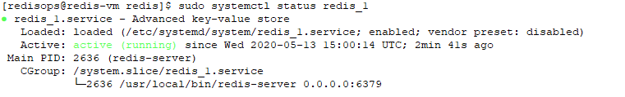

**sudo systemctl status redis_2**

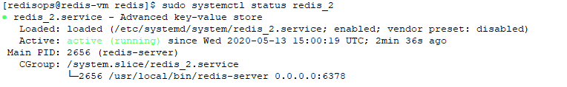

**sudo systemctl status sentinel_1**

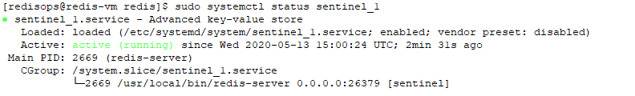

**sudo systemctl status sentinel_2**

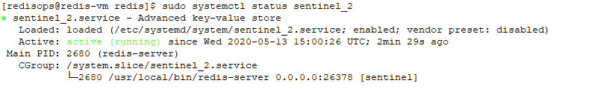

**We can check whether Redis and Sentinel have been setup properly using the following steps:**

1. Run the redis-cli and check if values can be stored and retrieved.

First run the redis-cli for the master Redis process. Enter ping and if PONG is returned then the redis process is running fine.

**redis-cli -p 6379**

**127.0.0.1:6379> ping**

**PONG**

Then get and set some values to see of data is being stored and retrieved.

**127.0.0.1:6379> set 1 hello**

**OK**

**127.0.0.1:6379> get 1**

**"hello"**

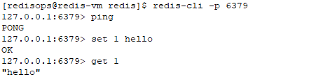

Then run the redis-cli for the slave process and see if the get command for the same key returns the same value. This will verify whether the replication is done properly.

**redis-cli -p 6378**

**127.0.0.1:6378> get 1**

**"hello"**

**test-1-2.PNG**

1. Check which process is the master process

**redis-cli -p 26379 sentinel get-master-addr-by-name redis-master**

**1) "0.0.0.0"**

**2) "6379"**

test-2-1.PNG

This shows the ip and port the master process is running on.

Stop the master process and run the command again to check whether the slave process has been promoted to master.

**sudo systemctl stop redis_1**

**redis-cli -p 26379 sentinel get-master-addr-by-name redis-master**

**1) "0.0.0.0"**

**2) "6378"**

test-2-2.PNG