**Why Visualize Data?**

**Defining Visualization:**

Computer based visualization systems provide visual representation of datasets designed to help people carry out tasks more effectively.

Why have a human in the loop?

Visualization is suitable when there is a need to augment human capabilities rather than replace people with computational decision-making methods.

* Don’t need visualization when fully automatic solution exists and is trusted .
* Many analysis problems ill-specified.
* Possibilities:
* Long- term use for end users.( Ex- exploratory analysis of scientific data)
* Presentation of known results.
* Stepping stone to better understanding of requirements before developing models.
* Help developers of automatic solution refine/debug, determine parameters.
* Help end users of automatic solutions verify, build trust.

Why use an external representation?

**Computer based visualization systems provide visual representation of datasets designed to help people carry out tasks more effectively.**

* External representation: Replace cognition with perception.
* Ex1: Religions by country: Which country has the most Hindus?
* Ex2: Migrant Deaths: When and where did migrant deaths occur? Are there any patterns or trends?

In representations of datasets

* Summaries lose information, details matter
* Confirm expected and find unexpected patterns.
* Assess validity of statistical model.

**Inputs for Data Visualization: Data & Tasks**

* Tables – Multidimensional Table
* Networks – Trees
* Spatial – Fields, Geometry

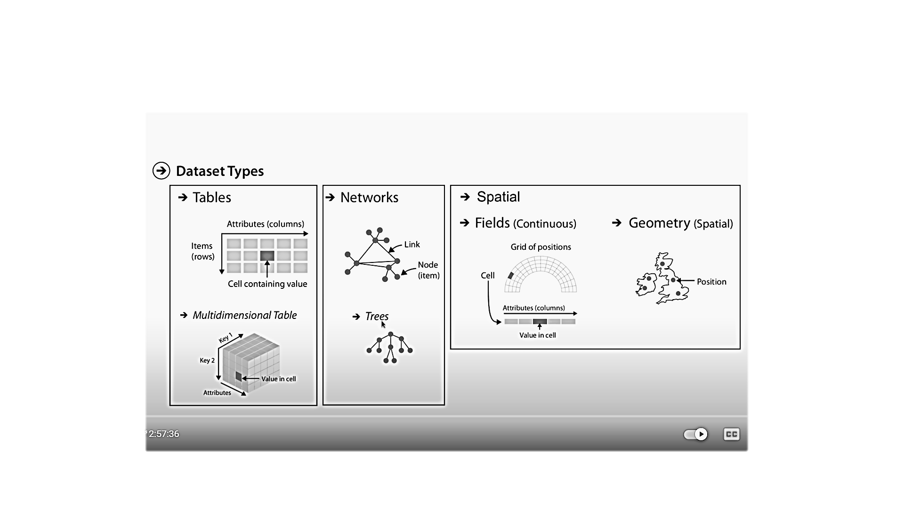

**Attribute Types-** Broad taxonomy for visualization design**.**

