Index.html
<!DOCTYPE html>
<html lang="en">
<head>
<meta charset="UTF-8">
<meta http-equiv="X-UA-Compatible" content="IE=edge">
<meta name="viewport" content="width=device-width, initial-scale=1.0">
<title>Portfolio</title>
<!-- css addition -->
<link rel="stylesheet" href="./styles/styles.css">
<!-- font-awesome -->
<link rel="preconnect" href="https://fonts.googleapis.com">
<link rel="preconnect" href="https://fonts.gstatic.com" crossorigin>
<link rel="stylesheet" href="https://cdnjs.cloudflare.com/ajax/libs/font-awesome/6.1.1/css/all.min.css" integrity="sha512-KfkfwYDsLkIlwQp6LFnl8zNdLGxu9YAA1QvwINks4PhcElQSvqcyVLLD9aMhXd13uQjoXtEKNosOWaZqXgel0g==" crossorigin="anonymous" referrerpolicy="no-referrer" />
<link href="https://fonts.googleapis.com/css2?family=Poppins:wght@400;500;600;700;800;900&display=swap" rel="stylesheet">
</head>
<body class="main-content">
<header class="section sec1 header active" id="home">
</header>
<main>
<section class="section sec2 about" id="about"></section>
<section class="section sec3 portfolio" id="portfolio"></section>
<section class="section sec4 blogs" id="blogs"></section>
<section class="section sec5 contact" id="contact"></section>
</main>
<div class="controlls">
<div class="control control-1 active-btn" data-id="home">
<i class="fa-solid fa-house-user"></i>
</div>
<div class="control control-2 " data-id="about">
<i class="fa-solid fa-user"></i>
</div>
<div class="control control-3 " data-id="portfolio">
<i class="fa-solid fa-briefcase"></i>
</div>
<div class="control control-4 " data-id="blogs">
<i class="fa-solid fa-newspaper"></i>
</div>
<div class="control control-5 " data-id="contact">
<i class="fa-solid fa-envelope-open"></i>
</div>
</div>
<script src="./app.js"></script>
</body>
</html>

Style.css
* {
margin: 0;
padding: 0;
box-sizing: border-box;
list-style: none;
}
:root {
--color-primary: #191d2b;
--color-secondary: #002aff;
--color-white: #ffffff;
--color-black: #000;
--color-grey0: #f8f8f8;
--color-grey-1: #dbe1e8;
--color-grey-2: #b2becd;
--color-grey-3: #6c7983;
--color-grey-4: #454e56;
--color-grey-5: #2a2e35;
--color-grey-6: #12181b;
--br-sm-2: 14px;
--box-shadow-1: 0 3px 15px rgba(0, 0, 0, 0.3);
}
body {
background-color: var(--color-primary);
font-family: 'Poppins', sans-serif;
font-size: 1.1rem;
color: var(--color-white);
transition: all 0.4s ease-in-out;
}
a {
display: inline-block;
text-decoration: none;
color: inherit;
font-family: inherit;
}
header{
height: 100vh;
color: var(--color-white);
overflow: hidden;
}
section {
min-height: 100vh;
width: 100%;
position: absolute;
left: 0;
top: 0;
padding: 3rem 18rem;
}
.section {
transform: translateY(-100%) scale(0);
transition: all .4s ease-in-out;
background-color: var(--color-primary);
}
.sec1 {
display: none;
transform: translateY(0) scale(1);
background-color: slateblue;
}
.sec2 {
display: none;
transform: translateY(0) scale(1);
background-color: rgb(27, 7, 153);
}
.sec3 {
display: none;
transform: translateY(0) scale(1);
background-color: rgb(90, 205, 105);
}
.sec4 {
display: none;
transform: translateY(0) scale(1);
background-color: rgb(199, 90, 205);
}
.sec5 {
display: none;
transform: translateY(0) scale(1);
background-color: rgb(205, 90, 107);
}
/* Controls */
.controlls {
position: fixed;
z-index: 10;
top: 50%;
right: 3%;
display: flex;
flex-direction: column;
align-items: center;
justify-content: center;
transform: translateY(-50%);
}

.control {
padding: 1rem;
cursor: pointer;
background-color: var(--color-grey-4);
width: 40px;
height: 40px;
border-radius: 50%;
display: flex;
justify-content: center;
align-items: center;
margin: 0.7rem 0;
box-shadow: var(--box-shadow-1);
}
i{
font-size: 1.2rem;
color: var(--color-grey-2);
pointer-events: none;
}
.active-btn {
background-color: var(--color-secondary);
transition: all 0.4s ease-in-out;
}
i{
color: var(--color-white) !important;
}

App.js:
1)
const sections = document.querySelectorAll('.section')
const sectBtns = document.querySelectorAll('.controlls') //parent
const sectBtn = document.querySelectorAll('.control') // actual button
const allSection = document.querySelector('.main-content')

function PageTransitions(){
// Button click active class only active class will working so when we call then events will answer.

for(let i=0; i < sectBtn.length; i++){
sectBtn[i].addEventListener('click',function(){
let currentBtn = document.querySelectorAll('.active-btn')
currentBtn[0].className = currentBtn[0].className.replace('active-btn', '')
this.className += ' active-btn'
})
}

//Sections Active class
// Here we used addeventlistener when i click event will call so when we

allSection.addEventListener('click', (e) => {
console.log(e.target);
})
}

PageTransitions();

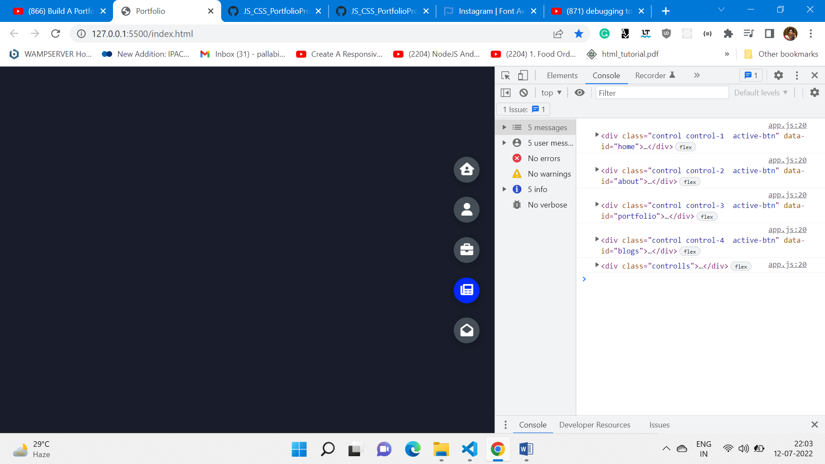

2)
const sections = document.querySelectorAll('.section')
const sectBtns = document.querySelectorAll('.controlls') //parent
const sectBtn = document.querySelectorAll('.control') // actual button
const allSection = document.querySelector('.main-content')

function PageTransitions(){
// Button click active class only active class will working
for(let i=0; i < sectBtn.length; i++){
sectBtn[i].addEventListener('click',function(){
let currentBtn = document.querySelectorAll('.active-btn')
currentBtn[0].className = currentBtn[0].className.replace('active-btn', '')
this.className += ' active-btn'
})
}

//Sections Active class
// Here we used addeventlistener when i click event will call so when we call then events will answer.

allSection.addEventListener('click', (e) => {
// dataset is like referreing to whatever we clicked on the element specially on the buttons it will worked silently it will not showing any kind of messages to the user.
const id = e.target.dataset.id;
if(id){
// remove selected from the other btns.
sectBtns.forEach((btn) => {
btn.classList.remove('active')
})
}
})
}

PageTransitions();

3)
const sections = document.querySelectorAll('.section')
const sectBtns = document.querySelectorAll('.controlls') //parent
const sectBtn = document.querySelectorAll('.control') // actual button
const allSection = document.querySelector('.main-content')

function PageTransitions(){
// Button click active class only active class will working
for(let i=0; i < sectBtn.length; i++){
sectBtn[i].addEventListener('click',function(){
let currentBtn = document.querySelectorAll('.active-btn')
currentBtn[0].className = currentBtn[0].className.replace('active-btn', '')
this.className += ' active-btn'
})
}

//Sections Active class
// Here we used addeventlistener when i click event will call so when we call then events will answer.

allSection.addEventListener('click', (e) => {
// dataset is like referreing to whatever we clicked on the element specially on the buttons it will worked silently it will not showing any kind of messages to the user.
const id = e.target.dataset.id;
if(id){
// remove selected from the other btns.
sectBtns.forEach((btn) => {
btn.classList.remove('active')
})
// when it is removed when we clicked on another button then it will automatically add the classList
e.target.classList.add('active')
}
})
}

PageTransitions();

4)
const sections = document.querySelectorAll('.section')
const sectBtns = document.querySelectorAll('.controlls') //parent
const sectBtn = document.querySelectorAll('.control') // actual button
const allSection = document.querySelector('.main-content')

function PageTransitions(){
// Button click active class only active class will working
for(let i=0; i < sectBtn.length; i++){
sectBtn[i].addEventListener('click',function(){
let currentBtn = document.querySelectorAll('.active-btn')
currentBtn[0].className = currentBtn[0].className.replace('active-btn', '')
this.className += ' active-btn'
})
}

//Sections Active class
// Here we used addeventlistener when i click event will call so when we call then events will answer.

allSection.addEventListener('click', (e) => {
// dataset is like referreing to whatever we clicked on the element specially on the buttons it will worked silently it will not showing any kind of messages to the user.
const id = e.target.dataset.id;
if(id){
// remove selected from the other btns.
sectBtns.forEach((btn) => {
btn.classList.remove('active')
})
// when it is removed when we clicked on another button then it will automatically add the classList
e.target.classList.add('active')
// hide other sections
// we are not seeing any sections over here When I click on the active button I want to be able to set the display and set to default & it will helps to remove the active from that specific part.
sections.forEach((section) => {
section.classList.remove('active')
})
}
})
}

PageTransitions();

5)
const sections = document.querySelectorAll('.section')
const sectBtns = document.querySelectorAll('.controlls') //parent
const sectBtn = document.querySelectorAll('.control') // actual button
const allSection = document.querySelector('.main-content')

function PageTransitions(){
// Button click active class only active class will working
for(let i=0; i < sectBtn.length; i++){
sectBtn[i].addEventListener('click',function(){
let currentBtn = document.querySelectorAll('.active-btn')
currentBtn[0].className = currentBtn[0].className.replace('active-btn', '')
this.className += ' active-btn'
})
}

//Sections Active class
// Here we used addeventlistener when i click event will call so when we call then events will answer.

allSection.addEventListener('click', (e) => {
// dataset is like referreing to whatever we clicked on the element specially on the buttons it will worked silently it will not showing any kind of messages to the user.
const id = e.target.dataset.id;
if(id){
// remove selected from the other btns.
sectBtns.forEach((btn) => {
btn.classList.remove('active')
})
// when it is removed when we clicked on another button then it will automatically add the classList
e.target.classList.add('active')
// hide other sections
// we are not seeing any sections over here When I click on the active button I want to be able to set the display and set to default & it will helps to remove the active from that specific part.
sections.forEach((section) => {
section.classList.remove('active')
})
// Whatever id we have mentioned at html it will call that id. Here id will be targetted so it will be activated. When I click home button will be activated now it's getting rid of the existing class . So now we can only use the active on one element.
const element = document.getElementById(id)
element.classList.add('active')
}
})
}

PageTransitions();

The element is got activated but we cannot see that sections because it’s hidden so for that we have to write one line in css.
.active {
display: block;
}

* {
margin: 0;
padding: 0;
box-sizing: border-box;
list-style: none;
}
:root {
--color-primary: #191d2b;
--color-secondary: #002aff;
--color-white: #ffffff;
--color-black: #000;
--color-grey0: #f8f8f8;
--color-grey-1: #dbe1e8;
--color-grey-2: #b2becd;
--color-grey-3: #6c7983;
--color-grey-4: #454e56;
--color-grey-5: #2a2e35;
--color-grey-6: #12181b;
--br-sm-2: 14px;
--box-shadow-1: 0 3px 15px rgba(0, 0, 0, 0.3);
}
body {
background-color: var(--color-primary);
font-family: 'Poppins', sans-serif;
font-size: 1.1rem;
color: var(--color-white);
transition: all 0.4s ease-in-out;
}
a {
display: inline-block;
text-decoration: none;
color: inherit;
font-family: inherit;
}
header{
height: 100vh;
color: var(--color-white);
overflow: hidden;
}
section {
min-height: 100vh;
width: 100%;
position: absolute;
left: 0;
top: 0;
padding: 3rem 18rem;
}
.section {
transform: translateY(-100%) scale(0);
transition: all .4s ease-in-out;
background-color: var(--color-primary);
}
.sec1 {
display: none;
transform: translateY(0) scale(1);
background-color: slateblue;
}
.sec2 {
display: none;
transform: translateY(0) scale(1);
background-color: rgb(27, 7, 153);
}
.sec3 {
display: none;
transform: translateY(0) scale(1);
background-color: rgb(90, 205, 105);
}
.sec4 {
display: none;
transform: translateY(0) scale(1);
background-color: rgb(199, 90, 205);
}
.sec5 {
display: none;
transform: translateY(0) scale(1);
background-color: rgb(205, 90, 107);
}
.active {
display: block;
}
/* Controls */
.controlls {
position: fixed;
z-index: 10;
top: 50%;
right: 3%;
display: flex;
flex-direction: column;
align-items: center;
justify-content: center;
transform: translateY(-50%);
}

.control {
padding: 1rem;
cursor: pointer;
background-color: var(--color-grey-4);
width: 40px;
height: 40px;
border-radius: 50%;
display: flex;
justify-content: center;
align-items: center;
margin: 0.7rem 0;
box-shadow: var(--box-shadow-1);
}
i{
font-size: 1.2rem;
color: var(--color-grey-2);
pointer-events: none;
}
.active-btn {
background-color: var(--color-secondary);
transition: all 0.4s ease-in-out;
}
i{
color: var(--color-white) !important;
}

Next we will add the animation at active
.active {
display: block;
animation: scaleAnim 1s ease-in-out;
}
@keyframes scaleAnim {
0% {
transform: translateY(-100%) scaleY(0);
}
100% {
transform: translateY(0) scaleY(1);
}
}

* {
margin: 0;
padding: 0;
box-sizing: border-box;
list-style: none;
}
:root {
--color-primary: #191d2b;
--color-secondary: #002aff;
--color-white: #ffffff;
--color-black: #000;
--color-grey0: #f8f8f8;
--color-grey-1: #dbe1e8;
--color-grey-2: #b2becd;
--color-grey-3: #6c7983;
--color-grey-4: #454e56;
--color-grey-5: #2a2e35;
--color-grey-6: #12181b;
--br-sm-2: 14px;
--box-shadow-1: 0 3px 15px rgba(0, 0, 0, 0.3);
}
body {
background-color: var(--color-primary);
font-family: 'Poppins', sans-serif;
font-size: 1.1rem;
color: var(--color-white);
transition: all 0.4s ease-in-out;
}
a {
display: inline-block;
text-decoration: none;
color: inherit;
font-family: inherit;
}
header{
height: 100vh;
color: var(--color-white);
overflow: hidden;
}
section {
min-height: 100vh;
width: 100%;
position: absolute;
left: 0;
top: 0;
padding: 3rem 18rem;
}
.section {
transform: translateY(-100%) scale(0);
transition: all .4s ease-in-out;
background-color: var(--color-primary);
}
.sec1 {
display: none;
transform: translateY(0) scale(1);
background-color: slateblue;
}
.sec2 {
display: none;
transform: translateY(0) scale(1);
background-color: rgb(27, 7, 153);
}
.sec3 {
display: none;
transform: translateY(0) scale(1);
background-color: rgb(90, 205, 105);
}
.sec4 {
display: none;
transform: translateY(0) scale(1);
background-color: rgb(199, 90, 205);
}
.sec5 {
display: none;
transform: translateY(0) scale(1);
background-color: rgb(205, 90, 107);
}
.active {
display: block;
animation: scaleAnim 1s ease-in-out;
}
@keyframes scaleAnim {
0% {
transform: translateY(-100%) scaleY(0);
}
100% {
transform: translateY(0) scaleY(1);
}
}

/* Controls */
.controlls {
position: fixed;
z-index: 10;
top: 50%;
right: 3%;
display: flex;
flex-direction: column;
align-items: center;
justify-content: center;
transform: translateY(-50%);
}

.control {
padding: 1rem;
cursor: pointer;
background-color: var(--color-grey-4);
width: 40px;
height: 40px;
border-radius: 50%;
display: flex;
justify-content: center;
align-items: center;
margin: 0.7rem 0;
box-shadow: var(--box-shadow-1);
}
i{
font-size: 1.2rem;
color: var(--color-grey-2);
pointer-events: none;
}
.active-btn {
background-color: var(--color-secondary);
transition: all 0.4s ease-in-out;
}
i{
color: var(--color-white) !important;
}

