**Database Layer**

Diagram

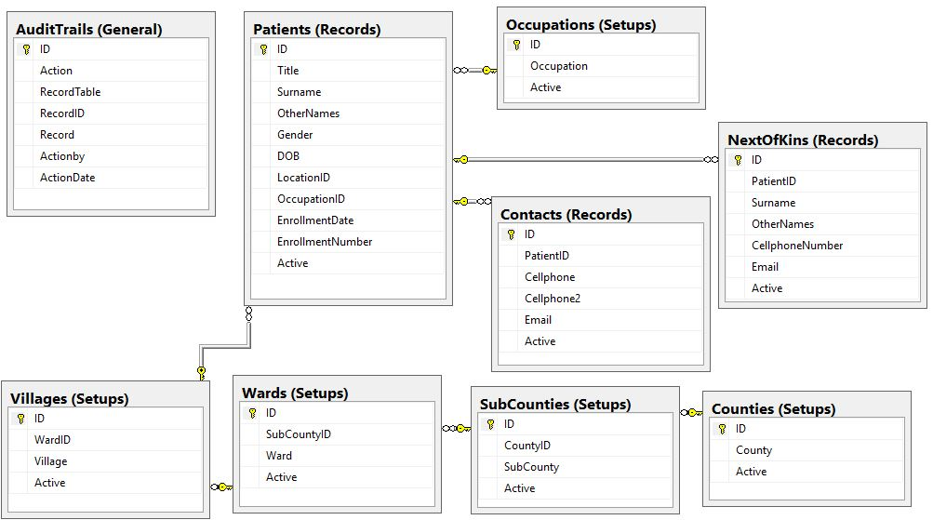

**Data Dictionary**

|  |  |  |  |
| --- | --- | --- | --- |
| **Table Name** | Patients | | |
| **Description** |  | | |
| **Columns** | **Data Type** | **Nullable** | **Description** |
| ID | int | Not Allowed |  |
| Title | Nvarchar(50) | Allowed |  |
| Surname | Nvarchar(250) | Not Allowed |  |
| OtherNames | Nvarchar(500) | Not Allowed |  |
| Gender | Nvarchar(1) | Allowed |  |
| DOB | Date | Allowed |  |
| LocationID | int | Allowed |  |
| OccupationID | int | Allowed |  |
| EnrollmentDate | Date | Allowed |  |
| EnrollmentNumber | Nvarchar(250) | Allowed |  |
| Active | bit | Not Allowed |  |
|  |  |  |  |

|  |  |  |  |
| --- | --- | --- | --- |
| **Table Name** | NextOfKins | | |
| **Description** |  | | |
| **Columns** | **Data Type** | **Nullable** | **Description** |
| ID | int | Not Allowed |  |
| PatientID | int | Not Allowed |  |
| Surname | Nvarchar(250) | Not Allowed |  |
| OtherNames | Nvarchar(500) | Not Allowed |  |
| CellphoneNumber | Nvarchar(50) | Not Allowed |  |
| Email | Nvarchar(500) | Allowed |  |
| Active | bit | Not Allowed |  |

|  |  |  |  |
| --- | --- | --- | --- |
| **Table Name** | Contacts | | |
| **Description** |  | | |
| **Columns** | **Data Type** | **Nullable** | **Description** |
| ID | int | Not Allowed |  |
| PatientID | int | Not Allowed |  |
| Cellphone | Nvarchar(50) | Allowed |  |
| CellPhone2 | Nvarchar(50) | Allowed |  |
| Email | Nvarchar(500) | Allowed |  |
| Active | bit | Not Allowed |  |

|  |  |  |  |
| --- | --- | --- | --- |
| **Table Name** | AuditTrails | | |
| **Description** |  | | |
| **Columns** | **Data Type** | **Nullable** | **Description** |
| ID | int | Not Allowed |  |
| Action | Nvarchar(50) | Not Allowed |  |
| RecordTable | Nvarchar(50) | Not Allowed |  |
| RecordID | int | Not Allowed |  |
| Record | Nvarchar(MAX) | Not Allowed |  |
| Actionby | int | Not Allowed |  |
| ActionDate | Datetime | Not Allowed |  |

|  |  |  |  |
| --- | --- | --- | --- |
| **Table Name** | Occupations | | |
| **Description** |  | | |
| **Columns** | **Data Type** | **Nullable** | **Description** |
| ID | int | Not Allowed |  |
| Occupation | Nvarchar(250) | Not Allowed |  |
| Active | bit | Not Allowed |  |

|  |  |  |  |
| --- | --- | --- | --- |
| **Table Name** | Counties | | |
| **Description** |  | | |
| **Columns** | **Data Type** | **Nullable** | **Description** |
| ID | int | Not Allowed |  |
| County | Nvarchar(200) | Not Allowed |  |
| Active | bit | Not Allowed |  |

|  |  |  |  |
| --- | --- | --- | --- |
| **Table Name** | SubCounties | | |
| **Description** |  | | |
| **Columns** | **Data Type** | **Nullable** | **Description** |
| ID | int | Not Allowed |  |
| CountyID | int | Not Allowed |  |
| SubCounty | Nvarchar(200) | Not Allowed |  |
| Active | bit | Not Allowed |  |

|  |  |  |  |
| --- | --- | --- | --- |
| **Table Name** | Wards | | |
| **Description** |  | | |
| **Columns** | **Data Type** | **Nullable** | **Description** |
| ID | int | Not Allowed |  |
| SubCountyID | int | Not Allowed |  |
| Ward | Nvarchar(200) | Not Allowed |  |
| Active | bit | Not Allowed |  |

|  |  |  |  |
| --- | --- | --- | --- |
| **Table Name** | Villages | | |
| **Description** |  | | |
| **Columns** | **Data Type** | **Nullable** | **Description** |
| ID | int | Not Allowed |  |
| WardID | int | Not Allowed |  |
| Village | Nvarchar(200) | Not Allowed |  |
| Active | bit | Not Allowed |  |

# How to Run

Developer

Download the solution

Run the database script (..\PHC\PHS\db.sql) in MSSQL to generate the database.

Open the solution in Visual Studio 2018

In DAL the App.Config connection string change user name, password and source to your MSSQL values

In PHS Web.config connection string change user name, password and source to your MSSQL values

Run the application in visual studio

# Hardware Requirements

|  |  |
| --- | --- |
| * **Processor** | * Client (computer not working in a server capacity) 90 megahertz (MHZ) Intel Processor, or and AMD Opteron, AMD Athlon64 or AMD Athlon XP processor * Server (a computer working in a server capacity) 133 MHz Intel Pentium-class processor, or an AMD Opteron, AMD Athlon64 or AMD Athlon XP processor |
| * **Operating System** | * windows platforms |
| * **Memory** | * Client : 32 megabytes (MB) of RAM, 96 MB recommended * Server: 128 MB of RAM, 256 MB recommended |
| * **Hard disk** | * 660 MB of Hard disk space required, 190 MB additional hard disk space required for installation (850 MB total) |
| * **Display** | 800 X 600 or higher resolution display with 256 colors |
| * **Input Device** | Microsoft mouse or compatible pointing device |
| * **Others** | * Microsoft Internet Explore 8 or later is required * Microsoft Data Access Components 2.6 is required for data scenarios. (Microsoft Data Access Components 2.8 is recommended on the server). * Install the last windows services packs and critical updates. |

# Software Requirements

* **Server Side**
  + .NET framework 2.0/3.0
  + SQL server connectivity
  + IIS
* **Client side**
  + Dot net framework
* **Development Side**
* VS2018
* Sql2012 or Later
* Dot net framework 4.5
* IE 8+
* IIS