Market Share Analysis

Pallak Goyal

2024-01-03

## Methodology

* Only Category 1 and Category 3 beneficiaries were considered.
* The consolidated statements contain the total sales of all goods sold by the company. These goods differ even at the two digit level. Therefore sales data was taken from the Standalone annual financial statements.
* For each year the respective two digit nic classification was considered for determination of market share.
* The market share was calculated by dividing the total sales of goods of that company by the total sales of goods of all companies that were at the same two-digit classification.
* For the years when sales were not available the data point was dropped and calculations were done.
* The beneficiaries were classified as micro, small, medium and large following the revised turnover definition by the Ministry of Micro, Small and Medium Enterprises. Under this method, turnover less than or equal to 5 crore is classified as micro, above 5 crore but less than or equal to 50 crore is classified as small and above 50 crore but less than or equal to 250 crore is classified as medium.
* 2023 data is not considered as it is not comparable since the base is smaller due to unavailability of data at present. Also, within beneficiaries, the data is available for less than 50% for this year.
* In order to establish causality of market share witth a time series data one would need the data on prices charged by the firm and its competitors[1].

## Heat Maps of Market Shares

The heat maps are drawn using a scaling at the enterprise level.

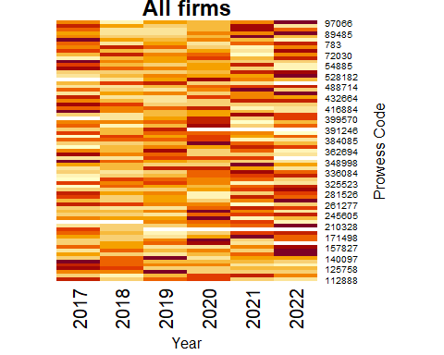 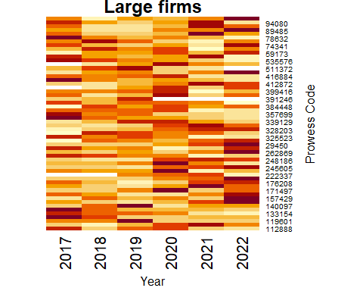 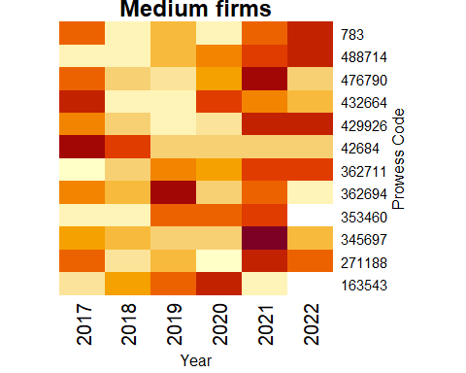 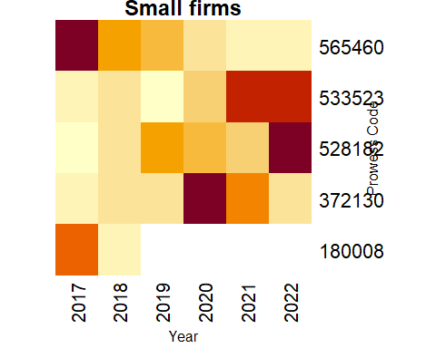 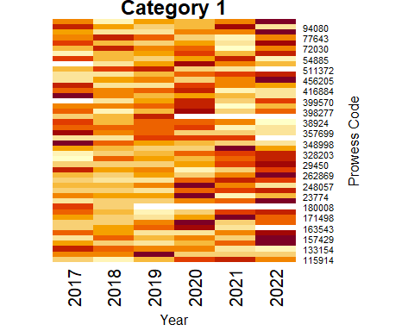 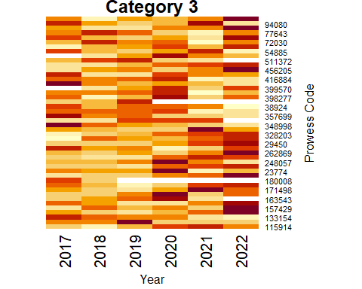

Mixon, Franklin G, and Yu Hsing. 1997. “The Determinants of Market Share for the ‘Dominant Firm’ in Telecommunications.” *Information Economics and Policy* 9 (4): 309–18. <https://doi.org/10.1016/S0167-6245(97)00013-9>.

Weiss, Doyle L. 1968. “Determinants of Market Share.” *Journal of Marketing Research* 5 (3): 290–95. <https://doi.org/10.1177/002224376800500307>.

1. For example see Mixon and Hsing (1997),Weiss (1968)