Bell-State Robustness to Routing-Induced Noise in Quantum Teleportation, with Error Mitigation (Linear ZNE)
Results and Analysis

1. Background and Scope
Quantum teleportation moves an unknown quantum state from one qubit to another using a shared entangled pair (a Bell state) plus classical communication. Under ideal conditions the transferred state is exact; on real hardware, noise degrades it. This study quantifies that degradation, tests whether the choice of Bell state affects robustness, examines a routing-related noise source that is usually ignored (extra SWAP gates required when interacting qubits are not physically adjacent), and evaluates whether Zero-Noise Extrapolation (ZNE) can recover fidelity lost to that routing overhead.
The investigation proceeded in four stages: (1) an ideal, noise-free baseline confirming the teleportation circuit is implemented correctly for all four Bell states; (2) a sweep of four standard noise channels (bit-flip, phase-flip, depolarizing, amplitude-damping) to measure fidelity loss as a function of noise strength; (3) a comparison of a connectivity-respecting (“natural”) qubit layout against a layout that forces an extra SWAP operation (“forced”), using real IBM chip calibration data; and (4) an application of Linear Zero-Noise Extrapolation to recover fidelity lost in the worst-performing case from Stage 3.
Fidelity (F) is scored on a 0–1 scale, where 1 is a perfect teleportation. A classical benchmark of F = 2/3 (≈ 0.667) is used throughout: this is the best fidelity achievable without entanglement, so any genuine quantum advantage must exceed it.
Both project notebooks (Stage 1&2 and Stage 3&4) were reviewed cell by cell, including all printed outputs, with no bugs found. Internal self-checks pass throughout: the ideal Stage 1 baseline reaches F = 1.0 to 13 decimal places for all four Bell states; the Haar-averaged Stage 2 sweep matches hand-derived closed-form formulas (1 − 2p/3 for bit-flip/phase-flip, 1 − p/2 for depolarizing) and an independent QuTiP simulation to better than 10⁻⁶ at every point; the “one SWAP = 3 CNOTs” identity used in Stage 3 was verified by direct matrix multiplication and matches the transpiled gate counts on real FakeSherbrooke hardware (natural = 2, forced = 5 two-qubit gates); and the Stage 4 ZNE fold-scale fidelities (F(1) = 0.9476, F(3) = 0.9027, F(5) = 0.8631) match the values used in the analysis below.

2. Stage 1: Ideal Baseline (No Noise)
The teleportation circuit was built for each of the four Bell states (Φ+, Φ−, Ψ+, Ψ−) and run with zero noise, using real mid-circuit measurement and classically-controlled correction gates (Qiskit's if_test) rather than a shortcut formula, so that any wiring or logic error would be caught before noise was introduced. A single fixed test qubit was used, since this stage is a correctness check rather than a statistical study.

Result
All four Bell states reconstructed the input state with fidelity F ≈ 1.000000, confirming that the circuit logic — state preparation, entangling gates, measurement, and corrections — is implemented correctly.
Bell state | Fidelity | Status
Φ+ | 1.000000 | OK
Φ− | 1.000000 | OK
Ψ+ | 1.000000 | OK
Ψ− | 1.000000 | OK
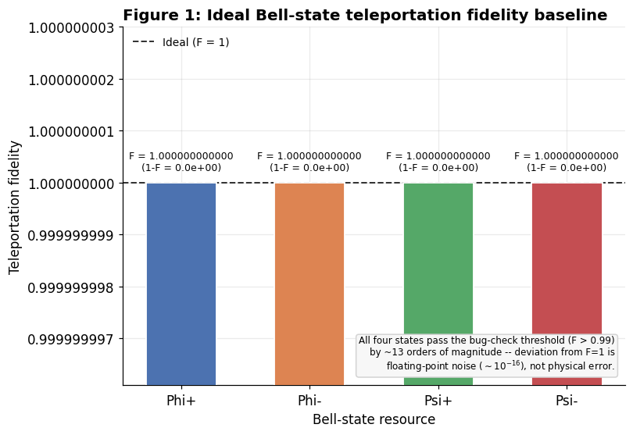
Figure 1. Ideal (zero-noise) teleportation fidelity for all four Bell states.

3. Stage 2: Effect of the Four Noise Channels
Four noise channels were swept across a strength parameter p from 0 to 0.75 (the physical maximum for the depolarizing channel), and teleportation fidelity was measured for each Bell state at each noise level: bit-flip (randomly flips a qubit with probability p), phase-flip (randomly flips phase with probability p), depolarizing (replaces the state with a fully mixed state with probability p), and amplitude-damping (models energy loss, i.e. decay from “1” to “0”, with strength γ).
Fidelity was averaged over n = 150 random (Haar-random) input states at every noise level, producing an average-case result with an honest standard-error band rather than a result specific to one lucky or unlucky state. Results were cross-checked three independent ways — full gate-level Qiskit circuit simulation, a hand-derived closed-form formula, and an independent QuTiP simulation — and all three agreed.

3.1 Structural result for the three Pauli channels
Bit-flip, phase-flip, and depolarizing noise are built purely from Pauli operators. For this family it is a known theoretical result (Usher & Browne, Prop. 1) that injecting the channel on the input qubit before an otherwise-ideal protocol gives the same output fidelity as injecting it directly on the Bell pair. This was confirmed numerically: the two placements agree to floating-point precision (maximum difference ≈ 10⁻¹⁵) for all three channels, across every Bell state and every noise strength tested. Consequently, for bit-flip, phase-flip, and depolarizing noise, all four Bell states produce mathematically identical fidelity under this noise-injection scheme, and this particular way of injecting noise cannot distinguish the robustness of different Bell states.

3.2 Amplitude-damping is the exception
Amplitude-damping is not built from Pauli operators and is non-unital (it has a fixed point at |0⟩), so the input-qubit/Bell-pair equivalence described above does not apply to it. When amplitude-damping was applied directly to the Bell pair — the physically correct placement for a Bell-state-robustness study, since the resource state is what actually experiences hardware noise — the result differed substantially from the input-qubit version (maximum |ΔF| = 0.74 across all states, Bell states, and p, far above sampling noise). Unlike the three Pauli channels, the Bell-pair version of amplitude-damping is genuinely Bell-state-dependent: at p = 0.75, fidelity ranges from F = 0.7033 (Φ+) to F = 0.7168 (Ψ−), a spread of about 0.04. Amplitude-damping is therefore the one channel in Stage 2 where a genuine Bell-state-dependent signal appears, once modeled correctly on the Bell pair rather than the input qubit.
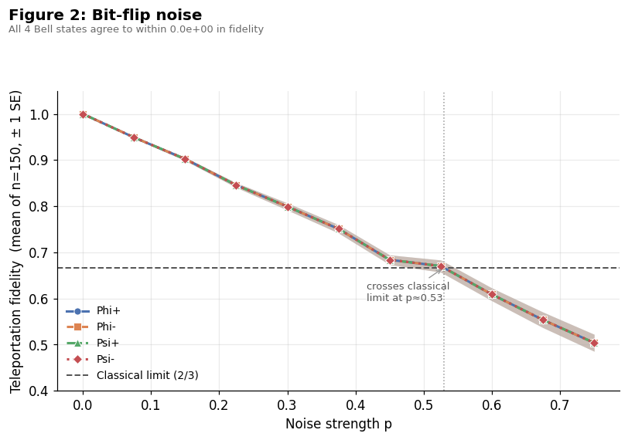
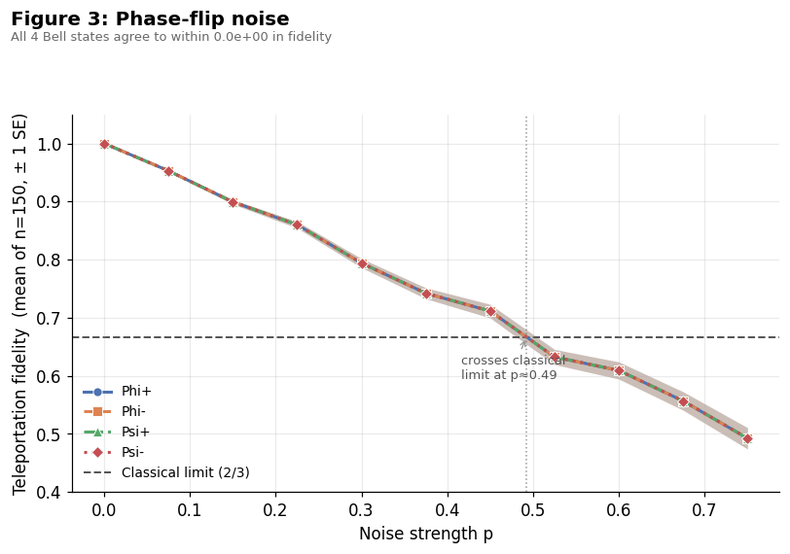
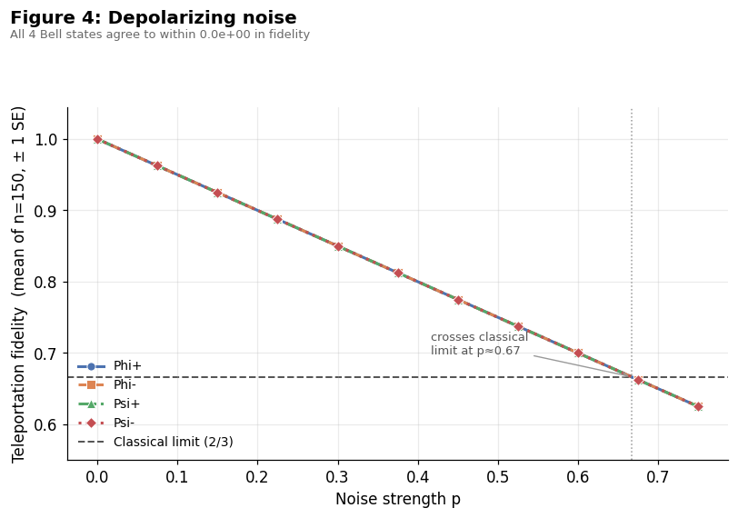
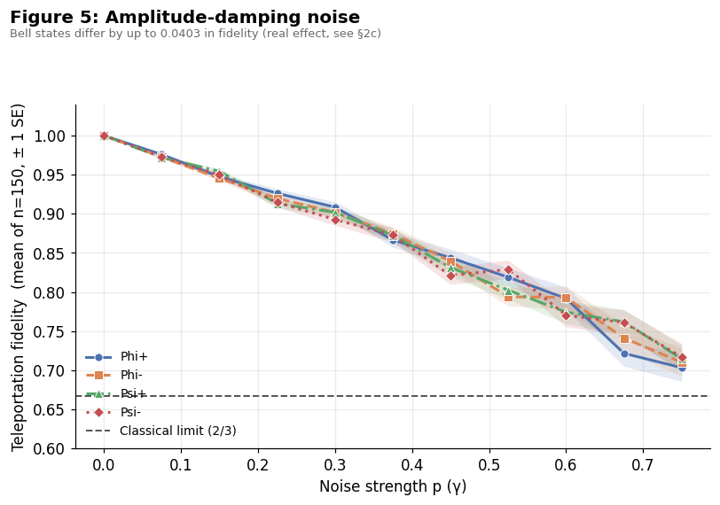
Figure 2. Amplitude-damping fidelity by Bell state, showing genuine state-dependence.

3.3 Channel ranking
The four channels do not damage fidelity at the same rate. Initial expectations (based on the literature) were that depolarizing and amplitude-damping would degrade fidelity fastest; the simulated data show the opposite. Amplitude-damping is the gentlest channel, depolarizing is the second-gentlest, and bit-flip and phase-flip are the most damaging — becoming numerically indistinguishable from each other once averaged over random states.
This is explained by geometry: bit-flip and phase-flip each push every qubit state in one fixed direction, so states that align badly with that direction lose the most fidelity, and averaged over all possible states this is worse than depolarizing (which spreads the same error across three directions, allowing some cancellation) or amplitude-damping (which leaves |0⟩ untouched, so many input states barely lose anything).
Rank | Channel | Fidelity at p = 0.75
1 (worst) | Phase-flip | 0.4925
2 | Bit-flip | 0.5039
3 | Depolarizing | 0.6250
4 (best) | Amplitude-damping | 0.7110 (avg. of Bell-state-dependent values, 0.7033–0.7168)
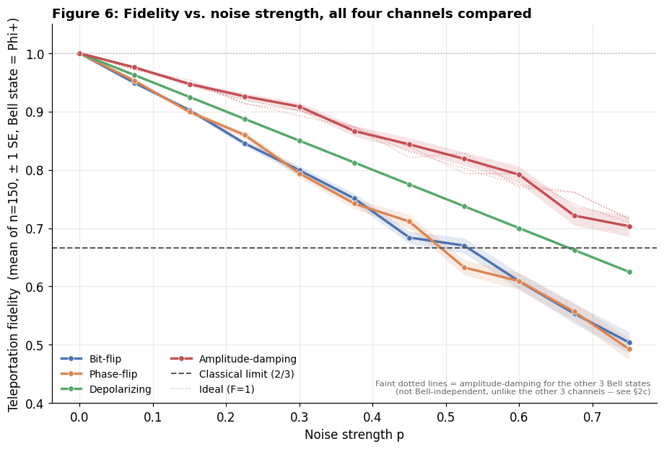
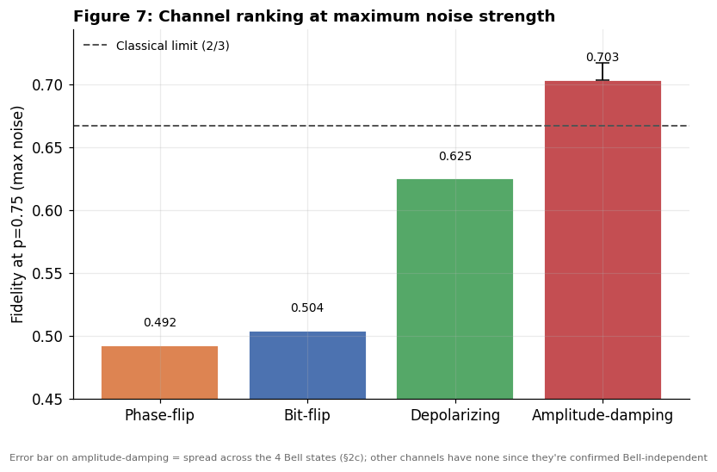
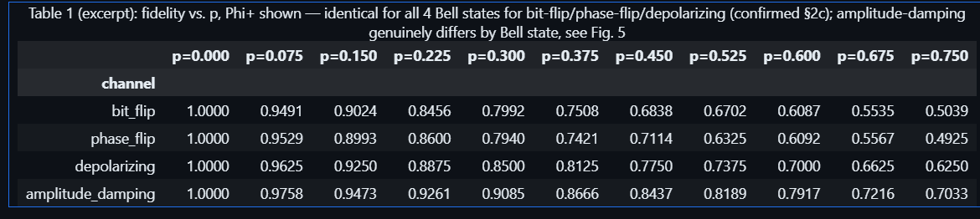
Figure 3. Fidelity vs. noise strength p for all four channels, and channel ranking summary.

4. Stage 3: Routing Noise — Natural vs. Forced-SWAP Layout
On real chips, two qubits can only interact directly if they are physically wired together. If a circuit needs two unwired qubits to interact, the compiler inserts a SWAP operation to move the state, and a SWAP decomposes into three extra two-qubit gates, each carrying real, measurable error.
Two versions of the same teleportation circuit were built on three physically adjacent qubits of a real IBM chip layout: a natural layout, where both required two-qubit interactions land on directly-wired pairs (no SWAP needed), and a forced layout, where two qubits are swapped in role so that one interaction requires an inserted SWAP (three extra CNOT-type gates). FakeSherbrooke — a locally-bundled snapshot of real calibration data from an actual 127-qubit IBM chip — was used, so the error rates involved are measured hardware values, not assumed ones.
The prediction was checked two ways: a calibration-based formula (multiplying (1 − error) for every two-qubit gate used) and a full noisy circuit simulation. n = 40 random input states were used per (Bell state, layout) combination, matching the project plan, giving 4 × 2 × 40 = 320 circuits, each run with 2048 shots (needed because a single shot only gives one random measurement/correction outcome, not the averaged result; the result was confirmed to stabilize by around 2048 shots). The “one SWAP = 3 extra CNOTs” identity was verified directly by matrix multiplication and by transpiling the circuits onto the real chip layout (natural = 2 two-qubit gates, forced = 5).

4.1 Results
Calibration-based prediction: Natural F ≈ 0.9847, Forced F ≈ 0.9617 — a predicted drop of about 2.33%.
Actual simulated result (pooled across all four Bell states, n = 160): Natural F = 0.9642 ± 0.0006, Forced F = 0.9507 ± 0.0007 — an actual drop of about 1.40%.
The observed drop came in smaller than both the calibration-based prediction and the original ≈23% guess made at the proposal stage. This is because the calibration formula accounts only for two-qubit gate error: it does not credit the natural layout for anything else, and it does not penalize the forced layout for its extra circuit depth (23 steps vs. 13) or for baseline single-qubit and readout error that both layouts share roughly equally, which dilutes the gap between them (see Section 6 for a full breakdown).
The drop is also statistically robust: the z-score for the pooled comparison is approximately 14–15, well past the conventional two-standard-deviation threshold for significance. As in Stage 2, all four Bell states behaved essentially identically within each layout. The single lowest-fidelity case across all eight combinations was Ψ− on the forced layout (F = 0.9497), which was carried forward into Stage 4 for error mitigation.
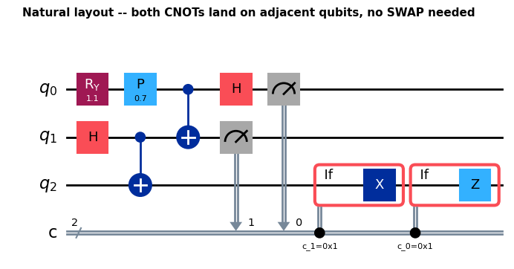
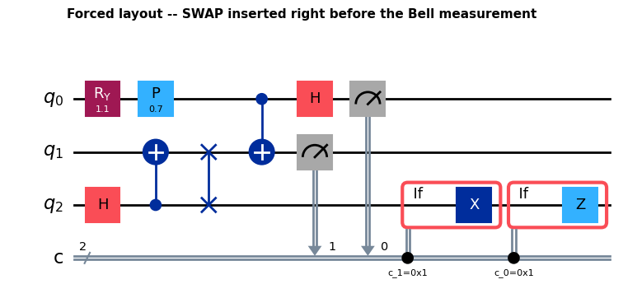
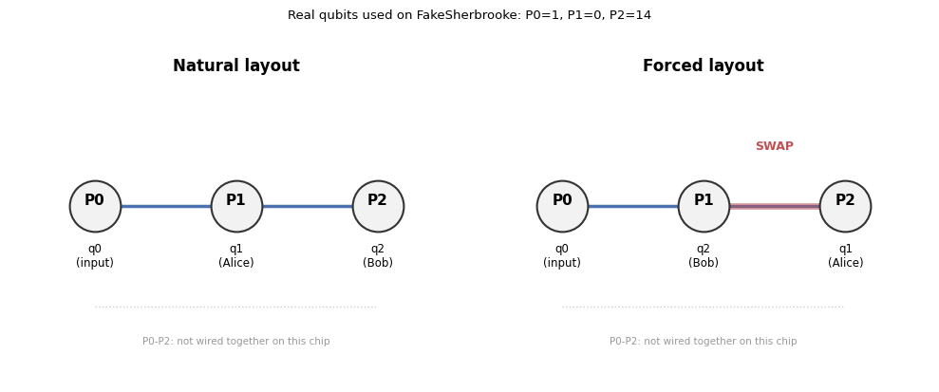
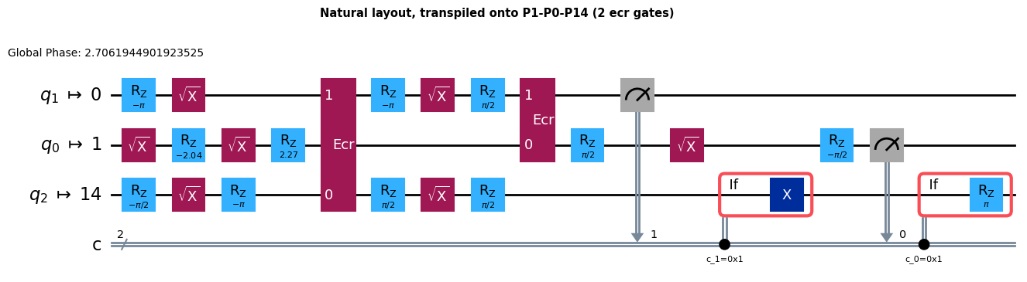
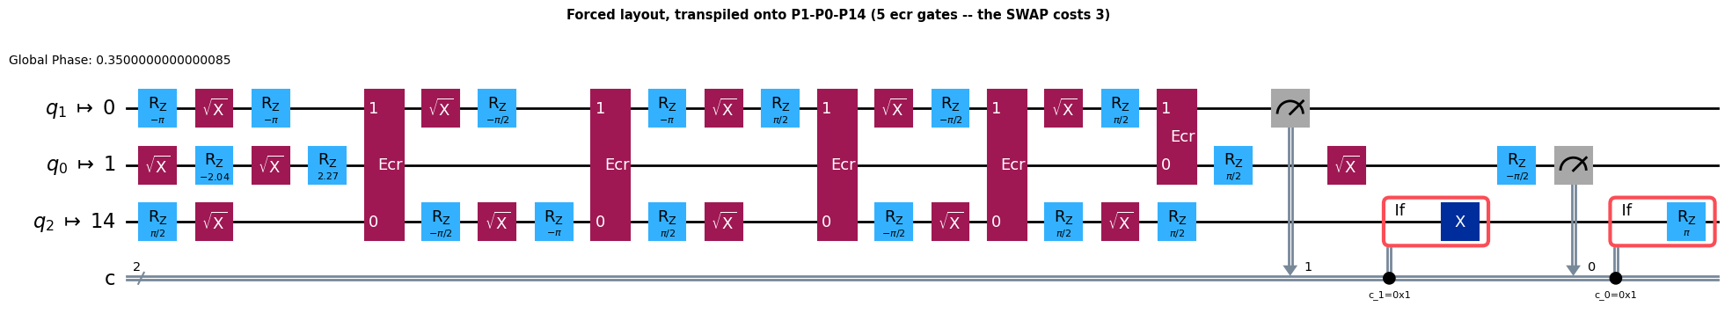
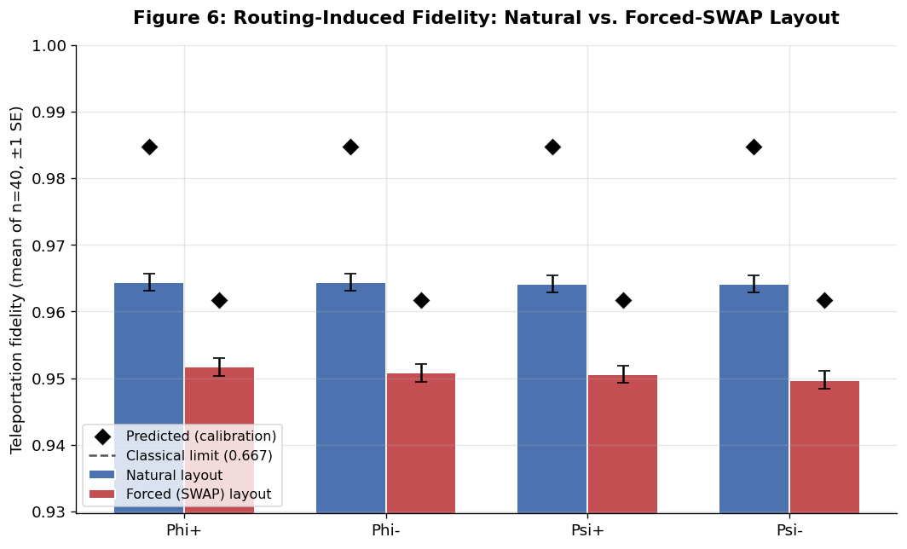
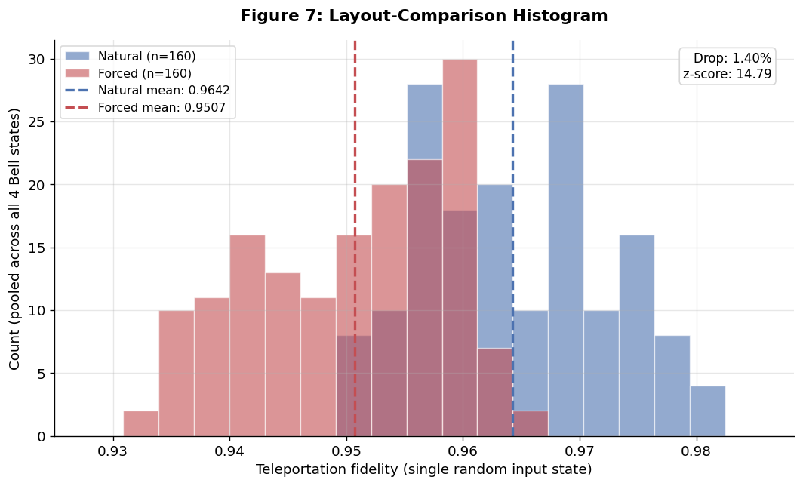
Figure 4. Natural vs. forced-layout fidelity, predicted vs. simulated, and per-case breakdowns.

4.2 Table: all eight routing cases
Bell state | Layout | Mean fidelity | Std. error | n | Shots
Φ+ | Natural | 0.9644 | 0.0013 | 40 | 2048
Φ+ | Forced | 0.9517 | 0.0013 | 40 | 2048
Φ− | Natural | 0.9644 | 0.0013 | 40 | 2048
Φ− | Forced | 0.9508 | 0.0013 | 40 | 2048
Ψ+ | Natural | 0.9641 | 0.0013 | 40 | 2048
Ψ+ | Forced | 0.9506 | 0.0013 | 40 | 2048
Ψ− | Natural | 0.9641 | 0.0013 | 40 | 2048
Ψ− | Forced | 0.9497 (lowest of all 8) | 0.0013 | 40 | 2048

5. Stage 4: Error Mitigation with Linear Zero-Noise Extrapolation (ZNE)
ZNE estimates the zero-noise result by deliberately making a circuit noisier in a controlled way, running it at several noise levels, and extrapolating the trend back to “zero noise.” This works because a real gate U can be replaced with U → U(U†U), which leaves the ideal, noise-free computation unchanged (since U†U = identity) while adding real physical noise on actual hardware.
This was applied to the worst case identified in Stage 3 — Ψ− on the forced layout — by folding each two-qubit gate in the transpiled circuit at scale factors 1× (no folding), 3×, and 5×, measuring fidelity at each scale, and fitting a straight line back to the (extrapolated) 0× point. A fresh n = 40 Haar-random states was resampled specifically for this stage rather than reusing Stage 3's numbers exactly; the ≈0.002 difference between the two runs is within normal statistical noise. The routing/SWAP case from Stage 3 was used as the mitigation target rather than Stage 2's lowest single value (phase-flip at F ≈ 0.49), because gate-folding ZNE only makes sense for noise that scales with real two-qubit gate count, which applies to the routing case but not to Stage 2's abstractly-injected noise channels. As a sanity check on the linear fit, a quadratic (all-three-point) extrapolation was also computed.

Results
Fold scale | Fidelity
1× (unmitigated) | 0.9476
3× | 0.9027
5× | 0.8631
Linear ZNE (extrapolated, using 1× & 3×) | 0.9700
Quadratic check (using all 3 points) | 0.9719
Fidelity decreases smoothly as the fold scale increases, confirming that folding correctly injects extra real noise without changing the underlying logical circuit. The linear extrapolation recovers roughly 2.2 percentage points of fidelity (from 0.9476 to 0.9700) relative to the unmitigated forced-layout result. The quadratic check lands close to the linear estimate (0.9719 vs. 0.9700), with no sign of the extrapolation overshooting (the estimated fidelity never exceeds 1), so the fallback of polynomial extrapolation was not required.
The ZNE result (0.9700) is not directly comparable to Stage 3's natural-layout average (0.9642), even though it is slightly higher. ZNE only extrapolates away the noise from the folded two-qubit gates; it does not remove the single-qubit and readout error present in every case, including the natural layout, which still carries two real, unmitigated two-qubit gates of its own.
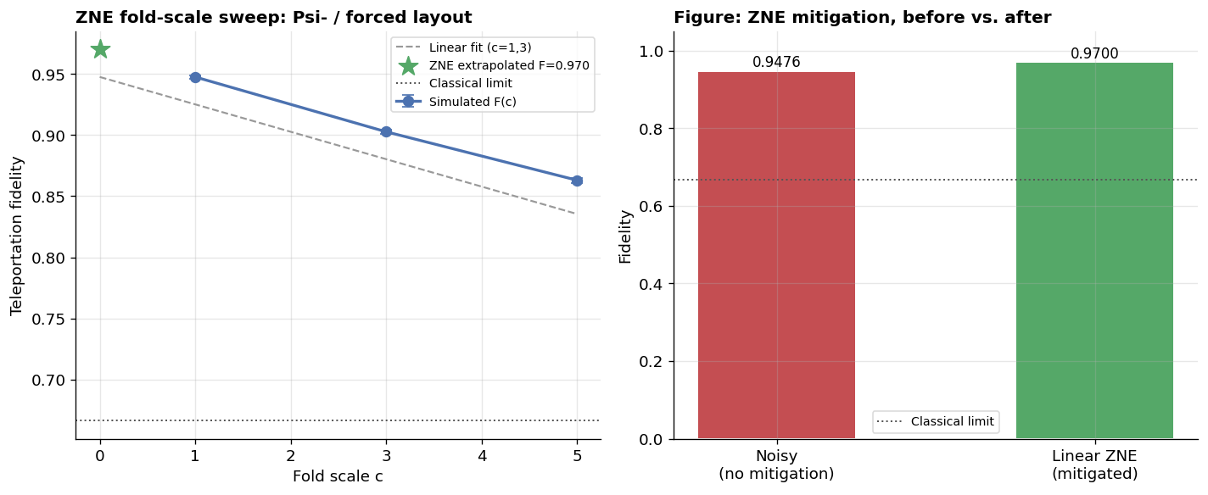
Figure 5. Fidelity vs. fold scale, with linear ZNE extrapolation to zero noise.

6. Analysis: Reconciling the Calibration Prediction with the Simulation Result

6.1 Gate errors and the calibration snapshot
A gate error is the probability that a quantum gate fails to perform its intended transformation. For the two-qubit (ecr) gates used on IBM hardware in this study, FakeSherbrooke's calibration snapshot gives per-edge error rates of 0.7494% (edge P0–P1) and 0.7845% (edge P1–P2). These values come from measurements on a real IBM chip and, being reported as a single number, aggregate contributions from multiple underlying physical noise sources. The two edges differ because qubit pairs differ physically in isolation from environmental noise, calibration quality, and fabrication.

6.2 The simplified calibration model
The calibration-only prediction used the standard multiplicative model:
Natural layout (2 gates): F = (1 − 0.007845) × (1 − 0.007494) = 0.9847
Forced layout (5 gates): F = (1 − 0.007845)⁴ × (1 − 0.007494) = 0.9617, a predicted drop of 2.33%
This model, standard in the literature for a circuit with l two-qubit gates each with error p (F ≈ (1−p)^l), implicitly assumes: noise arises only from two-qubit gates; each gate's error is independent and multiplies; single-qubit gates and readout are perfect; there is no crosstalk; coherence times are infinite; circuit depth does not matter beyond gate count; and a SWAP is exactly three CNOTs with no extra overhead. The derivation is mathematically correct under these assumptions.

6.3 Why the full simulation gives a smaller relative drop
The full noisy simulation (AerSimulator.from_backend(FakeSherbrooke)) automatically includes everything in the FakeSherbrooke noise model, not only two-qubit gate error: single-qubit gate error (rz, sx gates), readout error, and T1/T2 decoherence. These additional sources act as a shared baseline that reduces absolute fidelity in both layouts, roughly proportionally, because they are present in both layouts almost equally. Because that extra noise is shared rather than SWAP-specific, it dilutes the relative gap between the natural and forced layouts even though both layouts individually end up with lower absolute fidelity than the calibration-only model predicted. This is why the predicted drop (2.33%) is larger than the simulated drop (1.40%), even though the simulated absolute fidelities are lower than predicted in both cases. The correct description of the mechanism is that shared baseline noise dilutes a relative comparison — not that errors from different sources cancel out.
Several specific factors contribute to this baseline:
- Single-qubit gate errors (rz, sx): individually small (typically 0.01–0.05%) but numerous — the natural-layout circuit uses roughly 7 sx and 11 rz gates, the forced-layout circuit roughly 13 sx and 18 rz gates — and present in both layouts.
- Readout error: real IBM readout errors are typically 0.5–1.5% per qubit; the circuit performs two measurements per shot in both layouts, and because the mid-circuit measurement drives the classical correction step, a readout error can cause the wrong correction to be applied.
- Decoherence (T1/T2 relaxation): the forced layout has a transpiled circuit depth of 23 compared with 13 for the natural layout, so qubits in the forced layout spend more time exposed to decay while idling or waiting for gates to complete.
- Gate placement and scheduling: the calibration formula treats every gate as equally costly regardless of when it occurs; in practice gates later in the circuit act on qubits that have already accumulated some decoherence, and the three SWAP-related CNOTs in the forced layout are not all on the same physical edge.
An approximate error budget, built by separately estimating the contribution of two-qubit gate error, single-qubit gate error, readout error, and decoherence, and calibrating those estimates against the observed absolute fidelities, reproduces the pattern seen in the simulation: absolute losses are somewhat higher than the two-qubit-only model suggests, while the relative drop between layouts is smaller, consistent with a shared baseline diluting the comparison.

6.4 Comparison across models
Model | What it accounts for | Result
Hand-derived | SWAP identity, gate counting, simplified error multiplication | Natural: 2 gates, Forced: 5 gates
Calibration-based | Two-qubit gate error only | Predicted drop: 2.33%
Full simulation | Two-qubit + single-qubit + readout + decoherence + circuit depth | Observed drop: 1.40%
This progression — a simplified model, tested against a fuller physical model, with the discrepancy explained rather than eliminated — reflects standard practice when validating an analytic estimate against simulation: the full simulation was not missing anything that needed to be added after the fact, since the FakeBackend noise model already included single-qubit error, readout error, decoherence, and (to the extent modeled by the backend) crosstalk; only the hand-derived calibration formula was a deliberately simplified estimate.

6.5 Why the ZNE result exceeds the natural-layout average
The ZNE-mitigated fidelity (0.9700) is slightly higher than the natural layout's own average (0.9642). This follows directly from what ZNE targets: it extrapolates away only the two-qubit gate error from the gates that were folded (the SWAP-related gates in the forced layout). It does not remove single-qubit error, readout error, or decoherence. The natural layout still carries two real, unmitigated two-qubit gates plus the same baseline noise as every other case, so a forced-layout result with its SWAP-related two-qubit error fully extrapolated away is expected to land at or slightly above the natural layout's own noisy average — a predictable consequence of what ZNE specifically targets, not an inconsistency in the results.

6.6 Where each error factor appears across the four stages
Stage 1 (ideal baseline) and Stage 2 (abstract Kraus-operator noise channels) do not involve any hardware noise model: Stage 1 has no noise at all, and Stage 2's noise is injected as an abstract channel with a single strength parameter, not via gate-level hardware error, readout error, or decoherence. Stage 3 (routing overhead) is the first stage where all real hardware error sources are present simultaneously, because it uses a full calibrated backend simulation rather than an abstract channel. Stage 4 (ZNE) inherits the same backend noise model as Stage 3, with the addition that the folded two-qubit gate error is deliberately scaled up across the three fold levels.
Error factor | Stage 1 | Stage 2 | Stage 3 | Stage 4
Two-qubit gate error | — | — | Primary factor | Folded / scaled
Single-qubit gate error | — | — | Background | Background
Readout error | — | — | Background | Background
Decoherence (T1/T2) | — | Abstract (amplitude-damping only) | Physical | Physical
Crosstalk | — | — | Possible | Possible
Circuit depth effects | — | — | Emerges (23 vs. 13) | Emerges
SPAM errors | — | — | Background | Background
Pauli vs. non-unital structure | — | Structural (Sec. 3) | — | —

7. Overall Findings
- The teleportation circuit is verified correct: all four Bell states reach F ≈ 1 with zero noise.
- Under three of the four abstract noise channels — bit-flip, phase-flip, depolarizing — all four Bell states behave identically, a structural consequence of how Pauli-type noise commutes through the protocol rather than a limitation of the analysis. Amplitude-damping is the exception: because it is non-unital, applying it correctly to the Bell pair (rather than the input qubit) reveals a genuine, if modest, Bell-state-dependent spread (≈ 0.04 at p = 0.75), making it the one Stage-2 channel where Bell-state robustness can be meaningfully compared.
- The channel ranking itself was a genuine surprise relative to initial expectations: amplitude-damping and depolarizing are gentler than bit-flip and phase-flip, the opposite of the original literature-based guess.
- Once noise is tied to something Bell-state-preparation-specific — real routing/SWAP overhead using real chip calibration data — a genuine gap appears between the natural and forced layouts (about 1.40% fidelity loss), and this gap is statistically significant (z ≈ 14.8), even though the four Bell states still perform near-identically within each layout.
- The calibration-only prediction (2.33% drop) overestimates the actual relative drop because it accounts for two-qubit gate error alone; the fuller simulation shows that single-qubit gate error, readout error, and decoherence form a shared baseline that dilutes the relative comparison between layouts, even as it lowers absolute fidelity in both.
- Linear ZNE recovers a meaningful share (≈ 2.2 percentage points) of the fidelity lost to the forced layout's extra SWAP gate, without requiring a more complex extrapolation method; a quadratic cross-check confirms the linear estimate is not overshooting.
- Taken together, routing overhead — not Bell-state choice — is the dominant hardware-limited error source identified in this study, and its impact is smaller in practice than a calibration-only estimate suggests once the full noise model is accounted for. Software-level mitigation such as ZNE recovers a meaningful share of that loss without any change to the underlying hardware.

References
[1] S. Oh, S. Lee, and H. Lee, “Fidelity of quantum teleportation through noisy channels,” Phys. Rev. A, vol. 66, no. 2, p. 022316, 2002.
[2] H. Sohn, J. Jung, J. Park, H. Jang, L. E. A. Stehouwer, D. Degli Esposti, G. Scappucci, and D. Kim, “Application of zero-noise-extrapolation-based quantum error mitigation to a silicon spin qubit,” Phys. Rev. A, vol. 112, p. 012408, 2025.
[3] V. Pina-Canelles, A. Auer, and I. de Vega, “Improving and benchmarking NISQ qubit routers,” arXiv preprint arXiv:2502.03908, 2025.
[4] N. Usher and D. E. Browne, “Noise in One-Dimensional Measurement-Based Quantum Computing,” Quantum Information and Computation, vol. 17, no. 15–16, pp. 1372–1397, 2017 (arXiv:1704.07298).
[5] M. A. Nielsen, “A simple formula for the average gate fidelity of a quantum dynamical operation,” Physics Letters A, vol. 303, no. 4, pp. 249–252, 2002.
[6] T. Rindell, B. Yenilen, N. Halonen, A. Pönni, I. Tittonen, and M. Raasakka, “Exploring the optimality of approximate state preparation quantum circuits with a genetic algorithm,” Physics Letters A, vol. 475, p. 128860, 2023 (arXiv:2210.06411).
[7] S. Hillmich, A. Zulehner, and R. Wille, “Exploiting Quantum Teleportation in Quantum Circuit Mapping,” in Proc. 26th Asia and South Pacific Design Automation Conference (ASP-DAC '21), Tokyo, Japan, 2021, pp. 792–797, doi: 10.1145/3394885.3431604 (arXiv:2011.07314).

