Checkers User Manual

**LOADING THE GAME**

1. Run Checkers.java
2. Enter in IP address of the computer you want to connect with.
3. Enter in listening port and talking port

**PLAYING THE GAME**

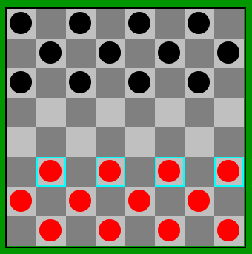

*Setup and Objective*

Checkers is played on a standard 64 square board. Only the 32 dark colored squares are used in play. Each player begins the game with 12 pieces, or checkers, placed in the three rows closest to him or her. Players take turns making moves. When it is your turn, the pieces (if there is more than one) that you can move will be highlighted in blue. Once you click one of those highlighted pieces, the location(s) you can move to will be highlighted in green.

The object of the game is to capture all of your opponent’s checkers or position your pieces so that your opponent has no available moves.

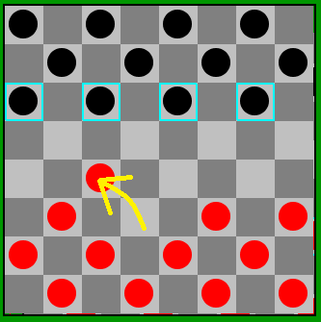

*Movement*

Basic movement is to move a checker one space diagonally forward. You can not move a checker backwards until it becomes a King, as described below. If a jump is available, you must take the jump, as described in the next question and answer.

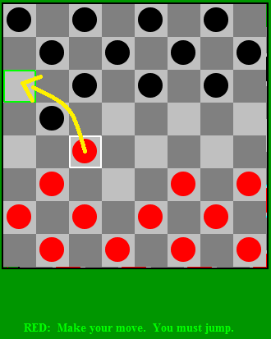

*Jumping*

If one of your opponent’s checkers is on a forward diagonal next to one of your checkers, and the next space beyond the opponent’s checker is empty, then your checker must jump the opponent’s checker and land in the space beyond. Your opponent’s checker is captured and removed from the board.

If, at the start of a turn, more than one of your checkers has a jump available, then you may decide which one you will move. But once you have chosen one, it must take all the jumps that it can.

*You Must Jump if Possible*

If a jump is available for one of your pieces, you must make that jump. If more jumps are available with that same piece, you must continue to jump with it until it can jump no more. To make the second and third jump with a piece, you do not need to click that piece again. Just click the next space to which it will jump.

If more than one of your pieces has a jump available at the start of your turn, you can choose which piece you will move. But then you must make all the jumps available for that piece.

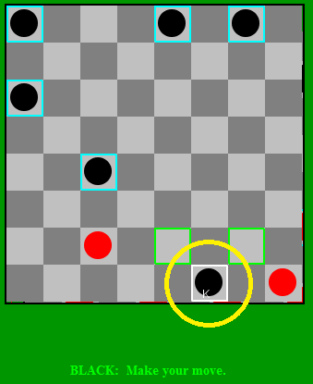

*Crowning*

When one of your checkers reaches the opposite side of the board, it is crowned and becomes a **King**. Your turn ends there.

A King can move backwards along the diagonals. It can only move a distance of one space.

A King can also jump backward. It must jump when possible, and it must take all jumps that are available to it. In each jump, the King can only jump over one opposing piece at a time, and it must land in the space just beyond the captured piece. The King can not move multiple spaces before or after jumping a piece.

*Ending the game*

The game officially ends when all of one opponent’s pieces have been captured or an opponent cannot make a move. Alternatively, a game may be ended by an opponent clicking the “Resign” button.

*Other*

Opponents can communicate with each other through the chat box.