**CHURN ANALYSIS PROJECT**

**INTRODUCTION**

The Churn Project Analysis in Power BI aims to analyze customer churn patterns and identify factors influencing customer attrition within the organization. The primary objective is to understand churn behavior and derive insights to minimize customer attrition. This document provides a high-level overview of the project for stakeholders, project managers, and data analysts involved in the churn analysis.

**PROJECT OVERVIEW**

The analysis utilizes historical customer data collected from various sources like CRM systems, transactional databases, and customer support logs. Power BI is the primary tool used for data visualization, exploration, and analysis. The project involves data preparation, including collection, cleaning, integration, and modeling.

**DATA PREPARATION**

Data Collection: Raw data is collected from relevant sources, such as CRM systems, transactional databases, and customer support logs. This includes data on customer demographics, product usage, purchase history, customer service interactions, and other relevant variables.

1. Data Cleaning: The collected data undergoes a cleaning process to handle missing values, outliers, and inconsistencies. This ensures that the data is of high quality and suitable for analysis.
2. Data Integration: Multiple data sources are integrated to create a unified dataset for churn analysis. This involves merging data from different systems and ensuring data consistency and accuracy.
3. Data Modeling: Data is modeled to create relationships between various entities and attributes for better analysis and visualization. This includes creating calculated columns, measures, and hierarchies to facilitate data exploration and analysis.

**ANALYSIS APPROACH**

1. Exploratory Data Analysis: The dataset is explored to identify key variables, patterns, and trends related to churn. This includes generating summary statistics, visualizing data distributions, and identifying correlations between variables. The goal is to gain initial insights into the data and understand the characteristics of churned customers.
2. Churn Metrics: Various churn metrics are calculated to understand the impact of churn on business. This includes calculating churn rate, customer lifetime value (CLV), and customer segmentation based on their churn behavior. These metrics provide a quantitative understanding of churn and its implications.
3. Key Drivers: Factors influencing churn are analyzed to identify the primary reasons behind customer attrition. This involves analyzing customer demographics, product usage patterns, customer service interactions, and customer satisfaction metrics. By identifying the key drivers of churn, the organization can focus on addressing those factors to reduce customer attrition.
4. Predictive Modeling: Machine learning techniques, such as logistic regression or decision trees, can be employed to predict future churn and identify customers at high risk of churn. By building predictive models, the organization can proactively target customers who are likely to churn and take appropriate actions to retain them.

**VISUALIZATION AND REPORTING**

1. Dashboards: Interactive dashboards are created in Power BI to visualize key churn metrics, trends, and insights. The dashboards provide an at-a-glance view of churn performance, allowing stakeholders to quickly identify areas of concern and take necessary actions.

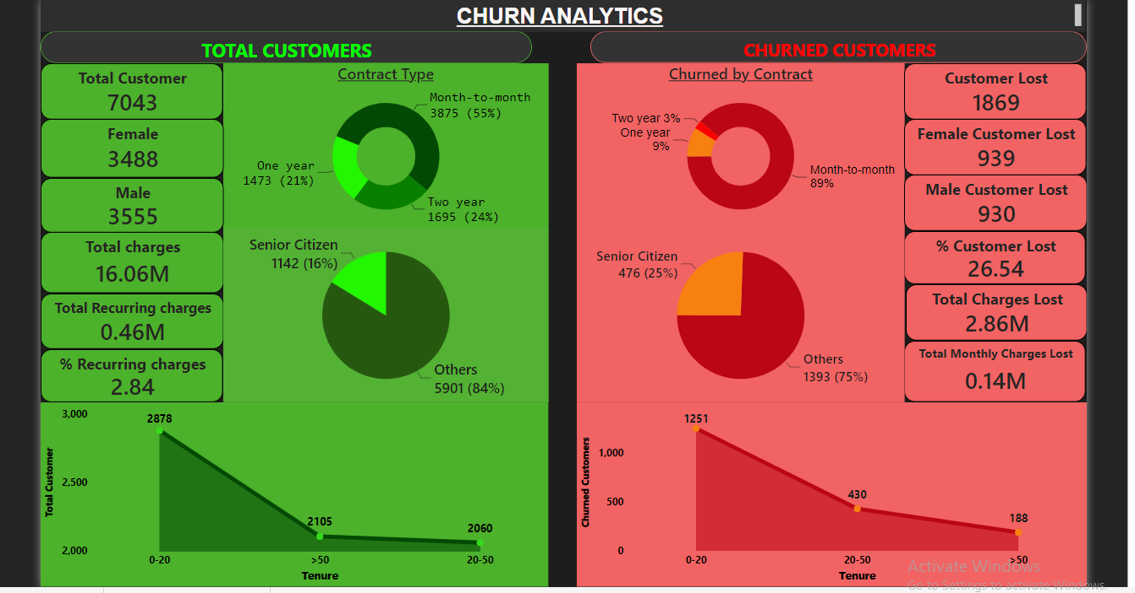

Dashboard

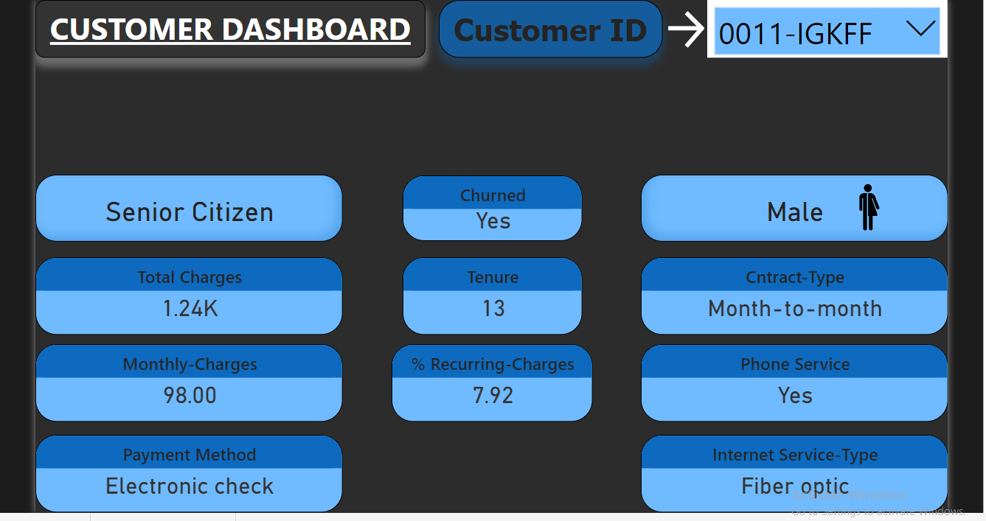

Customer Dashboard

1. Reports: Customized reports are generated to provide detailed analysis and actionable recommendations to stakeholders. These reports can include detailed churn analysis, customer segmentation insights, driver analysis, and predictive modeling results. The reports help stakeholders understand the underlying factors contributing to churn and make informed decisions.

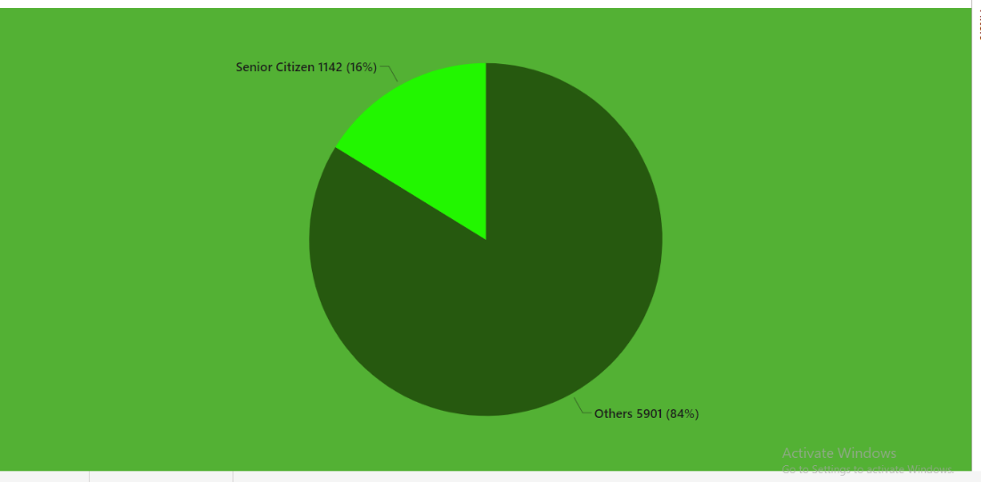

Total customers based on genders

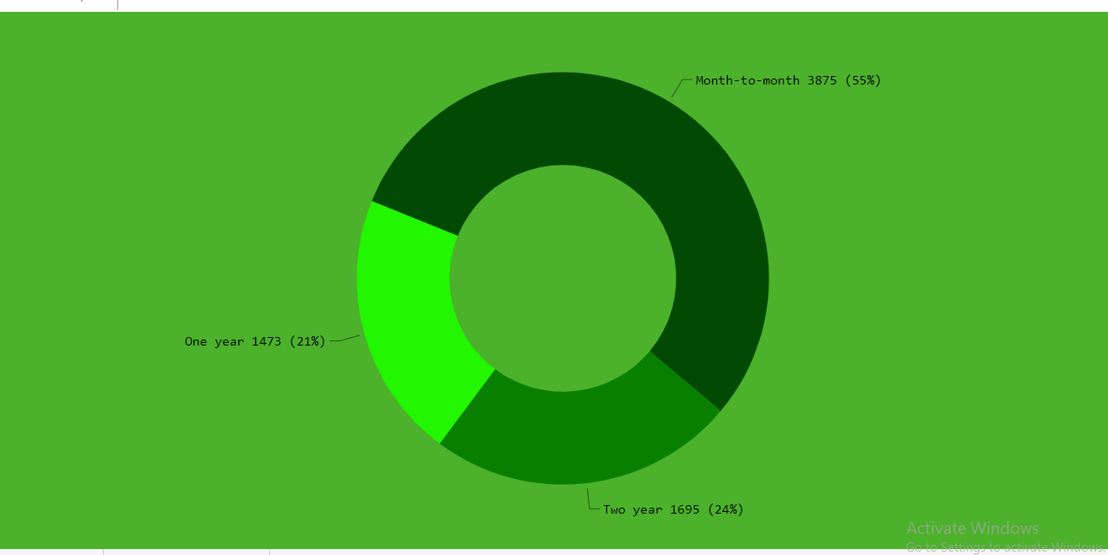

Total customers based on contract type

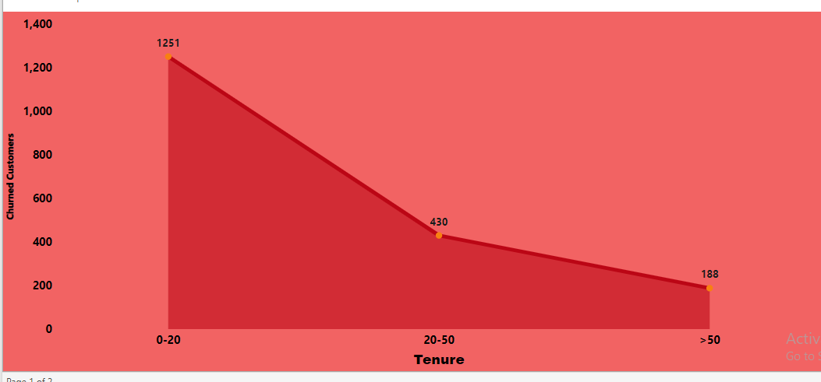

Churned customers based on Tenure

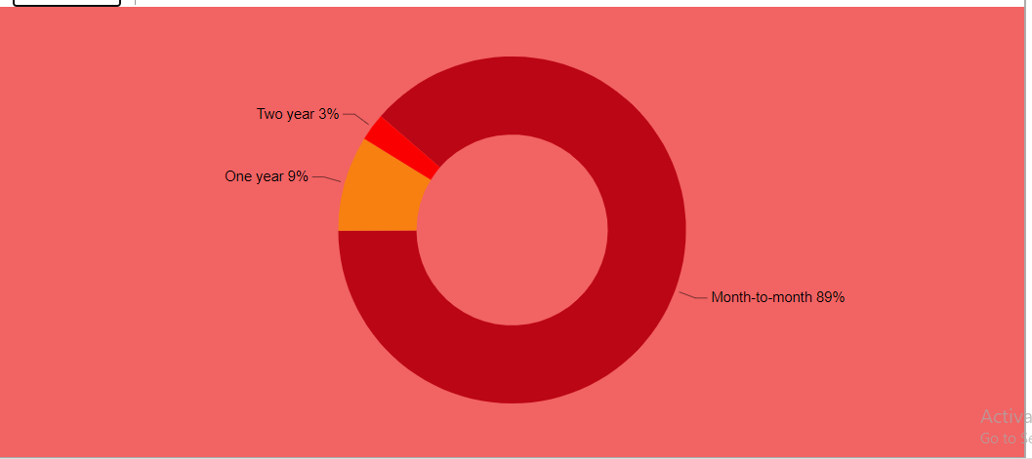

Churned customer based on contract type

1. Drill-Down Functionality: Power BI's drill-down capabilities enable users to explore data at different levels of granularity and slice and dice the data for deeper insights. Users can drill down from high-level metrics to individual customer-level details, enabling a granular analysis of churn patterns and identification of specific customers or customer segments that require attention.

**RECOMMENDATIONS AND ACTIONS**

1. Insights: The churn analysis provides insights into the primary reasons for churn and identifies potential areas of improvement. These insights help the organization understand the factors driving customer attrition and prioritize actions accordingly.
2. Actionable Recommendations: Based on the churn analysis, actionable recommendations are provided to reduce churn, improve customer satisfaction, and enhance customer retention strategies. These recommendations can include targeted marketing campaigns, personalized offers, improved customer service processes, product enhancements, or loyalty programs. By implementing these recommendations, the organization can effectively address the identified churn drivers and increase customer retention rates.
3. Monitoring: It is crucial to continuously monitor churn metrics and implement feedback loops to assess the effectiveness of implemented actions. Regularly reviewing churn performance and comparing it against predefined targets and benchmarks helps in evaluating the impact of implemented strategies. This monitoring process allows the organization to refine and optimize retention strategies based on real-time data and feedback.

**CONCLUSION**

The Churn Project Analysis conducted in Power BI enables organizations to identify factors contributing to customer attrition and take proactive measures to mitigate churn. By leveraging Power BI's data visualization and analysis capabilities, stakeholders can make informed decisions and optimize retention strategies. Continuous monitoring and refinement of strategies based on feedback loops are essential for ongoing success.