**CHURN ANALYSIS PROJECT**

1. **INTRODUCTION**

The purpose of this Low-Level Design (LLD) document is to provide a detailed overview of the churn project analysis in Power BI. This document outlines the design and architecture of the solution and focuses on the technical aspects of the churn analysis, including data sources, data transformations, visualizations, and interactive features.

1. **SYSTEM OVERVIEW**

The churn project analysis in Power BI comprises several key components. These include data sources, data transformations, data modeling, visualizations, and dashboards. The data sources for churn analysis include customer churn data, customer demographic data, and product usage data. The data transformations involve cleansing, integration, and aggregation to create a unified dataset. The data modeling stage involves designing a suitable data model to support churn analysis and enable efficient querying. Visualizations are created to analyze churn trends and patterns, and dashboards are designed to present key metrics and insights to stakeholders.

1. **DATA SOURCES**

The churn project analysis in Power BI relies on several data sources. These sources include historical customer churn data, which contains information about churn events, such as churn date, customer ID, and reason for churn. Customer demographic data provides additional details about customers, such as age, gender, location, and subscription type. Product usage data captures usage metrics for various products or services, such as login frequency, feature utilization, and transaction history.

Link: <https://www.kaggle.com/datasets/blastchar/telco-customer-churn>

1. **DATA TRANSFORMATIONS**

Data transformations are performed to prepare the data for analysis. These transformations include data cleansing, where missing or inconsistent data is handled, duplicates are removed, and data quality issues are resolved. Data integration involves combining data from different sources using common identifiers, such as customer ID. Data aggregation is performed to summarize the data at an appropriate level, such as monthly or quarterly, to facilitate analysis.

1. **DATA MODELING**

A robust data model is designed to support churn analysis. This typically involves creating a star schema or snowflake schema. Fact tables are defined to store churn events and related metrics, while dimension tables are created to store customer attributes, product details, and time dimensions. Relationships are established between the tables to enable efficient querying and analysis.

1. **VISUALIZATIONS**

Visualizations play a crucial role in churn analysis. Power BI offers various chart types, graphs, and tables to represent churn trends and patterns visually. Visual elements, colors, and formatting are applied to enhance clarity and understanding. Interactive features, such as filters, slicers, and drill-through capabilities, are incorporated to enable users to explore the data and gain deeper insights.

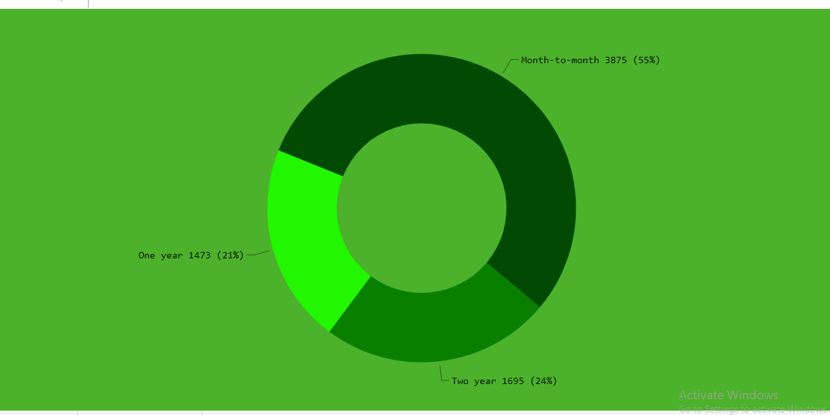

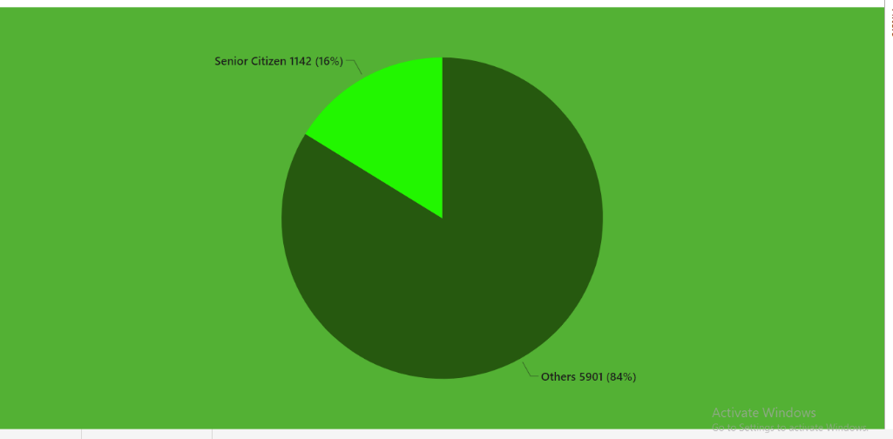

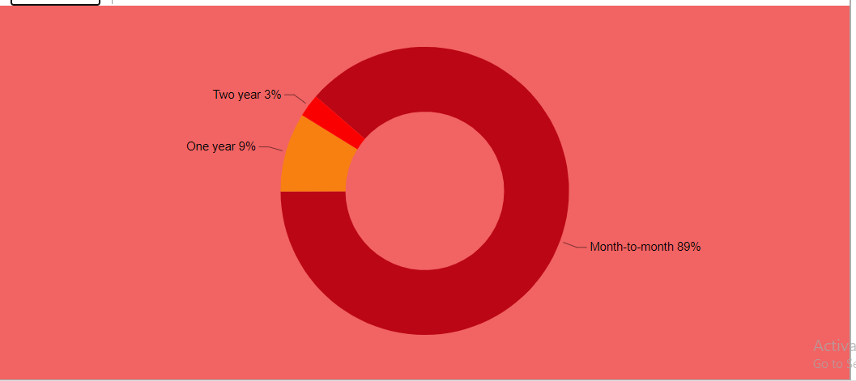

1. **DASHBOARDS**

Dashboards provide a comprehensive overview of churn metrics and insights. Key performance indicators (KPIs) are included to monitor churn rates, customer retention, and revenue impact. Interactive elements, such as filters and drill-through, allow users to perform detailed analysis and gain a deeper understanding of the churn data.

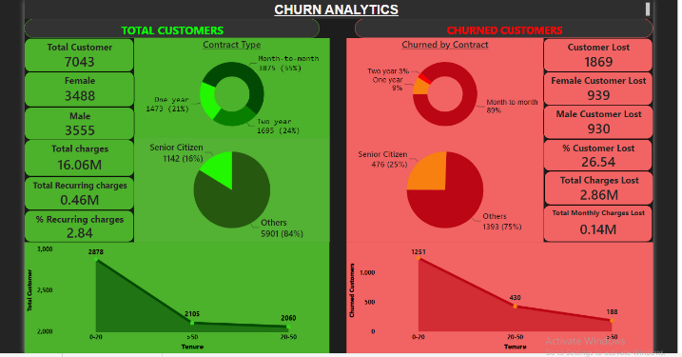

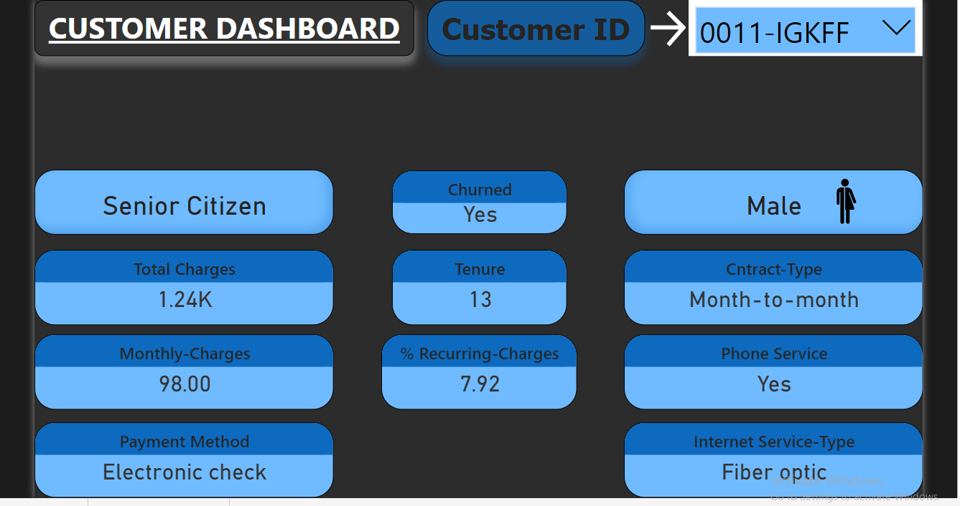

1. **SECURITY CONSIDERATIONS**

Security measures are implemented to ensure data privacy and access control. Role-based access controls are defined to limit data visibility and functionality based on user roles. Sensitive data is encrypted during transmission and storage to maintain confidentiality.

1. **DEPLOYMENT CONSIDERATIONS**

The deployment of the Power BI churn analysis solution requires careful planning. The target environment, such as Power BI Service or Power BI Report Server, needs to be identified. Data refresh schedules are established to ensure that the analysis is based on up-to-date data. Any dependencies or prerequisites for the deployment are documented for a smooth implementation process.

1. **CONCLUSION**

This Low-Level Design (LLD) document provides a detailed overview of the churn project analysis in Power BI, covering data sources, data transformations, data modeling, visualizations, dashboards, security considerations, and deployment considerations. It serves as a guide for the implementation and development of the churn analysis solution