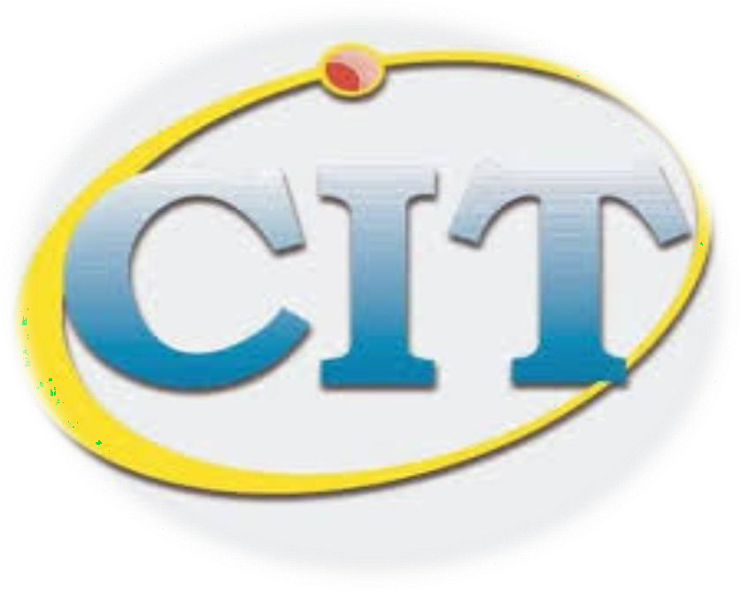
PURBANCHAL UNIVERSITY
College of Information Technology and Engineering
Subidanagar-32, Kathmandu Nepal

Project Work in C
Student Management System

SUBMITTED BY SUBMITTED TO
Pallav Bhattarai Pawan KC
BCA-IT
1st Semester

