PURBANCHAL UNIVERSITY
COLLEGE OF INFORMATION TECHNOLOGY AND ENGINEERING
Department of Science and Technology
Kathmandu, Nepal

CERTIFICATE OF APPROVAL

The undersigned certify that they have read and recommended this mini-project report entitled "STUDENT MANAGEMENT AND ATTENDANCE SYSTEM" submitted by Pallav Bhattarai, Dipesh Dahal, and Aayush Timalsina in partial fulfillment of the requirements for the degree of Bachelor of Computer Application and Information Technology (BCA-IT).
The project has been evaluated and accepted as satisfying the academic and technical standards required for the 1st Semester Final Project evaluation in C Programming.

Committee Chairperson / Head of Department: Signature: ___________________________
Date: _______________

Project Supervisor: Signature: ___________________________
Date: _______________

External Examiner: Signature: ___________________________
Date: _______________
ACKNOWLEDGEMENT
First and foremost, we would like to express our sincere gratitude to our project supervisor for providing immense support, valuable guidance, and constant encouragement throughout the development of this project. Their insightful feedback helped improve both our structural programming choices and our overall understanding of procedural system logic.
We are also highly thankful to the Department of Science and Technology at the College of Information Technology and Engineering for providing the necessary computing resources and a supportive learning environment. This project would not have been possible without the structured academic framework, foundational programming insights, and technical guidance provided by our teachers.
Lastly, we want to thank our families and friends for their continuous encouragement and assistance during our work. Implementing core features like custom structure (struct) definitions, file (I/O) data streams, and modular console architecture has been a valuable practical experience that has greatly enhanced our collective problem-solving skills obtained after learning C programming.
ABSTRACT
This project presents a lightweight, console-based Student Management and Attendance System developed using the C programming language. Traditional classroom record-keeping relies heavily on paper registers, which are prone to damage, difficult to search, and slow to update. Our system addresses these inefficiencies by providing a localized digital platform to handle student records directly through a terminal interface.
The application is built around foundational procedural programming principles, utilizing a custom structure (struct) to bundle student attributes and file input/output (I/O) operations to handle permanent data storage within a text file database (students.txt). Controlled by a modular, menu-driven interface using switch-case logic, the program allows users to seamlessly execute core operations: adding new records, displaying a tabular data grid, searching for individual profiles, deleting entries, and conducting classroom attendance tracking.
Furthermore, the system automates arithmetic calculations to output attendance percentages instantly, eliminating manual errors. Compiling and executing within the Visual Studio Code (VS Code) environment, this program serves as a practical, fast, and resource-efficient data management solution tailored for modern classroom administration.
Contents
CHAPTER 1: INTRODUCTION 2
1.1 Background 2
1.2 Problem statement 2
1.3 Goals and Objectives 2
1.4 Scope of the Project 2
CHAPTER 2: FEASIBILITY STUDY 2
2.1 Technical Feasibility 2
2.2 Economic Feasibility 2
2.3 Operational Feasibility 2
2.4 Educational Feasibility 2
CHAPTER 3: LITERATURE REVIEW 2
3.1 Review of Existing Record Systems 2
3.2 Evaluation of Console-Based Localized Architectures 2
CHAPTER 4: METHODOLOGY, IMPLEMENTATION, AND SOURCE CODE 2
4.1 System Architectural Design 2
4.2 Flowchart 2
4.3 Modular Functional Analysis 2
4.4 Full Program Source Code 2
4.5 Analysis of Existing System Constraints 2
CHAPTER 5: CONCLUSION AND FUTURE ENHANCEMENTS 2
5.1 Project Evaluation and Conclusions 2
5.2 Planned Future Enhancements 2
CHAPTER 6: APPENDIX 2

INTRODUCTION

Background
Managing student records and tracking academic progress is a core part of running any school or college. For a long time, schools have relied on paper registers to keep track of details, test marks, and daily classroom attendance. While this manual method works, it is slow and outdated compared to modern software tools.
Building a student management tool using C programming language is an excellent way to connect classroom theory with real-world software creation. By using structures and file handling in C, we can build a lightweight and fast command-line program. This application updates the old paperwork process by saving student records digitally on a computer storage disk, ensuring that data is safe and easy to access.

Problem statement
The traditional method of using paper logs and registers to track students has several major drawbacks:
- Time Wasting: Writing down names, marks, and attendance by hand for large groups of students takes up too much time.
- Slow Searching: Finding a single student’s past record requires searching through pages of a physical book one by one.
- Risk of Damage: Paper files can easily be lost, ruined by water or fire, or changed by unauthorized people.
- Calculation Errors: Teachers can easily make math mistakes when adding up total attendance days or calculating percentages by hand.
- Physical Space: Storing boxes of old paper registers over many years takes up too much physical office space.

Goals and Objectives
The main goal of this project is to create a simple, automated computer program that replaces physical paper logs with a reliable digital database system.
The specific goals are:
- Digital Data Entry: To create a clear system for typing and saving student information electronically.
- Permanent Data Storage: To use file handling in C so that student information is saved directly to the hard drive in a text file.
- Easy Access and Updates: To allow administrators to quickly add, view, search, and delete student entries.
- Automatic Math Calculations: To automate classroom roll calls and let the computer calculate attendance percentages without human error.
- Simple User Interface: To build an easy-to-use menu system where users can select options using simple numbers.

Scope of the Project
This program is designed for small-scale use, such as an individual classroom, a specific department, or a small training institute. It runs as a standalone desktop utility on a single computer and communicates directly with a local text file (students.txt). The system handles basic administrative tasks, stores test marks, tracks attendance, and updates student details without needing internet connectivity or heavy database software.

FEASIBILITY STUDY
A feasibility study was conducted across four main areas to make sure that this program is practical, useful, and safe to run in a school environment.

Technical Feasibility
The program is highly practical from a technical standpoint. It is written using the standard C framework with basic libraries like <stdio.h>, <stdlib.h>, and <string.h>. Student records are grouped using standard struct blocks, and data is permanently saved using standard C file operations like fopen, fscanf, and fprintf. Because the compiled program runs quickly on almost any operating system without needing high-end computer parts, it is technically sound.

Economic Feasibility
This project costs nothing to develop, deploy, or maintain. It is built using free, open-source programming tools, specifically Visual Studio Code (VS Code) paired with the GCC compiler. Since the final application runs smoothly on older computers that the school already owns, there is no need to purchase new hardware, expensive server setups, or paid software licenses.

Operational Feasibility
The system is very easy to operate. It features a straightforward text menu that guides the user through every option using simple number selections (like pressing 1 to add a student or 2 to view records). Because it is so simple, teachers and school office staff can manage data, search for students, or run an attendance roll call without needing any advanced technical training.

Educational Feasibility
For schools, this application saves time by replacing tedious paperwork, allowing teachers to spend more time focusing on their students. For the student developers, creating this tool provides valuable hands-on experience. It helps transform abstract programming ideas—like variable scopes, data streams, and logic planning—into a practical computer application.

LITERATURE REVIEW

Review of Existing Record Systems
Institutional tracking methods have moved through three major stages: paper-based logbooks, offline desktop software utilities, and modern web-based school management portals. While paper logbooks cost nothing upfront, they fail as student numbers grow and risk permanent data loss. On the other hand, modern cloud-hosted platforms offer excellent accessibility but come with high subscription costs, require a constant internet connection, and are prone to online hacking risks.

Evaluation of Console-Based Localized Architectures
Console-based applications that save data to local text files offer a reliable middle ground for smaller organizations. By storing records directly in flat text structures, these applications bypass the slow loading speeds and high system costs associated with heavy network database programs. Academic research shows that flat-file local systems are secure, run instantly on minimal hardware, and provide a practical option for small-scale operations were data privacy and low complexity matter most.

METHODOLOGY, IMPLEMENTATION, AND SOURCE CODE

System Architectural Design
The program uses a centralized, menu-driven design. The main loop acts as a central hub that redirects the user to separate, specialized tasks based on their menu choice.
Data is managed using a custom structure template called Student. This block bundles all related student attributes together into a single, clean memory unit:
typedef struct {
int roll; // Unique ID number for each student
char name[50]; // Array to store the student's name
float marks; // Storage for test or exam marks
int attended_days; // Counter for days the student was present
int total_days; // Counter for total school days held
} Student;

Flowchart
The visual logic flow of the menu loop
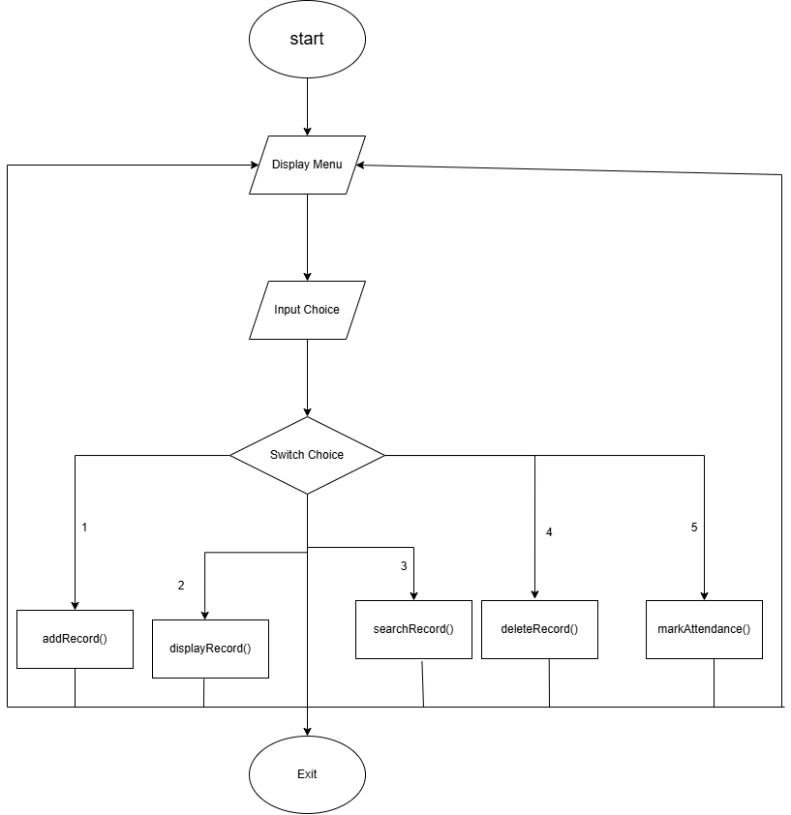

Modular Functional Analysis
- addRecord(): Opens the text database file in read mode to check if the entered roll number already exists. If a match is found, it blocks the entry to prevent duplicates. If the roll number is unique, it switches the file to append mode to write the new student data safely to the end of the file.
- displayRecords(): Opens the database file and loops through each student entry one by one. It prints out the details in a neat grid using spacing commands. It also includes a safety check to ensure total days are greater than zero before calculating percentages, avoiding system crashes.
- searchRecord(): Asks the user for a specific roll number, opens the data file, and checks each record in order. As soon as it matches the roll number, it prints the student's information on the screen and stops searching.
- markAttendance(): Loads all current student records from the text file into a temporary list in the computer's memory. The program loops through the students to let the teacher mark them present or absent, updates the counters, and rewrites the entire updated list back to the text file.
- deleteRecord(): Reads all student records from the file and stores them in a temporary memory list. It then asks for the roll number to remove, opens the file in write mode to wipe it clean, and saves all students back to the file except for the one chosen for deletion.

Full Program Source Code
Below is the complete, working C source code implementation for the Student Management and Attendance System:
#include <stdio.h> // For standard screen input and output
#include <stdlib.h> // For exit() and system operations
#include <string.h> // For handling names/strings

// Structure template for single student record
typedef struct {
int roll;
char name[50];
float marks;
int attended_days; // Classes attended
int total_days; // Total classes held
} Student;

// Main operational functions
void addRecord();
void displayRecords();
void searchRecord();
void markAttendance();
void deleteRecord();

int main() {
int choice;

// Continuous user interactive dashboard menu
while(1) {
printf("\n--- STUDENT MANAGEMENT & ATTENDANCE SYSTEM ---");
printf("\n1. Add New Student");
printf("\n2. View All Students");
printf("\n3. Search Student");
printf("\n4. Delete Student Record");
printf("\n5. Take Daily Roll Call (Attendance)");
printf("\n6. Exit");
printf("\nEnter choice: ");
scanf("%d", &choice);

switch(choice) {
case 1: addRecord(); break;
case 2: displayRecords(); break;
case 3: searchRecord(); break;
case 4: deleteRecord(); break;
case 5: markAttendance(); break;
case 6: printf("\nExiting system...\n"); exit(0);
default: printf("\nInvalid option! Try again.");
}
}
return 0;
}

// 1. Adds a new student record to the file
void addRecord() {
FILE *fp;
Student s, temp;
int rollExists = 0;

printf("\nEnter Roll Number: ");
scanf("%d", &s.roll);

// Read file to check if roll number is already taken
fp = fopen("students.txt", "r");
if (fp != NULL) {
while (fscanf(fp, "%d\t%[^\t]\t%f\t%d\t%d\n", &temp.roll, temp.name, &temp.marks, &temp.attended_days, &temp.total_days) != EOF) {
if (temp.roll == s.roll) {
rollExists = 1; // Duplicate match found
break;
}
}
fclose(fp);
}

// Stop execution if roll number is a duplicate
if (rollExists == 1) {
printf("Error: Roll Number %d already exists! Entry blocked.\n", s.roll);
return;
}

// Open file in Append ("a") mode to save new entry safely
fp = fopen("students.txt", "a");
if (fp == NULL) {
printf("Error: Could not open file.");
return;
}

printf("Enter Full Name: ");
scanf(" %[^\n]s", s.name); // Reads full string including white spaces

printf("Enter Marks: ");
scanf("%f", &s.marks);

// Initialize clean slate counters for new student tracking
s.attended_days = 0;
s.total_days = 0;

// Save fields using clean Tab (\t) separations
fprintf(fp, "%d\t%s\t%.2f\t%d\t%d\n", s.roll, s.name, s.marks, s.attended_days, s.total_days);
fclose(fp);

printf("Record saved successfully!\n");
}

// 2. Prints formatted table of all students from the file
void displayRecords() {
FILE *fp = fopen("students.txt", "r");
Student s;
float attendance_percentage = 0.0;

if (fp == NULL) {
printf("\nNo records found. Add a student first!");
return;
}

// Display aligned column layout labels
printf("\n%-7s %-20s %-7s %-12s %%", "Roll", "Name", "Marks", "Attendance");
printf("\n-----------------------------------------------------------");

// Read lines consecutively up to the end of the file
while (fscanf(fp, "%d\t%[^\t]\t%f\t%d\t%d\n", &s.roll, s.name, &s.marks, &s.attended_days, &s.total_days) != EOF) {
// Prevent math crash (division by zero) if no classes have run yet
if (s.total_days > 0) {
attendance_percentage = ((float)s.attended_days / s.total_days) * 100.0;
} else {
attendance_percentage = 0.0;
}

printf("\n%-7d %-20s %-7.1f %d/%-9d %.1f%%", s.roll, s.name, s.marks, s.attended_days, s.total_days, attendance_percentage);
}
fclose(fp);
printf("\n");
}

// 3. Search a single record using Roll Number lookup boundaries
void searchRecord() {
FILE *fp = fopen("students.txt", "r");
Student s;
int targetRoll, found = 0;

if (fp == NULL) {
printf("\nNo records found.");
return;
}

printf("\nEnter Roll Number to search: ");
scanf("%d", &targetRoll);

// Scan lines to check for matching targets
while (fscanf(fp, "%d\t%[^\t]\t%f\t%d\t%d\n", &s.roll, s.name, &s.marks, &s.attended_days, &s.total_days) != EOF) {
if (s.roll == targetRoll) {
printf("\nStudent Found!");
printf("\nRoll: %d\nName: %s\nMarks: %.1f\nAttendance: %d out of %d classes\n", s.roll, s.name, s.marks, s.attended_days, s.total_days);
found = 1;
break; // Drop lookup loop early once found
}
}

if (!found) {
printf("\nStudent with Roll %d not found.\n", targetRoll);
}
fclose(fp);
}

// 4. Batch Roll Call: Loops through all students sequentially to log tracking metrics
void markAttendance() {
FILE *fp;
Student list[100]; // Buffer array cache to hold entries in RAM memory
int count = 0, status;

fp = fopen("students.txt", "r");
if (fp == NULL) {
printf("\nNo student database found. Add records first!\n");
return;
}

// Step A: Load entire document lines inside storage caching array
while (fscanf(fp, "%d\t%[^\t]\t%f\t%d\t%d\n", &list[count].roll, list[count].name, &list[count].marks, &list[count].attended_days, &list[count].total_days) != EOF) {
count++;
}
fclose(fp);

if (count == 0) {
printf("\nNo students registered yet.\n");
return;
}

printf("\n--- DAILY ATTENDANCE ROLL CALL ---");
printf("\nEnter (1) for Present | (0) for Absent\n");

// Step B: Loop through every loaded student row for interactive verification
for (int i = 0; i < count; i++) {
list[i].total_days += 1; // Increment school working days conducted count

printf("Roll %d: %-20s -> ", list[i].roll, list[i].name);
scanf("%d", &status);

if (status == 1) {
list[i].attended_days += 1; // Increment specific presence counter tracker
}
}

// Step C: Re-open file in Write ("w") mode to completely overwrite with updated values
fp = fopen("students.txt", "w");
for (int i = 0; i < count; i++) {
fprintf(fp, "%d\t%s\t%.2f\t%d\t%d\n", list[i].roll, list[i].name, list[i].marks, list[i].attended_days, list[i].total_days);
}
fclose(fp);

printf("\nAttendance sheet saved successfully!\n");
}

// 5. Deletes a record by rewriting the file and skipping the targeted item
void deleteRecord() {
FILE *fp;
Student list[100]; // Local processing cache placeholder layout
int count = 0, targetRoll, found = 0;

fp = fopen("students.txt", "r");
if (fp == NULL) {
printf("\nNo records found to delete.");
return;
}

// Step A: Load current file structure cleanly inside system memory
while (fscanf(fp, "%d\t%[^\t]\t%f\t%d\t%d\n", &list[count].roll, list[count].name, &list[count].marks, &list[count].attended_days, &list[count].total_days) != EOF) {
count++;
}
fclose(fp);

printf("\nEnter Roll Number to delete: ");
scanf("%d", &targetRoll);

// Step B: Overwrite file back from scratch using Write ("w") rules, filtering target
fp = fopen("students.txt", "w");
for (int i = 0; i < count; i++) {
if (list[i].roll == targetRoll) {
found = 1; // Flag matching element dropped safely
} else {
// Rewrite data of non-matching structural items safely back down
fprintf(fp, "%d\t%s\t%.2f\t%d\t%d\n", list[i].roll, list[i].name, list[i].marks, list[i].attended_days, list[i].total_days);
}
}
fclose(fp);

if (found) {
printf("Record deleted successfully!\n");
} else {
printf("Record with Roll %d not found.\n", targetRoll);
}
}

Analysis of Existing System Constraints
While functional, engineering tests highlight a few software limits that should be noted:
- Fixed Memory Cap: The program uses static memory arrays capped at a strict maximum of 100 students. Going over this limit will cause program errors and corrupt system memory.
- File Overwrite Risks: During attendance updates or record deletions, the program temporarily wipes the file clean ("w") before writing data back. If the computer loses power or shuts down at that exact moment, the database file could be corrupted or lost.
- Sensitive Input Requirements: The code does not handle mixed inputs gracefully. If a user accidentally enters a letter when the program expects an integer roll number, the standard input stream can get stuck, causing the menu to loop indefinitely.
- Exact Case Searching: Name lookups require exact text matches. Searching for a lowercase string will fail if the student's name was originally typed and saved in capital letters.

CONCLUSION AND FUTURE ENHANCEMENTS

Project Evaluation and Conclusions
The console-based Student Management and Attendance System successfully meets its original design goals. By using key C programming features—like logical menus, custom structure definitions, and local file storage—the project delivers a quick and reliable alternative to paper-based tracking books. Automating the calculations removes manual math errors, and flat-file text storage keeps data safe over long periods. The final system stands as a practical desktop management solution and serves as excellent validation for foundational software engineering principles.

Planned Future Enhancements
To build upon this functional program, the following software updates are planned for future versions:
- Graphical User Interface (GUI): Adding an interactive visual windowing layout (using tools like graphics.h or Qt) to make the application more visually appealing and intuitive.
- Dynamic Data Arrays: Swapping out fixed memory bounds for dynamic data structures, such as linked lists, so that the application can expand fluidly without a 100-student cap.
- Smart Input Verification: Adding defensive validation filters that parse typed user data as strings first, screening out typing mistakes before they can crash the system loop.
- Safe Temp File Swapping: Changing file operations to write to a temporary backup file (temp.txt) first, and then safely renaming it only after a successful save to protect against unexpected power outages.
- Advanced Text Searching: Enhancing the search engine with case-insensitive logic and partial name-matching filters so users can find students without typing their full, exact names.

APPENDIX
Program Walkthrough and Screenshots
