# Build image
docker build -t flask-api .

# Run container
docker run -d -p 5000:5000 flask-api

# Login
docker login -u yourusername

# Tag image
docker tag flask-api yourusername/flask-api

# Push image
docker push yourusername/flask-api
# Apply deployment and service
kubectl apply -f deployment.yaml
kubectl apply -f service.yaml

# Check pods
kubectl get pods

# Check services
kubectl get svc

# Describe pod (debugging)
kubectl describe pod <pod-name>

# Check logs
kubectl logs <pod-name>

# Port forward (final working access)

kubectl port-for
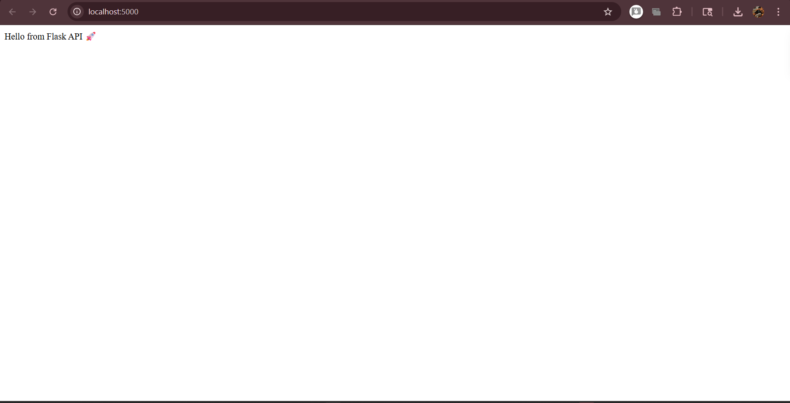ward svc/flask-service 5000:5000
