SIMATS ENGINEERING (SAVEETHA SCHOOL OF ENGINEERING)
Department of Artificial Intelligence and Data Science

ASSESSMENT TOOL 1 – ANALYTICAL PROBLEM SOLVING

Name: G. Pallavi
Reg no: 192472203
Course code: DSA0308
Course: Natural language processing

1. Morphological Analysis of Connected, Connecting, and Connection

Aim:
To design a morphological analysis pipeline that separates words into root and suffix, classifies the suffixes as inflectional or derivational, and normalizes the words for document indexing.

Algorithm:
- Start the program.
- Store the words connected, connecting, and connection.
- Identify the root word and suffix of each word.
- Classify each suffix as inflectional or derivational.
- Normalize all words to the common root connect.
- Display the results in tabular form.
- Stop the program.

Python Code:
print("Name: Pallavi")
print("Register Number: 192472203")
print("-----------------------------------------------")
words = ["connected", "connecting", "connection"]
print("Word Root Suffix Type Normalized")
print("------------------------------------------------------")
for word in words:
if word == "connected":
root = "connect"
suffix = "ed"
kind = "Inflectional"
elif word == "connecting":
root = "connect"
suffix = "ing"
kind = "Inflectional"
else:
root = "connect"
suffix = "ion"
kind = "Derivational"

print(word, " ", root, " ", suffix, " ", kind, " ", root)

output :
Name: Pallavi
Register Number: 192472203
Word Root Suffix Type Normalized
connected connect ed Inflectional connect
connecting connect ing Inflectional connect
connection connect ion Derivational connect

screenshort of output:

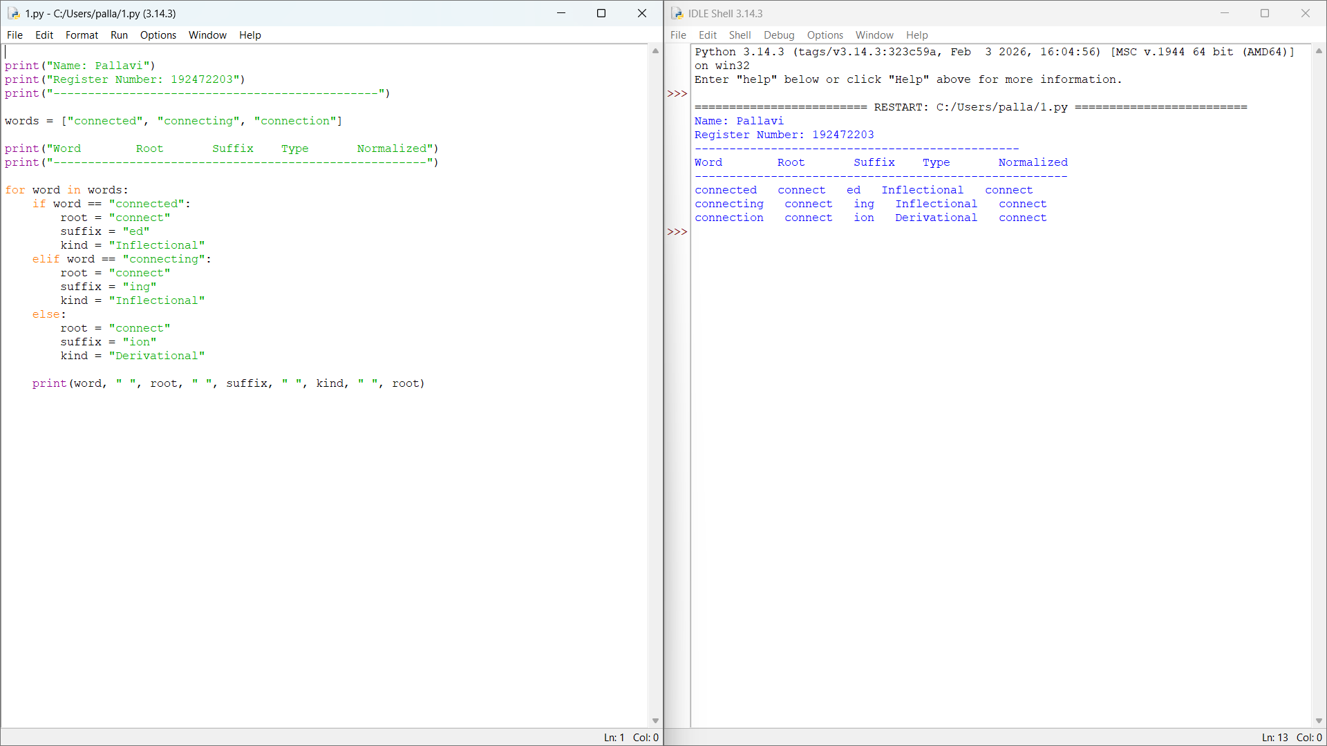

Result:
Morphological analysis was performed successfully. The words were decomposed into roots and suffixes, classified, and normalized to connect for document indexing.

2. Morphological Parsing of Unhappy, Happiness, and Happily

Aim:
To design a rule-based morphological parsing module that identifies prefixes, suffixes, and base forms, classifies transformations, and finds the common root for sentiment analysis.

Algorithm:
- Start the program.
- Store the words unhappy, happiness, and happily.
- Identify the prefix and suffix of each word.
- Find the base word happy.
- Classify the transformations as derivational.
- Display the morphological breakdown and normalized root.
- Stop the program.

Python Code
print("Name: Pallavi")
print("Register Number: 192472203")
print("-----------------------------------------------")
words = ["unhappy", "happiness", "happily"]
print("Word Prefix Base Suffix Type")
for word in words:
if word == "unhappy":
prefix = "un"
base = "happy"
suffix = "None"
elif word == "happiness":
prefix = "None"
base = "happy"
suffix = "ness"
else:
prefix = "None"
base = "happy"
suffix = "ly"

print(word, " ", prefix, " ", base, " ", suffix, " Derivational")

Output:

Name: Pallavi
Register Number: 192472203
Word Prefix Base Suffix Type
unhappy un happy None Derivational
happiness None happy ness Derivational
happily None happy ly Derivational

screenshort of output:

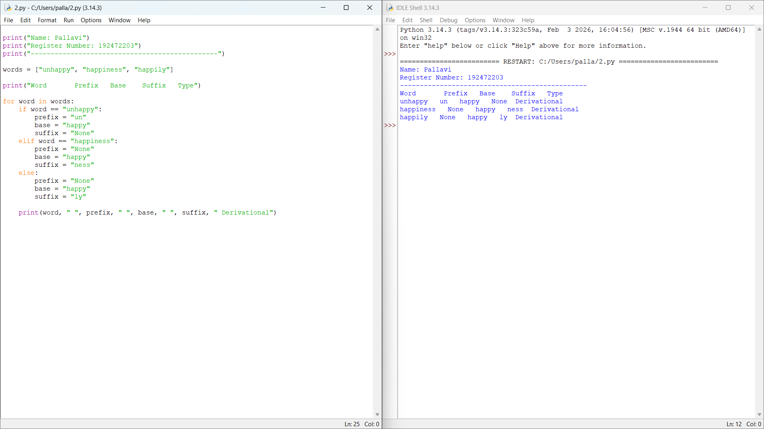

Result:
The morphological parsing module identified the prefixes, suffixes, and base forms. All three words were classified as derivational forms related to the base word happy.

3. Stemming-Based Preprocessing for Played, Player, and Playing

Aim:
To develop a stemming-based preprocessing module for a search engine that extracts stems, identifies removed affixes, classifies transformations, and produces normalized forms for indexing.

Algorithm:
- Start the program.
- Store the words played, player, and playing.
- Identify and remove the suffix from each word.
- Classify the suffix removal as inflectional or derivational.
- Normalize the words to the root play.
- Display the original word, stem, removed suffix, transformation type, and normalized form.
- Stop the program.

Python Code:
print("Name: Pallavi")
print("Register Number: 192472203")
print("-----------------------------------------------")
words = ["played", "player", "playing"]
print("Word Stem Suffix Type Normalized")
for word in words:
if word == "played":
stem = "play"
suffix = "ed"
kind = "Inflectional"
elif word == "player":
stem = "play"
suffix = "er"
kind = "Derivational"
else:
stem = "play"
suffix = "ing"
kind = "Inflectional"
print(word, " ", stem, " ", suffix, " ", kind, " ", stem)

Output:
Name: Pallavi
Register Number: 192472203
Word Stem Suffix Type Normalized
played play ed Inflectional play
player play er Derivational play
playing play ing Inflectional play

screenshort of output:

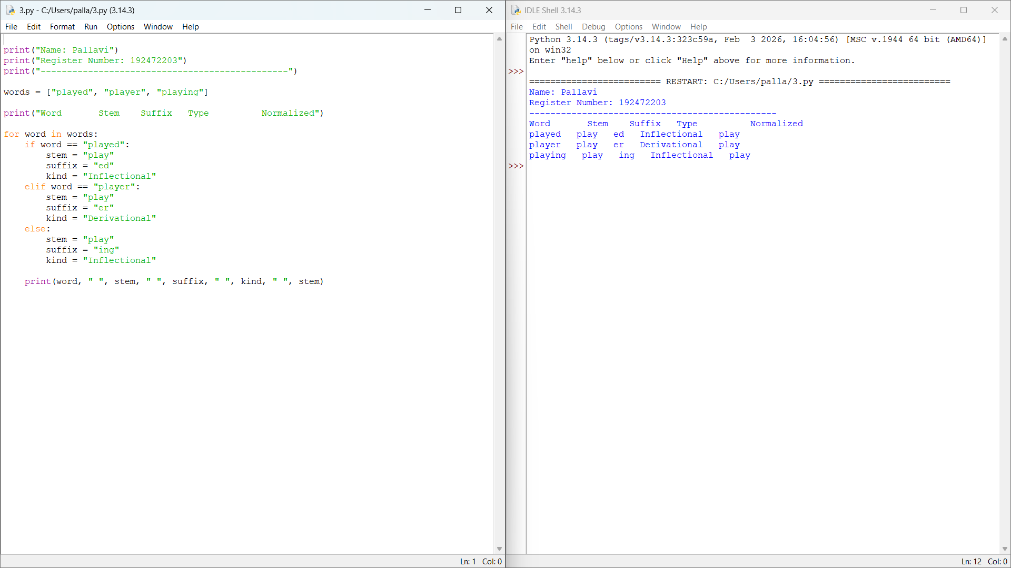

Result
The stemming-based preprocessing module extracted the common root play. It distinguished grammatical variations (-ed, -ing) from word formation (-er) and generated normalized forms for search engine indexing.

4. Finite-State Morphological Parsing of Writes, Writing, and Written

Aim:
To implement a finite-state morphological parser that processes regular and irregular verb forms, traces state transitions, identifies root words, and generates normalized representations.

Algorithm:
- Start the program.
- Store the words writes, writing, and written.
- Set the initial state to START.
- Identify the root and suffix using predefined rules.
- Move through the parsing states and record the transition path.
- Classify each word as a regular or irregular inflection.
- Display the transition path, morphological components, root, and normalized word.
- Stop the program.

Python Code:

print("Name: Pallavi")
print("Register Number: 192472203")
print("-----------------------------------------------")
words = ["writes", "writing", "written"]
for word in words:
if word == "writes":
root = "write"
suffix = "s"
kind = "Regular"
path = "START -> ROOT -> SUFFIX -> ACCEPT"
elif word == "writing":
root = "write"
suffix = "ing"
kind = "Regular"
path = "START -> ROOT -> SUFFIX -> ACCEPT"
else:
root = "write"
suffix = "en (irregular)"
kind = "Irregular"
path = "START -> IRREGULAR FORM -> ROOT -> ACCEPT"
print("\nWord:", word)
print("State Path:", path)
print("Root:", root)
print("Suffix:", suffix)
print("Type:", kind)
print("Normalized Form:", root)

Output:

Name: Pallavi
Register Number: 192472203
Word: writes
State Path: START -> ROOT -> SUFFIX -> ACCEPT
Root: write
Suffix: s
Type: Regular
Normalized Form: write
Word: writing
State Path: START -> ROOT -> SUFFIX -> ACCEPT
Root: write
Suffix: ing
Type: Regular
Normalized Form: write
Word: written
State Path: START -> IRREGULAR FORM -> ROOT -> ACCEPT
Root: write
Suffix: en (irregular)
Type: Irregular
Normalized Form: write
screenshort of output:

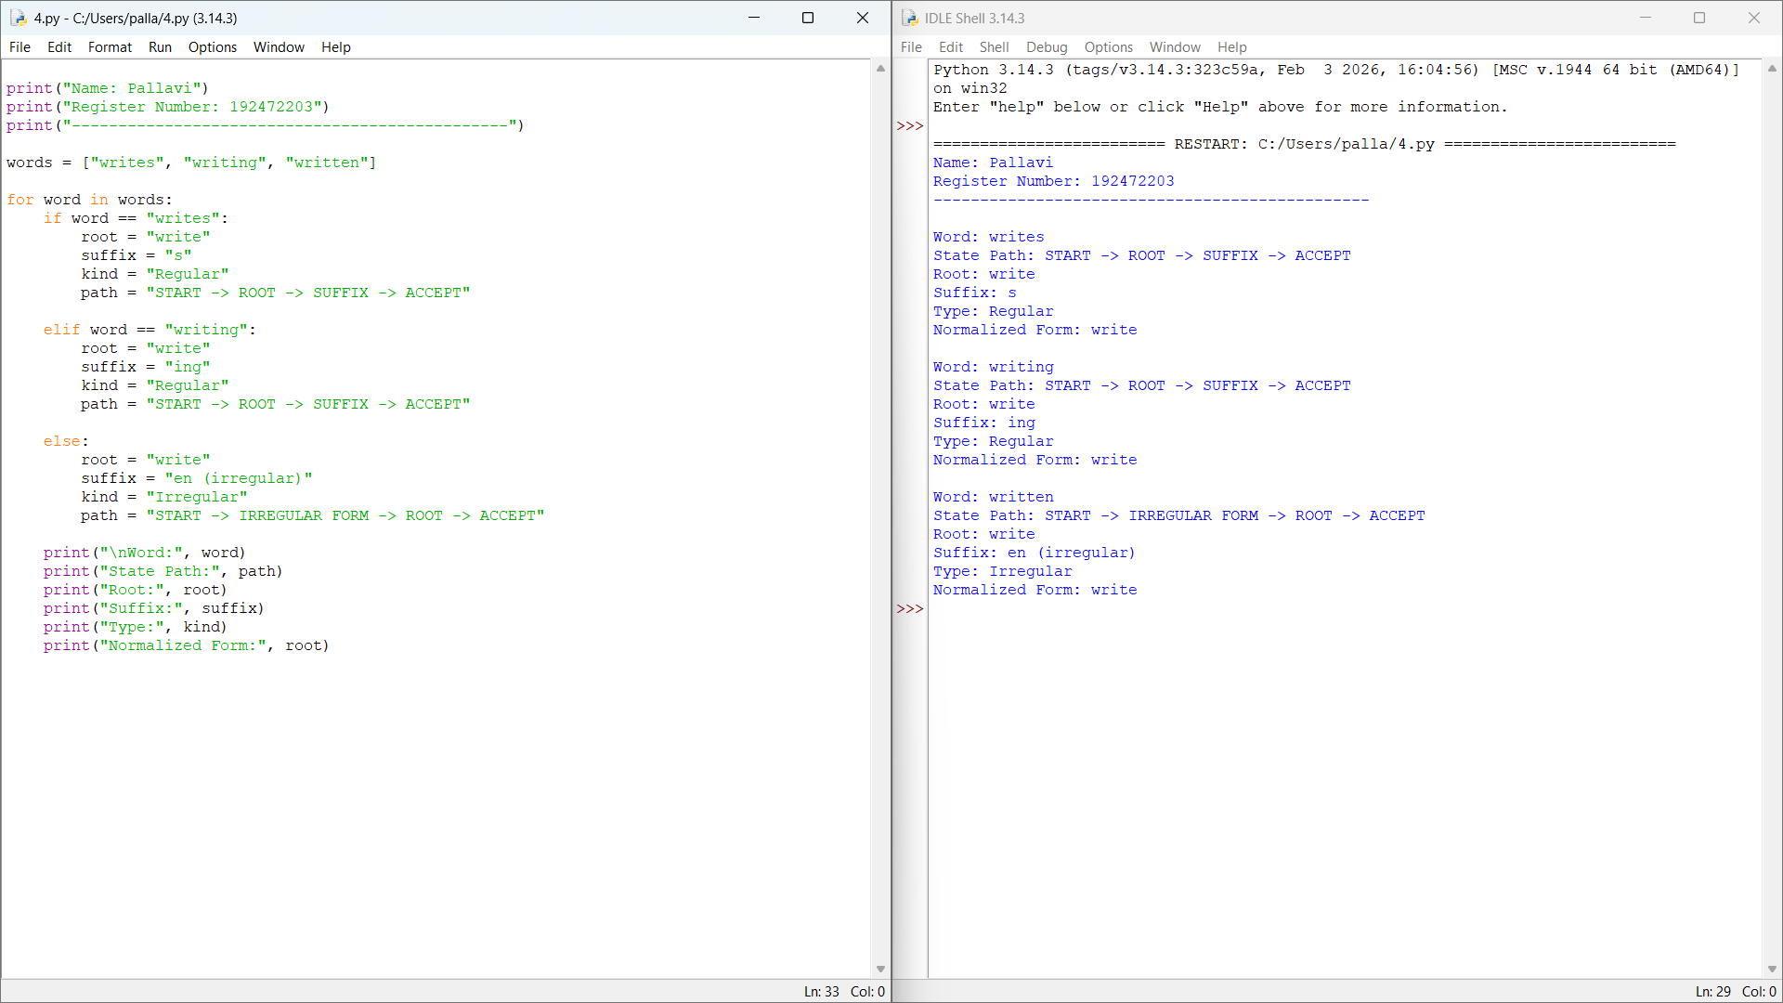

Result:
The finite-state morphological parser identified the root write for all three forms. It handled the regular forms writes and writing and the irregular form written, producing a common normalized representation.

5. Porter Stemmer for Relational, Relation, and Relate

Aim:
To implement a Porter Stemmer-based preprocessing module that removes derivational suffixes, displays intermediate forms, and generates normalized stems for document retrieval.

Algorithm:
- Start the program.
- Import the PorterStemmer class from NLTK.
- Store the words relational, relation, and relate.
- Apply Porter stemming rules to each word.
- Display the applied rule and intermediate form.
- Print the final stem of each word.
- Stop the program.

Python Code

from nltk.stem import PorterStemmer
print("Name: Pallavi")
print("Register Number: 192472203")
print("-----------------------------------------------")
ps = PorterStemmer()
words = ["relational", "relation", "relate"]
for word in words:
if word == "relational":
intermediate = "relate"
rule = "ational -> ate"
elif word == "relation":
intermediate = "relate"
rule = "ation -> ate"
else:
intermediate = "relate"
rule = "Remove final e"
stem = ps.stem(word)

print("\nOriginal Word:", word)
print("Applied Rule:", rule)
print("Intermediate Form:", intermediate)
print("Final Stem:", stem)

Output:

Name: Pallavi
Register Number: 192472203
Original Word: relational
Applied Rule: ational -> ate
Intermediate Form: relate
Final Stem: relat
Original Word: relation
Applied Rule: ation -> ate
Intermediate Form: relate
Final Stem: relat
Original Word: relate
Applied Rule: Remove final e
Intermediate Form: relate
Final Stem: relat

screenshort of output:

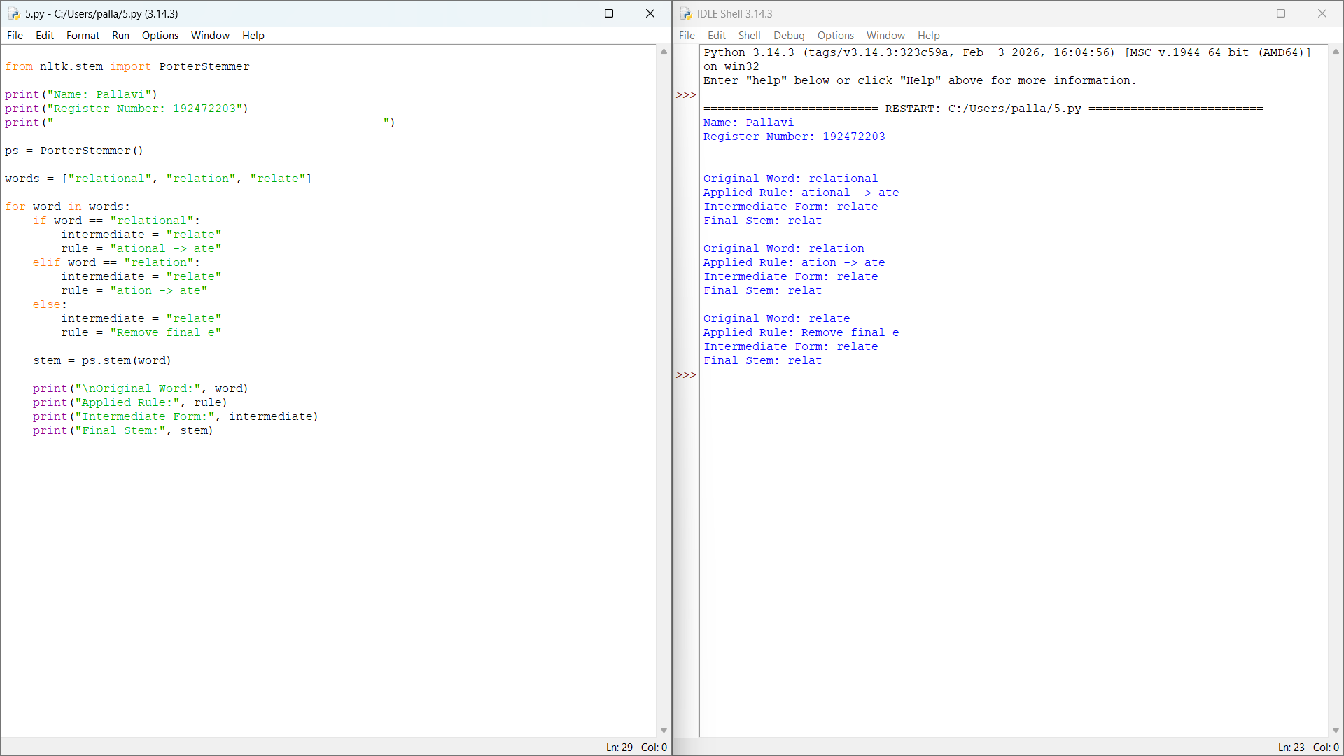

Result:
The Porter Stemmer was applied successfully to the three input words. All words produced the final stem relat, demonstrating stemming for document retrieval and search indexing.

