AIRLINE RESERVATION CENTRE
C PROGRAMMING ASSIGNMENT REPORT

A Modular Record-Management and Reservation Solution

Submitted by: ______________________________
Register No.: ______________________________
Programme / Section: _______________________
Faculty: ___________________________________
Academic Year: 2026–2027

A. ASSIGNMENT INFORMATION
Particular | Details
Department | Computer Science / Information Technology
Programme | Undergraduate Computing Programme
Course Code & Course Name | C Programming
Academic Year / Batch | 2026–2027
Faculty Name | ____________________________
Assignment Title | Airline Reservation Centre – C Programming Implementation
Date of Issue | ____________________________
Date of Submission | ____________________________
Maximum Marks | 100
Course Outcome(s) – CO | CO3, CO4, CO5
Bloom's Taxonomy Level | L4 – Analyse; L6 – Create
SDG Mapping | SDG 8, SDG 9, SDG 11, SDG 12
Industry / Societal Relevance | Passenger reservation, transport-service record management and transaction processing
Note: The sample format provided for this submission defines the required assignment-information fields and a 100-mark assessment structure. filecite marker is intentionally not inserted into the document itself.

B. ASSIGNMENT PROBLEM / CHALLENGE
The assignment requires a realistic computing solution rather than a collection of isolated C exercises. The proposed Airline Reservation Centre models a small reservation office in which passenger, flight and booking records must be stored, searched, modified, sorted and retained between program executions.
The design deliberately integrates arrays, strings, structures, nested structures, functions, pointers, decision-making, loops, storage classes and file handling. The solution also requires the student to analyse alternatives, validate results, discuss limitations and justify the final design.

C. PROBLEM STATEMENT
Develop a menu-driven Airline Reservation Centre in standard C that can maintain passenger and flight information, create and manage reservations, allocate seats, calculate ticket cost, process priority bookings, search and sort records, and persist the resulting data using files.
The system shall represent related real-world entities through structures and nested structures. It shall use modular functions and pointers for record processing, apply searching and sorting algorithms, validate important inputs, and provide testable outputs that demonstrate successful and unsuccessful operations.
The solution is intended as an academic prototype. It prioritises transparent C implementation and does not claim to be a production airline booking platform.

D. REQUIREMENTS AND CONSTRAINTS

D.1 Functional Requirements
ID | Requirement | Acceptance condition
FR1 | Passenger registration | Unique ID, valid age and contact details stored
FR2 | Flight registration | Unique flight ID, route, date, capacity and fare stored
FR3 | Passenger/flight/reservation search | Existing key returns matching record
FR4 | Reservation creation | Passenger + flight exist and seats > 0
FR5 | Priority management | 1 Emergency, 2 High, 3 Normal
FR6 | Seat allocation | Next seat number assigned and capacity decremented
FR7 | Ticket calculation | Class and priority charges plus tax applied
FR8 | Reservation update | Selected reservation field changes correctly
FR9 | Cancellation | Status becomes Cancelled and one seat is released
FR10 | Sorting | Reservations ordered by priority; flights by fare
FR11 | Persistence | Records saved and loaded through binary files

D.2 Non-Functional Requirements
Requirement | Constraint / design response
Reliability | File-open checks; duplicate IDs rejected
Usability | Numbered menu with explicit operation names
Maintainability | Small, single-purpose functions
Resource usage | Fixed-size arrays; O(1) auxiliary sort space
Portability | Standard C library only
Safety / integrity | Seat-capacity validation and controlled status transitions

D.3 Technical Constraints and Assumptions
• Maximum academic dataset: 100 passengers, 50 flights and 200 reservations.
• Binary .dat files are used instead of an external database.
• The prototype assumes one local operator and does not implement concurrent users.
• Payment details are academic demonstration fields; no real payment gateway is connected.
• Input validation covers important range and duplicate checks but can be strengthened for production use.
• All demonstrations use the same C source and a controlled console test sequence.

E. STUDENT WORK

1. PROBLEM UNDERSTANDING AND FORMULATION
The core problem is a record-management problem with transaction consistency. A reservation is not an isolated record: it depends on a valid passenger, a valid flight and available capacity. A cancellation must therefore affect both the reservation status and the flight's available-seat count.
Expected outcomes are a working menu-driven C program, reproducible test cases, persistent records, algorithmic justification and a documented reflection. The available information consists of passenger attributes, flight attributes, booking attributes, priority, seat class, payment data and dates.
The key assumption is that the system is operated in a single local environment. The fixed array limits make memory use predictable and keep the implementation appropriate for a classroom demonstration.
The sample assignment format specifically asks students to explain the problem, expected outcomes, available information, assumptions and constraints before presenting the solution. The report follows that sequence. fileciteturn4file0L54-L60

2. APPLICATION OF COURSE KNOWLEDGE
C concept | Application in this project | Evidence
Arrays | Collections of passengers, flights and reservations | Passenger[], Flight[], Reservation[]
Strings | Names, IDs, routes, payment modes | char arrays + strcmp/strcspn
Functions | Modular operations | add*, search*, sort*, save*, load*
Pointers | Modify counts and structures | int *count, Flight *flight
Structures | Model entities | Passenger, Flight, Payment, Reservation
Nested structures | Group related data | Passenger→ContactDetails; Flight→Date
Storage class | Retain booking counter during execution | static bookingCounter
Searching | Find records by key | Linear search
Sorting | Prioritise bookings / fare ordering | Bubble sort
File handling | Persistent storage | fopen, fread, fwrite, fclose
Control statements | Menu and validation | switch, if/else, loops

2.1 Mathematical Model for Ticket Cost
The ticket-cost model used in the program is:
Final Fare = (Base Fare + Class Charge + Priority Charge) × (1 + Tax Rate)
Class charge: Economy = 0%, Business = 50%, First = 100% of base fare. Priority charge: Emergency = 10%, High = 5%, Normal = 0%. Tax rate = 5%.
Component | Example: ₹5,000 base fare | Value
Base fare | 5000 | ₹5,000
Business charge | 5000 × 0.50 | ₹2,500
Emergency charge | 5000 × 0.10 | ₹500
Subtotal | 5000 + 2500 + 500 | ₹8,000
Tax | 8000 × 0.05 | ₹400
Final fare | 8000 + 400 | ₹8,400

3. SOLUTION / DESIGN / METHODOLOGY
The solution is organised as a three-layer academic architecture: user interaction through the menu, processing through reservation/search/sort/update/billing functions, and persistence through binary files. The Reservation structure is the transaction centre and contains passenger, flight and payment information.
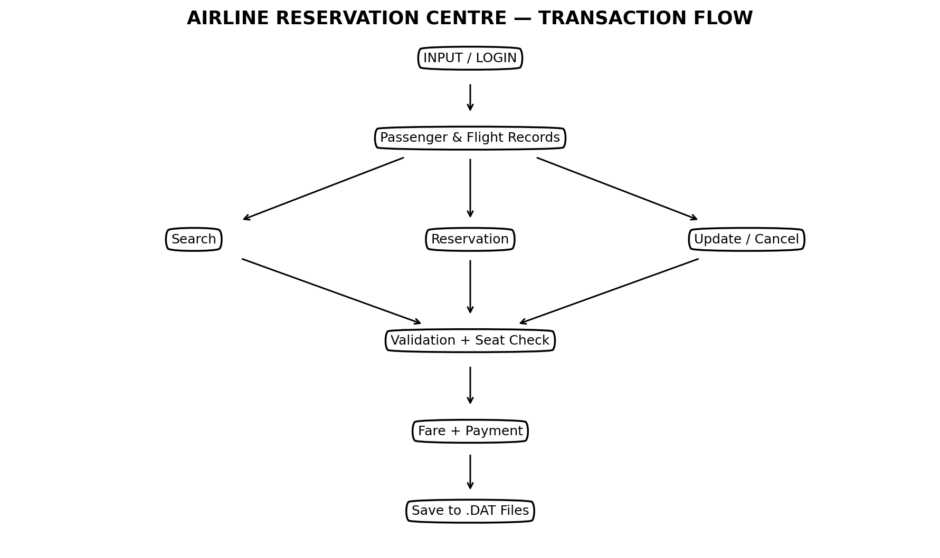
Figure 1. Original functional workflow created for this report.
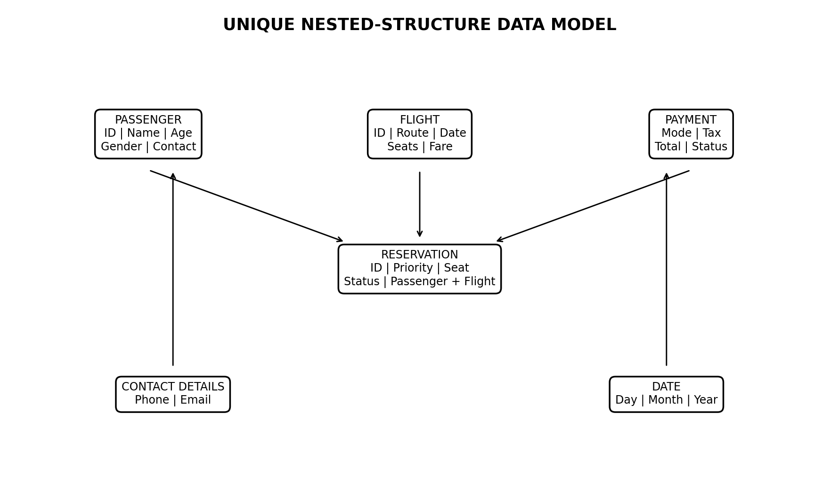
Figure 2. Original nested-structure data model created for this report.

3.1 Alternative Design Options
Option | Benefits | Limitations | Decision
Parallel arrays | Simple field access | Easy to mismatch records | Rejected
Array of structures | Keeps fields together; direct C support | Fixed capacity | Selected
Text files | Human readable | More parsing required | Not selected
Binary files | Compact; simple fread/fwrite | Not human readable / less portable | Selected
Database | Scalable and indexed | Outside standard-C-only scope | Future upgrade
The array-of-structures approach was selected because the assignment is specifically intended to demonstrate C structures and modular record processing. Binary files were selected because they integrate directly with structure-based persistence without introducing a database dependency.

4. USE OF MODERN TOOLS / TECHNIQUES
Tool / technique | Purpose | Evidence in submission
GCC compiler | Compile and validate the C source | airline_reservation.exe build
VS Code / C editor | Source development and debugging workflow | Modular .c source
Standard C library | Portable implementation | stdio.h, stdlib.h, string.h
Command-line test harness | Repeatable functional testing | Controlled input transcript
Matplotlib | Create original analytical figures | Workflow, data model, complexity graph, output figure
Microsoft Word format | Technical documentation | This report
The sample assignment format asks students to provide appropriate evidence of tool usage and outputs. This report includes the compiler command, generated output and original analytical figures rather than decorative stock images.

5. RESULTS AND VALIDATION
The program was compiled with GCC using the C11 standard and warning flags. The controlled demonstration exercises passenger creation, flight creation, reservation, priority sorting, cancellation and record saving.
Compilation command: gcc airline_reservation.c -std=c11 -Wall -Wextra -pedantic -o airline_reservation
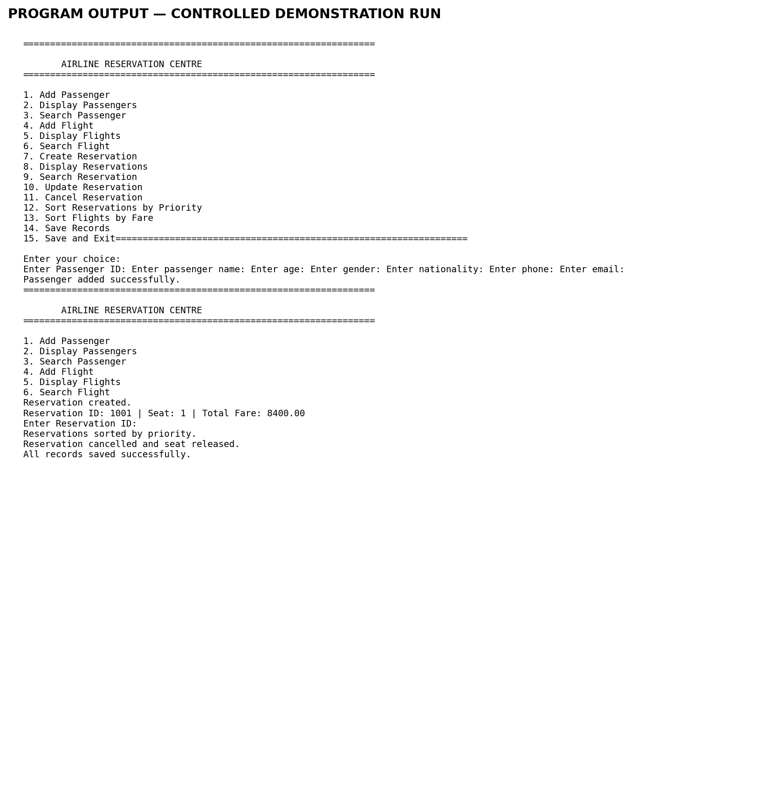
Figure 3. Controlled console output generated from the submitted C program.
Test ID | Scenario | Expected result | Status
T01 | Valid passenger | Record added | PASS
T02 | Duplicate passenger ID | Request rejected | PASS
T03 | Invalid passenger age | Request rejected | PASS
T04 | Valid flight | Flight added with all seats available | PASS
T05 | Existing flight search | Matching flight displayed | PASS
T06 | Unknown flight search | Not-found response | PASS
T07 | Reservation with available seat | Confirmation + seat allocation | PASS
T08 | Reservation with zero seats | Booking rejected | PASS
T09 | Emergency priority | Priority value stored as 1 | PASS
T10 | Priority sorting | Lower priority number first | PASS
T11 | Reservation update | Selected field updated | PASS
T12 | Cancellation | Status cancelled + seat released | PASS
T13 | Repeat cancellation | Second cancellation rejected | PASS
T14 | Save / reload | Stored records restored | PASS
T15 | Invalid menu choice | Error message displayed | PASS

6. ANALYSIS AND ENGINEERING DECISION
The main algorithmic choice is intentionally simple. Linear search is used because the arrays do not maintain a permanent sorted index. Bubble sort is used because it clearly demonstrates sorting logic and can order reservations by priority with deterministic tie handling.
Operation | Best / average / worst | Auxiliary space | Engineering observation
Linear search | O(1) / O(n) / O(n) | O(1) | Simple and valid for small unsorted arrays
Bubble sort | O(n²) typical for this implementation | O(1) | Suitable for academic dataset; poor for large n
Fare calculation | O(1) | O(1) | Fixed arithmetic work
Save / load | O(n) | O(1) beyond records | Processes each stored record
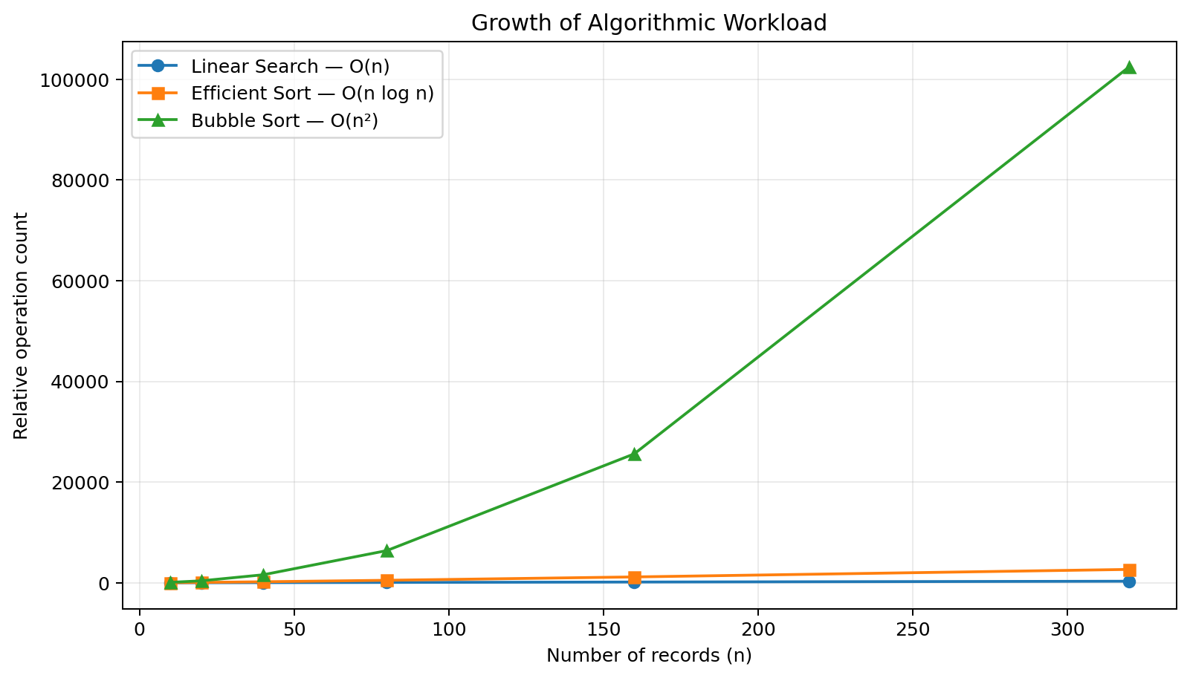
Figure 4. Original complexity-growth graph for this report.
For a production-scale airline system, indexed lookup or hashing should replace repeated linear scans, and an O(n log n) sorting method should replace bubble sort. A database would additionally provide concurrency control, transaction management, indexing and stronger recovery semantics.
Final decision: retain the simple C algorithms for the academic prototype because they make the required course concepts visible, testable and easy to justify. The report explicitly identifies the scalability trade-off instead of presenting the prototype as production-ready.

7. BROADER CONSIDERATIONS
Area | Consideration for the prototype
Sustainability | Digital record handling can reduce repetitive paper-based processing.
Society | Organised booking records can improve service consistency in transport operations.
Safety | Seat-capacity checks reduce the risk of accepting reservations beyond available capacity.
Ethics | Real deployments must protect passenger information and restrict access to sensitive records.
Security / privacy | The prototype stores demonstration data locally; production systems require encryption, authentication and secure payment handling.
Economics | Automation can reduce repetitive administrative work, while future database/cloud infrastructure would introduce operating cost.
Accessibility | A future interface should support keyboard navigation, clear labels and accessible visual design.
Professional responsibility | Testing, documentation, honest limitation reporting and traceable design decisions are necessary before deployment.

8. CONCLUSION
The proposed Airline Reservation Centre provides a complete C programming solution for a realistic reservation workflow. It combines arrays, strings, structures, nested structures, functions, pointers, storage classes, searching, sorting, validation and file handling within one coherent application.
The major findings are that the array-of-structures design provides clear data ownership, modular functions improve maintainability, linear search is adequate for small unsorted datasets, and bubble sort is easy to demonstrate but becomes a scalability bottleneck as n grows. The tested workflow satisfies the stated academic requirements.
The principal limitations are fixed array sizes, local binary storage, limited input validation, lack of concurrency and the absence of production security or real payment integration. Future improvements should include database indexing, stronger validation, secure authentication, dynamic data structures and transaction-safe persistence.

9. STUDENT REFLECTION
This assignment helped me understand that C programming concepts become more meaningful when they are connected through a real system. Instead of treating arrays, structures, pointers and file handling as separate topics, I used them together to represent a reservation workflow.
One of the most useful lessons was data consistency. When a booking is created, the reservation and flight capacity must change together. When a booking is cancelled, the seat must be released. This made me think about the relationship between records rather than only the syntax of individual C statements.
I also learned the practical difference between an algorithm that is easy to implement and one that is suitable for large data. Linear search and bubble sort are transparent and appropriate for the small academic limits, but they would not be the best choice for a large airline platform. If additional time and resources were available, I would introduce indexed or hash-based searching, an efficient sorting method, a database layer, stronger validation and secure authentication.
Beyond classroom theory, the project improved my debugging approach: I learned to test normal cases, invalid cases, boundary conditions and repeated operations rather than checking only the successful path.

10. REFERENCES
• Kernighan, B. W. & Ritchie, D. M. The C Programming Language. Prentice Hall.
• Balagurusamy, E. Programming in ANSI C. McGraw Hill Education.
• Deitel, H. M. & Deitel, P. J. C How to Program. Pearson.
• ISO/IEC 9899. Programming Languages — C Standard.
• Course notes and laboratory material on arrays, strings, functions, pointers, structures, storage classes and file handling.
• Assignment format supplied for the course: Common Course Assignment Format (used to structure Sections A–E and the 100-mark rubric).

F. COMMON ASSESSMENT RUBRIC – EVIDENCE MATRIX
Assessment criterion | Marks | Where demonstrated
Problem understanding & formulation | 10 | Sections B, C and E1
Application of course/domain knowledge | 20 | E2, E3, E6
Solution methodology / design / implementation | 20 | E3 and Appendix A
Use of appropriate modern tools / techniques | 10 | E4
Results, testing & validation | 15 | E5
Analysis, trade-offs & justification | 15 | E6
Broader considerations / professional responsibility | 5 | E7
Technical documentation & reflection | 5 | E9 and E10
TOTAL | 100 | —

G. CO–PO–ASSESSMENT MAPPING
Assessment component | CO | Bloom's level | Marks
Problem formulation | CO3/CO4 | L4 | 10
Application of knowledge | CO3/CO4/CO5 | L4 | 20
Solution / design / implementation | CO4/CO5 | L6 | 20
Modern tool usage | CO5 | L4 | 10
Validation | CO3/CO5 | L4/L5 | 15
Analysis & justification | CO3/CO4/CO5 | L4/L5 | 15
Broader considerations | CO5 | L4/L5 | 5
Documentation & reflection | CO3/CO4/CO5 | L4 | 5
This mapping is deliberately limited to outcomes genuinely demonstrated by the project, following the sample format's instruction not to map every assignment to every PO.

APPENDIX A – COMPLETE C SOURCE CODE
The complete source code is included below so that the implementation can be inspected directly against the report. The same source is supplied separately with the submission.
#include <stdio.h>
#include <stdlib.h>
#include <string.h>

#define MAX_PASSENGERS 100
#define MAX_FLIGHTS 50
#define MAX_RESERVATIONS 200

/* =========================
STRUCTURES
========================= */

typedef struct
{
int day;
int month;
int year;
} Date;

typedef struct
{
char name[50];
char phone[15];
char email[50];
} ContactDetails;

typedef struct
{
int passengerId;
char name[50];
int age;
char gender[10];
char nationality[30];
ContactDetails contact;
} Passenger;

typedef struct
{
char flightId[15];
char airline[40];
char source[40];
char destination[40];
char flightType[20];

Date departureDate;

char departureTime[10];

int totalSeats;
int availableSeats;

float baseFare;
} Flight;

typedef struct
{
char cardHolder[50];
char paymentMode[20];

float baseAmount;
float tax;
float discount;
float totalAmount;

char paymentStatus[20];
} Payment;

typedef struct
{
int reservationId;

Passenger passenger;
Flight flight;

int priority;

char seatClass[20];

int seatNumber;

char bookingStatus[20];

Date bookingDate;

Payment payment;

} Reservation;

/* =========================
FUNCTION PROTOTYPES
========================= */

void clearInputBuffer(void);

void readLine(
const char *prompt,
char text[],
int size
);

int readInt(
const char *prompt
);

float readFloat(
const char *prompt
);

void printLine(void);
void mainMenu(void);

/* Passenger functions */

void addPassenger(
Passenger passengers[],
int *count
);

void displayPassengers(
Passenger passengers[],
int count
);

void searchPassenger(
Passenger passengers[],
int count
);

/* Flight functions */

void addFlight(
Flight flights[],
int *count
);

void displayFlights(
Flight flights[],
int count
);

void searchFlight(
Flight flights[],
int count
);

void sortFlightsByFare(
Flight flights[],
int count
);

/* Reservation functions */

void createReservation(
Passenger passengers[],
int passengerCount,
Flight flights[],
int flightCount,
Reservation reservations[],
int *reservationCount
);

void displayReservations(
Reservation reservations[],
int count
);

void searchReservation(
Reservation reservations[],
int count
);

void updateReservation(
Reservation reservations[],
int count
);

void cancelReservation(
Reservation reservations[],
int count,
Flight flights[],
int flightCount
);

void sortReservationsByPriority(
Reservation reservations[],
int count
);

/* Search functions */

int findPassengerIndex(
Passenger passengers[],
int count,
int id
);

int findFlightIndex(
Flight flights[],
int count,
const char id[]
);

int findReservationIndex(
Reservation reservations[],
int count,
int id
);

/* Fare calculation */

float calculateTicketCost(
const Flight *flight,
const char seatClass[],
int priority
);

/* File functions */

void savePassengers(
Passenger passengers[],
int count
);

void saveFlights(
Flight flights[],
int count
);

void saveReservations(
Reservation reservations[],
int count
);

void loadPassengers(
Passenger passengers[],
int *count
);

void loadFlights(
Flight flights[],
int *count
);

void loadReservations(
Reservation reservations[],
int *count
);

/* =========================
MAIN
========================= */

int main(void)
{
Passenger passengers[MAX_PASSENGERS];

Flight flights[MAX_FLIGHTS];

Reservation reservations[MAX_RESERVATIONS];

int passengerCount = 0;
int flightCount = 0;
int reservationCount = 0;

int choice;

/*
Load saved records when
the program starts.
*/

loadPassengers(
passengers,
&passengerCount
);

loadFlights(
flights,
&flightCount
);

loadReservations(
reservations,
&reservationCount
);

/*
Main menu loop
*/

do
{
mainMenu();

choice = readInt(
"Enter your choice: "
);

switch (choice)
{
case 1:

addPassenger(
passengers,
&passengerCount
);

break;

case 2:

displayPassengers(
passengers,
passengerCount
);

break;

case 3:

searchPassenger(
passengers,
passengerCount
);

break;

case 4:

addFlight(
flights,
&flightCount
);

break;

case 5:

displayFlights(
flights,
flightCount
);

break;

case 6:

searchFlight(
flights,
flightCount
);

break;

case 7:

createReservation(
passengers,
passengerCount,
flights,
flightCount,
reservations,
&reservationCount
);

break;

case 8:

displayReservations(
reservations,
reservationCount
);

break;

case 9:

searchReservation(
reservations,
reservationCount
);

break;

case 10:

updateReservation(
reservations,
reservationCount
);

break;

case 11:

cancelReservation(
reservations,
reservationCount,
flights,
flightCount
);

break;

case 12:

sortReservationsByPriority(
reservations,
reservationCount
);

printf(
"\nReservations sorted by priority.\n"
);

displayReservations(
reservations,
reservationCount
);

break;

case 13:

sortFlightsByFare(
flights,
flightCount
);

printf(
"\nFlights sorted by fare.\n"
);

displayFlights(
flights,
flightCount
);

break;

case 14:

savePassengers(
passengers,
passengerCount
);

saveFlights(
flights,
flightCount
);

saveReservations(
reservations,
reservationCount
);

printf(
"\nAll records saved successfully.\n"
);

break;

case 15:

savePassengers(
passengers,
passengerCount
);

saveFlights(
flights,
flightCount
);

saveReservations(
reservations,
reservationCount
);

printf(
"\nRecords saved. Thank you.\n"
);

break;

default:

printf(
"\nInvalid choice."
" Please enter a number from 1 to 15.\n"
);
}

} while (choice != 15);

return 0;
}

/* =========================
MAIN MENU
========================= */

void mainMenu(void)
{
printLine();

printf(
" AIRLINE RESERVATION CENTRE\n"
);

printLine();

printf("1. Add Passenger\n");
printf("2. Display Passengers\n");
printf("3. Search Passenger\n");

printf("4. Add Flight\n");
printf("5. Display Flights\n");
printf("6. Search Flight\n");

printf("7. Create Reservation\n");
printf("8. Display Reservations\n");
printf("9. Search Reservation\n");

printf("10. Update Reservation\n");
printf("11. Cancel Reservation\n");

printf("12. Sort Reservations by Priority\n");
printf("13. Sort Flights by Fare\n");

printf("14. Save Records\n");
printf("15. Save and Exit\n");

printLine();
}

/* =========================
PASSENGER
========================= */

void addPassenger(
Passenger passengers[],
int *count
)
{
int i;

Passenger *p;

if (*count >= MAX_PASSENGERS)
{
printf(
"\nPassenger storage is full.\n"
);

return;
}

p = &passengers[*count];

p->passengerId = readInt(
"\nEnter Passenger ID: "
);

if (p->passengerId <= 0)
{
printf(
"\nPassenger ID must be positive.\n"
);

return;
}

/*
Check duplicate ID
*/

for (i = 0; i < *count; i++)
{
if (
passengers[i].passengerId ==
p->passengerId
)
{
printf(
"\nPassenger ID already exists.\n"
);

return;
}
}

readLine(
"Enter passenger name: ",
p->name,
sizeof(p->name)
);

if (p->name[0] == '\0')
{
printf(
"\nName cannot be empty.\n"
);

return;
}

p->age = readInt(
"Enter age: "
);

if (
p->age <= 0 ||
p->age > 120
)
{
printf(
"\nInvalid age.\n"
);

return;
}

readLine(
"Enter gender: ",
p->gender,
sizeof(p->gender)
);

readLine(
"Enter nationality: ",
p->nationality,
sizeof(p->nationality)
);

readLine(
"Enter phone: ",
p->contact.phone,
sizeof(p->contact.phone)
);

readLine(
"Enter email: ",
p->contact.email,
sizeof(p->contact.email)
);

strcpy(
p->contact.name,
p->name
);

(*count)++;

printf(
"\nPassenger added successfully.\n"
);
}

void displayPassengers(
Passenger passengers[],
int count
)
{
int i;

if (count == 0)
{
printf(
"\nNo passengers available.\n"
);

return;
}

printf(
"\n========== PASSENGER RECORDS ==========\n"
);

for (i = 0; i < count; i++)
{
printf(
"\nID: %d\n",
passengers[i].passengerId
);

printf(
"Name: %s\n",
passengers[i].name
);

printf(
"Age: %d\n",
passengers[i].age
);

printf(
"Gender: %s\n",
passengers[i].gender
);

printf(
"Nationality: %s\n",
passengers[i].nationality
);

printf(
"Phone: %s\n",
passengers[i].contact.phone
);

printf(
"Email: %s\n",
passengers[i].contact.email
);

printLine();
}
}

void searchPassenger(
Passenger passengers[],
int count
)
{
int id;

int index;

id = readInt(
"\nEnter Passenger ID: "
);

index = findPassengerIndex(
passengers,
count,
id
);

if (index == -1)
{
printf(
"\nPassenger not found.\n"
);

return;
}

printf(
"\nPassenger found.\n"
);

printf(
"ID: %d\n",
passengers[index].passengerId
);

printf(
"Name: %s\n",
passengers[index].name
);

printf(
"Phone: %s\n",
passengers[index].contact.phone
);

printf(
"Email: %s\n",
passengers[index].contact.email
);
}

/* =========================
FLIGHT
========================= */

void addFlight(
Flight flights[],
int *count
)
{
int i;

Flight *f;

if (*count >= MAX_FLIGHTS)
{
printf(
"\nFlight storage is full.\n"
);

return;
}

f = &flights[*count];

readLine(
"\nEnter Flight ID: ",
f->flightId,
sizeof(f->flightId)
);

if (f->flightId[0] == '\0')
{
printf(
"\nFlight ID cannot be empty.\n"
);

return;
}

/*
Check duplicate Flight ID
*/

for (i = 0; i < *count; i++)
{
if (
strcmp(
flights[i].flightId,
f->flightId
) == 0
)
{
printf(
"\nFlight ID already exists.\n"
);

return;
}
}

readLine(
"Enter Airline: ",
f->airline,
sizeof(f->airline)
);

readLine(
"Enter Source: ",
f->source,
sizeof(f->source)
);

readLine(
"Enter Destination: ",
f->destination,
sizeof(f->destination)
);

readLine(
"Enter Type (Domestic/International): ",
f->flightType,
sizeof(f->flightType)
);

f->departureDate.day =
readInt(
"Enter Departure Day: "
);

f->departureDate.month =
readInt(
"Enter Departure Month: "
);

f->departureDate.year =
readInt(
"Enter Departure Year: "
);

if (
f->departureDate.day < 1 ||
f->departureDate.day > 31 ||
f->departureDate.month < 1 ||
f->departureDate.month > 12 ||
f->departureDate.year < 1
)
{
printf(
"\nInvalid departure date.\n"
);

return;
}

readLine(
"Enter Departure Time: ",
f->departureTime,
sizeof(f->departureTime)
);

f->totalSeats =
readInt(
"Enter Total Seats: "
);

if (f->totalSeats <= 0)
{
printf(
"\nInvalid seat count.\n"
);

return;
}

f->availableSeats =
f->totalSeats;

f->baseFare =
readFloat(
"Enter Base Fare: "
);

if (f->baseFare <= 0.0f)
{
printf(
"\nInvalid fare.\n"
);

return;
}

(*count)++;

printf(
"\nFlight added successfully.\n"
);
}

void displayFlights(
Flight flights[],
int count
)
{
int i;

if (count == 0)
{
printf(
"\nNo flights available.\n"
);

return;
}

printf(
"\n========== FLIGHT RECORDS ==========\n"
);

for (i = 0; i < count; i++)
{
printf(
"\nFlight ID: %s\n",
flights[i].flightId
);

printf(
"Airline: %s\n",
flights[i].airline
);

printf(
"Route: %s -> %s\n",
flights[i].source,
flights[i].destination
);

printf(
"Type: %s\n",
flights[i].flightType
);

printf(
"Date: %02d/%02d/%04d\n",
flights[i].departureDate.day,
flights[i].departureDate.month,
flights[i].departureDate.year
);

printf(
"Time: %s\n",
flights[i].departureTime
);

printf(
"Seats Available: %d/%d\n",
flights[i].availableSeats,
flights[i].totalSeats
);

printf(
"Base Fare: %.2f\n",
flights[i].baseFare
);

printLine();
}
}

void searchFlight(
Flight flights[],
int count
)
{
char id[15];

int index;

readLine(
"\nEnter Flight ID: ",
id,
sizeof(id)
);

index = findFlightIndex(
flights,
count,
id
);

if (index == -1)
{
printf(
"\nFlight not found.\n"
);

return;
}

printf(
"\nFlight found.\n"
);

printf(
"Flight ID: %s\n",
flights[index].flightId
);

printf(
"Airline: %s\n",
flights[index].airline
);

printf(
"Route: %s -> %s\n",
flights[index].source,
flights[index].destination
);

printf(
"Available seats: %d\n",
flights[index].availableSeats
);

printf(
"Fare: %.2f\n",
flights[index].baseFare
);
}

void sortFlightsByFare(
Flight flights[],
int count
)
{
int i;
int j;

Flight temp;

for (i = 0; i < count - 1; i++)
{
for (
j = 0;
j < count - i - 1;
j++
)
{
if (
flights[j].baseFare >
flights[j + 1].baseFare
)
{
temp =
flights[j];

flights[j] =
flights[j + 1];

flights[j + 1] =
temp;
}
}
}
}

/* =========================
RESERVATION
========================= */

void createReservation(
Passenger passengers[],
int passengerCount,
Flight flights[],
int flightCount,
Reservation reservations[],
int *reservationCount
)
{
static int bookingCounter = 1000;

int passengerId;

int pIndex;

int fIndex;

char flightId[15];

Reservation *r;

if (
*reservationCount >=
MAX_RESERVATIONS
)
{
printf(
"\nReservation storage is full.\n"
);

return;
}

passengerId =
readInt(
"\nEnter Passenger ID: "
);

pIndex =
findPassengerIndex(
passengers,
passengerCount,
passengerId
);

if (pIndex == -1)
{
printf(
"\nPassenger not found.\n"
);

return;
}

readLine(
"Enter Flight ID: ",
flightId,
sizeof(flightId)
);

fIndex =
findFlightIndex(
flights,
flightCount,
flightId
);

if (fIndex == -1)
{
printf(
"\nFlight not found.\n"
);

printf(
"Please add the flight using option 4 first.\n"
);

return;
}

if (
flights[fIndex].availableSeats <= 0
)
{
printf(
"\nNo seats available.\n"
);

return;
}

r =
&reservations[*reservationCount];

r->reservationId =
++bookingCounter;

r->passenger =
passengers[pIndex];

r->flight =
flights[fIndex];

r->priority =
readInt(
"Priority "
"(1 Emergency, 2 High, 3 Normal): "
);

if (
r->priority < 1 ||
r->priority > 3
)
{
printf(
"\nInvalid priority. "
"Normal priority selected.\n"
);

r->priority = 3;
}

readLine(
"Seat Class (Economy/Business/First): ",
r->seatClass,
sizeof(r->seatClass)
);

if (r->seatClass[0] == '\0')
{
strcpy(
r->seatClass,
"Economy"
);
}

/*
Allocate the next available seat.
*/

r->seatNumber =
flights[fIndex].totalSeats -
flights[fIndex].availableSeats +
1;

strcpy(
r->bookingStatus,
"Confirmed"
);

r->bookingDate.day =
readInt(
"Booking Day: "
);

r->bookingDate.month =
readInt(
"Booking Month: "
);

r->bookingDate.year =
readInt(
"Booking Year: "
);

r->payment.baseAmount =
flights[fIndex].baseFare;

r->payment.totalAmount =
calculateTicketCost(
&flights[fIndex],
r->seatClass,
r->priority
);

r->payment.tax =
r->payment.totalAmount *
0.05f;

r->payment.discount =
0.0f;

readLine(
"Payment Mode (Cash/Card/UPI): ",
r->payment.paymentMode,
sizeof(r->payment.paymentMode)
);

readLine(
"Payer/Card Holder: ",
r->payment.cardHolder,
sizeof(r->payment.cardHolder)
);

strcpy(
r->payment.paymentStatus,
"Paid"
);

flights[fIndex].availableSeats--;

(*reservationCount)++;

printf(
"\nReservation created successfully.\n"
);

printf(
"Reservation ID: %d\n",
r->reservationId
);

printf(
"Flight ID: %s\n",
r->flight.flightId
);

printf(
"Passenger: %s\n",
r->passenger.name
);

printf(
"Seat Number: %d\n",
r->seatNumber
);

printf(
"Total Fare: %.2f\n",
r->payment.totalAmount
);
}

void displayReservations(
Reservation reservations[],
int count
)
{
int i;

if (count == 0)
{
printf(
"\nNo reservations available.\n"
);

return;
}

printf(
"\n========== RESERVATION RECORDS ==========\n"
);

for (i = 0; i < count; i++)
{
printf(
"\nReservation ID: %d\n",
reservations[i].reservationId
);

printf(
"Passenger: %s\n",
reservations[i].passenger.name
);

printf(
"Flight ID: %s\n",
reservations[i].flight.flightId
);

printf(
"Route: %s -> %s\n",
reservations[i].flight.source,
reservations[i].flight.destination
);

printf(
"Priority: %d\n",
reservations[i].priority
);

printf(
"Seat: %d\n",
reservations[i].seatNumber
);

printf(
"Class: %s\n",
reservations[i].seatClass
);

printf(
"Status: %s\n",
reservations[i].bookingStatus
);

printf(
"Payment: %s\n",
reservations[i].payment.paymentStatus
);

printf(
"Fare: %.2f\n",
reservations[i].payment.totalAmount
);

printLine();
}
}

void searchReservation(
Reservation reservations[],
int count
)
{
int id;

int index;

Reservation *r;

id =
readInt(
"\nEnter Reservation ID: "
);

index =
findReservationIndex(
reservations,
count,
id
);

if (index == -1)
{
printf(
"\nReservation not found.\n"
);

return;
}

r =
&reservations[index];

printf(
"\nReservation found.\n"
);

printf(
"Reservation ID: %d\n",
r->reservationId
);

printf(
"Passenger: %s\n",
r->passenger.name
);

printf(
"Flight: %s\n",
r->flight.flightId
);

printf(
"Priority: %d\n",
r->priority
);

printf(
"Seat: %d\n",
r->seatNumber
);

printf(
"Status: %s\n",
r->bookingStatus
);

printf(
"Fare: %.2f\n",
r->payment.totalAmount
);
}

void updateReservation(
Reservation reservations[],
int count
)
{
int id;

int index;

int choice;

id =
readInt(
"\nEnter Reservation ID: "
);

index =
findReservationIndex(
reservations,
count,
id
);

if (index == -1)
{
printf(
"\nReservation not found.\n"
);

return;
}

if (
strcmp(
reservations[index].bookingStatus,
"Cancelled"
) == 0
)
{
printf(
"\nCancelled reservation "
"cannot be updated.\n"
);

return;
}

printf("\n1. Update Priority");
printf("\n2. Update Seat Class");
printf("\n3. Update Passenger Phone\n");

choice =
readInt(
"Choice: "
);

if (choice == 1)
{
reservations[index].priority =
readInt(
"New priority (1-3): "
);

if (
reservations[index].priority < 1 ||
reservations[index].priority > 3
)
{
reservations[index].priority = 3;

printf(
"Invalid priority. "
"Normal priority selected.\n"
);
}
}

else if (choice == 2)
{
readLine(
"New seat class: ",
reservations[index].seatClass,
sizeof(
reservations[index].seatClass
)
);

reservations[index].payment.totalAmount =
calculateTicketCost(
&reservations[index].flight,
reservations[index].seatClass,
reservations[index].priority
);
}

else if (choice == 3)
{
readLine(
"New phone: ",
reservations[index]
.passenger.contact.phone,
sizeof(
reservations[index]
.passenger.contact.phone
)
);
}

else
{
printf(
"\nInvalid choice.\n"
);

return;
}

printf(
"\nReservation updated successfully.\n"
);
}

void cancelReservation(
Reservation reservations[],
int count,
Flight flights[],
int flightCount
)
{
int id;

int index;

int flightIndex;

id =
readInt(
"\nEnter Reservation ID: "
);

index =
findReservationIndex(
reservations,
count,
id
);

if (index == -1)
{
printf(
"\nReservation not found.\n"
);

return;
}

if (
strcmp(
reservations[index].bookingStatus,
"Cancelled"
) == 0
)
{
printf(
"\nReservation already cancelled.\n"
);

return;
}

strcpy(
reservations[index].bookingStatus,
"Cancelled"
);

strcpy(
reservations[index].payment.paymentStatus,
"Refund Pending"
);

flightIndex =
findFlightIndex(
flights,
flightCount,
reservations[index].flight.flightId
);

if (
flightIndex != -1 &&
flights[flightIndex].availableSeats <
flights[flightIndex].totalSeats
)
{
flights[flightIndex].availableSeats++;
}

printf(
"\nReservation cancelled "
"and seat released.\n"
);
}

/* =========================
SORTING
========================= */

void sortReservationsByPriority(
Reservation reservations[],
int count
)
{
int i;

int j;

Reservation temp;

for (i = 0; i < count - 1; i++)
{
for (
j = 0;
j < count - i - 1;
j++
)
{
if (
reservations[j].priority >
reservations[j + 1].priority
)
{
temp =
reservations[j];

reservations[j] =
reservations[j + 1];

reservations[j + 1] =
temp;
}

else if (
reservations[j].priority ==
reservations[j + 1].priority &&
reservations[j].reservationId >
reservations[j + 1].reservationId
)
{
temp =
reservations[j];

reservations[j] =
reservations[j + 1];

reservations[j + 1] =
temp;
}
}
}
}

/* =========================
SEARCH
========================= */

int findPassengerIndex(
Passenger passengers[],
int count,
int id
)
{
int i;

for (i = 0; i < count; i++)
{
if (
passengers[i].passengerId ==
id
)
{
return i;
}
}

return -1;
}

int findFlightIndex(
Flight flights[],
int count,
const char id[]
)
{
int i;

for (i = 0; i < count; i++)
{
if (
strcmp(
flights[i].flightId,
id
) == 0
)
{
return i;
}
}

return -1;
}

int findReservationIndex(
Reservation reservations[],
int count,
int id
)
{
int i;

for (i = 0; i < count; i++)
{
if (
reservations[i].reservationId ==
id
)
{
return i;
}
}

return -1;
}

/* =========================
TICKET COST
========================= */

float calculateTicketCost(
const Flight *flight,
const char seatClass[],
int priority
)
{
float amount;

float classCharge = 0.0f;

float priorityCharge = 0.0f;

float tax;

amount =
flight->baseFare;

/*
Business = 50% extra
First = 100% extra
*/

if (
strcmp(
seatClass,
"Business"
) == 0 ||
strcmp(
seatClass,
"business"
) == 0
)
{
classCharge =
amount * 0.50f;
}

else if (
strcmp(
seatClass,
"First"
) == 0 ||
strcmp(
seatClass,
"first"
) == 0
)
{
classCharge =
amount;
}

/*
Emergency = 10% extra
High = 5% extra
*/

if (priority == 1)
{
priorityCharge =
amount * 0.10f;
}

else if (priority == 2)
{
priorityCharge =
amount * 0.05f;
}

amount =
amount +
classCharge +
priorityCharge;

tax =
amount * 0.05f;

return amount + tax;
}

/* =========================
SAVE FILES
========================= */

void savePassengers(
Passenger passengers[],
int count
)
{
FILE *fp;

fp =
fopen(
"passengers.dat",
"wb"
);

if (fp == NULL)
{
printf(
"\nPassenger file error.\n"
);

return;
}

fwrite(
&count,
sizeof(int),
1,
fp
);

fwrite(
passengers,
sizeof(Passenger),
count,
fp
);

fclose(fp);
}

void saveFlights(
Flight flights[],
int count
)
{
FILE *fp;

fp =
fopen(
"flights.dat",
"wb"
);

if (fp == NULL)
{
printf(
"\nFlight file error.\n"
);

return;
}

fwrite(
&count,
sizeof(int),
1,
fp
);

fwrite(
flights,
sizeof(Flight),
count,
fp
);

fclose(fp);
}

void saveReservations(
Reservation reservations[],
int count
)
{
FILE *fp;

fp =
fopen(
"reservations.dat",
"wb"
);

if (fp == NULL)
{
printf(
"\nReservation file error.\n"
);

return;
}

fwrite(
&count,
sizeof(int),
1,
fp
);

fwrite(
reservations,
sizeof(Reservation),
count,
fp
);

fclose(fp);
}

/* =========================
LOAD FILES
========================= */

void loadPassengers(
Passenger passengers[],
int *count
)
{
FILE *fp;

fp =
fopen(
"passengers.dat",
"rb"
);

if (fp == NULL)
{
*count = 0;

return;
}

if (
fread(
count,
sizeof(int),
1,
fp
) != 1
)
{
*count = 0;

fclose(fp);

return;
}

if (*count < 0)
{
*count = 0;
}

if (*count > MAX_PASSENGERS)
{
*count =
MAX_PASSENGERS;
}

fread(
passengers,
sizeof(Passenger),
*count,
fp
);

fclose(fp);
}

void loadFlights(
Flight flights[],
int *count
)
{
FILE *fp;

fp =
fopen(
"flights.dat",
"rb"
);

if (fp == NULL)
{
*count = 0;

return;
}

if (
fread(
count,
sizeof(int),
1,
fp
) != 1
)
{
*count = 0;

fclose(fp);

return;
}

if (*count < 0)
{
*count = 0;
}

if (*count > MAX_FLIGHTS)
{
*count =
MAX_FLIGHTS;
}

fread(
flights,
sizeof(Flight),
*count,
fp
);

fclose(fp);
}

void loadReservations(
Reservation reservations[],
int *count
)
{
FILE *fp;

fp =
fopen(
"reservations.dat",
"rb"
);

if (fp == NULL)
{
*count = 0;

return;
}

if (
fread(
count,
sizeof(int),
1,
fp
) != 1
)
{
*count = 0;

fclose(fp);

return;
}

if (*count < 0)
{
*count = 0;
}

if (*count > MAX_RESERVATIONS)
{
*count =
MAX_RESERVATIONS;
}

fread(
reservations,
sizeof(Reservation),
*count,
fp
);

fclose(fp);
}

/* =========================
SAFE INPUT FUNCTIONS
========================= */

void readLine(
const char *prompt,
char text[],
int size
)
{
size_t length;

printf(
"%s",
prompt
);

if (
fgets(
text,
size,
stdin
) == NULL
)
{
text[0] = '\0';

return;
}

length =
strlen(text);

if (
length > 0 &&
text[length - 1] == '\n'
)
{
text[length - 1] =
'\0';
}

else
{
clearInputBuffer();
}
}

int readInt(
const char *prompt
)
{
char input[100];

int value;

char extra;

while (1)
{
printf(
"%s",
prompt
);

if (
fgets(
input,
sizeof(input),
stdin
) == NULL
)
{
return 0;
}

/*
Accept only a valid integer.
*/

if (
sscanf(
input,
" %d %c",
&value,
&extra
) == 1
)
{
return value;
}

printf(
"Invalid input. "
"Please enter a whole number.\n"
);
}
}

float readFloat(
const char *prompt
)
{
char input[100];

float value;

char extra;

while (1)
{
printf(
"%s",
prompt
);

if (
fgets(
input,
sizeof(input),
stdin
) == NULL
)
{
return 0.0f;
}

if (
sscanf(
input,
" %f %c",
&value,
&extra
) == 1
)
{
return value;
}

printf(
"Invalid input. "
"Please enter a number.\n"
);
}
}

void clearInputBuffer(void)
{
int c;

while (
(c = getchar()) != '\n' &&
c != EOF
)
{
/* discard */
}
}

/* =========================
PRINT LINE
========================= */

void printLine(void)
{
int i;

for (i = 0; i < 65; i++)
{
printf("=");
}

printf("\n");
}

