**BAN140** 

**Introduction to Data Visualization**

***Final Test-Part2***

Instructions:

• The final test-part2 should be completed **individually**.

• This question is worth 40% of the final test grade and will be evaluated through your submission.

• Submit the required file(s) through Blackboard.

• Download **CustomerService.xlsx** from Blackboard.

• Open Tableau Desktop, and then connect to Microsoft Excel file

Hints

When you make your visualizations, add the necessary elements to make it an adequately done one (i.e. ***Include title, annotations, sorting, coloring/highlighting***, etc., as you see fit to best communicate your message). Also,

⮚ **Pay attention to the data-to-ink ratio**

⮚ **Apply Pre-Attentive Attributes to your Chart**

⮚ **Apply design concepts to your Chart**

⮚ **Add any annotation or labelling that can help you.**

**Question 1.** Create Dashboard to answer the following sub-questions

1) Make a visualization showing the **total number of calls**, separated by **incoming** and **outgoing**, for each **sales representative** (rep ID). (**Copy your visualization to page 2**) 2) Make a visualization showing **how many calls** each branch of the company has **broken** out by the type of call (**call purpose**). (**Copy your visualization to page 3**)

• Save your tableau file as **FinalTestQ.twbx**.

Page **1** of **4**

**BAN140** 

**Introduction to Data Visualization**

***Final Test-Part2***

Make a visualization showing the **total number of calls**, separated by **incoming** and **outgoing**, for each **sales representative** (rep ID).

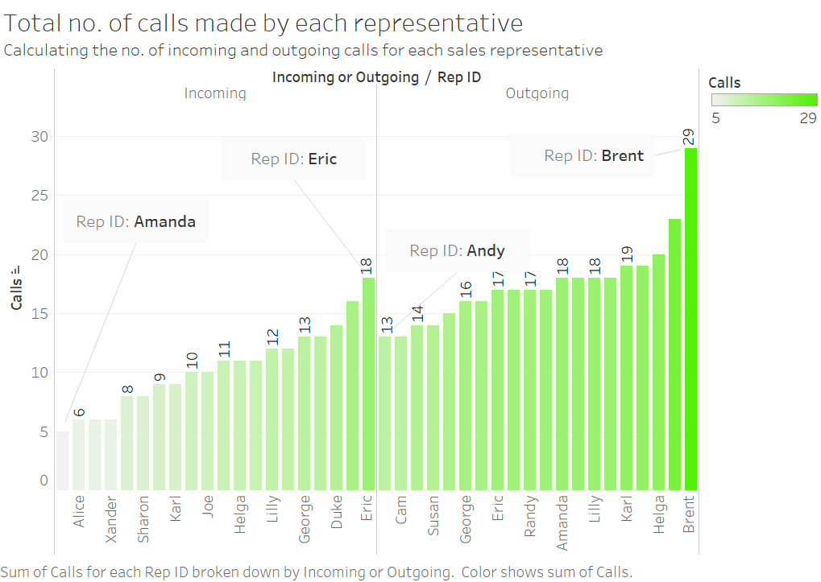

Page **2** of **4**

**BAN140** 

**Introduction to Data Visualization**

***Final Test-Part2***

Make a visualization showing **how many calls** each branch of the company has **broken** out by the type of call (**call purpose**).

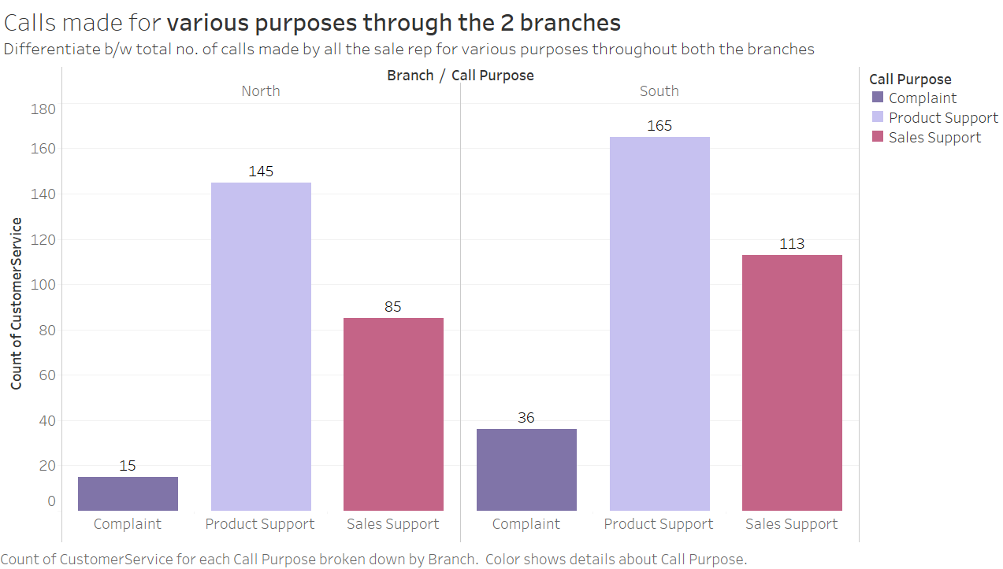

Page **3** of **4**

**BAN140** 

**Introduction to Data Visualization**

***Final Test-Part2***

Deliverables:

| **SENECA’S ACADEMIC HONESTY POLICY** |
| --- |
| As a Seneca student, you must conduct yourself in an honest and trustworthy manner in all aspects of your academic career. A dishonest attempt to obtain an academic advantage is considered an offense and will not be tolerated by the College. |

Add this declaration to your submission file:

I, **Pallavi Dadape**, declare that the attached assignment is our own work in accordance with the **Seneca Academic Honesty Policy**. I do not copy any part of this assignment, manually or electronically, from any other source including websites, unless specified as references. I do not distribute my work to other students.

***Using Blackboard, submit the following files***

**1. Pdf file contains your visualizations**

**2. FinalTestQ.twbx**

<**StudentID**>_<**Lastname**>_ **FinalTestQ**.twbx

<**StudentID**>_<**Lastname**>_ **FinalTestQ**.pdf

Page **4** of **4**