**Assignment 3**

Name: Pallavi Dadape

Roll No.: 43239

College ID:



Problem Statement:

Design a registration form having the following fields :

1) First name and last name (only alphabets allowed, numbers should not be allowed)

2) Mobile number (maximum and minimum 10 digits allowed, 11th digit should not be get typed )

3) Email field should accept min one dot after at (@) symbol and a maximum of two dots.

4)Password validation should include one uppercase and a special character as a mandatory part of it.

5) Pin code (maximum and minimum 6 digits allowed)

6) Use Check box for Educational qualification / any purpose)

7) Use radio buttons for gender selection.

**login.html**

<!DOCTYPE html>

<html>

<head>

<meta http-equiv="content-type" content="text/html; charset=windows-1252">

<title>Sign Up Page</title>

<meta name="viewport" content="width=device-width, initial-scale=1">

<link rel="stylesheet" href="registerationform_files/font-awesome.css">

<style>

body

{

font-family: Arial, Helvetica, sans-serif;

background-color:powderblue;

}

.footer

{

padding: 10px;

text-align: center;

background: #ddd;

margin-top: 20px;

}

*

{

box-sizing: border-box;

}

/* style the container */

.container

{

position: relative;

border-radius: 5px;

background-color: #f2f2f2;

padding: 30px 0 20px 0;

}

/* style inputs and link buttons */

input,

.btn1

{

width: 100%;

padding: 15px;

border: none;

border-radius: 10px;

margin: 10px ;

opacity: 0.85;

display: inline-block;

font-size: 17px;

line-height: 20px;

text-decoration: none; /* remove underline from anchors */

}

.btn2

{

align=center;

width: 25%;

padding: 20px;

border: none;

border-radius: 10px;

margin: 10px ;

opacity: 0.85;

display: inline-block;

font-size: 20px;

line-height: 20px;

text-decoration: none; /* remove underline from anchors */

}

input:hover,

.btn1:hover

{

opacity: 1;

}

.btn2:hover

{

opacity: 1;

}

/* add appropriate colors to fb, twitter and google buttons */

.fb

{

background-color: #3B5998;

color: white;

}

.twitter

{

background-color: #55ACEE;

color: white;

}

.google

{

background-color: #dd4b39;

color: white;

}

/* style the submit button */

input[type=submit]

{

background-color: #4CAF50;

color: white;

cursor: pointer;

}

input[type=submit]:hover

{

background-color: #45a049;

}

/* Two-column layout */

.col

{

float: right;

width: 50%;

margin: auto;

padding: 0 50px;

margin-top: 6px;

}

/* Clear floats after the columns */

.row:after

{

content: "";

display: table;

clear: both;

}

/* vertical line */

.vl

{

position: absolute;

left: 50%;

transform: translate(-50%);

border: 3px solid #ddd;

height: 263px;

}

/* text inside the vertical line */

.vl-innertext

{

position: absolute;

top: 50%;

transform: translate(-50%, -50%);

background-color: #f1f1f1;

border: 1px solid #ccc;

border-radius: 50%;

padding: 8px 10px;

}

/* hide some text on medium and large screens */

.hide-md-lg

{

display: none;

}

/* bottom container */

.bottom-container

{

text-align: center;

/*background-color: none;

border-radius: 0px 0px 4px 4px;*/

}

/* Responsive layout - when the screen is less than 650px wide, make the two columns stack on top of each other instead of next to each other */

@media screen and (max-width: 650px)

{

.col

{

width: 100%;

margin-top: 0;

}

/* hide the vertical line */

.vl

{

display: none;

}

/* show the hidden text on small screens */

.hide-md-lg

{

display: block;

text-align: center;

}

}

</style>

</head>

<body>

<h2>Login Page</h2>

<div class="container">

<form action="/action_page.php">

<div class="row">

<h2 style="text-align:center">Login with Social Media or Manually</h2>

<div class="vl">

<span class="vl-innertext">OR</span>

</div>

<div class="col">

<a href="https://www.facebook.com/" class="fb btn1">

<i class="fa fa-facebook fa-fw"></i> Login with Facebook

</a>

<a href="https://twitter.com/login?lang=en" class="twitter btn1">

<i class="fa fa-twitter fa-fw"></i> Login with Twitter

</a>

<a href="https://accounts.google.com/signin/v2/identifier?service=mail&passive=true&rm=false&continue=https%3A%2F%2Fmail.google.com%2Fmail%2F%3Ftab%3Dwm%26ogbl&scc=1&ltmpl=default&ltmplcache=2&emr=1&osid=1&flowName=GlifWebSignIn&flowEntry=ServiceLogin" class="google btn1"><i class="fa fa-google fa-fw"></i> Login with Google

</a>

</div>

<div class="col">

<label for="username"> <strong> Username: </strong> </label>

<input name="username" placeholder="Enter you username" required="" type="text">

<label for="password"> <strong> Password: </strong> </label>

<input name="password" placeholder="Enter the password" required="" type="password">

<input value="LOGIN" type="submit">

</div>

</div>

</form>

</div>

<h3 align=center> New Here? Sign Up today for free! =) </h3>

<div class="btn2">

<a href="Register.html" style="color:black" align=center>SIGN UP</a>

</div>

<!--<div class="bottom-container">

<div class="row">

<div class="col">

<a href="" style="color:black" class="btn2" align=center>Sign up</a>

</div>

<!-- <div class="col">

<a href="#" style="color:white" class="btn">Forgot password?</a>

</div>

</div>

</div> -->

<div class="footer">

<h2>Footer</h2>

</div>

</body>

</html>

**Register.html**

<!DOCTYPE html>

<html lang="en"><head>

<meta charset="utf-8">

<title>Form Validation using a sample registration form</title>

<meta name="keywords" content="Signup form" />

<meta name="description" content="This document is an example of JavaScript Form Validation using a sample registration form. " />

<link rel='stylesheet' href='js-form-validation.css' type='text/css' />

<script type = "text/javascript">

function validate()

{

var name=document.myform.name.value;

var userid=document.myform.userid.value;

var passid1=document.myform.passid1.value;

var passid2=document.myform.passid2.value;

if( document.myForm.name.value == "" )

{

alert( "Please provide your name!" );

document.myForm.name.focus() ;

return false;

}

if( document.myForm.EMail.value == "" )

{

alert( "Please provide your Email!" );

document.myForm.EMail.focus() ;

return false;

}

if( document.myForm.Zip.value == "" || isNaN( document.myForm.Zip.value ) || document.myForm.Zip.value.length != 5 )

{

alert( "Please provide a zip in the format #####." );

document.myForm.Zip.focus() ;

return false;

}

if( document.myForm.country.value == "-1" )

{

alert( "Please provide your country!" );

return false;

}

//window.location.(

return( true );

}//end of validation funciton

</script>

</head>

<body onload="document.registration.userid.focus();">

<h1>Registration Form</h1>

Use tab keys to move from one input field to the next.

<form name='myform' onSubmit="return formValidation();">

<ul>

<li> <label for="name">Name:</label> </li>

<input type="text" name="name" />

<li> <label for="userid">User id:</label> </li>

<input type="text" name="userid" size="12" />

<li> <label for="passid1">Password:</label> </li>

<input type="password" name="passid1" size="12" />

<li> <label for="passid2">Re-type Password:</label> </li>

<input type="text" name="passid2" size="12" />

<li> <label for="address">Address:</label> </li> <br>

<input type="text" name="address" size="50" />

<li> <label for="country">Country:</label> </li>

<select name="country">

<option selected="" value="Default">(Please select a country)</option>

<option value="AS">Qatar</option>

<option value="AD">USA</option>

<option value="AF">Australia</option>

<option value="AL">Canada</option>

<option value="DZ">India</option>

<option value="AS">Russia</option>

<option value="AD">Kuwait</option>

</select> </li>

<li> <label for="number">Phone Number:</label> </li>

<input type="text" name="number" size="10" />

<li> <label for="EMail">Email:</label> </li>

<input type="text" name="EMail" size="50" />

<li> <label for="dob">DOB</label> </li>

<input type="text" name="dob" size="50" />

<li> <label id="sex">Sexuality:</label> </li>

<input type="radio" name="sex" value="Male" /><span>Male</span> <!--same name so only one is chosen-->

<input type="radio" name="sex" value="Female" /><span>Female</span>

<input type="radio" name="sex" value="Not to disclose" /><span>Not To Disclose</span>

<li> <label>Language:</label> </li>

<input type="checkbox" name="en" value="en" checked /><span>English</span>

<input type="checkbox" name="ar" value="ar" /><span>Arabic</span>

<input type="checkbox" name="fr" value="fr" /><span>French</span>

<input type="checkbox" name="hin" value="hin" /><span>Hindi</span>

<li> <label for="desc">About:</label>

</ul>

<textarea name="desc" id="desc"></textarea> <br/> <br>

<button name="reset" type="submit">RESET</button>

<button name="submit" type="submit">SUBMIT</button>

</form>

</body>

</html>

SCREENSHOTS

Screen1 -

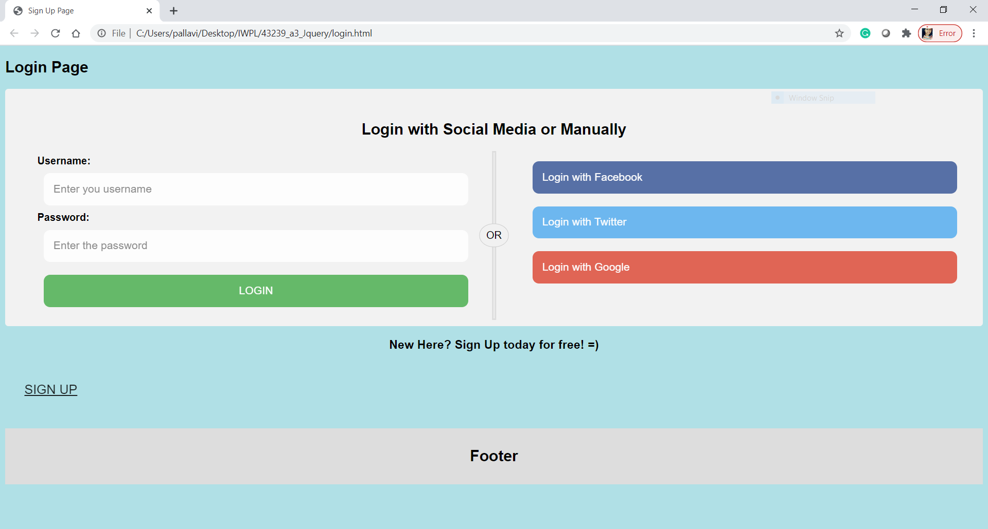

Screen 2 - Other options to login

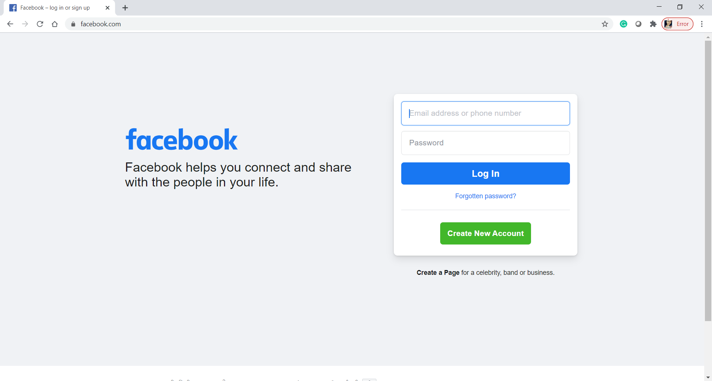



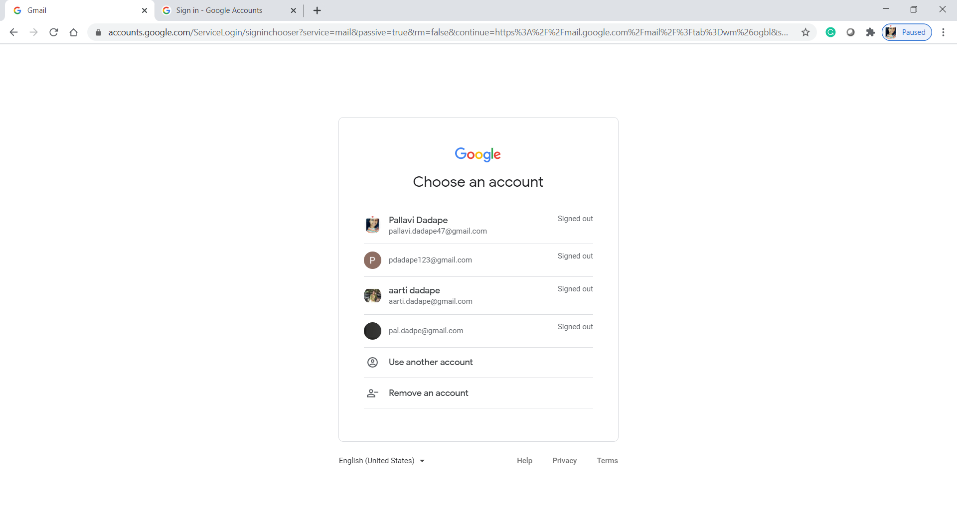

Screen 3 - to register

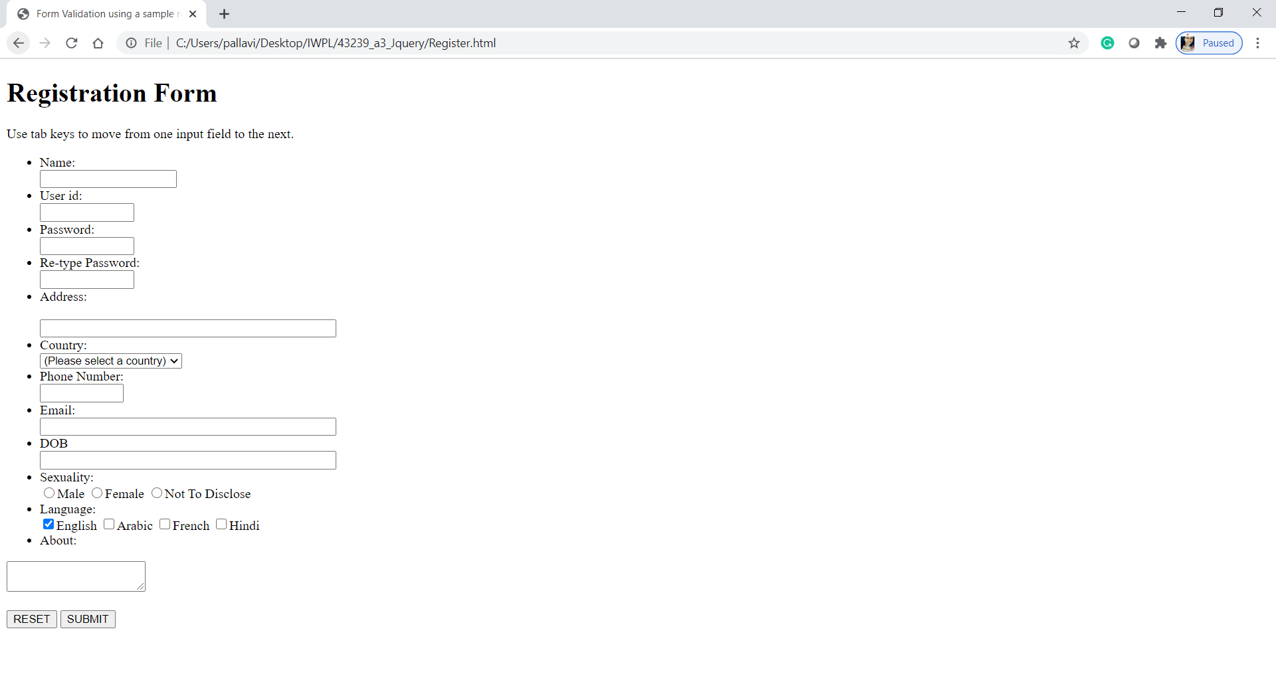

Conclusion

Thus, I have successfully implemented this assignment by creating a registration form in jQuery.