**Assignment 4**

Name: Pallavi Dadape

Roll No.: 43239

College ID:



Problem Statement:

Design and validate Login page having username and password using PHP. Add the essence of AJAX to it.

**CODES**

**Style.css**

body {

font-family: Arial, Helvetica, sans-serif;

font-size: 12px;

color: #333;

background-color: #FFF;

background-image: url("https://www.oyorooms.com/travel-guide/wpcontent/uploads/2019/11/shutterstock_1350638618.jpg");

/* Full height */

height: 1000px;

/* Center and scale the image nicely */

background-position: center;

background-repeat: no-repeat;

background-size: cover;

}

div{

margin-left:15px;margin-bottom:15px;

margin-top:15px;

color: black;

font-weight:bold;

background-color:lightgreen;

height: 400px;

width: 70%;

}

a {

-moz-user-select: none;

color: #1155CC !important;

font-family: "verdana", "Helvetica Neue", Helvetica, Arial, sans-serif;

text-decoration: none;

}

a:hover {

text-decoration: underline;

}

h3 {

margin:0;

padding:10px 5px 10px 5px;

}

#Frame0 {

background-color: lightgreen;

margin: 30px auto auto;padding: 10px;

width: 750px;

border: 1px solid #EEE;

}

.Button3 {

border-style: solid;

border-width: 1px;

box-shadow: 0 1px 0 rgba(0, 0, 0, 0.1);

cursor: pointer;

display: inline-block;

font-size: 11px;

font-weight: 700;

line-height: 23px;

margin-right: 2px;

min-width: 40px;

padding: 0 16px;

text-align: center;

-moz-user-select: none;

color: #FFFFFF;

-moz-box-shadow:inset 0 1px 0 #529E21, inset 1px 0 0 #4A911C, inset -1px 0 0

#4A911C, inset 0 -1px 0 #3D7F12, inset 0 2px 0 rgba(255, 255, 255, 0.3), inset 0 0 4px

rgba(255, 255, 255, 0.3), 0 1px 2px rgba(0, 0, 0, 0.3);

-webkit-box-shadow:inset 0 1px 0 #529E21, inset 1px 0 0 #4A911C, inset -1px 0

0 #4A911C, inset 0 -1px 0 #3D7F12, inset 0 2px 0 rgba(255, 255, 255, 0.3), inset 0 0

4px rgba(255, 255, 255, 0.3), 0 1px 2px rgba(0, 0, 0, 0.3);box-shadow:inset 0 1px 0 #529E21, inset 1px 0 0 #4A911C, inset -1px 0 0

#4A911C, inset 0 -1px 0 #3D7F12, inset 0 2px 0 rgba(255, 255, 255, 0.3), inset 0 0 4px

rgba(255, 255, 255, 0.3), 0 1px 2px rgba(0, 0, 0, 0.3);

background:#6dbd45;

background:-webkit-gradient(linear, left top, left bottom, color-stop(0.2, #6dbd45),

color-stop(1, #51a326));

background:-moz-linear-gradient(center top, #6dbd45 20%, #51a326 100%);

border:0;

-webkit-border-radius:3px;

-moz-border-radius:3px;

border-radius:3px;

padding: 3px 10px;

text-align:center;

overflow:hidden;

min-width:70px;

}

.Button1:hover {

text-decoration: none;

}

.button3:active {

background:#6dbd45;

background:-webkit-gradient(linear, left top, left bottom, color-stop(0.2,

#5EA534), color-stop(1, #519327));

background:-moz-linear-gradient(center top, #5EA534 20%, #519327 100%);

}

.Button3:active, .a:active {

position: relative;top: 1px;

}

.Input {

background-color: #FFFFFF;

border-color: #A0A0A0 #B9B9B9 #B9B9B9;

border-style: solid;

border-width: 1px;

box-shadow: 0 1px 2px rgba(0, 0, 0, 0.1) inset;

font-family: "lucida grande", tahoma, verdana, arial, sans-serif;

font-size: 11px;

margin: 0;

padding: 5px;

width: 200px;

}

.Table {

font-family: verdana, Helvetica, sans-serif;

font-size: 12px;

color: #333;

background-color: #E4E4E4;

}

.Table td {

background-color: #F8F8F8;

}

**index.php**

<?php session_start(); /* Starts the session */

if(!isset($_SESSION['UserData']['Username'])){

header("location:login.php");

exit;

}

?>

<h1><center>Congratulations! You are logged in Successfully!</center></h1><center>

<a href="logout.php">Click here</a> to Logout.</center>

**login.php**

<?php session_start();

/* Check Login form submitted */

if(isset($_POST['Submit'])){

/* Define username and associated password array */

$logins = array('Root' => '123456','User' => '012340','Admin' =>

'000000');

/* Check and assign submitted Username and Password to new variable */

$Username = isset($_POST['Username']) ? $_POST['Username'] : '';

$Password = isset($_POST['Password']) ? $_POST['Password'] : '';

/* Check Username and Password existence in defined array */

if (isset($logins[$Username]) && $logins[$Username] == $Password){

/* Success: Set session variables and redirect to Protected page */

$_SESSION['UserData']['Username']=$logins[$Username];

header("location:index.php");

exit;

} else {

/*Unsuccessful attempt: Set error message */

$msg="<span style='color:red'>Invalid Login Details</span>";

}

}?>

<!doctype html>

<html>

<head>

<meta charset="utf-8">

<link href="./css/style.css" rel="stylesheet">

</head>

<body>

<div id="Frame0">

<h1><center>Login Form</center></h1>

<br>

<form action="" method="post" name="Login_Form">

<table width="400" border="0" align="center" cellpadding="5" cellspacing="1"

class="Table">

<?php if(isset($msg)){?>

<tr>

<td colspan="2" align="center" valign="top"><?php echo $msg;?></td>

</tr>

<?php } ?>

<tr>

<td colspan="2" align="left" valign="top"><h3>Login</h3></td>

</tr>

<tr>

<td align="right" valign="top">Username</td>

<td><input name="Username" type="text" class="Input"></td> </tr>

<tr>

<td align="right">Password</td>

<td><input name="Password" type="password" class="Input"></td>

</tr>

<tr>

<td>&nbsp;</td>

<td><input name="Submit" type="submit" value="Login" class="Button3"></td>

</tr>

</table>

</form>

</div>

</body>

</html>

**logout.php**

<?php session_start(); /* Starts the session */

session_destroy(); /* Destroy started session */

header("location:login.php");

exit;

?>

**SCREENSHOTS**

1. **Starting page**

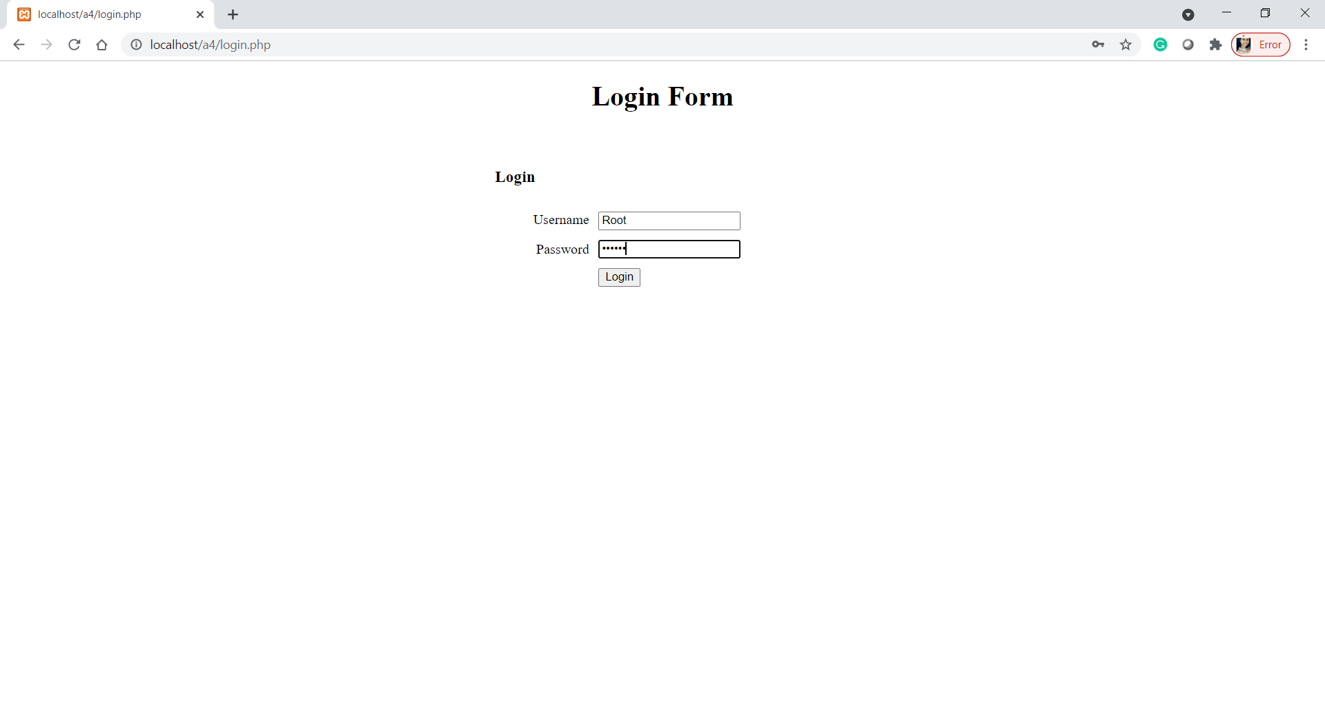

1. **Login in with correct credentials**

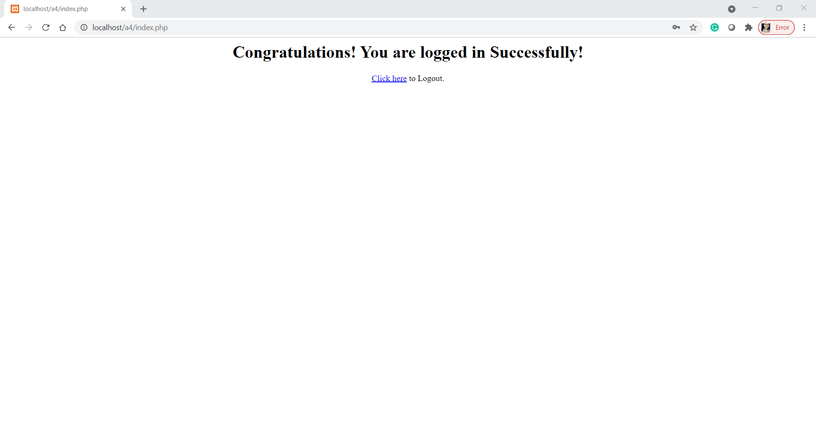

1. **Login with incorrect credentials**

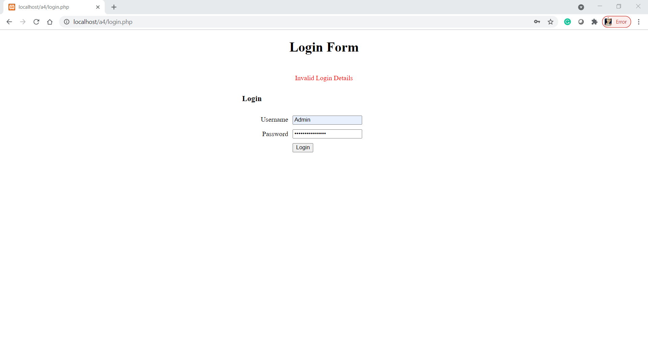

1. **Logout**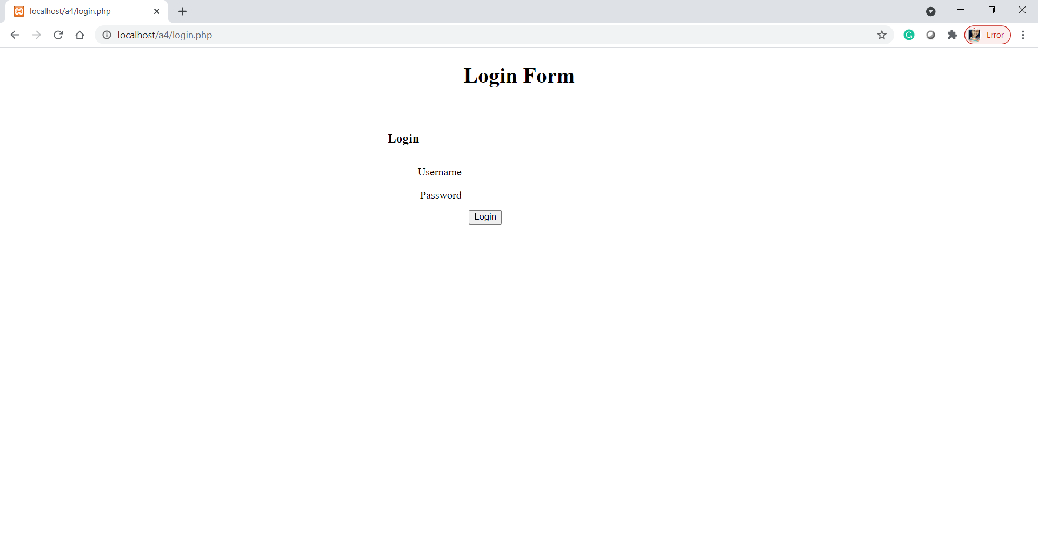

Conclusion

Thus, I have successfully implemented this assignment by creating a form in Php & Ajax.