**Assignment 5**

Name: Pallavi Dadape

Roll No.: 43239

College ID:

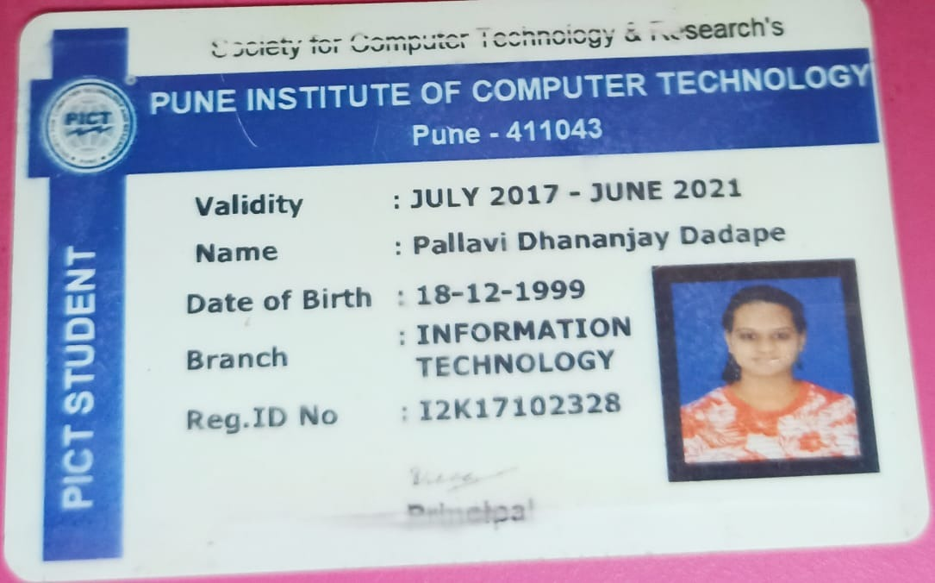

Problem Statement:

Create any Java Web Service and integrate it with any suitable application.

**CODES**

package org.me.calculator;

import javax.jws.WebService;

import javax.jws.WebMethod;

import javax.jws.WebParam;

import javax.ejb.Stateless;

@WebService(serviceName = "CalculatorWS")

@Stateless()

public class CalculatorWS {

/**

* Web service operation

*/

@WebMethod(operationName = "add")

public int add(@WebParam(name = "i") int i, @WebParam(name = "j") int j) { //TODO write your implementation code here:

int k = i + j;

return k;

}

}

Client :

package calculatorws_client_application;

public class CalculatorWS_Client_Application {

/**

* @param args the command line arguments

*/

public static void main(String[] args) {

// TODO code application logic here

try

{

int i = 10;

int j =20;

int result = add(i, j);

System.out.println("Addition of " + i + " and " + j + " is " + result); }

catch(Exception e)

{

System.out.println("Exception is "+ e);

}

}

private static int add(int i, int j) {

org.me.calculator.CalculatorWS_Service service = new

org.me.calculator.CalculatorWS_Service();

org.me.calculator.CalculatorWS port = service.getCalculatorWSPort(); return port.add(i, j);

}

}

**SCREENSHOTS**

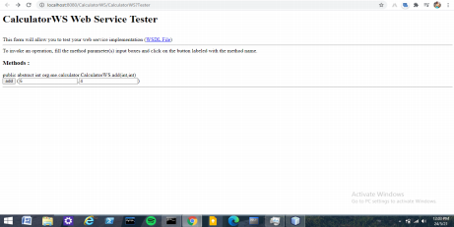

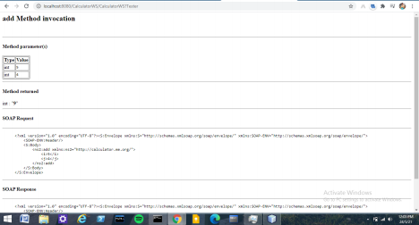

Conclusion

Thus, I have successfully implemented this assignment using Java Web Service in Netbeans.