**Assignment 6**

Name: Pallavi Dadape

Roll No.: 43239

College ID:



Problem Statement:

Create a JSP login page and validate it. Make use of Servlets.

**CODES**

**login.php**

import java.io.IOException;

import javax.servlet.ServletException;

import javax.servlet.annotation.WebServlet;

import javax.servlet.http.HttpServlet;

import javax.servlet.http.HttpServletRequest;

import javax.servlet.http.HttpServletResponse;

/**

* Servlet implementation class login

*/

@WebServlet("/login")

public class login extends HttpServlet {

private static final long serialVersionUID = 1 L;

/**

* @see HttpServlet#HttpServlet()

*/

public login() {

super();

// TODO Auto-generated constructor stub

}

/**

* @see HttpServlet#doPost(HttpServletRequest request, HttpServletResponse response)

*/

protected void doPost(HttpServletRequest request, HttpServletResponse response) throws ServletException, IOException {

// TODO Auto-generated method stub

String name, pwd;

name = request.getParameter("username");

pwd = request.getParameter("password");

if (name.equals("admin") && pwd.equals("pict")) {

response.sendRedirect("Second.html");

} else {

response.sendRedirect("loginn.html");

}

}

}

**Login.html**

<!doctype html>

<head>

<title>Login</title>

<link rel="stylesheet" type="text/css" href="loginstyle.css">

</head>

<body>

<div id="wrapper">

<form name="login-form" class="login-form" action="login" method="post"> <div class="header">

<h1>Login Form</h1>

<span>Fill out the form below to login

.</span>

</div>

<div class="content">

<input name="username" type="text" class="input username" placeholder="Username" />

<div class="user-icon"></div>

<input name="password" type="password" class="input password" placeholder="Password" />

<div class="pass-icon"></div>

</div>

<div class="footer">

<input type="submit" name="submit" value="Login" class="button" /> </div>

</form>

</div>

<div class="gradient"></div>

</body>

</html>

**SCREENSHOTS**

Screen1-

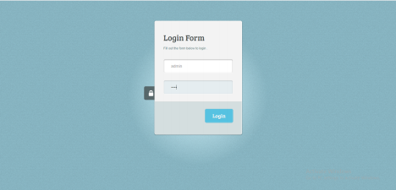

Screen 2- 

For wrong UN and password-

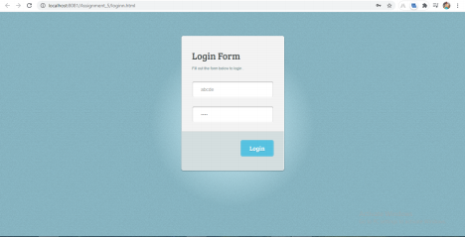

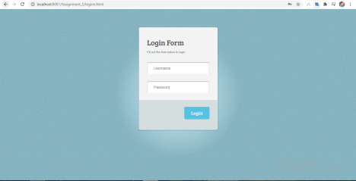

Conclusion

Thus, I have successfully implemented this assignment by validating the login form using JSP and Servlets.