**Assignment 7**

Name: Pallavi Dadape

Roll No.: 43239

College ID:



Problem Statement:

Create an application for bill payment using AngularJS.

**CODES**

**cart.html**

<html>

<head>

<script src="angular.min.js"></script>

</head>

<body>

<h2>Bill Invoice</h2>

<div ng-app="myapp" ng-controller="CartForm"> <!-- initializing angurlarjs-->

<table class="table">

<tr>

<th>Description</th>

<th>Qty</th>

<th>Cost</th>

<th>Total</th>

<th></th>

</tr>

<tr ng:repeat="item in cart.items">

<td><input type="text" ng:model="item.description"></td>

<td><input type="number" ng:model="item.qty" ng:required></td>

<td><input type="number" ng:model="item.cost" ng:required></td>

<td>{{item.qty * item.cost | currency:'Rs '}}</td>

<td>[<a href ng:click="removeItem($index)">X</a>]</td> <!-- to delete-->

</tr>

<tr>

<td><a href ng:click="addItem()">add item</a></td>

<td></td>

<td>Total:</td>

<td>{{total() | currency:'Rs '}}</td>

</tr>

</table>

</div>

<script src="cart.js"> </script>

</body>

</html>

**cart.js**

var app=angular.module('myapp',[]);

app.controller('CartForm', function($scope)

{

$scope.cart =

{

items: [{ qty: '', description: '', cost: ''}]

}

$scope.addItem = function()

{

$scope.cart.items.push({ qty: '', description: '', cost: ''});

}

$scope.removeItem = function(index)

{

$scope.cart.items.splice(index, 1); //removes 1 item form the cart.

}

$scope.total = function()

{

var total = 0;

angular.forEach($scope.cart.items, function(item) {

total += item.qty * item.cost;

})

return total;

}

}

);

**SCREENSHOTS**

Screen1-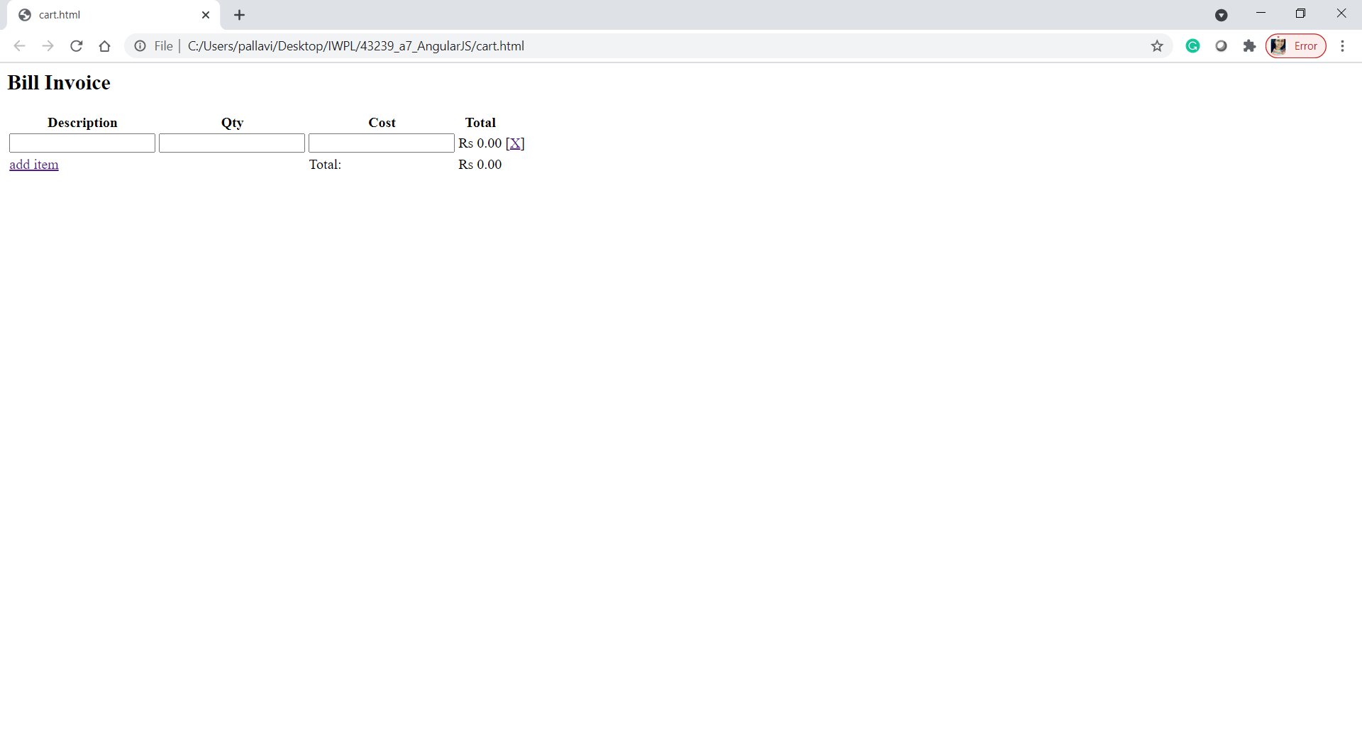

Screen2-

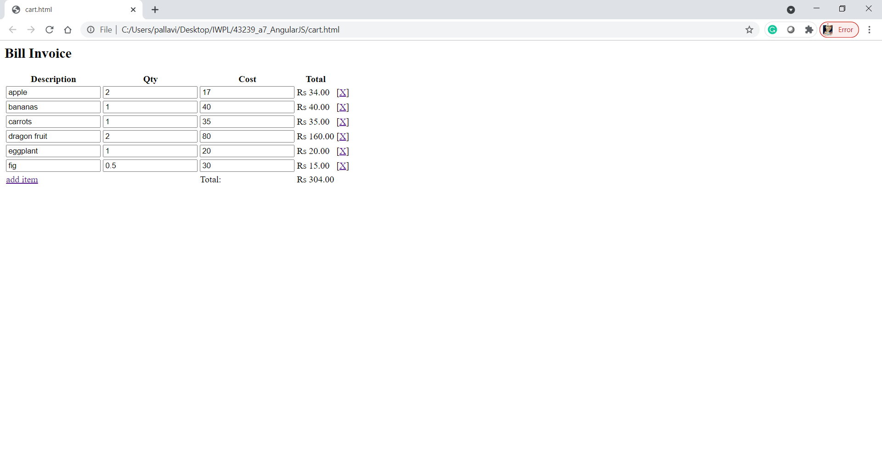

PS:- fig is in 0.5 quantity only to show the calculation.

Conclusion

Thus, I have successfully implemented this assignment by using AngularJS for bill payment.