# World Earthquakes Analysis

In this project, I have analysed earthquake data to explore trends and understand patterns of seismic activity around the world.

# Data Limitations:

* There are multiple columns which are missing intention or ambiguous, such as death and total deaths.
* More than 30% data is missing or NULL. This will impact the analysis.
* Data is inconsistent for years <1900 whereas it is more consistent post 1900.

# Data Assumptions:

* “Total” Columns are considered during the analysis.

For example – total deaths, total damage etc

* Analysis done for NON-NULL data i.e. data with NULL values has been filtered out in Tableau during analysis.

This may have significant impact on analysis

* Location Name column was split to group locations in groups. New calculated field “Location Final” is created
* For around 80+ regions (Location Final field), longitude and latitude data was unrecognized. This can be handled by adding these co-ordinates by going to Map->Edit Location and editing co-ordinates as below.

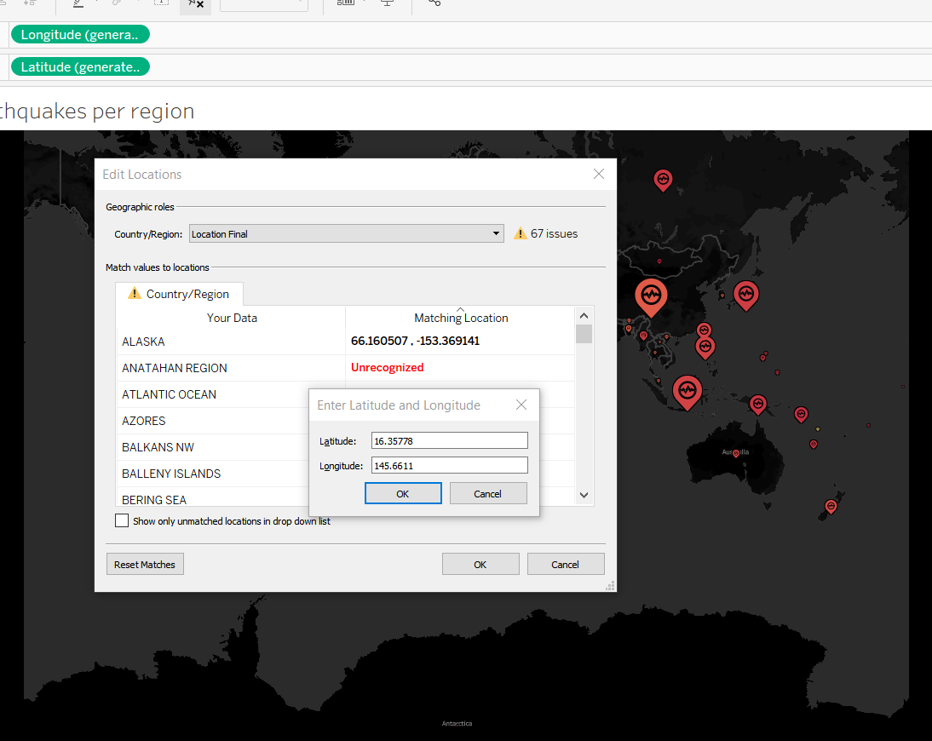

# Peer Review:

Peer review was conducted on projects. Below are the few comments received

**Comment 1: - Story creation: Change in sequence to make it logical**

It was suggested that visualization sequence should be changed in logical manner.

Necessary changes incorporated. Sequence is as follows:

1- Quick View having high level visualization of dataset

2- Significant Earthquakes analysis

3- Magnitude classification of Earthquakes and related analysis

4- Analysis as per regions

5- Summary

**Comment 2: Dashboard design and removing unnecessary clutter**

It was suggested that unnecessary filters are not required to be placed on dashboard.

Only Years filter is kept on dashboard with Average Magnitude legend.

# Structure of Tableau Workbook:

**1- Story –**

EarthquakeStory

**2- Dashboard**

QuickViewDashBoard

**3 – All visualizations created for analysis.**

There are few visualizations which are created for analysis but not added on dashboard or story.

# Note:

Given a chance I would like to find out relation between columns ‘tsu’ and ‘vol’ with magnitude and focal depth. As I can see, it has many values missing. But I would like to enhance my analysis around these parameter as these may relate to activities like tsunamis and volcanos.

# SHORT SUMMARY - Finding and RECOMMONDATIONS

SEISMIC ACTIVITIES FROM 1900-2020:

Findings:

Analysis shows that number of seismic activities was relatively lower but average magnitude was higher during 1930-1940.

There is increase in number of seismic activities since 2000 but there is decline in average magnitude.

Recommendation and Further Analysis Needed:

Further Analysis is needed to see if there are any human activities that are causing this increase. If yes, there should be measures taken.

Significant Earthquakes:

Findings:

Around 64.7% earthquakes are of 6+ Richter which are categorized as deadliest earthquakes. These have caused highest number of deaths and damages.

Recommendation:

Further analysis requited on granular data such as tectonic plates as earthquakes do occur near the boundaries of tectonic plates. Detailed geospatial analysis will also give insights around this.

Regions with highest number of earthquakes, deaths and damage

Finding:

CHINA , INDONASIA , IRAN , JAPAN and TURKEY are the top 5 regions having highest number of earthquakes. Among these, CHINA has experienced highest deaths and loss of houses with wealth.

Recommendations:

Further analysis of each region will give insights about what measures could be taken to avoid causalities and wealth loss in areas prone to earthquakes.

For example - types of bricks to be used for house infrastructure.

Focal depth and Magnitude Analysis:

Finding:

Majority of earthquakes are having focal depth upto 50 KM.

Further analysis with tsu and vol can be done to find the relation and probability of tsunamis and volcanos, mainly for magnitudes 7+.