Monte Carlo Tree Search for Tic Tac Toe
Course: INFO 6205 – Program Structures and Algorithms
Team-7 : 1.Pallavi Nile
2.Gaurav Sharma
3.Adarsh Pathak
Github Link: https://github.com/pallavi-nile/DSAIPG.git

Summary
This project implements a Monte Carlo Tree Search (MCTS) decision-making system for a Java-based Tic Tac Toe game.
It explores the statistical foundation of MCTS through the lens of a classic board game, enhanced by a polished Swing-based GUI.
The bot simulates future game states using playouts and backpropagation to choose intelligent moves. The report details the game rules, architecture, MCTS logic, GUI features, test results, and conclusions.

Introduction
Tic Tac Toe is a deterministic, zero-sum, perfect-information game — ideal for testing tree search algorithms.
MCTS is a probabilistic technique that uses simulations to evaluate potential moves, rather than brute-force depth search.
This makes it a natural fit for small-to-mid complexity games. The goal was to design a responsive user interface, integrate intelligent bot logic, and observe real-time behavior of MCTS.

Game Design and Rules
- 3x3 board, two players: Human (X) and Opponent Bot (O)
- Players alternate turns
- First to align three marks in a line wins
- Game ends in a draw if the board fills with no winner

Architecture Overview
A modular architecture with interfaces for re-usability across game types:
Component | Description
Game Interface | General game model with start() and opener() methods.
Move Interface | Represents a move for a given player.
State Interface | Encapsulates game position and legal moves.
Node Interface | Tree node with game state and stats for MCTS.
MCTS.java | Executes selection, expansion, simulation, backpropagation.
TicTacToe.java | Implements the game logic using interfaces.
TicTacToeUI.java | Swing-based GUI for gameplay.

Monte Carlo Tree Search (MCTS)
The MCTS process includes the following stages:
1. Selection: Traverse tree using Upper Confidence Bound (UCB1)
2. Expansion: Add unexplored children nodes
3. Simulation: Run random play outs from child state
4. Back-propagation: Update win/play stats up the tree
Scoring: win = 2, draw = 1. UCB1 balances exploration and exploitation.
UCB1 Formula Explanation Formula:
UCB1 = (w_i / n_i) + c * sqrt(ln(N) / n_i)
Where:
w_i : Number of wins for the child node i
n_i : Number of simulations for the child node I
N : Number of simulations for the parent node
c : Exploration constant (commonly sqrt(2))
Term Breakdown:
- (w_i / n_i): Exploitation term - how good this move has been so far
- sqrt(ln(N) / n_i): Exploration term - encourages trying less visited nodes
- c: Controls the tradeoff between exploration and exploitation In Code: return (double) wins / plays + c * Math.sqrt(Math.log(totalPlayouts) / plays);
Why Use UCB1?
- It balances exploitation and exploration. - Guarantees convergence to optimal play over time.
- It ensures even weakly explored paths are given a chance early on. This formula is used during the Selection phase of MCTS to choose the best child node from a parent node. If a child has never been visited (plays = 0), it is given priority to ensure all nodes are explored at least once.

User Interface (Swing)
- Black background and white foreground (high contrast)
- Buttons: New Game, Reset Score, Exit
- Move status: "Your turn" or "Opponent is thinking..."
- Prints MCTS timing and session stats in console
- Resizable layout with clean fonts

Performance Benchmarks
Bot Move Time (500 simulations per move):
Move Count | Time (ms)
1 | 5
3 | 12
5 | 21
7 | 40
9 | 45

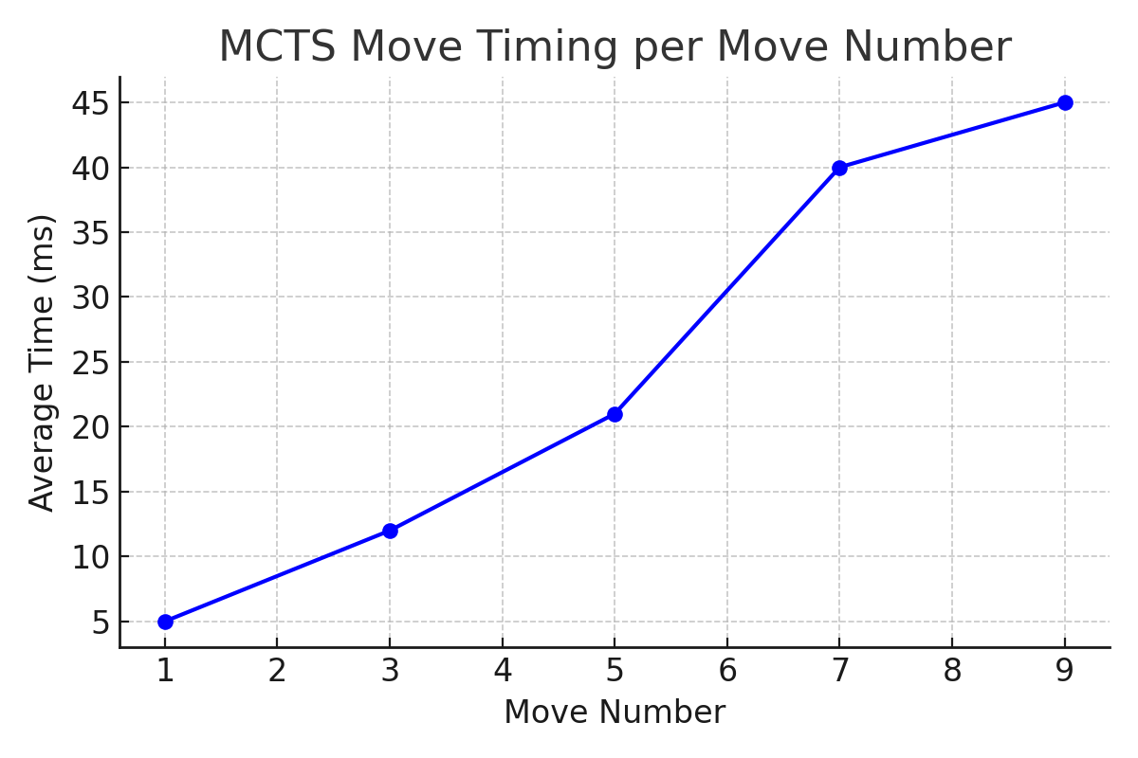

Testing and Validation
- Functional tests for winning logic and draw conditions
- Invalid move handling confirmed through button state
- Score resets and UI refresh tested
- Manual MCTS move logs verified for consistency

Conclusion
This project successfully demonstrated the application of Monte Carlo Tree Search (MCTS) in a classic board game environment. By simulating random playouts and using the UCB1 formula for move selection, the AI bot was able to make intelligent, balanced decisions in real-time.
The integration of MCTS with a responsive Java Swing interface resulted in an engaging, interactive experience. Key features like move timing, game status updates, and score tracking enhanced both functionality and user feedback.
Overall, this implementation showcased how a generic and modular design, combined with a statistical AI approach, can produce competitive gameplay without relying on hardcoded logic. The framework is also flexible enough to be extended to more complex games with minimal changes.

References
- Monte Carlo Tree Search – Wikipedia: https://en.wikipedia.org/wiki/Monte_Carlo_tree_search
- MCTS Review (arXiv:2103.04931): https://arxiv.org/abs/2103.04931
- Beginner’s Guide to MCTS
- Robin Hillyard – Generic Game Framework (DSAIPG)
OUTPUT:


