**PRIORITISING HOSPITAL ADMISSION ACCORDING TO EMERGENCY USING MACHINE LEARNING**

**ABSTRACT:**

the use of artificial intelligence and machine learning techniques in emergency medicine has grown rapidly. This paper reviews and assesses studies in this field, categorizing them into three areas: prediction and detection of disease, prediction of need for admission, discharge, and mortality, and machine learning-based triage systems. In the first category, several studies have been conducted using machine learning algorithms. These studies used various machine learning techniques, including Logistic Regression, Naive Bias, Random Forest, MLP, SVC, LSTM, and datasets from electronic health records and medical imaging. The second category focuses on predicting the need for hospital admission, discharge, and mortality using machine learning algorithms. These studies have used various datasets, including electronic health records, laboratory data, and vital signs. The algorithms used in these studies include decision trees, random forests, and logistic regression models. Finally, the third category explores the development of machine learning-based triage systems for emergency departments. These studies have used various datasets, including vital signs and medical history, and machine learning techniques such as decision trees, artificial neural networks, and fuzzy logic. Overall, the studies reviewed in this paper demonstrate the potential of artificial intelligence and machine learning techniques in emergency medicine. However, the accuracy and effectiveness of these algorithms depend on the quality and quantity of the data used. Further research is needed to validate the findings and improve the performance of these algorithms in bed settings.

**Keywords:** Logistic Regression, Naive Bias, Random Forest, MLP, SVC, LSTM,

**PROBLEM STATEMENT**

The field of emergency medicine has seen rapid growth in the application of machine learning algorithms for various purposes, such as disease prediction, hospital admission, discharge, and mortality prediction, and the development of machine learning-based triage systems. These applications hold promise in improving patient care and resource allocation in emergency departments. However, the effectiveness and accuracy of these algorithms are contingent upon the quality and quantity of available data, posing a significant challenge to their implementation.

**WHY THE PARTICULAR TOPIC CHOSEN?**

The selection of this topic is motivated by the increasing significance of leveraging artificial intelligence and machine learning in healthcare, especially in emergency medicine. The ability to predict diseases, assess admission needs, and optimize triage processes can potentially save lives and resources. Therefore, a comprehensive review of the existing research in this area is crucial for understanding the current state and driving future advancements.

**SCOPE:**

This paper's scope encompasses a systematic review and assessment of studies in three key areas: disease prediction and detection, hospital admission, discharge, and mortality prediction, and machine learning-based triage systems in the context of emergency medicine. The focus is on various machine learning algorithms and datasets used in these studies to evaluate their potential in improving emergency medical care.

**OBJECTIVE OF THE PROJECT:**

The primary objective of this project is to provide a thorough review and assessment of the existing studies in the field of artificial intelligence and machine learning in emergency medicine. It aims to categorize these studies and identify the techniques and datasets employed, shedding light on the current state of the field. Additionally, this project seeks to emphasize the importance of data quality and quantity in the effectiveness of these algorithms and to highlight the need for further research to validate findings and enhance algorithm performance within emergency medical settings.

**EXISTING METHOD**

In the existing system, implementation of machine learning algorithms is bit complex to build due to the lack of information about the data visualization. Mathematical calculations are used in existing system for Logistic Regression, Random Forest, SVC model building this may takes the lot of time and complexity. To overcome all this, we use machine learning packages available in the scikit-learn library.

**Disadvantages:**

1. Accuracy low

2. Requires more time

3. Difficult to handle

**PROPOSED SYSTEM**

Proposed several machine learning models to classify the hospital admission according to emergency, but none have adequately addressed this misdiagnosis problem. Also, similar studies that have proposed models for evaluation of such Hospital Emergency case and the size of the data Therefore, we propose Naive Bias, MLP, and LSTM performing classifier tests based.

**Advantages:**

1. Requires less time

2. Good Accuracy

3. Easy to handle

**Block Diagram:**

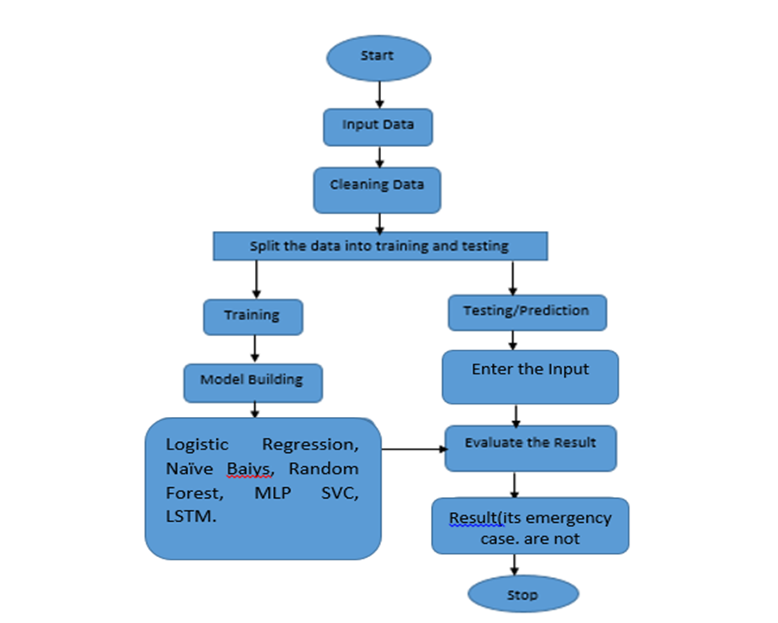**Fig 1. Block Diagram of Proposed System**

**HARDWARE & SOFTWARE REQUIREMENTS**

# **H/W CONFIGURATION:**

# Processor - I7/Intel Processor

* Hard Disk -160GB
* Key Board - Standard Windows Keyboard
* Mouse - Two or Three Button Mouse
* RAM - 8Gb

**S/W CONFIGURATION:**

* Operating System : Windows 11
* Server side Script : Python, HTML, MYSQL, CSS, Bootstrap.
* Libraries : PANDAS, Django
* IDE : PyCharm (or) VS code
* Technology : Python 3.10

**MODULES:**

1. **User**:
   1. **Register:**

Users can register for the Hospital web application here.

* 1. **Login:**

After registering, the user can access his portal.

**1.3 Upload:**

Upload dataset which is downloaded from the kaggle

* 1. **View Data:**

View data before preprocessing

* 1. **Preprocessing Data:**

User Can View After Preprocessing Data

* 1. **Input :**

User will give the input values.

* 1. **Result History:**

After giving the inputs, model will predict the result which it was set according to performance, it will predict that the Hospital Emergency is it’s a emergency case are its not emergency case.

**Take Dataset:**

The dataset for the EDAdmissionDataset is collected from the kaggle website (kaggle.com).

The size of overall dataset is 9.08 MB.

**Pre-processing:**

* In preprocessing first of all we will check whether there is any Nan values.
* If any Nan values is present we will fill the Nan values with different fillna techniques like bfill, ffill, mode, and mean.
* Here we used the ffill (front fill) technique on our project.

**Training the data:**

Irrespective of the algorithm we select the training is the same for every algorithm**.**

Given a dataset we split the data into two parts training and testing, the reason behind doing this is to test our model/algorithm performance just like the exams for a student the testing is also exam for the model.

We can split data into anything we want but it is just good practice to split the data such that the training has more data than the testing data, we generally split the data.

And for training and testing there are two variables X and Y in each of them, the X is the features that we use to predict the Y target and same for the testing also.

Then we call the .fit ( ) method on any given algorithm which takes two parameters i.e., X and Y for calculating the math and after that when we call the .predict ( ) giving our testing X as parameter and checking it with the accuracy score giving the testing Y and predicted X as the two parameters will get our accuracy score and same steps , these are just checking for how good our model performed on a given dataset.