**Documentation**

Name: Bux Khurana

Mehek Malhotra

Name of the project: FlappyTrash

Idea: Change begins from a young age. If we can create a gamified version of the cleanup process, it is possible that we might create an impact.

Technology Implemented: Html and Javascript

Screenshots:

Start / General screen:

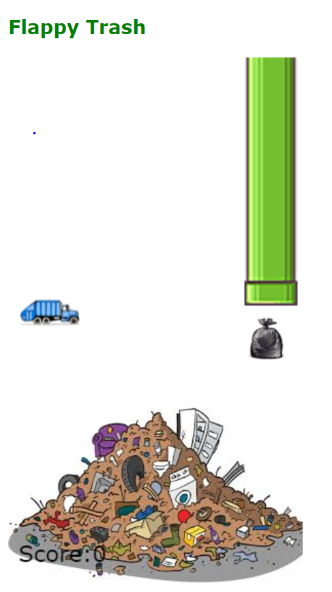

Losing Screen:

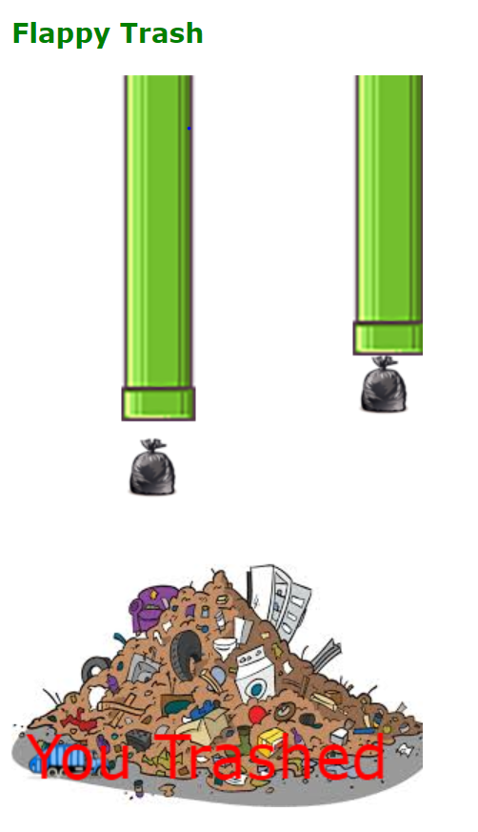

Winning Screen:

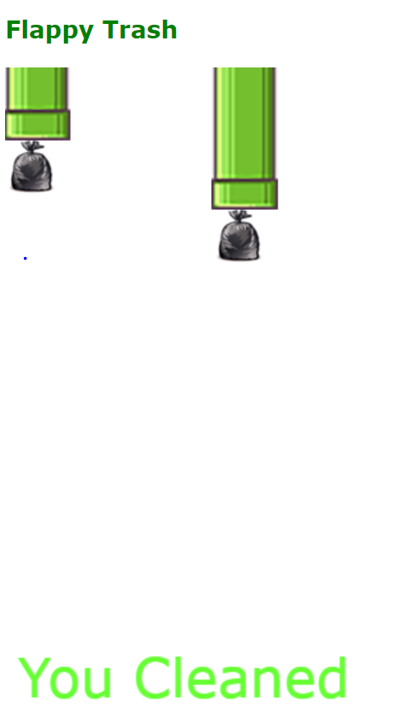

Future scope: This can be converted to an android game, VR/ AR game.