**th**

**DAILY ONLINE ACTIVITIES SUMMARY**

|  |  |  |  |  |  |  |  |
| --- | --- | --- | --- | --- | --- | --- | --- |
| **Date:** | **24-06-2020** | | | | **Name:** | PALLAVI | |
| **Sem & Sec** | **6 sem, ‘A’ sec** | | | | **USN:** | **4AL17CS056** | |
| **Online Test Summary** | | | | | | | |
| **Subject** | | **Java**  **Data Structures in C** | | | | | |
| **Max. Marks** | | **--** | | **Score** | | **--** | |
| **Certification Course Summary** | | | | | | | |
| **Course** | - | | | | | | |
| **Certificate Provider** | | | **-** | **Duration** | | | **-** |
| **Coding Challenges** | | | | | | | |
| **Problem Statement: 1 java program** | | | | | | | |
| **Status: executed** | | | | | | | |
| **Uploaded the report in GitHub** | | | | **Yes** | | | |
| **If yes Repository name** | | | | <https://github.com/pallavi056/DAILY_STATUS> | | | |
| **Uploaded the report in slack** | | | | **Yes** | | | |

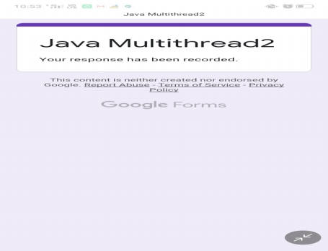

**Online Test Details:**

Java :

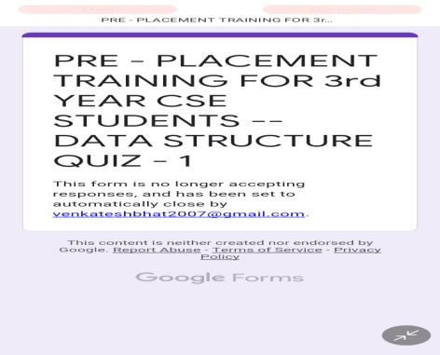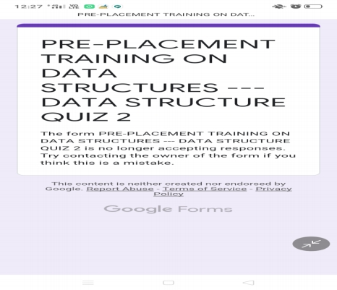

Data Structures in C:

**Coding Challenges Details:**

[https://github.com/pallavi056/DAILY_STATUS/tree/master/24-6-2020/ONLINE%20CODING](https://github.com/pallavi056/DAILY_STATUS/tree/master/24-6-2020/ONLINE CODING)