
AI CAREER FOR WOMEN
Engineer Spoke

AI-Powered Invoice Processing and Expense
Classification System

A Project Report
submitted in partial fulfillment of the requirements
of
AICW project.

by

Aliza Imran, alizaimran.it27@gmail.com
Dakshita Sharma, dakshita5002@gmail.com
Pallavi Sharma, Ps358690@gmail.com
Tanisha Rathore, tanisharathore.it27@gmail.com

Under the Guidance of
Mr. Umang Tyagi

ACKNOWLEDGEMENT

We would like to take this opportunity to express our deep sense of gratitude to all individuals who helped us directly or indirectly during this thesis work.

Firstly, we would like to thank my supervisor, Mr. Umang Tyagi, for being a great mentor and the best adviser I could ever have. His advice, encouragement and the critics are a source of innovative ideas, inspiration and causes behind the successful completion of this project. The confidence shown in me by him was the biggest source of inspiration for me. It has been a privilege working with him for the last one year. He always helped me during my project and many other aspects related to the program. His talks and lessons not only help in project work and other activities of the program but also make me a good and responsible professional.

Aliza Imran
Dakshita Sharma
Pallavi Sharma
Tanisha Rathore

ABSTRACT of the Project

This project presents an AI-Powered Invoice Processing and Expense Classification System aimed at automating the traditionally manual and error-prone process of handling invoices. The problem addressed is the difficulty in extracting and organizing useful information from invoices, especially when dealing with large volumes and varied formats such as images and PDFs.
The primary objective of the system is to automatically extract important invoice details and categorize expenses efficiently. To achieve this, the system uses Optical Character Recognition (OCR) to convert invoice images into text, followed by text processing techniques to identify key fields such as vendor name, invoice date, and total amount. For expense categorization, an intelligent classification approach is applied, which may include rule-based logic or lightweight machine learning techniques such as TF-IDF with Logistic Regression.
The methodology follows a pipeline-based approach: invoice upload → OCR-based text extraction → data processing → classification → database storage → dashboard visualization. The system is implemented as a full-stack web application using React for the frontend, Node.js for the backend, and MongoDB for data storage.
Key results demonstrate that the system successfully automates invoice data extraction and categorization, significantly reducing manual effort and improving processing speed. The dashboard provides clear insights through charts and tables, enabling better financial analysis.
In conclusion, the proposed system offers an efficient and scalable solution for invoice management by integrating AI, NLP, and basic machine learning techniques. It can be further enhanced with advanced models and deployed for real-world applications.

TABLE OF CONTENTS
Abstract
List of Figures
List of Tables
Chapter 1. Introduction
1.1 Problem Statement
1.2 Motivation
1.3 Objectives
1.4. Scope of the Project
Chapter 2. Literature Survey
Chapter 3. Proposed Methodology
Chapter 4. Implementation and Results
Chapter 5. Discussion and Conclusion
References

CHAPTER 1
Introduction

Problem Statement

The process of invoice management in many organizations and small businesses is still largely manual. Users are required to read each invoice individually, extract relevant information such as vendor name, invoice date, and total amount, and then organize or categorize the expenses accordingly.

This manual approach is time-consuming, repetitive, and prone to human errors, especially when dealing with a large number of invoices. Additionally, invoices are often available in different formats such as scanned images, PDFs, or photographs, making it difficult to extract structured data efficiently.

Due to the lack of automation, important financial insights are often delayed or inaccurate. Therefore, there is a significant need for a system that can automatically extract, process, and organize invoice data in a fast, accurate, and scalable manner.

1.2 Motivation

The motivation behind this project arises from the increasing need to automate repetitive financial tasks and improve efficiency in data processing. Invoice handling is a common requirement in both personal and organizational finance management, yet it is often handled manually.

With advancements in Artificial Intelligence, Optical Character Recognition (OCR), and Machine Learning, it has become possible to build systems that can understand and process unstructured data such as invoices. This project aims to leverage these technologies to simplify invoice processing.

The potential applications of this system include:
- Business expense management
- Financial record keeping
- Accounting automation
- Personal expense tracking
The impact of this project lies in reducing manual effort, improving accuracy, saving time, and enabling better financial decision-making through data visualization and analytics.

Objective

The main objectives of this project are:
- To develop a system that can automatically extract text from invoices using OCR techniques
- To identify and extract key invoice details such as vendor name, invoice number, date, and total amount
- To implement an intelligent mechanism for expense classification into predefined categories
- To store processed data in a structured format using a database
- To design an interactive dashboard for visualization and analysis of invoice data
- To reduce manual effort and improve the efficiency and accuracy of invoice processing

Scope of the Project

The scope of this project includes the development of a complete invoice processing pipeline that handles invoice upload, text extraction, data processing, classification, and visualization. The system supports invoices in the form of images and PDFs and provides a user-friendly interface for interaction.

The project focuses on:
- Automated extraction of invoice data
- Basic classification of expenses
- Visualization of processed data through charts and tables
However, the project has certain limitations:
- OCR accuracy may vary depending on the quality and format of the invoice
- The classification system is basic and may not handle highly complex or ambiguous cases
- The system currently supports limited categories
- Advanced features such as fraud detection and real-time cloud deployment are not included
Despite these limitations, the system provides a strong foundation that can be extended with more advanced machine learning models and real-world integrations in the future.

CHAPTER 2
Literature Survey

2.1 Review of Relevant Literature

Invoice processing has been an active research area due to the need for automation in financial systems. Traditional invoice handling relies heavily on manual data entry, which is time-consuming, error-prone, and inefficient. Research shows that manual processing leads to delays and increased operational costs, highlighting the need for automated solutions.

To address this, many studies have explored the use of Optical Character Recognition (OCR) for extracting text from invoices. OCR-based systems convert scanned or image-based invoices into machine-readable text, enabling further processing. Recent approaches combine OCR with artificial intelligence to improve accuracy and efficiency.

Modern research also focuses on integrating Natural Language Processing (NLP) and machine learning techniques to interpret unstructured invoice text. These systems not only extract text but also identify key information such as invoice number, vendor details, and total amount.

Advanced systems further use deep learning models to classify and understand invoice content automatically.

2.2 Existing Models, Techniques, and Methodologies

Several techniques have been proposed for automated invoice processing:
- OCR-based systems: Convert images or PDFs into text for further analysis
- Rule-based extraction: Use predefined patterns and keywords to extract invoice fields
- Machine Learning models: Algorithms like Logistic Regression and LSTM are used for classification and prediction tasks
- Deep Learning approaches: Models such as CNNs, Transformers, and BERT are used for advanced text recognition and classification
- Hybrid systems: Combine OCR with NLP and machine learning to improve accuracy and adaptability
Many modern systems follow a pipeline-based approach, which includes text extraction, field identification, and classification. Some frameworks also use key-value pair extraction techniques to map invoice data efficiently.

2.3 Gaps and Limitations in Existing Solutions

Despite significant advancements, existing solutions have several limitations:
- Variation in invoice formats: Different layouts and structures make it difficult for systems to generalize across all invoices
- OCR inaccuracies: Poor image quality or handwritten text can lead to incorrect extraction
- High dependency on training data: Advanced models require large labeled datasets, which are difficult to obtain
- Complex implementation: Deep learning models increase system complexity and computational cost
- Limited adaptability: Many systems struggle with real-time processing and diverse invoice types

How This Project Addresses the Gaps

The proposed system addresses these limitations by:
- Using a lightweight OCR-based approach for text extraction
- Applying intelligent classification (rule-based or ML) without requiring large datasets
- Designing a simple and scalable pipeline architecture
- Supporting multiple invoice formats (images and PDFs)
- Providing a user-friendly dashboard for visualization and analysis
This approach ensures a balance between efficiency, simplicity, and practical usability.

CHAPTER 3
Proposed Methodology

3.1 System Design

The system is designed as a pipeline-based architecture that processes invoices in multiple stages. It integrates frontend, backend, OCR, data processing, and classification modules to automate invoice handling.
The workflow begins with invoice upload, followed by text extraction using OCR, processing of extracted data, classification of expenses, storage in a database, and visualization through a dashboard.

3.1.1 Invoice Upload

The system allows users to upload invoices in the form of images or PDF files through the frontend interface.
- Implemented using React frontend
- Supports formats like JPG, PNG, and PDF
- Uploaded files are sent to the backend server
- Backend stores the file temporarily for processing
This module acts as the entry point of the system.

3.1.2 Text Extraction (OCR)

Once the invoice is uploaded, the system uses Optical Character Recognition (OCR) to extract text from the file.
- Implemented using Tesseract OCR
- Converts image/PDF into machine-readable text
- Handles printed text effectively
- Output is raw unstructured text
Example:
Input: Invoice Image
Output: “Total Amount: ₹500, Vendor: Uber”
This is the AI component (Computer Vision) of the system.

3.1.3 Data Processing and Field Extraction

The extracted text is processed to identify key invoice details.
- Text is cleaned and formatted
- Pattern matching and keyword detection are applied
- Important fields are extracted:
  - Vendor name
  - Invoice number
  - Date
  - Total amount
- This module converts unstructured text → structured data.

3.1.4 Expense Classification

The system categorizes invoices into predefined categories.
- Uses intelligent logic or machine learning
- May use TF-IDF + Logistic Regression
- Assigns categories like:
  - Travel
  - Food
  - Utilities
  - Software
- Generates a confidence score
This is the ML/NLP component of the system.

3.1.5 Data Storage

Processed invoice data is stored in the database.
- MongoDB is used
- Stores structured fields and classification results
- Enables easy retrieval and analysis

3.1.6 Dashboard Visualization

The final data is displayed through an interactive dashboard.
- Built using React
- Uses charts (Chart.js)
- Displays:
  - Total invoices
  - Revenue
  - Category distribution
  - Status
This helps users analyze data effectively.

3.2 Modules Used

The system is divided into multiple functional modules:
- Invoice Upload Module
- OCR Module
- Data Processing Module
- Classification Module
- Database Module
- Dashboard Module

3.2.1 OCR Module (Text Extraction)
- Extracts text from invoice images/PDFs
- Uses Tesseract OCR
- Converts visual data into text

3.2.2 Data Processing Module
- Cleans and structures extracted text
- Identifies key invoice fields

3.2.3 Classification Module
- Categorizes expenses
- Uses rule-based or ML techniques
- Generates confidence score

3.2.4 Database Module
- Stores invoice data
- Enables data retrieval

3.2.5 Dashboard Module
- Displays processed data
- Provides analytics and visualization

3.3 Data Flow Diagram

3.3.1 DFD Level 0

Description:
DFD Level 0 shows the overall high-level flow of the system. At this level, the entire system is represented as a single process, which takes an invoice file from the user, processes it, and returns the final result in the form of a dashboard.

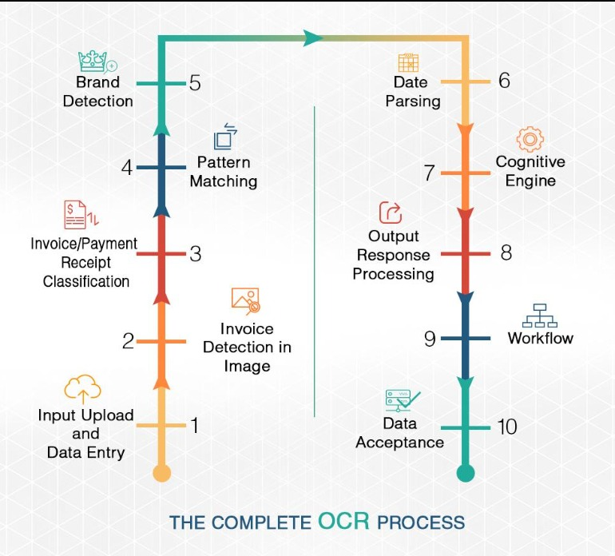

Flow:
- User uploads invoice
- System extracts text using OCR
- System processes invoice data
- System classifies expense category
- System stores data in database
- Dashboard displays processed results
Entities involved:
- User
- Invoice Processing System
- Database

3.3.2 DFD Level 1 – Invoice Upload Module

Description:
In this module, the user uploads an invoice image or PDF. The frontend sends the uploaded file to the backend, where the file is validated and stored.

Flow:
- User selects invoice file
- Frontend sends file to backend
- Backend validates file format
- File is stored for processing
- Status updated as uploaded
Input: Invoice image/PDF
Output: Uploaded invoice file stored in system

3.3.3 DFD Level 1 – OCR and Data Extraction Module

Description:
In this module, OCR is applied to the uploaded invoice, and text is extracted from the image or PDF. Then, the extracted text is processed to identify key fields.

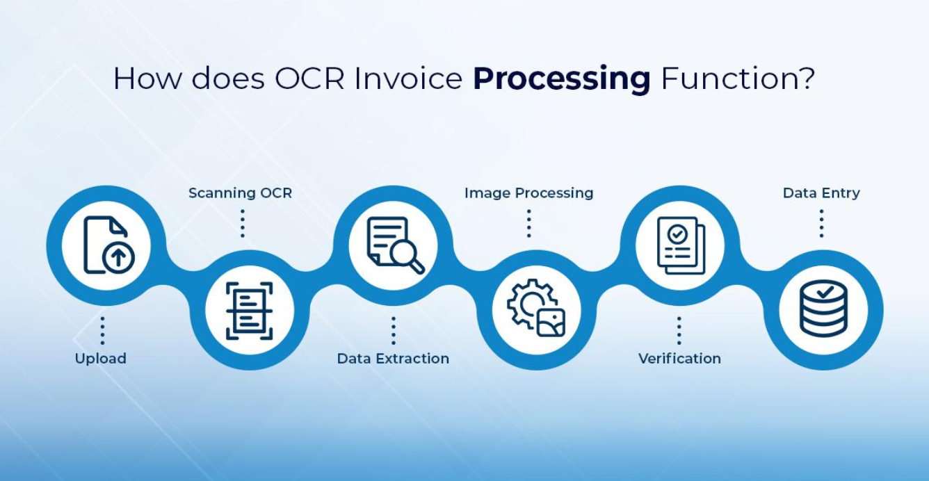

Flow:
- Uploaded file sent to OCR engine
- OCR extracts raw text
- System processes text
- Vendor name, invoice number, date, total amount extracted
Input: Uploaded invoice file
Output: Raw text + structured invoice fields

3.3.4 DFD Level 1 – Expense Classification and Dashboard Module

Description:
In this module, the extracted invoice text is classified. An expense category is assigned, a confidence score is generated, and the processed data is displayed on the dashboard.

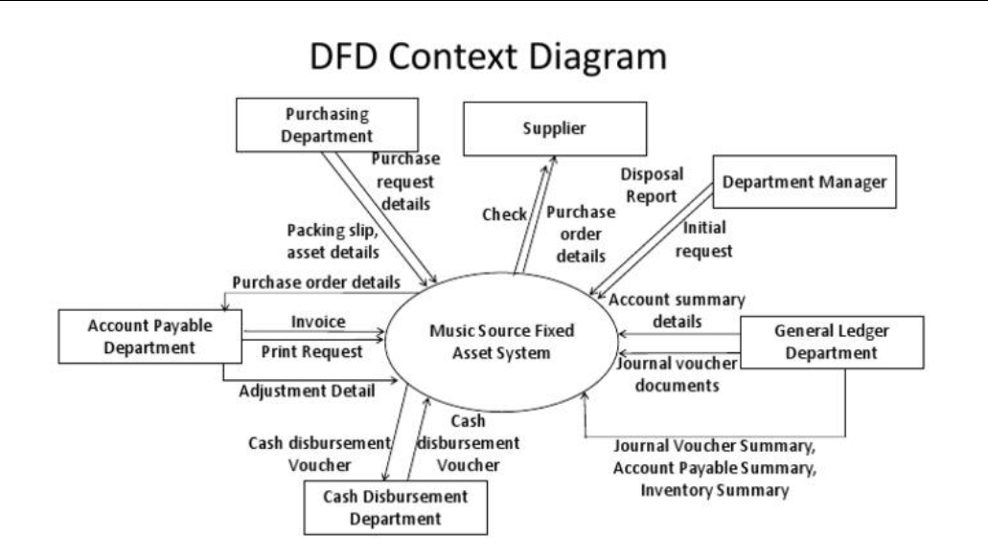

Flow:
- Processed text sent to classification module
- Category predicted
- Confidence score generated
- Data saved in MongoDB
- Dashboard shows charts, summaries, and invoice table
Input: Structured invoice data
Output: Classified data + dashboard visualization

3.4 Advantages
- Reduces manual effort in invoice handling
- Saves time by automating data extraction
- Minimizes human errors
- Supports invoice files in image and PDF format
- Organizes invoice data in a structured form
- Provides category-wise expense analysis
- Generates dashboard-based insights for better decision-making
- Improves efficiency and usability in invoice management

3.5 Requirement Specification

3.5.1 Hardware Requirements
- Processor: Intel i3 / i5 or above
- RAM: Minimum 4 GB (8 GB recommended)
- Storage: Minimum 20 GB free disk space
- System Type: 64-bit computer/laptop
- Internet Connection: Required for package installation and deployment
- Display: Standard monitor/laptop screen

3.5.2 Software Requirements
- Operating System: Windows 10/11, Linux, or macOS
- Frontend: React.js
- Backend: Node.js and Express.js
- Database: MongoDB
- OCR Tool: Tesseract OCR / Tesseract.js
- Styling Framework: Tailwind CSS
- Chart Library: Chart.js
- Development Tools:
  - VS Code
  - Git/GitHub
  - Postman (for API testing)
- Browser: Google Chrome / Microsoft Edge
- Package Manager: npm
- Optional ML Tools:
  - Python
  - scikit-learn
  - Flask / FastAPI

CHAPTER 4
Implementation and Result

4.1 Results of Invoice Upload and OCR Extraction

The system successfully accepts invoice files from the user through the frontend interface. The uploaded invoices are processed using OCR (Tesseract), which extracts text from images and PDFs.
Observations:
- The system correctly extracts readable text from invoices
- Works well for clear and printed invoices
- OCR output is generated in real-time
Example Result:
- Input: Invoice image
- Output: Extracted text containing vendor name, amount, and date

4.2 Results of Data Extraction and Field Identification

After OCR, the extracted text is processed to identify key invoice details.
Fields extracted:
- Vendor name
- Invoice number
- Invoice date
- Total amount
Observations:
- The system successfully converts unstructured text into structured data
- Accuracy depends on the quality of OCR output
- Most standard invoices are processed correctly

4.3 Results of Expense Classification and Dashboard

The system classifies invoices into categories using intelligent logic or machine learning.
Categories:
- Travel
- Food
- Utilities
- Software
- Medical
Additional Outputs:
- Confidence score for each prediction
- Status (Processed / Pending)
- Flags (if any issue is detected)
Dashboard Results:
- Displays total invoices and revenue
- Shows category-wise distribution using charts
- Provides a table view of all processed invoices
Observations:
- Classification works effectively for common invoice types
- Dashboard provides clear visualization of data
- System improves understanding of expenses

CHAPTER 5
Discussion and Conclusion

5.1 Key Findings

The project successfully demonstrates an automated approach for invoice processing using OCR and intelligent classification techniques. The system is capable of extracting meaningful information from invoices in image and PDF formats and converting it into structured data.
Key findings include:
- OCR effectively extracts readable text from invoices
- Important fields such as vendor name, date, and amount are identified successfully
- Expense classification helps in organizing financial data efficiently
- Dashboard visualization improves data understanding and analysis
- The system significantly reduces manual effort and processing time
Overall, the system proves to be efficient, user-friendly, and suitable for basic invoice management tasks.

  - Git Hub Link of the Project:
https://github.com/rathore950/invoice-view-pro.git

  - Video Recording of Project:
Demonstration: https://drive.google.com/file/d/1z6A05CPd3PzUml46BGGv_QeDfBHJmP4/view?usp=sharing

5.4 Limitations: Despite its effectiveness, the system has some limitations:
- OCR accuracy depends on image quality and format
- The system may struggle with handwritten or complex invoices
- Classification is basic and may not handle ambiguous cases accurately
- Limited number of predefined categories
- No real-time cloud deployment or scalability features
These limitations indicate the need for further improvements in the system.

Future Work: The system can be enhanced in the following ways:
- Integration of advanced machine learning or deep learning models
- Improved OCR accuracy using better preprocessing techniques
- Support for multi-language invoices
- Cloud-based deployment for real-time access
- Implementation of fraud detection and anomaly detection
- Integration with accounting and financial software
These improvements can make the system more robust and suitable for real-world applications.
Conclusion The project successfully presents an AI-powered solution for automating invoice processing and expense classification. By integrating OCR, text processing, and classification techniques, the system reduces manual effort and improves efficiency.
The dashboard provides meaningful insights through visualization, making it easier for users to analyze and manage financial data.
Overall, the system demonstrates the practical application of AI, NLP, and machine learning concepts in solving real-world problems and can be further extended for advanced financial automation.

REFERENCES

Books / Concepts

[1] I. Goodfellow, Y. Bengio, and A. Courville, Deep Learning. MIT Press, 2016.
[2] C. M. Bishop, Pattern Recognition and Machine Learning. Springer, 2006.

Research Papers / Articles

[3] R. Smith, “An Overview of the Tesseract OCR Engine,” Proceedings of the International Conference on Document Analysis and Recognition (ICDAR), 2007.
[4] A. Graves, “Supervised Sequence Labelling with Recurrent Neural Networks,” Springer, 2012.
[5] S. R. Katti et al., “Chargrid: Towards Understanding 2D Documents,” EMNLP Conference, 2018.

Web References / Tools Used

[6] Tesseract OCR Documentation. Available: https://github.com/tesseract-ocr/tesseract
[7] React.js Documentation. Available: https://reactjs.org
[8] Node.js Documentation. Available: https://nodejs.org
[9] MongoDB Documentation. Available: https://www.mongodb.com
[10] Chart.js Documentation. Available: https://www.chartjs.org
[11] Scikit-learn Documentation. Available: https://scikit-learn.org
[12] J. Han, M. Kamber, and J. Pei, Data Mining: Concepts and Techniques. Morgan Kaufmann, 2011.

