JANGAM PALLAVI

23BTRCM024
JAIN(Deemed-to-be-University)

CLOUD TECHNOLOGY AND MOBILE APPLICATION

2023 - 2027
Date : 10/10/2026

TITLE : AWS Cloud & Data Engineering

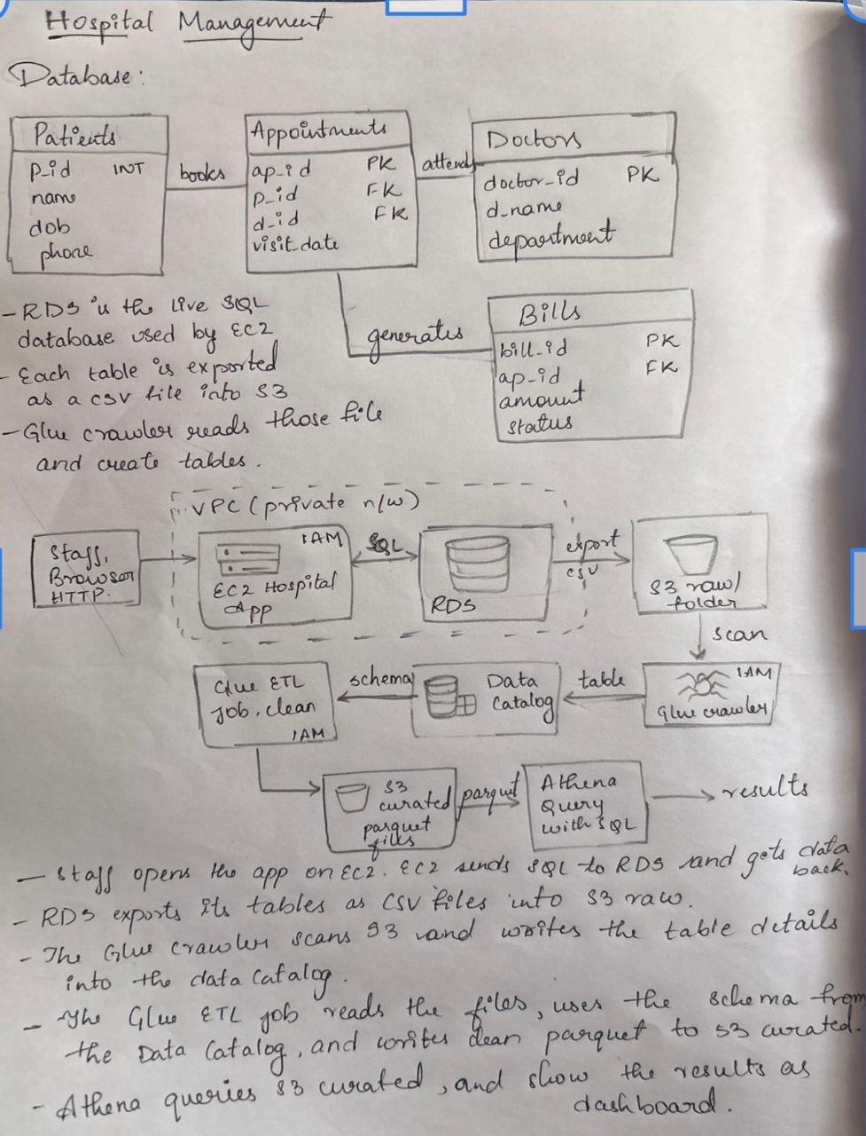

Hospital Management System Using SQL
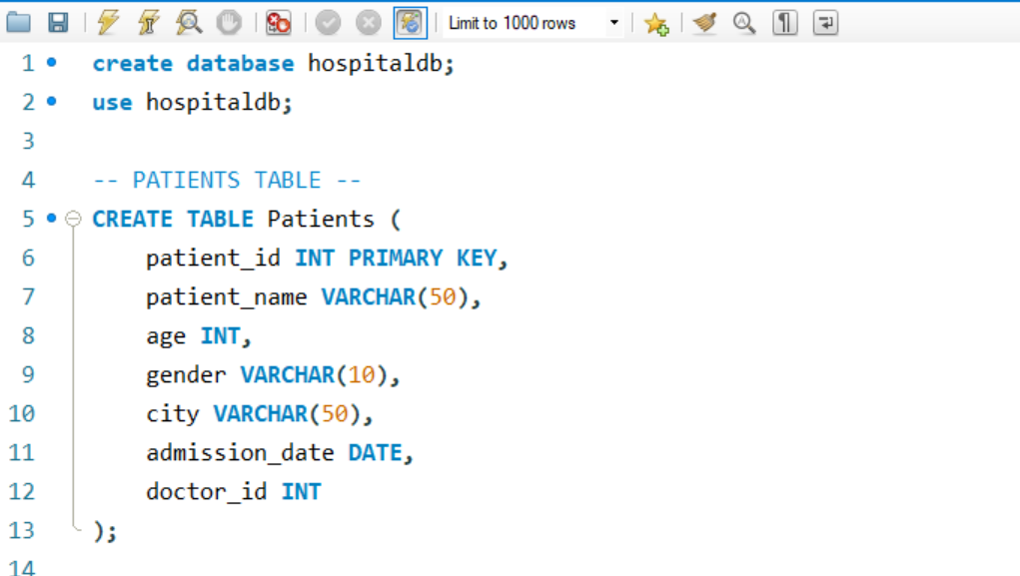

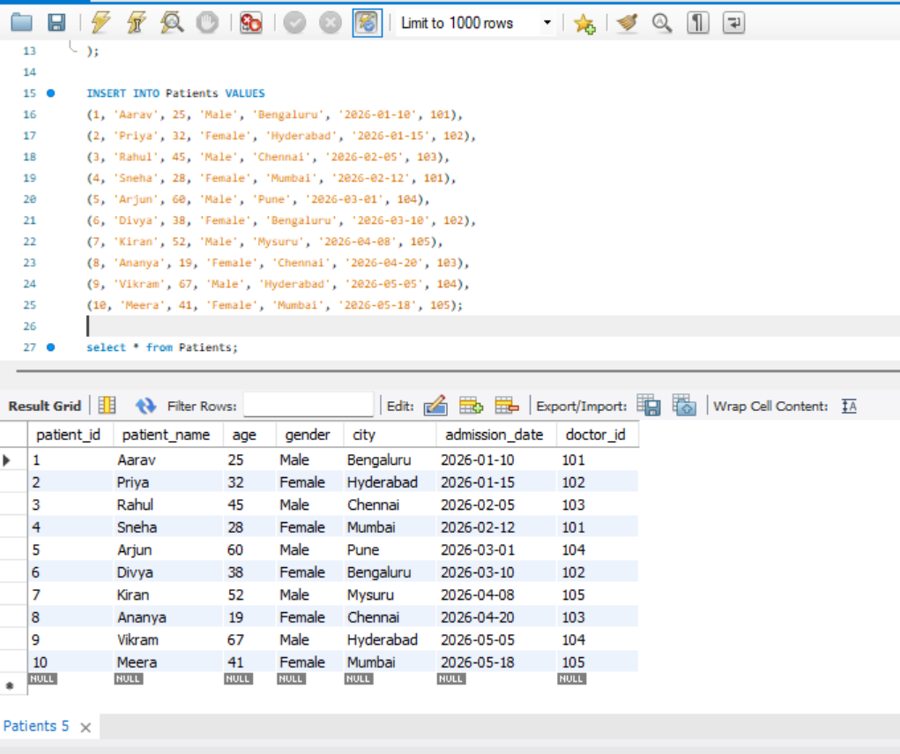

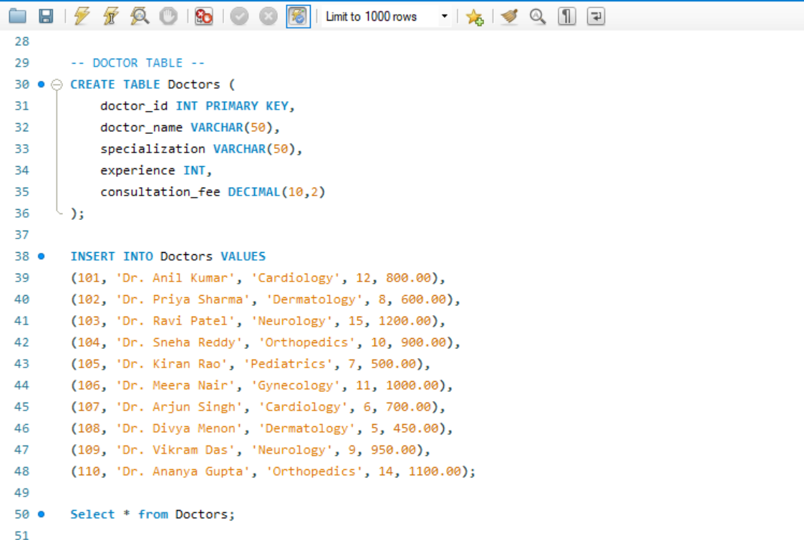

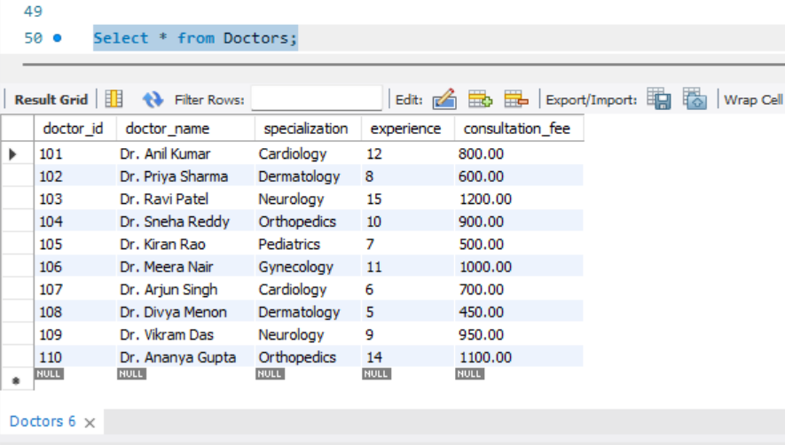

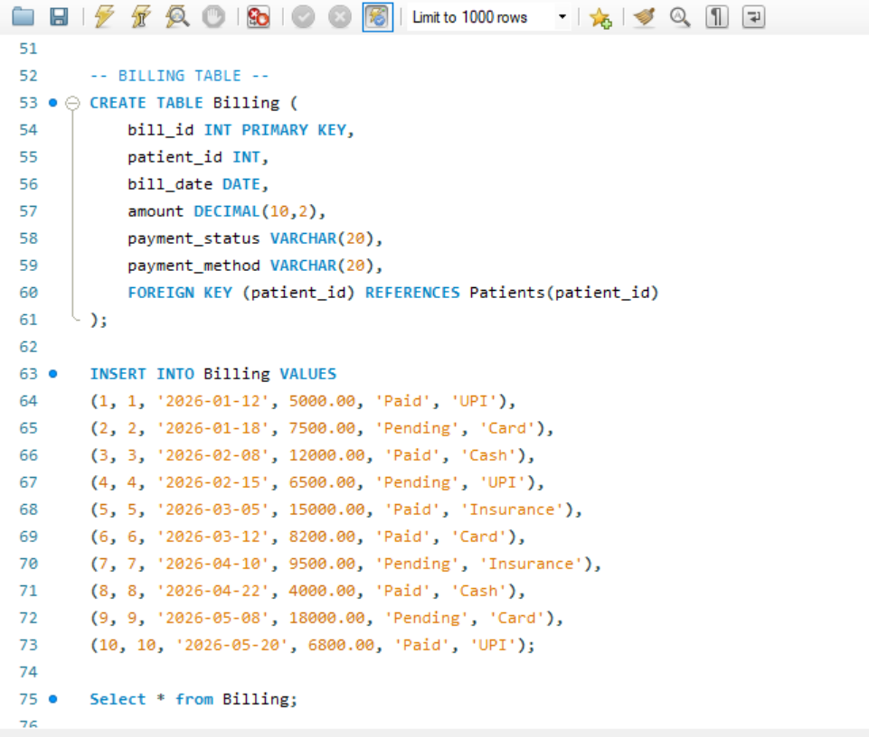

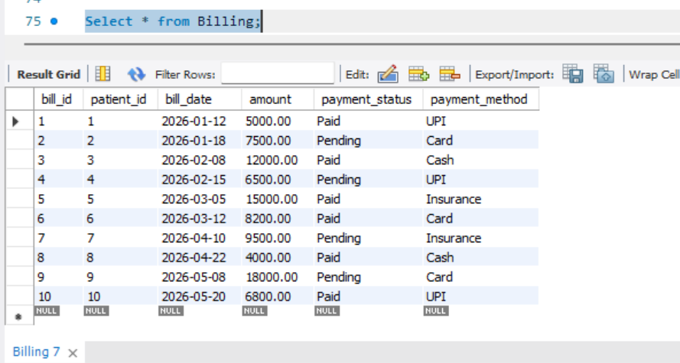

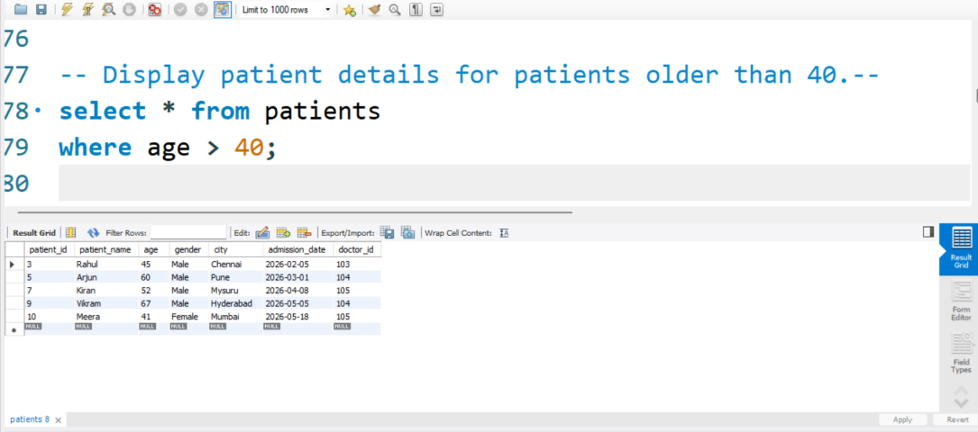

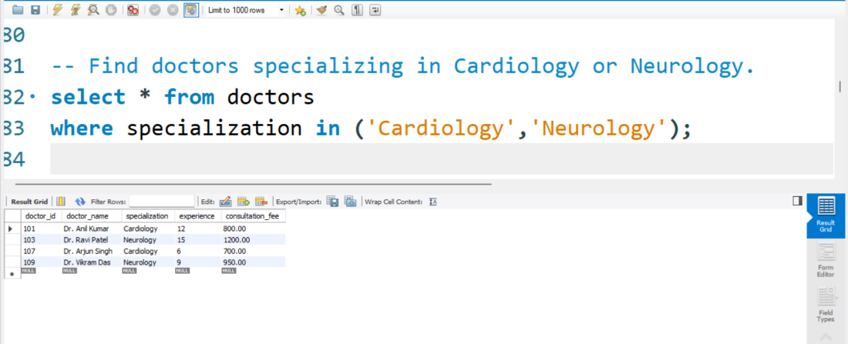

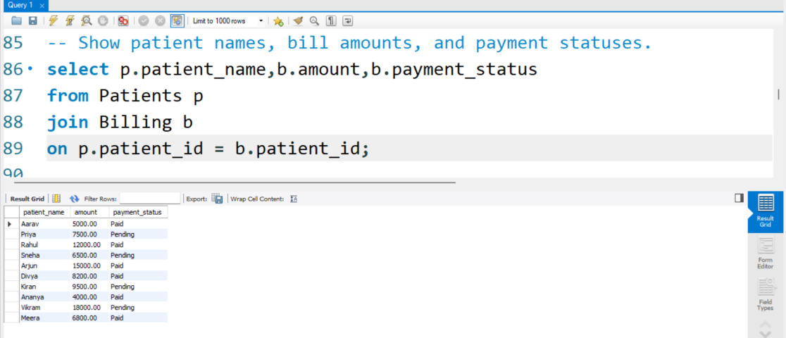

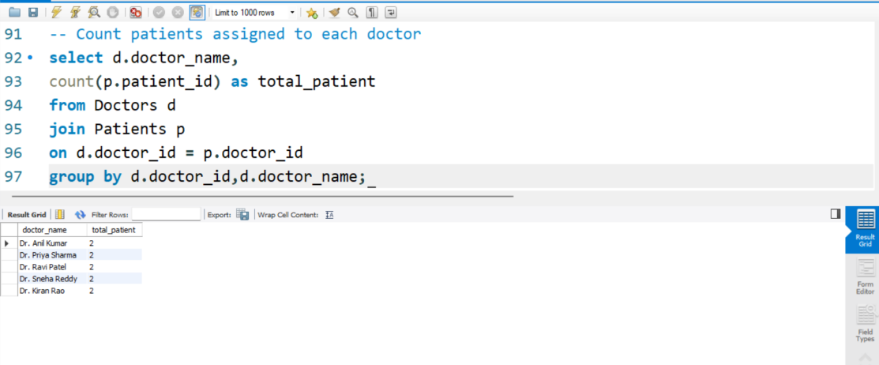

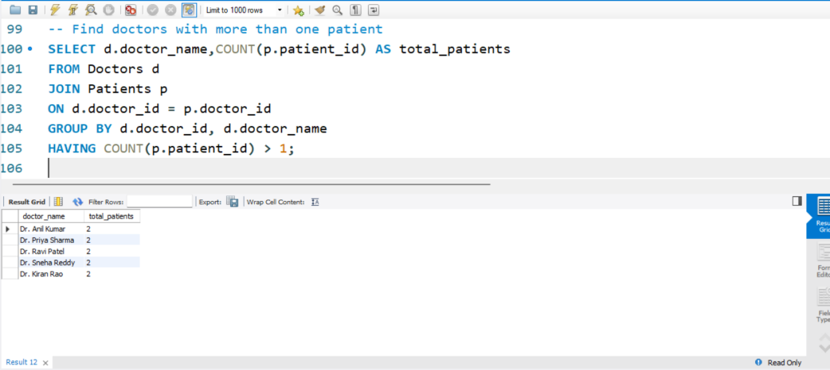

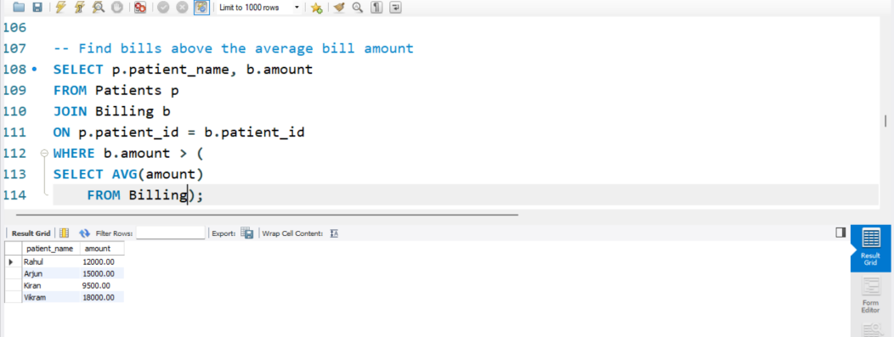

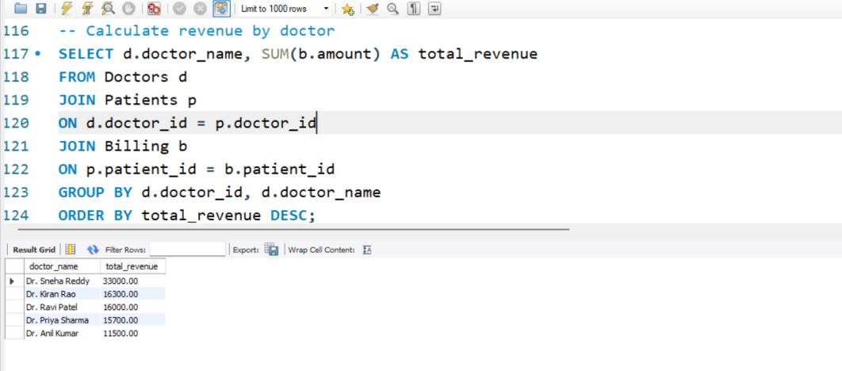

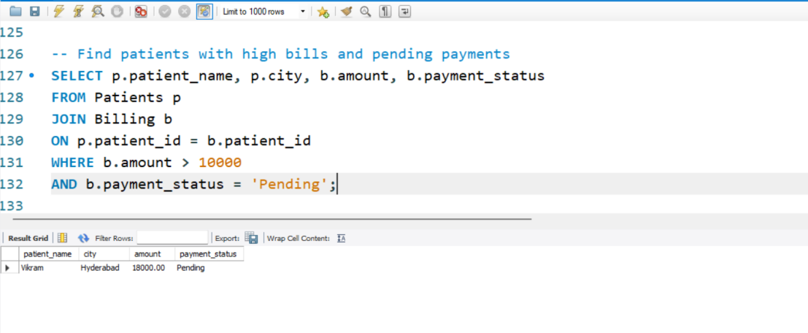

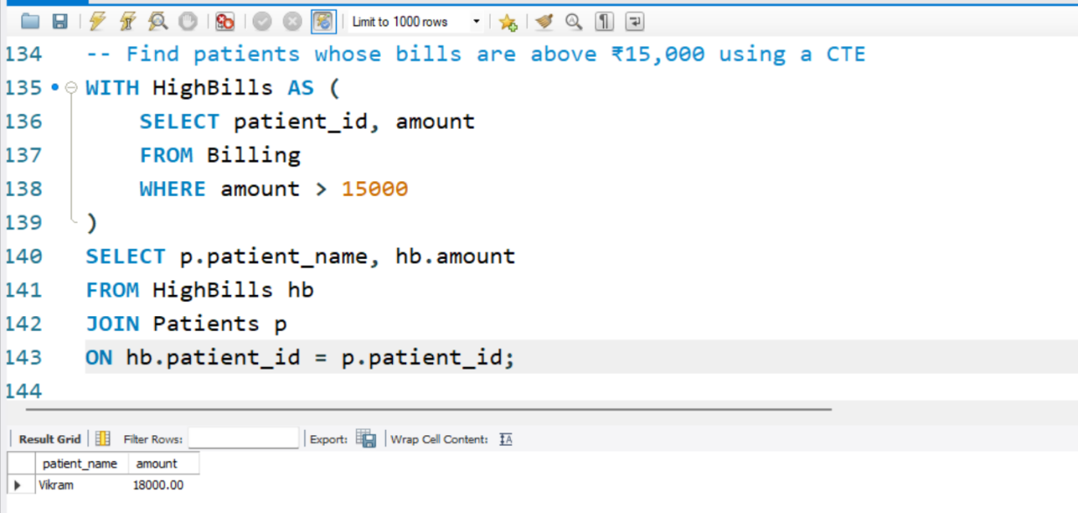

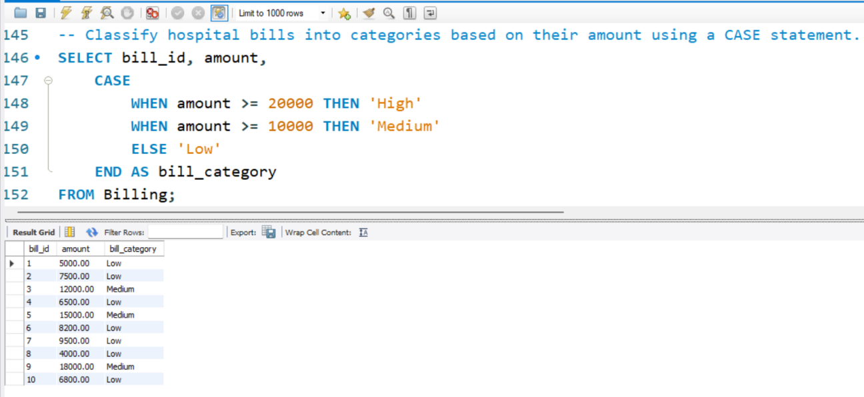

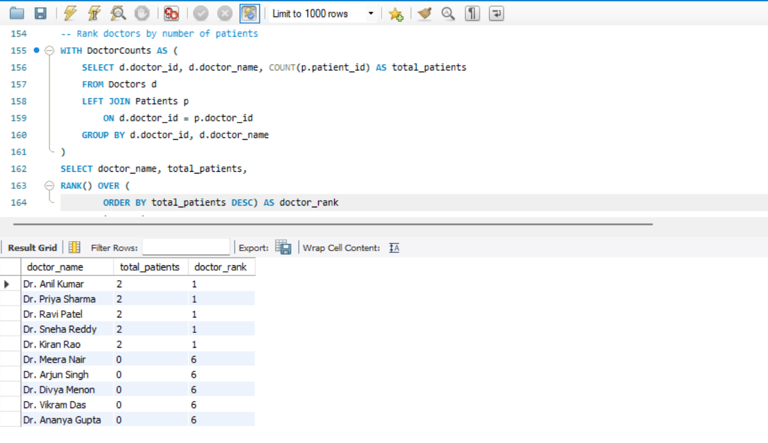

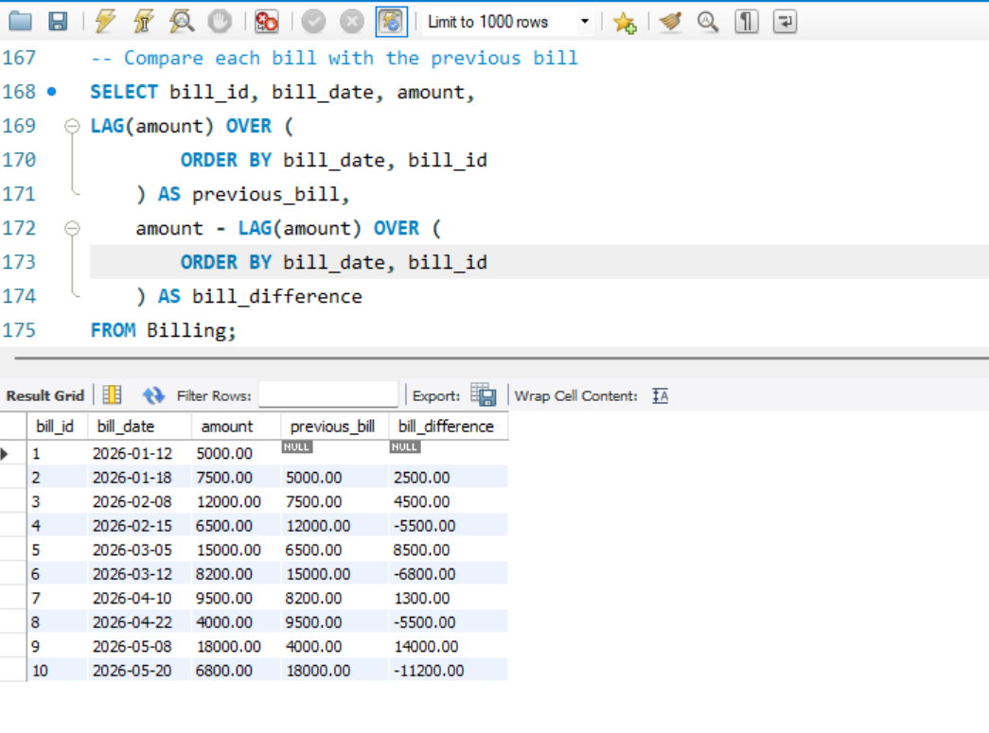

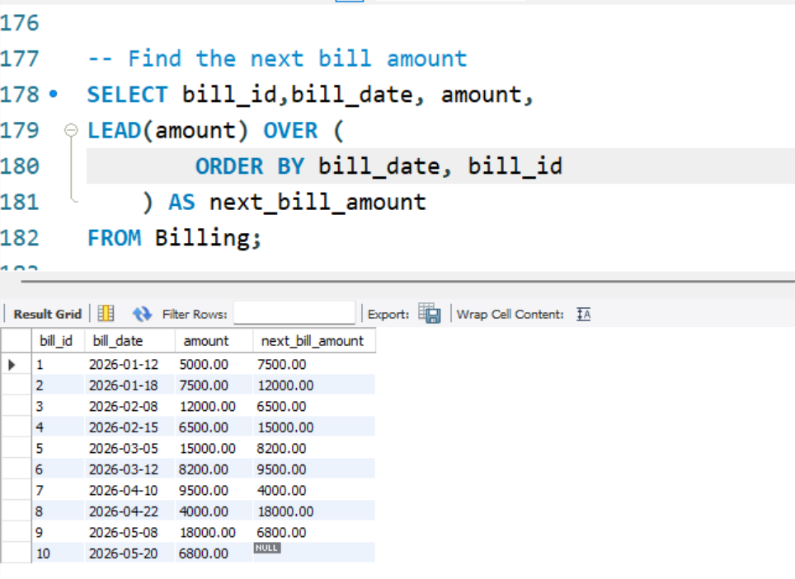

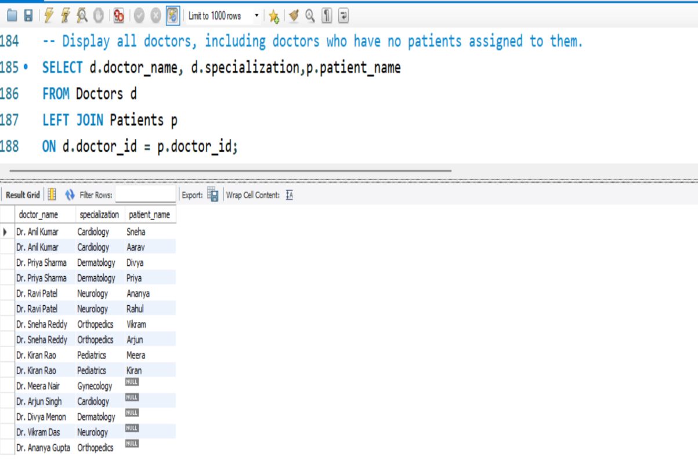

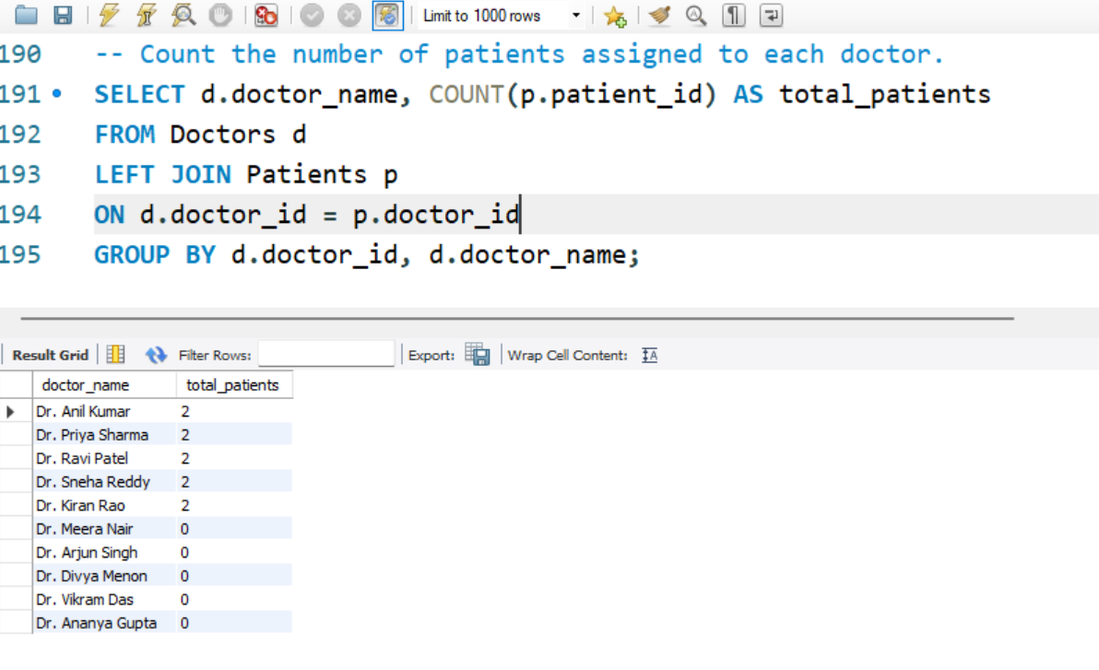

Linux Commands:

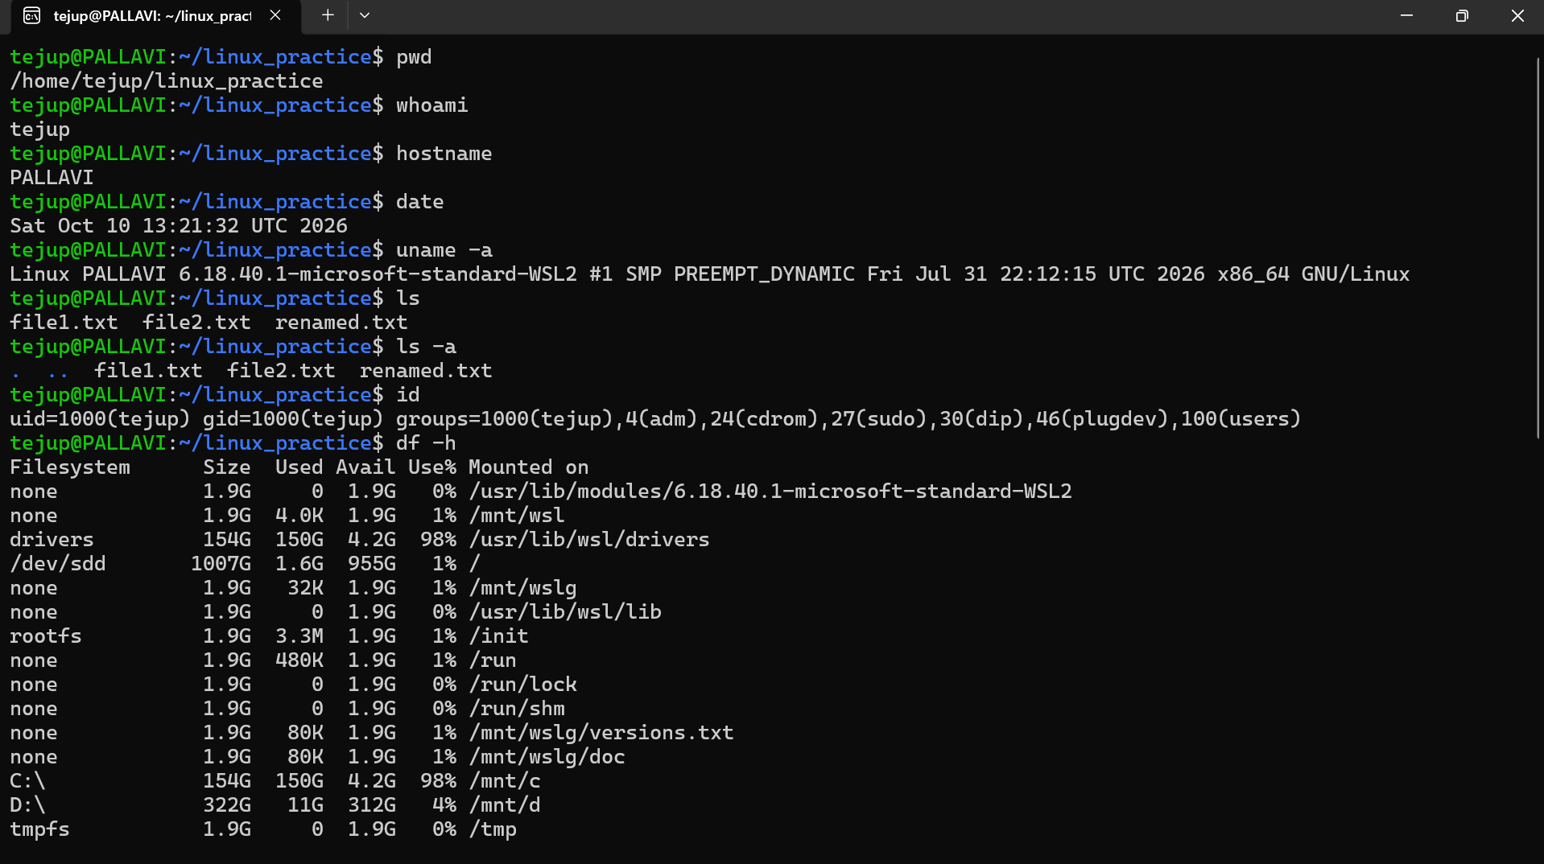

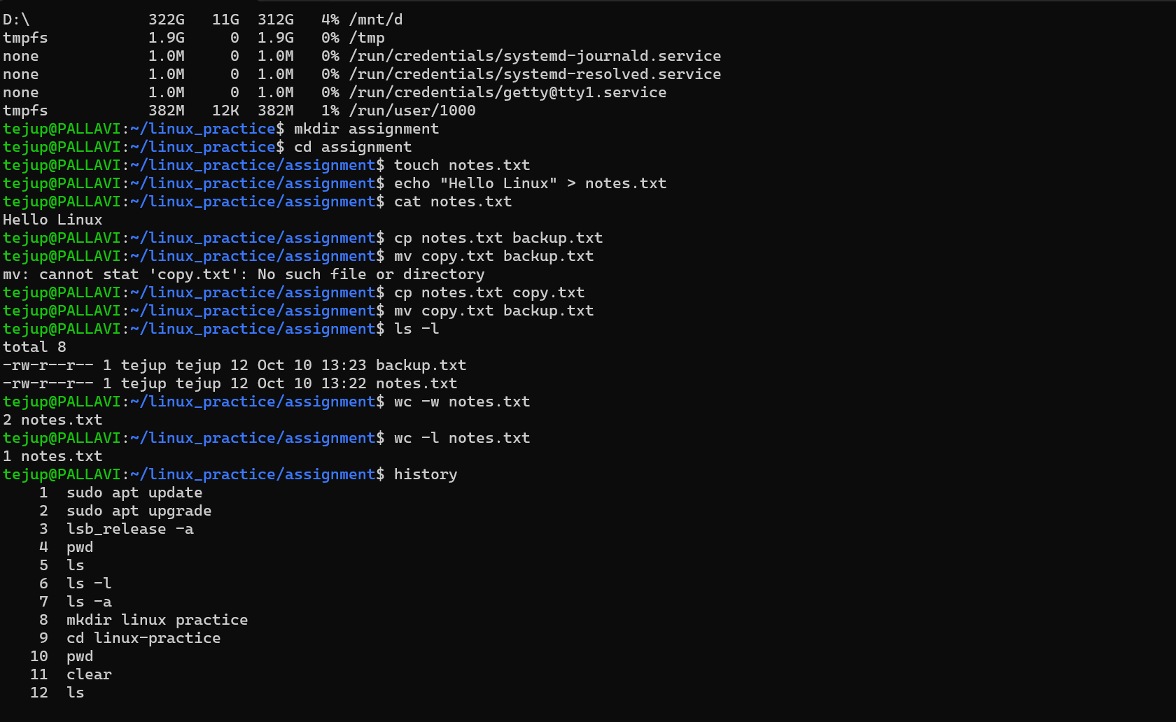

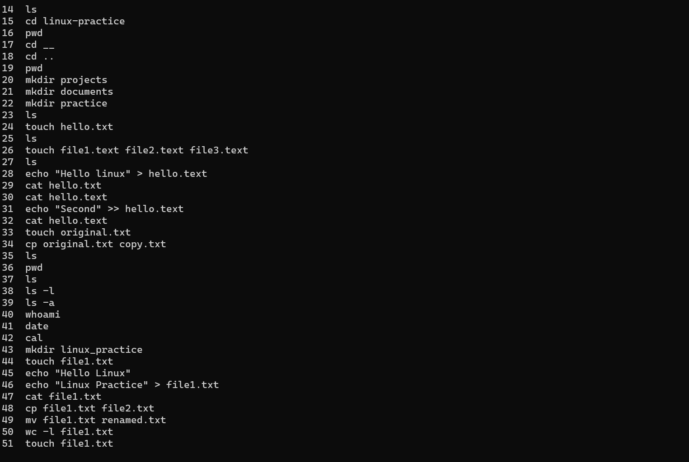

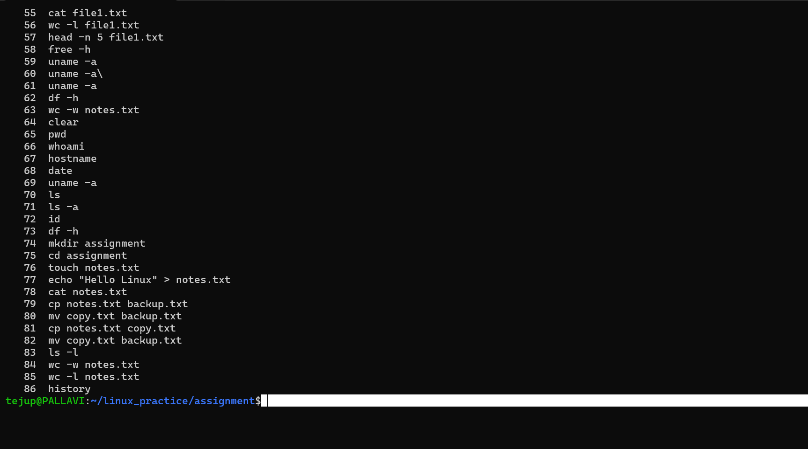

AWS Account / Region:

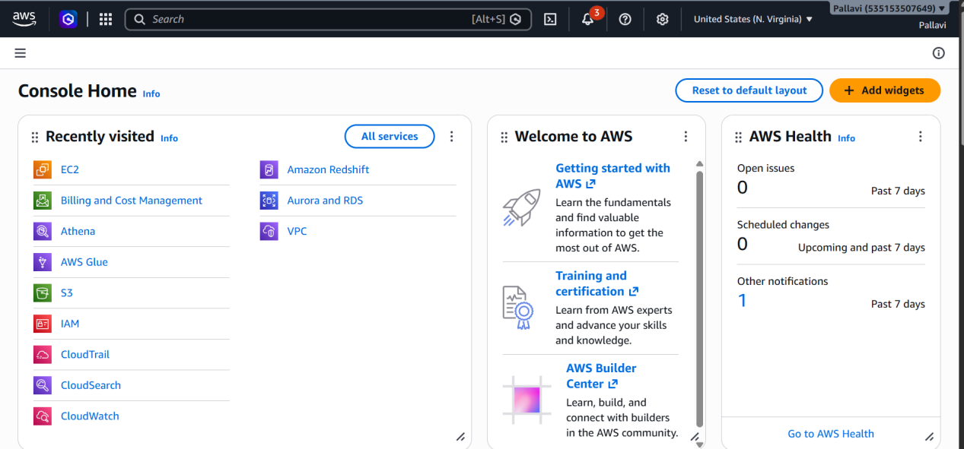

Amazon S3:

Create an S3 bucket and keep the bucket type as general purpose

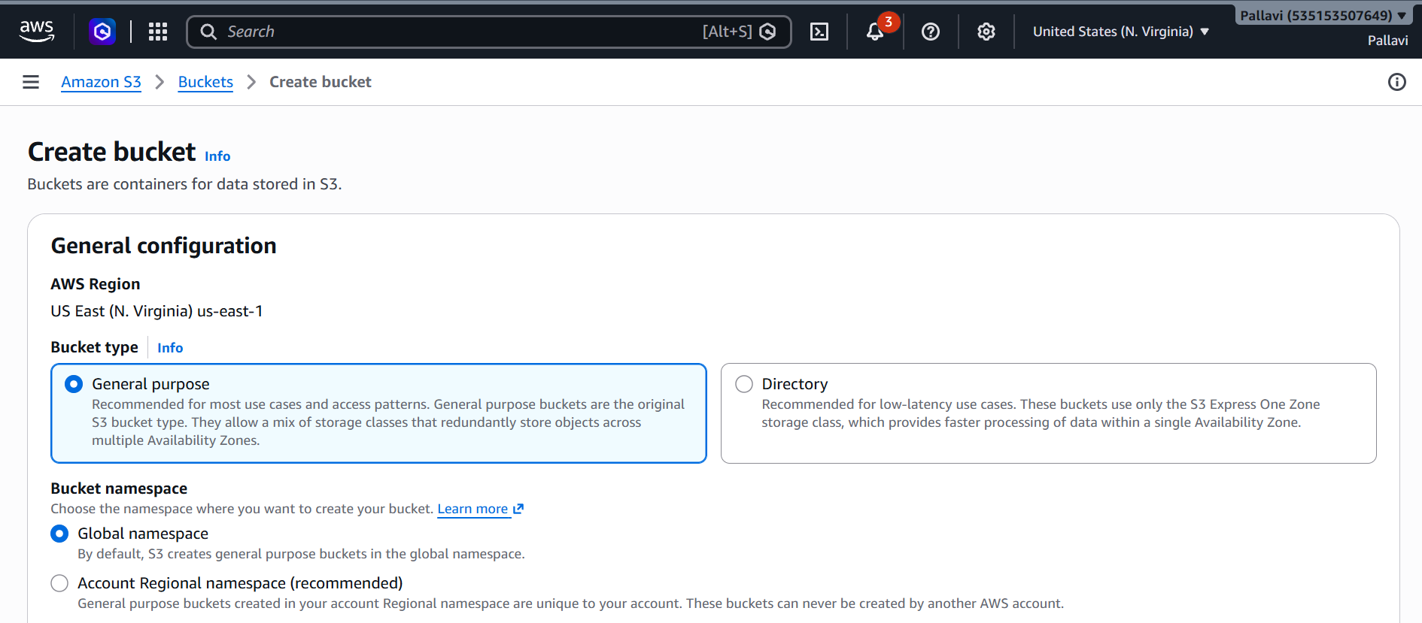

Enter a unique bucket name

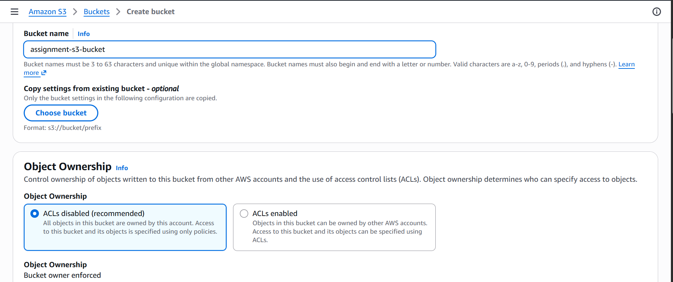

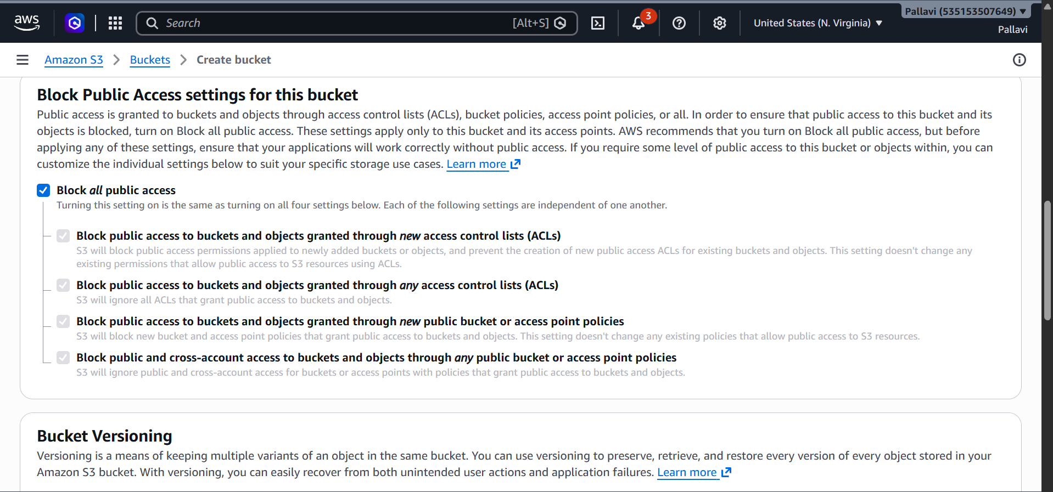

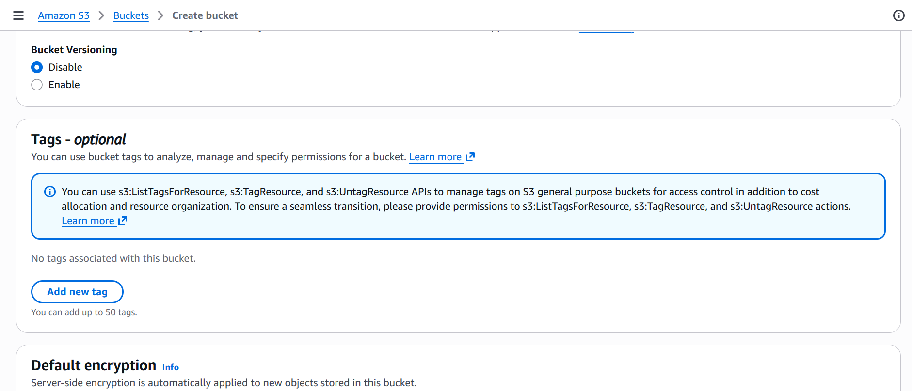

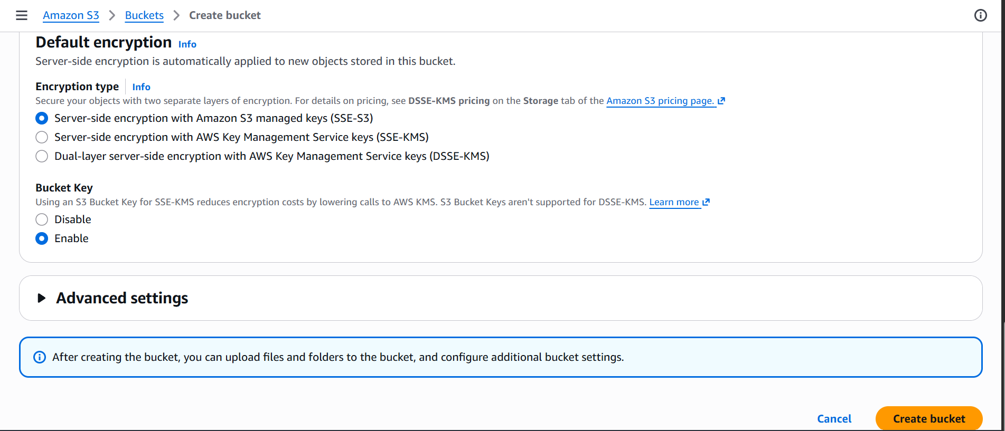

Bucket is created successfully and now appears empty with 0 objects

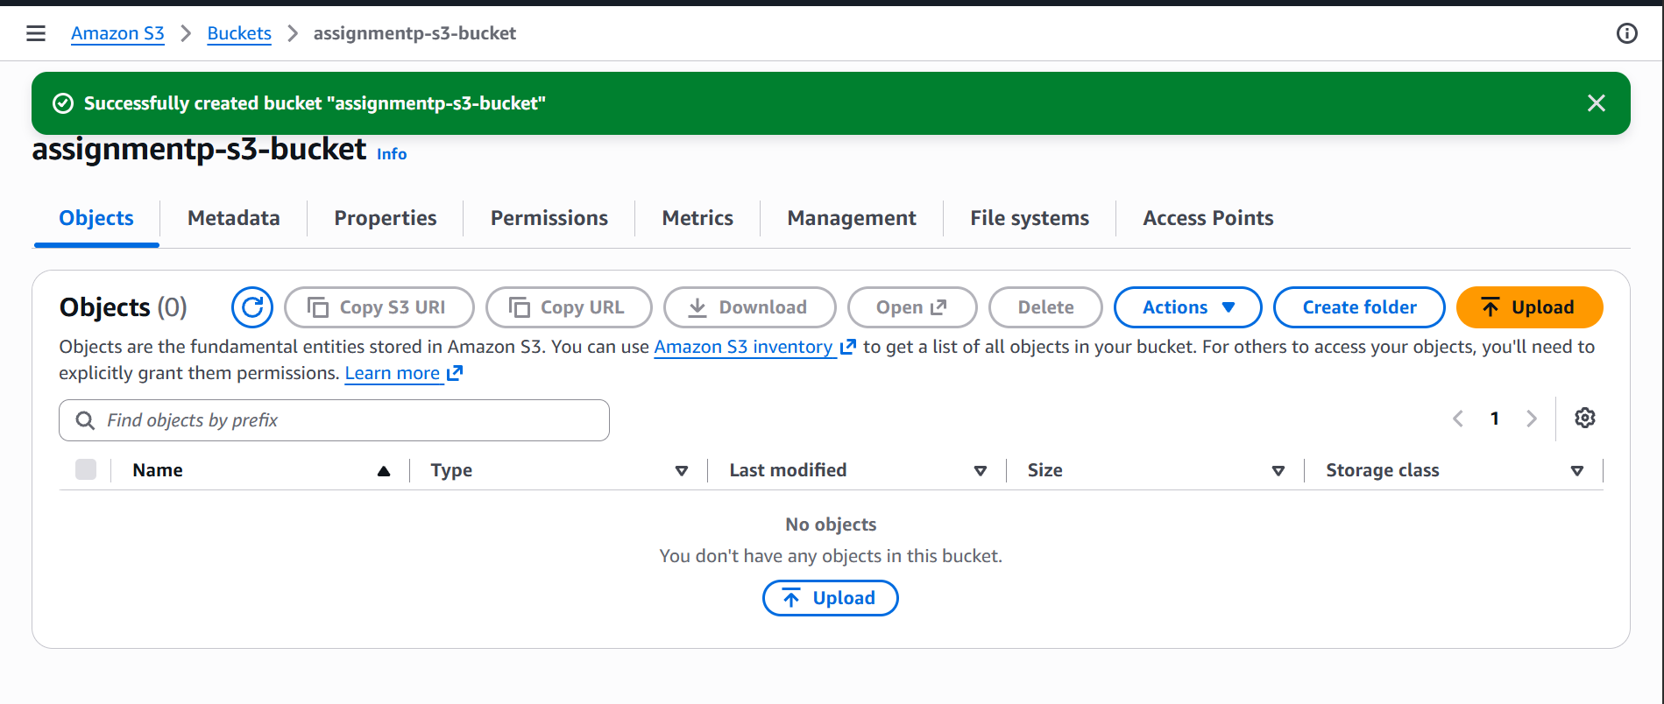

Create a folder

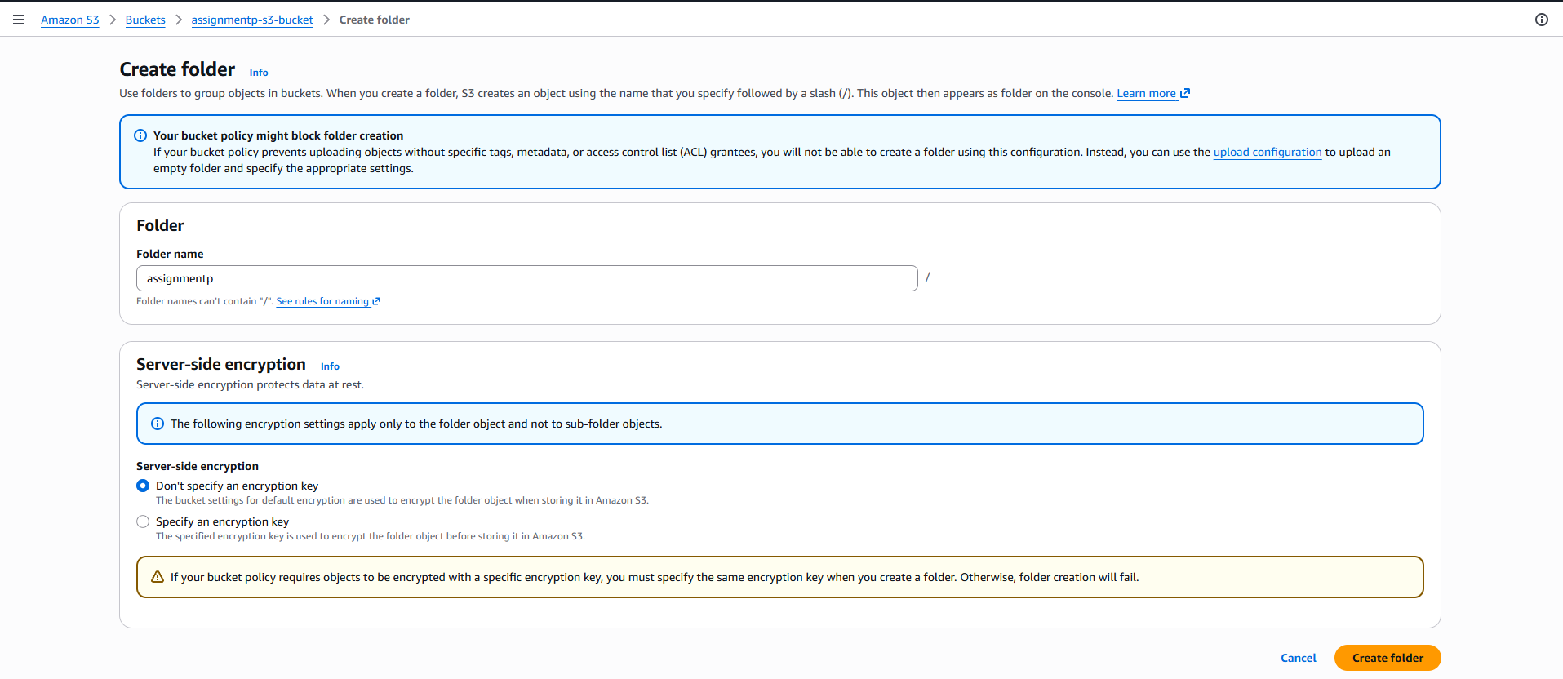

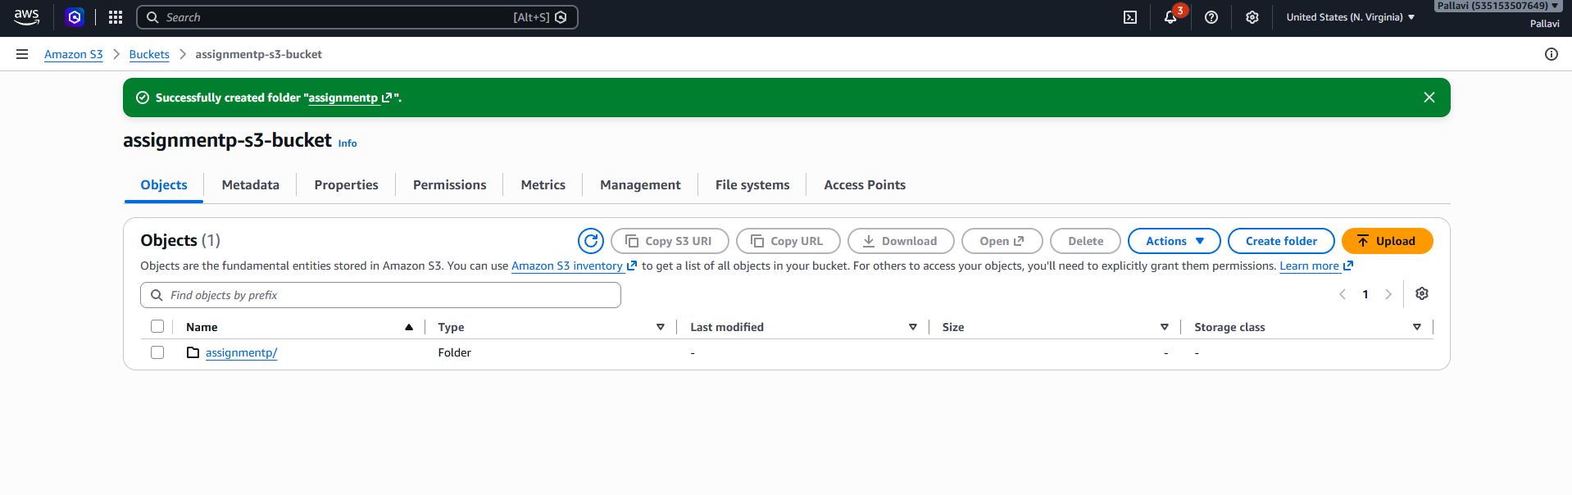
Upload the file

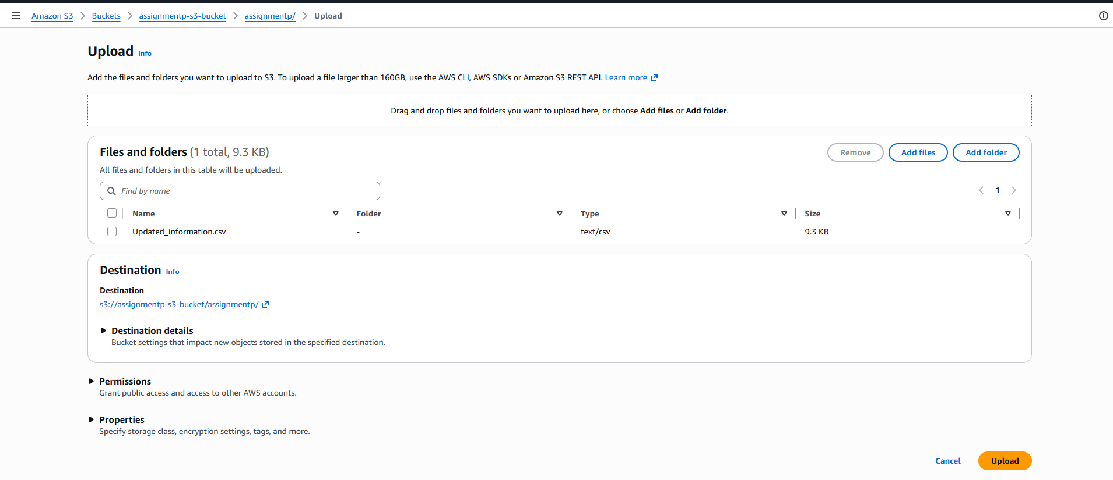

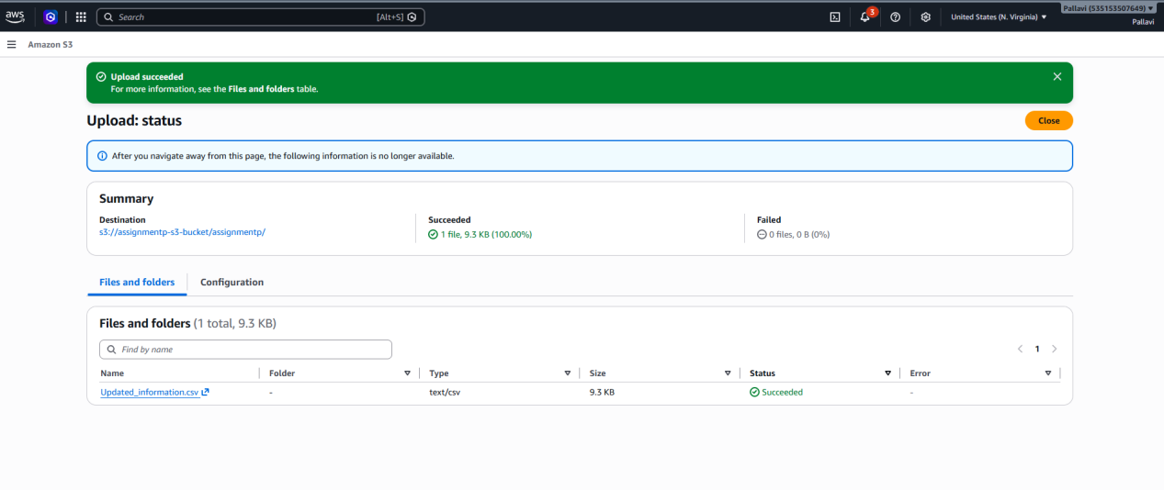

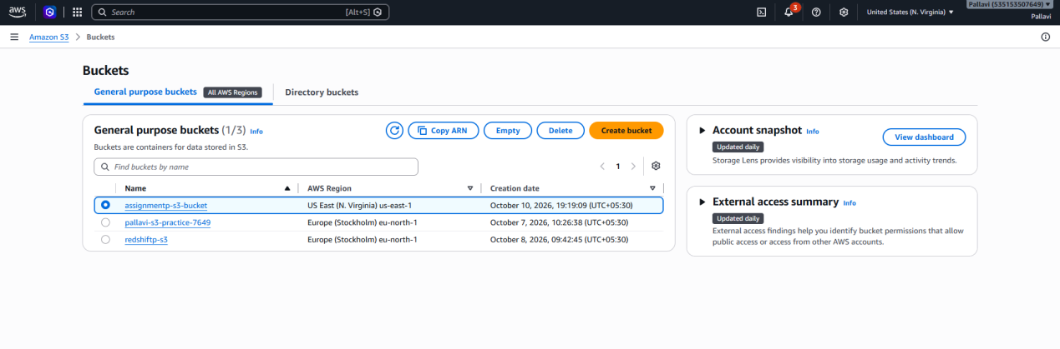
IAM:
Select trusted entity as AWS service
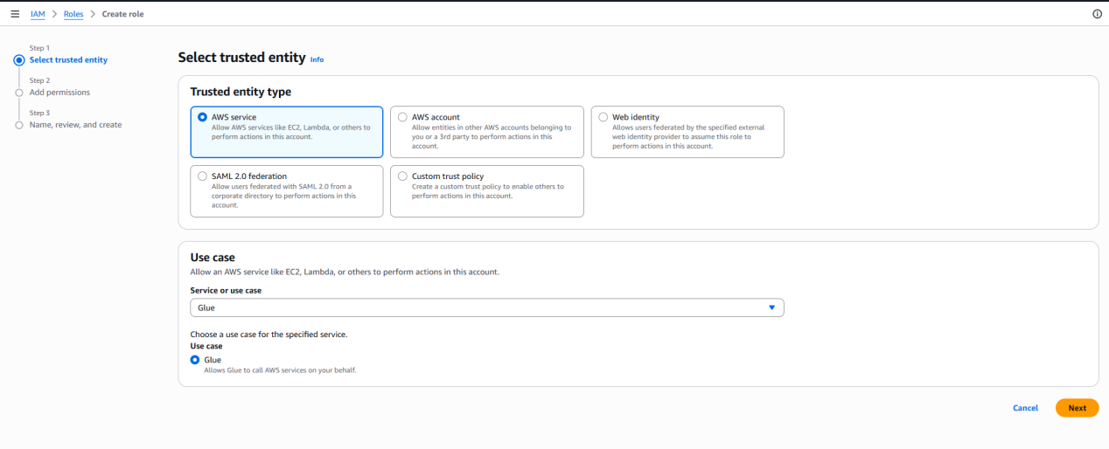
Add permissions

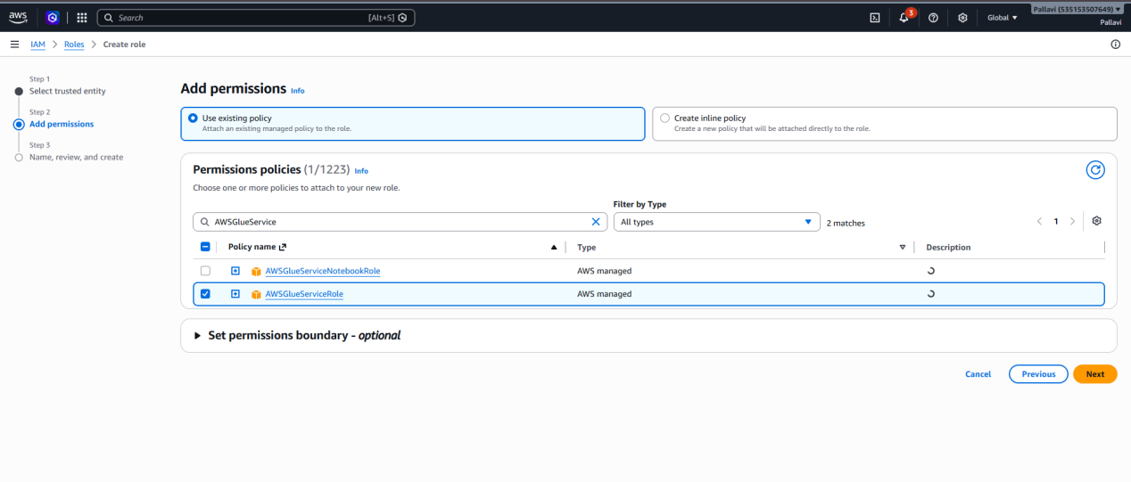
Role name

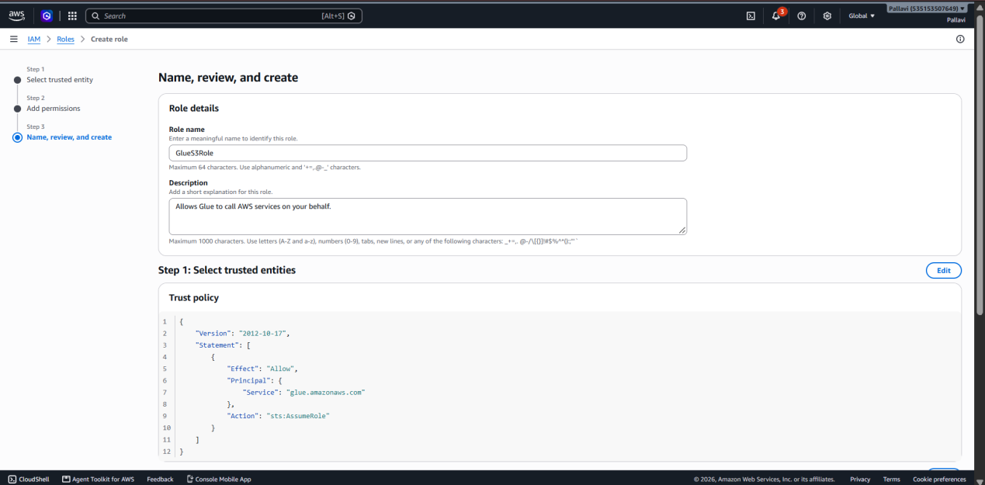
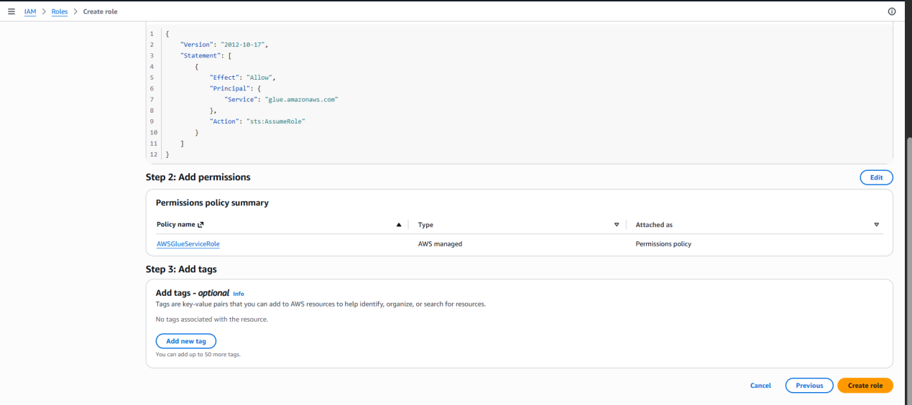

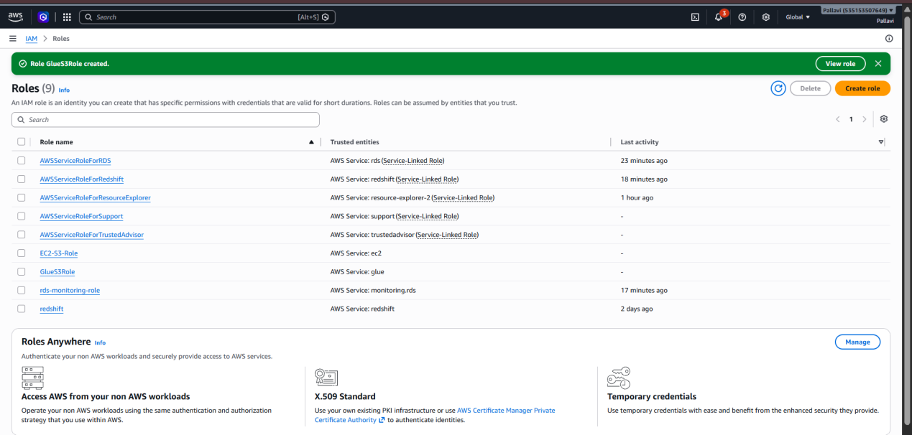

GLUE:
AWS Glue Console
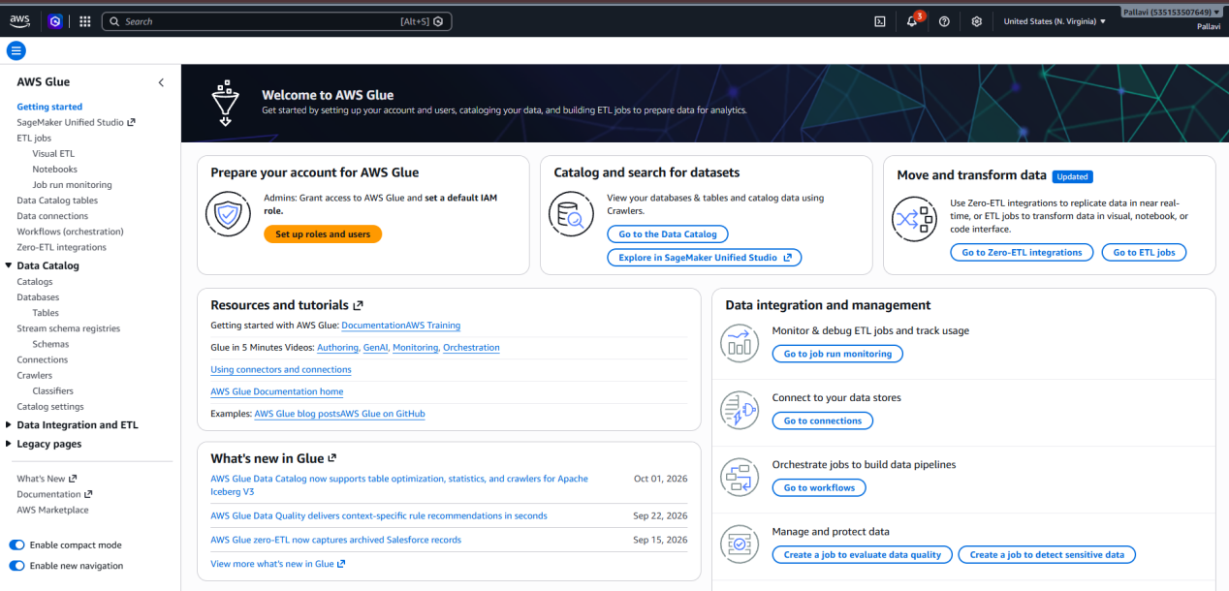

Data Catalog -> Databases
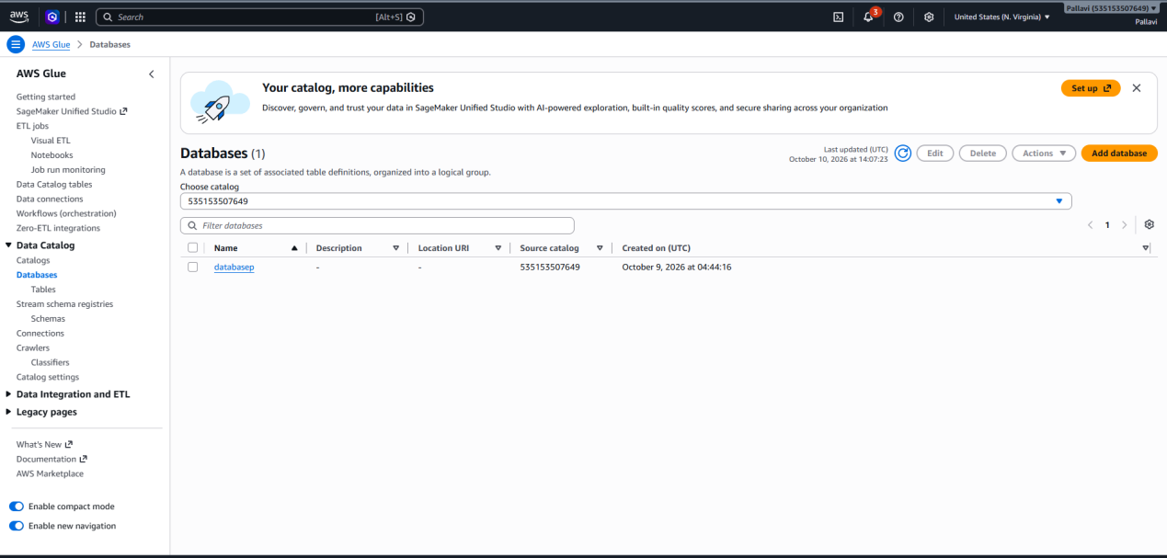
Create a database

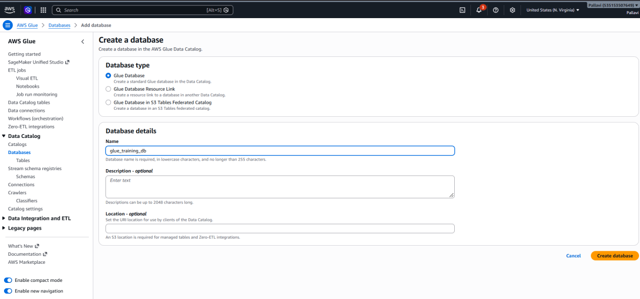
Database list now showing glue_training_db

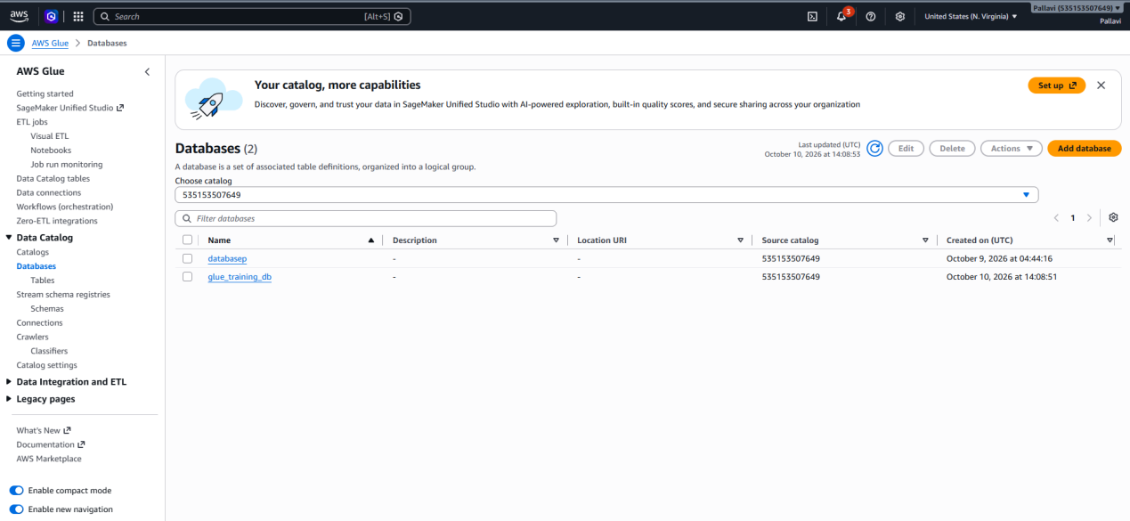

AWS CRAWLER
Crawler page with no crawlers yet
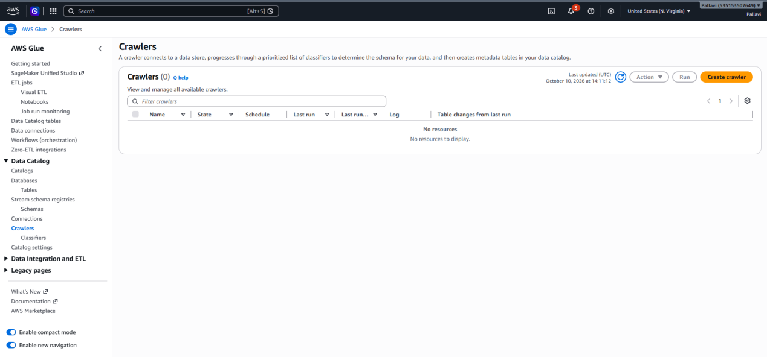
Crawler properties page with the crawler name entered as assignment_crawler.

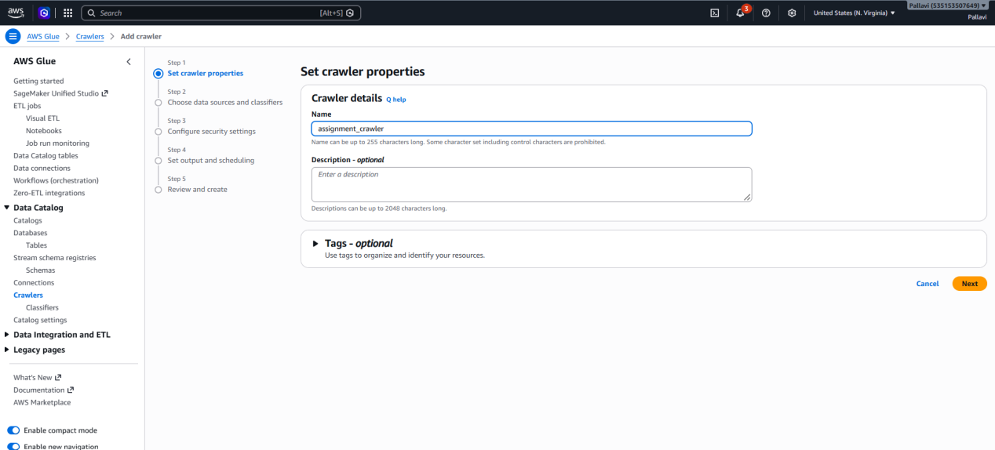

S3 source location
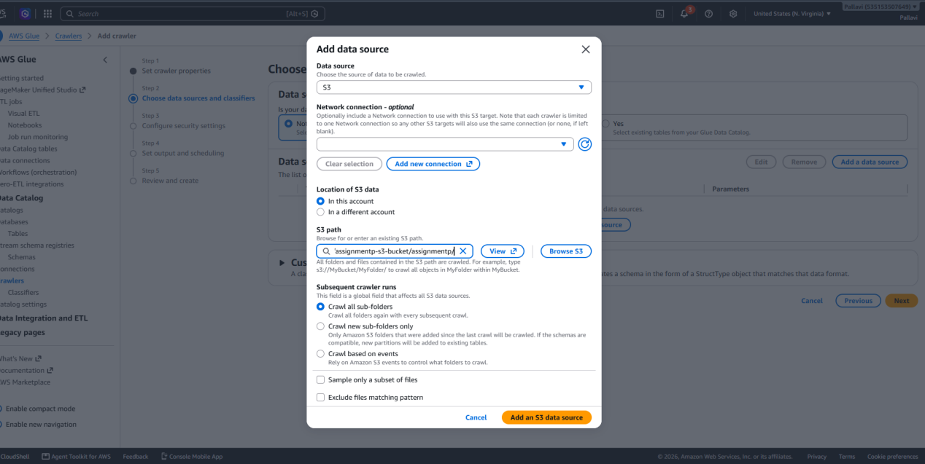

Data Source added

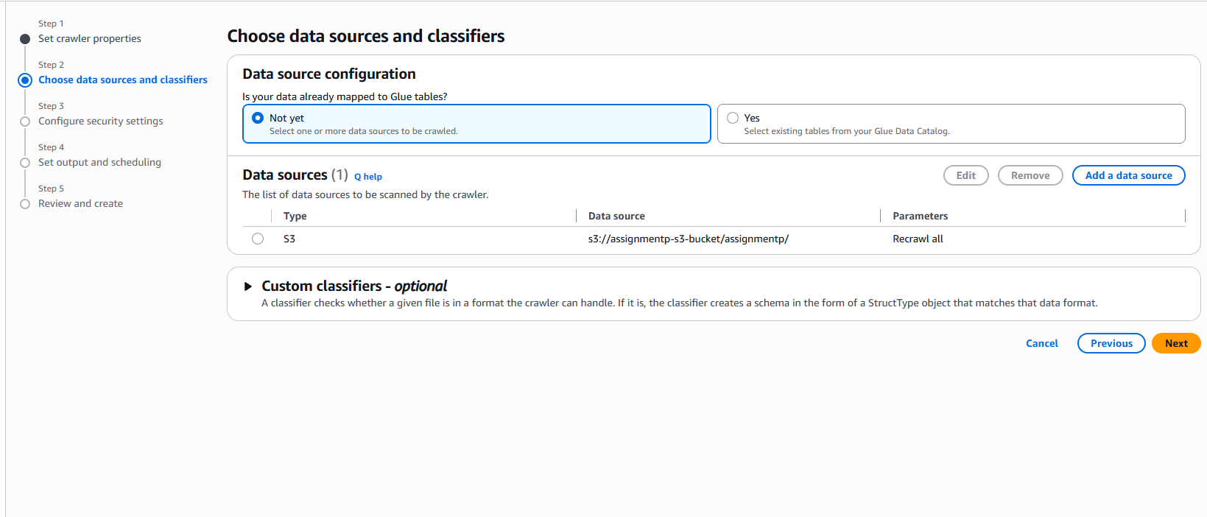
Configure security settings page with IAM role

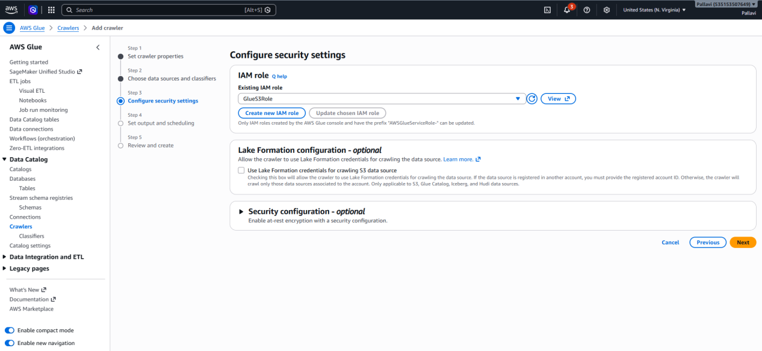

Output and scheduling page with glue_training_db as the target database
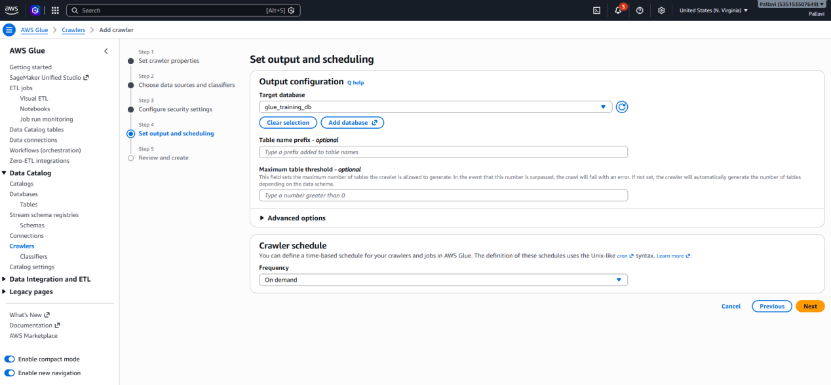

Review and create

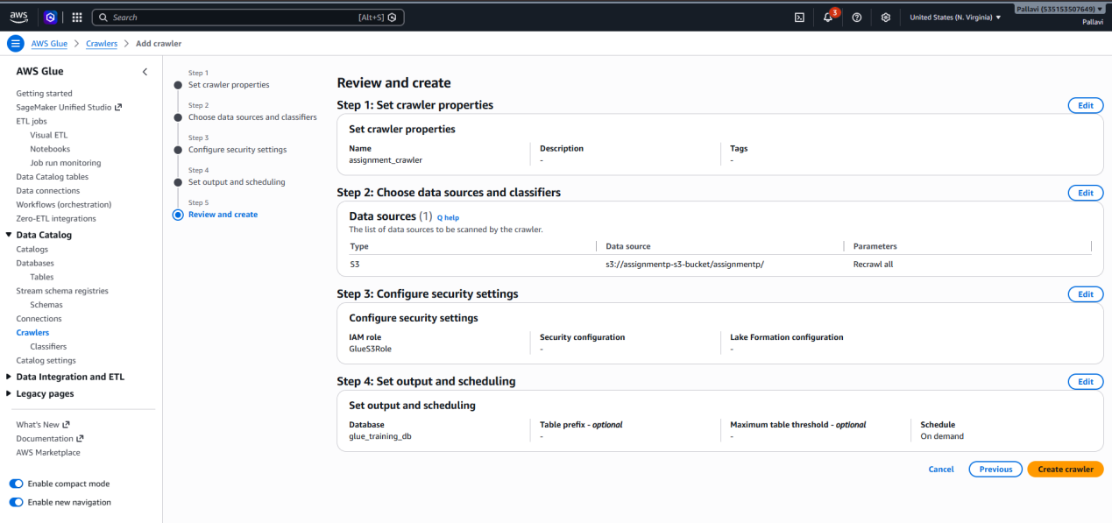

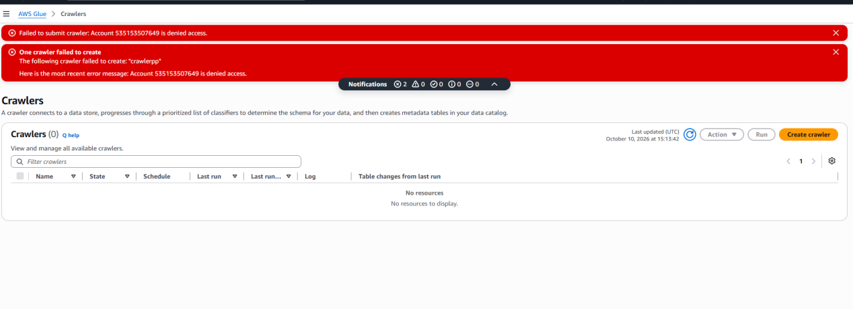

GLUE DATA CATALOG
Set table properties
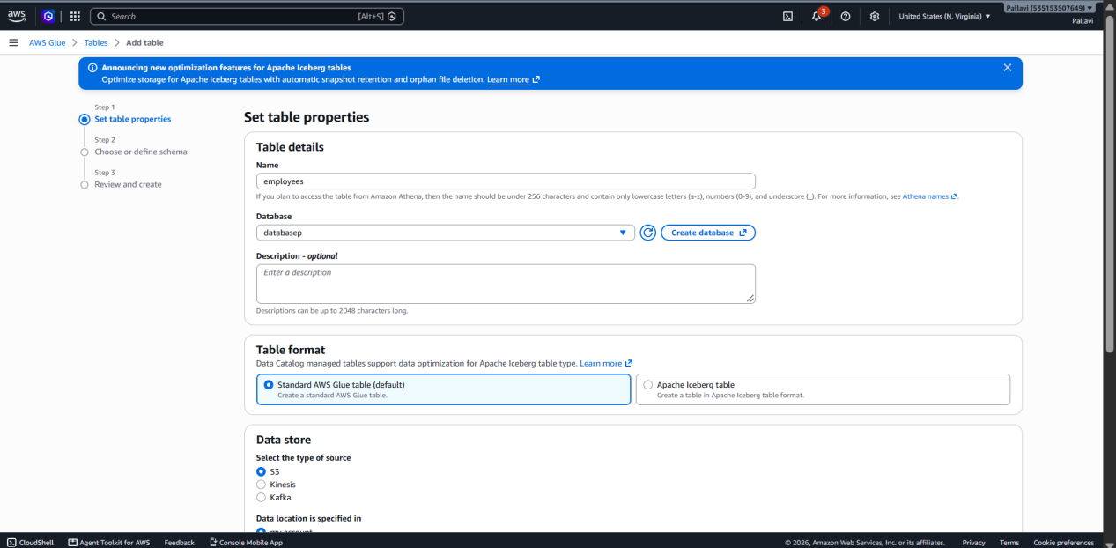

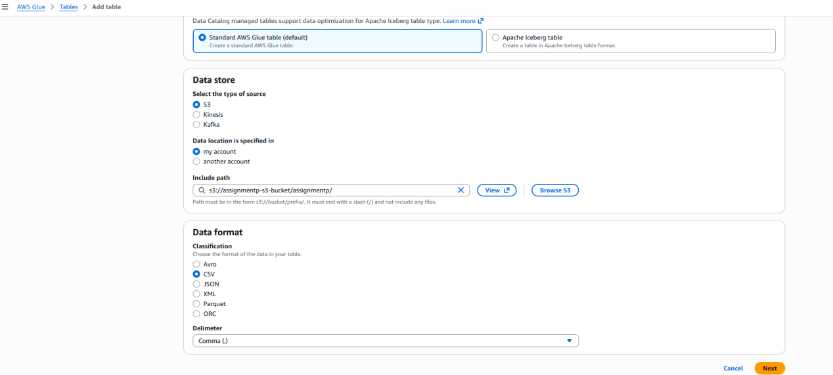

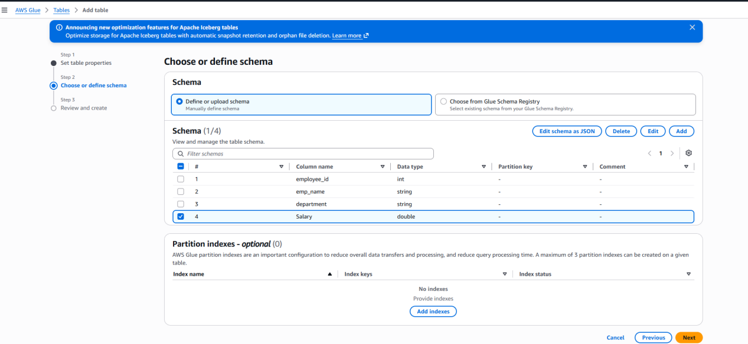

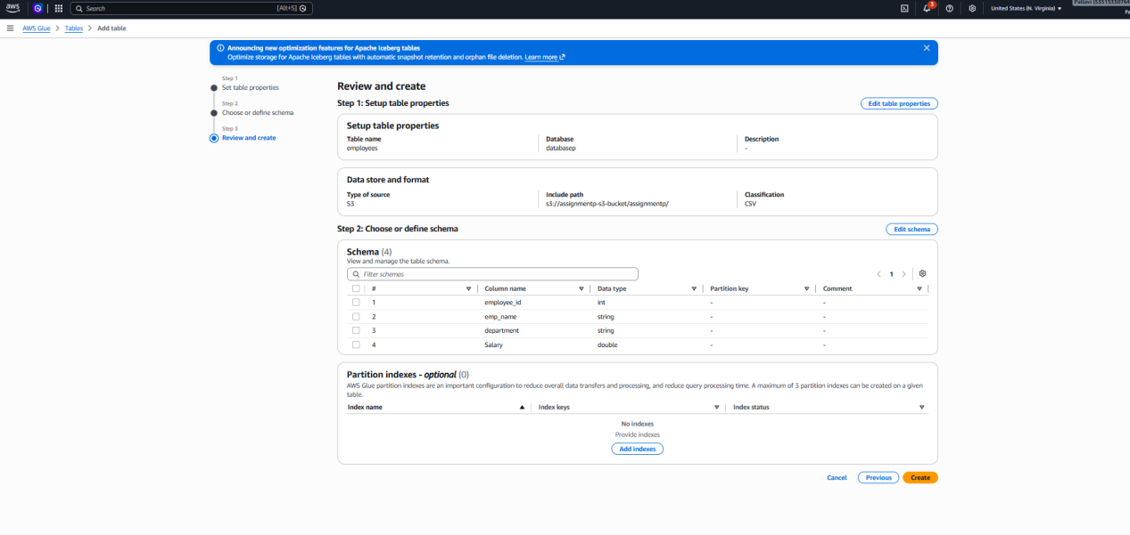

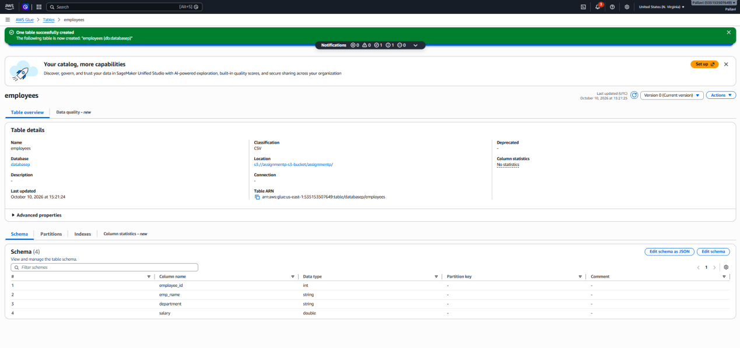

GLUE VISUAL ETL
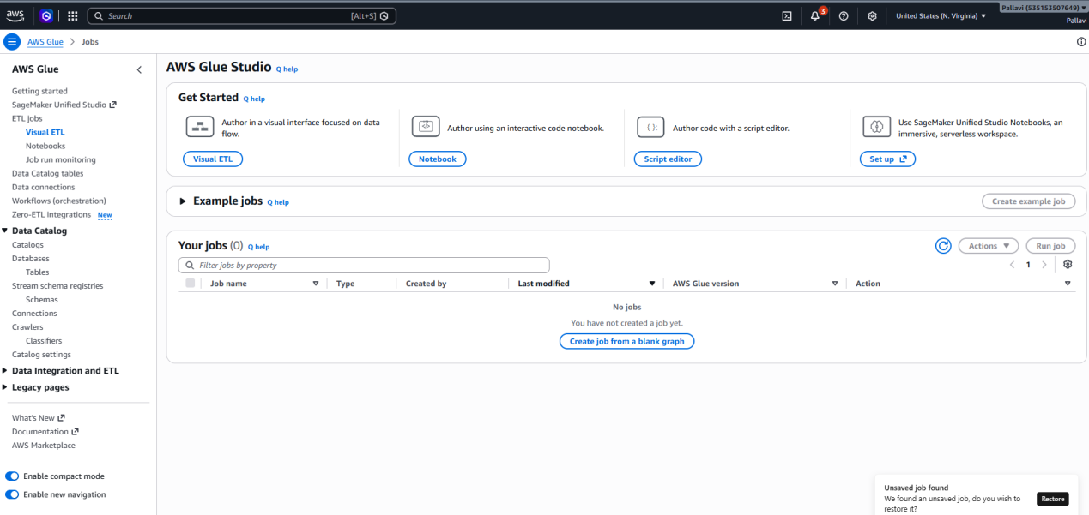

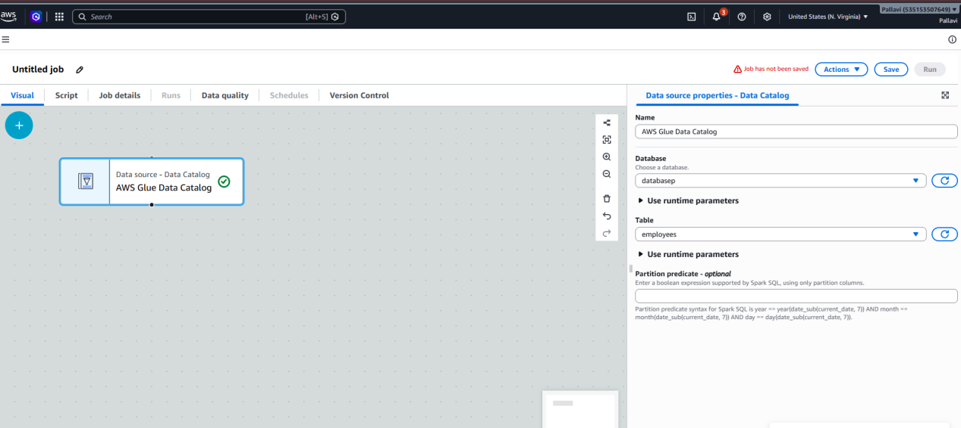

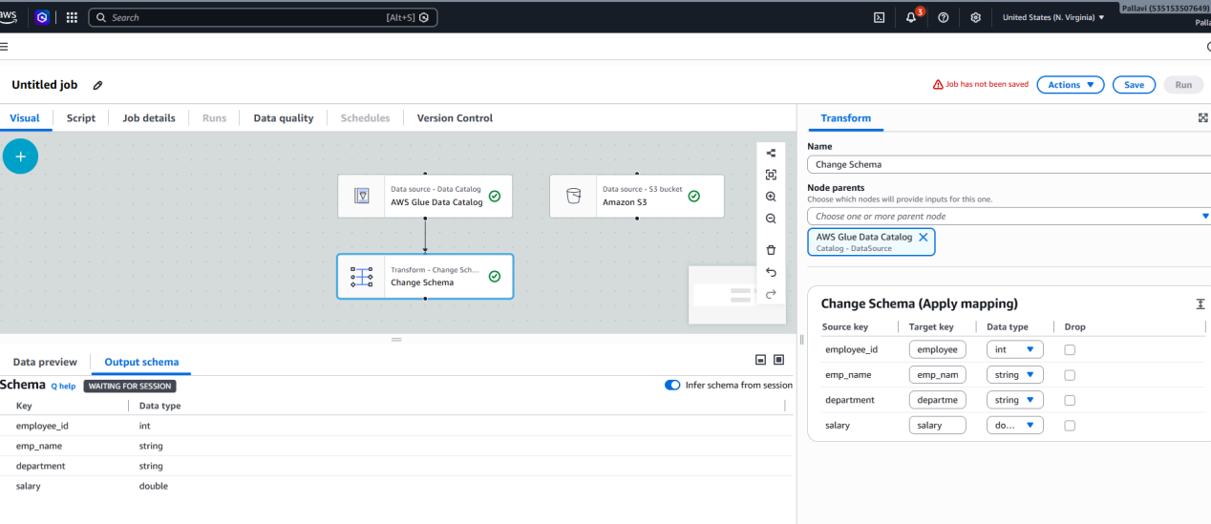

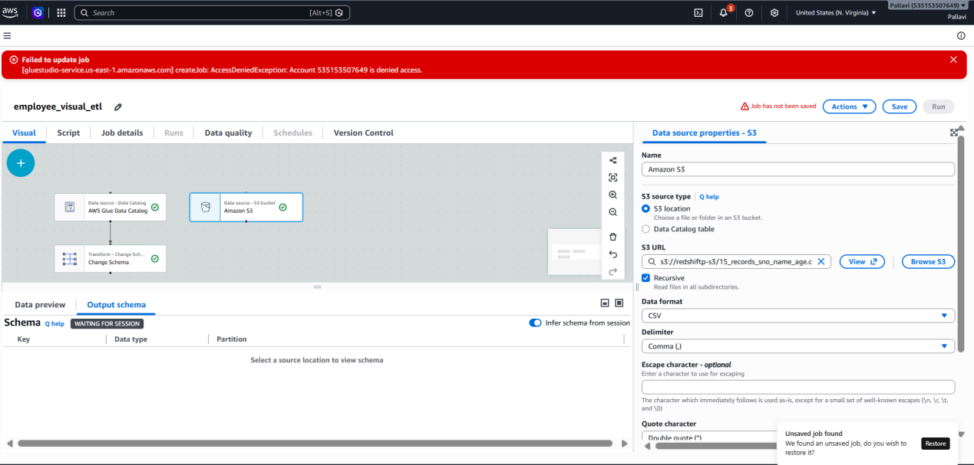

S3 Target Location

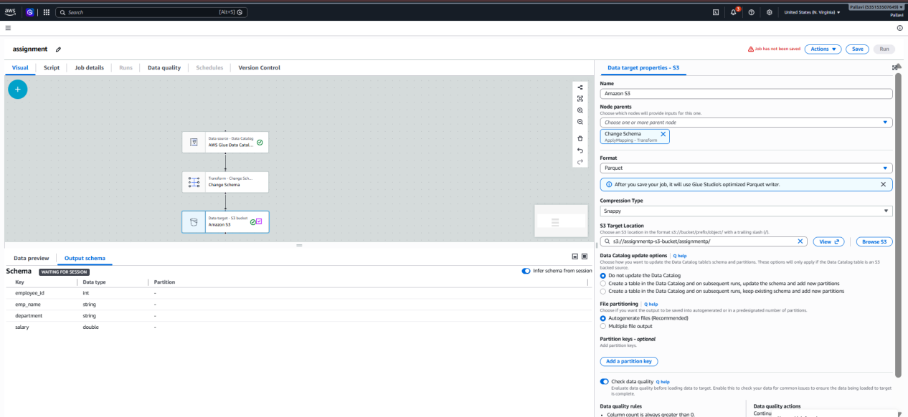

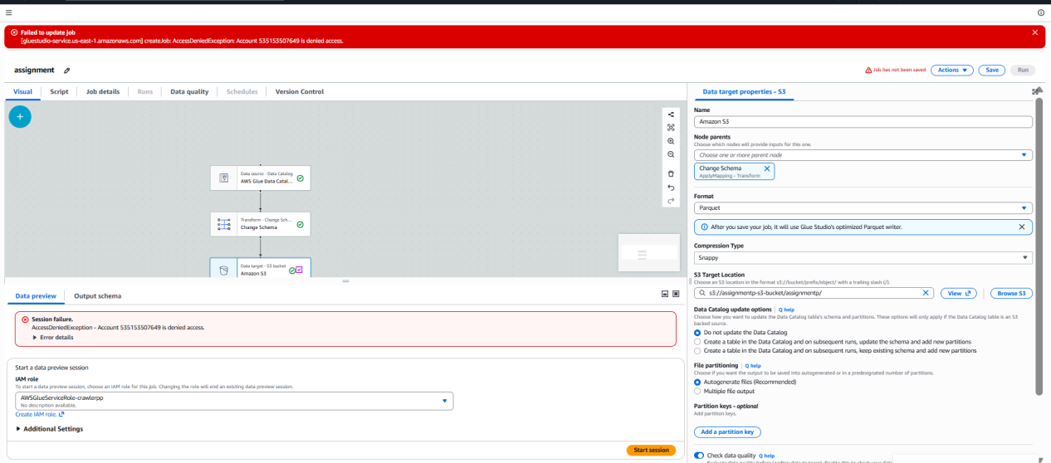

Final Explanation : AWS Glue ETL Workflow

1. Amazon S3:
Amazon S3 is used to store data.
First, we upload the employee data file to an S3 bucket.
The file contains details of employees.
We store the raw data in the input folder.
This data is used in the next steps of the workflow.

2. Glue Crawler
A Glue Crawler is used to scan the data stored in S3.
It checks the file and identifies its structure.
It finds the column names and data types.
It collects the details about the data.I
t sends these details to the Glue Data Catalog.

3. Glue Data Catalog
The Glue Data Catalog stores information about the data.
It contains databases and tables.
We create a database and an employees table.
The table stores details about the columns in the employee data.
Glue uses this table to read the source data.

4. Glue Visual ETL
Glue Visual ETL is used to create a data workflow.
We create the workflow using boxes on the screen.
We select the employees table as the data source.
We connect the source to a transformation and an S3 target.
This helps us move and change the data without writing the whole code manually.

5. Transformation
Transformation is used to make changes to the data.I
In this workflow, we use the Change Schema option.
We select the required employee columns.
We can change the column names or data types if needed.
The changed data is then sent to the S3 target.

6. S3 Curated Data
The transformed data is stored in the S3 curated folder.
We set the output location as s3://glue-ass-p/curated/.
We select Parquet as the output format.
When the Glue job runs successfully, it creates output files in this folder.
We can use these files for further analysis and reporting.
WORKFLOW : s3 -> Glue Crawler -> Glue Data Catalog -> Glue Visual ETL -> Transformation -> S3 Curated data

