Employee performance analysis

1. Project summary

This project is an oversight of INX Future Inc. employee performance and factor affecting the same. This analysis focuses on employee efficiency development areas that are to be identified and provide suitable recommendations ensuring improved employee performance, thus improving the service delivery and customer satisfaction.

It is a Supervised Categorical Problem which can be solved using any of the Classification Algorithms like, Random Forest, Decision Tree, XGBoost Classifier, ANN etc.

The code has been written in Python using the Jupyter Notebook which yields better visualization. Tableau has also been used for visualizing.

# 1.1 Requirement

* Employee Performance Data from INX Future Inc.
* Identifying the objectives of INX Future Inc.
* Applying Machine Learning Model and predict the Employee Performance.

# 1.2 Analysis

* Random Forest Algorithm and XGBoost Algorithm have been used to analyze the data received from INX Future Inc.
* Applied Principal Component Analysis (PCA) Technique, because the given data has more number of predictors. So PCA technique has applied here for reduction of dimensions. It is giving 81% accuracy which is less than normal modelling and its confusion matrix is not so good. So, it is not that much required.
* The given data set has 27 features. When I have taken all features, it has given accuracy 94%. When I have taken only 7 features then it has given 93% accuracy. But when I have taken the top 3 features it has given 90% accuracy.
* **Department Wise Performances:**
* **From the insight into the data, below are the Department-Wise employee performance.**

|  |  |  |  |  |  |  |
| --- | --- | --- | --- | --- | --- | --- |
| Employee Department | Count of Employees Based on Performance Rating | | | |  |  |
|  | **Good**  **(2)** | **Excellent**  **(3)** | **Outstanding**  **(4)** | **Grand Total** | **% of 3 Ratings** | **% of 4 Ratings** |
| Data Science | 1 | 17 | 2 | 20 | 85 | 10 |
| Development | 13 | 304 | 44 | 361 | 84.21 | 12.19 |
| Finance | 15 | 30 | 4 | 49 | 61.22 | 8.16 |
| Human Resources | 10 | 38 | 6 | 54 | 70.37 | 11.11 |
| Research & Development | 68 | 234 | 41 | 343 | 68.22 | 11.95 |
| Sales | 87 | 251 | 35 | 373 | 67.29 | 9.38 |
| Grand Total | 194 | 874 | 132 | 1200 |  |  |

* From the above data and analysis, it is evident that Development, Human resources and Research & Sales are the top employee performing Departments.
* Even though, the Department of Data science has a high percentage of 3 ratings, its percentage of 4 ratings are comparatively, barring it from top 3 Performing Departments.
* **Top 3 Important Factors Affecting Employee Performance:**
* EmpEmvironmenSatisfaction – For performance rating EmpEmvironmenSatisfaction plays an important role. If it is high, it gives outstanding performance.
* EmpLastSalaryHikePercentage – According to Employee performance they get salary hike. So how frequently they get salary hike that shows their better performance in their office. So, it is also very important.
* YearsSinceLastPromotion – If any employee has done a good job then they get promotion. So, how soon they get promotion it shows their high performance.

# 1.3 Summary

Random Forest & XGBoost trained Model are an efficient model to predict the employee performance based on the factors as inputs and the same can be used to hire the employees.

The percentage of trained model efficiency resulted as 93% and helping to identify if the employee being hired will be a “Good”, “Excellent” or “Outstanding” performer.

**Recommendations:**

1. The Department of Data Science and Finance can hire more employees with relevant education background.
2. Based on Exploratory Data Analysis the major factors affecting the performance are Employee’s satisfaction, hike in their salary and duration for which they are in the same position.
3. The Employer should take care of the Employees by keeping the work environment friendly and motivating, and also the basic amenities must be provided. Once in a while a Counselling can be provided if the Employer feels that there is a performance issues with a particular employee.
4. The salary of the employees must be increased as per the company’s standard based on their performance to keep them motivated and interested.

# 2.1 Visualization

1. 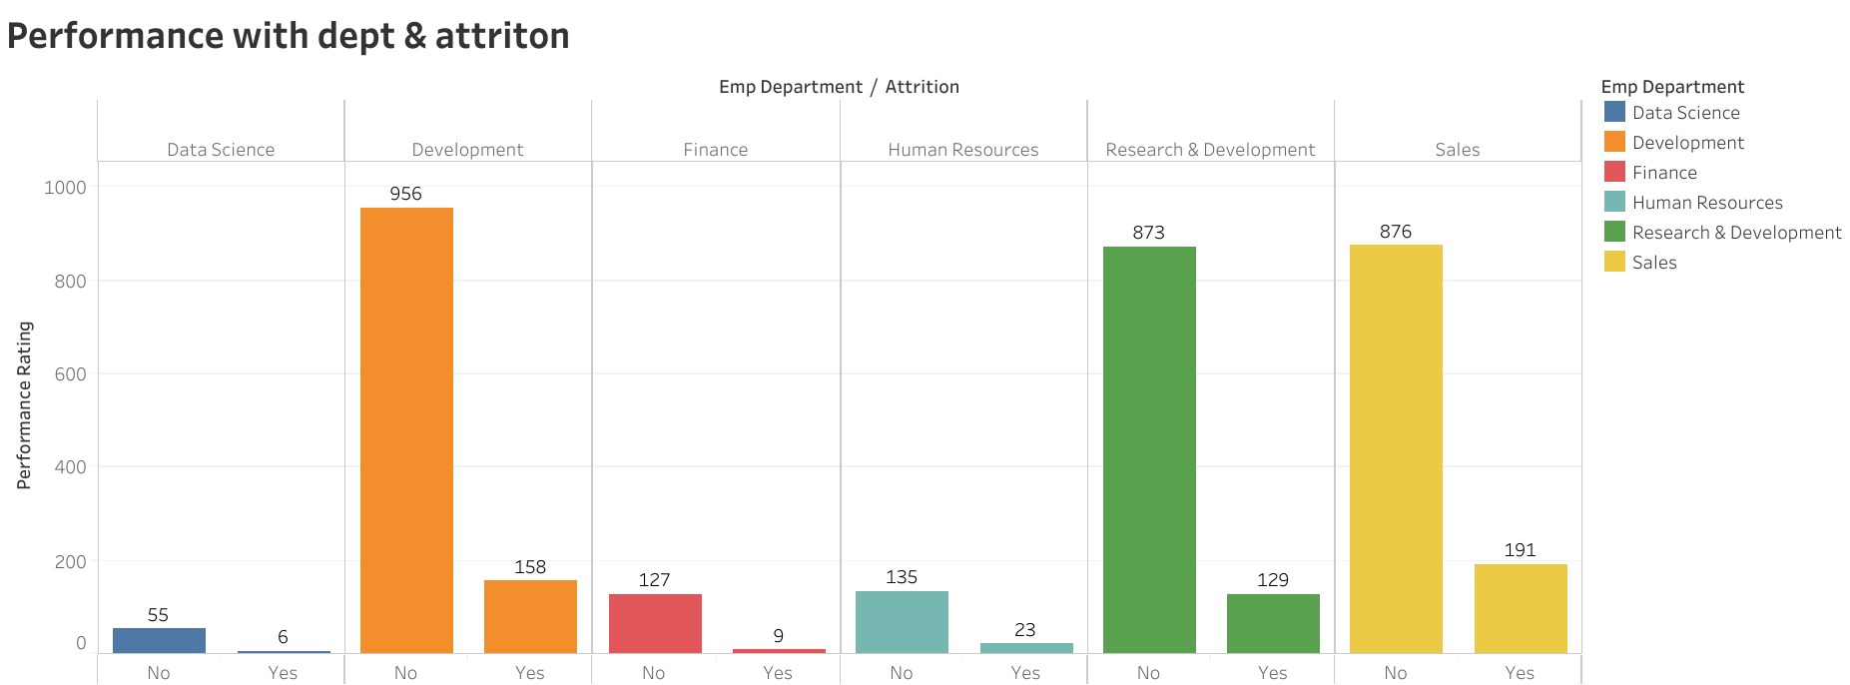

Graph showing Performance With Department and Attrition

**2.2 Top 3 Important Factors Effecting Employee Performance**

**1.**

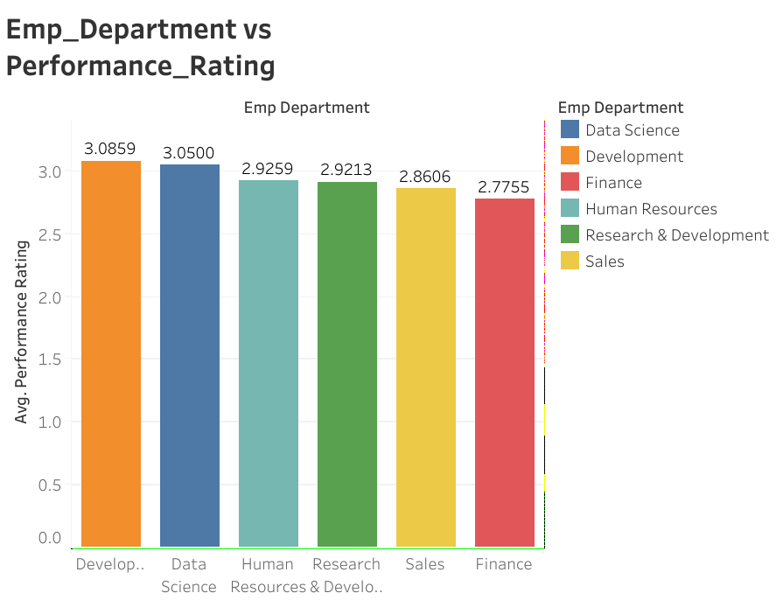

Graph showing Emp_Department v/s Avg Performance Rating

2. 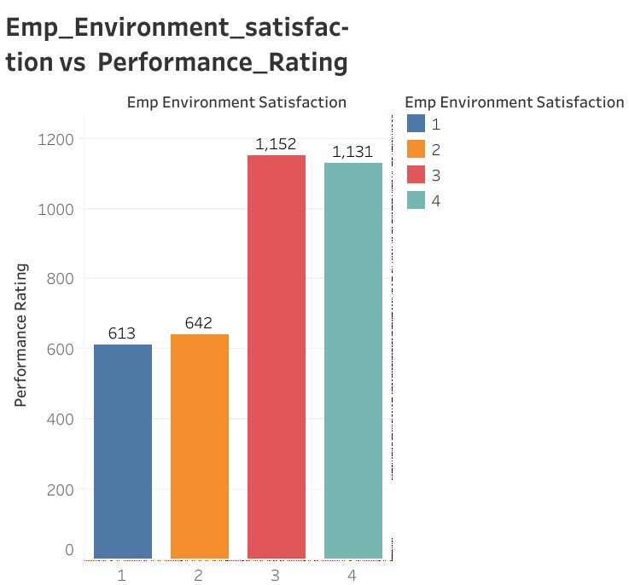

Graph showing Emp_Environment_Satisfaction vs performance Rating

3. 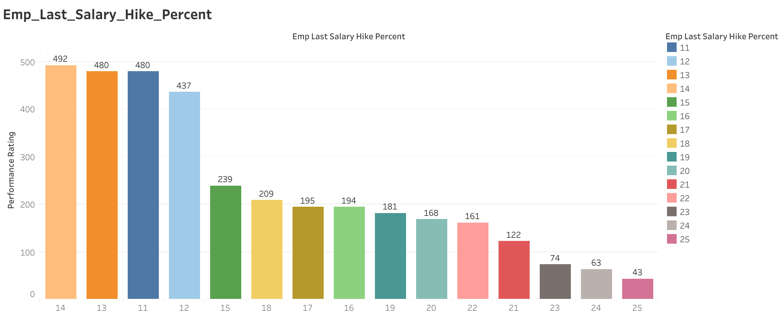

Graph showing Employee_Last_Salary_Hike_Percent v/s performance Rating

**1. Department wise performances**

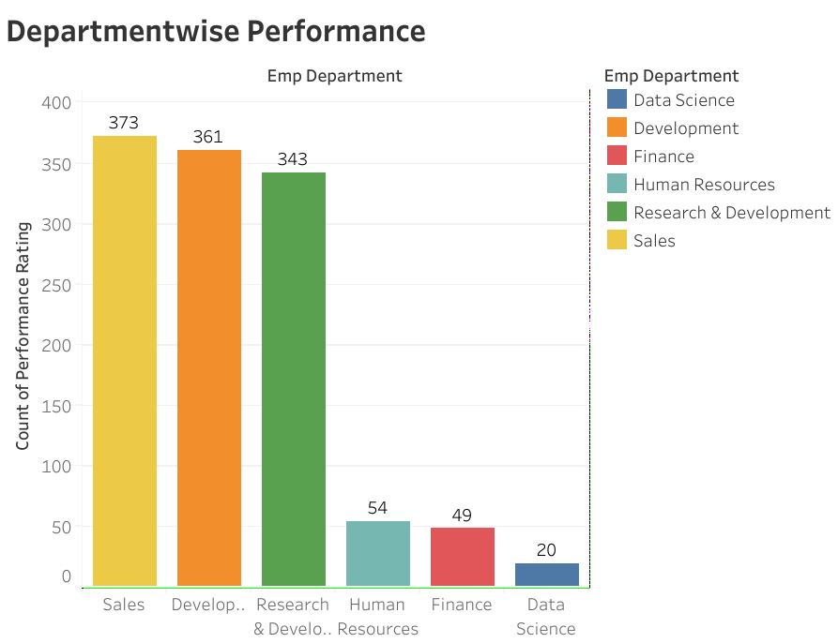

Graph shows Department wise Performance

# 3.4 References

Not available/Applicable.